

**边缘计算网关**

**ESHG-RJ-MBSVR-T3(v1.1)-20220906**

**程序测试报告**

|  |  |  |  |
| --- | --- | --- | --- |
| 产品名称  和型号 | 边缘计算网关  ESHG-RJ-MBSVR-T3(v1.1)-20220906 | 测试时间和工时 | 20220909- |
| 计划提交时间 | 20220906 | 实际提交时间 | 20220906 |
| 软件版本 | ESHG-RJ-MBSVR-T3(v1.1)-20220906 | 硬件版本 | 边缘计算网关T3 |
| 测试人员 | 樊晓光 | 测试复核 | 周永康 |
| 软件研发 | 张金金 |  |  |
| 测试结论 | 测试中 | | |
| 本版本测试次数累计、时间周期和问题说明 | ESHG-RJ-MBSVR-T3(v1.1)-20220906：  平台建议1、平台问题1、上位机建议1、程序问题1（详细见问题与建议） | | |
| 新增测试用例 | 1. 本版本对多联机空调控制器C的支持；测试程序对大金、美的空调网关的控制、读取。 2. 本版本对2路色温控制器的支持情况。 3. 对4路调光控制器的支持情况。 4. 对8路开关控制器的支持情况。 | | |

# 测试问题、建议

平台建议1：建议说明此处：通道号的含义，方便理解后，填写正确的内容。

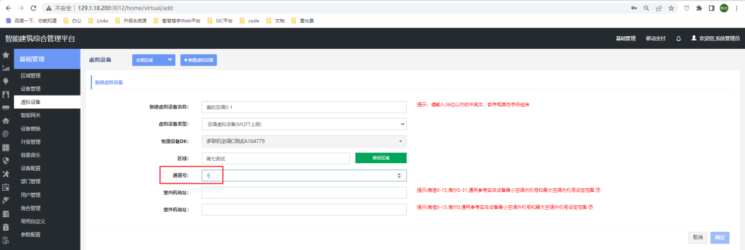

平台问题1：采集时间间隔在成功下发后，再次打开界面，依旧显示226ms

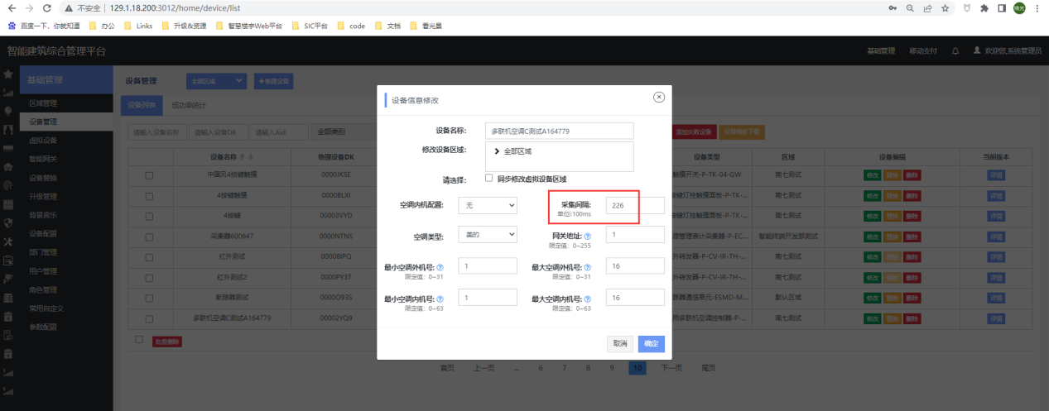

平台问题2：平台未支持8路开关执行器。（已修复3012平台）

平台问题3：未能支持2路色温控制器。（已修复3012平台）

平台问题4：未能支持4路调光控制器。（已修复3012平台）

**上位机建议：**测试上位机的地址范围建议做最新适配。

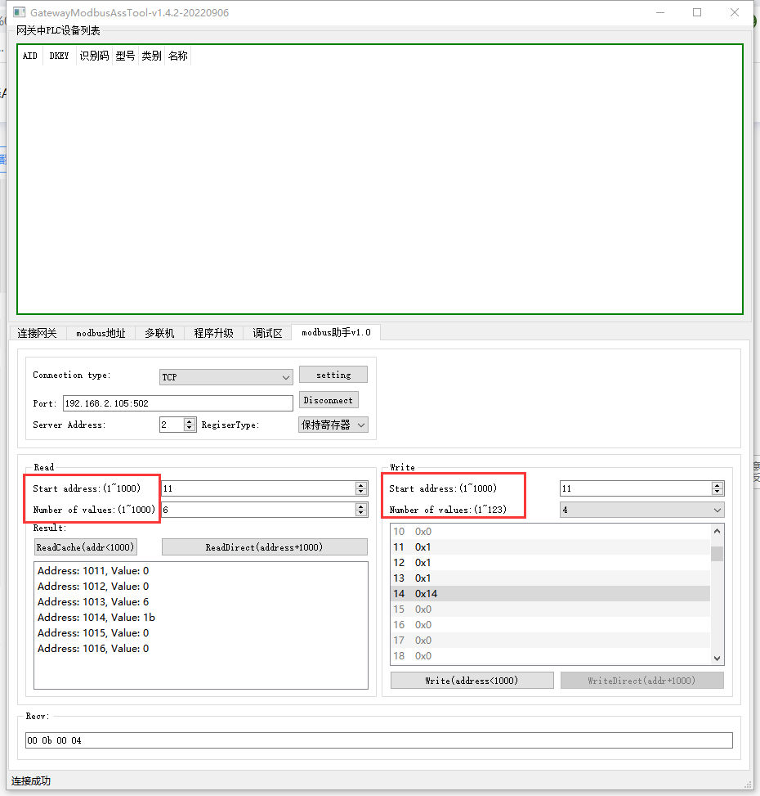

问题1：读取控制设备失败（报错：83 02），sewenkzq2ch.json（2路色温控制器）中modbus寄存器起始地址(start_registers)与寄存器个数(nb_registers)颠倒的modbus起始地址和地址个数颠倒。如下图所示（20220919）（已修复）

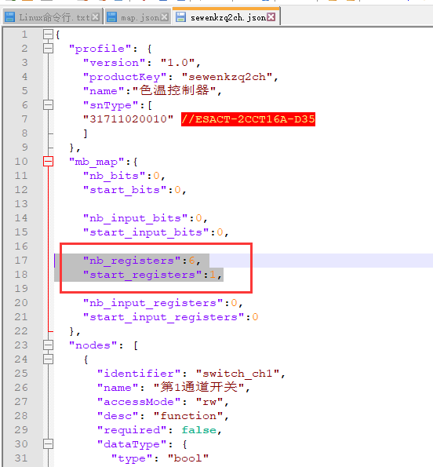

问题2：V3S单相网关设置modbus服务开机自启动失败：V3S网关启动脚本全路径为/usr/sbin/gateway_boot.sh，而非T3网关的/usr/bin/gateway_boot.sh（已修复）

# 迭代记录

|  |  |  |  |
| --- | --- | --- | --- |
| 版本号(更新说明) | 更新 | 测试问题 | 时间 |
| 历史版本请查之前的测试报告 |  |  |  |
| ESHG-RJ-MBSVR-T3(v1.1)-20220906 | 1修正温湿度传感器ESSN-TH-C的无法读取温湿度问题json描述错误)  2.支持中国风系列2按键3按键开关  3.支持大功率遥控计量开关  4.支持空气质量采集器  5.支持多联机空调控制器C  6.支持8路开关执行器  7.支持色温控制器(两路，0~10v)  8.支持4路调光控制器(0~10v) | 问题1：读取控制设备失败（报错：83 02），sewenkzq2ch.json（2路色温控制器）中modbus寄存器起始地址(start_registers)与寄存器个数(nb_registers)颠倒的modbus起始地址和地址个数颠倒。如下图所示（20220919）（已修复）  问题2：V3S单相网关设置modbus服务开机自启动失败：V3S网关启动脚本全路径为/usr/sbin/gateway_boot.sh，而非T3网关的/usr/bin/gateway_boot.sh（已修复） | 20220919 |
|  |  |  |  |

# 测试说明&验证设备

目前验证过的设备及细分型号

|  |  |  |
| --- | --- | --- |
| 名称 | 型号 | SN |
| 四路开关执行器 | P-ACT-4S16A-A-63 | 31711050003 |
| 四路开关执行器 | P-ACT-4S10A-M | 31711050011 |
| 四路开关执行器 | P-ACT-4S10A-S | 31711050012 |
| 四路开关执行器 | ESACT-4S10A-M | 32011050011 |
| 四路开关执行器 | ESACT-4S10A-S | 32011050012 |
| 四路开关执行器（CT） | ESACT-4S16A-63-CT | 31711050005 |
| 计时联网温控器 | ESTK-05-FC-CT-A | 31712010032 |
| 单轨窗帘控制模块（开度控制） | ESACT-CC1-AC-C | 32011040013 |
| 双规窗帘控制模块 | ESACT-CC2-AC-A | 32011040012 |
| 调光控制模块 | ESACT-1D1S2A-63 | 32011020002 |
| 调光控制器 | P-ACT-2D2A-D35-63 | 31711020004 |
| 载波电能表 | DDSI16-D35-A | 31741060001 |
| 人体红外传感器 | P-SN-IR-IM-A | 31721010013 |
| 四寸智能终端 | P-DT-L-CTP4 | 31713010201 |
| 2路干接点开关 | P-ACT-2S1A-DCS 2 | 31711010105 |
| 3路干接点开关 | P-ACT-3S5A-DCS | 31711010106 |
| 睿智智能开关 | P-TK-03-3S1A-S | 31712020405 |
| 两路色温控制器(0~10v) | ESACT-2CCT16A-D35 | 31711020010 |

# 测试使用的工具



# 程序烧录\上传ok

**说明：**目前还没有实现打包到网关中，测试通过后再进行打包。

## 软件更新

1. 文件上传

上传的文件包含协议转换程序modbus_svr，json文件夹（其中包含了所支持的设备类型及功能），map.json（网关内添加过的设备类型及modbus对应地址），mbsvr_star.sh（启动文件）

登录网关将如下图4个文件上上传到对应目录/gateway/modbus/，注意文件的加密问题。

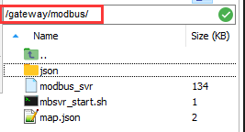

1. 启动文件

**说明：**测试期间modbus_svr文件需要手动启动。

进入目录/gateway/modbus/后，手动启动# ./modbus_svr &程序

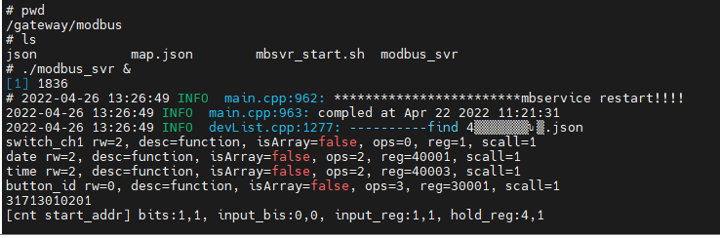

启动后可见程序会按照对应map.josn查找设备

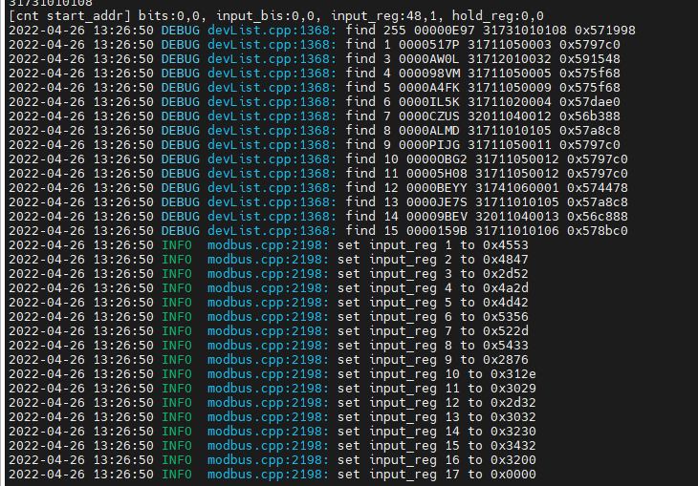

查询是否启动成功——成功

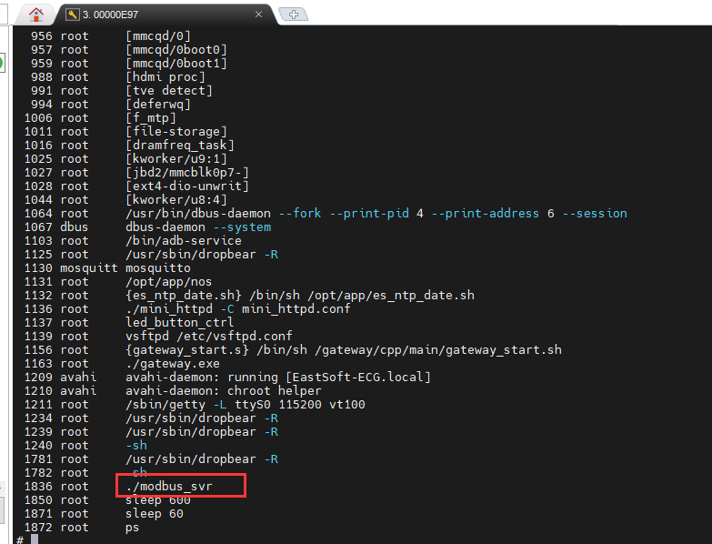

## 验证更新

查询程序版本，通过TCP Client连接设备，服务器端口号为502

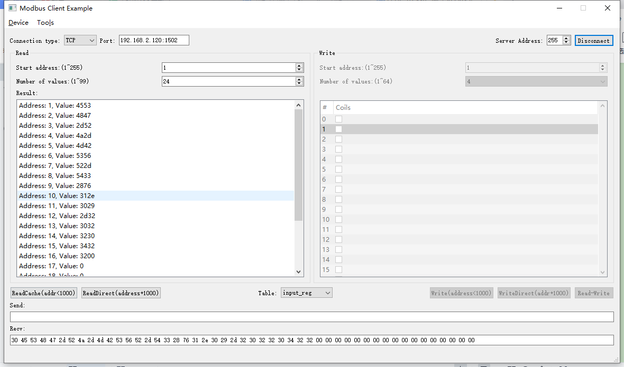

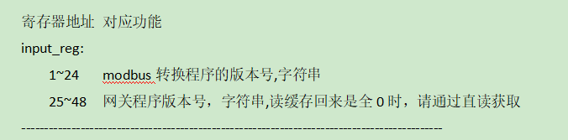

### 读取程序版本

#### 读取缓存版本号

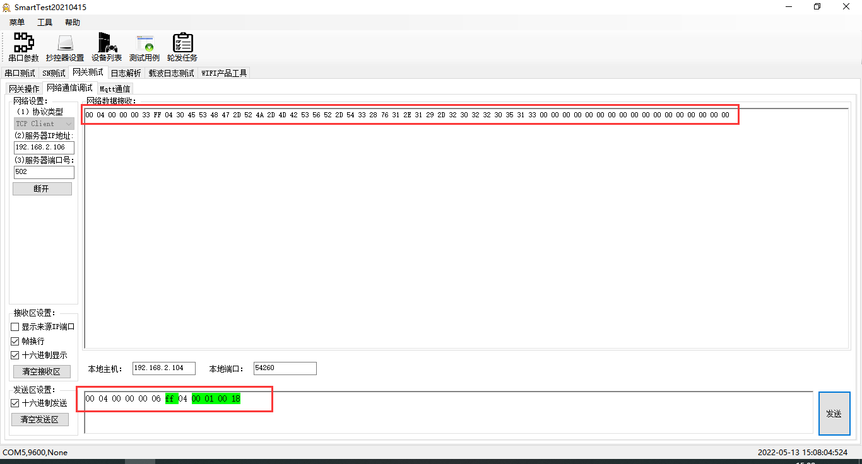

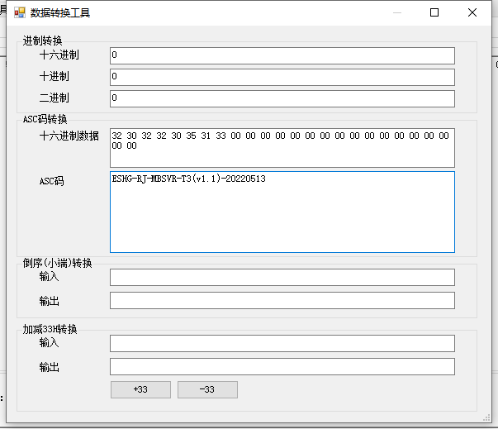

解析回复报文：ESHG-RJ-MBSVR-T3(v1.1)-20220513，版本是提测版本

#### 读取直读版本号（addr1001）

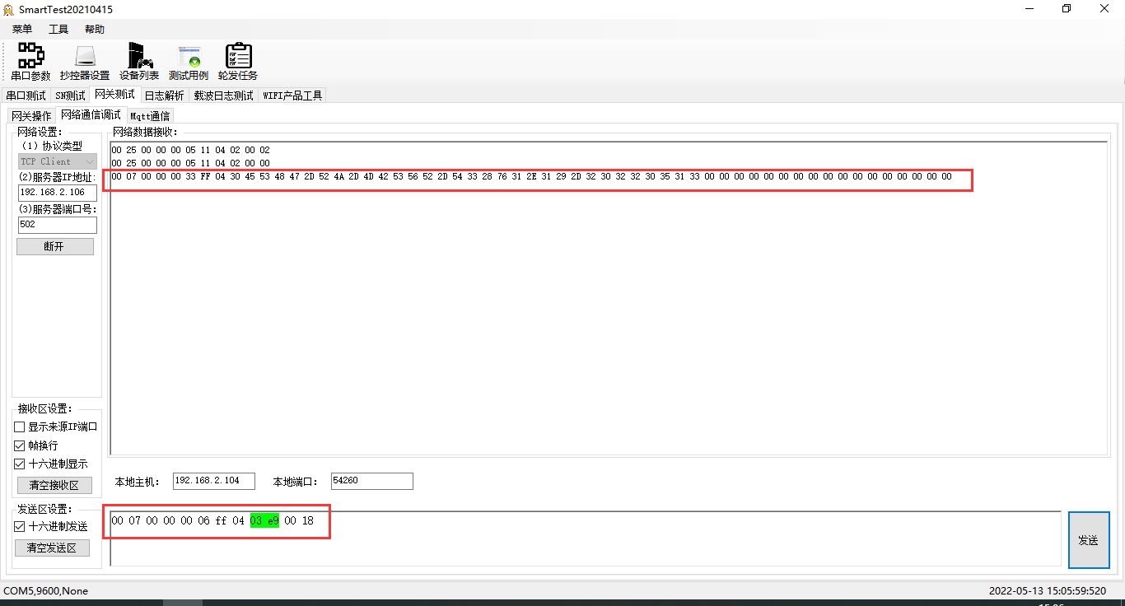

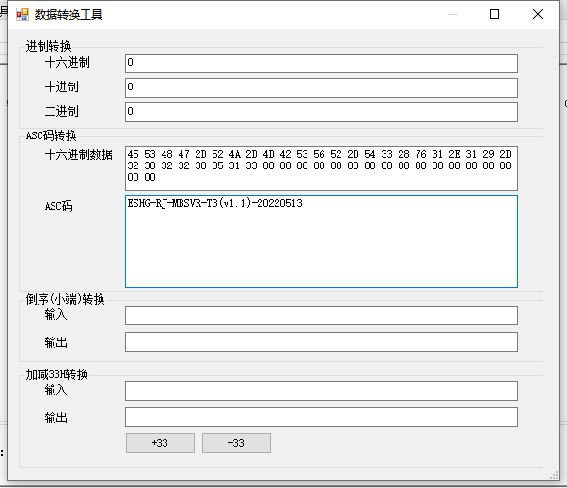解析回复报文：ESHG-RJ-MBSVR-T3(v1.1)-20220513，版本是提测版本

### 读取网关版本

#### 读取缓存版本（协议转换程序+网关程序）

rcv from 192.168.2.119:54668:

[ 00 14 00 00 00 06 ff 04 00 01 00 30 ]

snd to 192.168.2.119:54668:

[ 00 14 00 00 00 63 ff 04 60 45 53 48 47 2d 52 4a 2d 4d 42 53 56 52 2d 54 33 28 76 31 2e 30 29 2d 32 30 32 32 30 34 32 32 00 00 00 00 00 00 00 00 00 00 00 00 00 00 00 00 00 45 53 48 47 2d 52 4a 2d 4d 51 54 54 2d 54 33 28 76 31 2e 31 38 29 2d 32 30 32 31 31 32 32 32 00 00 00 00 00 00 00 00 00 00 00 00 00 00 00 00 00 ]

解析回复版本：ESHG-RJ-MQTT-T3(v1.18)-20211222

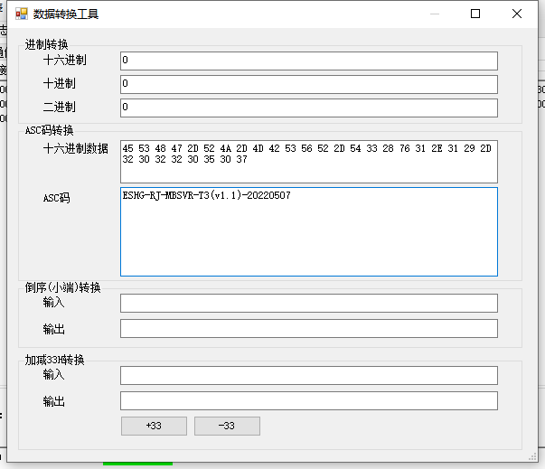

#### 读取直读版本（协议转换程序+网关程序）

rcv from 192.168.2.119:54668:

[ 00 15 00 00 00 06 ff 04 03 e9 00 30 ]

snd to 192.168.2.119:54668:

[ 00 15 00 00 00 63 ff 04 60 45 53 48 47 2d 52 4a 2d 4d 42 53 56 52 2d 54 33 28 76 31 2e 30 29 2d 32 30 32 32 30 34 32 32 00 00 00 00 00 00 00 00 00 00 00 00 00 00 00 00 00 45 53 48 47 2d 52 4a 2d 4d 51 54 54 2d 54 33 28 76 31 2e 31 38 29 2d 32 30 32 31 31 32 32 32 00 00 00 00 00 00 00 00 00 00 00 00 00 00 00 00 00 ]

解析：ESHG-RJ-MBSVR-T3(v1.0)-20220422，ESHG-RJ-MQTT-T3(v1.18)-20211222

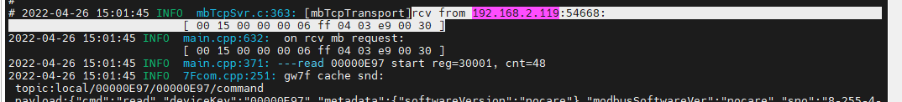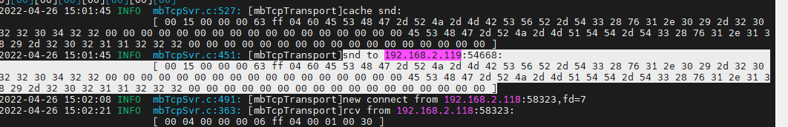

测试结果：测试合格。

#### 错误的寄存器范围

如上图input_reg地址范围，测试超出边界的读取（此为只读）

##### 读取1-23

##### 读取1-25

##### 读取25-47

##### 读取25-49

##### 读取1-47

##### 读取1-49

##### 读取24-48

##### 读取24-25

**设备类型测试说明：**将网关和设备连接到载波环境中，根据网关数据库编写更新map.json文件。

# 4路开关执行器ok

**当期支持的设备类型**

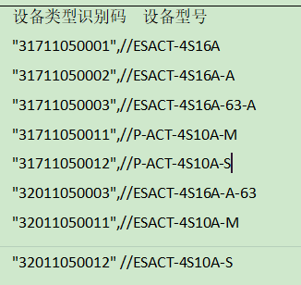

**寄存器地址对应功能**

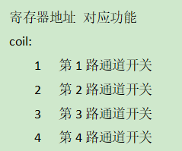

查询设备modbus地址--1

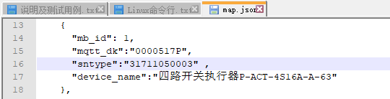

此处使用如上图中的设备做典型验证。

## 通道1

### 写1通道闭合

#### 写入

rcv from 192.168.2.119:57405:

[ 00 20 00 00 00 06 01 05 00 01 ff 00 ]

snd to 192.168.2.119:57405:

[ 00 20 00 00 00 06 01 05 00 01 ff 00 ]

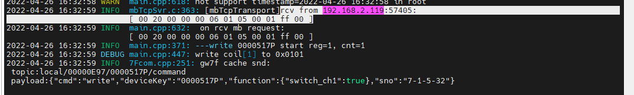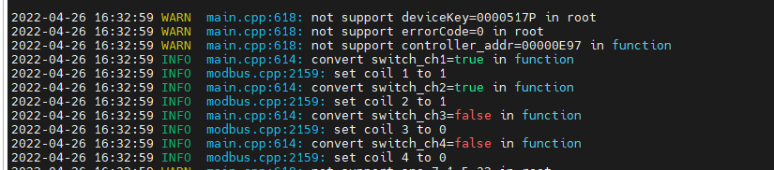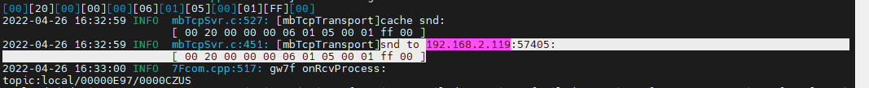

#### 读取1通道缓存

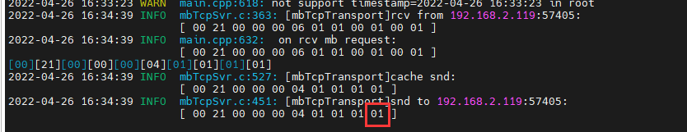

#### 1通道直读

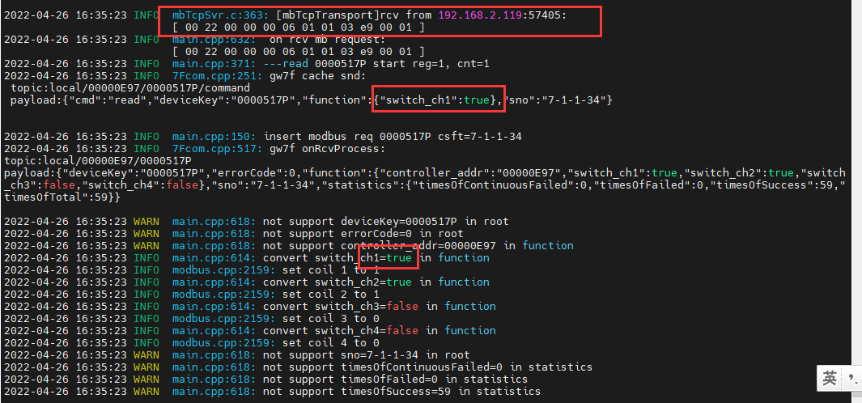



### 写1通道断开

#### 写入

rcv from 192.168.2.119:57405:

[ 00 32 00 00 00 06 01 05 00 01 00 00 ]

snd to 192.168.2.119:57405:

[ 00 32 00 00 00 06 01 05 00 01 00 00 ]

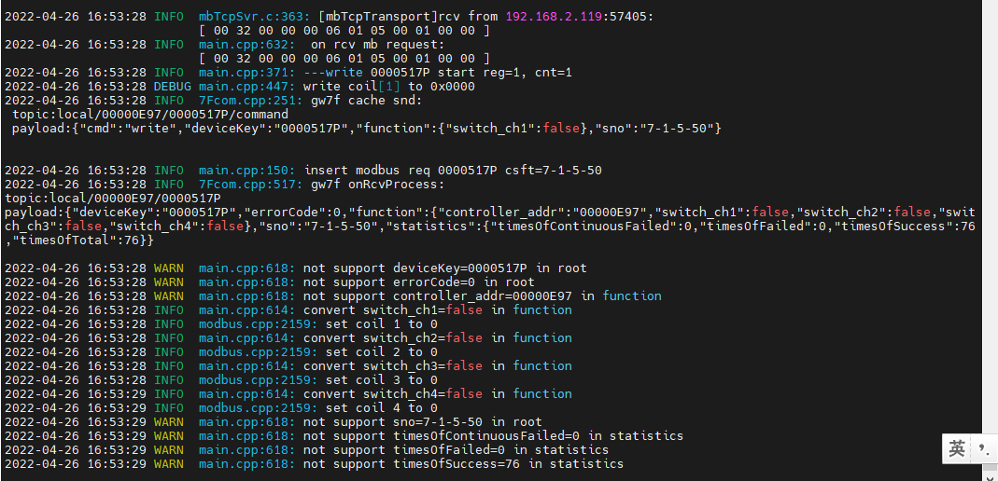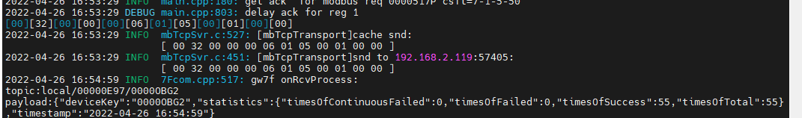

#### 读取1通道缓存

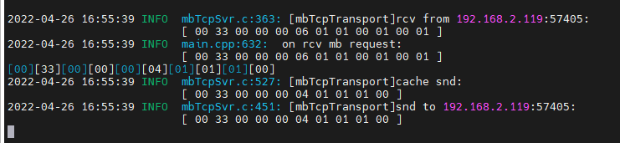

读取与写入状态一致

#### 1通道直读

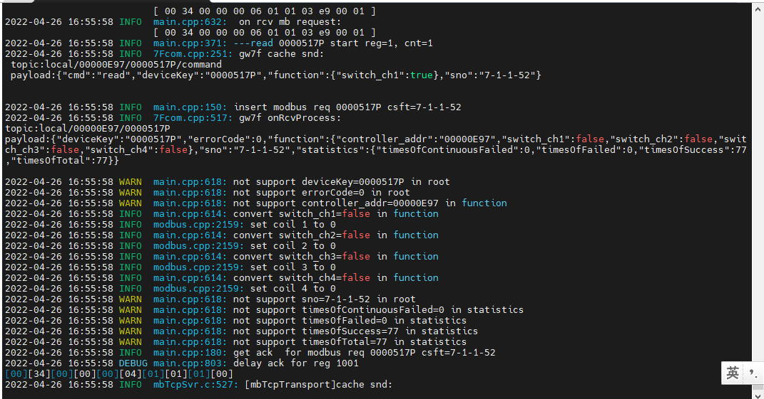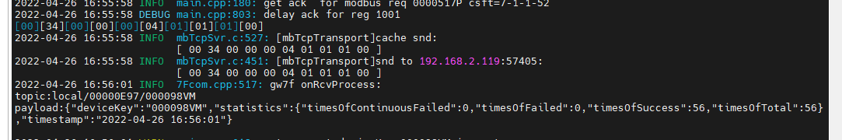

读取与写入状态一致

## 通道2

### 写入

2022-04-26 17:02:25 INFO mbTcpSvr.c:363: [mbTcpTransport]rcv from 192.168.2.119:57405:

[ 00 35 00 00 00 06 01 05 00 02 ff 00 ]

2022-04-26 17:02:25 INFO mbTcpSvr.c:451: [mbTcpTransport]snd to 192.168.2.119:57405:

[ 00 35 00 00 00 06 01 05 00 02 ff 00 ]

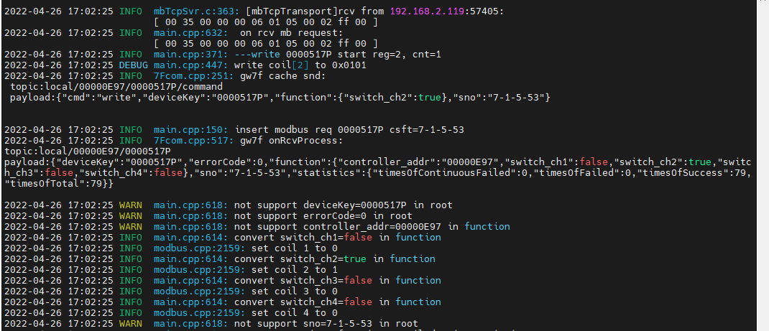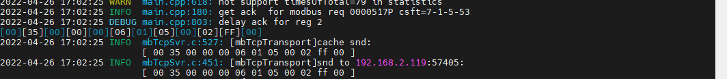

### 读取通道2缓存

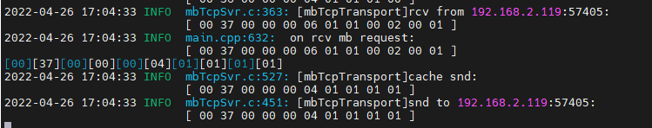

读取与写入值一致

### 直读通道2

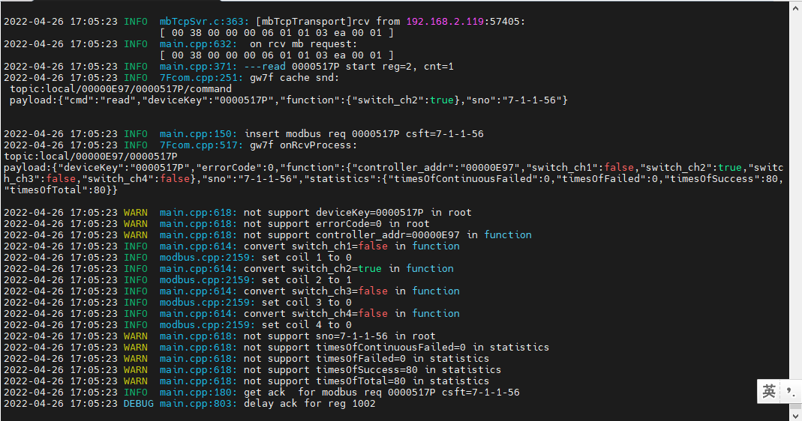

读取与写入值一致

## 通道3

### 写入

2022-04-29 09:06:51 INFO mbTcpSvr.c:363: [mbTcpTransport]rcv from 192.168.2.119:51447:

[ 00 09 00 00 00 06 01 05 00 03 00 00 ]write 0000517P start reg=3, cnt=1

2022-04-29 09:06:51 INFO mbTcpSvr.c:451: [mbTcpTransport]snd to 192.168.2.119:51447:

[ 00 09 00 00 00 06 01 05 00 03 00 00 ]

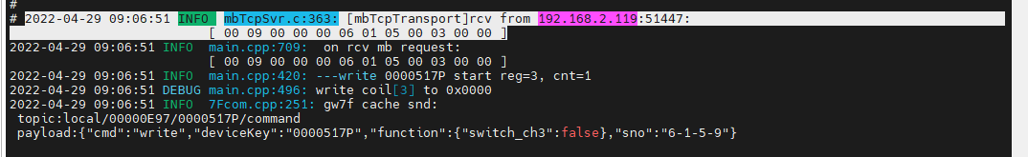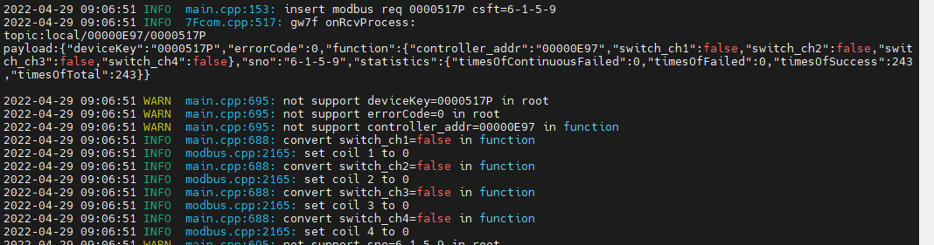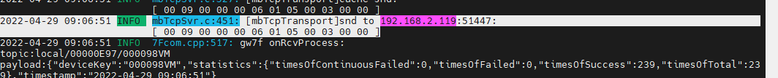

### 读取通道3缓存

2022-04-29 09:09:46 INFO mbTcpSvr.c:363: [mbTcpTransport]rcv from 192.168.2.119:51447:

[ 00 0a 00 00 00 06 01 01 00 03 00 01 ]

2022-04-29 09:09:46 INFO mbTcpSvr.c:451: [mbTcpTransport]snd to 192.168.2.119:51447:

[ 00 0a 00 00 00 04 01 01 01 00 ]解析：通道全关

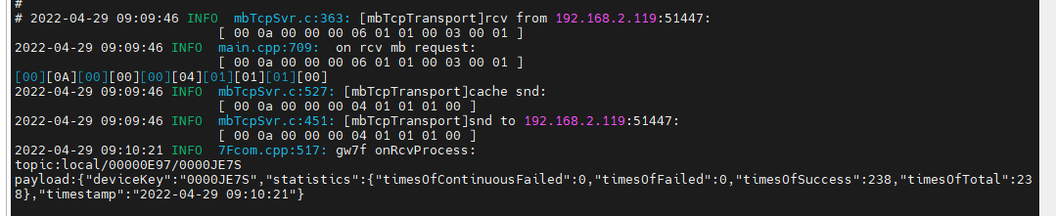

读取与写入值一致

### 直读通道3

2022-04-29 09:22:54 INFO mbTcpSvr.c:363: [mbTcpTransport]rcv from 192.168.2.119:51447:

[ 00 0e 00 00 00 06 01 01 03 eb 00 01 ]read 0000517P start reg=3, cnt=1

2022-04-29 09:22:54 INFO mbTcpSvr.c:451: [mbTcpTransport]snd to 192.168.2.119:51447:

[ 00 0e 00 00 00 04 01 01 01 00 ]

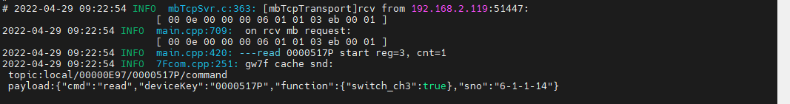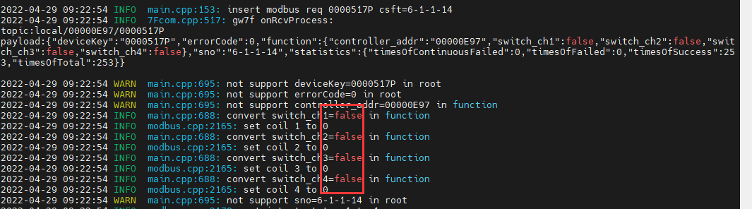

读取与写入值一致

## 通道4

### 写入闭合

2022-04-29 09:25:25 INFO mbTcpSvr.c:363: [mbTcpTransport]rcv from 192.168.2.119:51652:

[ 00 0d 00 00 00 06 01 05 00 04 ff 00 ]write 0000517P start reg=4, cnt=1

2022-04-29 09:25:25 INFO mbTcpSvr.c:451: [mbTcpTransport]snd to 192.168.2.119:51652:

[ 00 0d 00 00 00 06 01 05 00 04 ff 00 ]

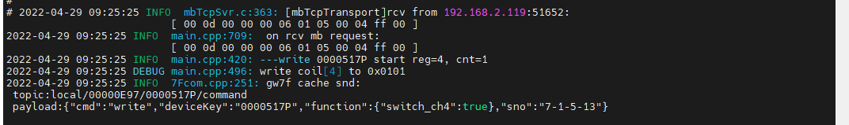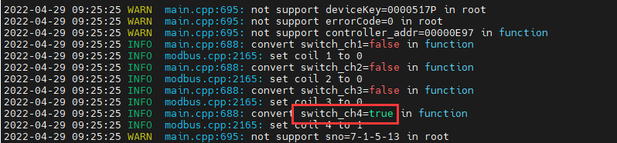

写入4通道闭合

#### 读取通道4缓存

2022-04-29 09:28:04 INFO mbTcpSvr.c:363: [mbTcpTransport]rcv from 192.168.2.119:51652:

[ 00 0d 00 00 00 06 01 01 00 04 00 01 ]读取寄存器4

2022-04-29 09:28:04 INFO mbTcpSvr.c:451: [mbTcpTransport]snd to 192.168.2.119:51652:

[ 00 0d 00 00 00 04（长度） 01（modbus地址） 01（coil读取） 01（长度） 01（按位解析，4通道为1） ]

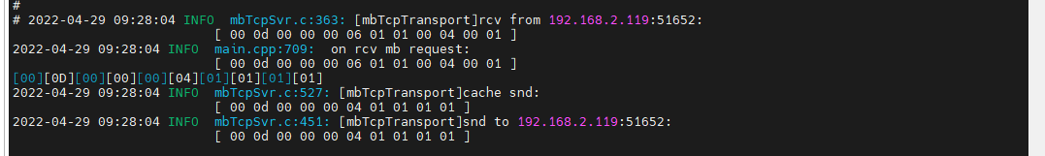

读取4通道闭合，其他通道断开，与写入一致

#### 直读通道4

2022-04-29 09:37:14 INFO mbTcpSvr.c:363: [mbTcpTransport]rcv from 192.168.2.119:51652:

[ 00 0d 00 00 00 06 01 01 03 ec 00 01 ]---read 0000517P start reg=4, cnt=1

2022-04-29 09:37:14 INFO mbTcpSvr.c:451: [mbTcpTransport]snd to 192.168.2.119:51652:

[ 00 0d 00 00 00 04 01 01 01 01 ]

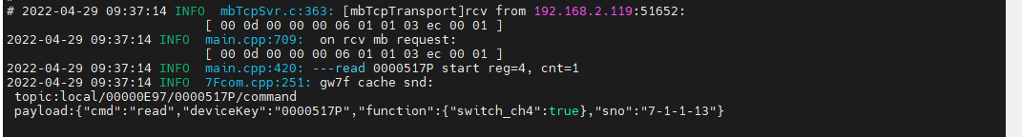





读取4通道闭合，其他通道断开，与写入一致

### 写入断开

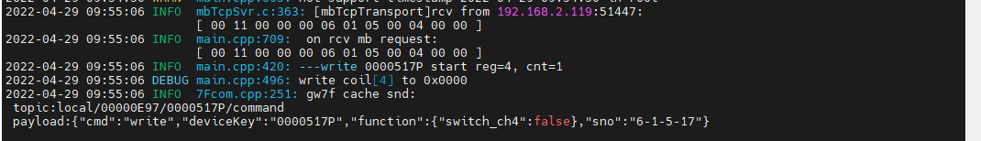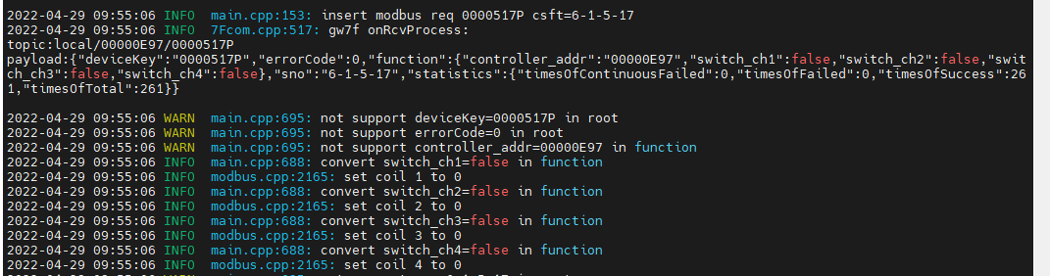

### 多通道读写

测试多通道同时读、写操作；

#### 通道1+2读写

##### 写闭合

1. 写入

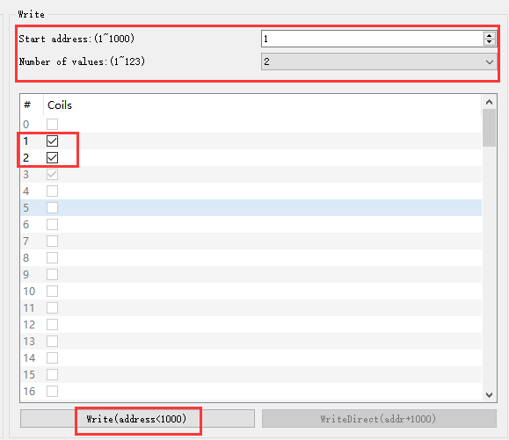

2022-04-29 10:01:04 INFO mbTcpSvr.c:363: [mbTcpTransport]rcv from 192.168.2.119:51447:

[ 00 12 00 00 00 08 01 0f 00 01 00 02 01 03 ]write 0000517P start reg=1, cnt=2

2022-04-29 10:01:05 INFO mbTcpSvr.c:451: [mbTcpTransport]snd to 192.168.2.119:51447:

[ 00 12 00 00 00 06 01 0f 00 01 00 02 ]

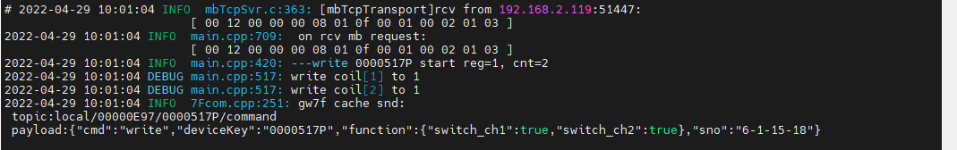

1. 直读

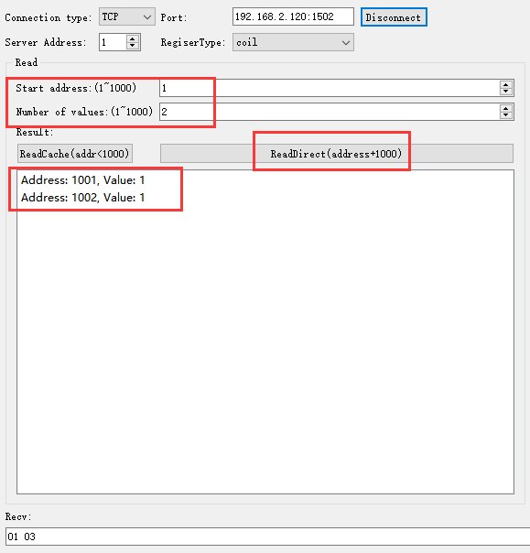

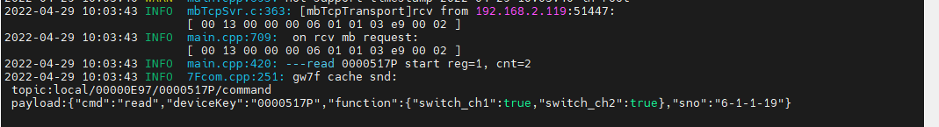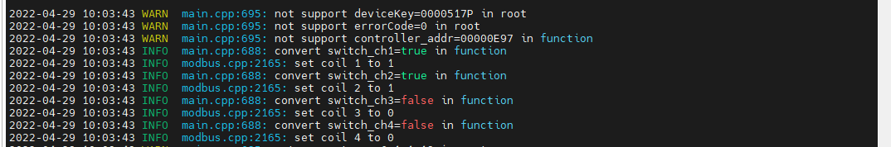

读取状态与写入一致

1. 读缓存

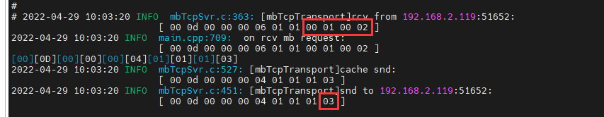

读取状态与写入一致

##### 写断开

1. 写入

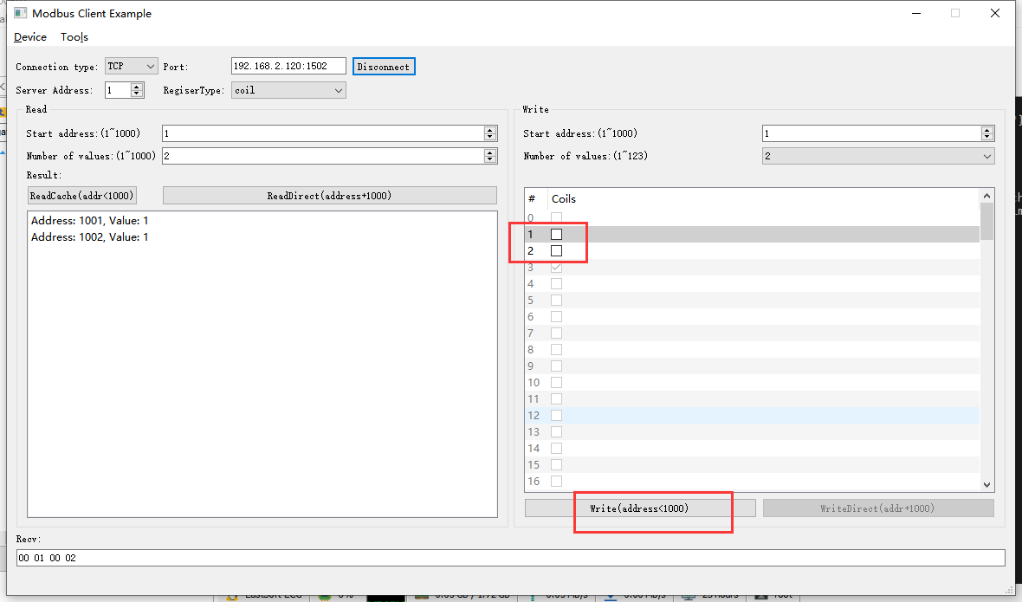

2022-04-29 10:06:24 INFO mbTcpSvr.c:363: [mbTcpTransport]rcv from 192.168.2.119:51447:

[ 00 14 00 00 00 08 01 0f 00 01 00 02 01 00 ]

2022-04-29 10:06:24 INFO main.cpp:420: ---write 0000517P start reg=1, cnt=2

2022-04-29 10:06:24 DEBUG main.cpp:517: write coil[1] to 0

2022-04-29 10:06:24 DEBUG main.cpp:517: write coil[2] to 0

2022-04-29 10:06:24 INFO mbTcpSvr.c:451: [mbTcpTransport]snd to 192.168.2.119:51447:

[ 00 14 00 00 00 06 01 0f 00 01 00 02 ]

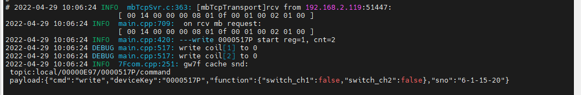

写入1,2通道断开

1. 直读

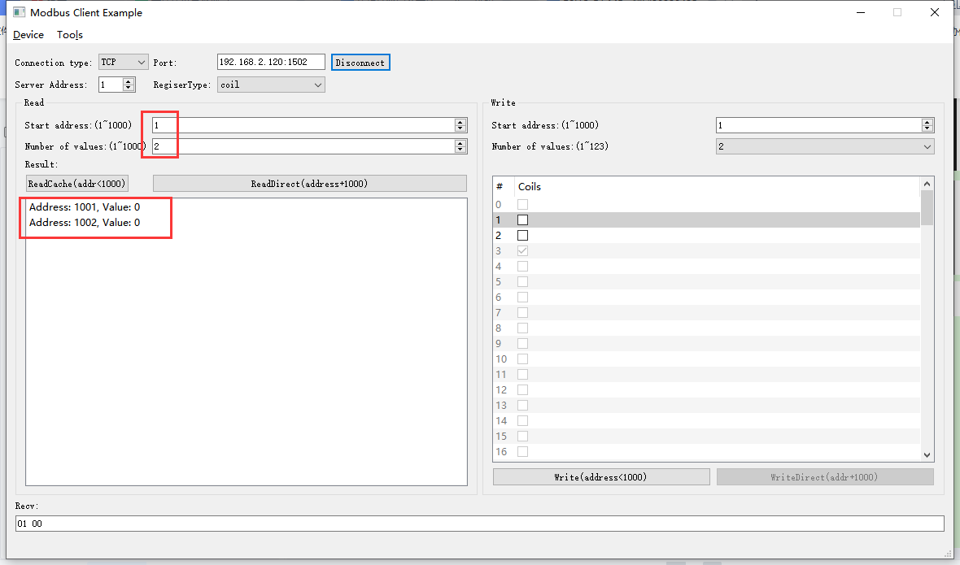

2022-04-29 10:09:14 INFO mbTcpSvr.c:363: [mbTcpTransport]rcv from 192.168.2.119:51447:

[ 00 15 00 00 00 06 01 01 03 e9 00 02 ]

2022-04-29 10:09:14 INFO main.cpp:420: ---read 0000517P start reg=1, cnt=2

2022-04-29 10:09:14 INFO mbTcpSvr.c:451: [mbTcpTransport]snd to 192.168.2.119:51447:

[ 00 15 00 00 00 04 01 01 01 00 ]

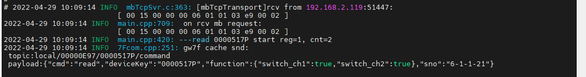

1. 读缓存

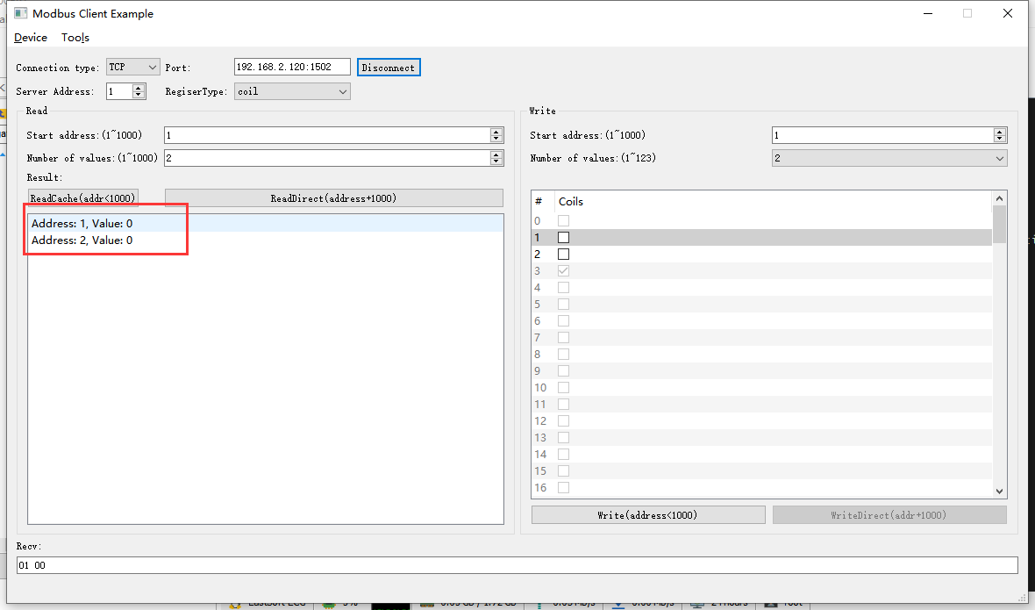

2022-04-29 10:12:47 INFO mbTcpSvr.c:363: [mbTcpTransport]rcv from 192.168.2.119:51447:

[ 00 16 00 00 00 06 01 01 00 01 00 02 ]

2022-04-29 10:12:47 INFO mbTcpSvr.c:451: [mbTcpTransport]snd to 192.168.2.119:51447:

[ 00 16 00 00 00 04 01 01 01 00 ]

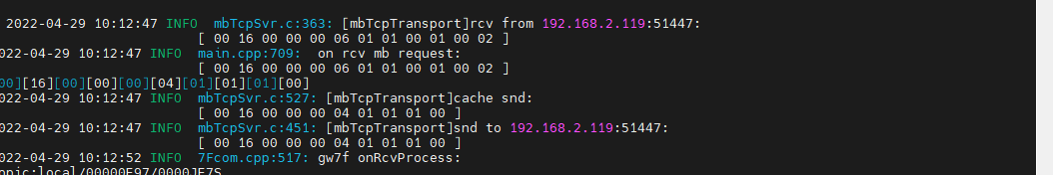

#### 通道2+3+4读写

##### 写闭合

1. 写入

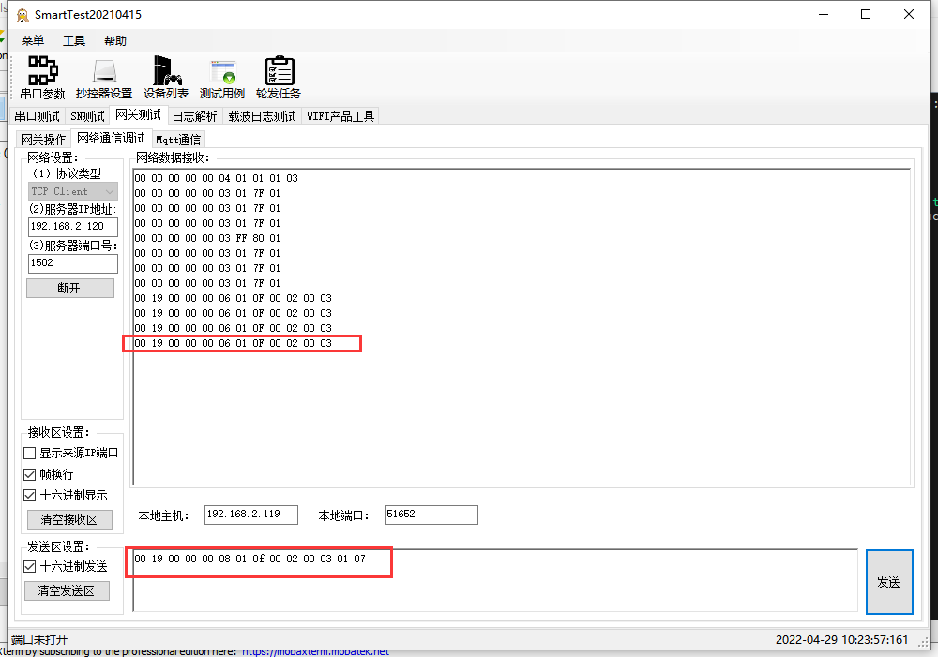

2022-04-29 10:23:56 INFO mbTcpSvr.c:363: [mbTcpTransport]rcv from 192.168.2.119:51652:

[ 00 19 00 00 00 08 01 0f 00 02 00 03 01 07 ]

2022-04-29 10:23:56 INFO main.cpp:420: ---write 0000517P start reg=2, cnt=3

2022-04-29 10:23:56 DEBUG main.cpp:517: write coil[2] to 1

2022-04-29 10:23:56 DEBUG main.cpp:517: write coil[3] to 1

2022-04-29 10:23:56 DEBUG main.cpp:517: write coil[4] to 1

2022-04-29 10:23:56 INFO mbTcpSvr.c:451: [mbTcpTransport]snd to 192.168.2.119:51652:

[ 00 19 00 00 00 06 01 0f 00 02 00 03 ]

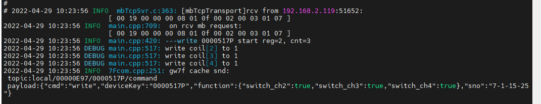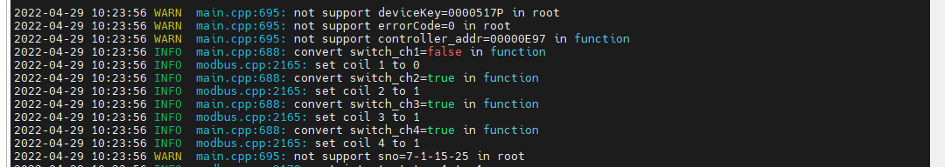

写入2,3,4通道闭合。

1. 直读

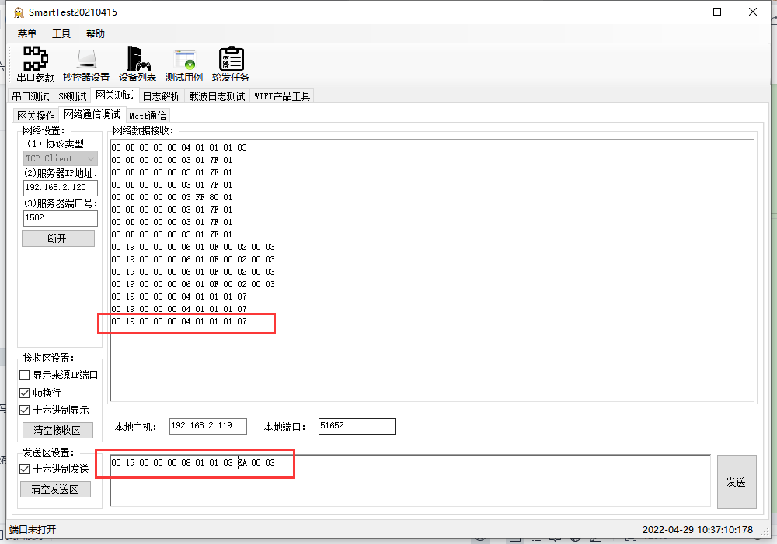

2022-04-29 10:35:48 INFO mbTcpSvr.c:363: [mbTcpTransport]rcv from 192.168.2.119:51652:

[ 00 19 00 00 00 08 01 01 03 ea 00 03 ]

2022-04-29 10:35:48 INFO main.cpp:709: on rcv mb request:

[ 00 19 00 00 00 08 01 01 03 ea 00 03 ]

2022-04-29 10:35:48 INFO main.cpp:420: ---read 0000517P start reg=2, cnt=3

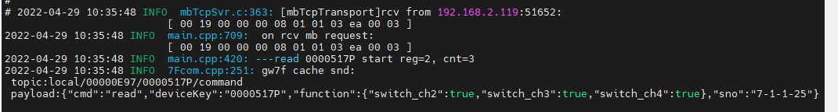

1. 读缓存

2022-04-29 10:33:53 INFO mbTcpSvr.c:363: [mbTcpTransport]rcv from 192.168.2.119:51652:

[ 00 19 00 00 00 08 01 01 00 02 00 03 ]

2022-04-29 10:33:53 INFO mbTcpSvr.c:451: [mbTcpTransport]snd to 192.168.2.119:51652:

[ 00 19 00 00 00 04 01 01 01 07 ]

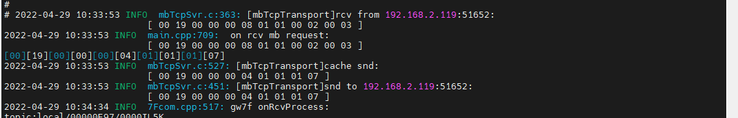

解析：读取2,3,4通道闭合

##### 写断开

1. 写入

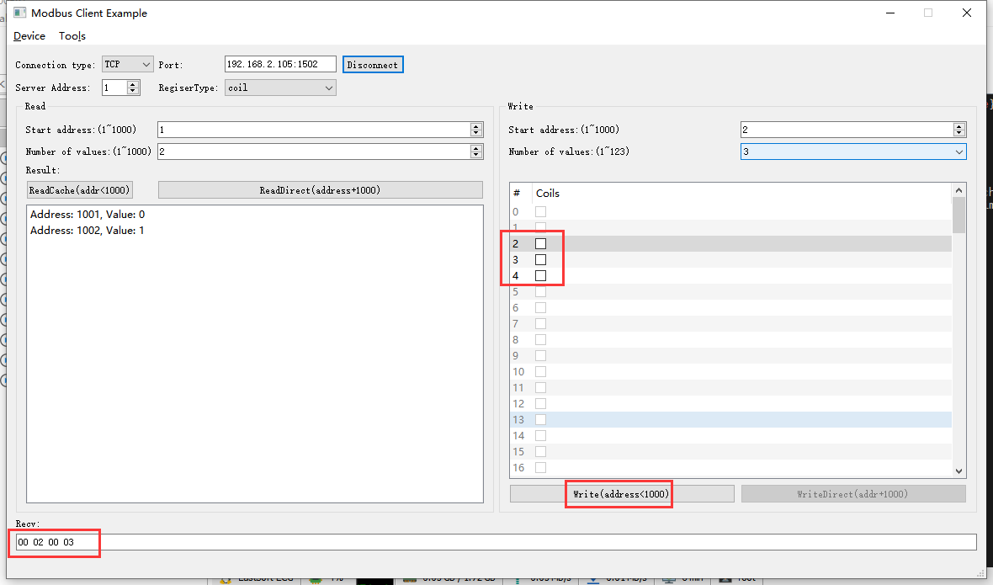

2022-04-29 14:05:52 INFO mbTcpSvr.c:363: [mbTcpTransport]rcv from 192.168.2.103:50956:

[ 00 1f 00 00 00 08 01 0f 00 02 00 03 01 00 ]

2022-04-29 14:05:52 INFO main.cpp:709: on rcv mb request:

[ 00 1f 00 00 00 08 01 0f 00 02 00 03 01 00 ]

2022-04-29 14:05:52 INFO main.cpp:420: ---write 0000517P start reg=2, cnt=3

2022-04-29 14:05:52 DEBUG main.cpp:517: write coil[2] to 0

2022-04-29 14:05:52 DEBUG main.cpp:517: write coil[3] to 0

2022-04-29 14:05:52 DEBUG main.cpp:517: write coil[4] to 0

2022-04-29 14:05:53 INFO mbTcpSvr.c:451: [mbTcpTransport]snd to 192.168.2.103:50956:

[ 00 1f 00 00 00 06 01 0f 00 02 00 03 ]

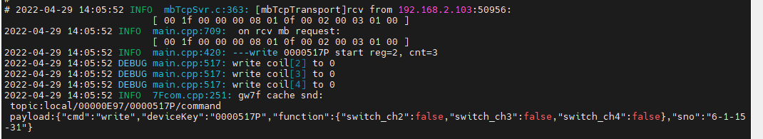

写入2,3,4通道断开。

1. 直读

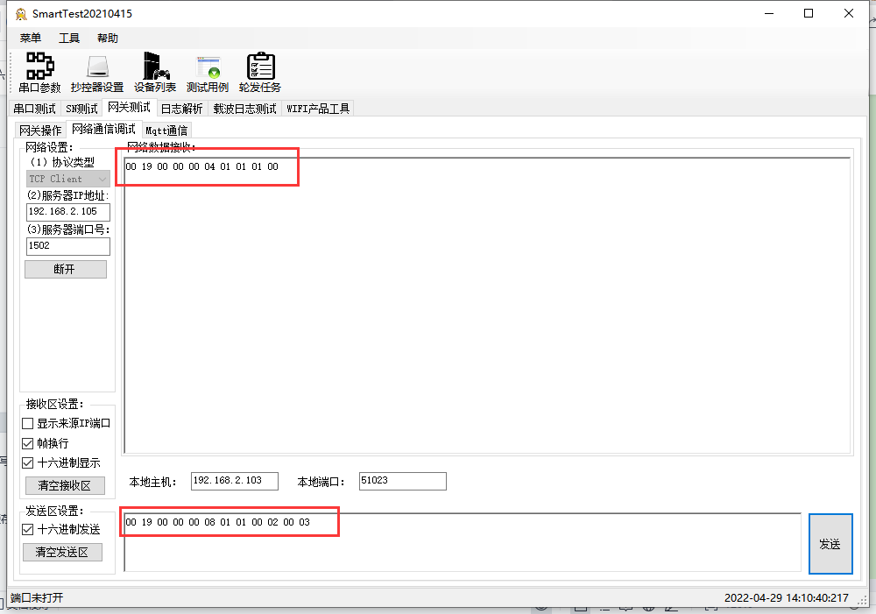

2022-04-29 14:10:12 INFO mbTcpSvr.c:363: [mbTcpTransport]rcv from 192.168.2.103:51023:

[ 00 19 00 00 00 08 01 01 00 02 00 03 ]

2022-04-29 14:10:12 INFO mbTcpSvr.c:451: [mbTcpTransport]snd to 192.168.2.103:51023:

[ 00 19 00 00 00 04 01 01 01 00 ]

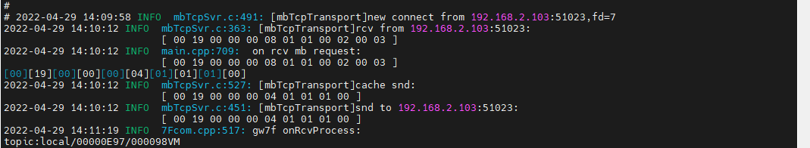

1. 读缓存

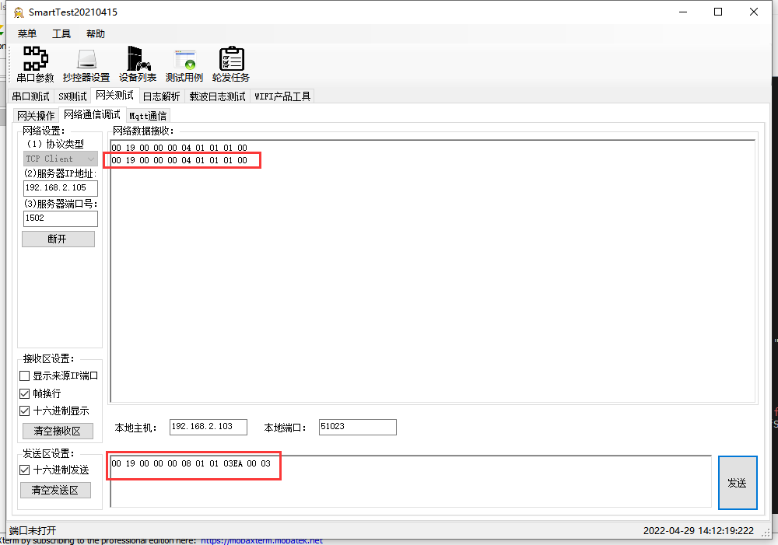

2022-04-29 14:12:16 INFO mbTcpSvr.c:363: [mbTcpTransport]rcv from 192.168.2.103:51023:

[ 00 19 00 00 00 08 01 01 03 ea 00 03 ]

2022-04-29 14:12:16 INFO main.cpp:709: on rcv mb request:

[ 00 19 00 00 00 08 01 01 03 ea 00 03 ]

2022-04-29 14:12:16 INFO main.cpp:420: ---read 0000517P start reg=2, cnt=3

2022-04-29 14:12:16 INFO mbTcpSvr.c:451: [mbTcpTransport]snd to 192.168.2.103:51023:

[ 00 19 00 00 00 04 01 01 01 00 ]

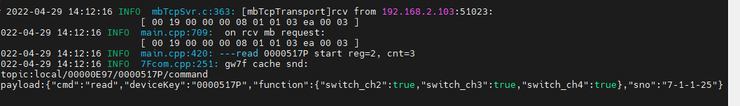

读取与写入一致

#### 通道1+2+3+4读写

##### 写入闭合

1. 写入

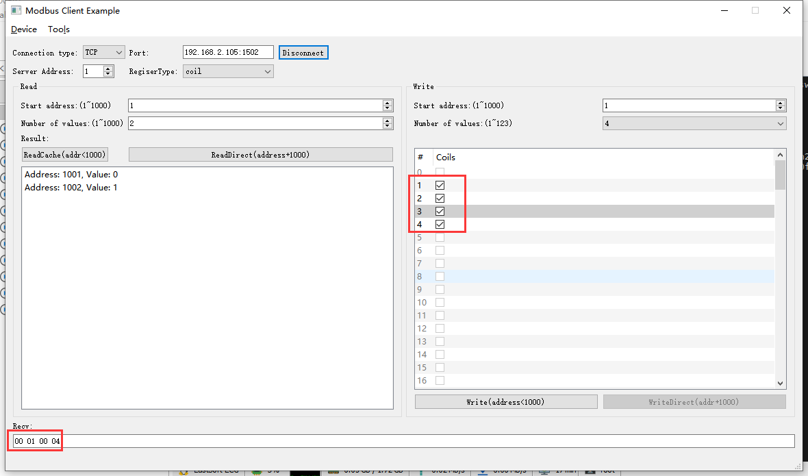

2022-04-29 14:17:13 INFO mbTcpSvr.c:363: [mbTcpTransport]rcv from 192.168.2.103:50956:

[ 00 20 00 00 00 08 01 0f 00 01 00 04 01 0f ]

2022-04-29 14:17:13 INFO main.cpp:709: on rcv mb request:

[ 00 20 00 00 00 08 01 0f 00 01 00 04 01 0f ]

2022-04-29 14:17:13 INFO main.cpp:420: ---write 0000517P start reg=1, cnt=4

2022-04-29 14:17:13 DEBUG main.cpp:517: write coil[1] to 1

2022-04-29 14:17:13 DEBUG main.cpp:517: write coil[2] to 1

2022-04-29 14:17:13 DEBUG main.cpp:517: write coil[3] to 1

2022-04-29 14:17:13 DEBUG main.cpp:517: write coil[4] to 1

2022-04-29 14:17:14 INFO mbTcpSvr.c:451: [mbTcpTransport]snd to 192.168.2.103:50956:

[ 00 20 00 00 00 06 01 0f 00 01 00 04 ]

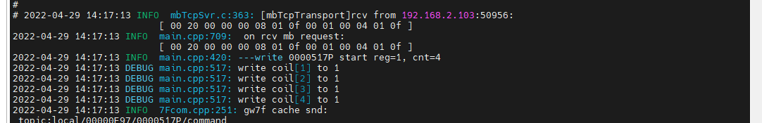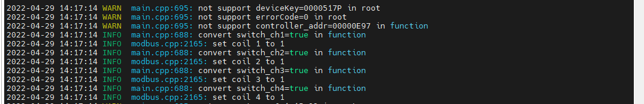1,2,3,4通道闭合

1. 多通道直读

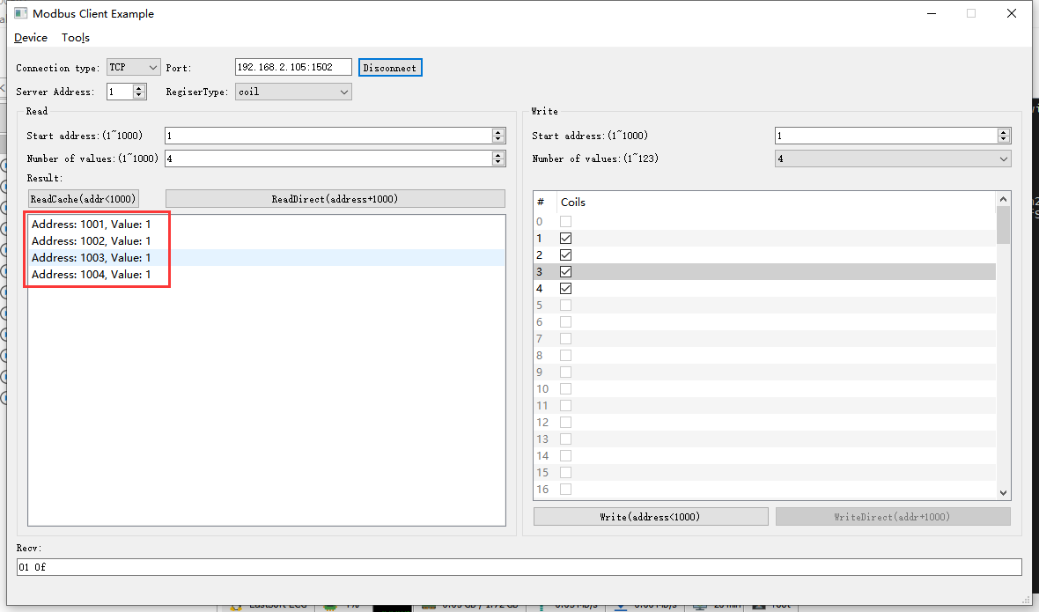

2022-04-29 14:19:44 INFO mbTcpSvr.c:363: [mbTcpTransport]rcv from 192.168.2.103:50956:

[ 00 21 00 00 00 06 01 01 03 e9 00 04 ]

2022-04-29 14:19:44 INFO main.cpp:709: on rcv mb request:

[ 00 21 00 00 00 06 01 01 03 e9 00 04 ]

2022-04-29 14:19:44 INFO main.cpp:420: ---read 0000517P start reg=1, cnt=4

2022-04-29 14:19:44 INFO mbTcpSvr.c:451: [mbTcpTransport]snd to 192.168.2.103:50956:

[ 00 21 00 00 00 04 01 01 01 0f ]

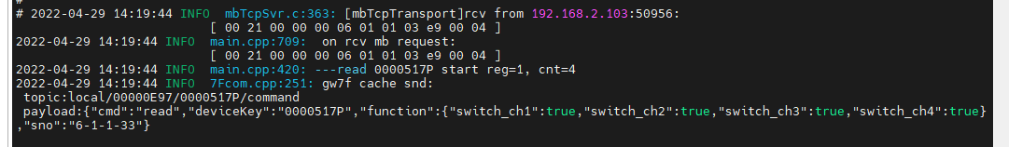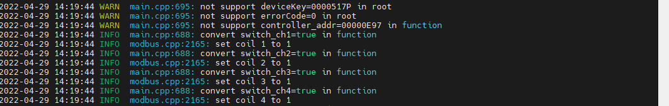

读取1,2,3,4通道闭合，与写入的一致

1. 读取多通道缓存

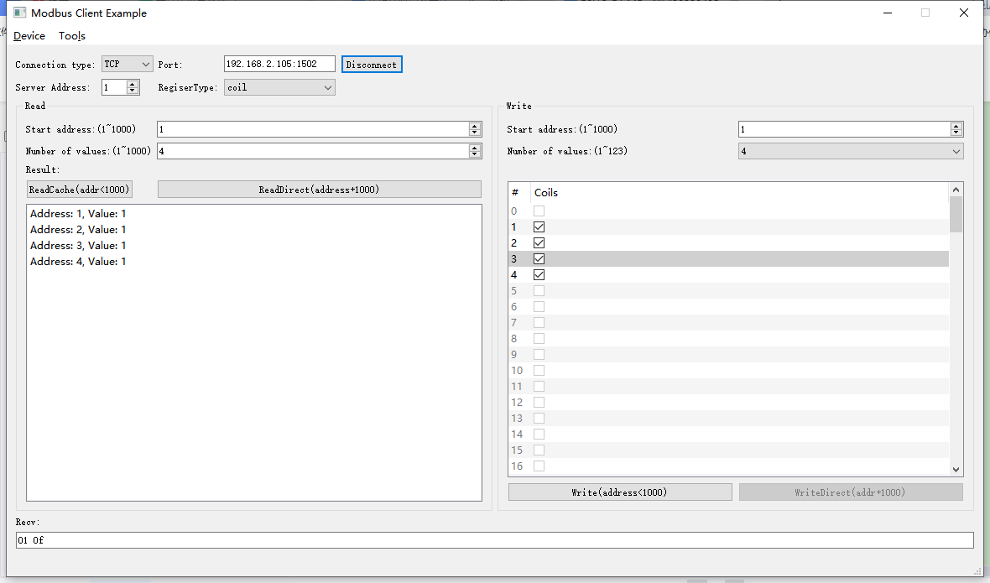2022-04-29 14:21:20 INFO mbTcpSvr.c:363: [mbTcpTransport]rcv from 192.168.2.103:50956:

[ 00 23 00 00 00 06 01 01 00 01 00 04 ]

2022-04-29 14:21:20 INFO mbTcpSvr.c:451: [mbTcpTransport]snd to 192.168.2.103:50956:

[ 00 23 00 00 00 04 01 01 01 0f ]

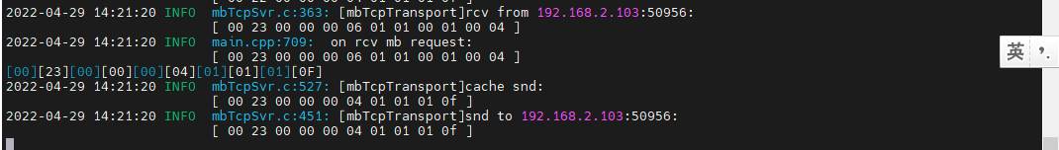

与写入的一致

##### 写入断开

1. 写入

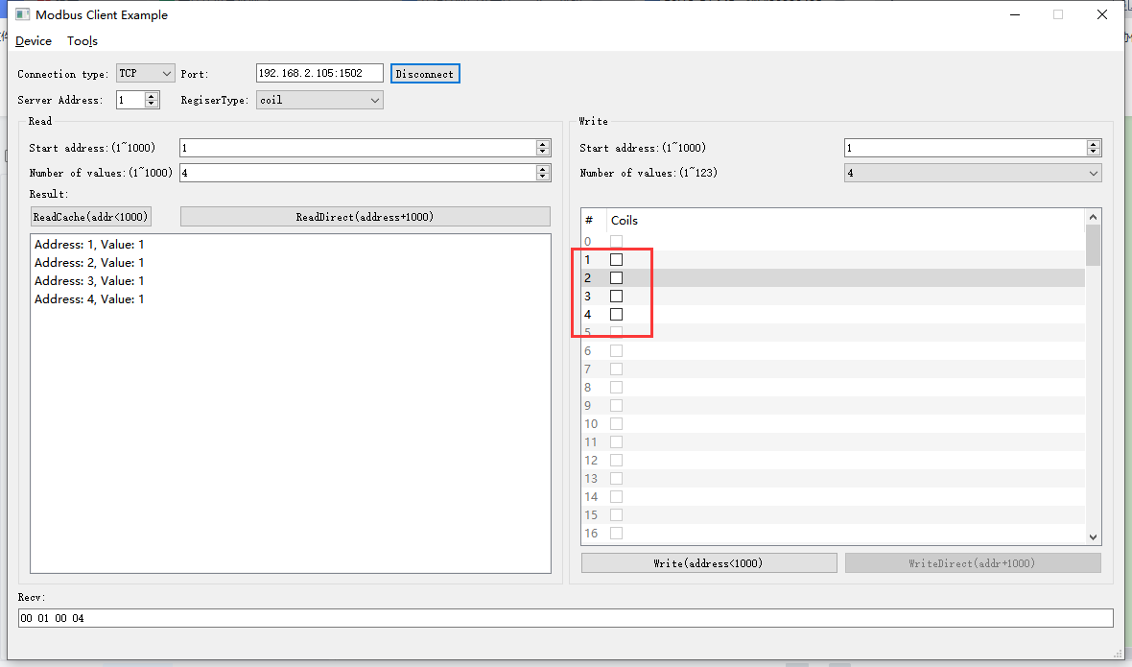2022-04-29 14:23:21 INFO mbTcpSvr.c:363: [mbTcpTransport]rcv from 192.168.2.103:50956:

[ 00 24 00 00 00 08 01 0f 00 01 00 04 01 00 ]

2022-04-29 14:23:21 INFO main.cpp:709: on rcv mb request:

[ 00 24 00 00 00 08 01 0f 00 01 00 04 01 00 ]

2022-04-29 14:23:21 INFO main.cpp:420: ---write 0000517P start reg=1, cnt=4

2022-04-29 14:23:21 DEBUG main.cpp:517: write coil[1] to 0

2022-04-29 14:23:21 DEBUG main.cpp:517: write coil[2] to 0

2022-04-29 14:23:21 DEBUG main.cpp:517: write coil[3] to 0

2022-04-29 14:23:21 DEBUG main.cpp:517: write coil[4] to 0

2022-04-29 14:23:22 INFO mbTcpSvr.c:451: [mbTcpTransport]snd to 192.168.2.103:50956:

[ 00 24 00 00 00 06 01 0f 00 01 00 04 ]

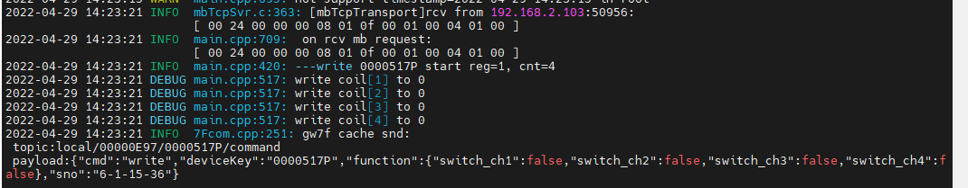

写入1,2,3,4通道断开。

1. 多通道直读

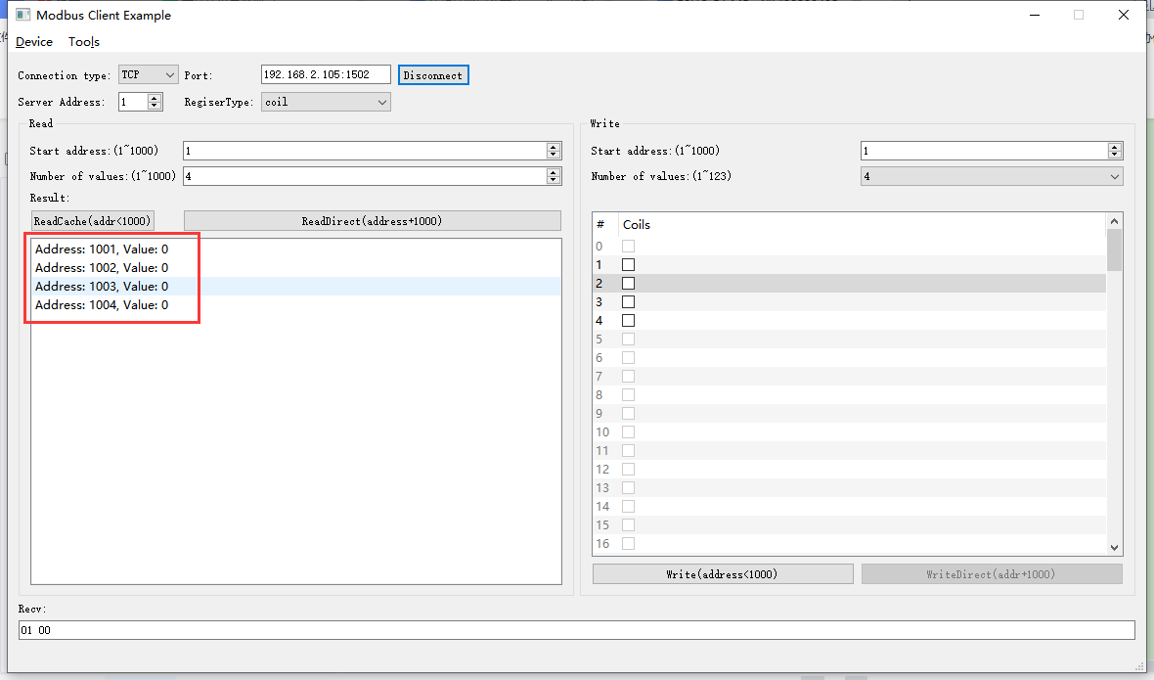 2022-04-29 14:25:13 INFO mbTcpSvr.c:363: [mbTcpTransport]rcv from 192.168.2.103:50956:

[ 00 25 00 00 00 06 01 01 03 e9 00 04 ]

2022-04-29 14:25:13 INFO main.cpp:709: on rcv mb request:

[ 00 25 00 00 00 06 01 01 03 e9 00 04 ]

2022-04-29 14:25:13 INFO main.cpp:420: ---read 0000517P start reg=1, cnt=4

2022-04-29 14:25:13 INFO mbTcpSvr.c:451: [mbTcpTransport]snd to 192.168.2.103:50956:

[ 00 25 00 00 00 04 01 01 01 00 ]

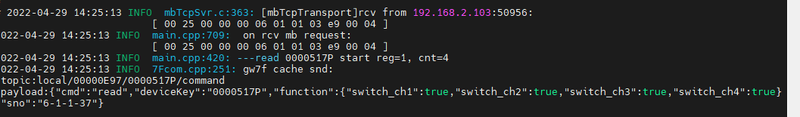

读取与写入一致。

1. 读取多通道缓存

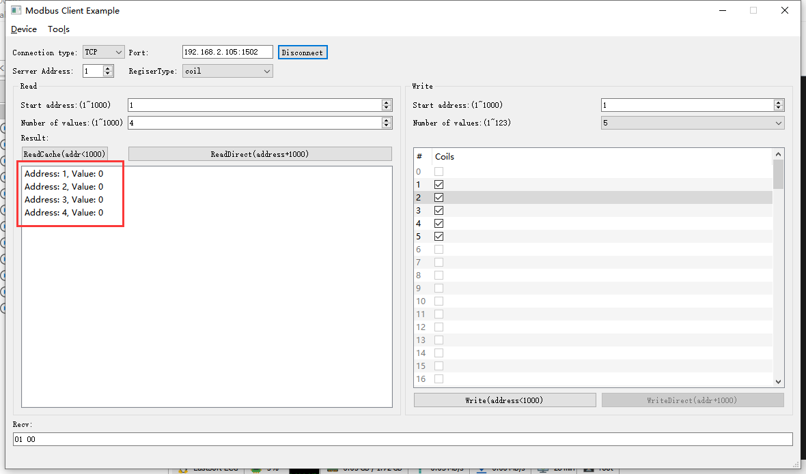

2022-04-29 14:27:31 INFO mbTcpSvr.c:363: [mbTcpTransport]rcv from 192.168.2.103:50956:

[ 00 2c 00 00 00 06 01 01 00 01 00 04 ]

2022-04-29 14:27:31 INFO mbTcpSvr.c:451: [mbTcpTransport]snd to 192.168.2.103:50956:

[ 00 2c 00 00 00 04 01 01 01 00 ]

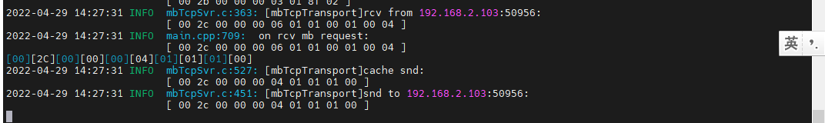

读取与写入一致。

## 不存在的通道

### 通道1,2,3,4,5

1. 写入

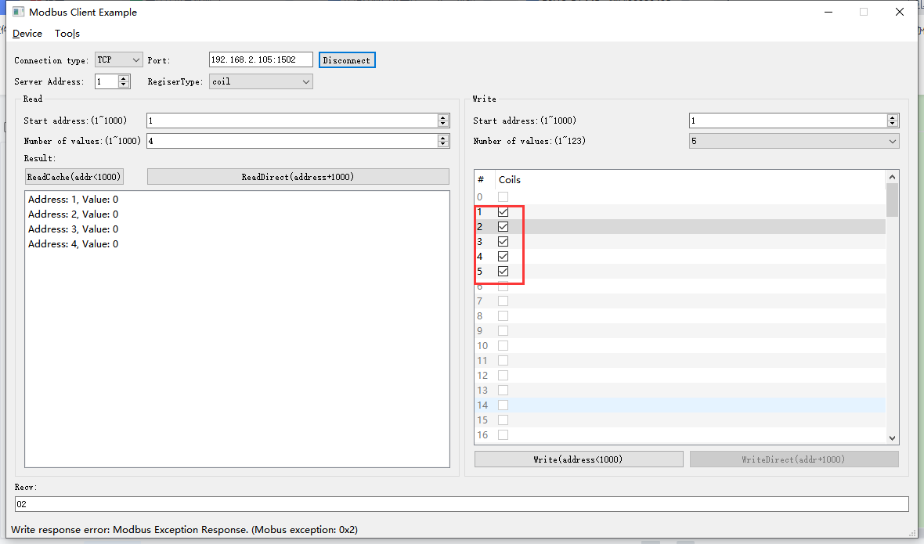

2022-04-29 14:31:40 INFO mbTcpSvr.c:363: [mbTcpTransport]rcv from 192.168.2.103:50956:

[ 00 2d 00 00 00 08 01 0f 00 01 00 05 01 1f ]

2022-04-29 14:31:40 INFO mbTcpSvr.c:451: [mbTcpTransport]snd to 192.168.2.103:50956:

[ 00 2d 00 00 00 03 01 8f 02 ]回复错误

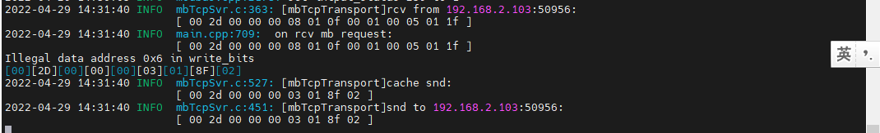

回复数据错误。

1. 读取

读取缓存

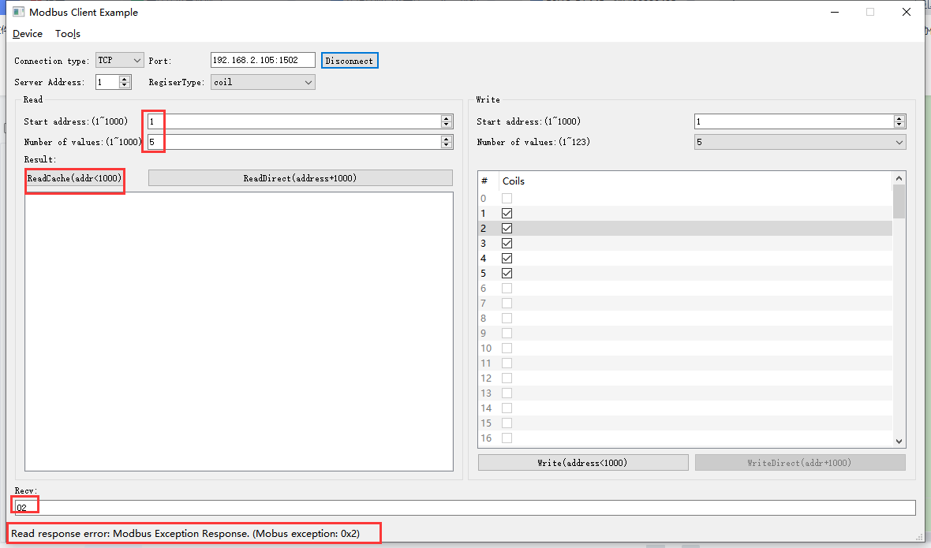

2022-04-29 14:34:32 INFO mbTcpSvr.c:363: [mbTcpTransport]rcv from 192.168.2.103:50956:

[ 00 2f 00 00 00 06 01 01 00 01 00 05 ]

2022-04-29 14:34:32 INFO main.cpp:709: on rcv mb request:

[ 00 2f 00 00 00 06 01 01 00 01 00 05 ]

Illegal data address 0x6 in read_bits

[00][2F][00][00][00][03][01][81][02]

2022-04-29 14:34:32 INFO mbTcpSvr.c:527: [mbTcpTransport]cache snd:

[ 00 2f 00 00 00 03 01 81 02 ]

2022-04-29 14:34:32 INFO mbTcpSvr.c:451: [mbTcpTransport]snd to 192.168.2.103:50956:

[ 00 2f 00 00 00 03 01 81 02 ]

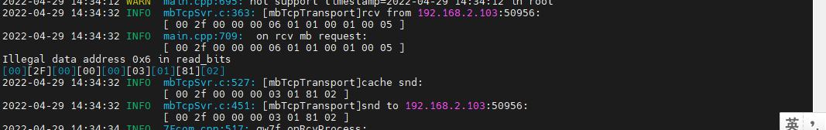

直读

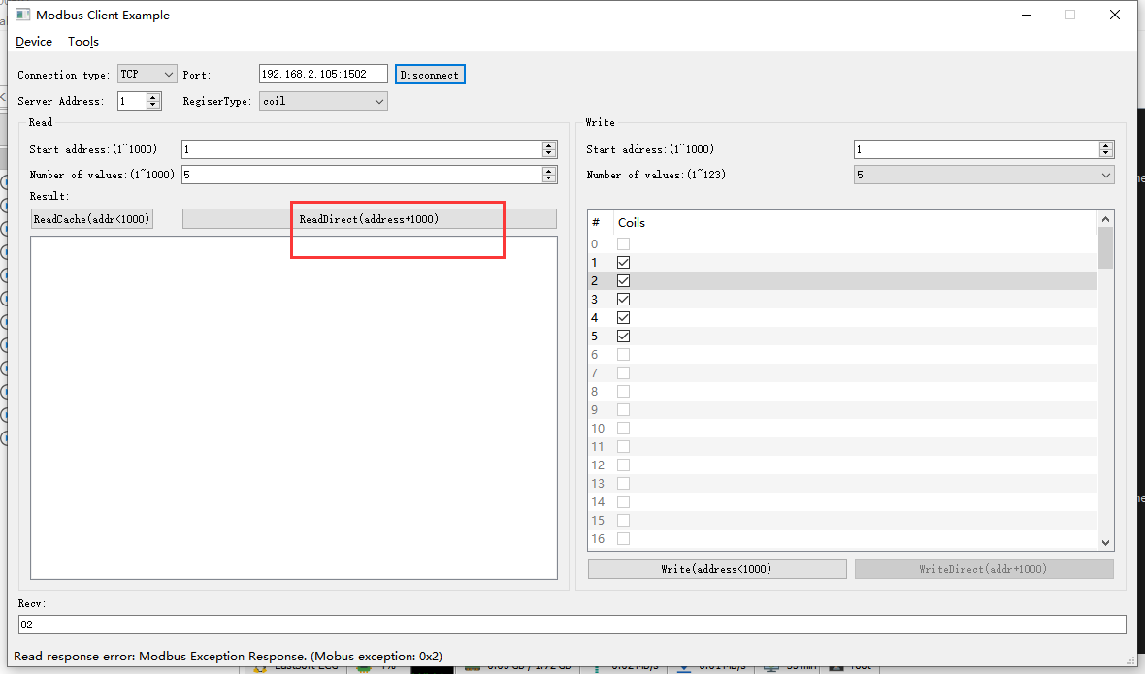

2022-04-29 14:35:14 INFO mbTcpSvr.c:363: [mbTcpTransport]rcv from 192.168.2.103:50956:

[ 00 30 00 00 00 06 01 01 03 e9 00 05 ]

2022-04-29 14:35:14 INFO mbTcpSvr.c:451: [mbTcpTransport]snd to 192.168.2.103:50956:

[ 00 30 00 00 00 03 01 81 02 ]

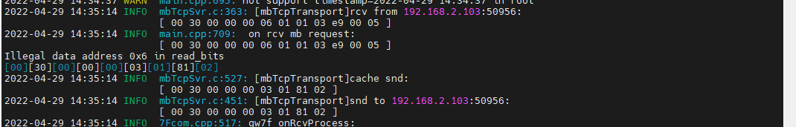

### 通道5

1. 写入

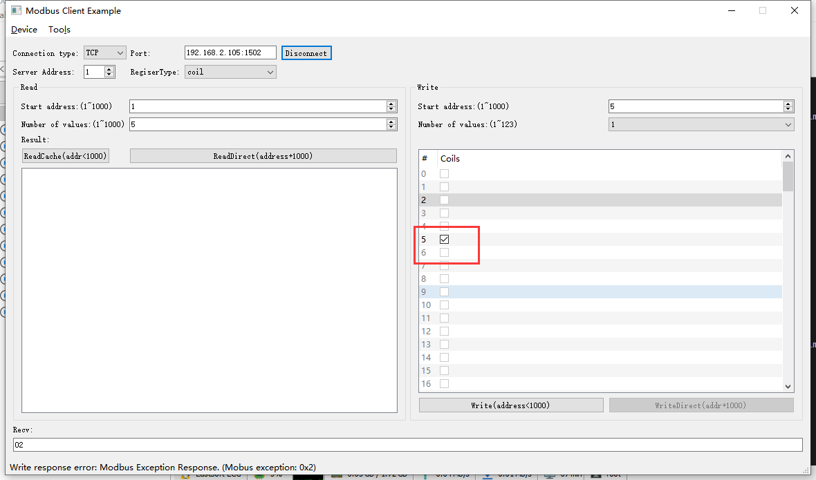

2022-04-29 15:06:41 INFO mbTcpSvr.c:363: [mbTcpTransport]rcv from 192.168.2.103:51730:

[ 00 31 00 00 00 06 01 05 00 05 ff 00 ]

2022-04-29 15:06:41 INFO mbTcpSvr.c:451: [mbTcpTransport]snd to 192.168.2.103:51730:

[ 00 31 00 00 00 03 01 85 02 ]

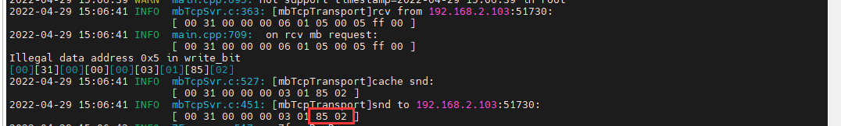

回复错误。

1. 读取

**读缓存**

2022-04-29 15:08:42 INFO mbTcpSvr.c:363: [mbTcpTransport]rcv from 192.168.2.103:51730:

[ 00 32 00 00 00 06 01 01 00 05 00 01 ]

2022-04-29 15:08:42 INFO main.cpp:709: on rcv mb request:

[ 00 32 00 00 00 06 01 01 00 05 00 01 ]

Illegal data address 0x6 in read_bits

[00][32][00][00][00][03][01][81][02]

2022-04-29 15:08:42 INFO mbTcpSvr.c:527: [mbTcpTransport]cache snd:

[ 00 32 00 00 00 03 01 81 02 ]

2022-04-29 15:08:42 INFO mbTcpSvr.c:451: [mbTcpTransport]snd to 192.168.2.103:51730:

[ 00 32 00 00 00 03 01 **81 02** ]

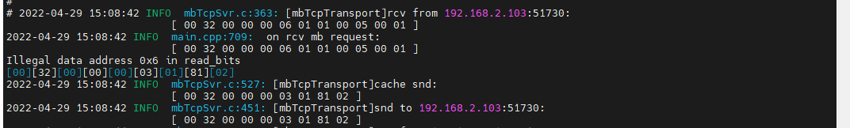

**直读**

2022-04-29 15:08:44 INFO mbTcpSvr.c:363: [mbTcpTransport]rcv from 192.168.2.103:51730:

[ 00 33 00 00 00 06 01 01 03 ed 00 01 ]

2022-04-29 15:08:44 INFO main.cpp:709: on rcv mb request:

[ 00 33 00 00 00 06 01 01 03 ed 00 01 ]

Illegal data address 0x6 in read_bits

[00][33][00][00][00][03][01][81][02]

2022-04-29 15:08:44 INFO mbTcpSvr.c:527: [mbTcpTransport]cache snd:

[ 00 33 00 00 00 03 01 81 02 ]

2022-04-29 15:08:44 INFO mbTcpSvr.c:451: [mbTcpTransport]snd to 192.168.2.103:51730:

[ 00 33 00 00 00 03 01 81 02 ]

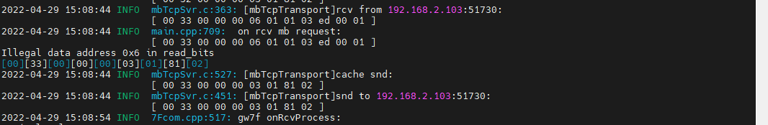

回复错误。

# 4路开关执行器4S10A-M-S ok

**当期支持的设备类型**



**寄存器地址对应功能**



查询设备modbus地址--3

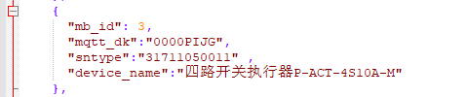

此处使用如上图中的设备做典型验证。

## 通道1

### 写1通道断开

#### 写入

rcv from 192.168.2.107:56076:

[ 00 0f 00 00 00 06 03 05 00 01 00 00 ]

snd to 192.168.2.107:56076:

[ 00 0f 00 00 00 06 03 05 00 01 00 00 ]

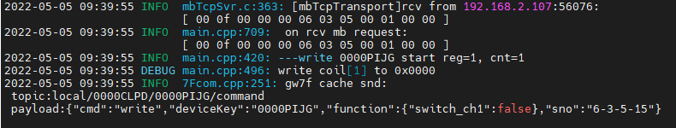

#### 读取1通道缓存

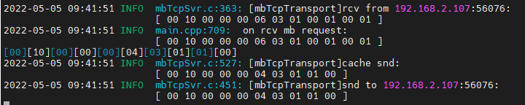

#### 1通道直读

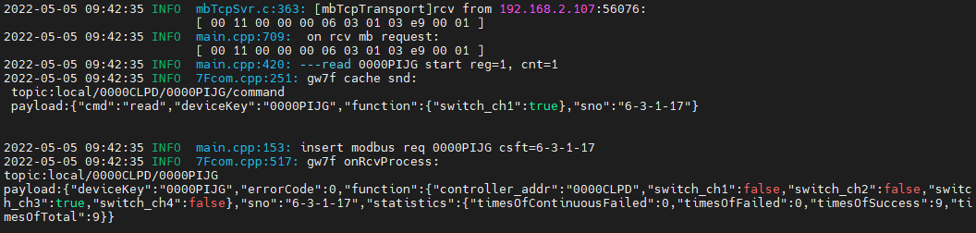



### 写1通道闭合

#### 写入

rcv from 192.168.2.107:56076:

[ 00 12 00 00 00 06 03 05 00 01 ff 00 ]

snd to 192.168.2.107:56076:

[ 00 12 00 00 00 06 03 05 00 01 ff 00 ]

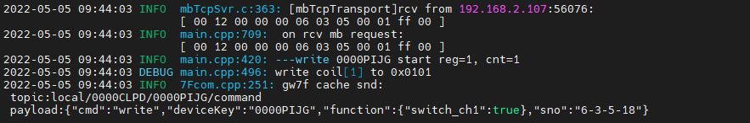

#### 读取1通道缓存

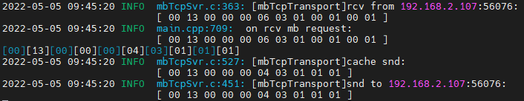

读取与写入状态一致

#### 1通道直读

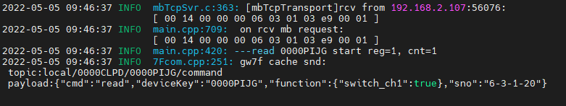

读取与写入状态一致

## 通道2

### 写入

rcv from 192.168.2.107:56076:

[ 00 15 00 00 00 06 03 05 00 02 ff 00 ]

snd to 192.168.2.107:56076:

[ 00 15 00 00 00 06 03 05 00 02 ff 00 ]

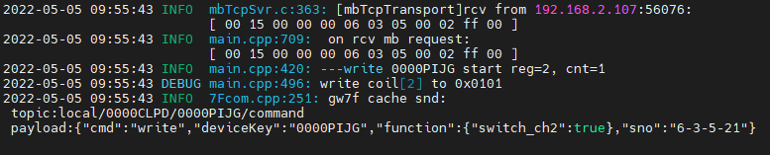

### 读取通道2缓存

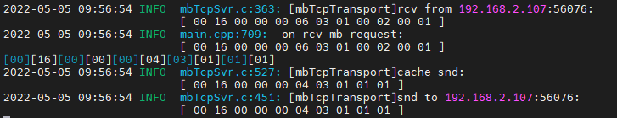

读取与写入值一致

### 直读通道2

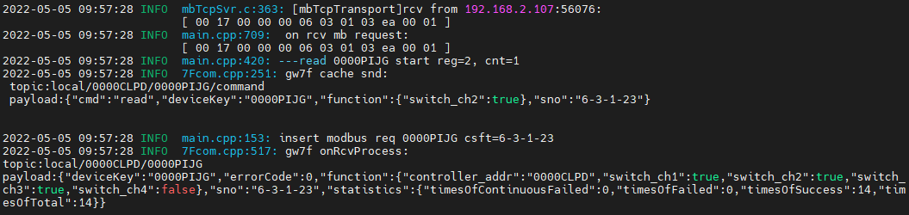

读取与写入值一致

## 通道3

### 写入

rcv from 192.168.2.107:56076:

[ 00 18 00 00 00 06 03 05 00 03 00 00 ]

snd to 192.168.2.107:56076:

[ 00 18 00 00 00 06 03 05 00 03 00 00 ]

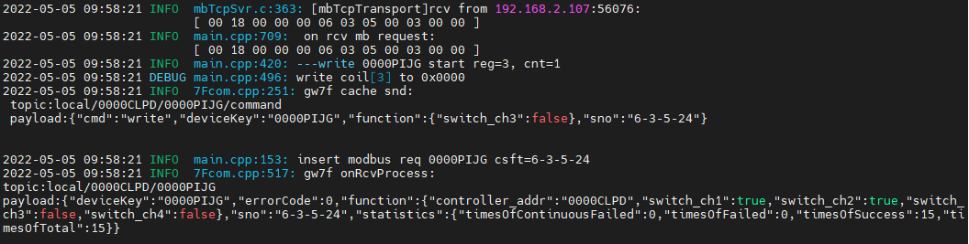

### 读取通道3缓存

rcv from 192.168.2.107:56076:

[ 00 19 00 00 00 06 03 01 00 03 00 01 ]

snd to 192.168.2.107:56076:

[ 00 19 00 00 00 04 03 01 01 00 ]

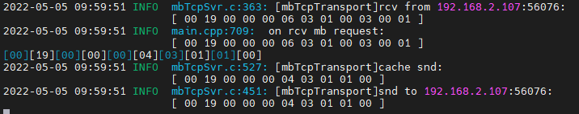

读取与写入值一致

### 直读通道3

rcv from 192.168.2.107:56076:

[ 00 1a 00 00 00 06 03 01 03 eb 00 01 ]

snd to 192.168.2.107:56076:

[ 00 1a 00 00 00 04 03 01 01 00 ]

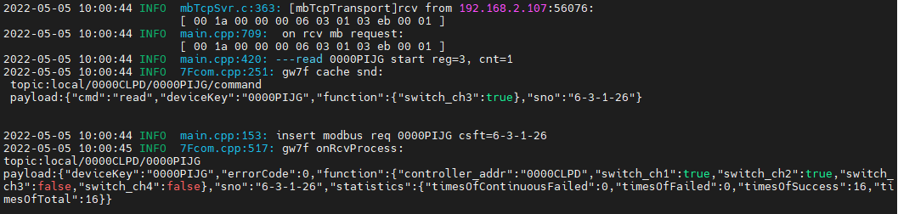

读取与写入值一致

## 通道4

### 写入闭合

rcv from 192.168.2.107:56076:

[ 00 1b 00 00 00 06 03 05 00 04 ff 00 ]

snd to 192.168.2.107:56076:

[ 00 1b 00 00 00 06 03 05 00 04 ff 00 ]

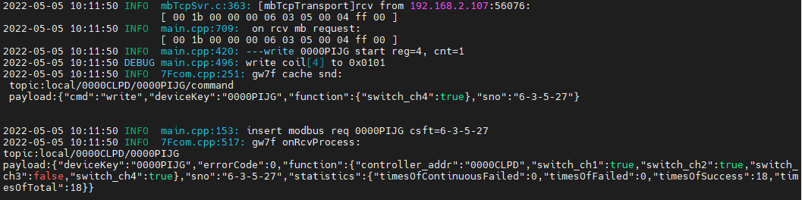

#### 读取通道4缓存

rcv from 192.168.2.107:56076:

[ 00 1c 00 00 00 06 03 01 00 04 00 01 ]

snd to 192.168.2.107:56076:

[ 00 1c 00 00 00 04 03 01 01 01 ]

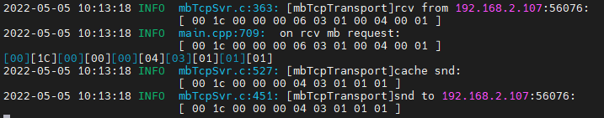

读取4通道闭合，其他通道断开，与写入一致

#### 直读通道4

rcv from 192.168.2.107:56076:

[ 00 1d 00 00 00 06 03 01 03 ec 00 01 ]

snd to 192.168.2.107:56076:

[ 00 1d 00 00 00 04 03 01 01 01 ]

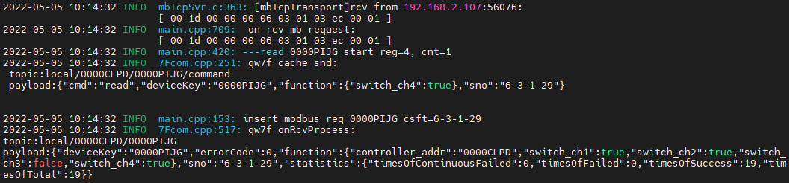



读取4通道闭合，其他通道断开，与写入一致

### 写入断开

rcv from 192.168.2.107:56076:

[ 00 1e 00 00 00 06 03 05 00 04 00 00 ]

snd to 192.168.2.107:56076:

[ 00 1e 00 00 00 06 03 05 00 04 00 00 ]

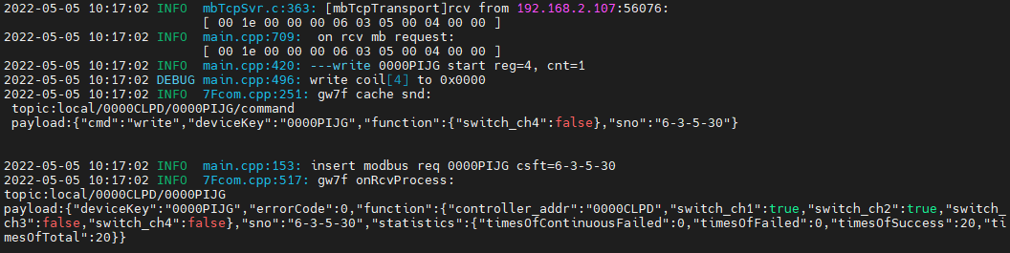

### 多通道读写

测试多通道同时读、写操作；

#### 通道1+2读写

##### 写闭合

1. 写入

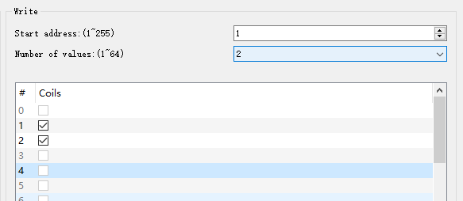

rcv from 192.168.2.107:56076:

[ 00 20 00 00 00 08 03 0f 00 01 00 02 01 03 ]

snd to 192.168.2.107:56076:

[ 00 20 00 00 00 06 03 0f 00 01 00 02 ]

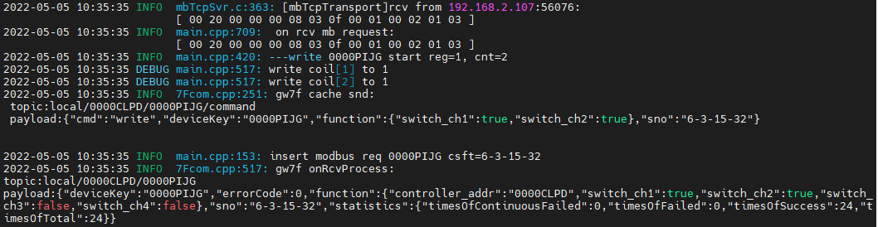

1. 直读

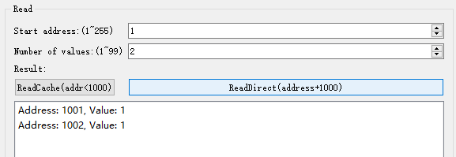

rcv from 192.168.2.107:56076:

[ 00 21 00 00 00 06 03 01 03 e9 00 02 ]

snd to 192.168.2.107:56076:

[ 00 21 00 00 00 04 03 01 01 03 ]

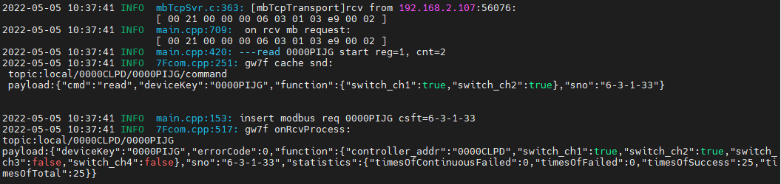

读取状态与写入一致

1. 读缓存

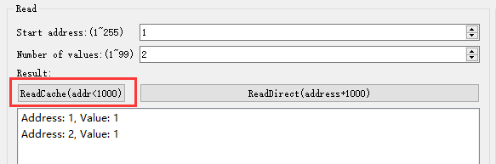

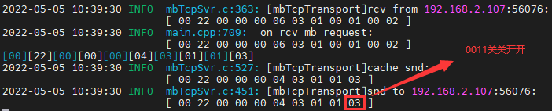

读取状态与写入一致

##### 写断开

1. 写入

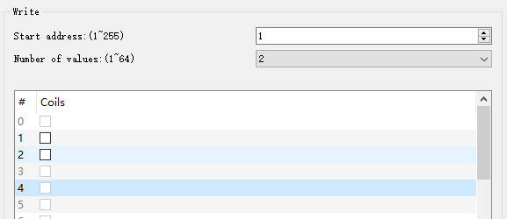

rcv from 192.168.2.107:56076:

[ 00 23 00 00 00 08 03 0f 00 01 00 02 01 00 ]

snd to 192.168.2.107:56076:

[ 00 23 00 00 00 06 03 0f 00 01 00 02 ]

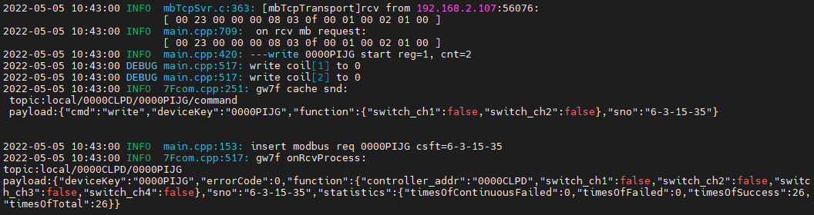



写入1,2通道断开

1. 直读

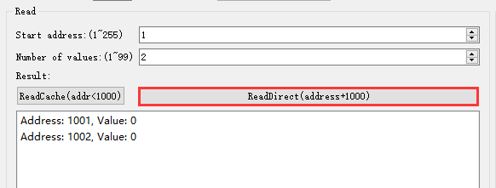

rcv from 192.168.2.107:56076:

[ 00 24 00 00 00 06 03 01 03 e9 00 02 ]

snd to 192.168.2.107:56076:

[ 00 24 00 00 00 04 03 01 01 00 ]

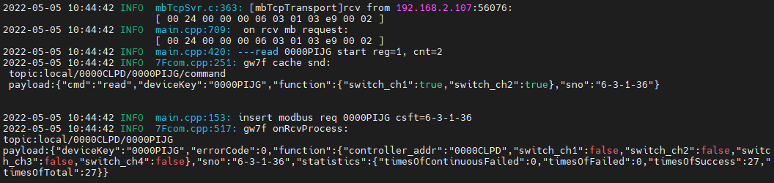

1. 读缓存

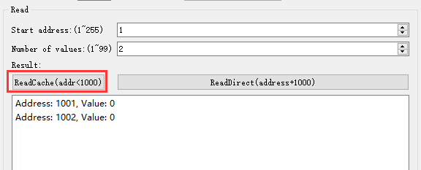

rcv from 192.168.2.107:56076:

[ 00 25 00 00 00 06 03 01 00 01 00 02 ]

snd to 192.168.2.107:56076:

[ 00 25 00 00 00 04 03 01 01 00 ]

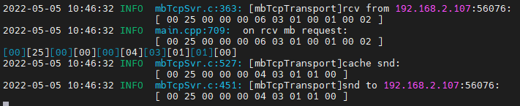

#### 通道2+3+4读写

##### 写闭合

1. 写入

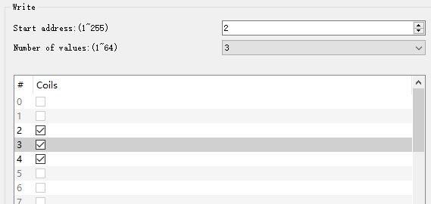

rcv from 192.168.2.107:56076:

[ 00 26 00 00 00 08 03 0f 00 02 00 03 01 07 ]

snd to 192.168.2.107:56076:

[ 00 26 00 00 00 06 03 0f 00 02 00 03 ]

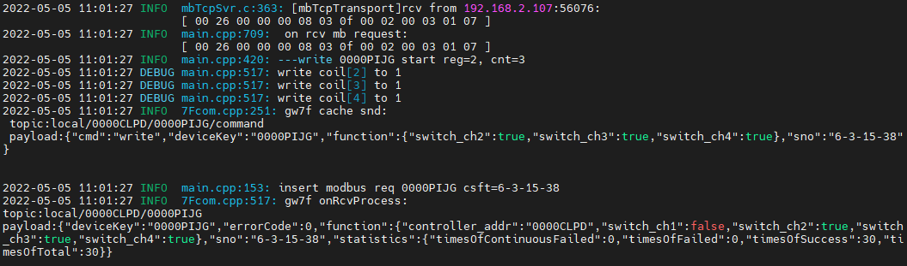



写入2,3,4通道闭合。

1. 直读

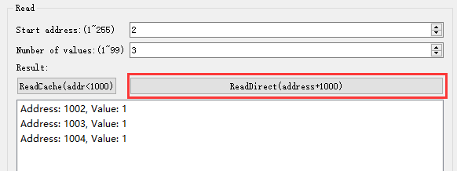

rcv from 192.168.2.107:56076:

[ 00 27 00 00 00 06 03 01 03 ea 00 03 ]

snd to 192.168.2.107:56076:

[ 00 27 00 00 00 04 03 01 01 07 ]

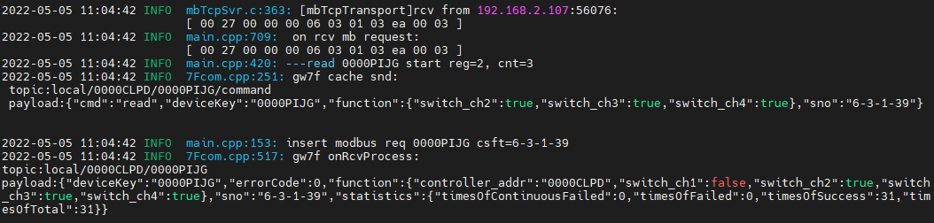

1. 读缓存

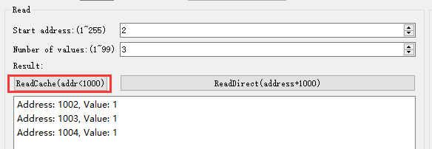

rcv from 192.168.2.107:56076:

[ 00 28 00 00 00 06 03 01 00 02 00 03 ]

snd to 192.168.2.107:56076:

[ 00 28 00 00 00 04 03 01 01 07 ]

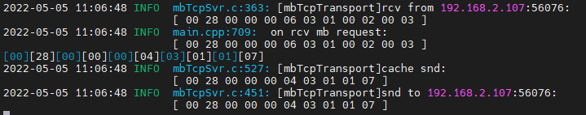

读取2,3,4通道闭合

##### 写断开

1. 写入

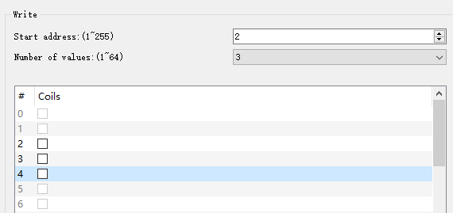

rcv from 192.168.2.107:56076:

[ 00 29 00 00 00 08 03 0f 00 02 00 03 01 00 ]

snd to 192.168.2.107:56076:

[ 00 29 00 00 00 06 03 0f 00 02 00 03 ]

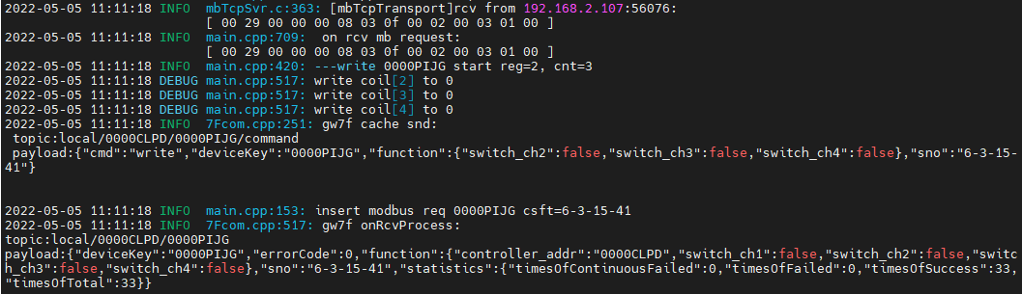

写入2,3,4通道断开。

1. 直读

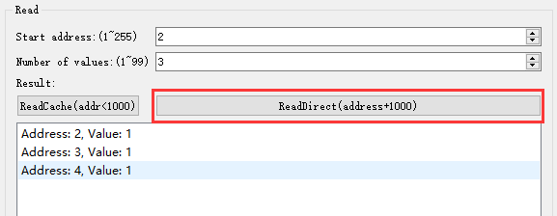

rcv from 192.168.2.107:56076:

[ 00 2a 00 00 00 06 03 01 03 ea 00 03 ]

snd to 192.168.2.107:56076:

[ 00 2a 00 00 00 04 03 01 01 00 ]

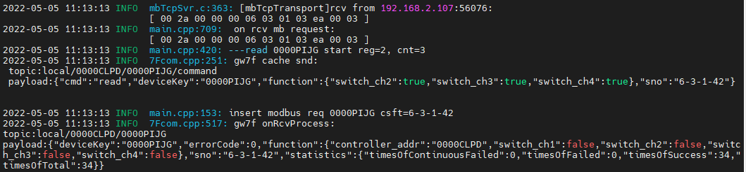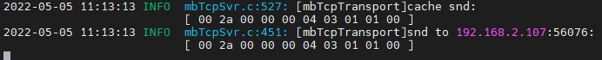

1. 读缓存

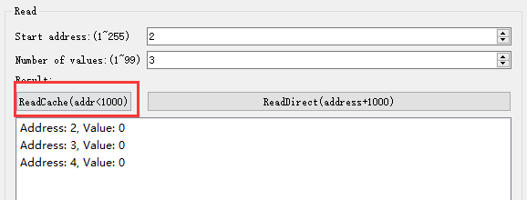

rcv from 192.168.2.107:56076:

[ 00 2b 00 00 00 06 03 01 00 02 00 03 ]

snd to 192.168.2.107:56076:

[ 00 2b 00 00 00 04 03 01 01 00 ]

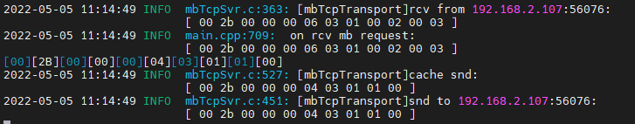

读取与写入一致

#### 通道1+2+3+4读写

##### 写入闭合

1. 写入

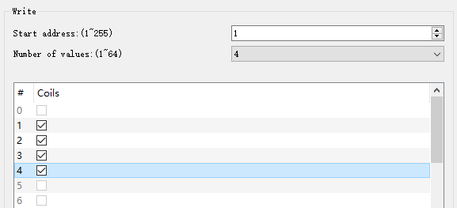

rcv from 192.168.2.107:59165:

[ 00 2c 00 00 00 08 03 0f 00 01 00 04 01 0f ]

snd to 192.168.2.107:59165:

[ 00 2c 00 00 00 06 03 0f 00 01 00 04 ]

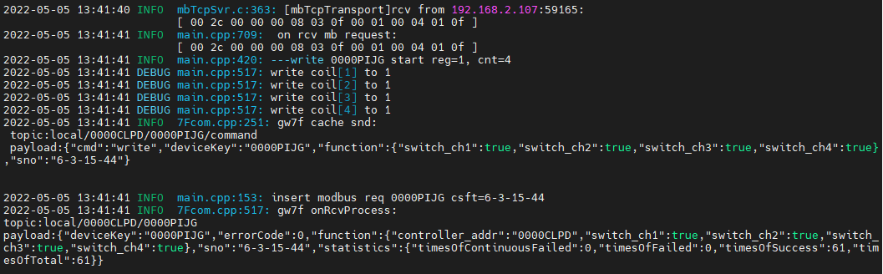1,2,3,4通道闭合

1. 多通道直读

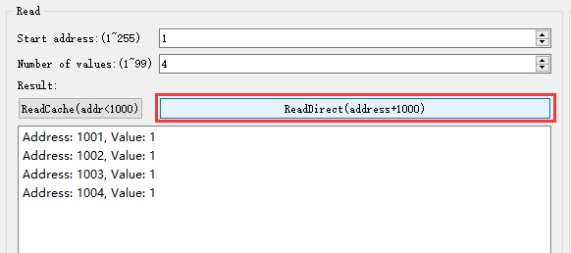

rcv from 192.168.2.107:59165:

[ 00 2d 00 00 00 06 03 01 03 e9 00 04 ]

snd to 192.168.2.107:59165:

[ 00 2d 00 00 00 04 03 01 01 0f ]

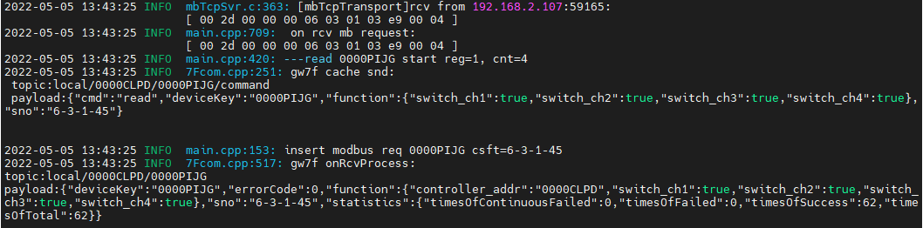

读取1,2,3,4通道闭合，与写入的一致

1. 读取多通道缓存

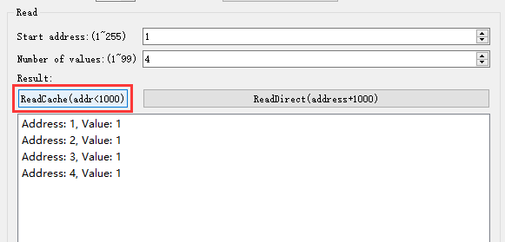rcv from 192.168.2.107:59165:

[ 00 2e 00 00 00 06 03 01 00 01 00 04 ]

snd to 192.168.2.107:59165:

[ 00 2e 00 00 00 04 03 01 01 0f ]

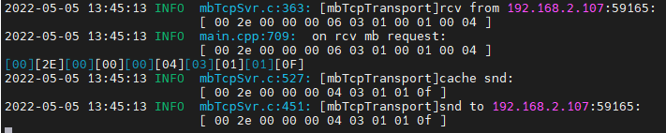

与写入的一致

##### 写入断开

1. 写入

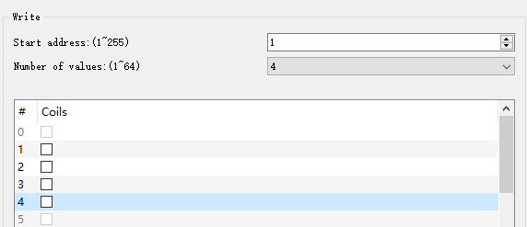rcv from 192.168.2.107:59165:

[ 00 2f 00 00 00 08 03 0f 00 01 00 04 01 00 ]

snd to 192.168.2.107:59165:

[ 00 2f 00 00 00 06 03 0f 00 01 00 04 ]

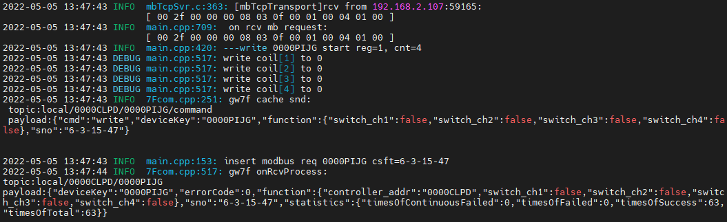



写入1,2,3,4通道断开。

1. 多通道直读

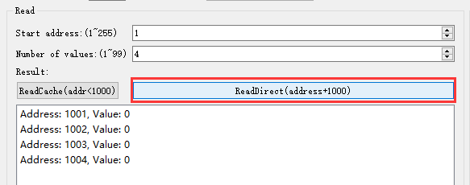rcv from 192.168.2.107:59165:

[ 00 30 00 00 00 06 03 01 03 e9 00 04 ]

snd to 192.168.2.107:59165:

[ 00 30 00 00 00 04 03 01 01 00 ]

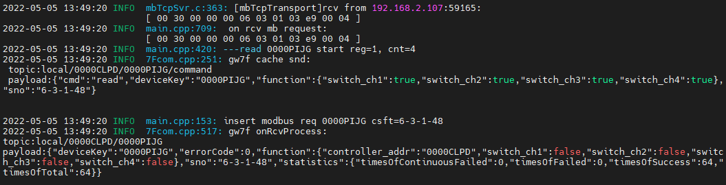

读取与写入一致。

1. 读取多通道缓存

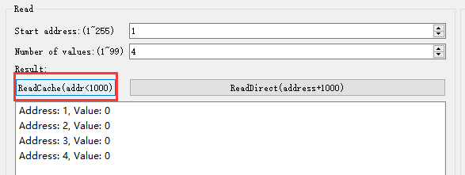

rcv from 192.168.2.107:59165:

[ 00 31 00 00 00 06 03 01 00 01 00 04 ]

snd to 192.168.2.107:59165:

[ 00 31 00 00 00 04 03 01 01 00 ]

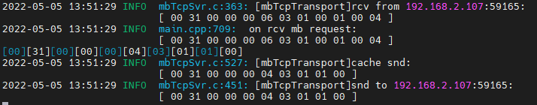

读取与写入一致。

## 不存在的通道

### 通道1,2,3,4,5

1. 写入

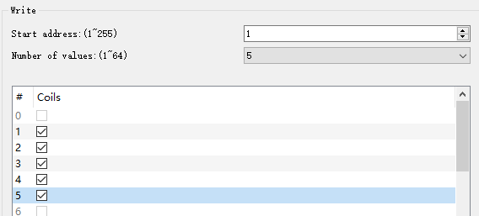

rcv from 192.168.2.107:59165:

[ 00 32 00 00 00 08 03 0f 00 01 00 05 01 1f ]

snd to 192.168.2.107:59165:

[ 00 32 00 00 00 03 03 8f 02 ]

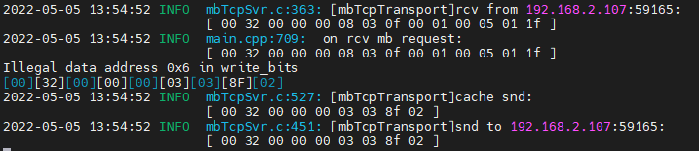

回复数据错误。

1. 读取

读取缓存

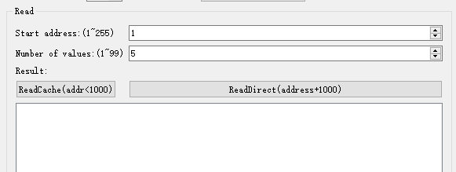

rcv from 192.168.2.107:59165:

[ 00 34 00 00 00 06 03 01 00 01 00 05 ]

snd to 192.168.2.107:59165:

[ 00 34 00 00 00 03 03 81 02 ]

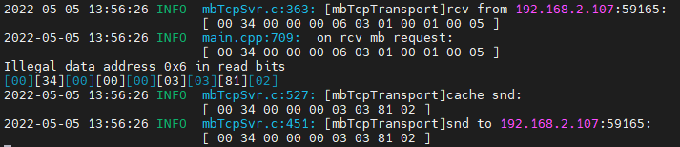

直读

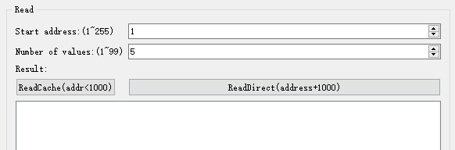

rcv from 192.168.2.107:59165:

[ 00 35 00 00 00 06 03 01 03 e9 00 05 ]

snd to 192.168.2.107:59165:

[ 00 35 00 00 00 03 03 81 02 ]

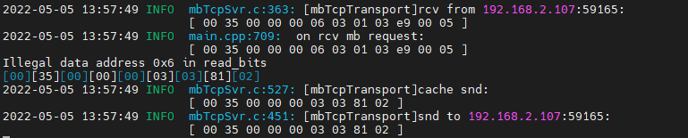

### 通道5

1. 写入

rcv from 192.168.2.107:59165:

[ 00 36 00 00 00 06 03 05 00 05 ff 00 ]

snd to 192.168.2.107:59165:

[ 00 36 00 00 00 03 03 85 02 ]

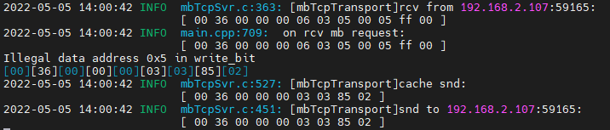

报错，写入不成功。

1. 读取

直读：

rcv from 192.168.2.107:59165:

[ 00 37 00 00 00 06 03 01 03 e9 00 05 ]

snd to 192.168.2.107:59165:

[ 00 37 00 00 00 03 03 81 02 ]

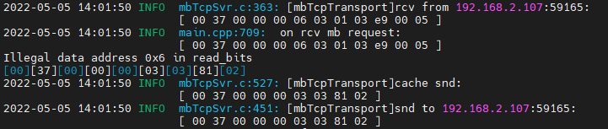

读缓存：

rcv from 192.168.2.107:59165:

[ 00 38 00 00 00 06 03 01 00 01 00 05 ]

snd to 192.168.2.107:59165:

[ 00 38 00 00 00 03 03 81 02 ]

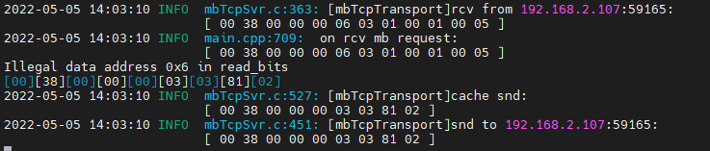

报错，读取不成功。

查询设备modbus地址--4

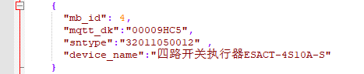

## 通道1

### 写1通道断开

#### 写入

rcv from 192.168.2.107:62343:

[ 00 36 00 00 00 06 04 05 00 01 00 00 ]

snd to 192.168.2.107:62343:

[ 00 36 00 00 00 06 04 05 00 01 00 00 ]

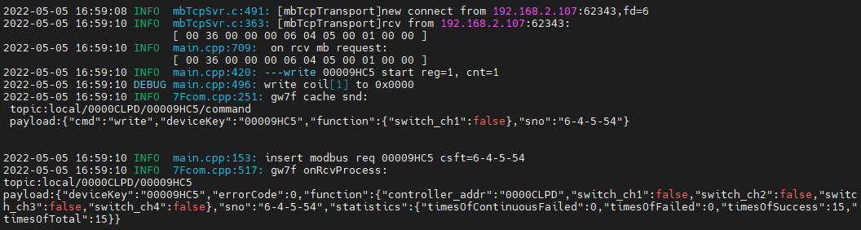

#### 读取1通道缓存

rcv from 192.168.2.107:62343:

[ 00 37 00 00 00 06 04 01 00 01 00 01 ]

snd to 192.168.2.107:62343:

[ 00 37 00 00 00 04 04 01 01 00 ]

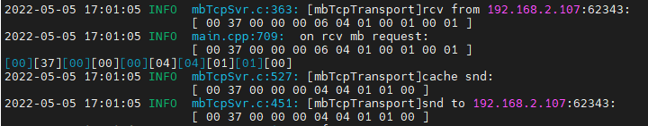

#### 1通道直读

rcv from 192.168.2.107:62343:

[ 00 38 00 00 00 06 04 01 03 e9 00 01 ]

snd to 192.168.2.107:62343:

[ 00 38 00 00 00 04 04 01 01 00 ]

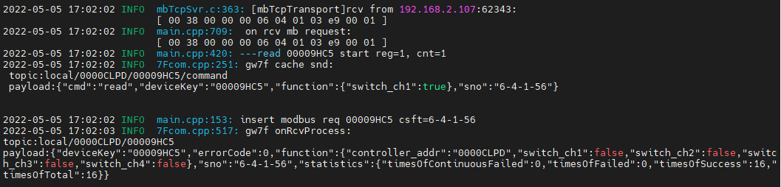



### 写1通道闭合

#### 写入

rcv from 192.168.2.107:62343:

[ 00 39 00 00 00 06 04 05 00 01 ff 00 ]

snd to 192.168.2.107:62343:

[ 00 39 00 00 00 06 04 05 00 01 ff 00 ]

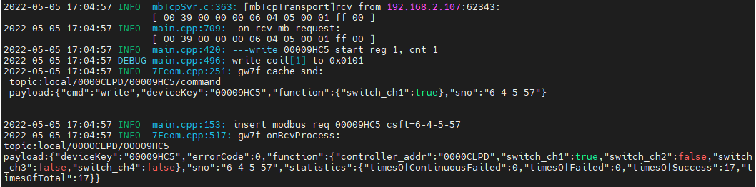

#### 读取1通道缓存

rcv from 192.168.2.107:62343:

[ 00 3a 00 00 00 06 04 01 00 01 00 01 ]

snd to 192.168.2.107:62343:

[ 00 3a 00 00 00 04 04 01 01 01 ]

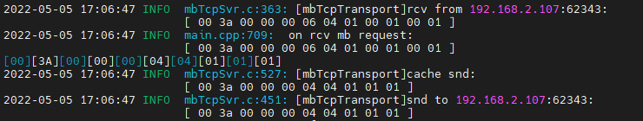

读取与写入状态一致

#### 1通道直读

rcv from 192.168.2.107:62343:

[ 00 3b 00 00 00 06 04 01 03 e9 00 01 ]

snd to 192.168.2.107:62343:

[ 00 3b 00 00 00 04 04 01 01 01 ]

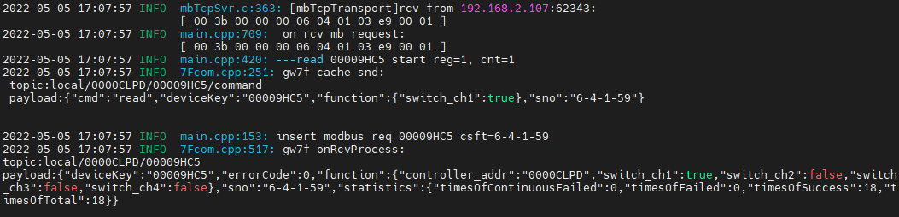

读取与写入状态一致

## 通道2

### 写入

rcv from 192.168.2.107:63422:

[ 00 00 00 00 00 06 04 05 00 02 ff 00 ]

snd to 192.168.2.107:63422:

[ 00 00 00 00 00 06 04 05 00 02 ff 00 ]

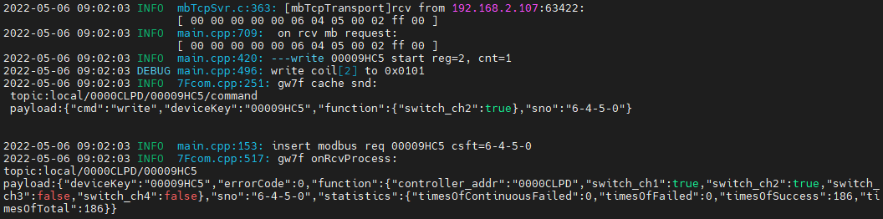

### 读取通道2缓存

rcv from 192.168.2.107:63422:

[ 00 01 00 00 00 06 04 01 00 02 00 01 ]

snd to 192.168.2.107:63422:

[ 00 01 00 00 00 04 04 01 01 01 ]

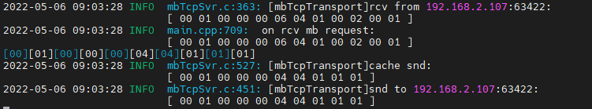

读取与写入值一致

### 直读通道2

rcv from 192.168.2.107:63422:

[ 00 02 00 00 00 06 04 01 03 ea 00 01 ]

snd to 192.168.2.107:63422:

[ 00 02 00 00 00 04 04 01 01 01 ]

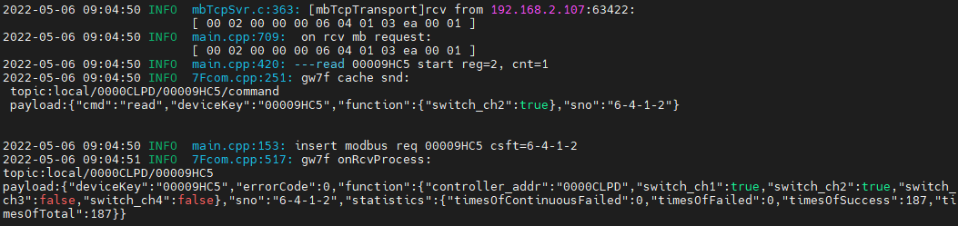



读取与写入值一致

## 通道3

### 写入

rcv from 192.168.2.107:63422:

[ 00 03 00 00 00 06 04 05 00 03 ff 00 ]

snd to 192.168.2.107:63422:

[ 00 03 00 00 00 06 04 05 00 03 ff 00 ]

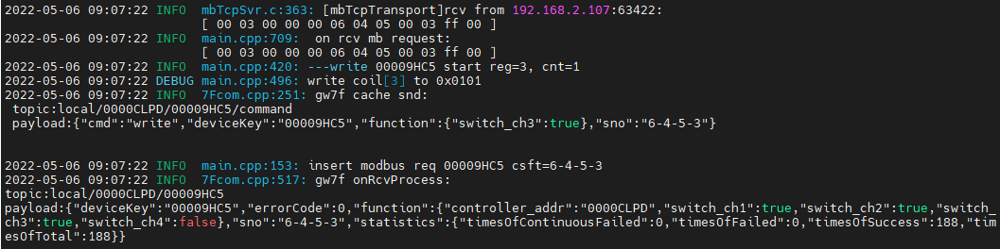

### 读取通道3缓存

rcv from 192.168.2.107:63422:

[ 00 04 00 00 00 06 04 01 00 03 00 01 ]

snd to 192.168.2.107:63422:

[ 00 04 00 00 00 04 04 01 01 01 ]

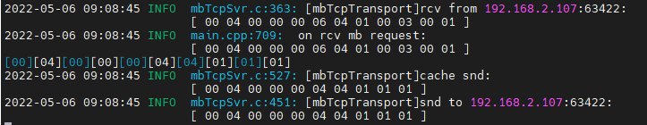

读取与写入值一致

### 直读通道3

rcv from 192.168.2.107:63422:

[ 00 05 00 00 00 06 04 01 03 eb 00 01 ]

snd to 192.168.2.107:63422:

[ 00 05 00 00 00 04 04 01 01 01 ]

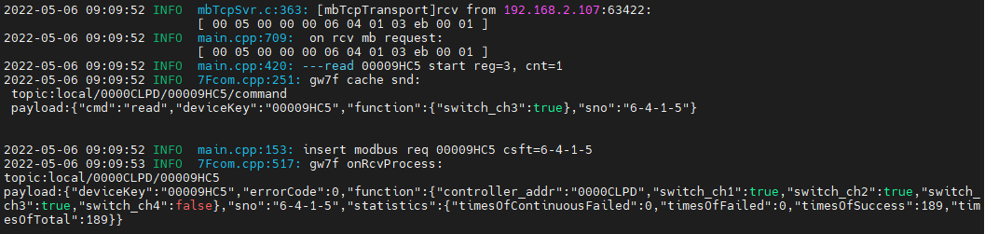

读取与写入值一致

## 通道4

### 写入闭合

rcv from 192.168.2.107:63422:

[ 00 06 00 00 00 06 04 05 00 04 ff 00 ]

snd to 192.168.2.107:63422:

[ 00 06 00 00 00 06 04 05 00 04 ff 00 ]

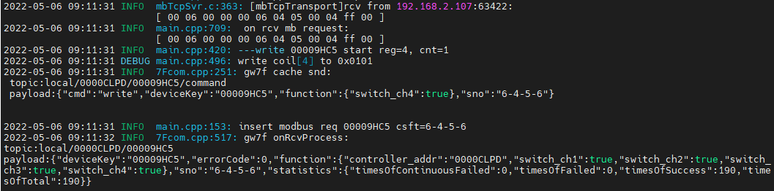

#### 读取通道4缓存

rcv from 192.168.2.107:63422:

[ 00 07 00 00 00 06 04 01 00 04 00 01 ]

snd to 192.168.2.107:63422:

[ 00 07 00 00 00 04 04 01 01 01 ]

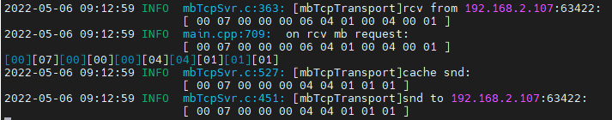

读取4通道闭合，与写入一致

#### 直读通道4

rcv from 192.168.2.107:63422:

[ 00 08 00 00 00 06 04 01 03 ec 00 01 ]

snd to 192.168.2.107:63422:

[ 00 08 00 00 00 04 04 01 01 01 ]

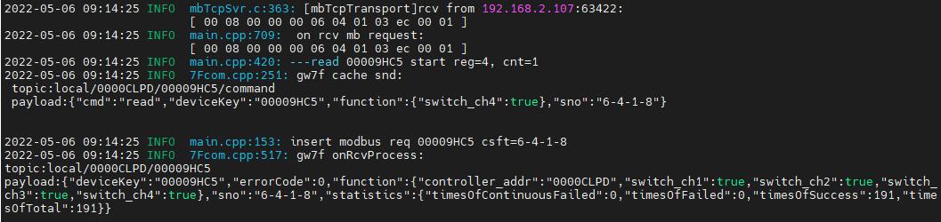

读取4通道闭合，与写入一致

### 写入断开

rcv from 192.168.2.107:63422:

[ 00 09 00 00 00 06 04 05 00 04 00 00 ]

snd to 192.168.2.107:63422:

[ 00 09 00 00 00 06 04 05 00 04 00 00 ]

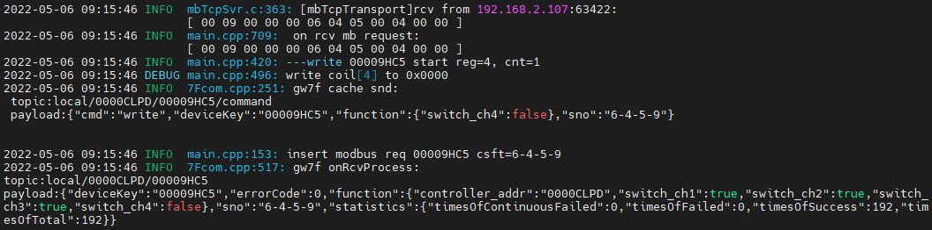

### 多通道读写

测试多通道同时读、写操作；

#### 通道1+2读写

##### 写闭合

1. 写入



rcv from 192.168.2.107:63422:

[ 00 0b 00 00 00 08 04 0f 00 01 00 02 01 03 ]

snd to 192.168.2.107:63422:

[ 00 0b 00 00 00 06 04 0f 00 01 00 02 ]

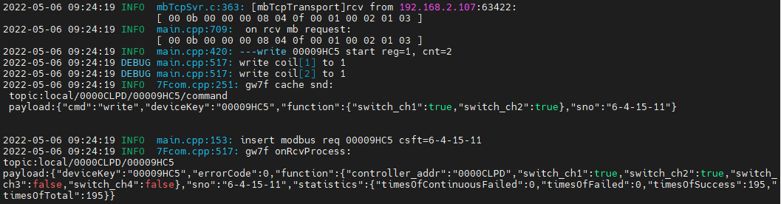

1. 直读



rcv from 192.168.2.107:63422:

[ 00 0c 00 00 00 06 04 01 03 e9 00 02 ]

snd to 192.168.2.107:63422:

[ 00 0c 00 00 00 04 04 01 01 03 ]

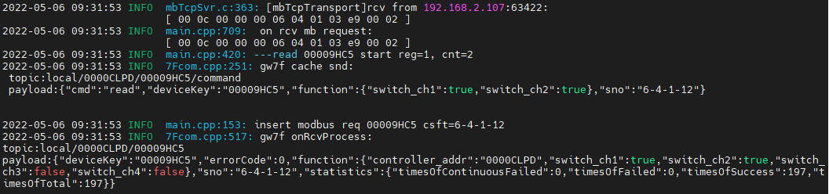

读取状态与写入一致

1. 读缓存



rcv from 192.168.2.107:63422:

[ 00 0d 00 00 00 06 04 01 00 01 00 02 ]

snd to 192.168.2.107:63422:

[ 00 0d 00 00 00 04 04 01 01 03 ]

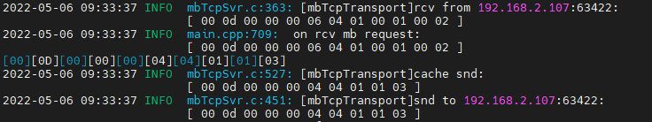

读取状态与写入一致

##### 写断开

1. 写入

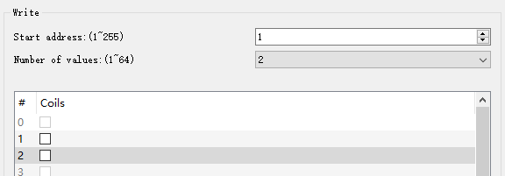

rcv from 192.168.2.107:63422:

[ 00 0e 00 00 00 08 04 0f 00 01 00 02 01 00 ]

snd to 192.168.2.107:63422:

[ 00 0e 00 00 00 06 04 0f 00 01 00 02 ]

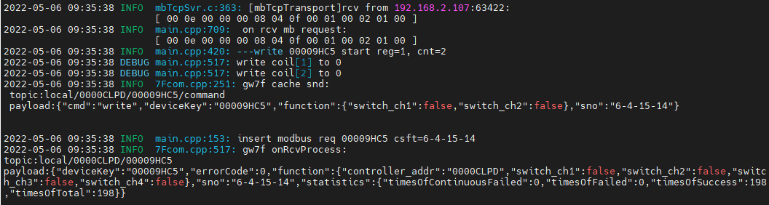

写入1,2通道断开

1. 直读



rcv from 192.168.2.107:63422:

[ 00 0f 00 00 00 06 04 01 03 e9 00 02 ]

snd to 192.168.2.107:63422:

[ 00 0f 00 00 00 04 04 01 01 00 ]

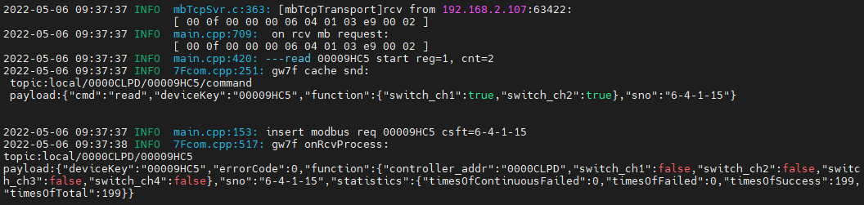

1. 读缓存



rcv from 192.168.2.107:63422:

[ 00 10 00 00 00 06 04 01 00 01 00 02 ]

snd to 192.168.2.107:63422:

[ 00 10 00 00 00 04 04 01 01 00 ]

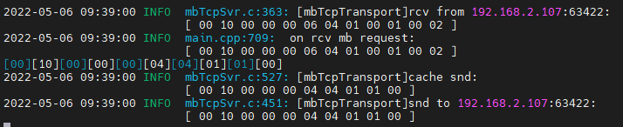

#### 通道2+3+4读写

##### 写闭合

1. 写入



rcv from 192.168.2.107:64663:

[ 00 11 00 00 00 08 04 0f 00 02 00 03 01 07 ]

snd to 192.168.2.107:64663:

[ 00 11 00 00 00 06 04 0f 00 02 00 03 ]

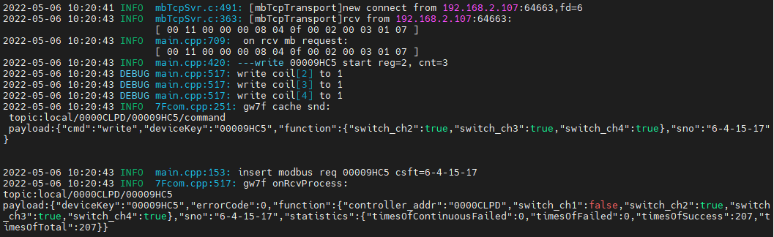

写入2,3,4通道闭合。

1. 直读



rcv from 192.168.2.107:64663:

[ 00 12 00 00 00 06 04 01 03 ea 00 03 ]

snd to 192.168.2.107:64663:

[ 00 12 00 00 00 04 04 01 01 07 ]

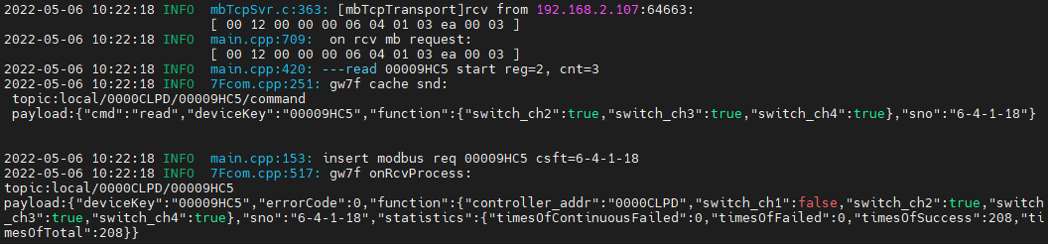

1. 读缓存



rcv from 192.168.2.107:64663:

[ 00 13 00 00 00 06 04 01 00 02 00 03 ]

snd to 192.168.2.107:64663:

[ 00 13 00 00 00 04 04 01 01 07 ]

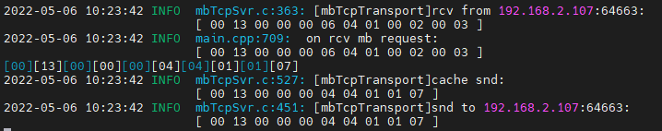

读取2,3,4通道闭合

##### 写断开

1. 写入



rcv from 192.168.2.107:64663:

[ 00 14 00 00 00 08 04 0f 00 02 00 03 01 00 ]

snd to 192.168.2.107:64663:

[ 00 14 00 00 00 06 04 0f 00 02 00 03 ]

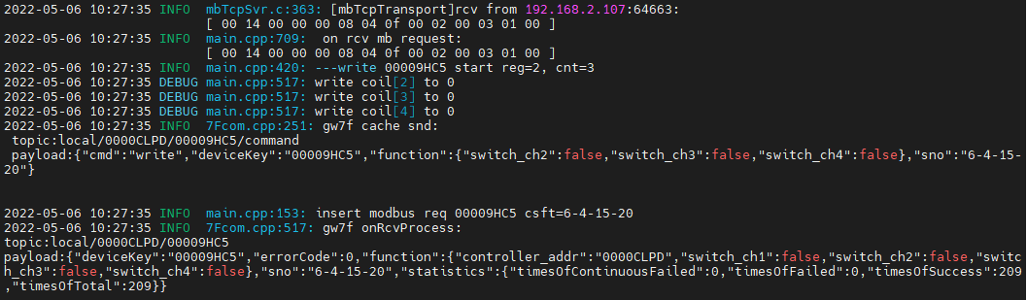

写入2,3,4通道断开。

1. 直读



rcv from 192.168.2.107:64663:

[ 00 15 00 00 00 06 04 01 03 ea 00 03 ]

snd to 192.168.2.107:64663:

[ 00 15 00 00 00 04 04 01 01 00 ]

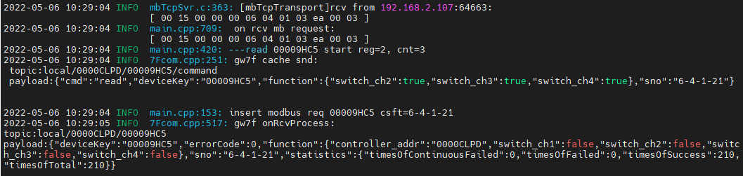

1. 读缓存



rcv from 192.168.2.107:64663:

[ 00 16 00 00 00 06 04 01 00 02 00 03 ]

snd to 192.168.2.107:64663:

[ 00 16 00 00 00 04 04 01 01 00 ]

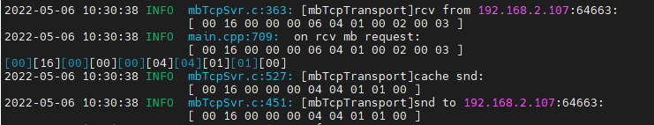

读取与写入一致

#### 通道1+2+3+4读写

##### 写入闭合

1. 写入



rcv from 192.168.2.107:64663:

[ 00 17 00 00 00 08 04 0f 00 01 00 04 01 0f ]

snd to 192.168.2.107:64663:

[ 00 17 00 00 00 06 04 0f 00 01 00 04 ]

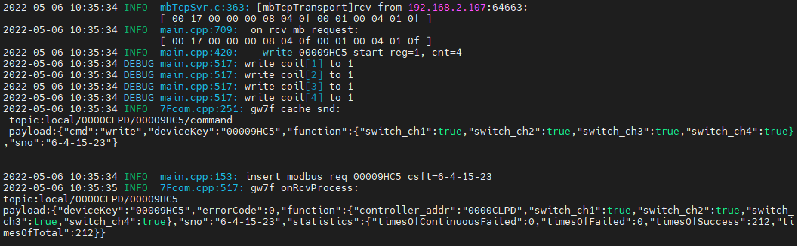

1,2,3,4通道闭合

1. 多通道直读



rcv from 192.168.2.107:64663:

[ 00 18 00 00 00 06 04 01 03 e9 00 04 ]

snd to 192.168.2.107:64663:

[ 00 18 00 00 00 04 04 01 01 0f ]

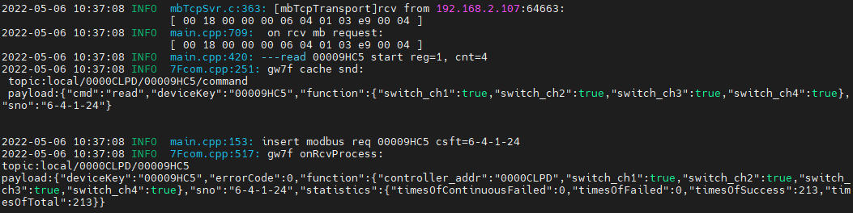

读取1,2,3,4通道闭合，与写入的一致

1. 读取多通道缓存

rcv from 192.168.2.107:64663:

[ 00 19 00 00 00 06 04 01 00 01 00 04 ]

snd to 192.168.2.107:64663:

[ 00 19 00 00 00 04 04 01 01 0f ]

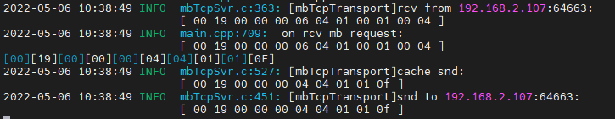

与写入的一致

##### 写入断开

1. 写入

rcv from 192.168.2.107:64663:

[ 00 1a 00 00 00 08 04 0f 00 01 00 04 01 00 ]

snd to 192.168.2.107:64663:

[ 00 1a 00 00 00 06 04 0f 00 01 00 04 ]

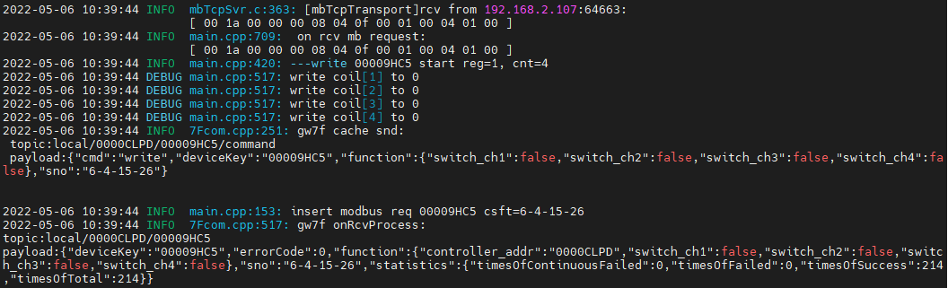

写入1,2,3,4通道断开。

1. 多通道直读

rcv from 192.168.2.107:64663:

[ 00 1b 00 00 00 06 04 01 03 e9 00 04 ]

snd to 192.168.2.107:64663:

[ 00 1b 00 00 00 04 04 01 01 00 ]

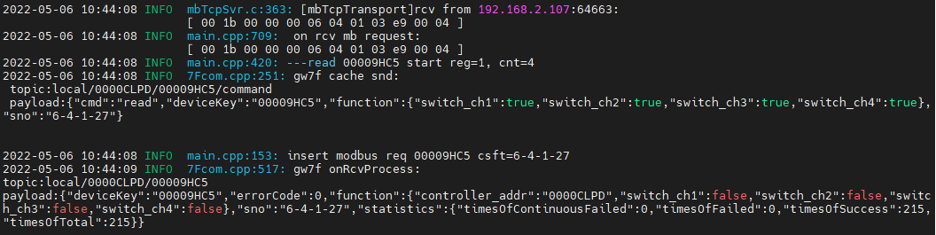

读取与写入一致。

1. 读取多通道缓存



rcv from 192.168.2.107:64663:

[ 00 1c 00 00 00 06 04 01 00 01 00 04 ]

snd to 192.168.2.107:64663:

[ 00 1c 00 00 00 04 04 01 01 00 ]

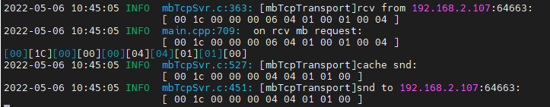

读取与写入一致。

## 不存在的通道

### 通道1,2,3,4,5

1. 写入



rcv from 192.168.2.107:64663:

[ 00 1d 00 00 00 08 04 0f 00 01 00 05 01 1f ]

snd to 192.168.2.107:64663:

[ 00 1d 00 00 00 03 04 8f 02 ]

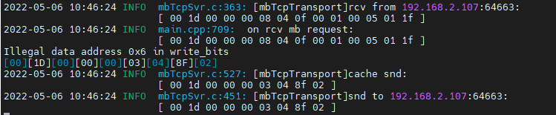

回复数据错误。

1. 读取

读取缓存



rcv from 192.168.2.107:64663:

[ 00 1e 00 00 00 06 04 01 00 01 00 05 ]

snd to 192.168.2.107:64663:

[ 00 1e 00 00 00 03 04 81 02 ]

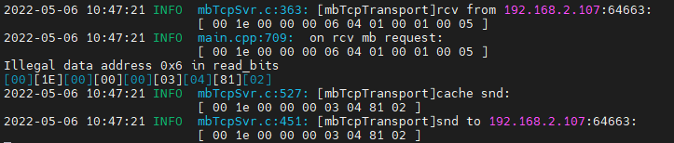

直读



rcv from 192.168.2.107:64663:

[ 00 1f 00 00 00 06 04 01 03 e9 00 05 ]

snd to 192.168.2.107:64663:

[ 00 1f 00 00 00 03 04 81 02 ]

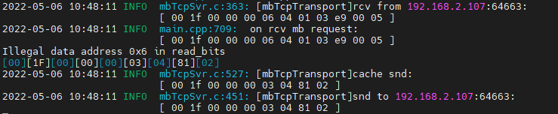

### 通道5

1. 写入

rcv from 192.168.2.107:64663:

[ 00 20 00 00 00 06 04 05 00 05 ff 00 ]

snd to 192.168.2.107:64663:

[ 00 20 00 00 00 03 04 85 02 ]

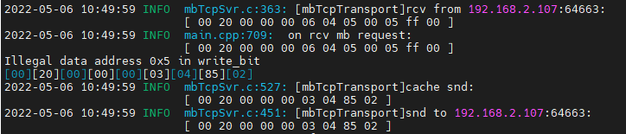

报错，写入不成功。

1. 读取

直读：

rcv from 192.168.2.107:64663:

[ 00 21 00 00 00 06 04 01 03 ed 00 01 ]

snd to 192.168.2.107:64663:

[ 00 21 00 00 00 03 04 81 02 ]

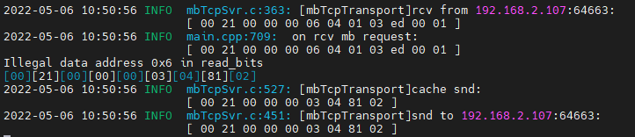

读缓存：

rcv from 192.168.2.107:64663:

[ 00 22 00 00 00 06 04 01 00 05 00 01 ]

snd to 192.168.2.107:64663:

[ 00 22 00 00 00 03 04 81 02 ]

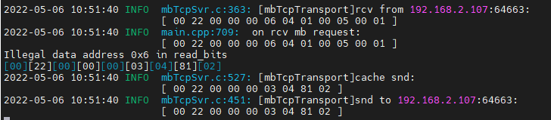

报错，读取不成功。

查询设备modbus地址--5

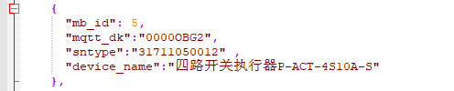

## 通道1

### 写1通道断开

#### 写入

rcv from 192.168.2.107:51182:

[ 00 05 00 00 00 06 05 05 00 01 00 00 ]

snd to 192.168.2.107:51182:

[ 00 05 00 00 00 06 05 05 00 01 00 00 ]

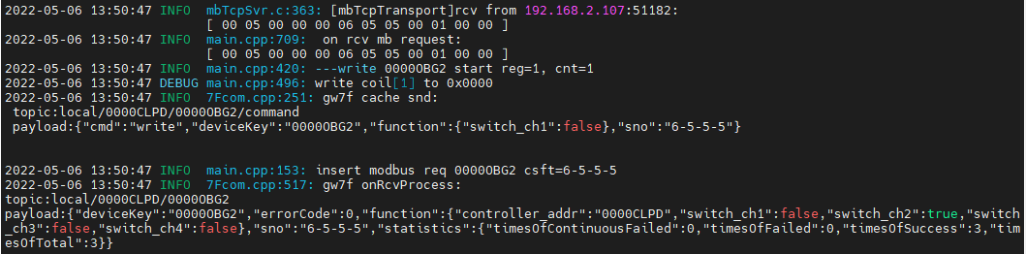

#### 读取1通道缓存

rcv from 192.168.2.107:51212:

[ 00 07 00 00 00 06 05 01 00 01 00 01 ]

snd to 192.168.2.107:51212:

[ 00 07 00 00 00 04 05 01 01 00 ]

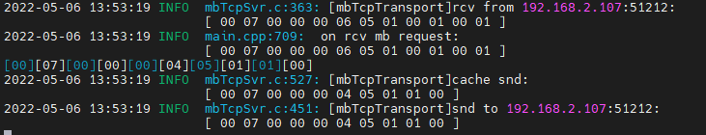

#### 1通道直读

rcv from 192.168.2.107:51212:

[ 00 08 00 00 00 06 05 01 03 e9 00 01 ]

snd to 192.168.2.107:51212:

[ 00 08 00 00 00 04 05 01 01 00 ]

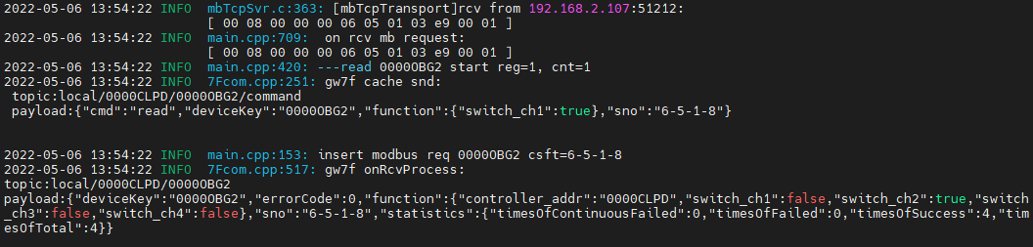

### 写1通道闭合

#### 写入

rcv from 192.168.2.107:51212:

[ 00 09 00 00 00 06 05 05 00 01 ff 00 ]

snd to 192.168.2.107:51212:

[ 00 09 00 00 00 06 05 05 00 01 ff 00 ]

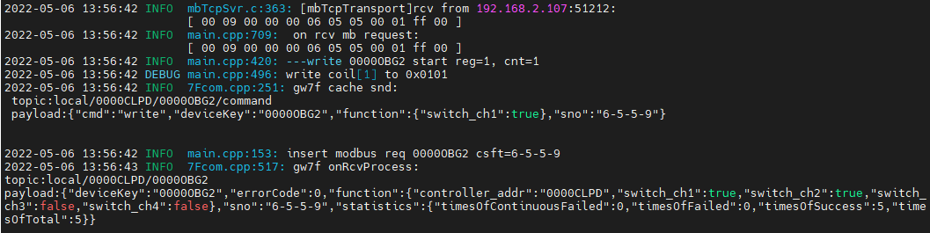

#### 读取1通道缓存

rcv from 192.168.2.107:51212:

[ 00 0a 00 00 00 06 05 01 00 01 00 01 ]

snd to 192.168.2.107:51212:

[ 00 0a 00 00 00 04 05 01 01 01 ]

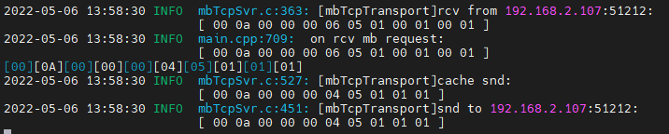

读取与写入状态一致

#### 1通道直读

rcv from 192.168.2.107:51212:

[ 00 0b 00 00 00 06 05 01 03 e9 00 01 ]

snd to 192.168.2.107:51212:

[ 00 0b 00 00 00 04 05 01 01 01 ]

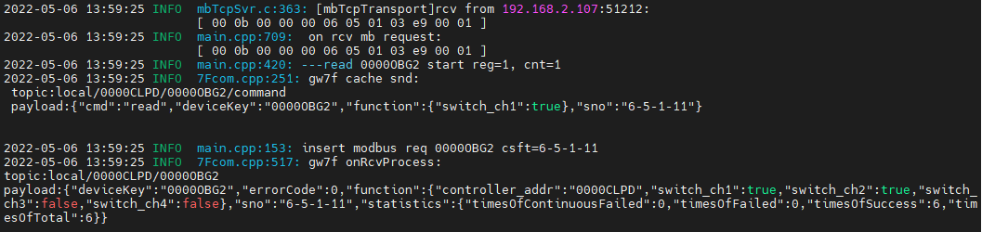

读取与写入状态一致

## 通道2

### 写入

rcv from 192.168.2.107:51212:

[ 00 0d 00 00 00 06 05 05 00 02 ff 00 ]

snd to 192.168.2.107:51212:

[ 00 0d 00 00 00 06 05 05 00 02 ff 00 ]

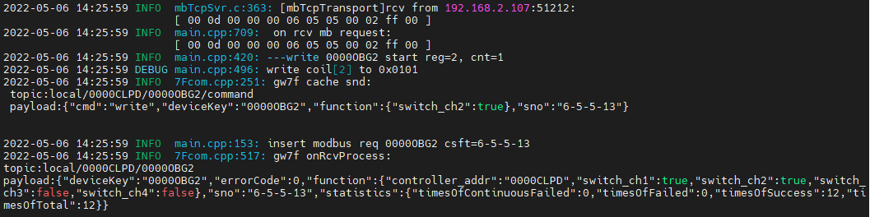

### 读取通道2缓存

rcv from 192.168.2.107:51212:

[ 00 0e 00 00 00 06 05 01 00 02 00 01 ]

snd to 192.168.2.107:51212:

[ 00 0e 00 00 00 04 05 01 01 01 ]

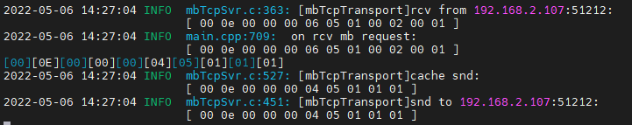

读取与写入值一致

### 直读通道2

rcv from 192.168.2.107:51212:

[ 00 0f 00 00 00 06 05 01 03 ea 00 01 ]

snd to 192.168.2.107:51212:

[ 00 0f 00 00 00 04 05 01 01 01 ]

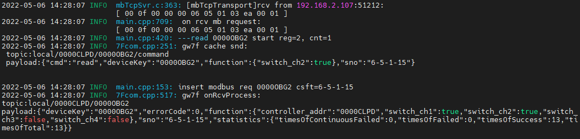



读取与写入值一致

## 通道3

### 写入

rcv from 192.168.2.107:51212:

[ 00 10 00 00 00 06 05 05 00 03 ff 00 ]

snd to 192.168.2.107:51212:

[ 00 10 00 00 00 06 05 05 00 03 ff 00 ]

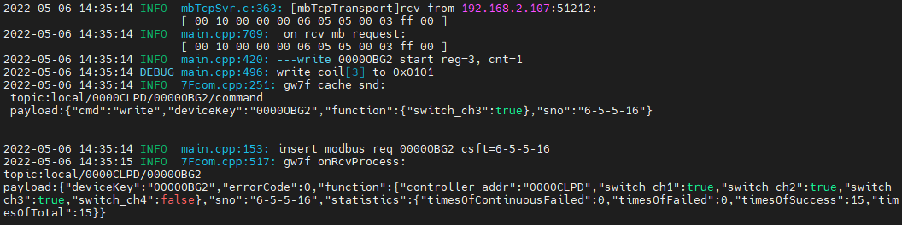

### 读取通道3缓存

rcv from 192.168.2.107:51212:

[ 00 11 00 00 00 06 05 01 00 03 00 01 ]

snd to 192.168.2.107:51212:

[ 00 11 00 00 00 04 05 01 01 01 ]

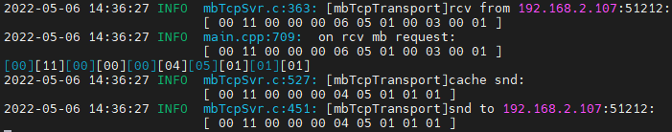

读取与写入值一致

### 直读通道3

rcv from 192.168.2.107:51212:

[ 00 12 00 00 00 06 05 01 03 eb 00 01 ]

snd to 192.168.2.107:51212:

[ 00 12 00 00 00 04 05 01 01 01 ]

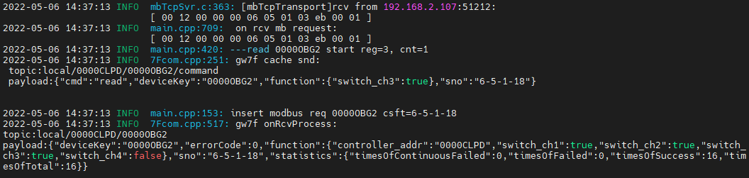

读取与写入值一致

## 通道4

### 写入闭合

rcv from 192.168.2.107:51212:

[ 00 13 00 00 00 06 05 05 00 04 ff 00 ]

snd to 192.168.2.107:51212:

[ 00 13 00 00 00 06 05 05 00 04 ff 00 ]

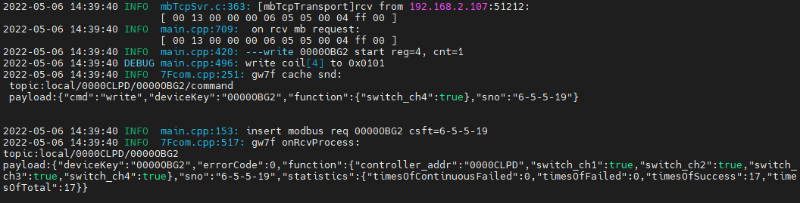

#### 读取通道4缓存

rcv from 192.168.2.107:51212:

[ 00 14 00 00 00 06 05 01 00 04 00 01 ]

snd to 192.168.2.107:51212:

[ 00 14 00 00 00 04 05 01 01 01 ]

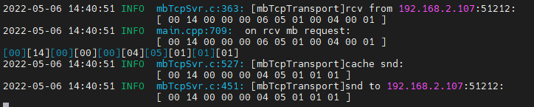

读取4通道闭合，与写入一致

#### 直读通道4

rcv from 192.168.2.107:51212:

[ 00 15 00 00 00 06 05 01 03 ec 00 01 ]

snd to 192.168.2.107:51212:

[ 00 15 00 00 00 04 05 01 01 01 ]

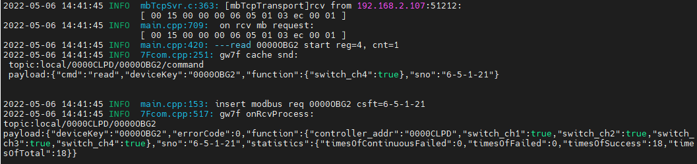

读取4通道闭合，与写入一致

### 写入断开

rcv from 192.168.2.107:51212:

[ 00 16 00 00 00 06 05 05 00 04 00 00 ]

snd to 192.168.2.107:51212:

[ 00 16 00 00 00 06 05 05 00 04 00 00 ]

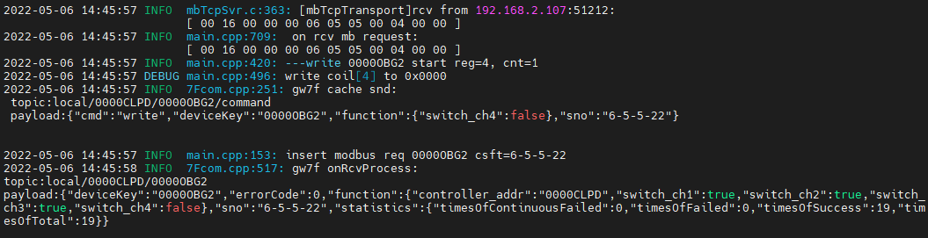

### 多通道读写

测试多通道同时读、写操作；

#### 通道1+2读写

##### 写闭合

1. 写入



rcv from 192.168.2.107:51212:

[ 00 17 00 00 00 08 05 0f 00 01 00 02 01 03 ]

snd to 192.168.2.107:51212:

[ 00 17 00 00 00 06 05 0f 00 01 00 02 ]

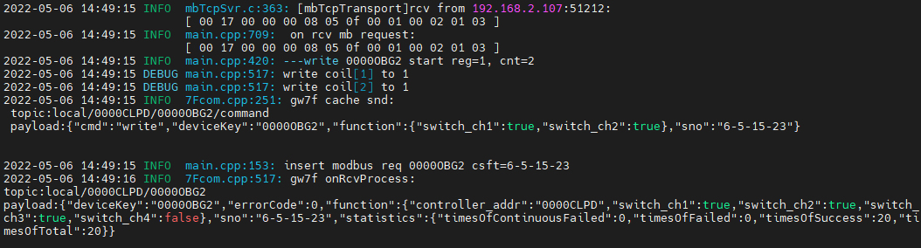

1. 直读



rcv from 192.168.2.107:51212:

[ 00 18 00 00 00 06 05 01 03 e9 00 02 ]

snd to 192.168.2.107:51212:

[ 00 18 00 00 00 04 05 01 01 03 ]

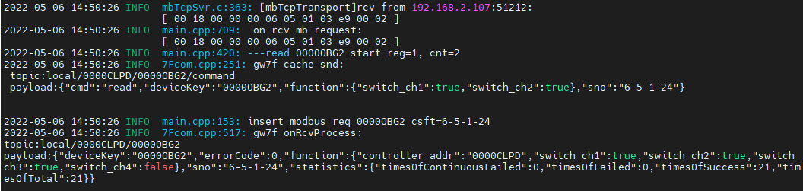

读取状态与写入一致

1. 读缓存



rcv from 192.168.2.107:51212:

[ 00 19 00 00 00 06 05 01 00 01 00 02 ]

snd to 192.168.2.107:51212:

[ 00 19 00 00 00 04 05 01 01 03 ]

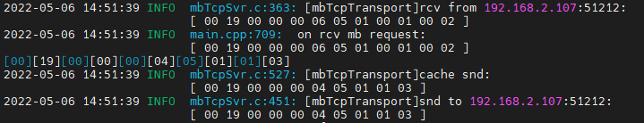

读取状态与写入一致

##### 写断开

1. 写入



rcv from 192.168.2.107:51212:

[ 00 1d 00 00 00 08 05 0f 00 01 00 02 01 00 ]

snd to 192.168.2.107:51212:

[ 00 1d 00 00 00 06 05 0f 00 01 00 02 ]

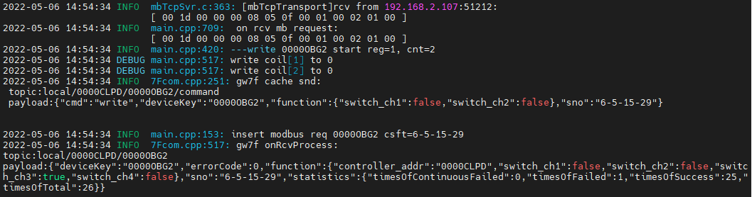

写入1,2通道断开

1. 直读



rcv from 192.168.2.107:51212:

[ 00 1e 00 00 00 06 05 01 03 e9 00 02 ]

snd to 192.168.2.107:51212:

[ 00 1e 00 00 00 04 05 01 01 00 ]

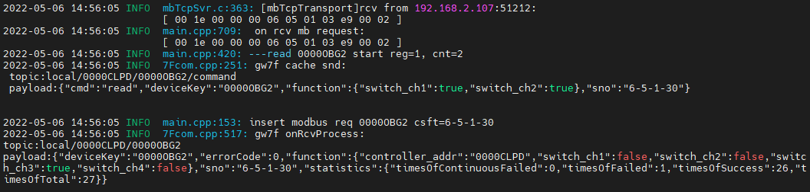

1. 读缓存



rcv from 192.168.2.107:51212:

[ 00 1f 00 00 00 06 05 01 00 01 00 02 ]

snd to 192.168.2.107:51212:

[ 00 1f 00 00 00 04 05 01 01 00 ]

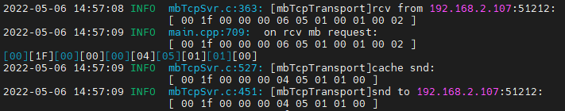

#### 通道2+3+4读写

##### 写闭合

1. 写入



rcv from 192.168.2.107:51212:

[ 00 20 00 00 00 08 05 0f 00 02 00 03 01 07 ]

snd to 192.168.2.107:51212:

[ 00 20 00 00 00 06 05 0f 00 02 00 03 ]

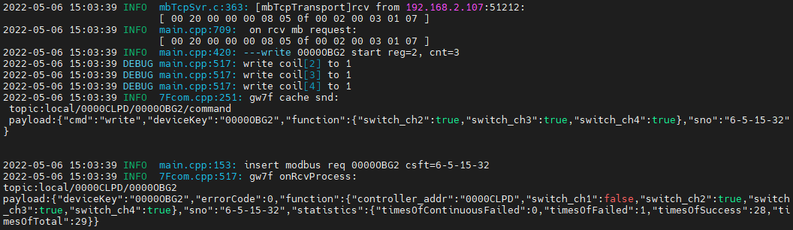

写入2,3,4通道闭合。

1. 直读



rcv from 192.168.2.107:51212:

[ 00 21 00 00 00 06 05 01 03 ea 00 03 ]

snd to 192.168.2.107:51212:

[ 00 21 00 00 00 04 05 01 01 07 ]

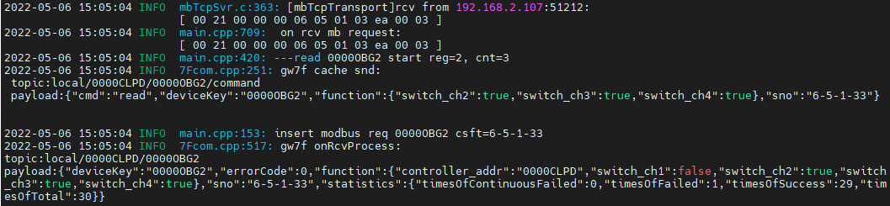

1. 读缓存



rcv from 192.168.2.107:51212:

[ 00 22 00 00 00 06 05 01 00 02 00 03 ]

snd to 192.168.2.107:51212:

[ 00 22 00 00 00 04 05 01 01 07 ]

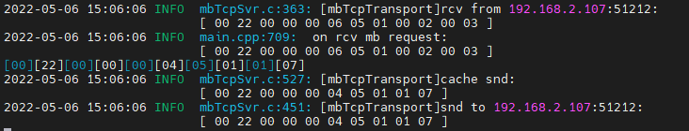

读取2,3,4通道闭合

##### 写断开

1. 写入



rcv from 192.168.2.107:51212:

[ 00 23 00 00 00 08 05 0f 00 02 00 03 01 00 ]

snd to 192.168.2.107:51212:

[ 00 23 00 00 00 06 05 0f 00 02 00 03 ]

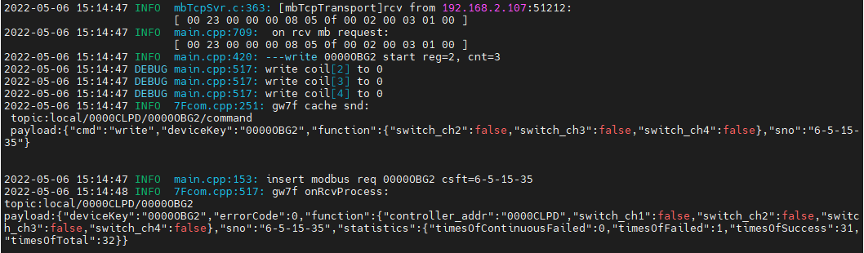

写入2,3,4通道断开。

1. 直读



rcv from 192.168.2.107:51212:

[ 00 24 00 00 00 06 05 01 03 ea 00 03 ]

snd to 192.168.2.107:51212:

[ 00 24 00 00 00 04 05 01 01 00 ]

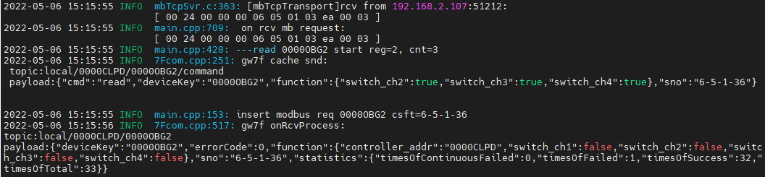

1. 读缓存



rcv from 192.168.2.107:51212:

[ 00 25 00 00 00 06 05 01 00 02 00 03 ]

snd to 192.168.2.107:51212:

[ 00 25 00 00 00 04 05 01 01 00 ]

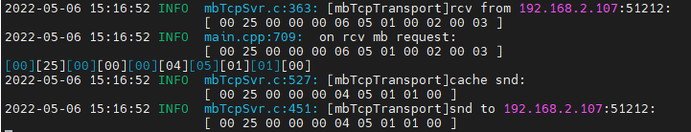

读取与写入一致

#### 通道1+2+3+4读写

##### 写入闭合

1. 写入



rcv from 192.168.2.107:51212:

[ 00 26 00 00 00 08 05 0f 00 01 00 04 01 0f ]

snd to 192.168.2.107:51212:

[ 00 26 00 00 00 06 05 0f 00 01 00 04 ]

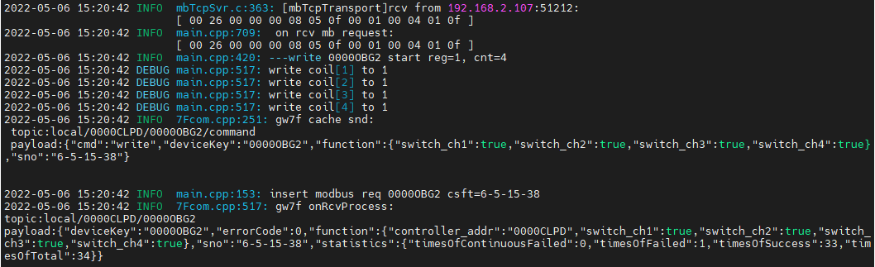1,2,3,4通道闭合

1. 多通道直读



rcv from 192.168.2.107:51212:

[ 00 27 00 00 00 06 05 01 03 e9 00 04 ]

snd to 192.168.2.107:51212:

[ 00 27 00 00 00 04 05 01 01 0f ]

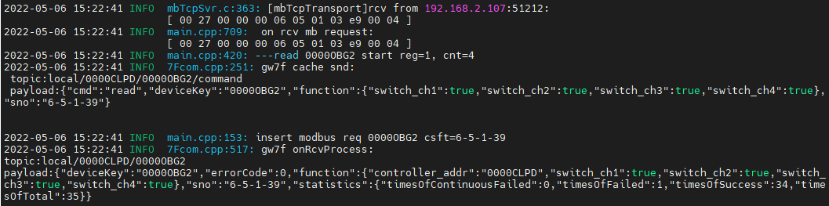

读取1,2,3,4通道闭合，与写入的一致

1. 读取多通道缓存

rcv from 192.168.2.107:51212:

[ 00 28 00 00 00 06 05 01 00 01 00 04 ]

snd to 192.168.2.107:51212:

[ 00 28 00 00 00 04 05 01 01 0f ]

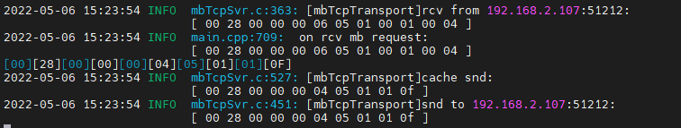

与写入的一致

##### 写入断开

1. 写入

rcv from 192.168.2.107:51212:

[ 00 29 00 00 00 08 05 0f 00 01 00 04 01 00 ]

snd to 192.168.2.107:51212:

[ 00 29 00 00 00 06 05 0f 00 01 00 04 ]

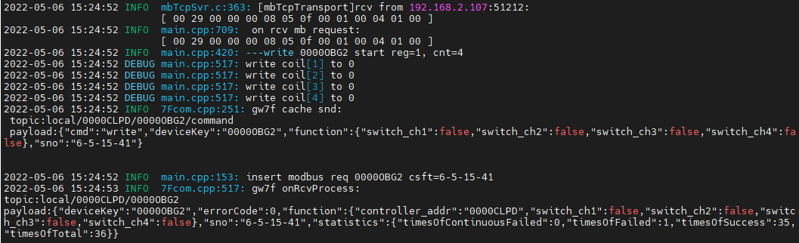

写入1,2,3,4通道断开。

1. 多通道直读

rcv from 192.168.2.107:51212:

[ 00 2a 00 00 00 06 05 01 03 e9 00 04 ]

snd to 192.168.2.107:51212:

[ 00 2a 00 00 00 04 05 01 01 00 ]

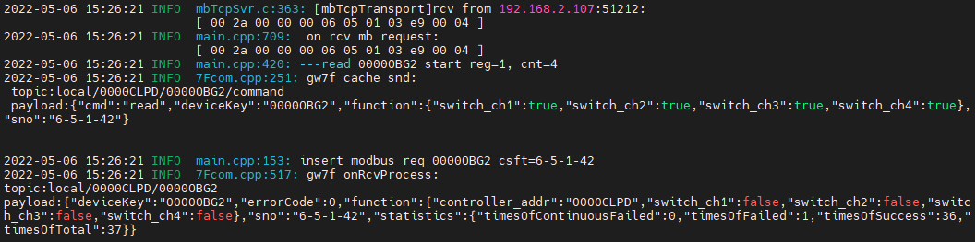

读取与写入一致。

1. 读取多通道缓存



rcv from 192.168.2.107:51212:

[ 00 2b 00 00 00 06 05 01 00 01 00 04 ]

snd to 192.168.2.107:51212:

[ 00 2b 00 00 00 04 05 01 01 00 ]

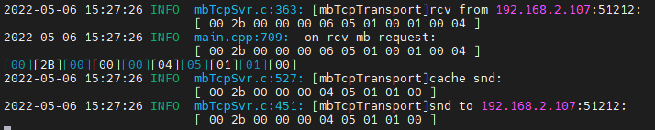

读取与写入一致。

## 不存在的通道

### 通道1,2,3,4,5

1. 写入



rcv from 192.168.2.107:51212:

[ 00 2c 00 00 00 08 05 0f 00 01 00 05 01 1f ]

snd to 192.168.2.107:51212:

[ 00 2c 00 00 00 03 05 8f 02 ]

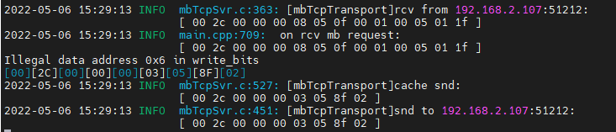

回复数据错误。

1. 读取

读取缓存



rcv from 192.168.2.107:51212:

[ 00 2d 00 00 00 06 05 01 00 01 00 05 ]

snd to 192.168.2.107:51212:

[ 00 2d 00 00 00 03 05 81 02 ]

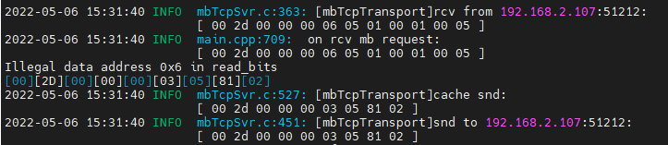

直读



rcv from 192.168.2.107:51212:

[ 00 2e 00 00 00 06 05 01 03 e9 00 05 ]

snd to 192.168.2.107:51212:

[ 00 2e 00 00 00 03 05 81 02 ]

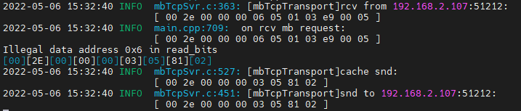

### 通道5

1. 写入

rcv from 192.168.2.107:51212:

[ 00 2f 00 00 00 06 05 05 00 05 ff 00 ]

snd to 192.168.2.107:51212:

[ 00 2f 00 00 00 03 05 85 02 ]

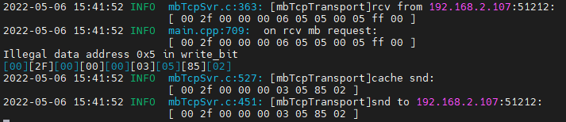

报错，写入不成功。

1. 读取

直读：

rcv from 192.168.2.107:51212:

[ 00 30 00 00 00 06 05 01 03 e9 00 05 ]

snd to 192.168.2.107:51212:

[ 00 30 00 00 00 03 05 81 02 ]

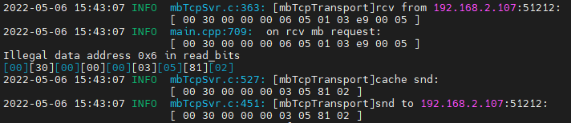

读缓存：

rcv from 192.168.2.107:51212:

[ 00 31 00 00 00 06 05 01 00 01 00 05 ]

snd to 192.168.2.107:51212:

[ 00 31 00 00 00 03 05 81 02 ]

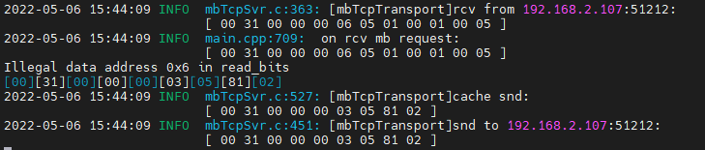

报错，读取不成功。

# 带电流检测的4路开关执行器ok

**说明：**根据转换程序锁支持的设备，典型选取一种测试。

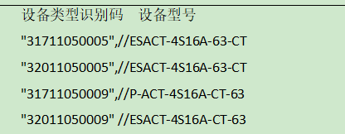

查询设备modbus地址--4，设备类型31711050005

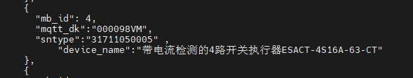

此处使用如上图中的设备做典型验证。

## 通道1

### 闭合

1. 写入

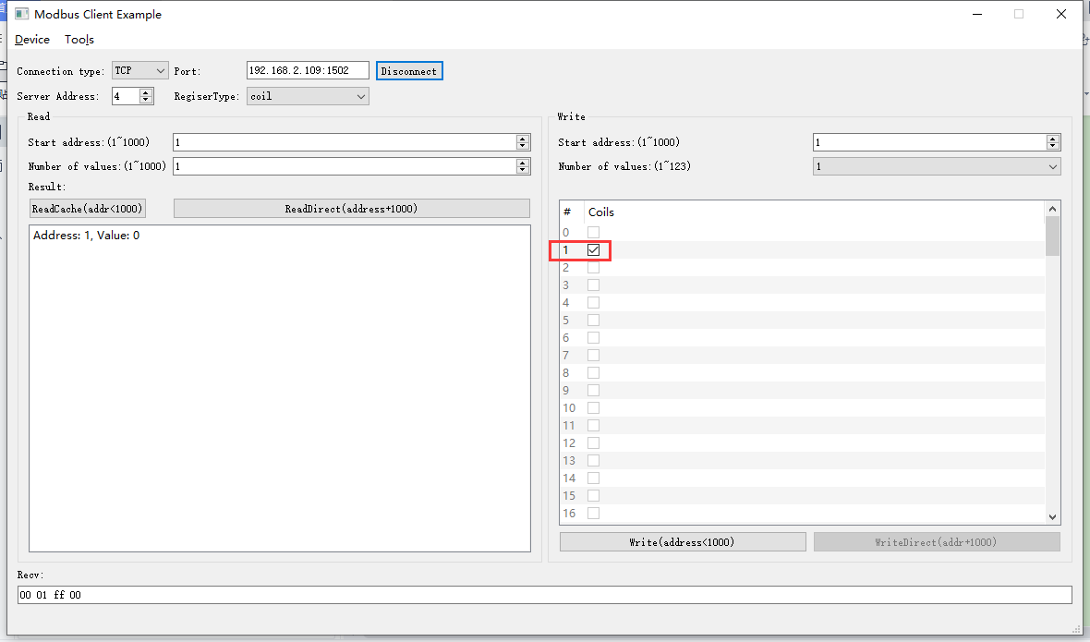

2022-05-05 09:08:24 INFO mbTcpSvr.c:363: [mbTcpTransport]rcv from 192.168.2.104:51841:

[ 00 01 00 00 00 06 04 05 00 01 ff 00 ]

2022-05-05 09:08:24 INFO mbTcpSvr.c:527: [mbTcpTransport]cache snd:

[ 00 01 00 00 00 06 04 05 00 01 ff 00 ]

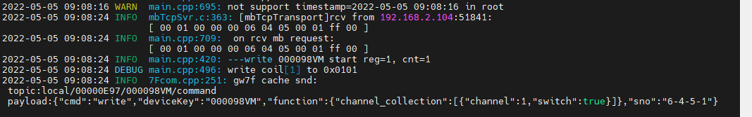

1. 通道1直读

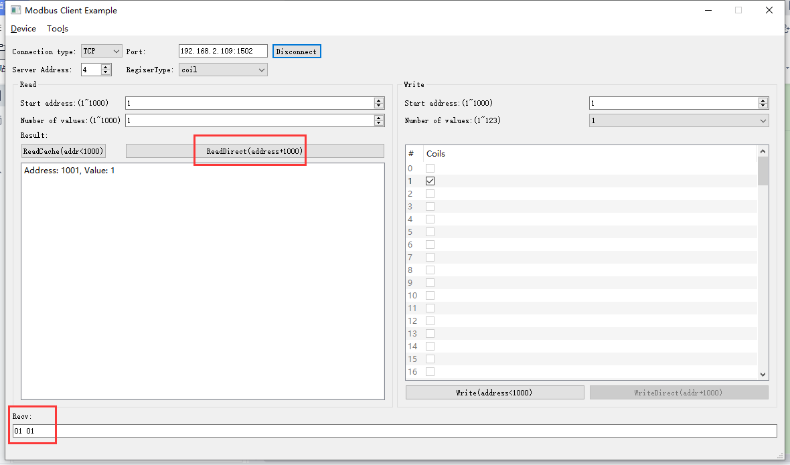

2022-05-05 09:12:16 INFO mbTcpSvr.c:363: [mbTcpTransport]rcv from 192.168.2.104:51841:

[ 00 02 00 00 00 06 04 01 03 e9 00 01 ]

2022-05-05 09:12:16 INFO mbTcpSvr.c:451: [mbTcpTransport]snd to 192.168.2.104:51841:

[ 00 02 00 00 00 04 04 01 01 01 ]

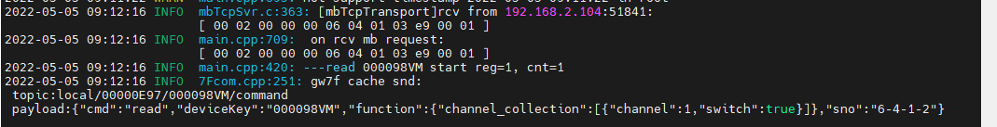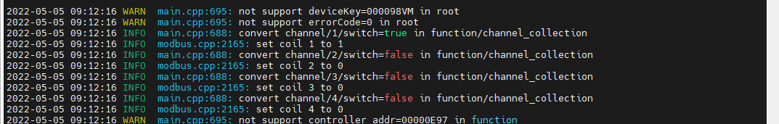

1. 读取1通道缓存

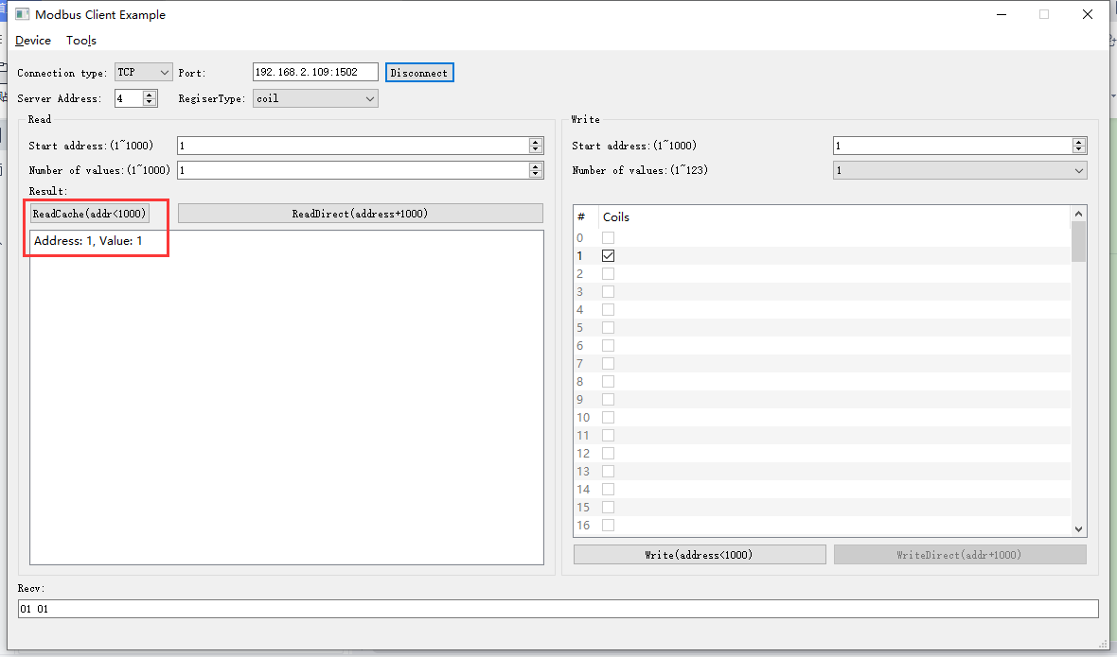

2022-05-05 09:14:33 INFO mbTcpSvr.c:363: [mbTcpTransport]rcv from 192.168.2.104:51841:

[ 00 03 00 00 00 06 04 01 00 01 00 01 ]

2022-05-05 09:14:33 INFO mbTcpSvr.c:451: [mbTcpTransport]snd to 192.168.2.104:51841:

[ 00 03 00 00 00 04 04 01 01 01 ]



### 断开

1. 写入

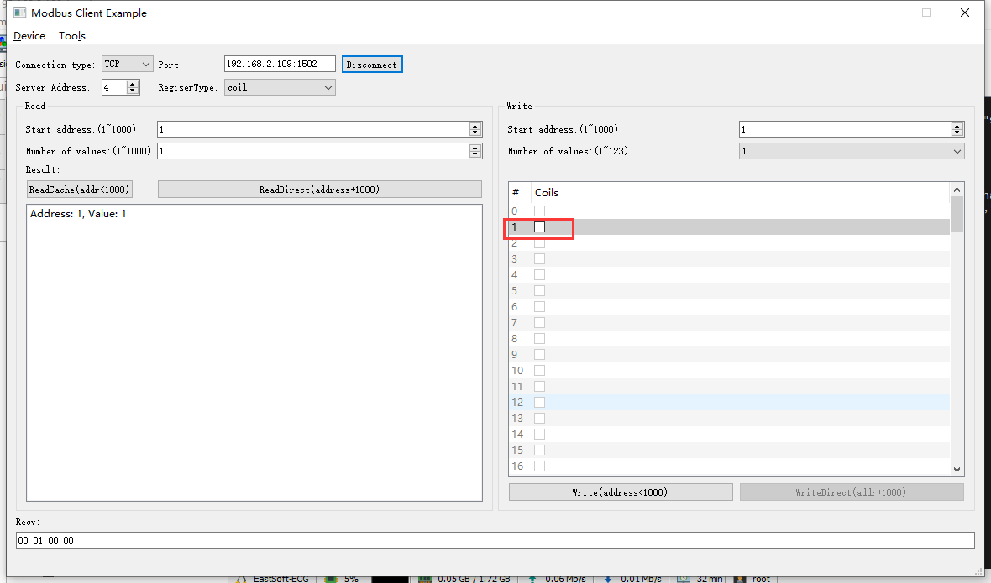

2022-05-05 09:28:51 INFO mbTcpSvr.c:363: [mbTcpTransport]rcv from 192.168.2.104:51841:

[ 00 06 00 00 00 06 04 05 00 01 00 00 ]

2022-05-05 09:28:51 INFO main.cpp:709: on rcv mb request:

[ 00 06 00 00 00 06 04 05 00 01 00 00 ]

2022-05-05 09:28:51 INFO main.cpp:420: ---write 000098VM start reg=1, cnt=1

2022-05-05 09:28:52 INFO mbTcpSvr.c:451: [mbTcpTransport]snd to 192.168.2.104:51841:

[ 00 06 00 00 00 06 04 05 00 01 00 00 ]

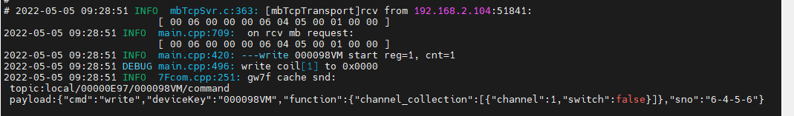

1. 通道1直读

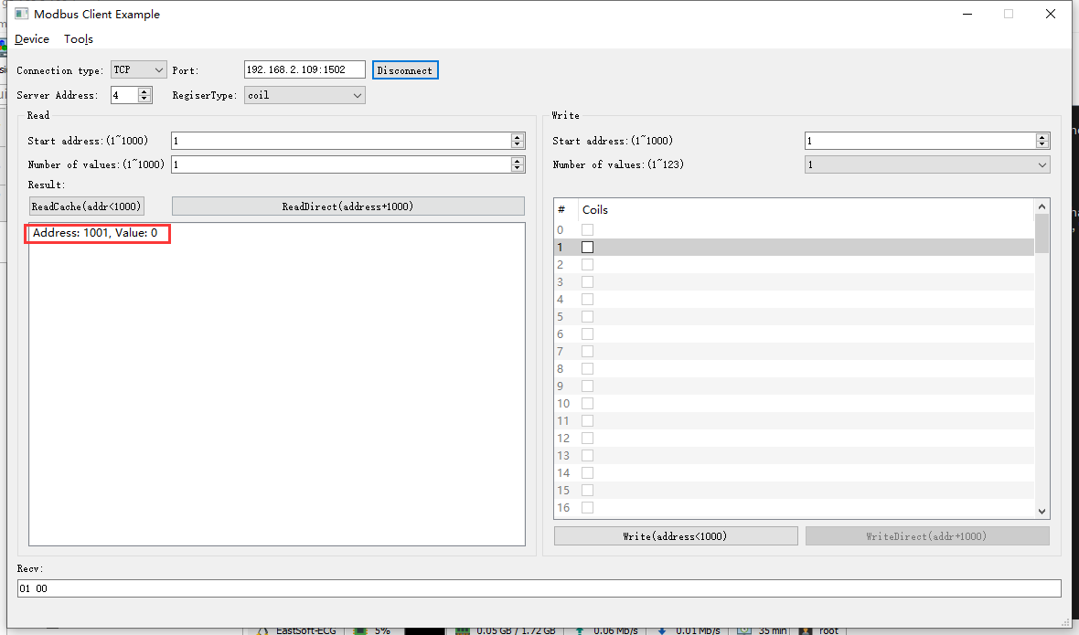

2022-05-05 09:31:41 INFO mbTcpSvr.c:363: [mbTcpTransport]rcv from 192.168.2.104:51841:

[ 00 07 00 00 00 06 04 01 03 e9 00 01 ]

2022-05-05 09:31:41 INFO main.cpp:709: on rcv mb request:

[ 00 07 00 00 00 06 04 01 03 e9 00 01 ]

2022-05-05 09:31:41 INFO main.cpp:420: ---read 000098VM start reg=1, cnt=1

2022-05-05 09:31:41 INFO mbTcpSvr.c:451: [mbTcpTransport]snd to 192.168.2.104:51841:

[ 00 07 00 00 00 04 04 01 01 00 ]

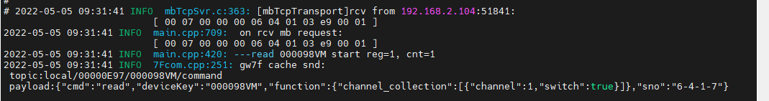

1. 读取1通道缓存

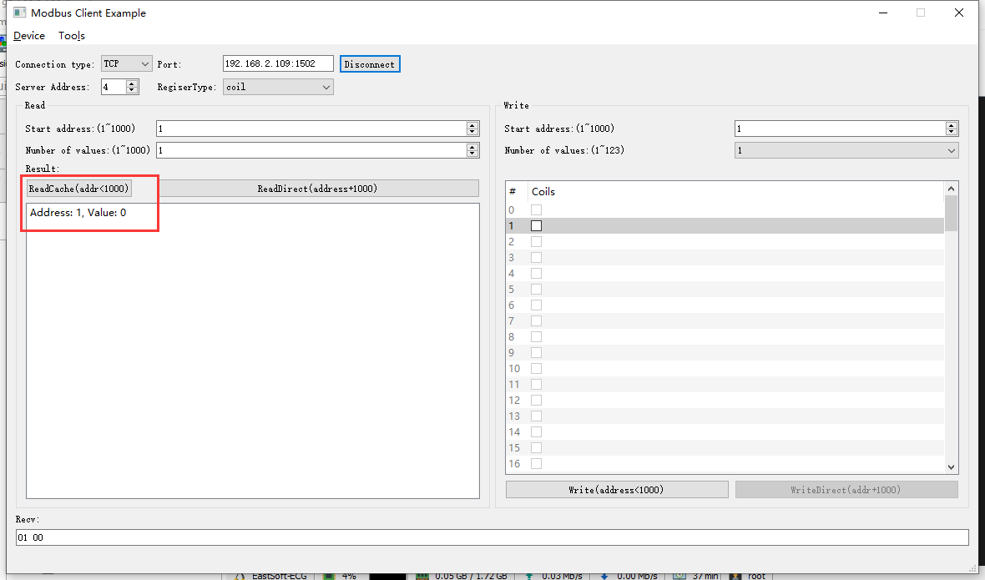

2022-05-05 09:33:11 INFO mbTcpSvr.c:363: [mbTcpTransport]rcv from 192.168.2.104:51841:

[ 00 08 00 00 00 06 04 01 00 01 00 01 ]

2022-05-05 09:33:11 INFO mbTcpSvr.c:451: [mbTcpTransport]snd to 192.168.2.104:51841:

[ 00 08 00 00 00 04 04 01 01 00 ]

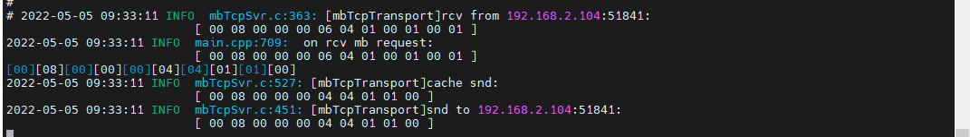

**说明：**读取缓存状态是通用功能，故每种设备只验证一次。

## 通道2

### 闭合

1. 写入

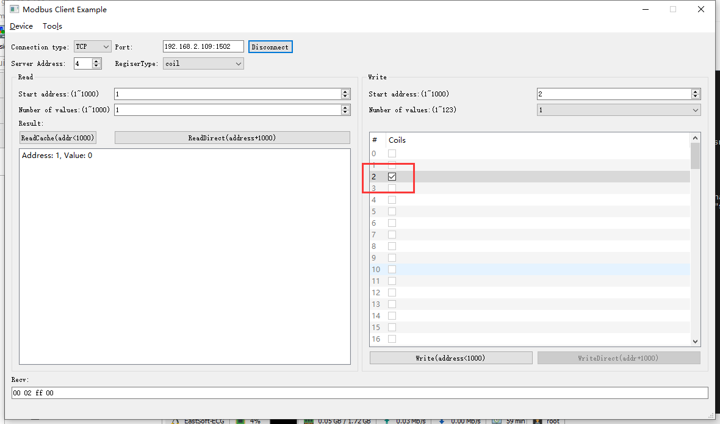

2022-05-05 09:55:01 INFO mbTcpSvr.c:363: [mbTcpTransport]rcv from 192.168.2.104:51841:

[ 00 09 00 00 00 06 04 05 00 02 ff 00 ]

2022-05-05 09:55:01 INFO main.cpp:709: on rcv mb request:

[ 00 09 00 00 00 06 04 05 00 02 ff 00 ]

2022-05-05 09:55:01 INFO main.cpp:420: ---write 000098VM start reg=2, cnt=1

2022-05-05 09:55:01 DEBUG main.cpp:496: write coil[2] to 0x0101

2022-05-05 09:55:01 INFO mbTcpSvr.c:451: [mbTcpTransport]snd to 192.168.2.104:51841:

[ 00 09 00 00 00 06 04 05 00 02 ff 00 ]

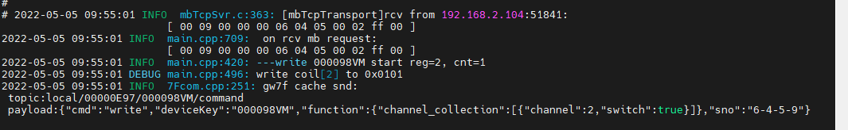

1. 通道2直读

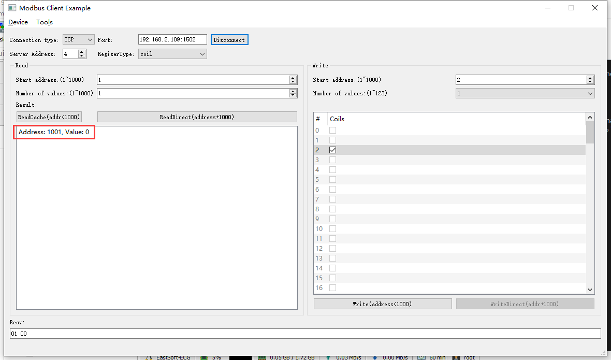

2022-05-05 09:56:23 INFO mbTcpSvr.c:363: [mbTcpTransport]rcv from 192.168.2.104:51841:

[ 00 0a 00 00 00 06 04 01 03 e9 00 01 ]

2022-05-05 09:56:23 INFO main.cpp:709: on rcv mb request:

[ 00 0a 00 00 00 06 04 01 03 e9 00 01 ]

2022-05-05 09:56:23 INFO main.cpp:420: ---read 000098VM start reg=1, cnt=1

2022-05-05 09:56:23 INFO mbTcpSvr.c:451: [mbTcpTransport]snd to 192.168.2.104:51841:

[ 00 0a 00 00 00 04 04 01 01 00 ]

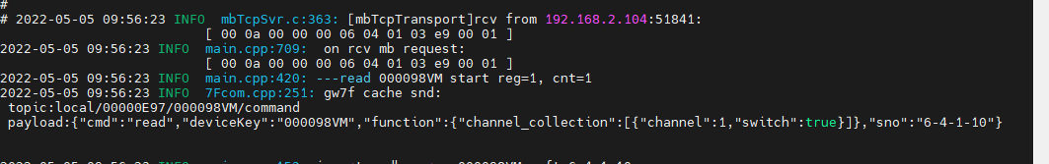

### 断开

1. 写入

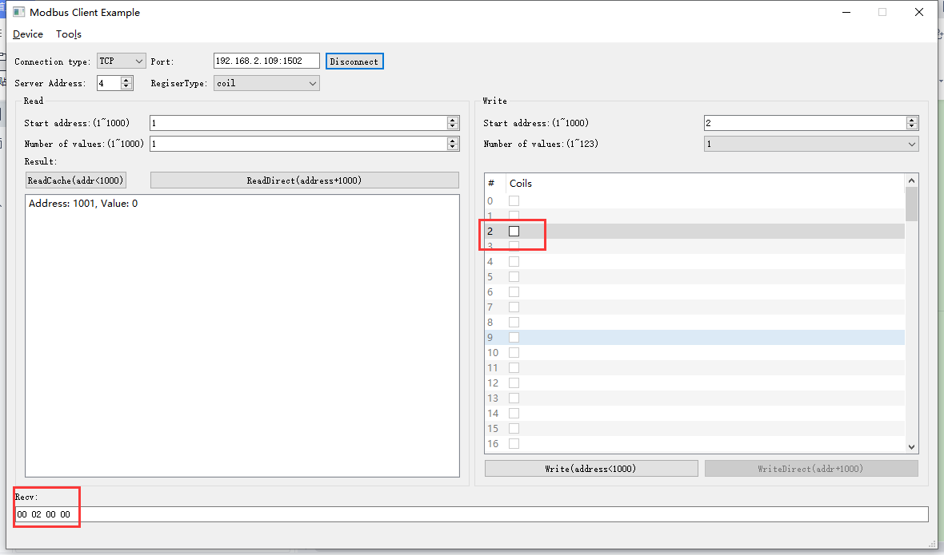

2022-05-05 09:56:23 INFO mbTcpSvr.c:527: [mbTcpTransport]cache snd:

[ 00 0a 00 00 00 04 04 01 01 00 ]

2022-05-05 09:56:23 INFO mbTcpSvr.c:451: [mbTcpTransport]snd to 192.168.2.104:51841:

[ 00 0a 00 00 00 04 04 01 01 00 ]

2022-05-05 09:57:59 INFO mbTcpSvr.c:363: [mbTcpTransport]rcv from 192.168.2.104:51841:

[ 00 0b 00 00 00 06 04 05 00 02 00 00 ]

2022-05-05 09:57:59 INFO main.cpp:709: on rcv mb request:

[ 00 0b 00 00 00 06 04 05 00 02 00 00 ]

2022-05-05 09:57:59 INFO main.cpp:420: ---write 000098VM start reg=2, cnt=1

2022-05-05 09:57:59 INFO mbTcpSvr.c:451: [mbTcpTransport]snd to 192.168.2.104:51841:

[ 00 0b 00 00 00 06 04 05 00 02 00 00 ]



1. 通道2直读

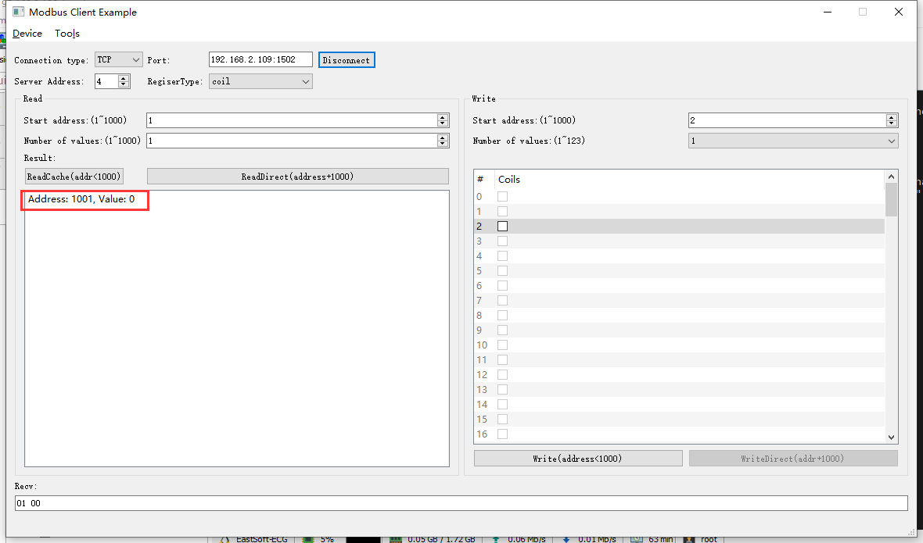

2022-05-05 09:59:25 INFO mbTcpSvr.c:363: [mbTcpTransport]rcv from 192.168.2.104:51841:

[ 00 0c 00 00 00 06 04 01 03 e9 00 01 ]

2022-05-05 09:59:25 INFO main.cpp:709: on rcv mb request:

[ 00 0c 00 00 00 06 04 01 03 e9 00 01 ]

2022-05-05 09:59:25 INFO main.cpp:420: ---read 000098VM start reg=1, cnt=1

2022-05-05 09:59:25 INFO mbTcpSvr.c:451: [mbTcpTransport]snd to 192.168.2.104:51841:

[ 00 0c 00 00 00 04 04 01 01 00 ]

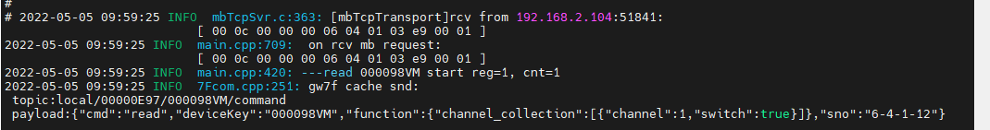

## 通道3

### 闭合

1. 写入

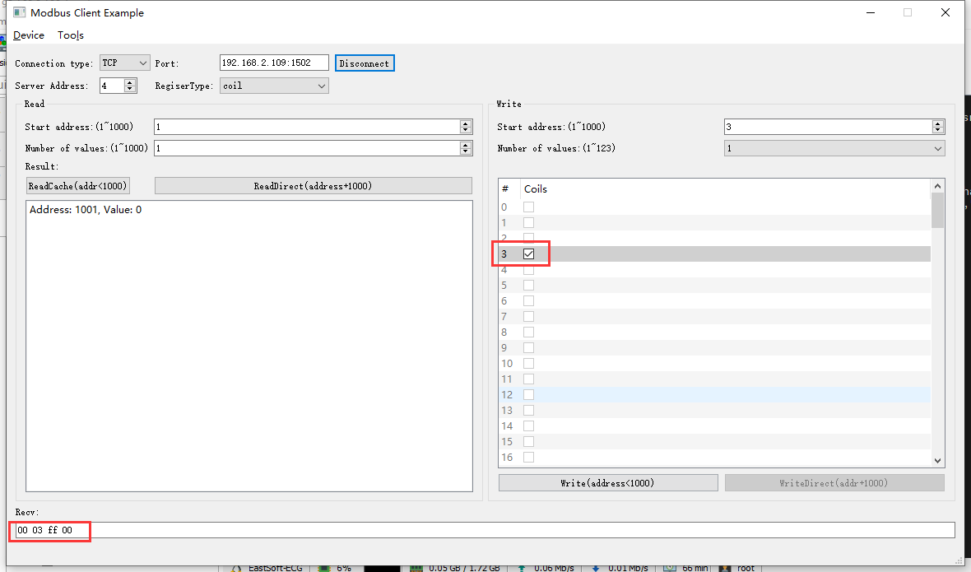

2022-05-05 10:01:56 INFO mbTcpSvr.c:363: [mbTcpTransport]rcv from 192.168.2.104:51841:

[ 00 0d 00 00 00 06 04 05 00 03 ff 00 ]

2022-05-05 10:01:56 INFO main.cpp:709: on rcv mb request:

[ 00 0d 00 00 00 06 04 05 00 03 ff 00 ]

2022-05-05 10:01:56 INFO main.cpp:420: ---write 000098VM start reg=3, cnt=1

2022-05-05 10:01:56 DEBUG main.cpp:496: write coil[3] to 0x0101

2022-05-05 10:01:56 INFO mbTcpSvr.c:451: [mbTcpTransport]snd to 192.168.2.104:51841:

[ 00 0d 00 00 00 06 04 05 00 03 ff 00 ]

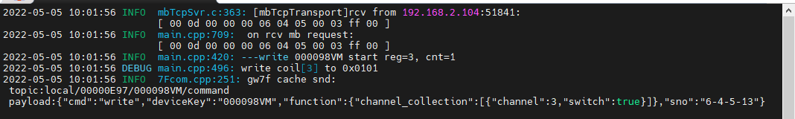

1. 通道3直读

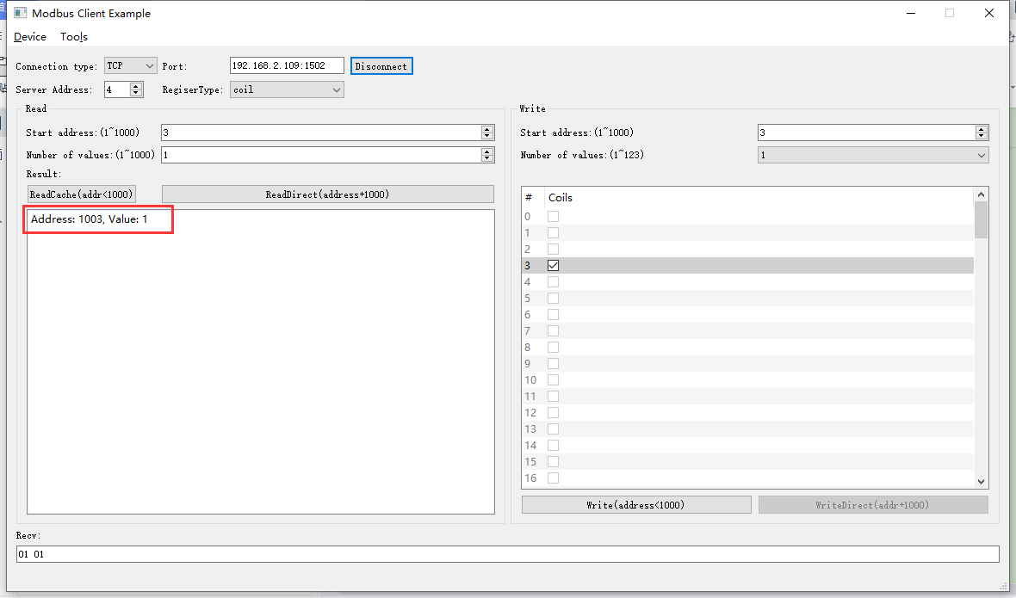

### 断开

1. 写入

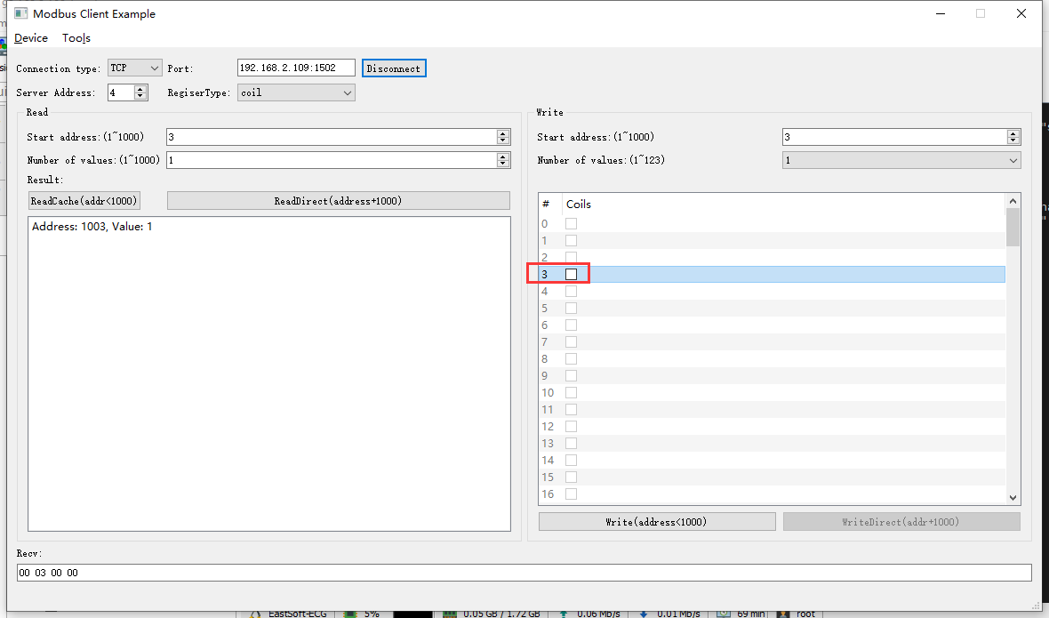

2022-05-05 10:05:03 INFO mbTcpSvr.c:363: [mbTcpTransport]rcv from 192.168.2.104:51841:

[ 00 0f 00 00 00 06 04 05 00 03 00 00 ]

2022-05-05 10:05:03 INFO main.cpp:709: on rcv mb request:

[ 00 0f 00 00 00 06 04 05 00 03 00 00 ]

2022-05-05 10:05:03 INFO main.cpp:420: ---write 000098VM start reg=3, cnt=1

2022-05-05 10:05:03 DEBUG main.cpp:496: write coil[3] to 0x0000

2022-05-05 10:05:04 INFO mbTcpSvr.c:451: [mbTcpTransport]snd to 192.168.2.104:51841:

[ 00 0f 00 00 00 06 04 05 00 03 00 00 ]

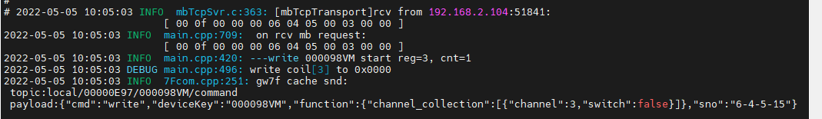

1. 通道3直读

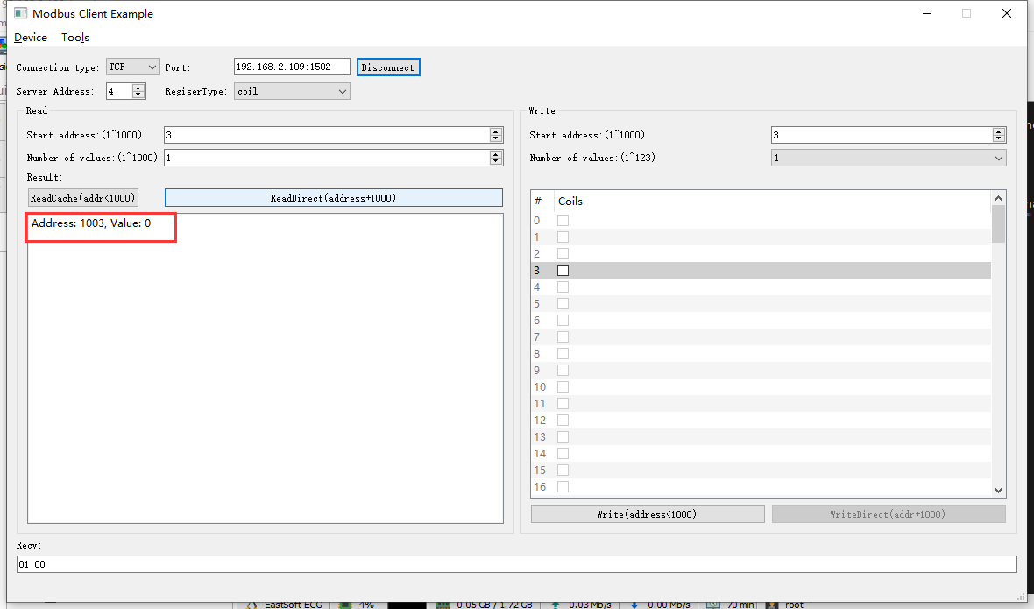

2022-05-05 10:06:04 INFO mbTcpSvr.c:363: [mbTcpTransport]rcv from 192.168.2.104:51841:

[ 00 10 00 00 00 06 04 01 03 eb 00 01 ]

2022-05-05 10:06:04 INFO main.cpp:709: on rcv mb request:

[ 00 10 00 00 00 06 04 01 03 eb 00 01 ]

2022-05-05 10:06:04 INFO main.cpp:420: ---read 000098VM start reg=3, cnt=1

2022-05-05 10:06:04 INFO mbTcpSvr.c:451: [mbTcpTransport]snd to 192.168.2.104:51841:

[ 00 10 00 00 00 04 04 01 01 00 ]

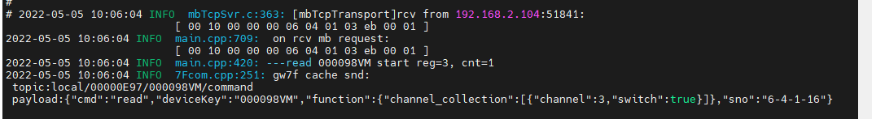

## 通道4

### 闭合

1. 写入

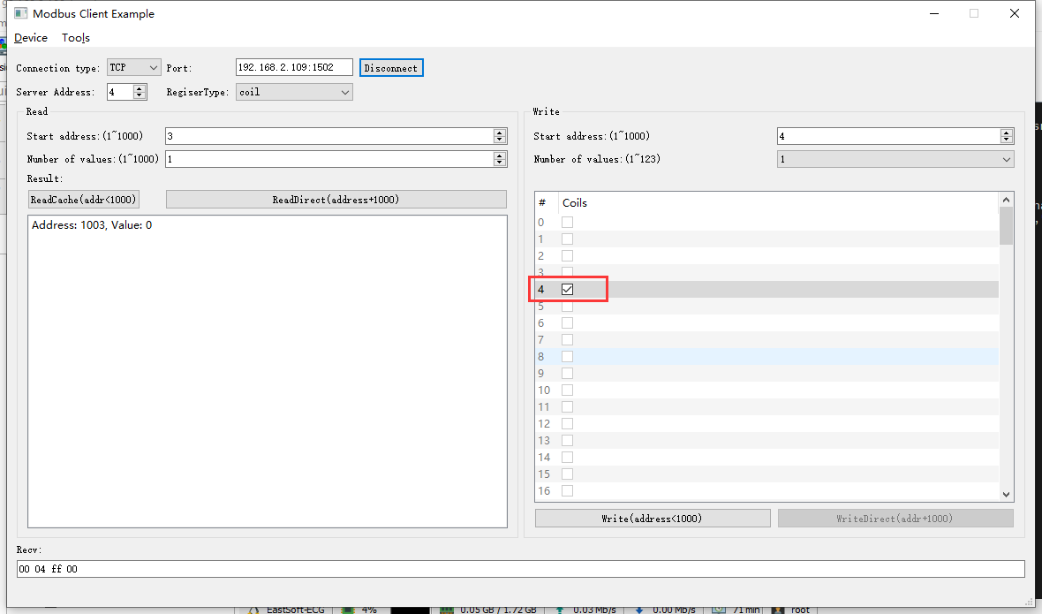

2022-05-05 10:07:41 INFO mbTcpSvr.c:363: [mbTcpTransport]rcv from 192.168.2.104:51841:

[ 00 11 00 00 00 06 04 05 00 04 ff 00 ]

2022-05-05 10:07:41 INFO main.cpp:709: on rcv mb request:

[ 00 11 00 00 00 06 04 05 00 04 ff 00 ]

2022-05-05 10:07:41 INFO main.cpp:420: ---write 000098VM start reg=4, cnt=1

2022-05-05 10:07:41 DEBUG main.cpp:496: write coil[4] to 0x0101

2022-05-05 10:07:41 INFO mbTcpSvr.c:451: [mbTcpTransport]snd to 192.168.2.104:51841:

[ 00 11 00 00 00 06 04 05 00 04 ff 00 ]

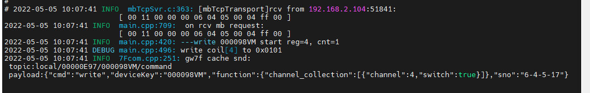

1. 通道4直读

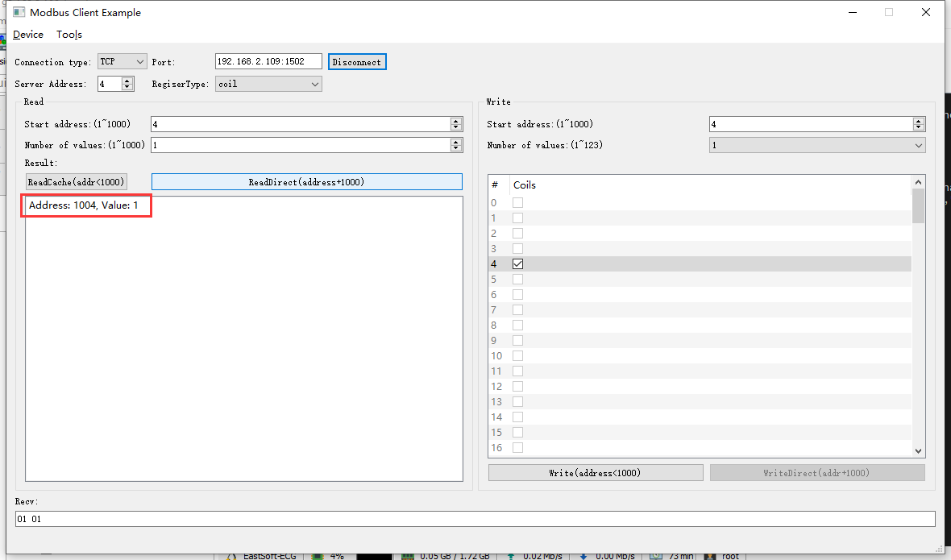

2022-05-05 10:09:08 INFO mbTcpSvr.c:363: [mbTcpTransport]rcv from 192.168.2.104:51841:

[ 00 12 00 00 00 06 04 01 03 ec 00 01 ]

2022-05-05 10:09:08 INFO main.cpp:709: on rcv mb request:

[ 00 12 00 00 00 06 04 01 03 ec 00 01 ]

2022-05-05 10:09:08 INFO main.cpp:420: ---read 000098VM start reg=4, cnt=1

2022-05-05 10:09:08 INFO mbTcpSvr.c:451: [mbTcpTransport]snd to 192.168.2.104:51841:

[ 00 12 00 00 00 04 04 01 01 01 ]

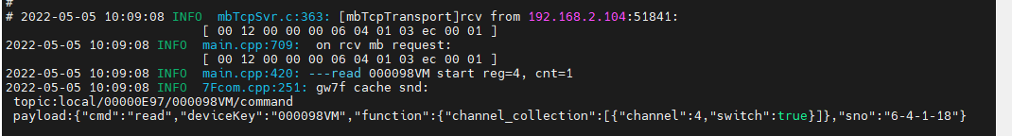

### 断开

1. 写入

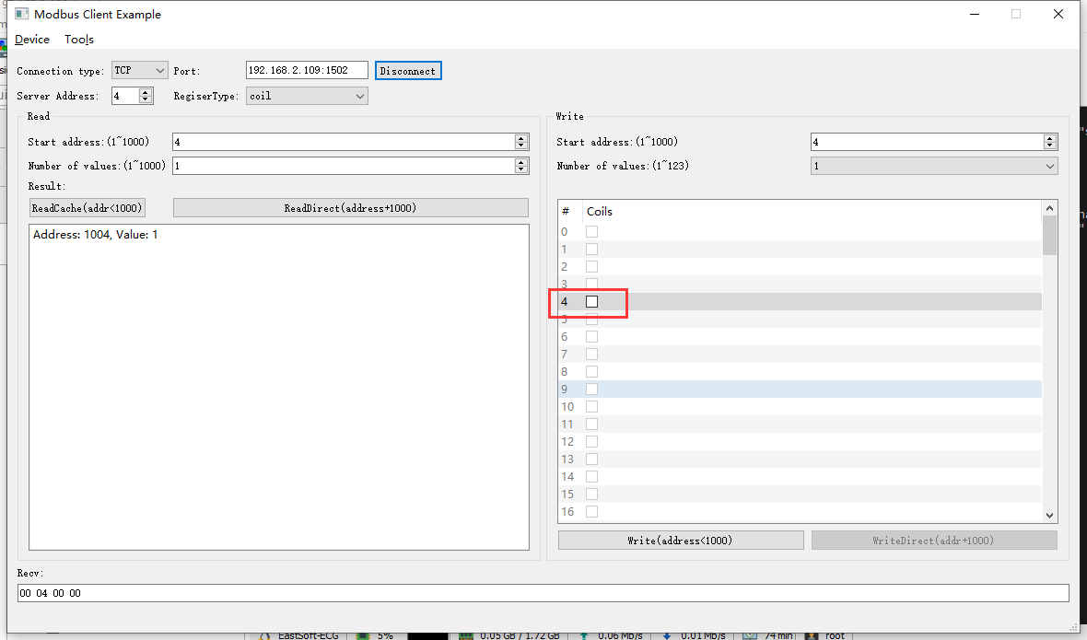

2022-05-05 10:10:49 INFO mbTcpSvr.c:363: [mbTcpTransport]rcv from 192.168.2.104:51841:

[ 00 13 00 00 00 06 04 05 00 04 00 00 ]

2022-05-05 10:10:49 INFO main.cpp:709: on rcv mb request:

[ 00 13 00 00 00 06 04 05 00 04 00 00 ]

2022-05-05 10:10:49 INFO main.cpp:420: ---write 000098VM start reg=4, cnt=1

2022-05-05 10:10:49 DEBUG main.cpp:496: write coil[4] to 0x0000

2022-05-05 10:10:49 INFO mbTcpSvr.c:451: [mbTcpTransport]snd to 192.168.2.104:51841:

[ 00 13 00 00 00 06 04 05 00 04 00 00 ]

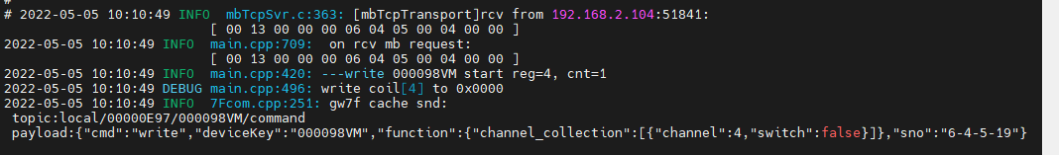

1. 通道4直读

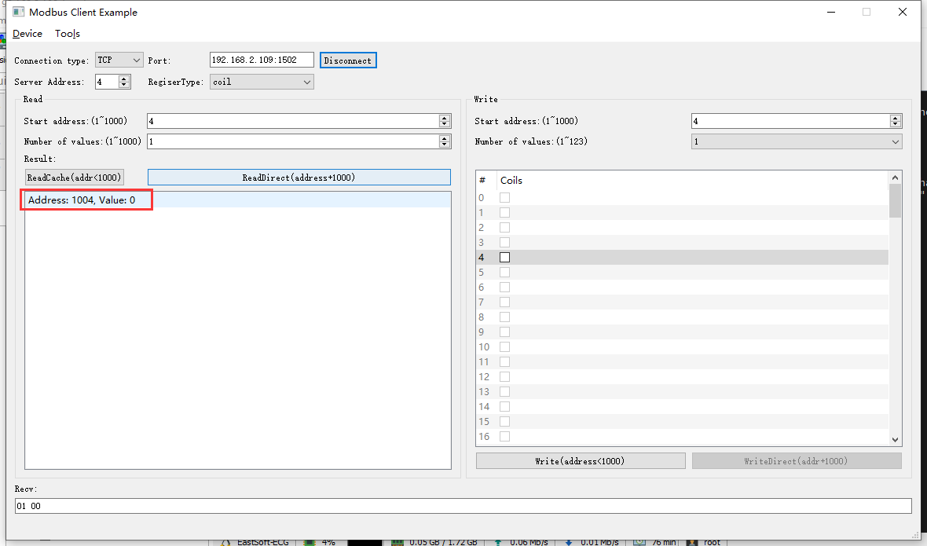

2022-05-05 10:11:58 INFO mbTcpSvr.c:363: [mbTcpTransport]rcv from 192.168.2.104:51841:

[ 00 14 00 00 00 06 04 01 03 ec 00 01 ]

2022-05-05 10:11:58 INFO mbTcpSvr.c:451: [mbTcpTransport]snd to 192.168.2.104:51841:

[ 00 14 00 00 00 04 04 01 01 00 ]

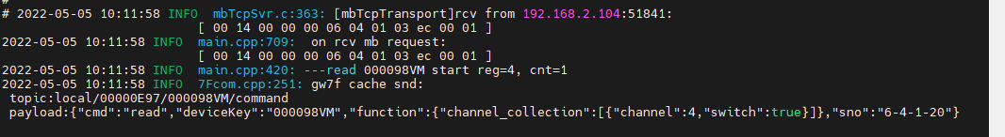

## 多通道读写

### 通道1+2

#### 写入闭合

1. 写

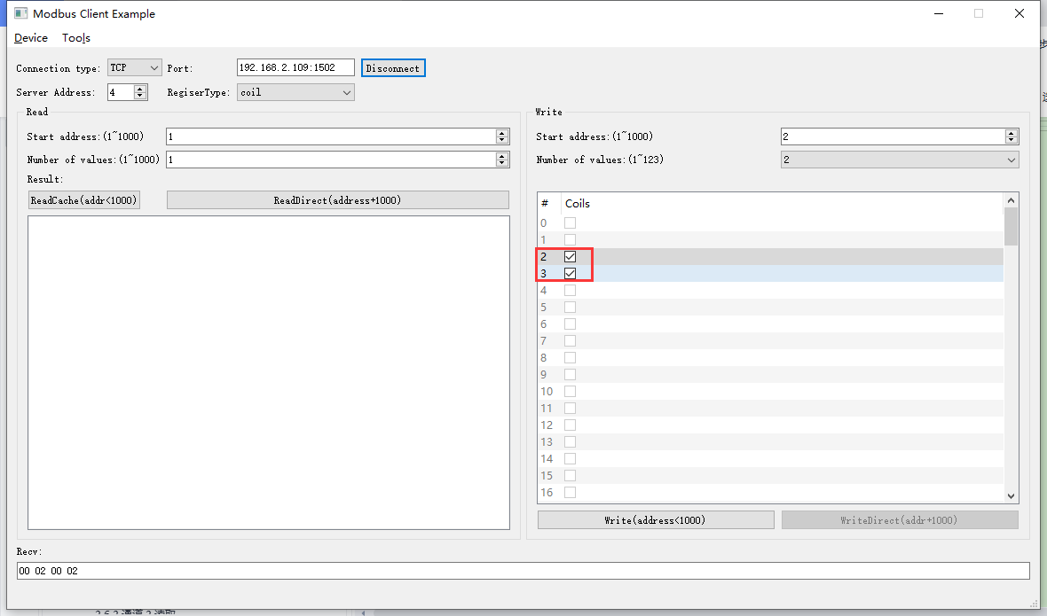

2022-05-05 10:19:05 INFO mbTcpSvr.c:363: [mbTcpTransport]rcv from 192.168.2.104:53482:

[ 00 00 00 00 00 08 04 0f 00 02 00 02 01 03 ]

2022-05-05 10:19:05 INFO main.cpp:709: on rcv mb request:

[ 00 00 00 00 00 08 04 0f 00 02 00 02 01 03 ]

2022-05-05 10:19:05 INFO main.cpp:420: ---write 000098VM start reg=2, cnt=2

2022-05-05 10:19:05 DEBUG main.cpp:517: write coil[2] to 1

2022-05-05 10:19:05 DEBUG main.cpp:517: write coil[3] to 1

2022-05-05 10:19:05 INFO mbTcpSvr.c:451: [mbTcpTransport]snd to 192.168.2.104:53482:

[ 00 00 00 00 00 06 04 0f 00 02 00 02 ]

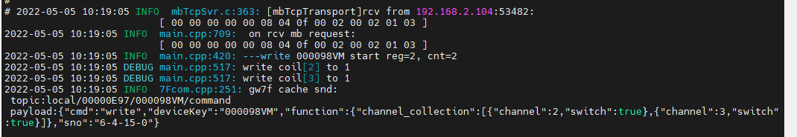

1. 直读

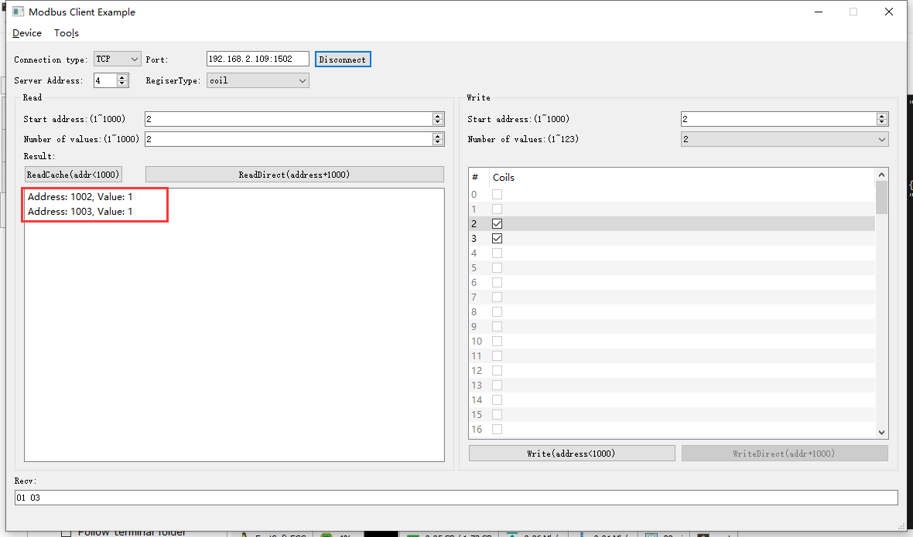

2022-05-05 10:24:38 INFO mbTcpSvr.c:363: [mbTcpTransport]rcv from 192.168.2.104:53482:

[ 00 01 00 00 00 06 04 01 03 ea 00 02 ]

2022-05-05 10:24:38 INFO main.cpp:709: on rcv mb request:

[ 00 01 00 00 00 06 04 01 03 ea 00 02 ]

2022-05-05 10:24:38 INFO main.cpp:420: ---read 000098VM start reg=2, cnt=2

2022-05-05 10:24:39 INFO mbTcpSvr.c:451: [mbTcpTransport]snd to 192.168.2.104:53482:

[ 00 01 00 00 00 04 04 01 01 03 ]



1. 读取缓存

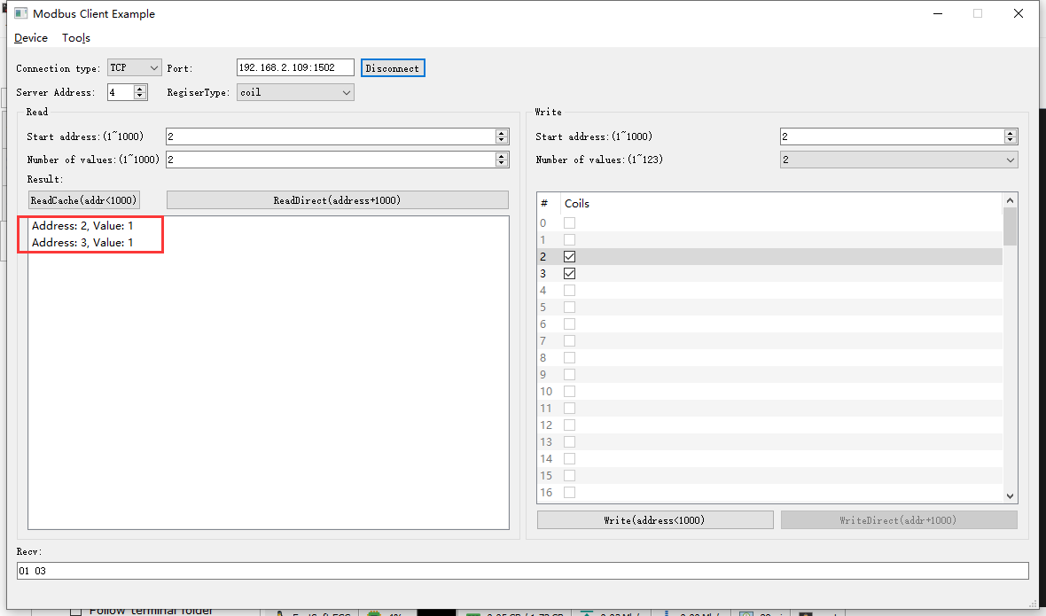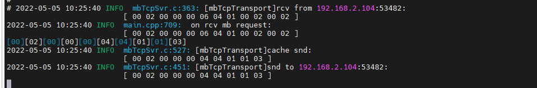

#### 写入断开

1. 写

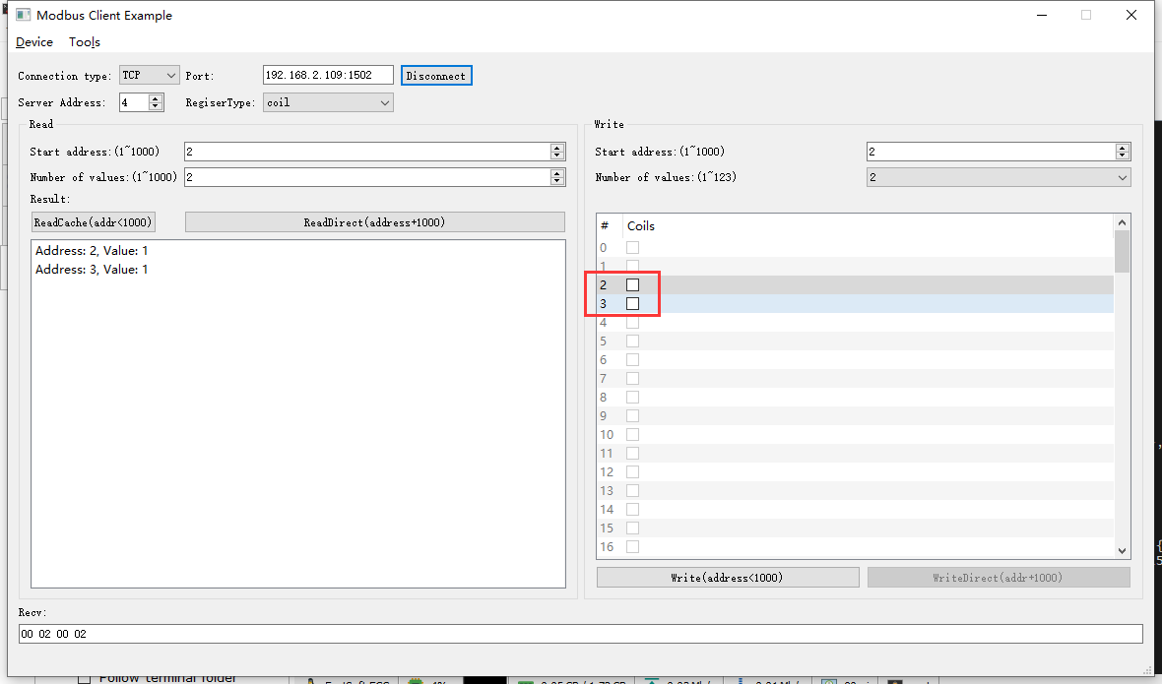

2022-05-05 10:26:17 INFO mbTcpSvr.c:363: [mbTcpTransport]rcv from 192.168.2.104:53482:

[ 00 03 00 00 00 08 04 0f 00 02 00 02 01 00 ]

2022-05-05 10:26:17 INFO main.cpp:709: on rcv mb request:

[ 00 03 00 00 00 08 04 0f 00 02 00 02 01 00 ]

2022-05-05 10:26:17 INFO main.cpp:420: ---write 000098VM start reg=2, cnt=2

2022-05-05 10:26:17 DEBUG main.cpp:517: write coil[2] to 0

2022-05-05 10:26:17 DEBUG main.cpp:517: write coil[3] to 0

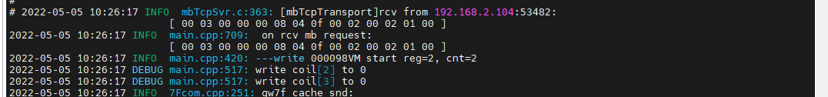2022-05-05 10:26:17 INFO mbTcpSvr.c:451: [mbTcpTransport]snd to 192.168.2.104:53482:

[ 00 03 00 00 00 06 04 0f 00 02 00 02 ]



1. 直读

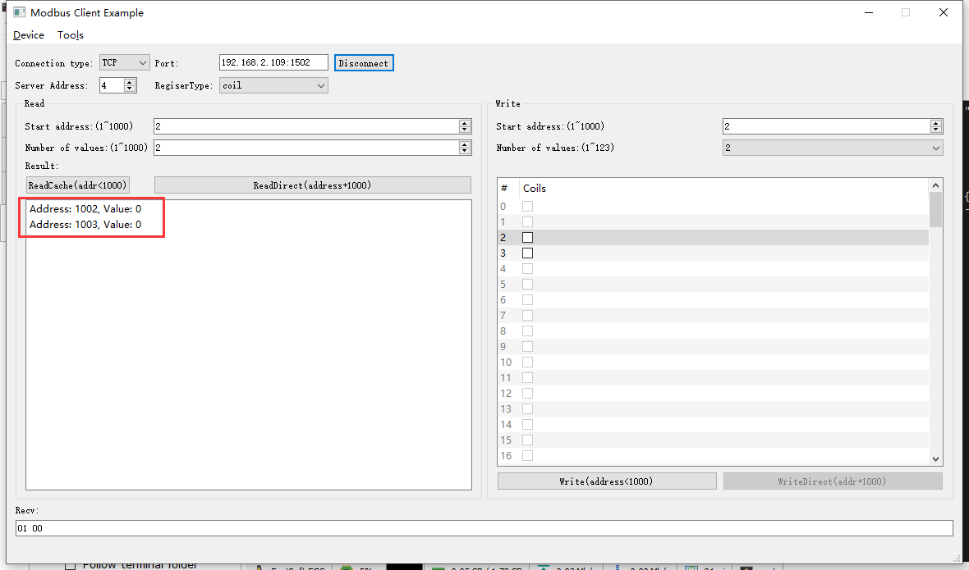 2022-05-05 10:27:50 INFO mbTcpSvr.c:363: [mbTcpTransport]rcv from 192.168.2.104:53482:

[ 00 04 00 00 00 06 04 01 03 ea 00 02 ]

2022-05-05 10:27:50 INFO main.cpp:709: on rcv mb request:

[ 00 04 00 00 00 06 04 01 03 ea 00 02 ]

2022-05-05 10:27:50 INFO main.cpp:420: ---read 000098VM start reg=2, cnt=2

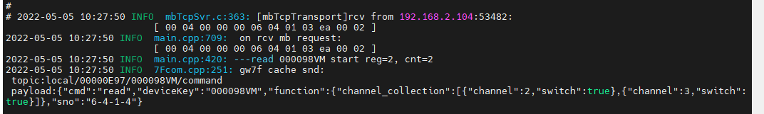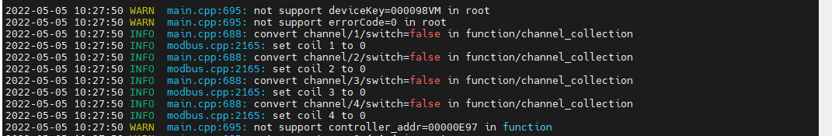2022-05-05 10:27:50 INFO mbTcpSvr.c:451: [mbTcpTransport]snd to 192.168.2.104:53482:

[ 00 04 00 00 00 04 04 01 01 00 ]



1. 读取缓存

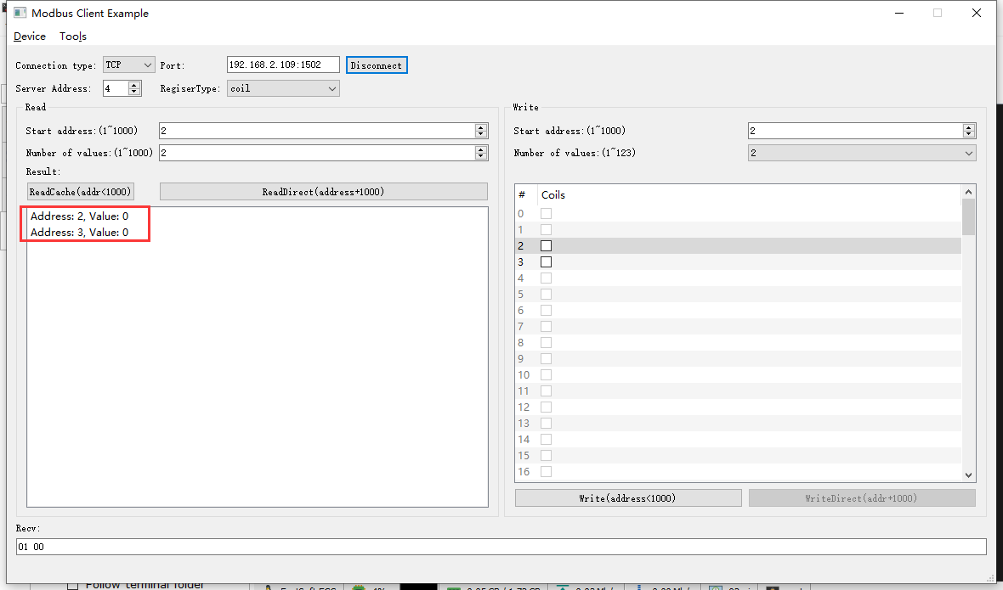2022-05-05 10:28:41 INFO mbTcpSvr.c:363: [mbTcpTransport]rcv from 192.168.2.104:53482:

[ 00 05 00 00 00 06 04 01 00 02 00 02 ]

2022-05-05 10:28:41 INFO mbTcpSvr.c:451: [mbTcpTransport]snd to 192.168.2.104:53482:

[ 00 05 00 00 00 04 04 01 01 00 ]

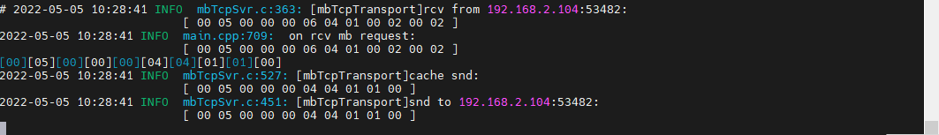

### 通道1+3

#### 写入闭合

1. 写

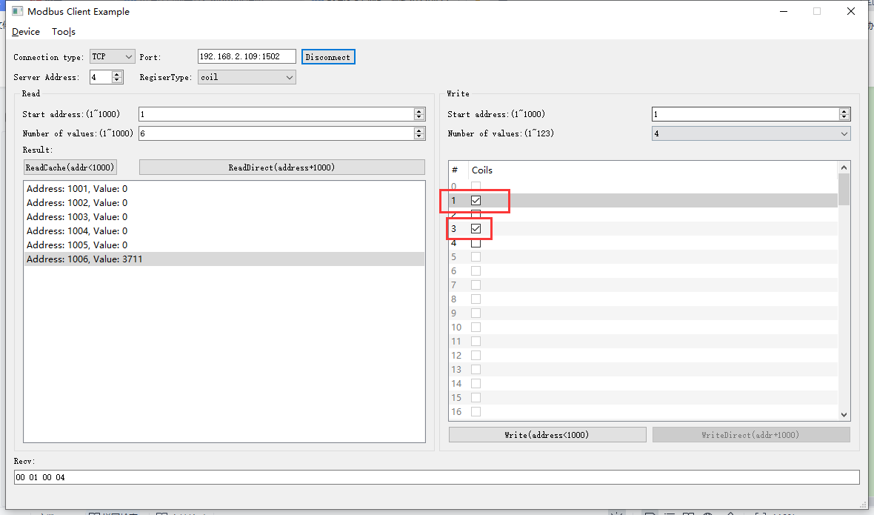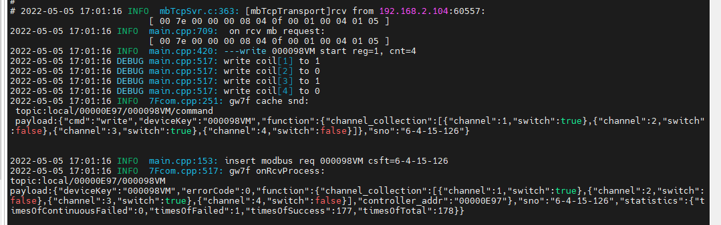2022-05-05 17:01:16 INFO mbTcpSvr.c:363: [mbTcpTransport]rcv from 192.168.2.104:60557:

[ 00 7e 00 00 00 08 04 0f 00 01 00 04 01 05 ]

2022-05-05 17:01:16 INFO main.cpp:709: on rcv mb request:

[ 00 7e 00 00 00 08 04 0f 00 01 00 04 01 05 ]

2022-05-05 17:01:16 INFO main.cpp:420: ---write 000098VM start reg=1, cnt=4

2022-05-05 17:01:16 DEBUG main.cpp:517: write coil[1] to 1

2022-05-05 17:01:16 DEBUG main.cpp:517: write coil[2] to 0

2022-05-05 17:01:16 DEBUG main.cpp:517: write coil[3] to 1

2022-05-05 17:01:16 DEBUG main.cpp:517: write coil[4] to 0

2022-05-05 17:01:16 INFO 7Fcom.cpp:251: gw7f cache snd:

topic:local/00000E97/000098VM/command

payload:{"cmd":"write","deviceKey":"000098VM","function":{"channel_collection":[{"channel":1,"switch":true},{"channel":2,"switch":false},{"channel":3,"switch":true},{"channel":4,"switch":false}]},"sno":"6-4-15-126"}

2022-05-05 17:01:16 INFO mbTcpSvr.c:451: [mbTcpTransport]snd to 192.168.2.104:60557:

[ 00 7e 00 00 00 06 04 0f 00 01 00 04 ]

1. 直读

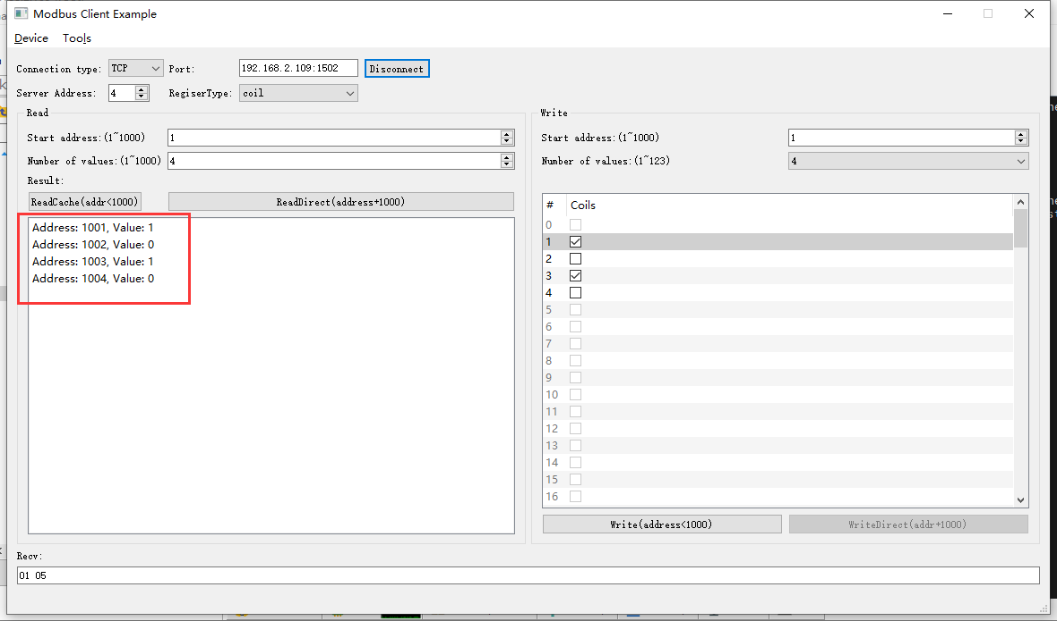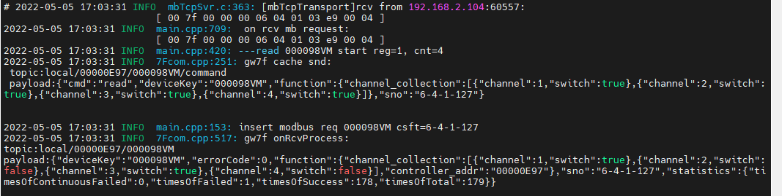2022-05-05 17:03:31 INFO mbTcpSvr.c:363: [mbTcpTransport]rcv from 192.168.2.104:60557:

[ 00 7f 00 00 00 06 04 01 03 e9 00 04 ]

2022-05-05 17:03:31 INFO main.cpp:709: on rcv mb request:

[ 00 7f 00 00 00 06 04 01 03 e9 00 04 ]

2022-05-05 17:03:31 INFO main.cpp:420: ---read 000098VM start reg=1, cnt=4

2022-05-05 17:03:31 INFO 7Fcom.cpp:251: gw7f cache snd:

topic:local/00000E97/000098VM/command

payload:{"cmd":"read","deviceKey":"000098VM","function":{"channel_collection":[{"channel":1,"switch":true},{"channel":2,"switch":true},{"channel":3,"switch":true},{"channel":4,"switch":true}]},"sno":"6-4-1-127"}

2022-05-05 17:03:31 INFO mbTcpSvr.c:451: [mbTcpTransport]snd to 192.168.2.104:60557:

[ 00 7f 00 00 00 04 04 01 01 05 ]

#### 写入断开

1. 写入

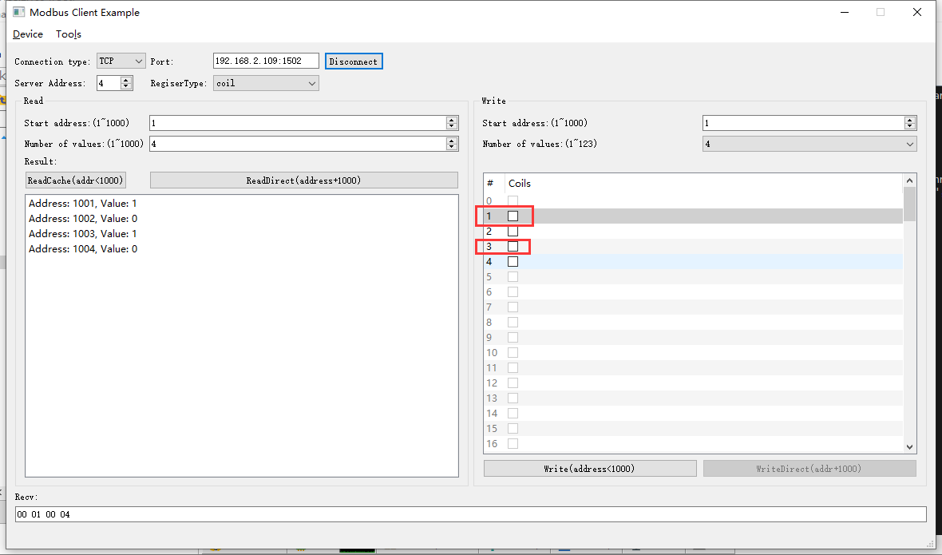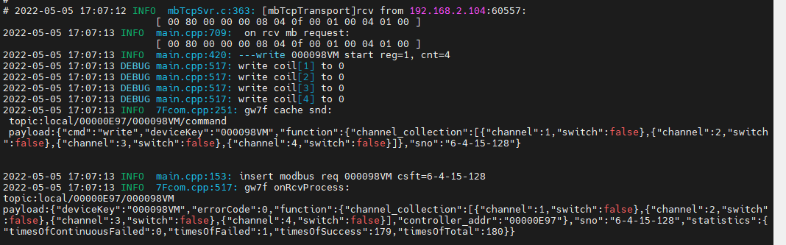2022-05-05 17:07:12 INFO mbTcpSvr.c:363: [mbTcpTransport]rcv from 192.168.2.104:60557:

[ 00 80 00 00 00 08 04 0f 00 01 00 04 01 00 ]

2022-05-05 17:07:13 INFO main.cpp:709: on rcv mb request:

[ 00 80 00 00 00 08 04 0f 00 01 00 04 01 00 ]

2022-05-05 17:07:13 INFO main.cpp:420: ---write 000098VM start reg=1, cnt=4

2022-05-05 17:07:13 DEBUG main.cpp:517: write coil[1] to 0

2022-05-05 17:07:13 DEBUG main.cpp:517: write coil[2] to 0

2022-05-05 17:07:13 DEBUG main.cpp:517: write coil[3] to 0

2022-05-05 17:07:13 DEBUG main.cpp:517: write coil[4] to 0

2022-05-05 17:07:13 INFO mbTcpSvr.c:451: [mbTcpTransport]snd to 192.168.2.104:60557:

[ 00 80 00 00 00 06 04 0f 00 01 00 04 ]

1. 直读

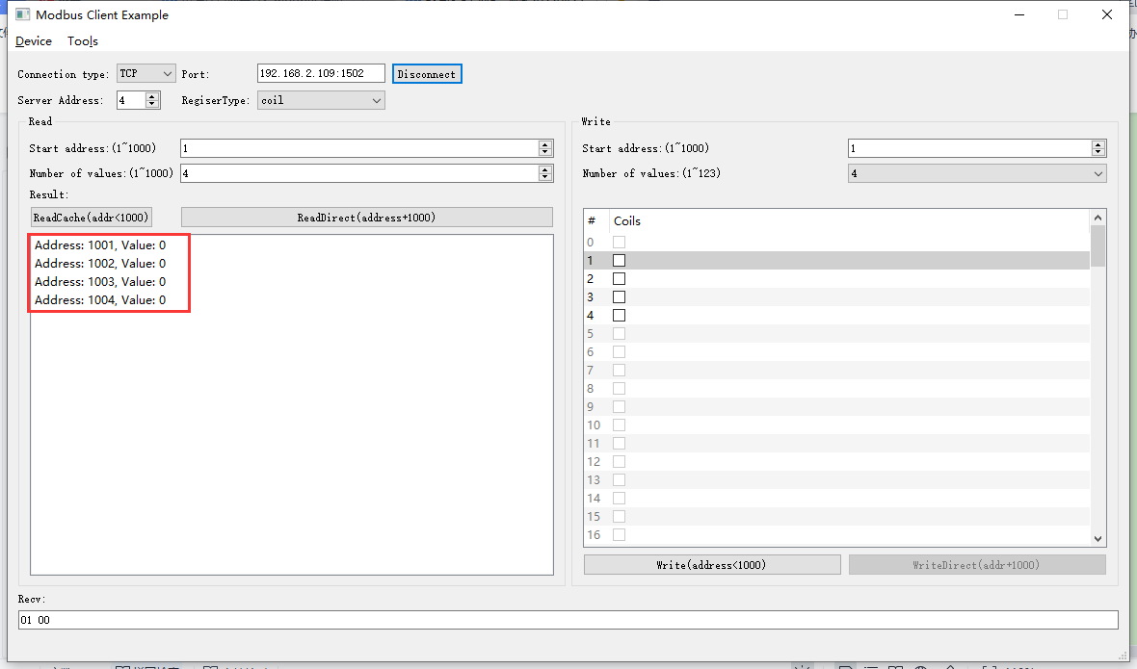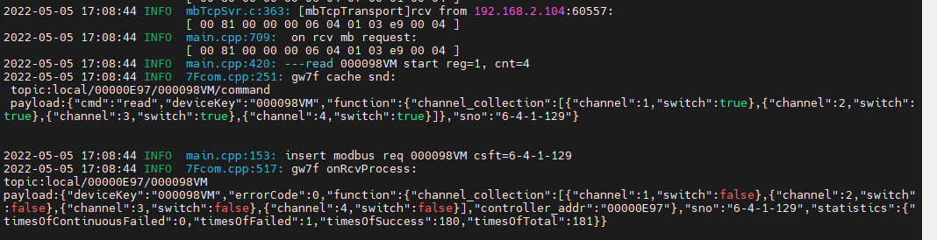 

与写入状态一致。

### 通道1+2+4

#### 写入闭合

1. 写

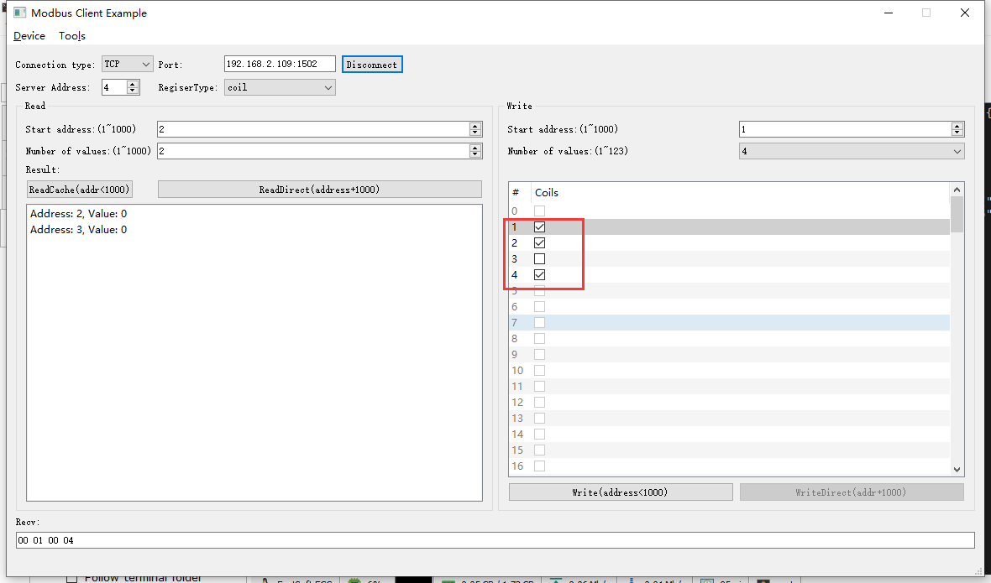 2022-05-05 10:30:54 INFO mbTcpSvr.c:363: [mbTcpTransport]rcv from 192.168.2.104:53482:

[ 00 06 00 00 00 08 04 0f 00 01 00 04 01 0b ]

2022-05-05 10:30:54 INFO main.cpp:709: on rcv mb request:

[ 00 06 00 00 00 08 04 0f 00 01 00 04 01 0b ]

2022-05-05 10:30:54 INFO main.cpp:420: ---write 000098VM start reg=1, cnt=4

2022-05-05 10:30:54 DEBUG main.cpp:517: write coil[1] to 1

2022-05-05 10:30:54 DEBUG main.cpp:517: write coil[2] to 1

2022-05-05 10:30:54 DEBUG main.cpp:517: write coil[3] to 0

2022-05-05 10:30:54 DEBUG main.cpp:517: write coil[4] to 1

2022-05-05 10:30:55 INFO mbTcpSvr.c:451: [mbTcpTransport]snd to 192.168.2.104:53482:

[ 00 06 00 00 00 06 04 0f 00 01 00 04 ]



1. 直读

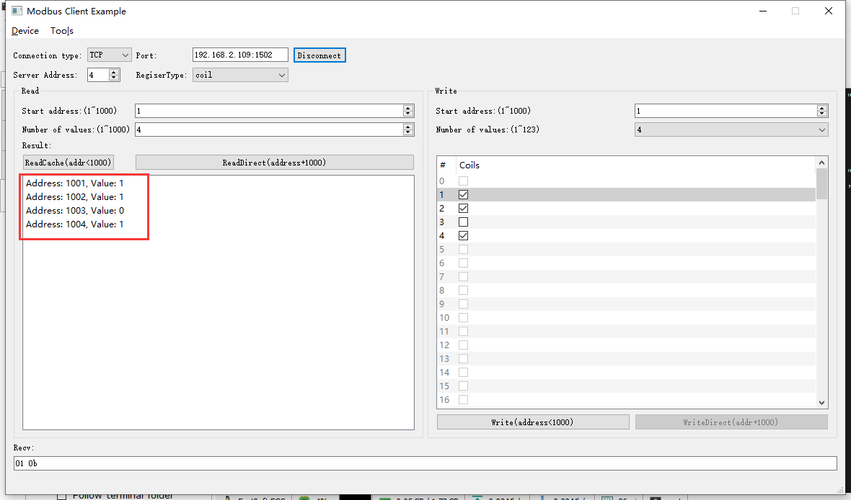 2022-05-05 10:32:28 INFO mbTcpSvr.c:363: [mbTcpTransport]rcv from 192.168.2.104:53482:

[ 00 07 00 00 00 06 04 01 03 e9 00 04 ]

2022-05-05 10:32:28 INFO main.cpp:709: on rcv mb request:

[ 00 07 00 00 00 06 04 01 03 e9 00 04 ]

2022-05-05 10:32:28 INFO main.cpp:420: ---read 000098VM start reg=1, cnt=4

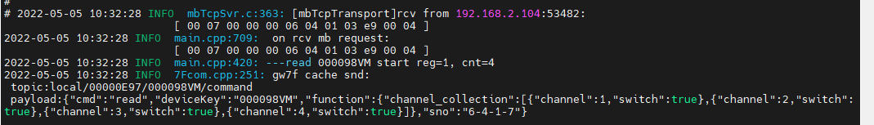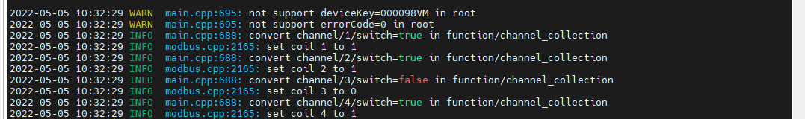2022-05-05 10:32:29 INFO mbTcpSvr.c:451: [mbTcpTransport]snd to 192.168.2.104:53482:

[ 00 07 00 00 00 04 04 01 01 0b ]



#### 写入断开

1. 写

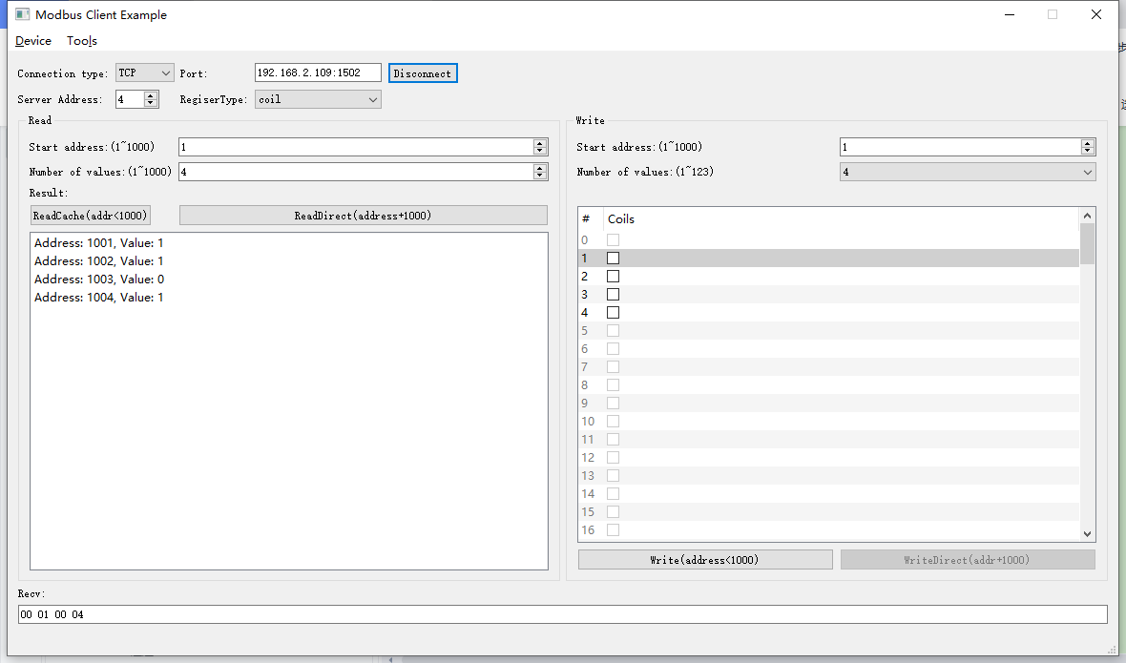2022-05-05 13:48:28 INFO mbTcpSvr.c:363: [mbTcpTransport]rcv from 192.168.2.104:57062:

[ 00 08 00 00 00 08 04 0f 00 01 00 04 01 0b ]

2022-05-05 13:48:28 INFO main.cpp:709: on rcv mb request:

[ 00 08 00 00 00 08 04 0f 00 01 00 04 01 0b ]

2022-05-05 13:48:28 INFO main.cpp:420: ---write 000098VM start reg=1, cnt=4

2022-05-05 13:48:28 DEBUG main.cpp:517: write coil[1] to 1

2022-05-05 13:48:28 DEBUG main.cpp:517: write coil[2] to 1

2022-05-05 13:48:28 DEBUG main.cpp:517: write coil[3] to 0

2022-05-05 13:48:28 DEBUG main.cpp:517: write coil[4] to 1

2022-05-05 13:48:28 INFO mbTcpSvr.c:451: [mbTcpTransport]snd to 192.168.2.104:57062:

[ 00 08 00 00 00 06 04 0f 00 01 00 04 ]

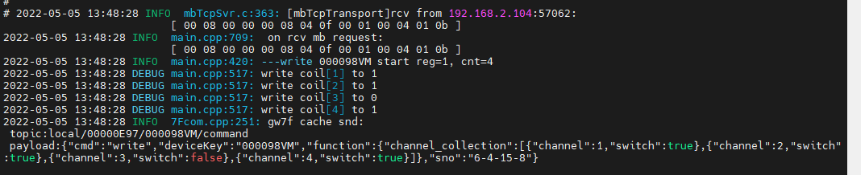

1. 直读

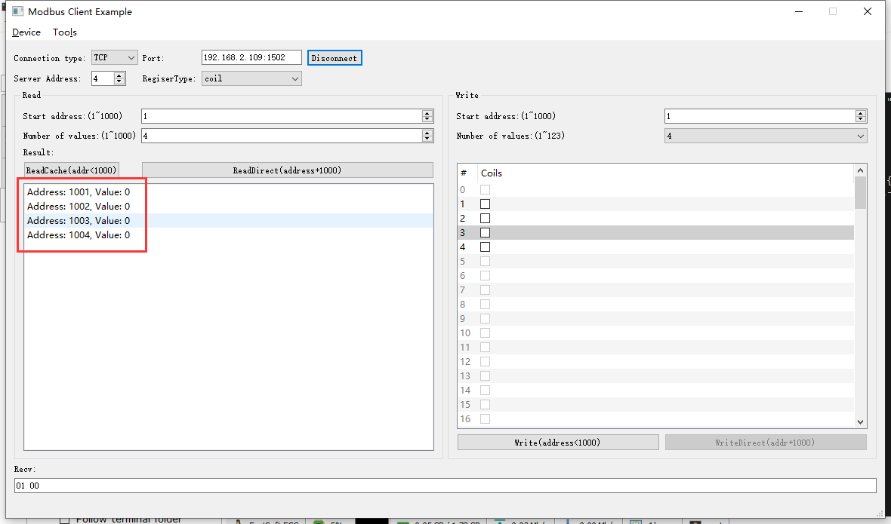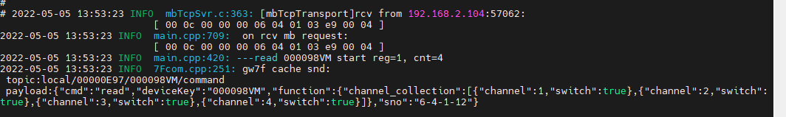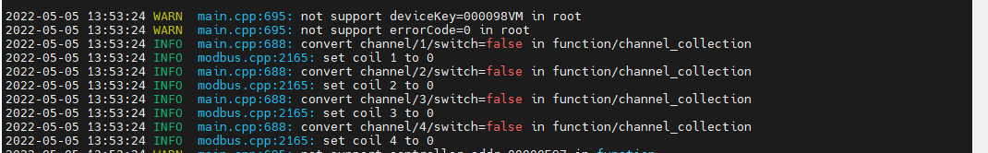

### 通道1+2+3+4

#### 写入闭合

1. 写

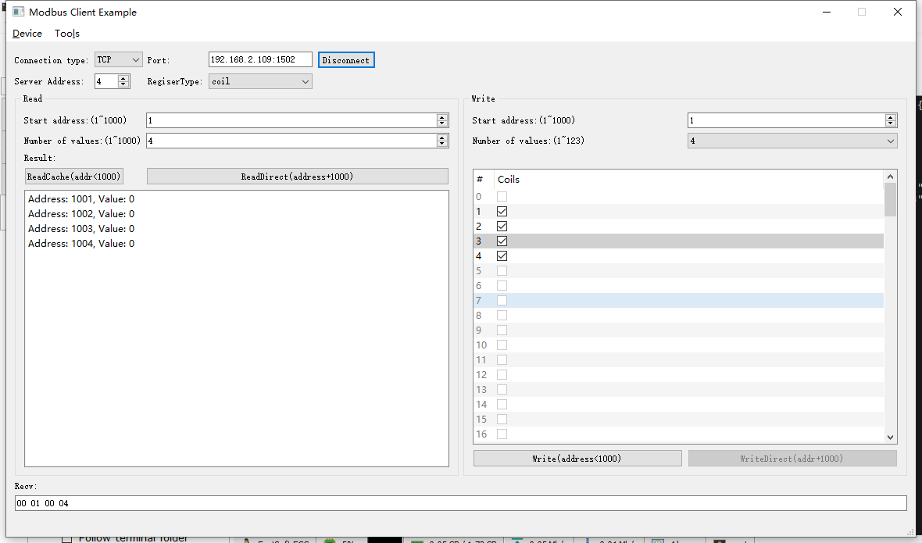2022-05-05 13:54:35 INFO mbTcpSvr.c:363: [mbTcpTransport]rcv from 192.168.2.104:57062:

[ 00 0d 00 00 00 08 04 0f 00 01 00 04 01 0f ]

2022-05-05 13:54:35 INFO main.cpp:709: on rcv mb request:

[ 00 0d 00 00 00 08 04 0f 00 01 00 04 01 0f ]

2022-05-05 13:54:35 INFO main.cpp:420: ---write 000098VM start reg=1, cnt=4

2022-05-05 13:54:35 DEBUG main.cpp:517: write coil[1] to 1

2022-05-05 13:54:35 DEBUG main.cpp:517: write coil[2] to 1

2022-05-05 13:54:35 DEBUG main.cpp:517: write coil[3] to 1

2022-05-05 13:54:35 DEBUG main.cpp:517: write coil[4] to 1

2022-05-05 13:54:35 INFO mbTcpSvr.c:451: [mbTcpTransport]snd to 192.168.2.104:57062:

[ 00 0d 00 00 00 06 04 0f 00 01 00 04 ]

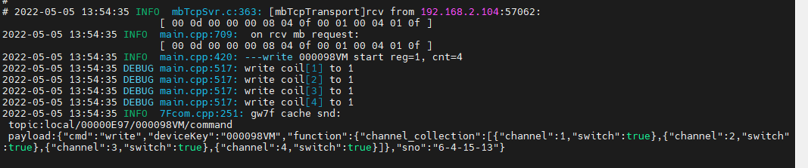

1. 直读

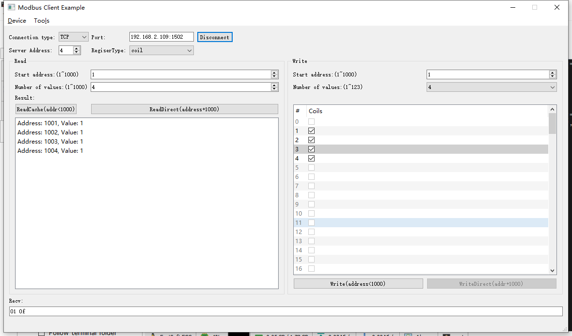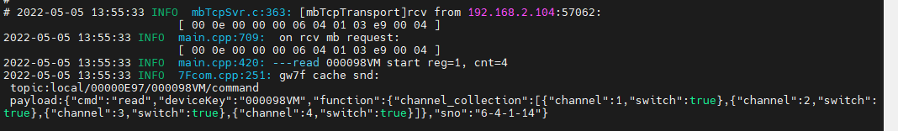

#### 写入断开

1. 写

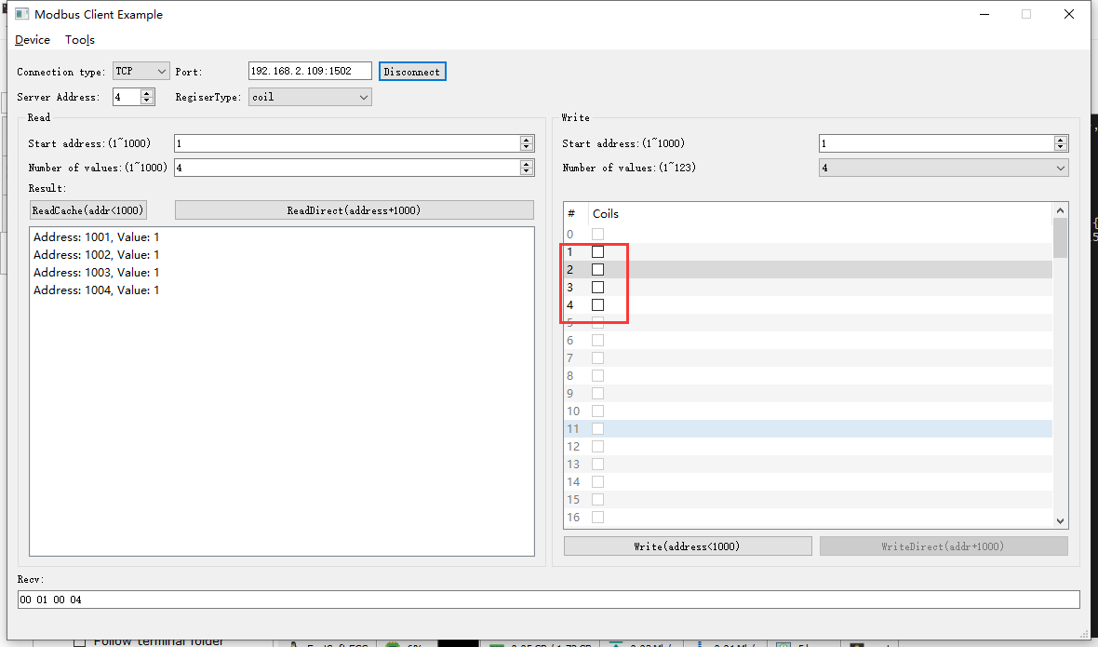2022-05-05 13:56:13 INFO mbTcpSvr.c:363: [mbTcpTransport]rcv from 192.168.2.104:57062:

[ 00 0f 00 00 00 08 04 0f 00 01 00 04 01 00 ]

2022-05-05 13:56:13 INFO main.cpp:709: on rcv mb request:

[ 00 0f 00 00 00 08 04 0f 00 01 00 04 01 00 ]

2022-05-05 13:56:13 INFO main.cpp:420: ---write 000098VM start reg=1, cnt=4

2022-05-05 13:56:13 DEBUG main.cpp:517: write coil[1] to 0

2022-05-05 13:56:13 DEBUG main.cpp:517: write coil[2] to 0

2022-05-05 13:56:13 DEBUG main.cpp:517: write coil[3] to 0

2022-05-05 13:56:13 DEBUG main.cpp:517: write coil[4] to 0

2022-05-05 13:56:13 INFO mbTcpSvr.c:451: [mbTcpTransport]snd to 192.168.2.104:57062:

[ 00 0f 00 00 00 06 04 0f 00 01 00 04 ]

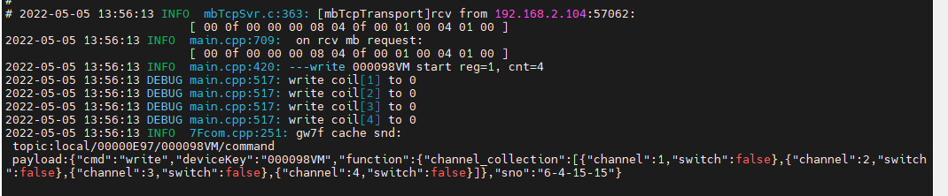

1. 直读

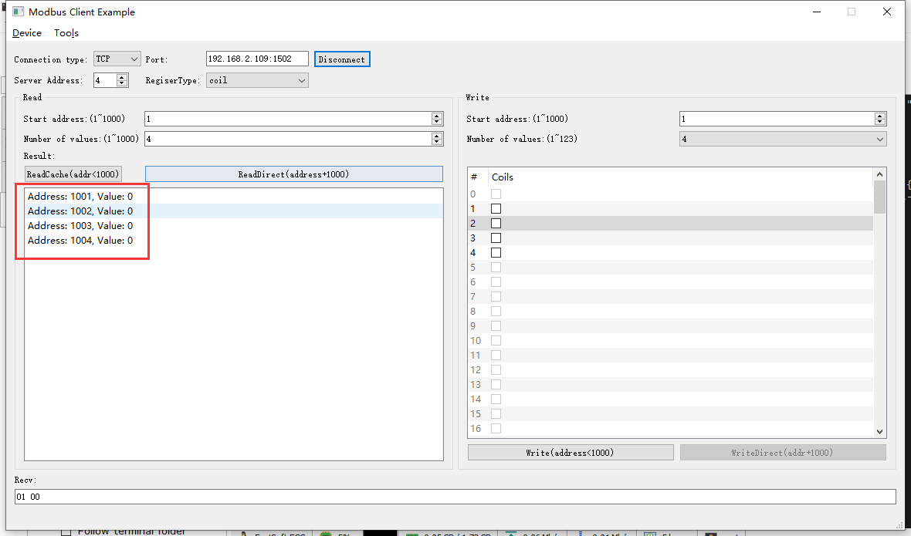

## 读取电流值

电表

**说明：**读取时可带载查看真实数值

电流读取的寄存器如下图：

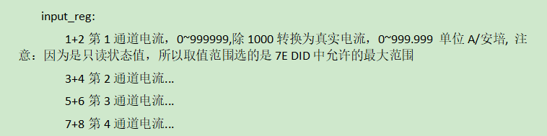

通过抄控器读取设备电流值

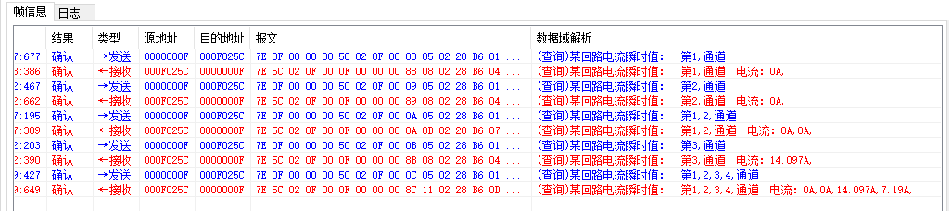

### 通道1读取

说明：第一通道未接通负载

#### 闭合时

1. 写闭合

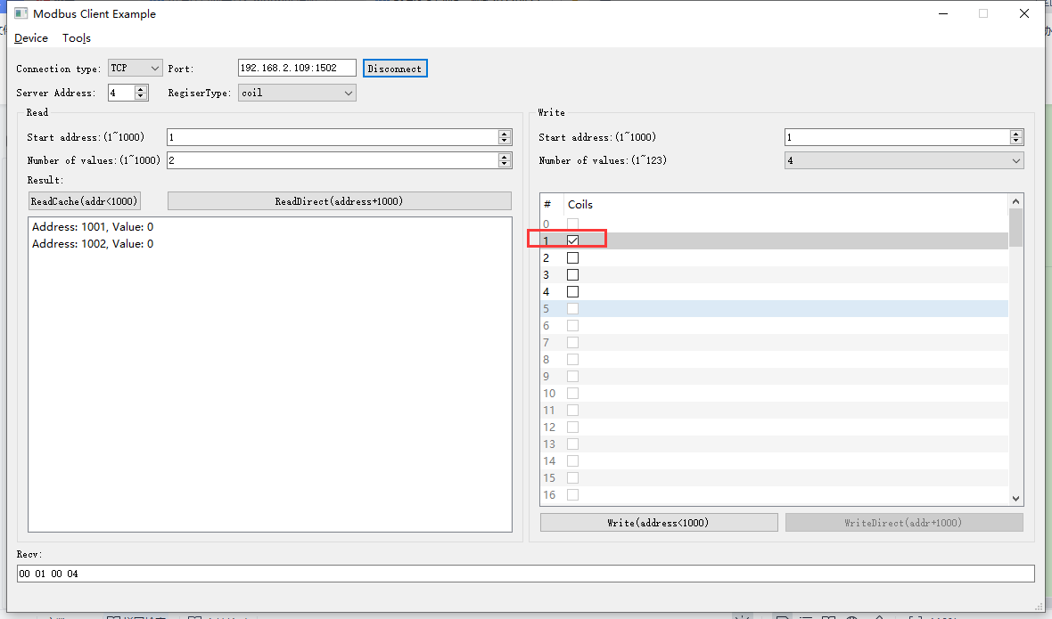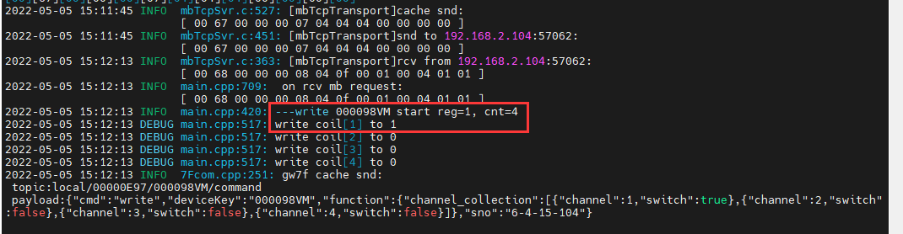

1. 直读

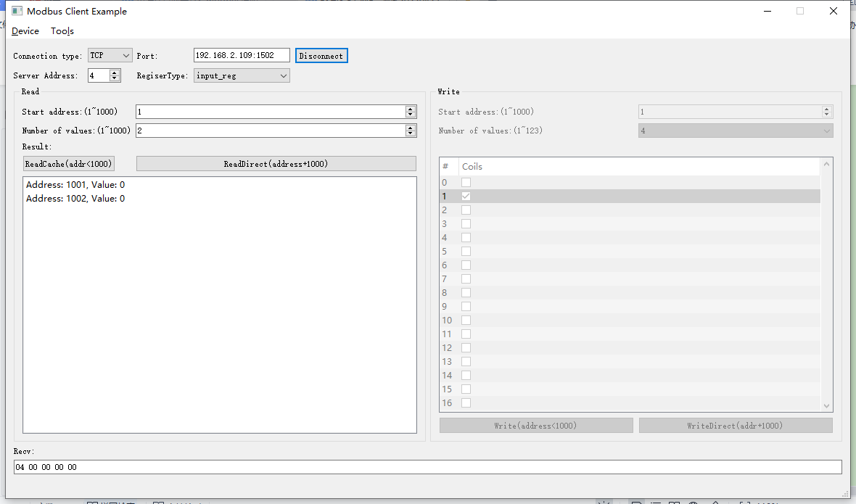2022-05-05 15:33:02 INFO mbTcpSvr.c:363: [mbTcpTransport]rcv from 192.168.2.104:57062:

[ 00 6b 00 00 00 06 04 04 03 e9 00 02 ]

2022-05-05 15:33:02 INFO main.cpp:709: on rcv mb request:

[ 00 6b 00 00 00 06 04 04 03 e9 00 02 ]

2022-05-05 15:33:02 INFO main.cpp:420: ---read 000098VM start reg=30001, cnt=2

2022-05-05 15:33:02 INFO 7Fcom.cpp:251: gw7f cache snd:

topic:local/00000E97/000098VM/command

payload:{"cmd":"read","deviceKey":"000098VM","function":{"channel_collection":[{"channel":1,"current":0}]},"sno":"6-4-4-107"}

2022-05-05 15:33:03 INFO mbTcpSvr.c:451: [mbTcpTransport]snd to 192.168.2.104:57062:

[ 00 6b 00 00 00 07 04 04 04 00 00 00 00 ]

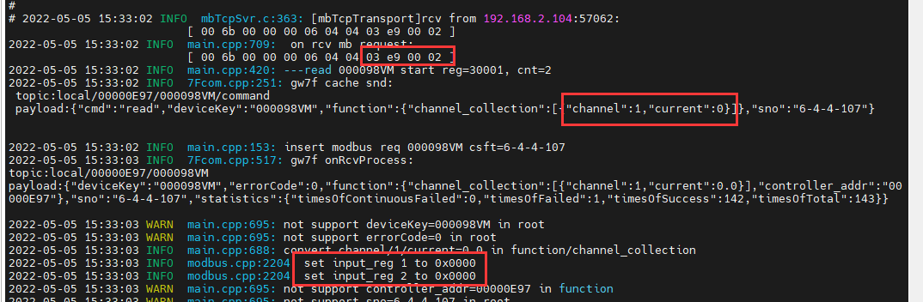

#### 断开时

1. 写断开

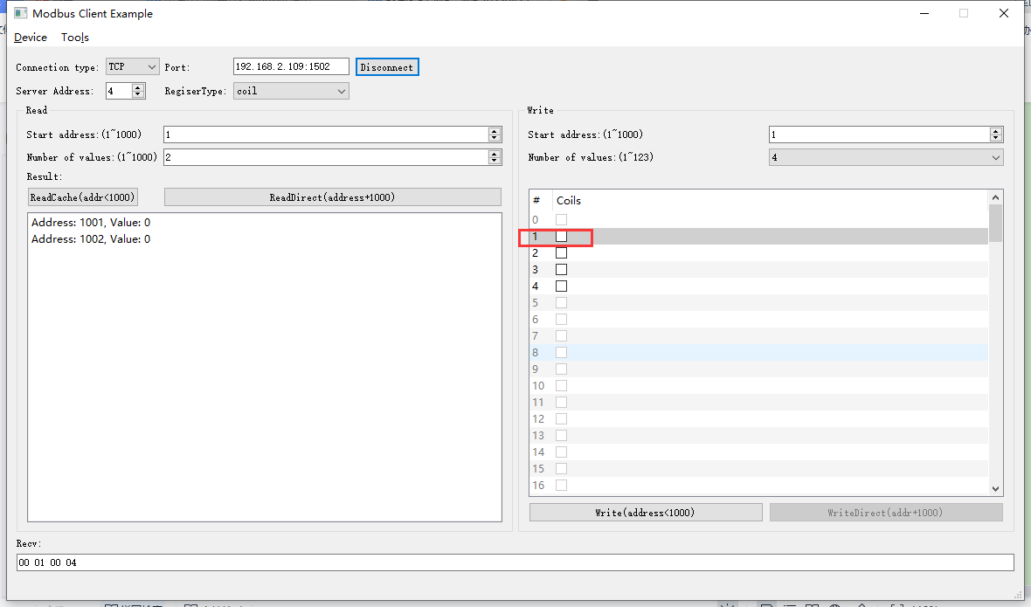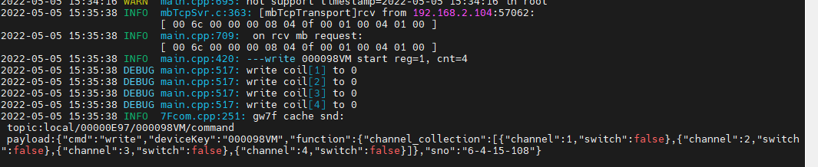

1. 直读

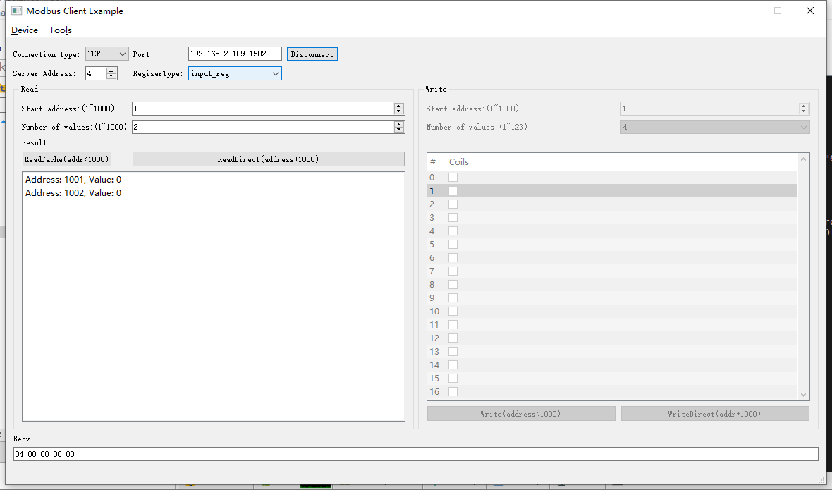2022-05-05 15:36:51 INFO mbTcpSvr.c:363: [mbTcpTransport]rcv from 192.168.2.104:57062:

[ 00 6d 00 00 00 06 04 04 03 e9 00 02 ]

2022-05-05 15:36:51 INFO main.cpp:709: on rcv mb request:

[ 00 6d 00 00 00 06 04 04 03 e9 00 02 ]

2022-05-05 15:36:51 INFO main.cpp:420: ---read 000098VM start reg=30001, cnt=2

2022-05-05 15:36:51 INFO 7Fcom.cpp:251: gw7f cache snd:

topic:local/00000E97/000098VM/command

payload:{"cmd":"read","deviceKey":"000098VM","function":{"channel_collection":[{"channel":1,"current":0}]},"sno":"6-4-4-109"}

2022-05-05 15:36:51 INFO mbTcpSvr.c:451: [mbTcpTransport]snd to 192.168.2.104:57062:

[ 00 6d 00 00 00 07 04 04 04 00 00 00 00 ]

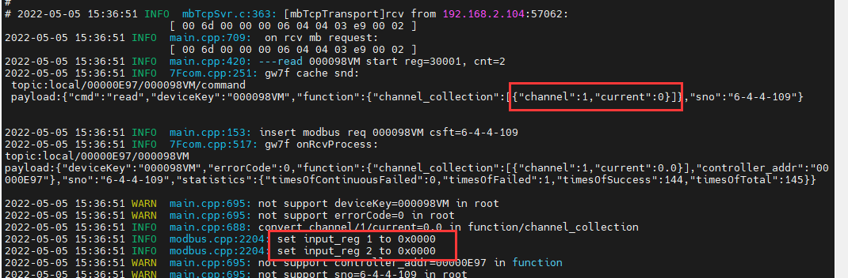

此通道未接负载，读取到电流为0

### 通道2读取

说明：第2通道未接通负载

#### 闭合时

1. 写闭合

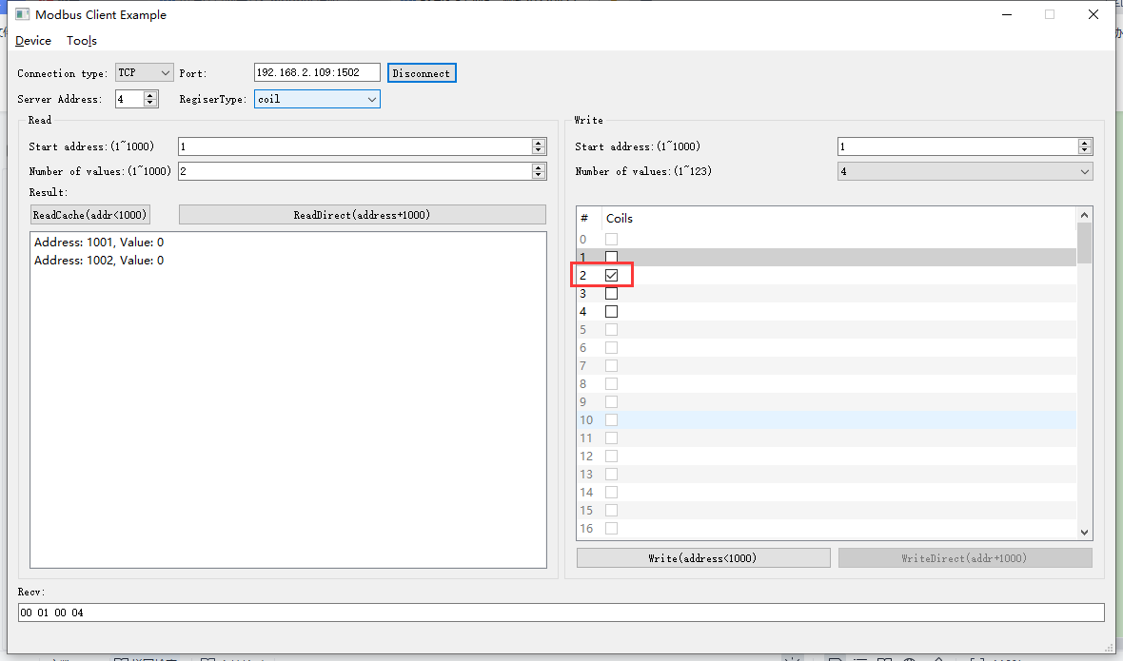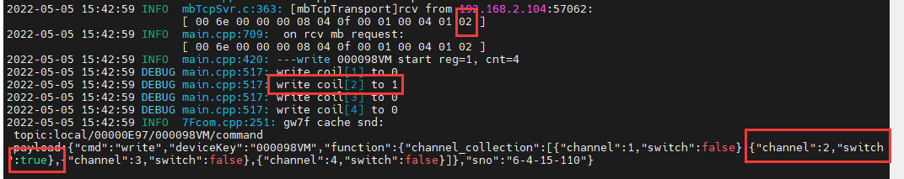

1. 直读

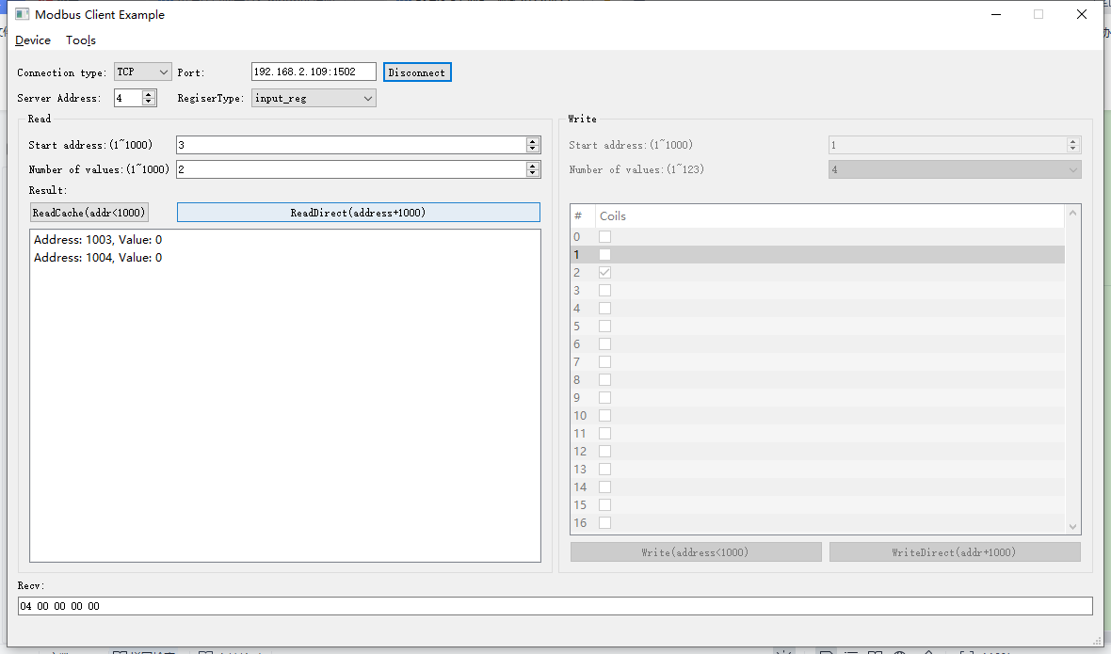2022-05-05 15:45:36 INFO mbTcpSvr.c:363: [mbTcpTransport]rcv from 192.168.2.104:57062:

[ 00 6f 00 00 00 06 04 04 03 eb 00 02 ]

2022-05-05 15:45:36 INFO main.cpp:709: on rcv mb request:

[ 00 6f 00 00 00 06 04 04 03 eb 00 02 ]

2022-05-05 15:45:36 INFO main.cpp:420: ---read 000098VM start reg=30003, cnt=2

2022-05-05 15:45:36 INFO 7Fcom.cpp:251: gw7f cache snd:

topic:local/00000E97/000098VM/command

payload:{"cmd":"read","deviceKey":"000098VM","function":{"channel_collection":[{"channel":2,"current":0}]},"sno":"6-4-4-111"}

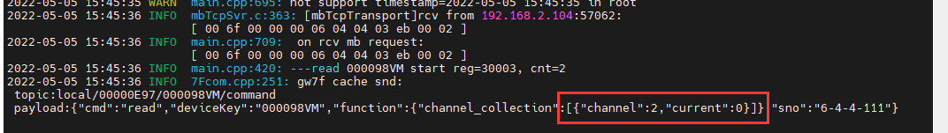

2022-05-05 15:45:36 INFO mbTcpSvr.c:451: [mbTcpTransport]snd to 192.168.2.104:57062:

[ 00 6f 00 00 00 07 04 04 04 00 00 00 00 ]



2通道未接负载读取到的电流为0.

#### 断开时

1. 写断开

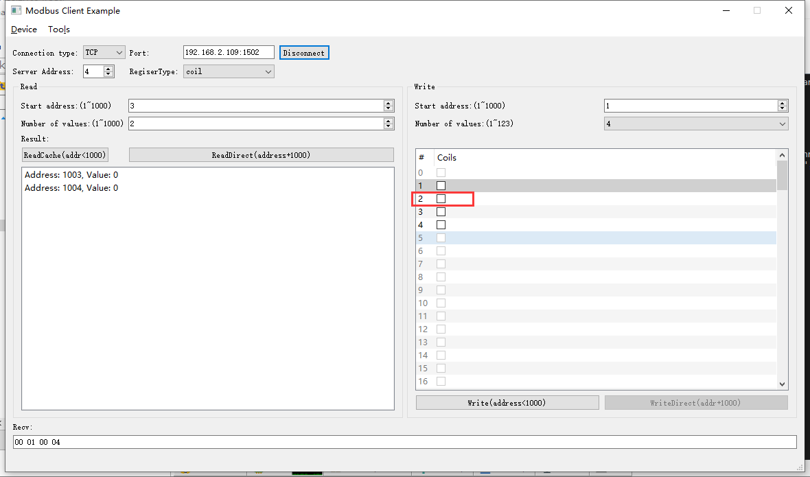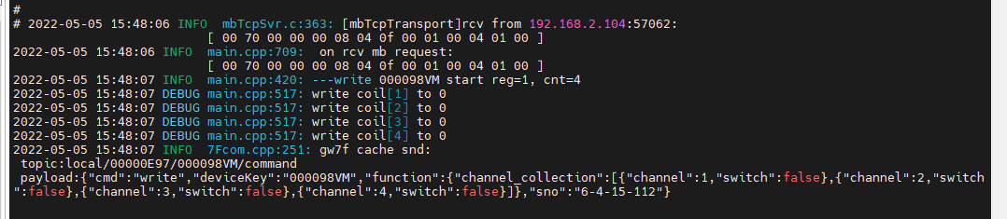

1. 直读

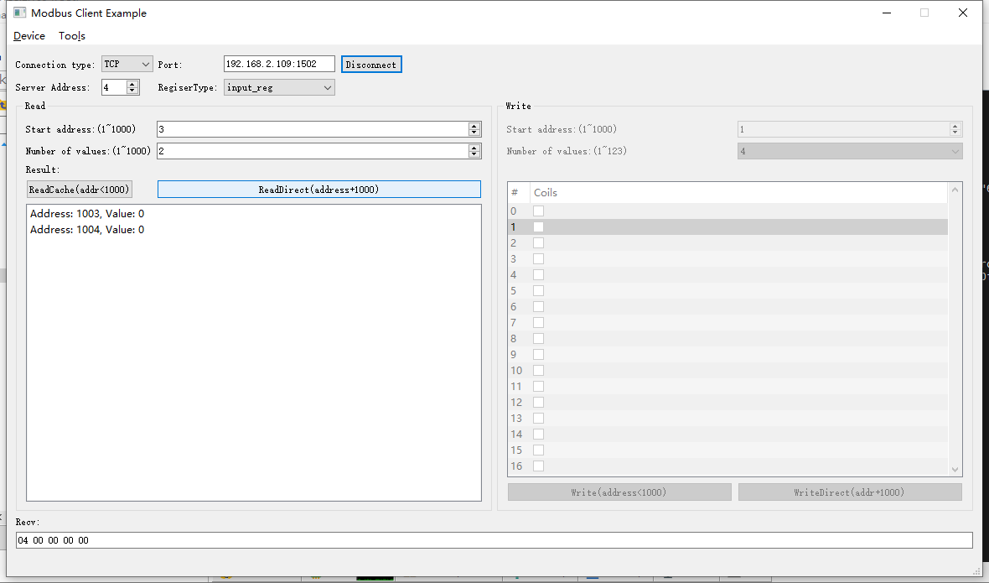2022-05-05 15:48:48 INFO mbTcpSvr.c:363: [mbTcpTransport]rcv from 192.168.2.104:57062:

[ 00 72 00 00 00 06 04 04 03 eb 00 02 ]

2022-05-05 15:48:48 INFO main.cpp:709: on rcv mb request:

[ 00 72 00 00 00 06 04 04 03 eb 00 02 ]

2022-05-05 15:48:48 INFO main.cpp:420: ---read 000098VM start reg=30003, cnt=2

2022-05-05 15:48:48 INFO 7Fcom.cpp:251: gw7f cache snd:

topic:local/00000E97/000098VM/command

payload:{"cmd":"read","deviceKey":"000098VM","function":{"channel_collection":[{"channel":2,"current":0}]},"sno":"6-4-4-114"}

2022-05-05 15:48:48 INFO mbTcpSvr.c:451: [mbTcpTransport]snd to 192.168.2.104:57062:

[ 00 72 00 00 00 07 04 04 04 00 00 00 00 ]

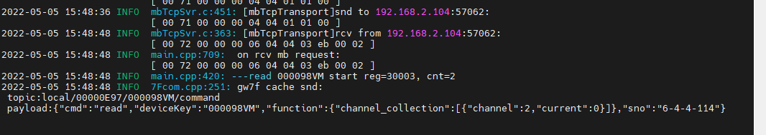



结果：读取电流为0

### 通道3读取

说明：第3通道未接通负载

#### 闭合时

1. 写闭合

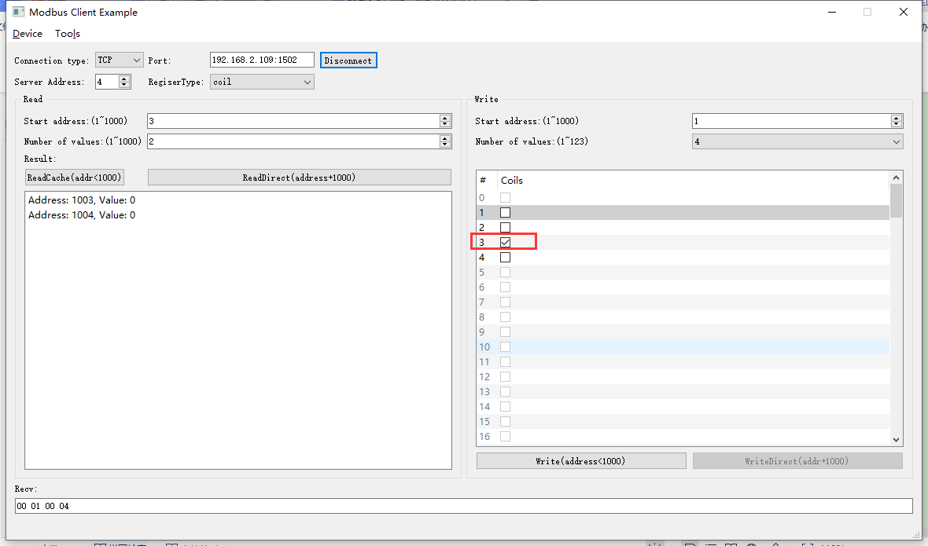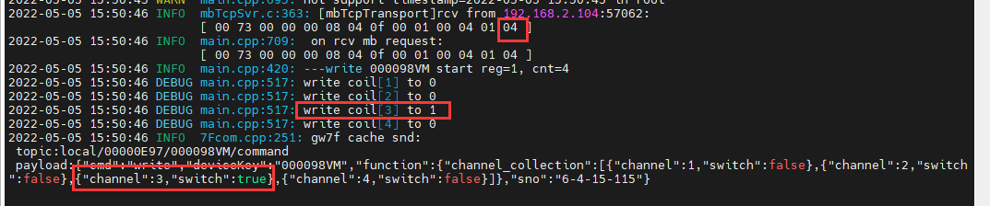

1. 直读

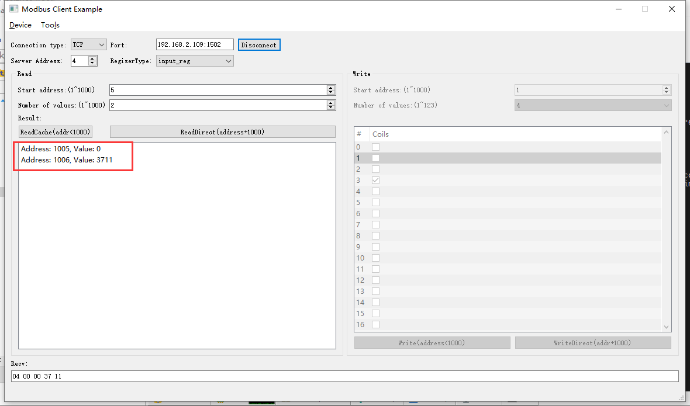2022-05-05 15:52:03 INFO mbTcpSvr.c:363: [mbTcpTransport]rcv from 192.168.2.104:57062:

[ 00 74 00 00 00 06 04 04 03 ed 00 02 ]

2022-05-05 15:52:03 INFO main.cpp:709: on rcv mb request:

[ 00 74 00 00 00 06 04 04 03 ed 00 02 ]

2022-05-05 15:52:03 INFO main.cpp:420: ---read 000098VM start reg=30005, cnt=2

2022-05-05 15:52:03 INFO 7Fcom.cpp:251: gw7f cache snd:

topic:local/00000E97/000098VM/command

payload:{"cmd":"read","deviceKey":"000098VM","function":{"channel_collection":[{"channel":3,"current":0}]},"sno":"6-4-4-116"}

2022-05-05 15:52:03 INFO mbTcpSvr.c:451: [mbTcpTransport]snd to 192.168.2.104:57062:

[ 00 74 00 00 00 07 04 04 04 00 00 37 11 ]

结果：1+3通道断开时读取到的电流分别为0，14.0970，使用抄控器通过载波直读设备电流与此相同，此处为设备本身问题，本接口程序数据转换正确。

#### 断开时

1. 写断开

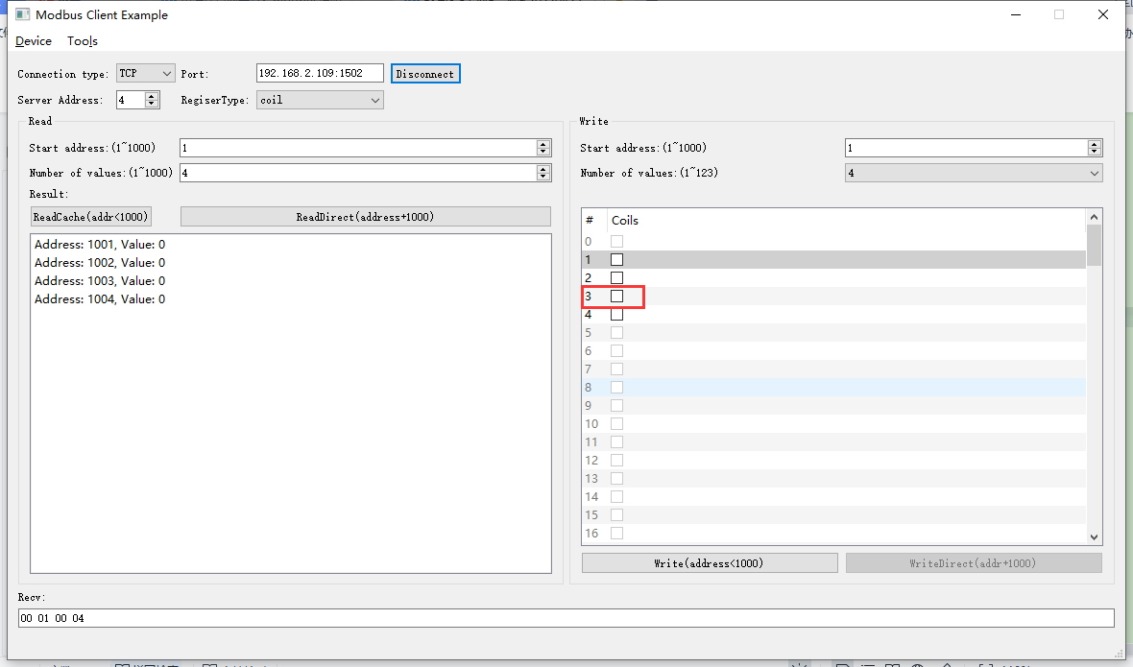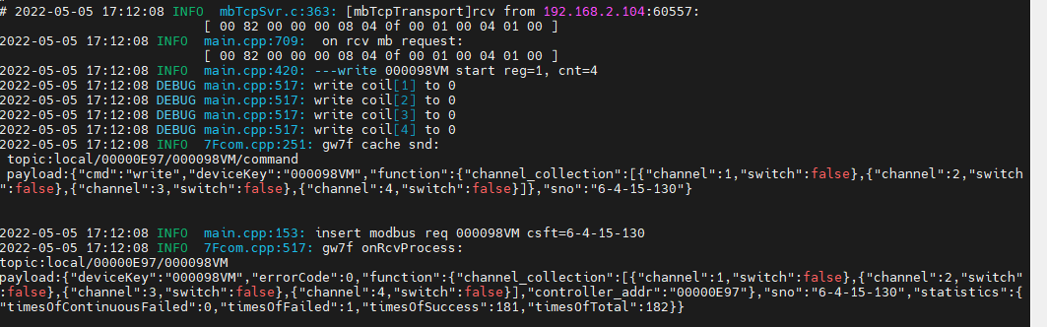

1. 直读

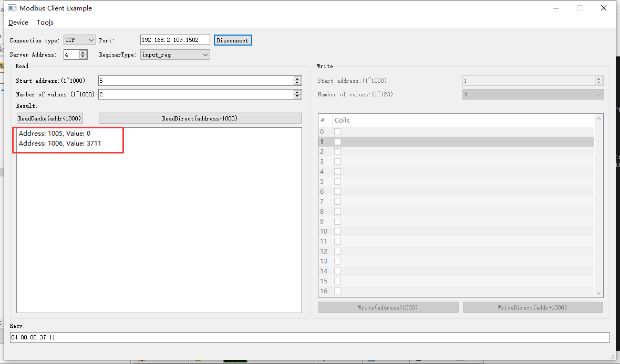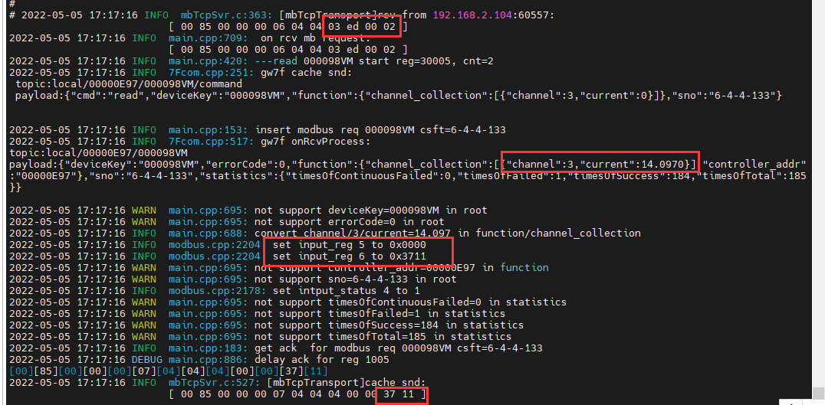2022-05-05 17:17:16 INFO mbTcpSvr.c:363: [mbTcpTransport]rcv from 192.168.2.104:60557:

[ 00 85 00 00 00 06 04 04 03 ed 00 02 ]

2022-05-05 17:17:16 INFO mbTcpSvr.c:451: [mbTcpTransport]snd to 192.168.2.104:60557:

[ 00 85 00 00 00 07 04 04 04 00 00 37 11 ]

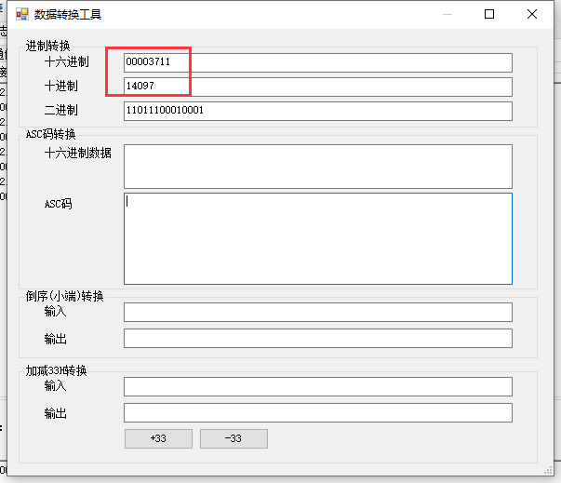

结果：读取到电流为14.097

### 通道4读取

说明：第4通道已接通负载（灯泡：150W，220V）

#### 闭合时

1. 写闭合

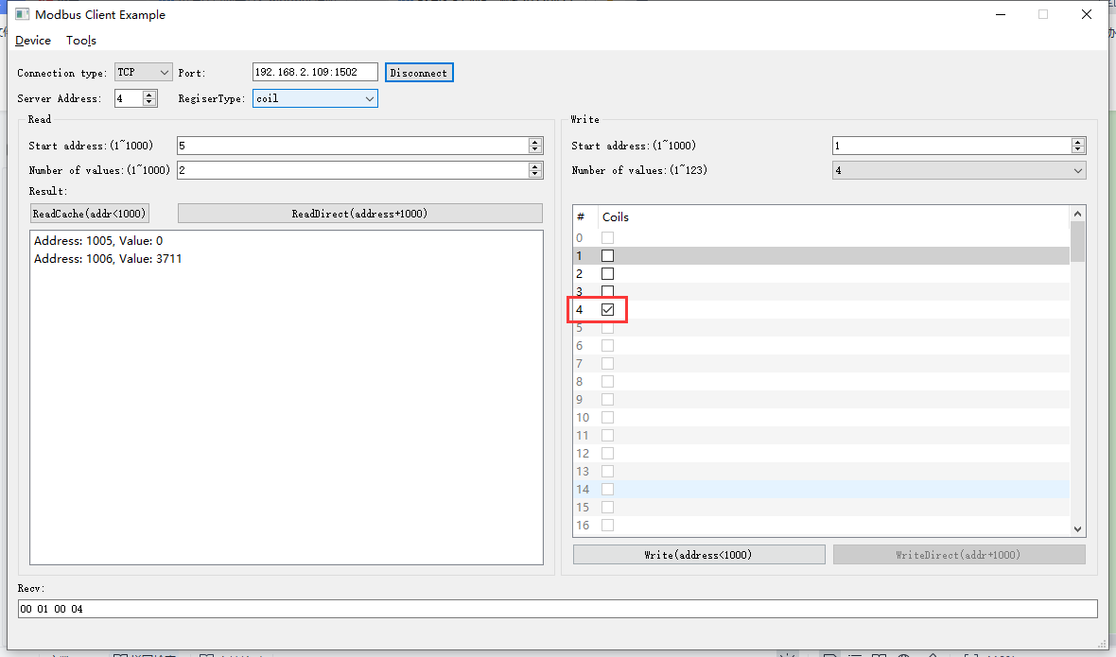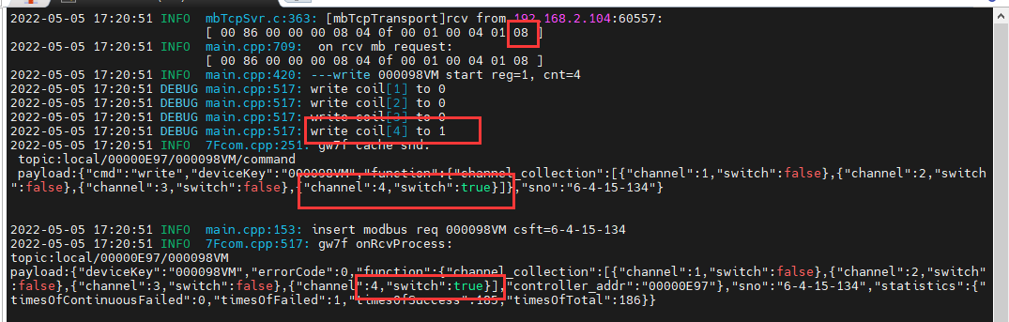

1. 直读

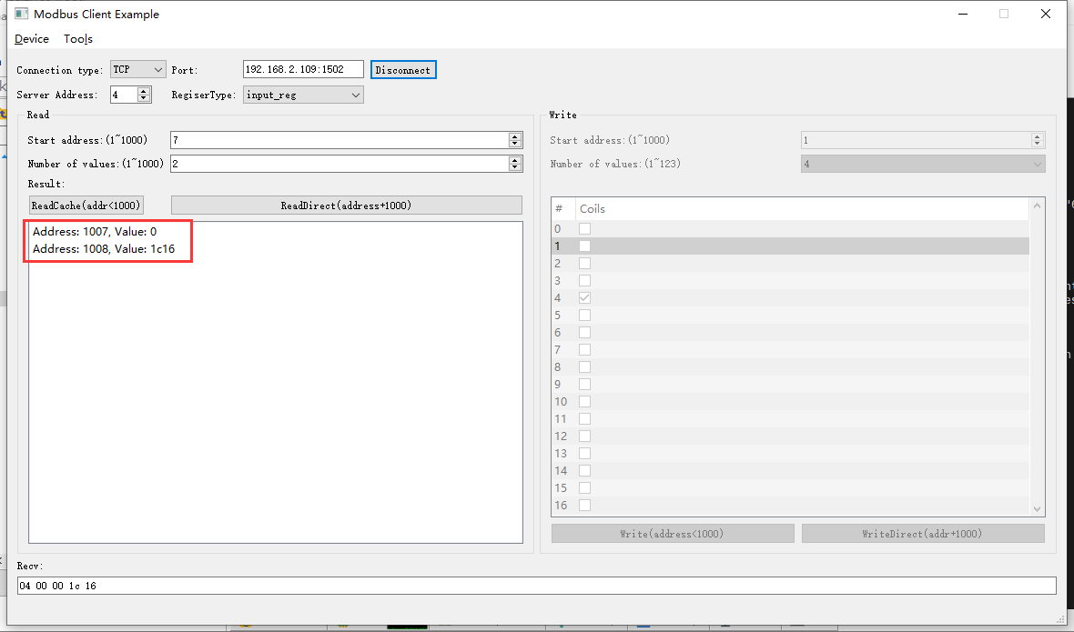2022-05-05 17:22:12 INFO mbTcpSvr.c:363: [mbTcpTransport]rcv from 192.168.2.104:60557:

[ 00 87 00 00 00 06 04 04 03 ef 00 02 ]

2022-05-05 17:22:12 INFO 7Fcom.cpp:517: gw7f onRcvProcess:

topic:local/00000E97/000098VM

payload:{"deviceKey":"000098VM","errorCode":0,"function":{"channel_collection":[{"channel":4,"current":7.190}],"controller_addr":"00000E97"},"sno":"6-4-4-135","statistics":{"timesOfContinuousFailed":0,"timesOfFailed":1,"timesOfSuccess":186,"timesOfTotal":187}}

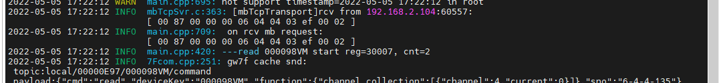

**结果：**读取4通道电流为7.190。

#### 断开时

1. 写断开

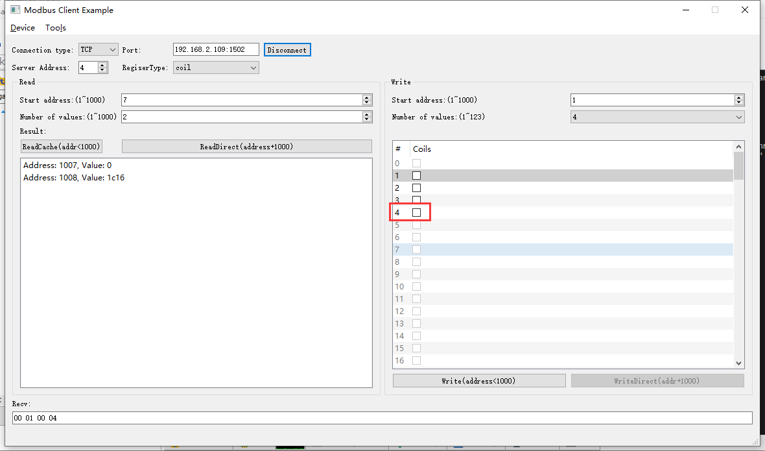2022-05-06 09:19:44 INFO mbTcpSvr.c:363: [mbTcpTransport]rcv from 192.168.2.104:57223:

[ 00 88 00 00 00 08 04 0f 00 01 00 04 01 00 ]

2022-05-06 09:19:44 INFO main.cpp:709: on rcv mb request:

[ 00 88 00 00 00 08 04 0f 00 01 00 04 01 00 ]

2022-05-06 09:19:44 INFO main.cpp:420: ---write 000098VM start reg=1, cnt=4

2022-05-06 09:19:44 DEBUG main.cpp:517: write coil[1] to 0

2022-05-06 09:19:44 DEBUG main.cpp:517: write coil[2] to 0

2022-05-06 09:19:44 DEBUG main.cpp:517: write coil[3] to 0

2022-05-06 09:19:44 DEBUG main.cpp:517: write coil[4] to 0

2022-05-06 09:19:44 INFO mbTcpSvr.c:451: [mbTcpTransport]snd to 192.168.2.104:57223:

[ 00 88 00 00 00 06 04 0f 00 01 00 04 ]

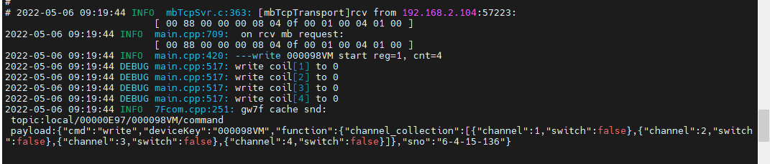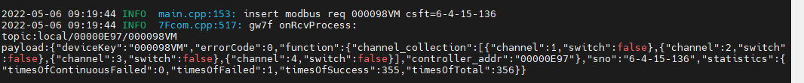

1. 直读

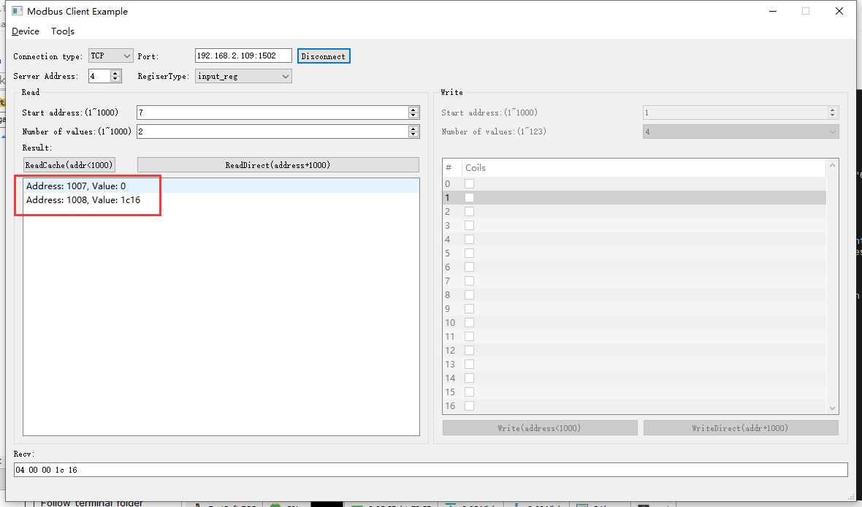2022-05-06 09:32:27 INFO mbTcpSvr.c:363: [mbTcpTransport]rcv from 192.168.2.104:57223:

[ 00 8b 00 00 00 06 04 04 03 ef 00 02 ]

2022-05-06 09:32:27 INFO main.cpp:709: on rcv mb request:

[ 00 8b 00 00 00 06 04 04 03 ef 00 02 ]

2022-05-06 09:32:27 INFO main.cpp:420: ---read 000098VM start reg=30007, cnt=2

2022-05-06 09:32:27 INFO mbTcpSvr.c:451: [mbTcpTransport]snd to 192.168.2.104:57223:

[ 00 8b 00 00 00 07 04 04 04 00 00 1c 16 ]

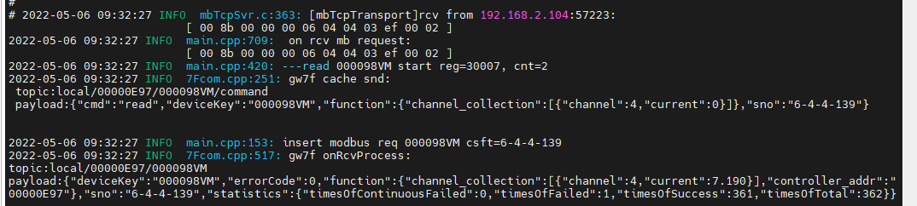

### 通道1+2读取

说明：第1,2通道未接入负载

#### 闭合时

1. 写闭合

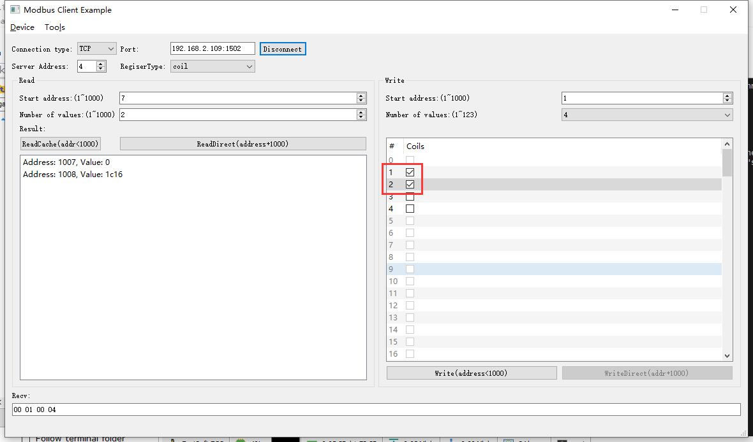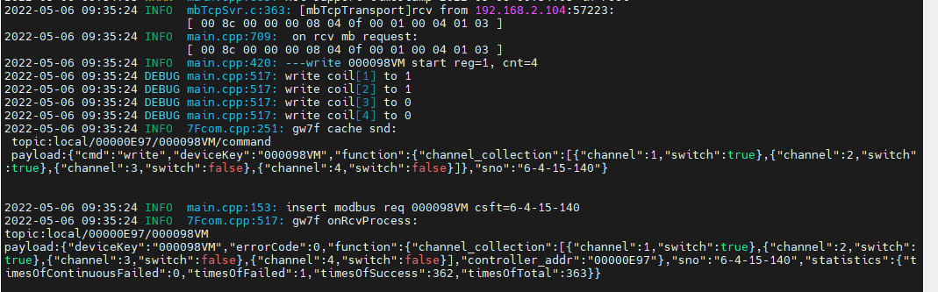

1. 直读

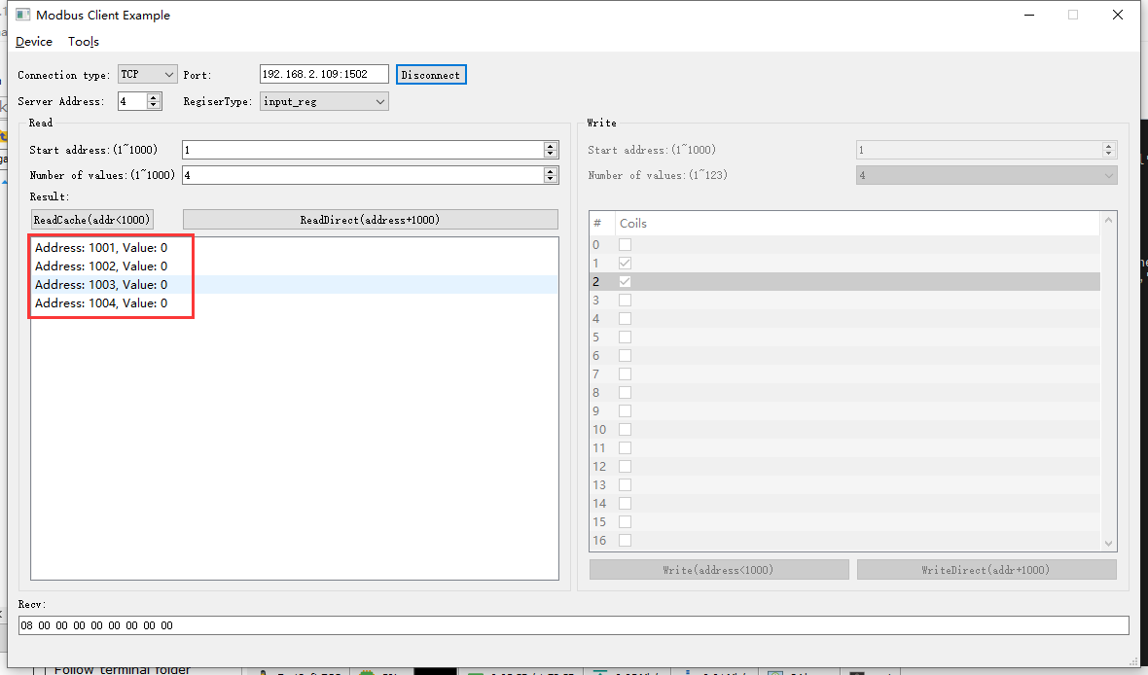 2022-05-06 09:38:06 INFO mbTcpSvr.c:363: [mbTcpTransport]rcv from 192.168.2.104:57223:

[ 00 8e 00 00 00 06 04 04 03 e9 00 04 ]

2022-05-06 09:38:06 INFO main.cpp:709: on rcv mb request:

[ 00 8e 00 00 00 06 04 04 03 e9 00 04 ]

2022-05-06 09:38:06 INFO main.cpp:420: ---read 000098VM start reg=30001, cnt=4

2022-05-06 09:38:06 INFO 7Fcom.cpp:251: gw7f cache snd:

topic:local/00000E97/000098VM/command

payload:{"cmd":"read","deviceKey":"000098VM","function":{"channel_collection":[{"channel":1,"current":0},{"channel":2,"current":0}]},"sno":"6-4-4-142"}

022-05-06 09:38:07 INFO mbTcpSvr.c:451: [mbTcpTransport]snd to 192.168.2.104:57223:

[ 00 8e 00 00 00 0b 04 04 08 00 00 00 00 00 00 00 00 ]

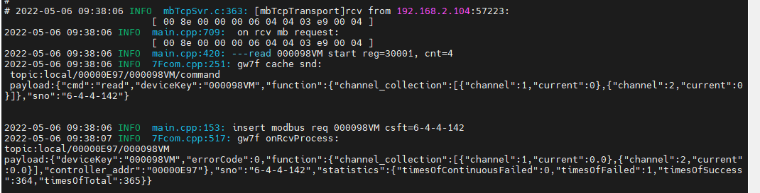

结果：读取电流为0

#### 断开时

1. 写断开

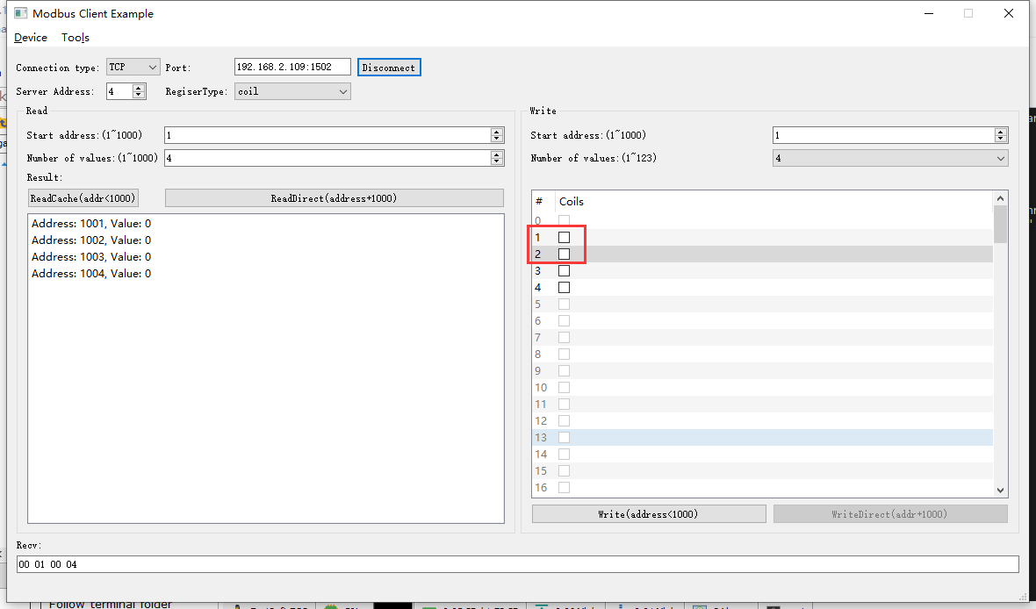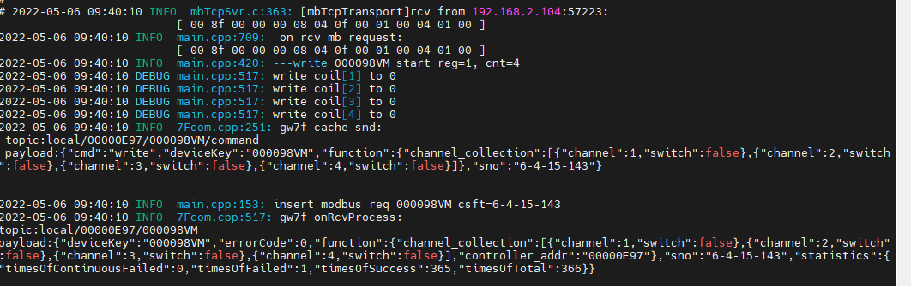

1. 直读

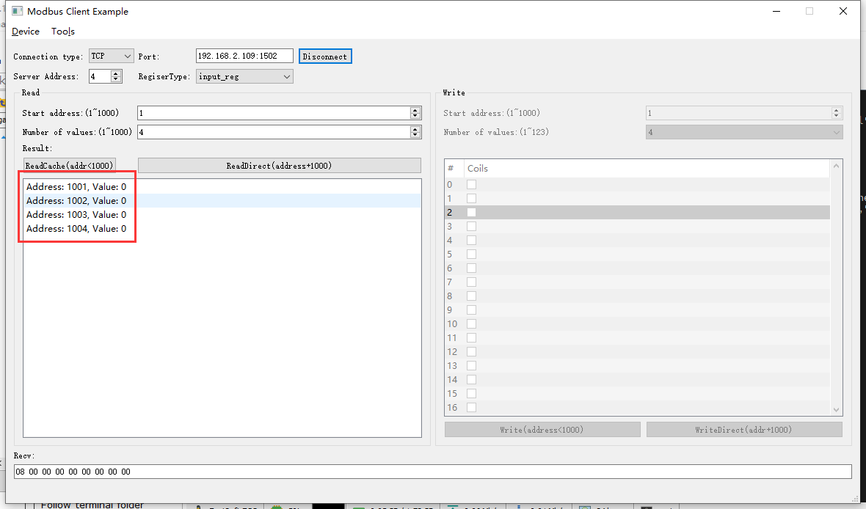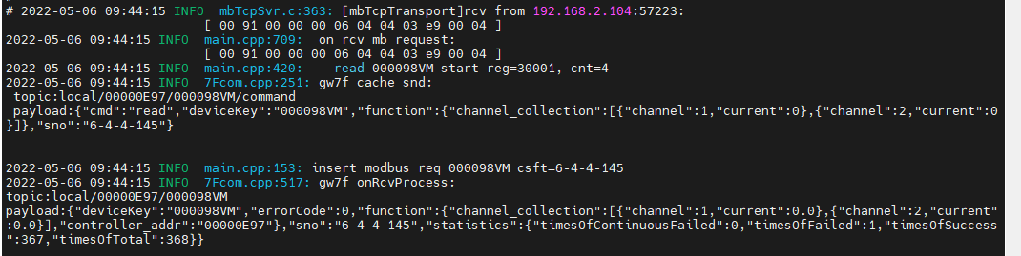

### 通道1+3读取

说明：第4通道已接通负载（灯泡：150W，220V）

#### 闭合时

1. 写闭合

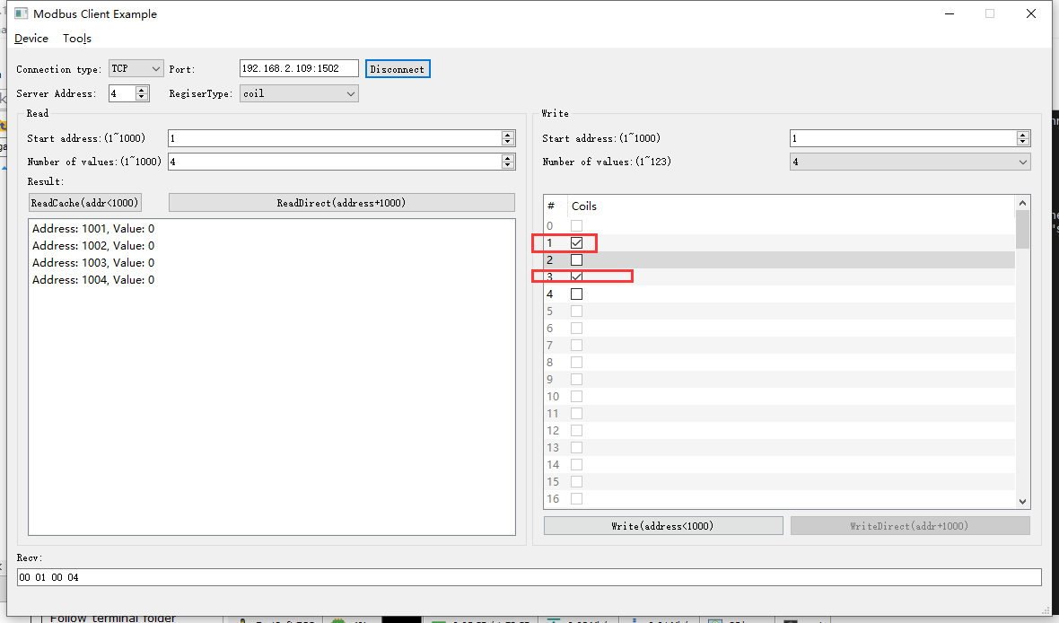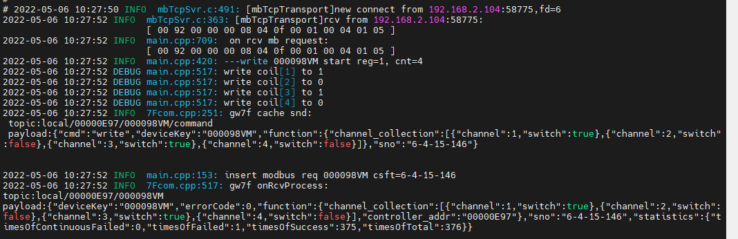

1. 直读

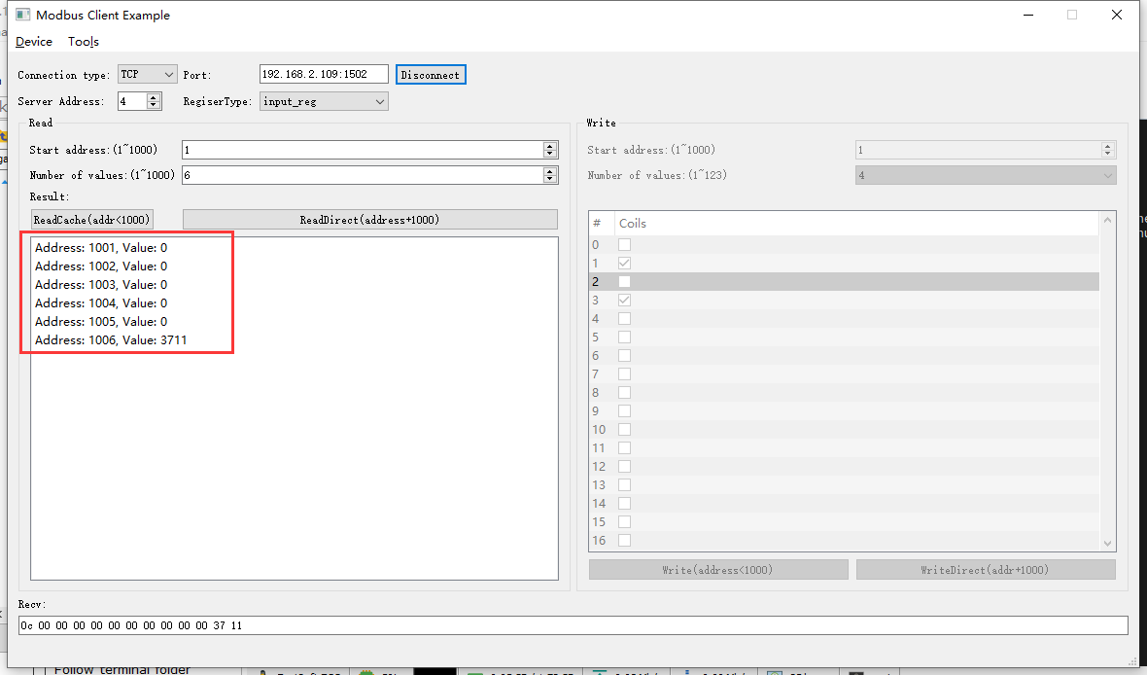2022-05-06 10:28:40 INFO mbTcpSvr.c:363: [mbTcpTransport]rcv from 192.168.2.104:58775:

[ 00 94 00 00 00 06 04 04 03 e9 00 06 ]

2022-05-06 10:28:40 INFO main.cpp:709: on rcv mb request:

[ 00 94 00 00 00 06 04 04 03 e9 00 06 ]

2022-05-06 10:28:40 INFO main.cpp:420: ---read 000098VM start reg=30001, cnt=6

2022-05-06 10:28:40 INFO 7Fcom.cpp:251: gw7f cache snd:

topic:local/00000E97/000098VM/command

payload:{"cmd":"read","deviceKey":"000098VM","function":{"channel_collection":[{"channel":1,"current":0},{"channel":2,"current":0},{"channel":3,"current":0}]},"sno":"6-4-4-148"}

2022-05-06 10:28:40 INFO mbTcpSvr.c:451: [mbTcpTransport]snd to 192.168.2.104:58775:

[ 00 94 00 00 00 0f 04 04 0c 00 00 00 00 00 00 00 00 00 00 37 11 ]

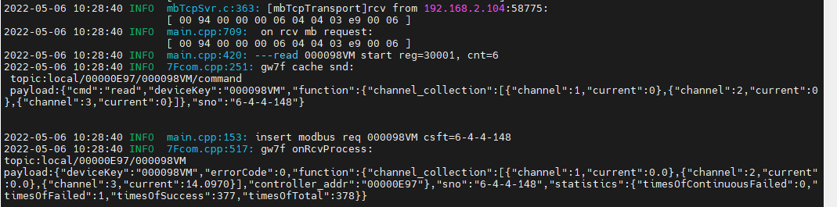

结果：读取到的电流与抄控器读取的一致，程序转换正确。

#### 断开时

1. 写断开

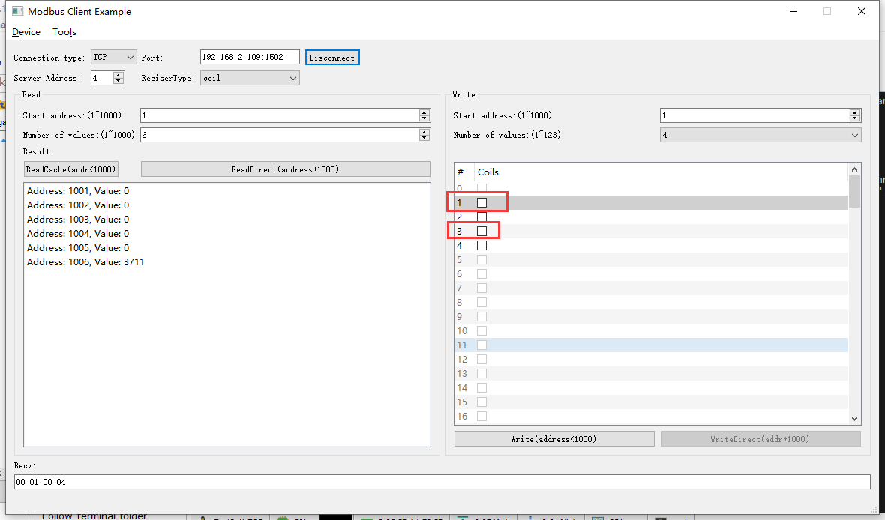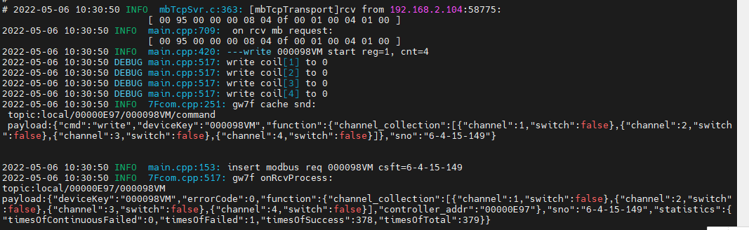

1. 直读

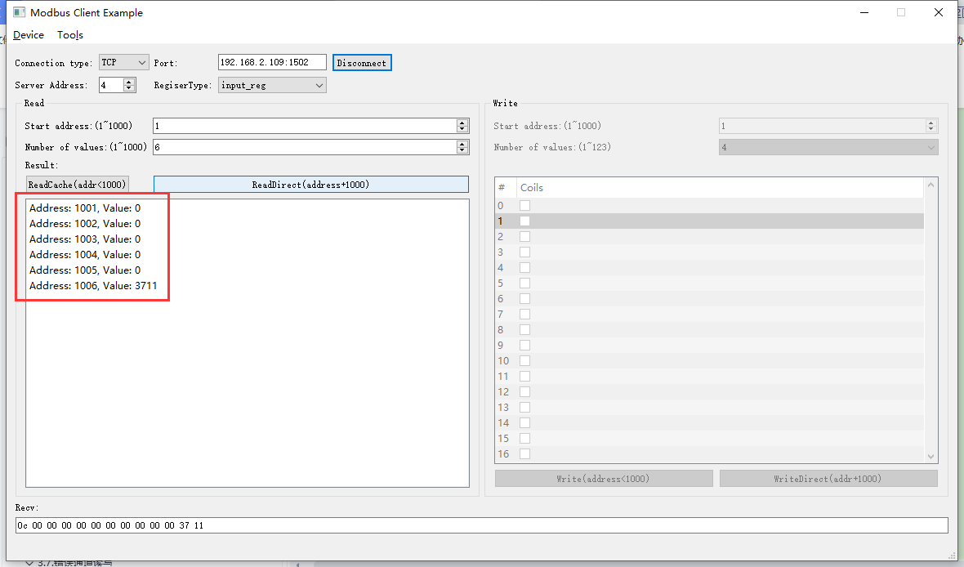2022-05-06 10:31:32 INFO mbTcpSvr.c:363: [mbTcpTransport]rcv from 192.168.2.104:58775:

[ 00 96 00 00 00 06 04 04 03 e9 00 06 ]

2022-05-06 10:31:32 INFO main.cpp:709: on rcv mb request:

[ 00 96 00 00 00 06 04 04 03 e9 00 06 ]

2022-05-06 10:31:32 INFO main.cpp:420: ---read 000098VM start reg=30001, cnt=6

2022-05-06 10:31:32 INFO 7Fcom.cpp:517: gw7f onRcvProcess:

topic:local/00000E97/000098VM

payload:{"deviceKey":"000098VM","errorCode":0,"function":{"channel_collection":[{"channel":1,"current":0.0},{"channel":2,"current":0.0},{"channel":3,"current":14.0970}],"controller_addr":"00000E97"},"sno":"6-4-4-150","statistics":{"timesOfContinuousFailed":0,"timesOfFailed":1,"timesOfSuccess":379,"timesOfTotal":380}}

2022-05-06 10:31:32 INFO mbTcpSvr.c:451: [mbTcpTransport]snd to 192.168.2.104:58775:

[ 00 96 00 00 00 0f 04 04 0c 00 00 00 00 00 00 00 00 00 00 37 11 ]

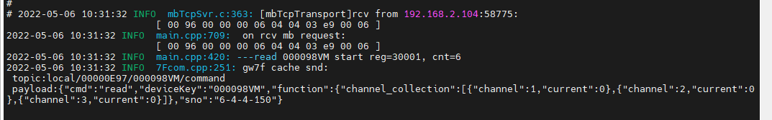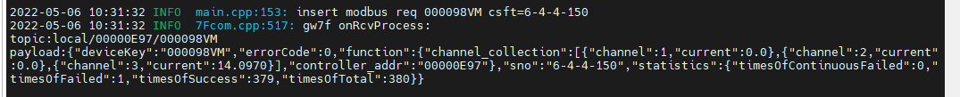

### 通道1+2+3+4读取

说明：第4通道已接通负载（灯泡：150W，220V）

#### 闭合时

1. 写闭合

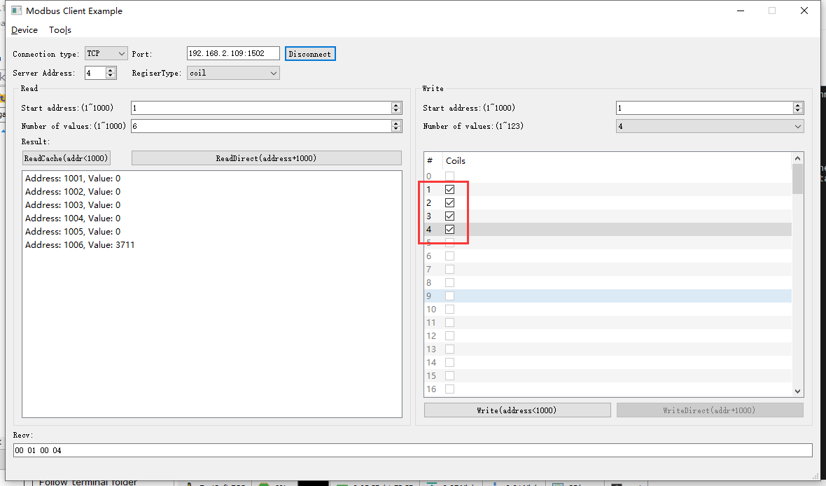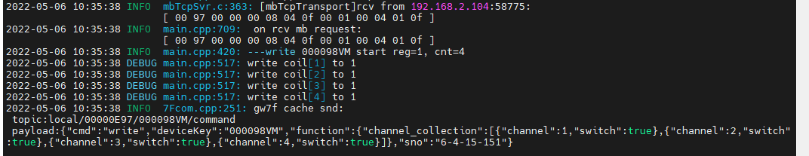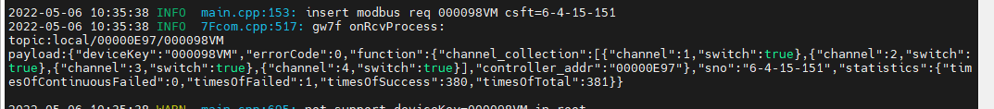

1. 直读

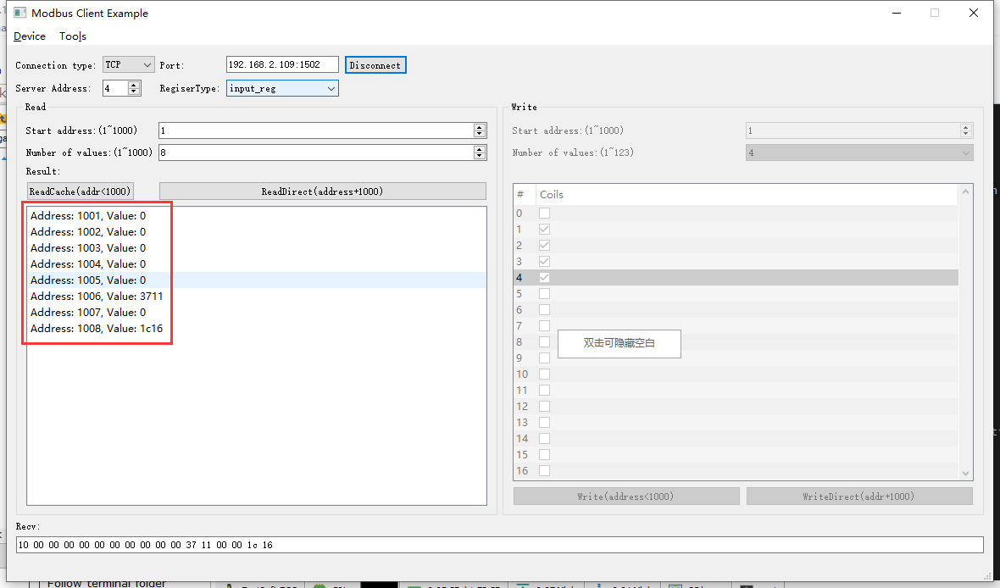 2022-05-06 10:36:34 INFO mbTcpSvr.c:363: [mbTcpTransport]rcv from 192.168.2.104:58775:

[ 00 98 00 00 00 06 04 04 03 e9 00 08 ]

2022-05-06 10:36:34 INFO main.cpp:709: on rcv mb request:

[ 00 98 00 00 00 06 04 04 03 e9 00 08 ]

2022-05-06 10:36:34 INFO main.cpp:420: ---read 000098VM start reg=30001, cnt=8

2022-05-06 10:36:34 INFO 7Fcom.cpp:517: gw7f onRcvProcess:

topic:local/00000E97/000098VM

payload:{"deviceKey":"000098VM","errorCode":0,"function":{"channel_collection":[{"channel":1,"current":0.0},{"channel":2,"current":0.0},{"channel":3,"current":14.0970},{"channel":4,"current":7.190}],"controller_addr":"00000E97"},"sno":"6-4-4-152","statistics":{"timesOfContinuousFailed":0,"timesOfFailed":1,"timesOfSuccess":381,"timesOfTotal":382}}

2022-05-06 10:36:34 INFO mbTcpSvr.c:451: [mbTcpTransport]snd to 192.168.2.104:58775:

[ 00 98 00 00 00 13 04 04 10 00 00 00 00 00 00 00 00 00 00 37 11 00 00 1c 16 ]

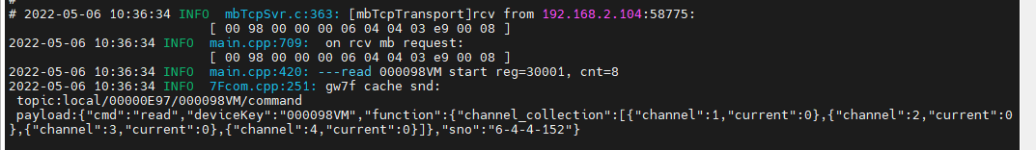

结果：各个通道电流如上面刷绿部分所示，与设备实际数据一致。

#### 断开时

1. 写断开

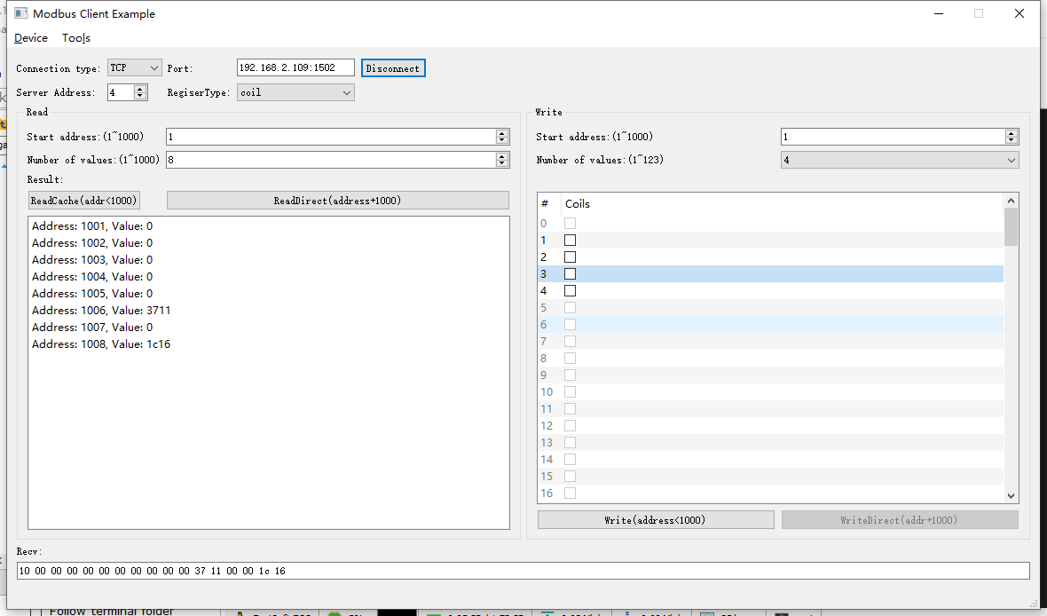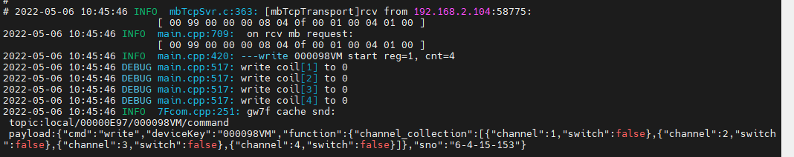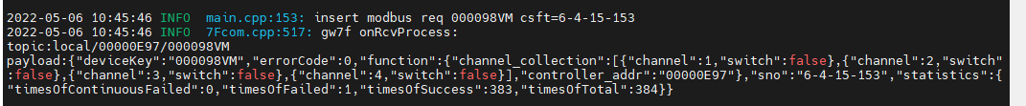

1. 直读

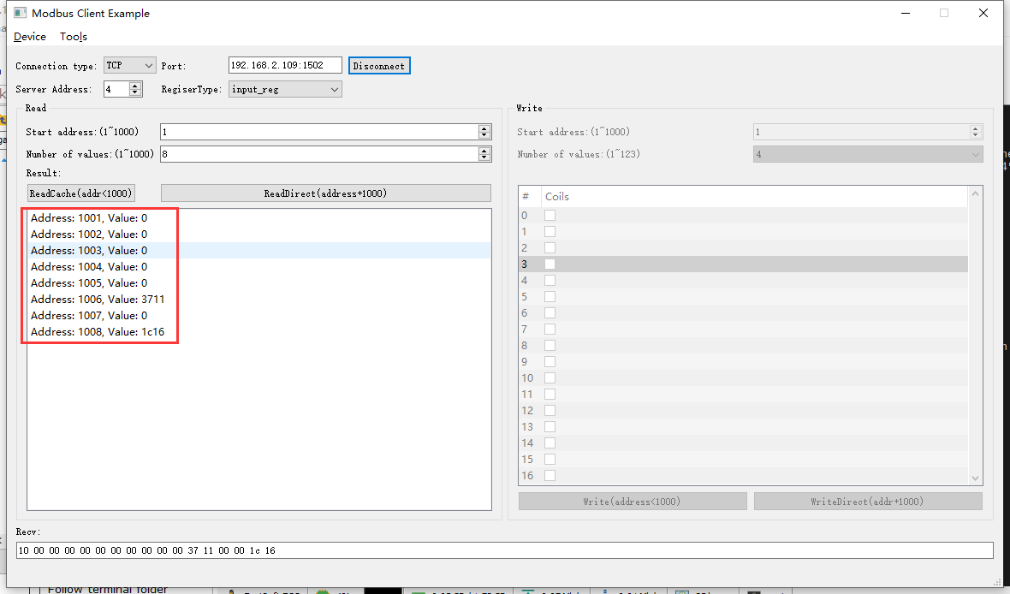2022-05-06 10:48:35 INFO mbTcpSvr.c:363: [mbTcpTransport]rcv from 192.168.2.104:58775:

[ 00 9a 00 00 00 06 04 04 03 e9 00 08 ]

2022-05-06 10:48:35 INFO main.cpp:709: on rcv mb request:

[ 00 9a 00 00 00 06 04 04 03 e9 00 08 ]

2022-05-06 10:48:35 INFO main.cpp:420: ---read 000098VM start reg=30001, cnt=8

2022-05-06 10:48:35 INFO 7Fcom.cpp:517: gw7f onRcvProcess:

topic:local/00000E97/000098VM

payload:{"deviceKey":"000098VM","errorCode":0,"function":{"channel_collection":[{"channel":1,"current":0.0},{"channel":2,"current":0.0},{"channel":3,"current":14.0970},{"channel":4,"current":7.190}],"controller_addr":"00000E97"},"sno":"6-4-4-154","statistics":{"timesOfContinuousFailed":0,"timesOfFailed":1,"timesOfSuccess":384,"timesOfTotal":385}}

2022-05-06 10:48:35 INFO mbTcpSvr.c:451: [mbTcpTransport]snd to 192.168.2.104:58775:

[ 00 9a 00 00 00 13 04 04 10 00 00 00 00 00 00 00 00 00 00 37 11 00 00 1c 16 ]

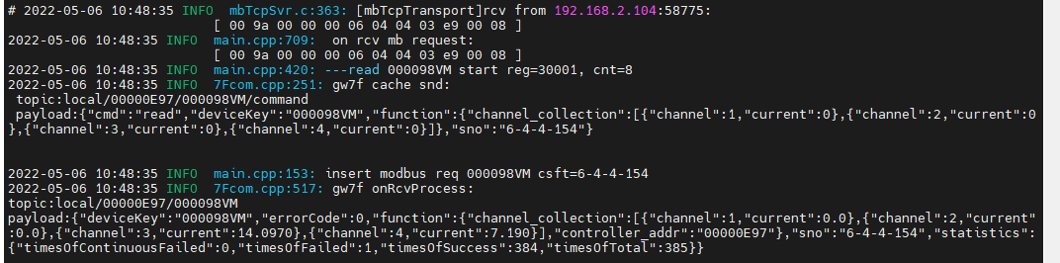

结果：各个通道电流如上面刷绿部分所示，与设备实际数据一致。

### 电流错误范围读取

如下图是正确范围：

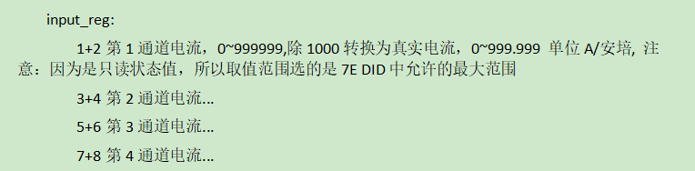

#### 读取地址1-3

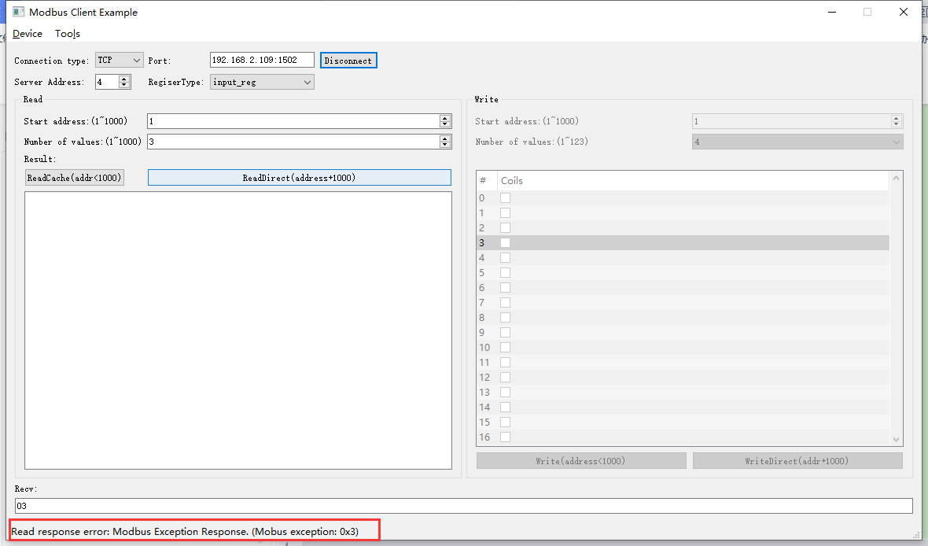2022-05-06 11:25:22 INFO mbTcpSvr.c:363: [mbTcpTransport]rcv from 192.168.2.104:59646:

[ 00 9c 00 00 00 06 04 04 03 e9 00 03 ]

2022-05-06 11:25:22 INFO main.cpp:709: on rcv mb request:

[ 00 9c 00 00 00 06 04 04 03 e9 00 03 ]

2022-05-06 11:25:22 INFO main.cpp:420: ---read 000098VM start reg=30001, cnt=3

2022-05-06 11:25:22 INFO mbTcpSvr.c:451: [mbTcpTransport]snd to 192.168.2.104:59646:

[ 00 9c 00 00 00 03 04 84 03 ]

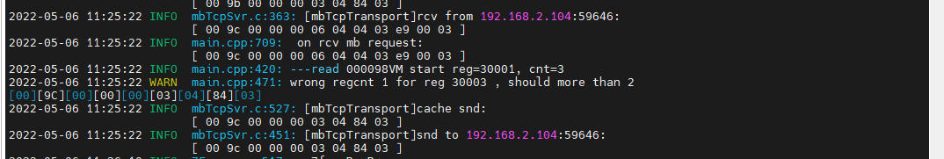

结果：返回异常84 03

#### 读取地址2-3

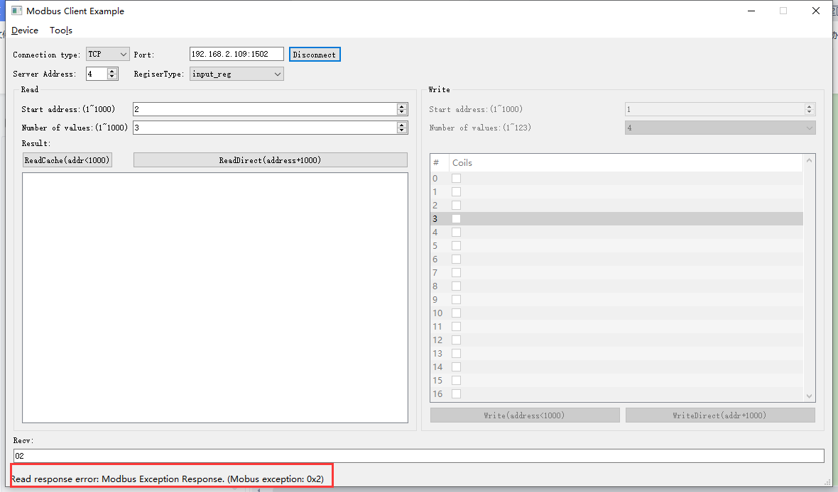2022-05-06 11:28:03 INFO mbTcpSvr.c:363: [mbTcpTransport]rcv from 192.168.2.104:59646:

[ 00 9d 00 00 00 06 04 04 03 ea 00 03 ]

2022-05-06 11:28:03 INFO main.cpp:709: on rcv mb request:

[ 00 9d 00 00 00 06 04 04 03 ea 00 03 ]

2022-05-06 11:28:03 INFO main.cpp:420: ---read 000098VM start reg=30002, cnt=3

2022-05-06 11:28:03 INFO mbTcpSvr.c:451: [mbTcpTransport]snd to 192.168.2.104:59646:

[ 00 9d 00 00 00 03 04 84 02 ]

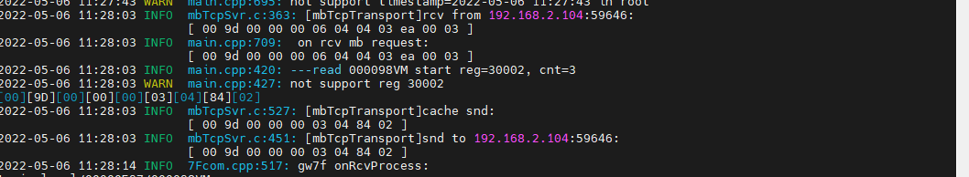

#### 读取地址7-9

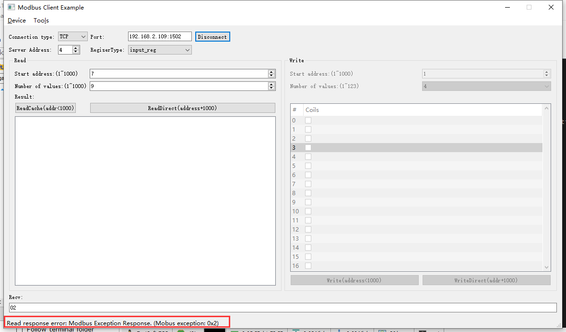2022-05-06 11:29:21 INFO mbTcpSvr.c:363: [mbTcpTransport]rcv from 192.168.2.104:59646:

[ 00 9e 00 00 00 06 04 04 03 ef 00 09 ]

2022-05-06 11:29:21 INFO main.cpp:709: on rcv mb request:

[ 00 9e 00 00 00 06 04 04 03 ef 00 09 ]

2022-05-06 11:29:21 INFO mbTcpSvr.c:451: [mbTcpTransport]snd to 192.168.2.104:59646:

[ 00 9e 00 00 00 03 04 84 02 ]

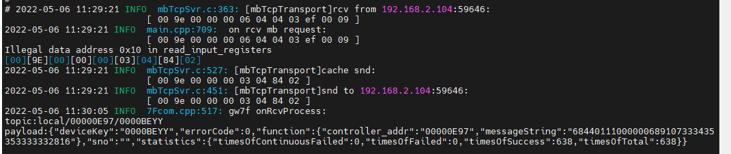

## 错误通道读写

控制不存在的通道，然后读取数据，试验设备会否异常。

### 写通道5

1. 写

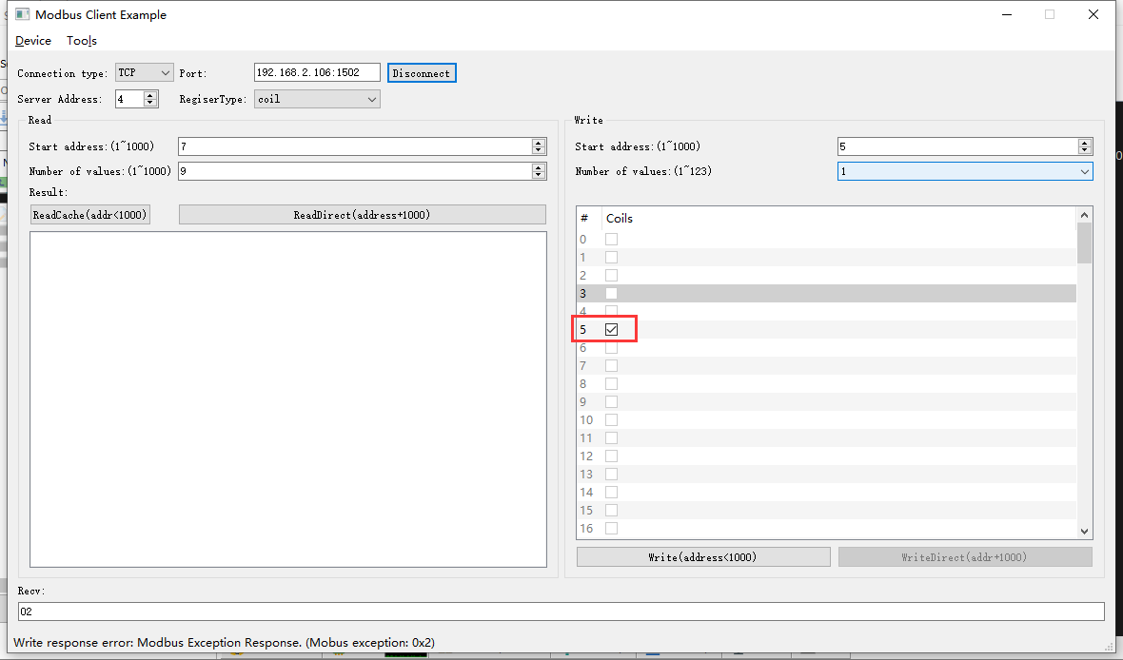2022-05-06 13:50:25 INFO mbTcpSvr.c:363: [mbTcpTransport]rcv from 192.168.2.104:56013:

[ 00 a0 00 00 00 06 04 05 00 05 ff 00 ]

2022-05-06 13:50:25 INFO mbTcpSvr.c:451: [mbTcpTransport]snd to 192.168.2.104:56013:

[ 00 a0 00 00 00 03 04 85 02 ]

解释：回复错误

1. 直读

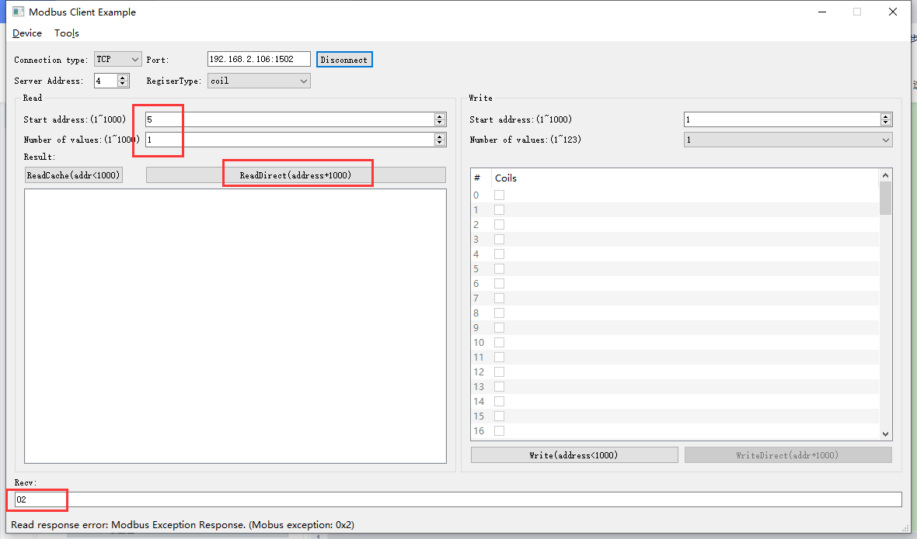2022-05-06 14:37:01 INFO mbTcpSvr.c:363: [mbTcpTransport]rcv from 192.168.2.110:50911:

[ 00 00 00 00 00 06 04 01 03 ed 00 01 ]

2022-05-06 14:37:01 INFO mbTcpSvr.c:451: [mbTcpTransport]snd to 192.168.2.110:50911:

[ 00 00 00 00 00 03 04 81 02 ]

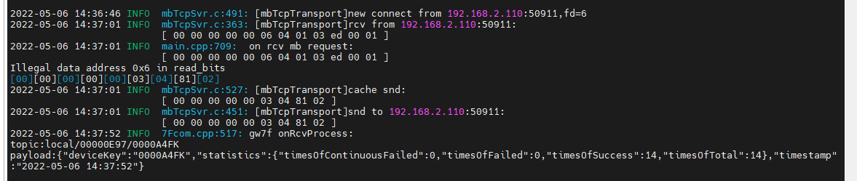

解释：回复错误

1. 读取缓存

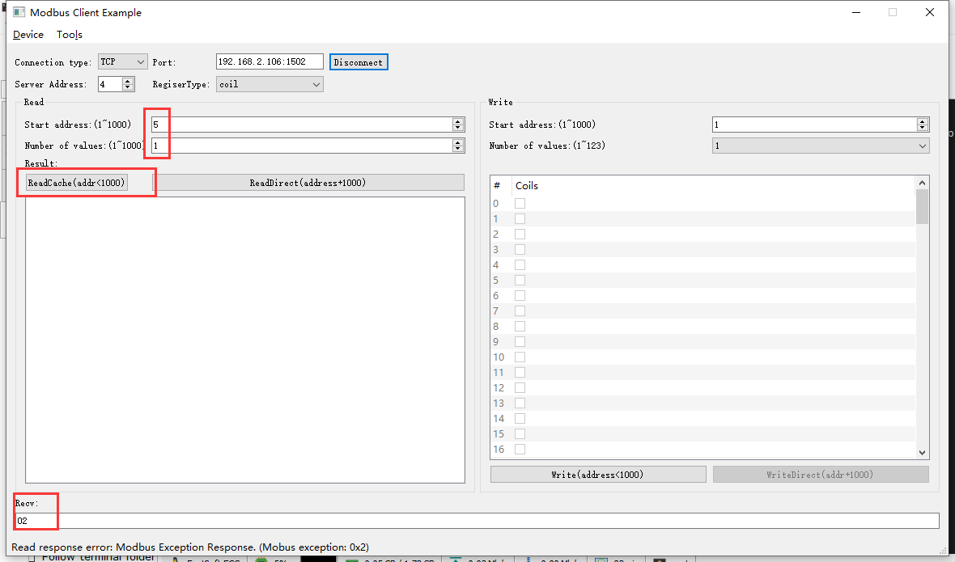2022-05-06 14:45:40 INFO mbTcpSvr.c:363: [mbTcpTransport]rcv from 192.168.2.110:50911:

[ 00 01 00 00 00 06 04 01 00 05 00 01 ]

2022-05-06 14:45:40 INFO main.cpp:709: on rcv mb request:

[ 00 01 00 00 00 06 04 01 00 05 00 01 ]

Illegal data address 0x6 in read_bits

[00][01][00][00][00][03][04][81][02]

2022-05-06 14:45:40 INFO mbTcpSvr.c:527: [mbTcpTransport]cache snd:

[ 00 01 00 00 00 03 04 81 02 ]

2022-05-06 14:45:40 INFO mbTcpSvr.c:451: [mbTcpTransport]snd to 192.168.2.110:50911:

[ 00 01 00 00 00 03 04 81 02 ]

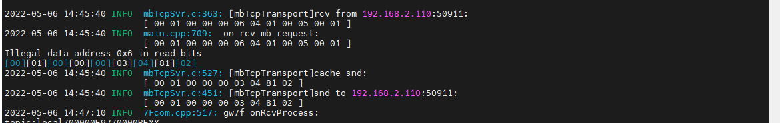

解释：回复错误

### 写通道1,2,3,4,5

1. 写

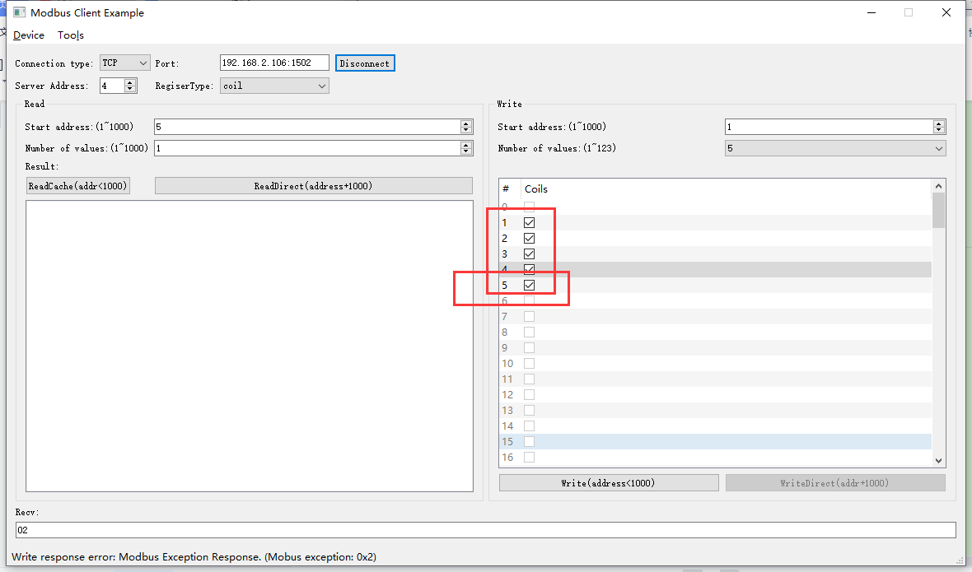2022-05-06 14:55:26 INFO mbTcpSvr.c:363: [mbTcpTransport]rcv from 192.168.2.110:50911:

[ 00 02 00 00 00 08 04 0f 00 01 00 05 01 1f ]

2022-05-06 14:55:26 INFO main.cpp:709: on rcv mb request:

[ 00 02 00 00 00 08 04 0f 00 01 00 05 01 1f ]

Illegal data address 0x6 in write_bits

[00][02][00][00][00][03][04][8F][02]

2022-05-06 14:55:26 INFO mbTcpSvr.c:527: [mbTcpTransport]cache snd:

[ 00 02 00 00 00 03 04 8f 02 ]

2022-05-06 14:55:26 INFO mbTcpSvr.c:451: [mbTcpTransport]snd to 192.168.2.110:50911:

[ 00 02 00 00 00 03 04 8f 02 ]

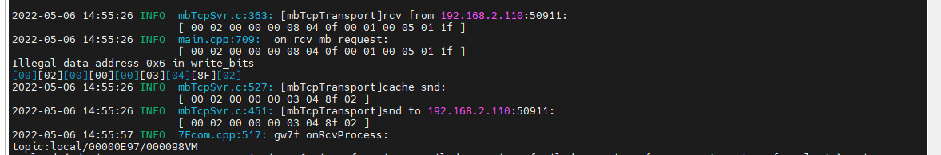

1. 直读

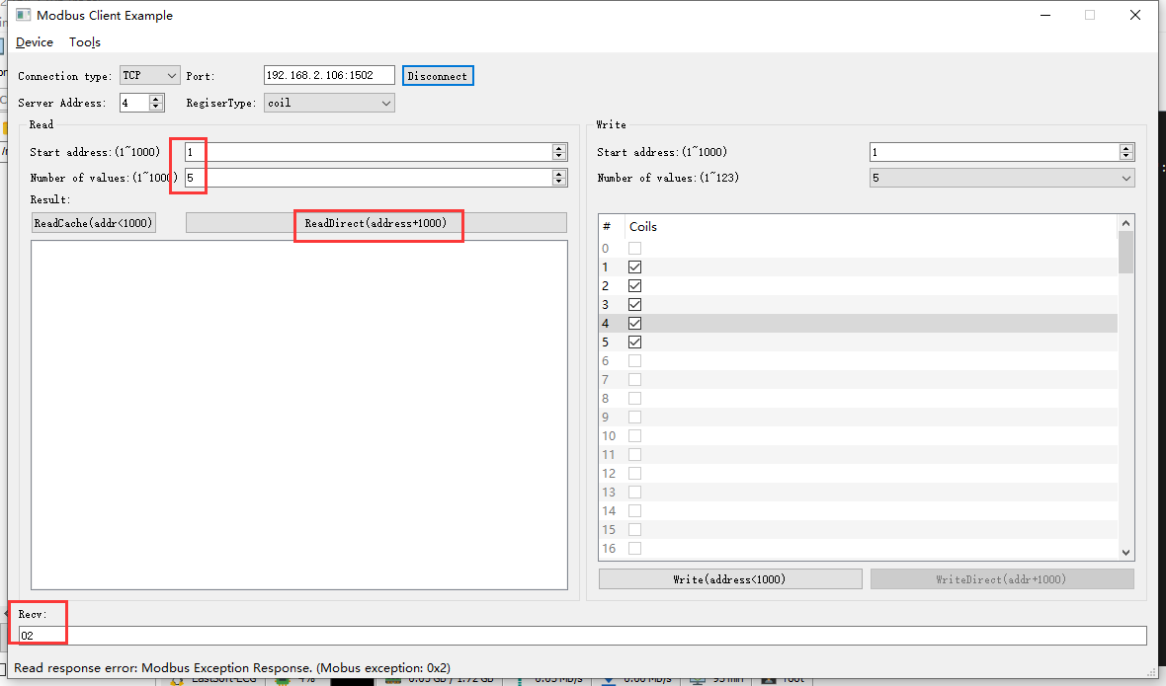

2022-05-06 14:56:53 INFO mbTcpSvr.c:363: [mbTcpTransport]rcv from 192.168.2.110:50911:

[ 00 03 00 00 00 06 04 01 03 e9 00 05 ]

2022-05-06 14:56:53 INFO mbTcpSvr.c:451: [mbTcpTransport]snd to 192.168.2.110:50911:

[ 00 03 00 00 00 03 04 81 02 ]

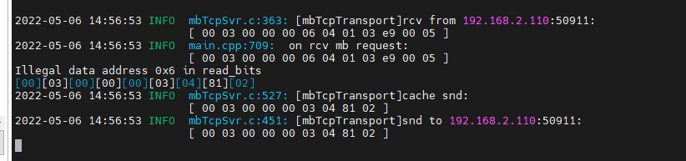

解释：回复错误。

1. 读取缓存

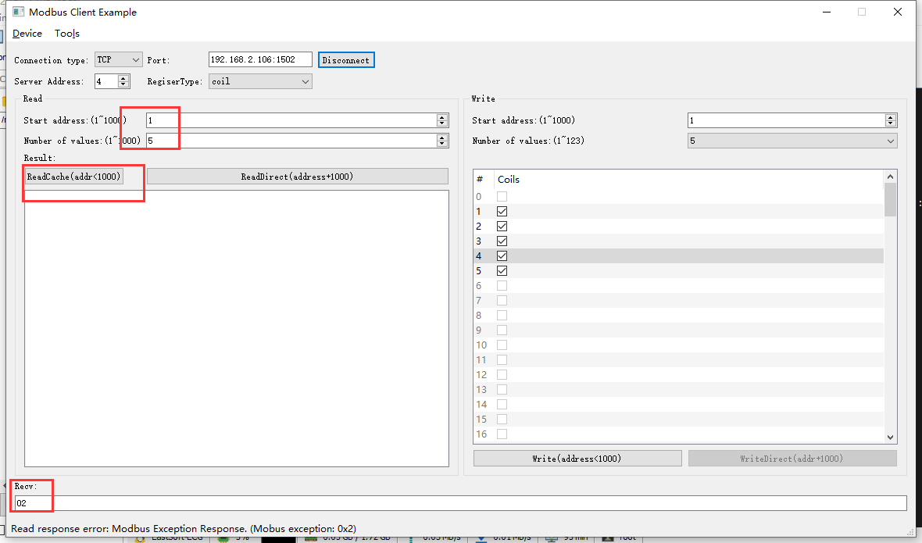2022-05-06 14:58:51 INFO mbTcpSvr.c:363: [mbTcpTransport]rcv from 192.168.2.110:50911:

[ 00 04 00 00 00 06 04 01 00 01 00 05 ]

2022-05-06 14:58:51 INFO mbTcpSvr.c:451: [mbTcpTransport]snd to 192.168.2.110:50911:

[ 00 04 00 00 00 03 04 81 02 ]

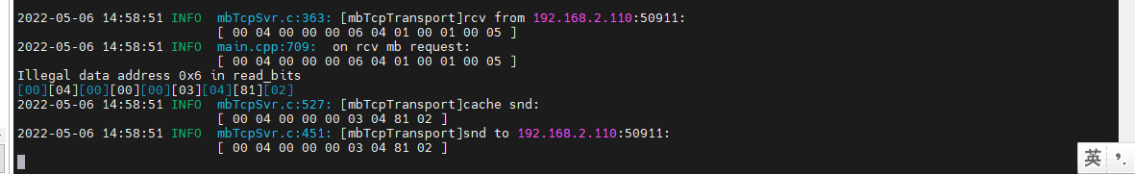

解释；回复错误。

# 联网温控器（通用功能）

此设备未验证

**说明：**根据转换程序锁支持的设备，典型选取一种测试。

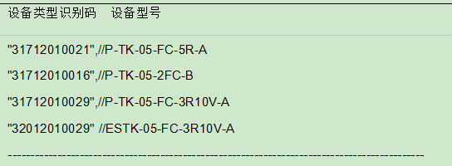

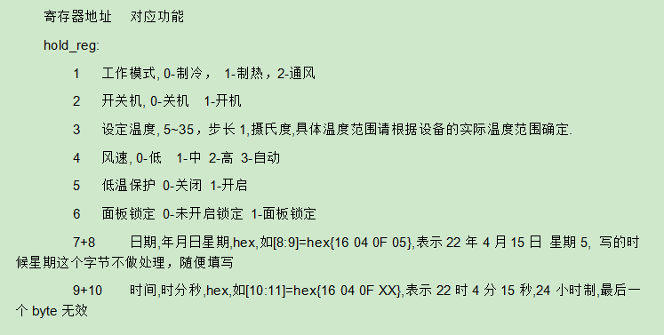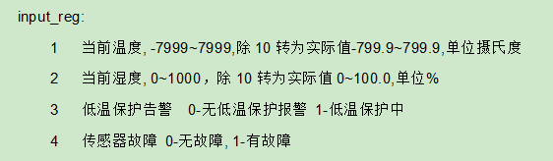

## 工作模式

### 配置为制冷模式

#### 写入

#### 直读

#### 读缓存

### 配置为制热模式

#### 写入

#### 直读

### 配置为通风模式

#### 写入

#### 直读

## 开关机

### 配置为开机

#### 写入

#### 直读

### 配置为关机

#### 写入

#### 直读

#### 读缓存

## 设定温度

**说明：**协议支持5~35，步长1，具体温度范围请根据设备的实际温度范围确定。

测试时先配置设备的温度范围为5-35，目的在于测试协议转换程序的范围。

### 配置为4度

#### 写入

#### 直读

#### 读取缓存

### 配置为5度

#### 写入

#### 直读

### 配置为20度

#### 写入

#### 直读

### 配置为35度

#### 写入

#### 直读

### 配置为36度

#### 写入

#### 直读

## 风速

### 设置低风速

#### 写入

#### 直读

#### 读缓存

### 设置中风速

#### 写入

#### 直读

### 设置高风速

#### 写入

#### 直读

## 低温保护

### 开启

#### 写入

#### 直读

#### 读缓存

### 关闭

#### 写入

#### 直读

## 面板锁定

### 开启

#### 写入

#### 直读

#### 读缓存

### 关闭

#### 写入

#### 直读

## 日期

**协议说明：**



### 读取日期

### 读取不正确日期寄存器



#### 读取8-9

#### 读取6-7

#### 读取7-9

### 写入日期

#### 写入

#### 直读

#### 读缓存

### 写入不存在的日期

#### 写入

#### 直读

## 时间

**协议说明：**



### 读取时间

### 读取不正确时间寄存器



#### 读取8-9

#### 读取10-11

#### 读取9-11

### 写入时间

#### 写入

#### 直读

#### 读缓存

### 写入不存在的时间

#### 写入

#### 直读

## 设备只读状态

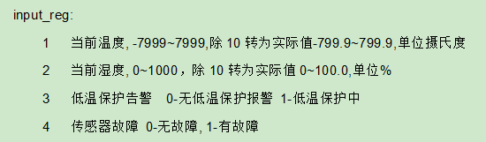

### 直读当前温度

### 读取缓存温度

### 直读低温保护

### 读取缓存低温保护状态

### 直读传感器故障

### 读取缓存传感器故障

# 计时联网型温控器ok

**说明：**根据转换程序锁支持的设备，典型选取一种测试。

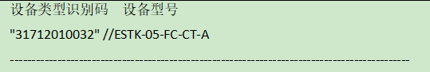

**寄存器定义：**

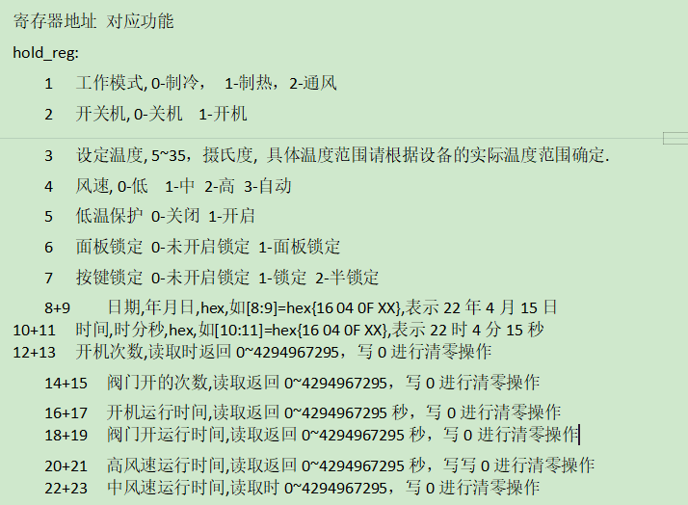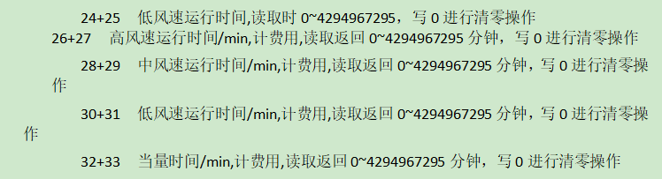

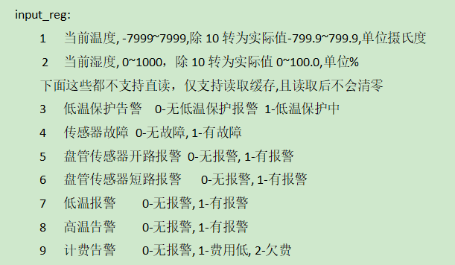

**说明：**先添加设备到网关，设备校时等操作完成后，进行测试。

查询设备modbus地址--16，设备类型31712010032

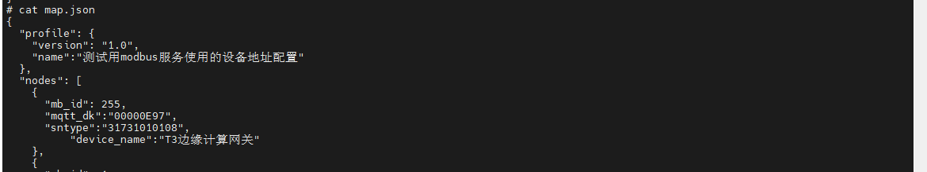

## 工作模式ok

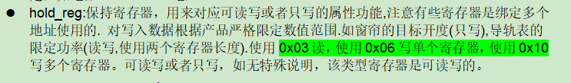

### 配置为制冷模式

1. 写入

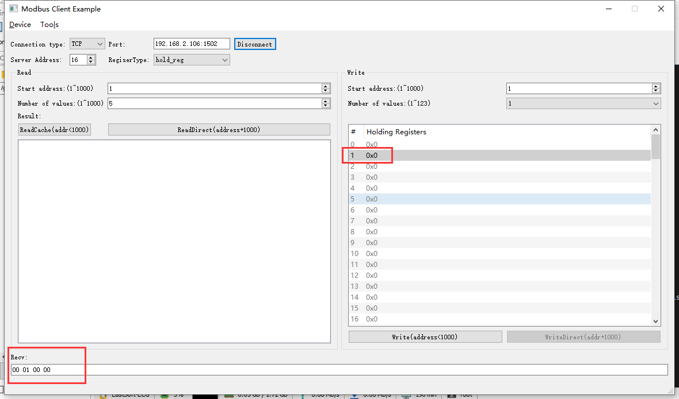2022-05-06 17:22:53 INFO mbTcpSvr.c:363: [mbTcpTransport]rcv from 192.168.2.110:54805:

[ 00 06 00 00 00 06 10 06 00 01 00 00 ]

2022-05-06 17:22:53 INFO main.cpp:709: on rcv mb request:

[ 00 06 00 00 00 06 10 06 00 01 00 00 ]

2022-05-06 17:22:53 INFO main.cpp:420: ---write 000047L1 start reg=40001, cnt=1

2022-05-06 17:22:53 DEBUG main.cpp:504: write reg[40001] to 0x0000

2022-05-06 17:22:53 DEBUG devList.cpp:664: write enum[0]=cold

2022-05-06 17:22:54 INFO mbTcpSvr.c:451: [mbTcpTransport]snd to 192.168.2.110:54805:

[ 00 06 00 00 00 06 10 06 00 01 00 00 ]

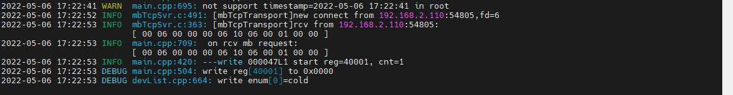



1. 直读

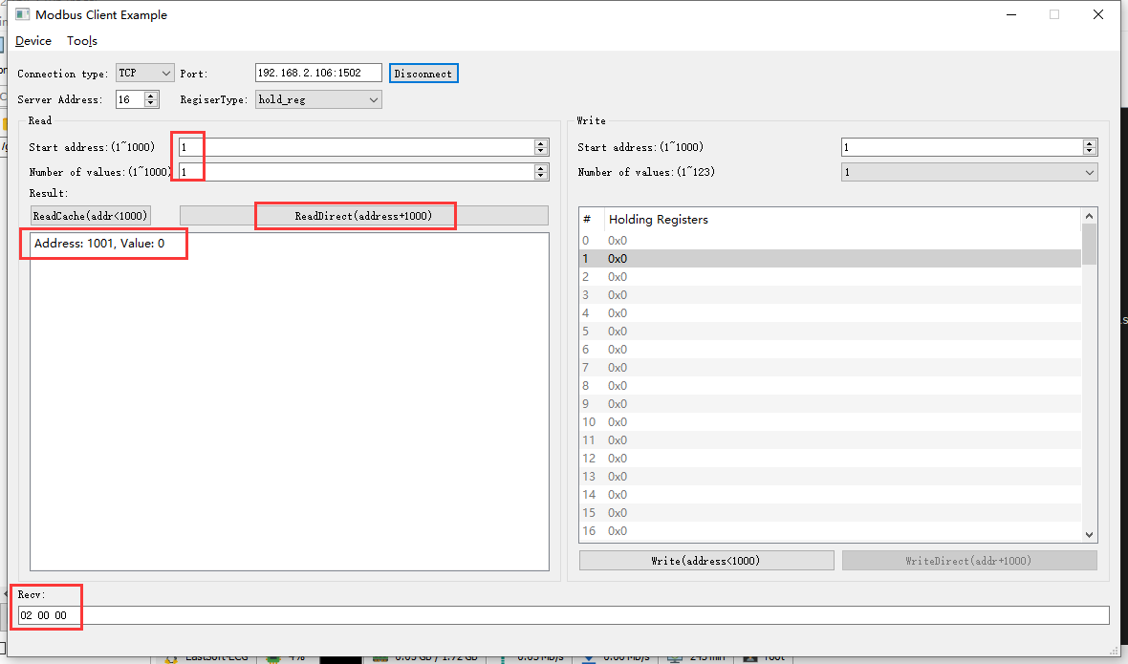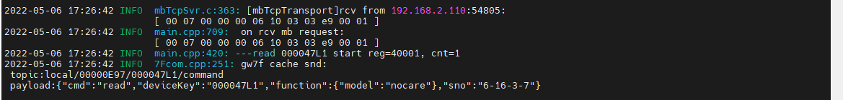

1. 读缓存

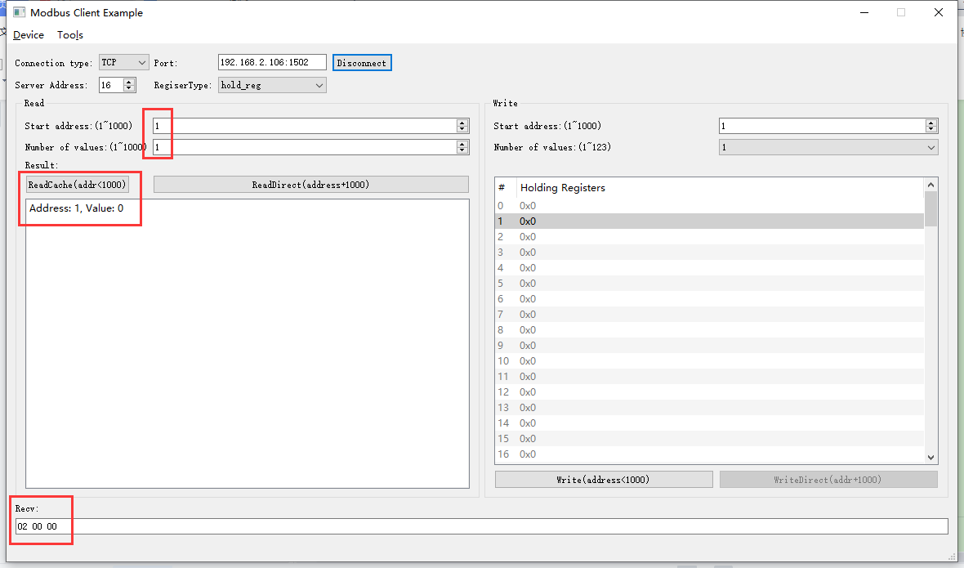2022-05-07 09:21:42 INFO mbTcpSvr.c:363: [mbTcpTransport]rcv from 192.168.2.110:56874:

[ 00 08 00 00 00 06 10 03 00 01 00 01 ]

2022-05-07 09:21:42 INFO mbTcpSvr.c:451: [mbTcpTransport]snd to 192.168.2.110:56874:

[ 00 08 00 00 00 05 10 03 02 00 00 ]

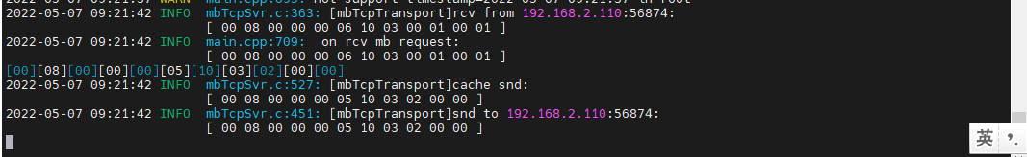

结果:读取到设备当前为制冷模式。

### 配置为制热模式



1. 写入

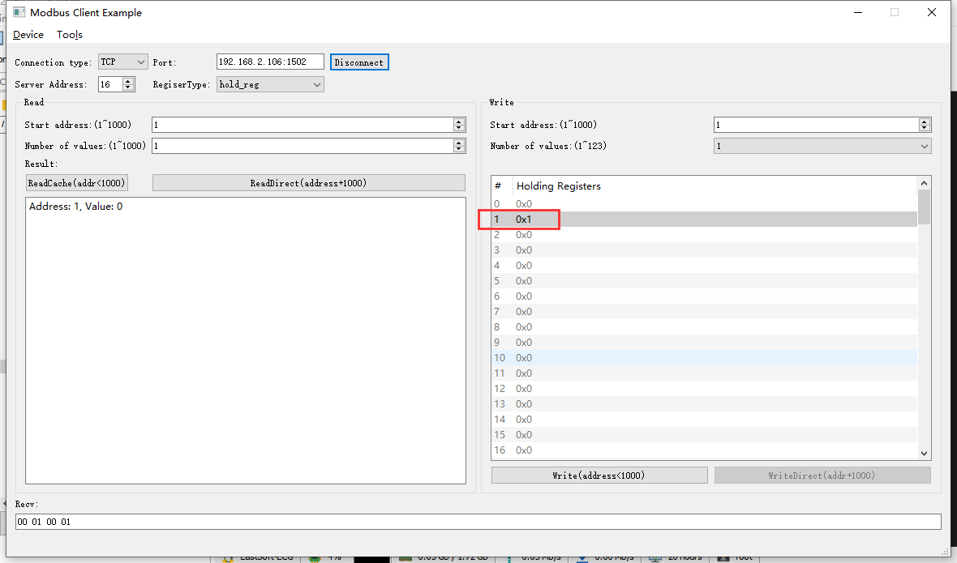2022-05-07 09:26:25 INFO mbTcpSvr.c:363: [mbTcpTransport]rcv from 192.168.2.110:56874:

[ 00 09 00 00 00 06 10 06 00 01 00 01 ]

2022-05-07 09:26:25 INFO main.cpp:709: on rcv mb request:

[ 00 09 00 00 00 06 10 06 00 01 00 01 ]

2022-05-07 09:26:25 INFO main.cpp:420: ---write 000047L1 start reg=40001, cnt=1

2022-05-07 09:26:25 DEBUG main.cpp:504: write reg[40001] to 0x0001

2022-05-07 09:26:25 DEBUG devList.cpp:664: write enum[1]=heat

2022-05-07 09:26:26 INFO mbTcpSvr.c:451: [mbTcpTransport]snd to 192.168.2.110:56874:

[ 00 09 00 00 00 06 10 06 00 01 00 01 ]

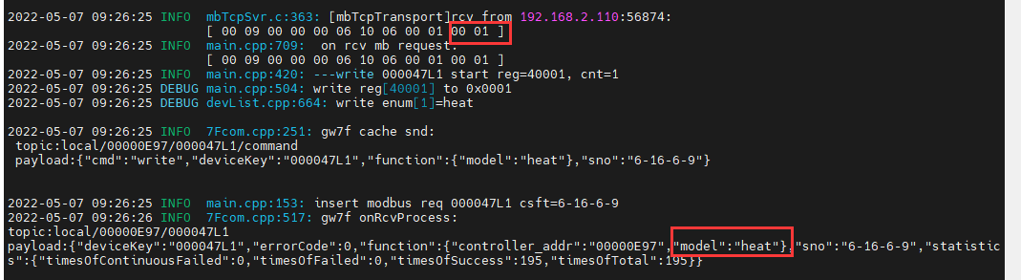

1. 直读

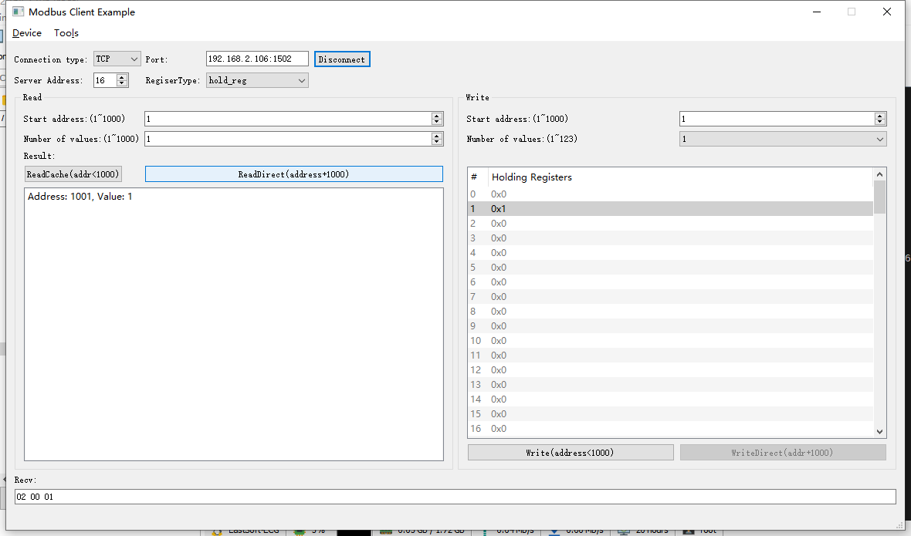2022-05-07 09:28:14 INFO mbTcpSvr.c:363: [mbTcpTransport]rcv from 192.168.2.110:56874:

[ 00 0a 00 00 00 06 10 03 03 e9 00 01 ]

2022-05-07 09:28:14 INFO main.cpp:709: on rcv mb request:

[ 00 0a 00 00 00 06 10 03 03 e9 00 01 ]

2022-05-07 09:28:14 INFO main.cpp:420: ---read 000047L1 start reg=40001, cnt=1

2022-05-07 09:28:14 INFO mbTcpSvr.c:451: [mbTcpTransport]snd to 192.168.2.110:56874:

[ 00 0a 00 00 00 05 10 03 02 00 01 ]

### 配置为通风模式



1. 写入

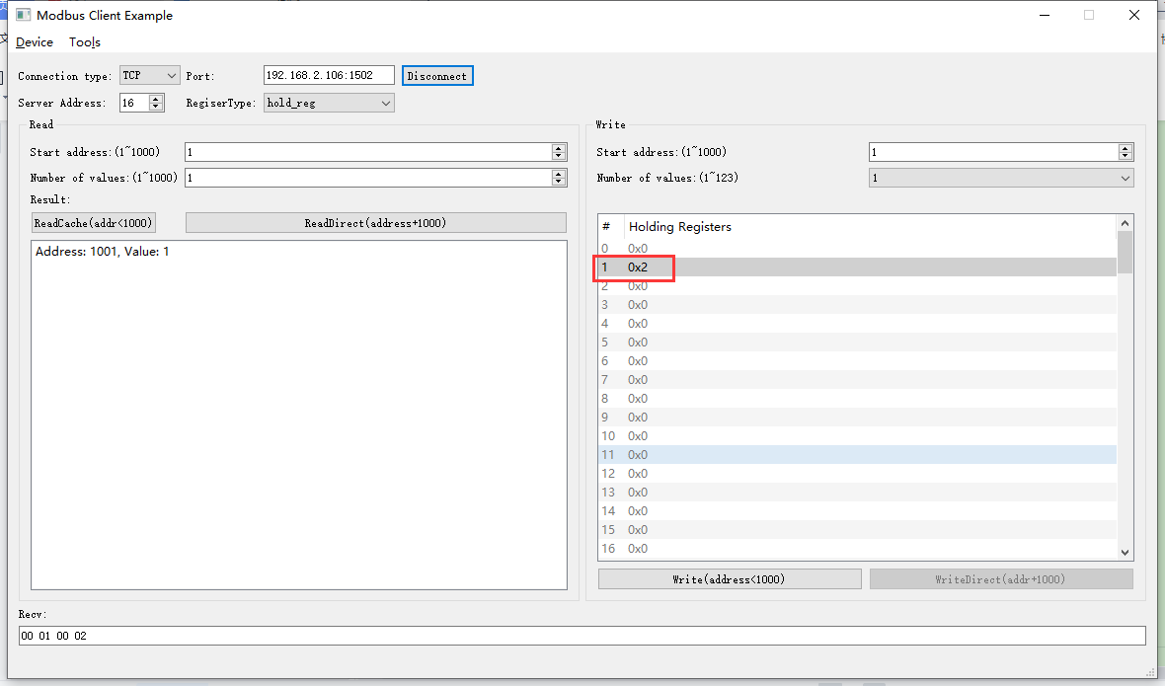2022-05-07 09:29:18 INFO mbTcpSvr.c:363: [mbTcpTransport]rcv from 192.168.2.110:56874:

[ 00 0b 00 00 00 06 10 06 00 01 00 02 ]

2022-05-07 09:29:18 INFO main.cpp:709: on rcv mb request:

[ 00 0b 00 00 00 06 10 06 00 01 00 02 ]

2022-05-07 09:29:18 INFO main.cpp:420: ---write 000047L1 start reg=40001, cnt=1

2022-05-07 09:29:18 DEBUG main.cpp:504: write reg[40001] to 0x0002

2022-05-07 09:29:18 DEBUG devList.cpp:664: write enum[2]=fan

2022-05-07 09:29:18 INFO mbTcpSvr.c:451: [mbTcpTransport]snd to 192.168.2.110:56874:

[ 00 0b 00 00 00 06 10 06 00 01 00 02 ]



1. 直读

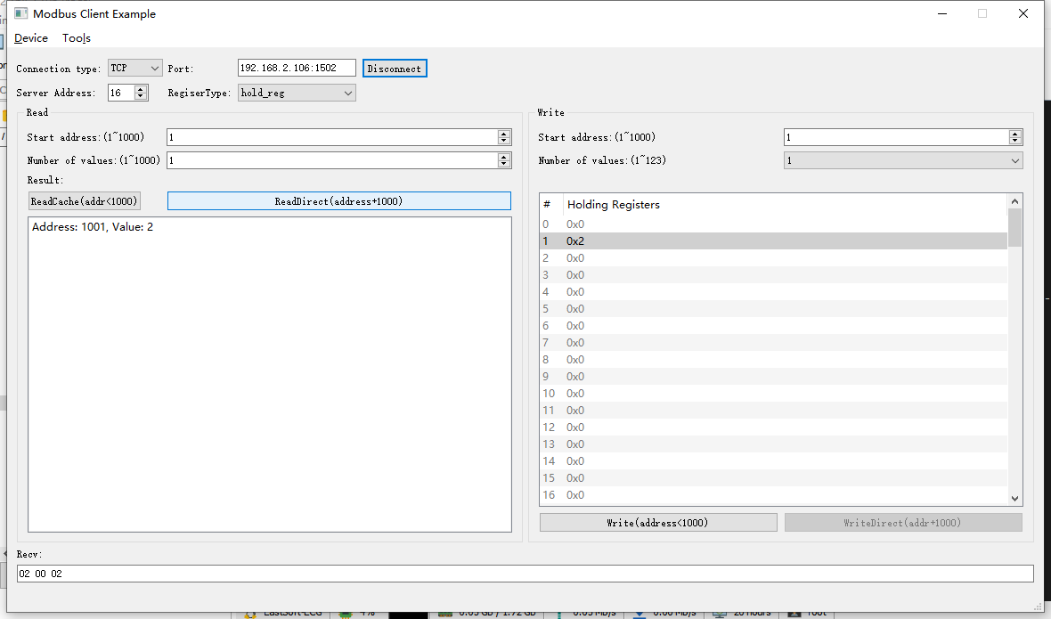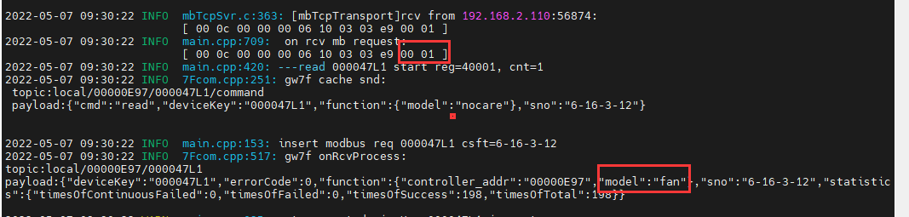

## 开关机ok





### 配置为开机

1. 写入

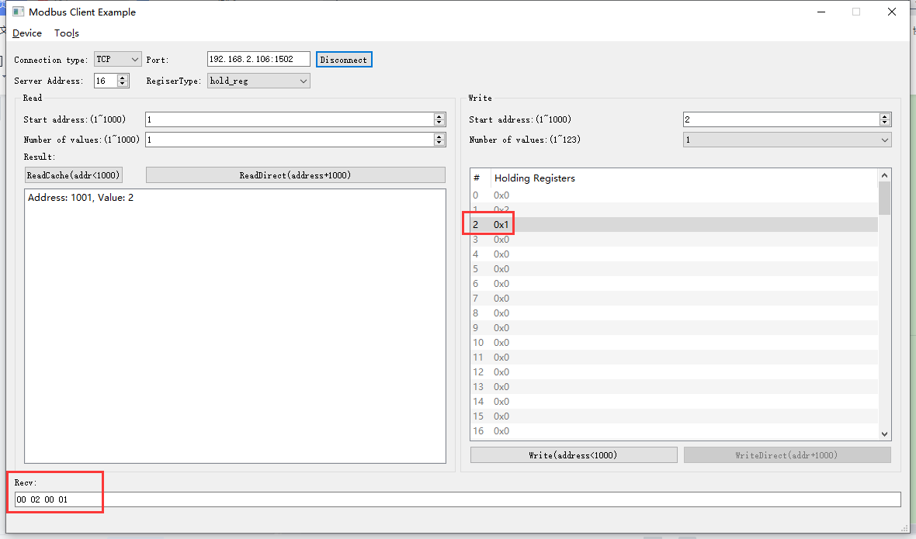2022-05-07 09:32:19 INFO mbTcpSvr.c:363: [mbTcpTransport]rcv from 192.168.2.110:56874:

[ 00 0d 00 00 00 06 10 06 00 02 00 01 ]

2022-05-07 09:32:19 INFO main.cpp:709: on rcv mb request:

[ 00 0d 00 00 00 06 10 06 00 02 00 01 ]

2022-05-07 09:32:19 INFO main.cpp:420: ---write 000047L1 start reg=40002, cnt=1

2022-05-07 09:32:19 DEBUG main.cpp:504: write reg[40002] to 0x0001

2022-05-07 09:32:19 INFO mbTcpSvr.c:451: [mbTcpTransport]snd to 192.168.2.110:56874:

[ 00 0d 00 00 00 06 10 06 00 02 00 01 ]

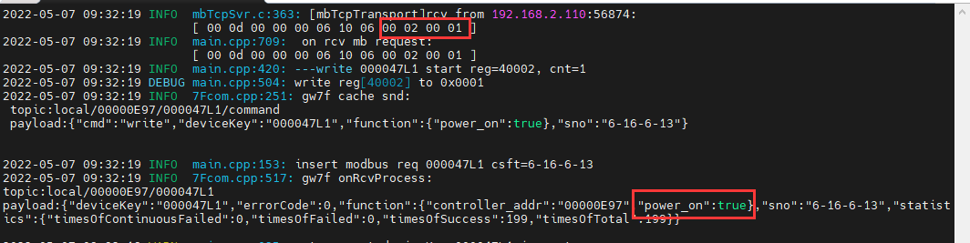

1. 直读

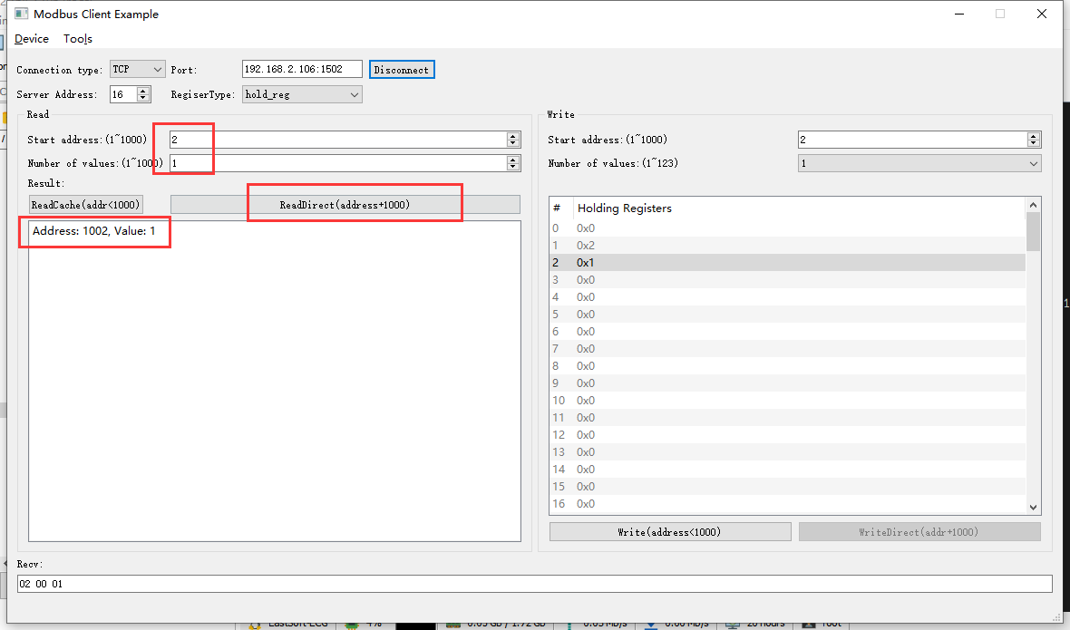2022-05-07 09:35:26 INFO mbTcpSvr.c:363: [mbTcpTransport]rcv from 192.168.2.110:56874:

[ 00 0e 00 00 00 06 10 03 03 ea 00 01 ]

2022-05-07 09:35:26 INFO main.cpp:709: on rcv mb request:

[ 00 0e 00 00 00 06 10 03 03 ea 00 01 ]

2022-05-07 09:35:26 INFO main.cpp:420: ---read 000047L1 start reg=40002, cnt=1

2022-05-07 09:35:26 INFO mbTcpSvr.c:451: [mbTcpTransport]snd to 192.168.2.110:56874:

[ 00 0e 00 00 00 05 10 03 02 00 01 ]

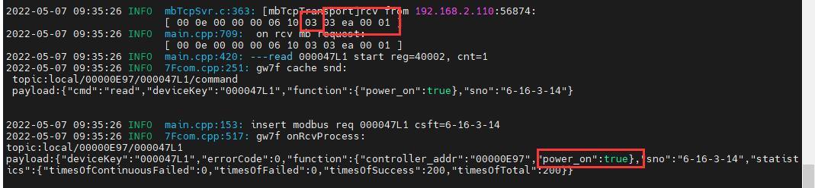

### 配置为关机

1. 写入

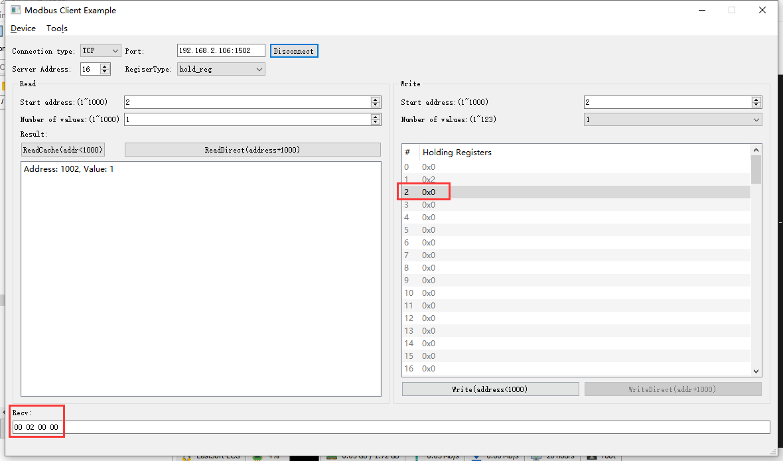2022-05-07 09:37:27 INFO mbTcpSvr.c:363: [mbTcpTransport]rcv from 192.168.2.110:56874:

[ 00 0f 00 00 00 06 10 06 00 02 00 00 ]

2022-05-07 09:37:27 INFO main.cpp:709: on rcv mb request:

[ 00 0f 00 00 00 06 10 06 00 02 00 00 ]

2022-05-07 09:37:27 INFO main.cpp:420: ---write 000047L1 start reg=40002, cnt=1

2022-05-07 09:37:27 DEBUG main.cpp:504: write reg[40002] to 0x0000

2022-05-07 09:37:27 INFO 7Fcom.cpp:251: gw7f cache snd:

topic:local/00000E97/000047L1/command

payload:{"cmd":"write","deviceKey":"000047L1","function":{"power_on":false},"sno":"6-16-6-15"}

2022-05-07 09:37:27 INFO mbTcpSvr.c:451: [mbTcpTransport]snd to 192.168.2.110:56874:

[ 00 0f 00 00 00 06 10 06 00 02 00 00 ]

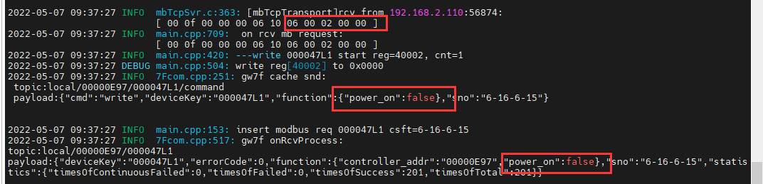

1. 直读

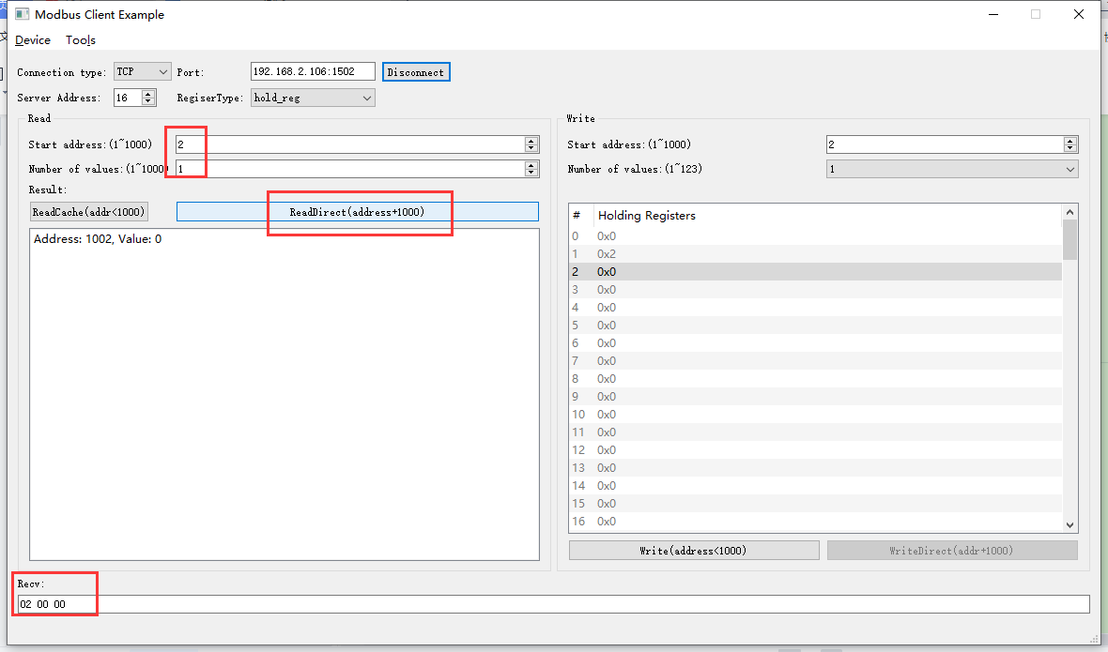2022-05-07 09:40:52 INFO mbTcpSvr.c:363: [mbTcpTransport]rcv from 192.168.2.110:56874:

[ 00 10 00 00 00 06 10 03 03 ea 00 01 ]

解析：03-读取；03 ea-直读起始地址；00 01-读取的寄存器个数

2022-05-07 09:40:52 INFO main.cpp:709: on rcv mb request:

[ 00 10 00 00 00 06 10 03 03 ea 00 01 ]

2022-05-07 09:40:52 INFO main.cpp:420: ---read 000047L1 start reg=40002, cnt=1

2022-05-07 09:40:52 INFO 7Fcom.cpp:251: gw7f cache snd:

topic:local/00000E97/000047L1/command

payload:{"cmd":"read","deviceKey":"000047L1","function":{"power_on":true},"sno":"6-16-3-16"}

2022-05-07 09:40:53 INFO mbTcpSvr.c:451: [mbTcpTransport]snd to 192.168.2.110:56874:

[ 00 10 00 00 00 05 10 03 02 00 00 ]

解析：03-读取；02-寄存器；00 00-关机状态

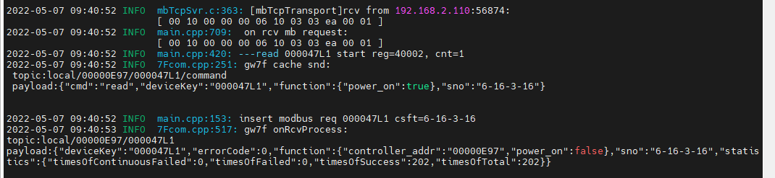

1. 读缓存

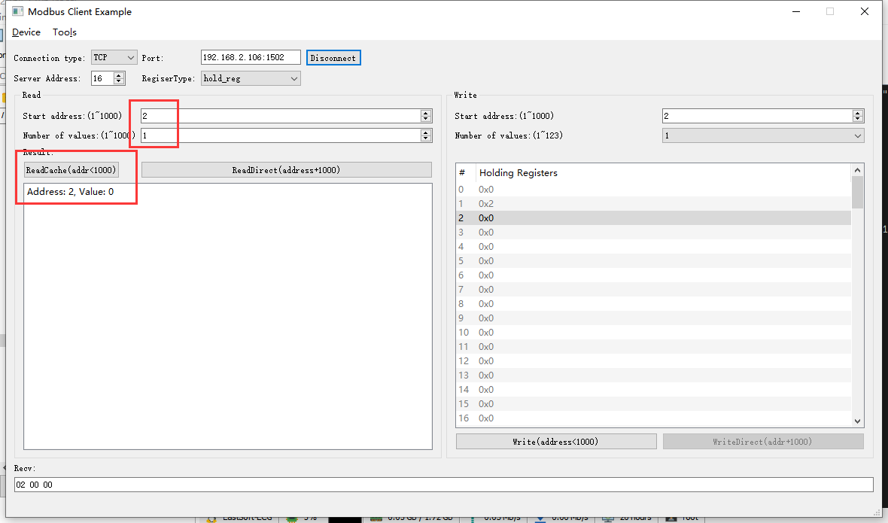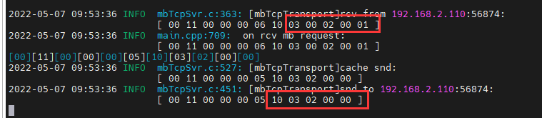

结果：读取状态为关闭。

## 风速ok

**使用的协议：**



### 低风速-0

1. 写入

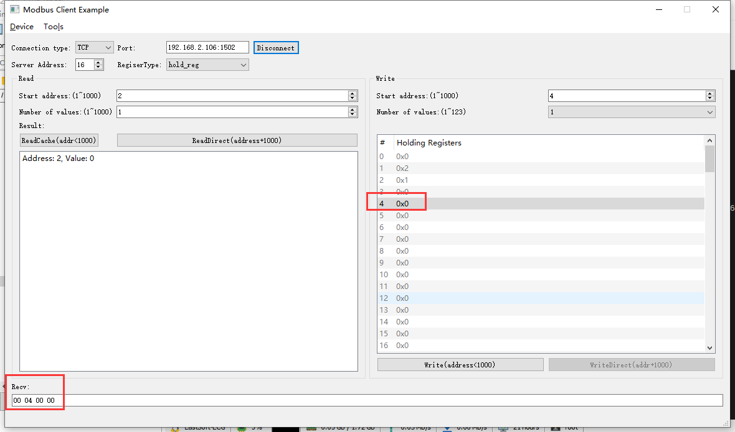2022-05-07 10:25:51 INFO mbTcpSvr.c:363: [mbTcpTransport]rcv from 192.168.2.110:58033:

[ 00 13 00 00 00 06 10 06 00 04 00 00 ]

解析：06-写单个寄存器；00 04-寄存器地址；00 00-低风速

2022-05-07 10:25:51 INFO main.cpp:709: on rcv mb request:

[ 00 13 00 00 00 06 10 06 00 04 00 00 ]

2022-05-07 10:25:51 INFO main.cpp:420: ---write 000047L1 start reg=40004, cnt=1

2022-05-07 10:25:51 DEBUG main.cpp:504: write reg[40004] to 0x0000

2022-05-07 10:25:51 DEBUG devList.cpp:664: write enum[0]=low

2022-05-07 10:25:51 INFO mbTcpSvr.c:451: [mbTcpTransport]snd to 192.168.2.110:58033:

[ 00 13 00 00 00 06 10 06 00 04 00 00 ]

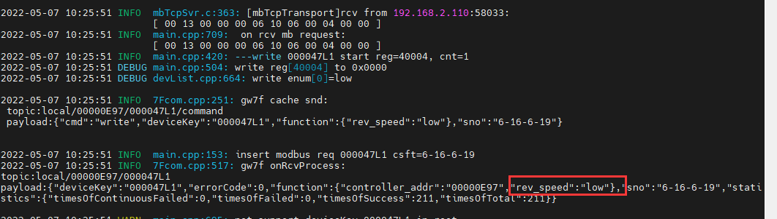

1. 直读

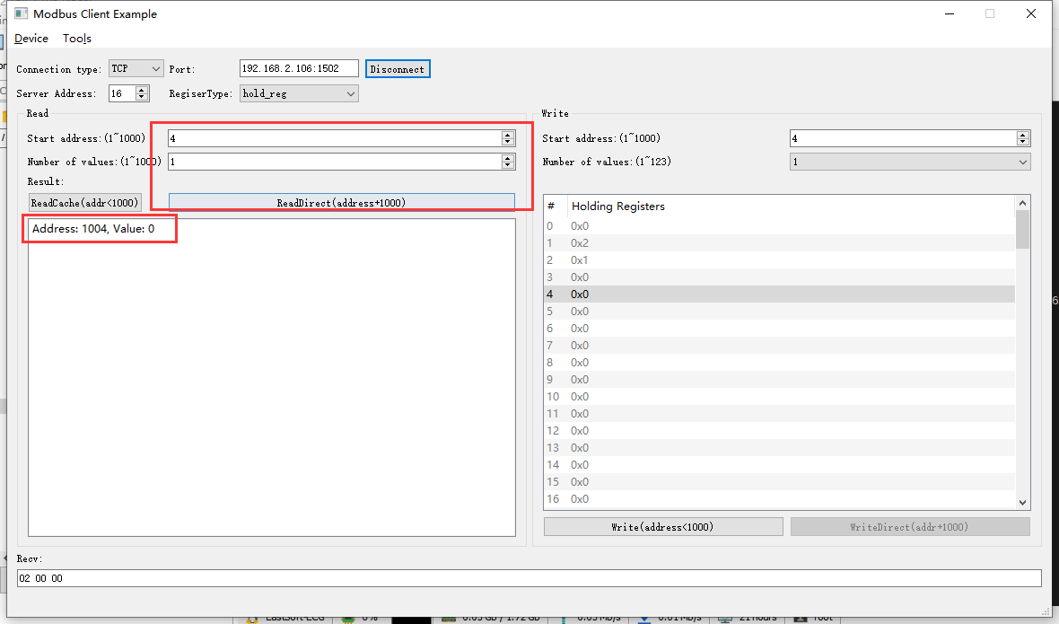2022-05-07 10:28:54 INFO mbTcpSvr.c:363: [mbTcpTransport]rcv from 192.168.2.110:58033:

[ 00 14 00 00 00 06 10 03 03 ec 00 01 ]

2022-05-07 10:28:54 INFO main.cpp:709: on rcv mb request:

[ 00 14 00 00 00 06 10 03 03 ec 00 01 ]

2022-05-07 10:28:54 INFO mbTcpSvr.c:451: [mbTcpTransport]snd to 192.168.2.110:58033:

[ 00 14 00 00 00 05 10 03 02 00 00 ]

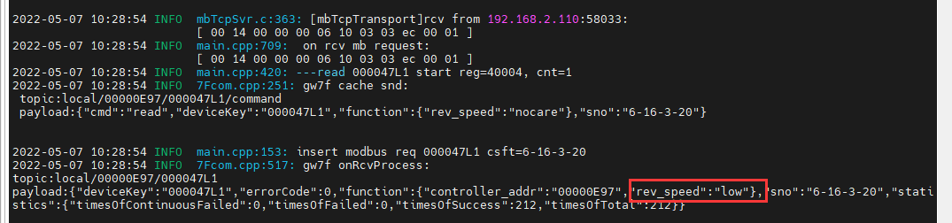

结果：读取为低风速

### 中风速-1

1. 写入

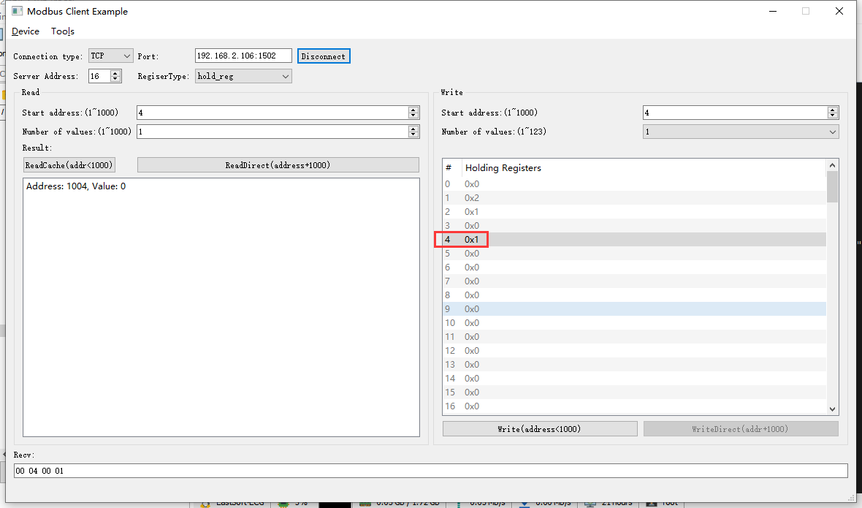2022-05-07 10:31:02 INFO mbTcpSvr.c:363: [mbTcpTransport]rcv from 192.168.2.110:58033:

[ 00 15 00 00 00 06 10 06 00 04 00 01 ]

2022-05-07 10:31:02 INFO main.cpp:709: on rcv mb request:

[ 00 15 00 00 00 06 10 06 00 04 00 01 ]

2022-05-07 10:31:02 INFO main.cpp:420: ---write 000047L1 start reg=40004, cnt=1

2022-05-07 10:31:02 DEBUG main.cpp:504: write reg[40004] to 0x0001

2022-05-07 10:31:02 DEBUG devList.cpp:664: write enum[1]=middle

2022-05-07 10:31:02 INFO mbTcpSvr.c:451: [mbTcpTransport]snd to 192.168.2.110:58033:

[ 00 15 00 00 00 06 10 06 00 04 00 01 ]

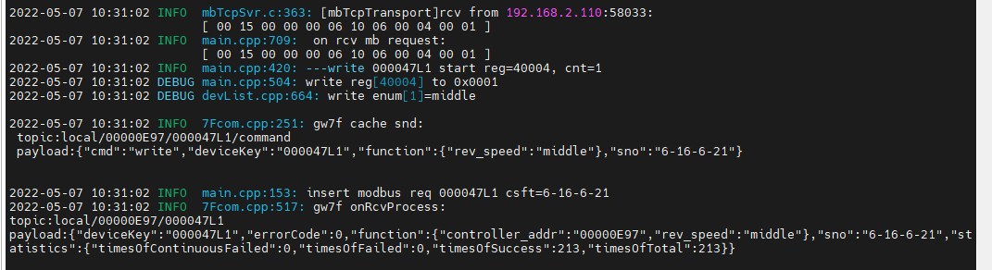

1. 直读

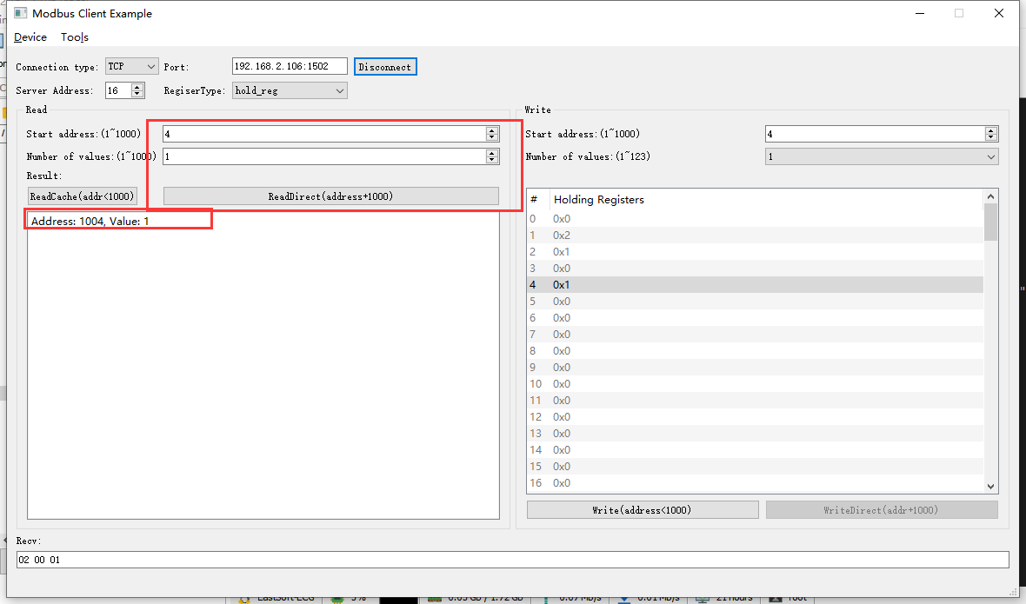2022-05-07 10:32:16 INFO mbTcpSvr.c:363: [mbTcpTransport]rcv from 192.168.2.110:58033:

[ 00 16 00 00 00 06 10 03 03 ec 00 01 ]

2022-05-07 10:32:16 INFO main.cpp:709: on rcv mb request:

[ 00 16 00 00 00 06 10 03 03 ec 00 01 ]

2022-05-07 10:32:16 INFO main.cpp:420: ---read 000047L1 start reg=40004, cnt=1

2022-05-07 10:32:16 INFO mbTcpSvr.c:451: [mbTcpTransport]snd to 192.168.2.110:58033:

[ 00 16 00 00 00 05 10 03 02 00 01 ]

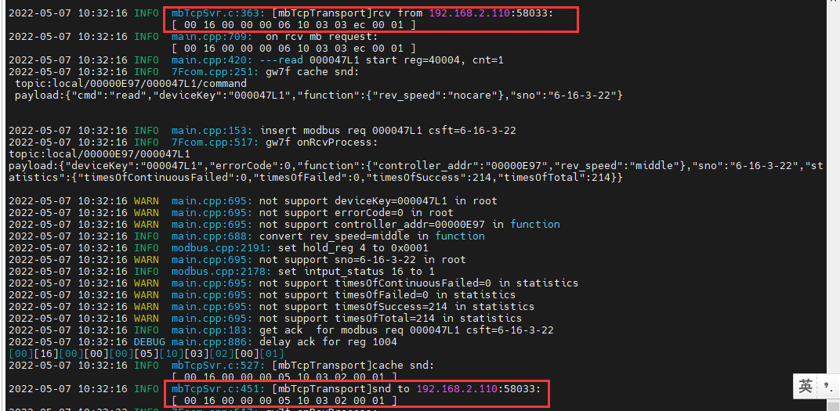

结果：读取风速为中风速。

### 高风速-2

1. 写入

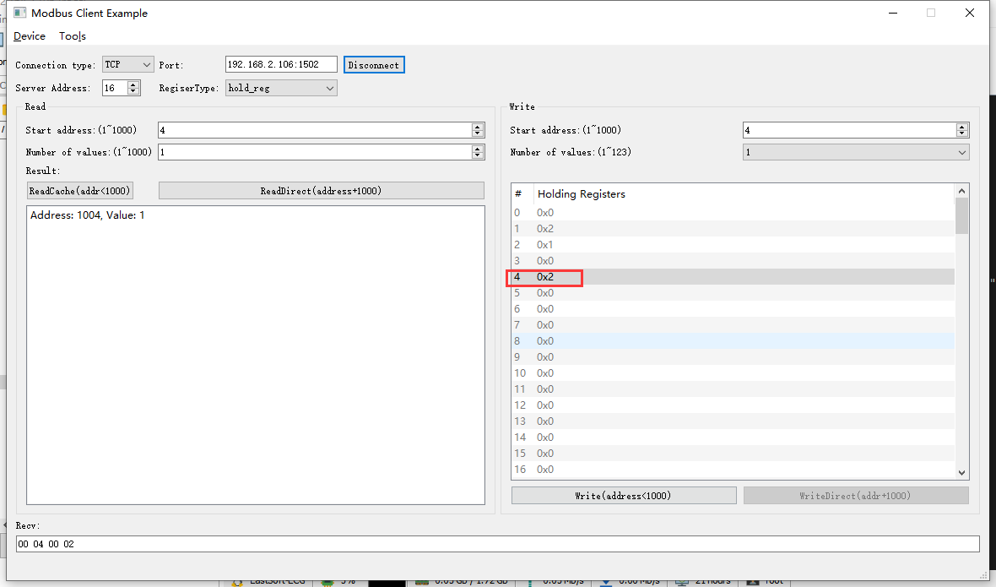2022-05-07 10:33:56 INFO mbTcpSvr.c:363: [mbTcpTransport]rcv from 192.168.2.110:58033:

[ 00 17 00 00 00 06 10 06 00 04 00 02 ]

2022-05-07 10:33:56 INFO main.cpp:709: on rcv mb request:

[ 00 17 00 00 00 06 10 06 00 04 00 02 ]

2022-05-07 10:33:56 INFO main.cpp:420: ---write 000047L1 start reg=40004, cnt=1

2022-05-07 10:33:56 DEBUG main.cpp:504: write reg[40004] to 0x0002

2022-05-07 10:33:56 DEBUG devList.cpp:664: write enum[2]=high

2022-05-07 10:33:56 INFO mbTcpSvr.c:451: [mbTcpTransport]snd to 192.168.2.110:58033:

[ 00 17 00 00 00 06 10 06 00 04 00 02 ]

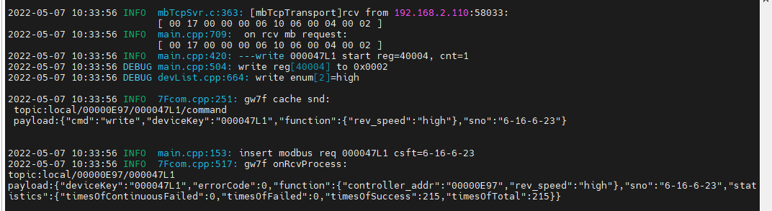

1. 直读

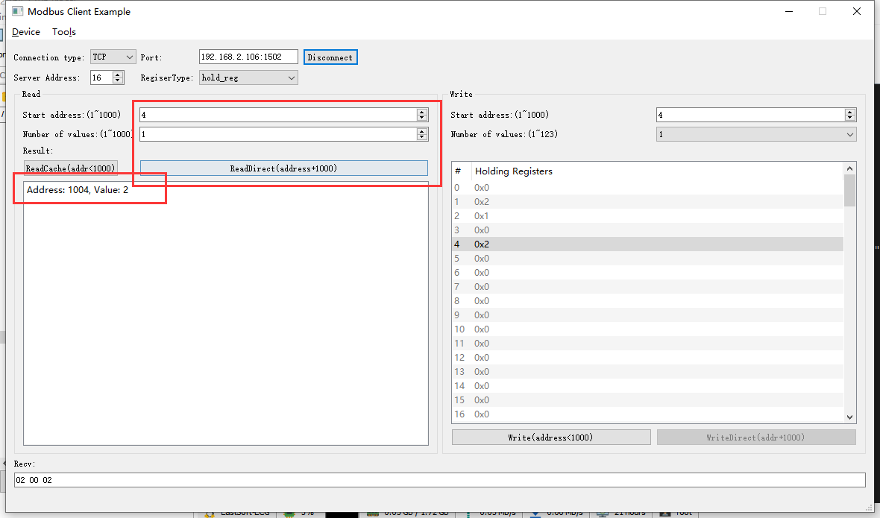2022-05-07 10:35:20 INFO mbTcpSvr.c:363: [mbTcpTransport]rcv from 192.168.2.110:58033:

[ 00 18 00 00 00 06 10 03 03 ec 00 01 ]

2022-05-07 10:35:20 INFO main.cpp:709: on rcv mb request:

[ 00 18 00 00 00 06 10 03 03 ec 00 01 ]

2022-05-07 10:35:20 INFO main.cpp:420: ---read 000047L1 start reg=40004, cnt=1

2022-05-07 10:35:20 INFO mbTcpSvr.c:451: [mbTcpTransport]snd to 192.168.2.110:58033:

[ 00 18 00 00 00 05 10 03 02 00 02 ]

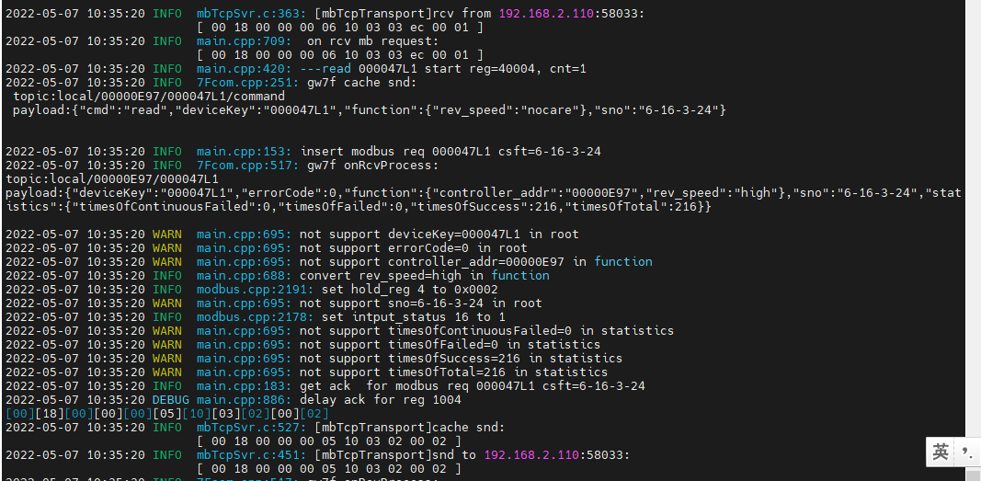

### 自动模式-3

1. 写入

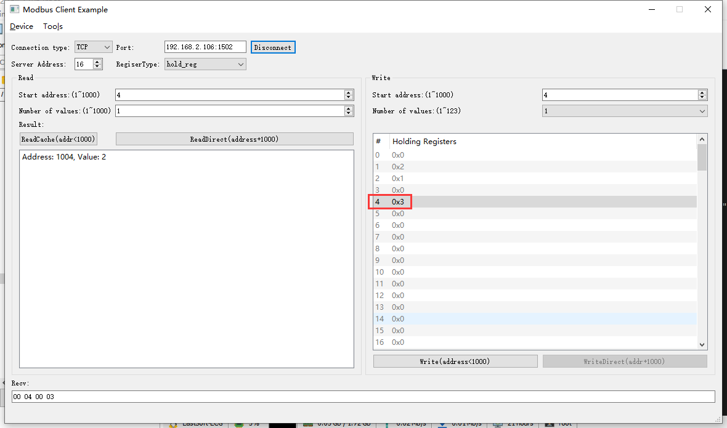2022-05-07 10:36:32 INFO mbTcpSvr.c:363: [mbTcpTransport]rcv from 192.168.2.110:58033:

[ 00 19 00 00 00 06 10 06 00 04 00 03 ]

2022-05-07 10:36:32 INFO main.cpp:709: on rcv mb request:

[ 00 19 00 00 00 06 10 06 00 04 00 03 ]

2022-05-07 10:36:32 INFO main.cpp:420: ---write 000047L1 start reg=40004, cnt=1

2022-05-07 10:36:32 DEBUG main.cpp:504: write reg[40004] to 0x0003

2022-05-07 10:36:32 DEBUG devList.cpp:664: write enum[3]=auto

2022-05-07 10:36:32 INFO mbTcpSvr.c:451: [mbTcpTransport]snd to 192.168.2.110:58033:

[ 00 19 00 00 00 06 10 06 00 04 00 03 ]

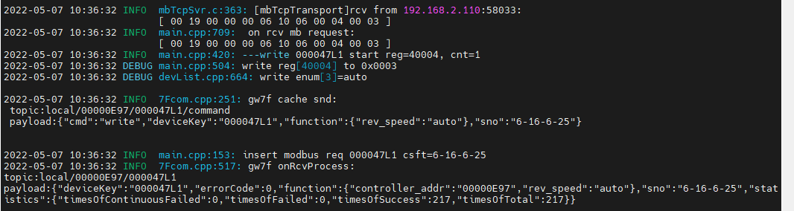

1. 直读

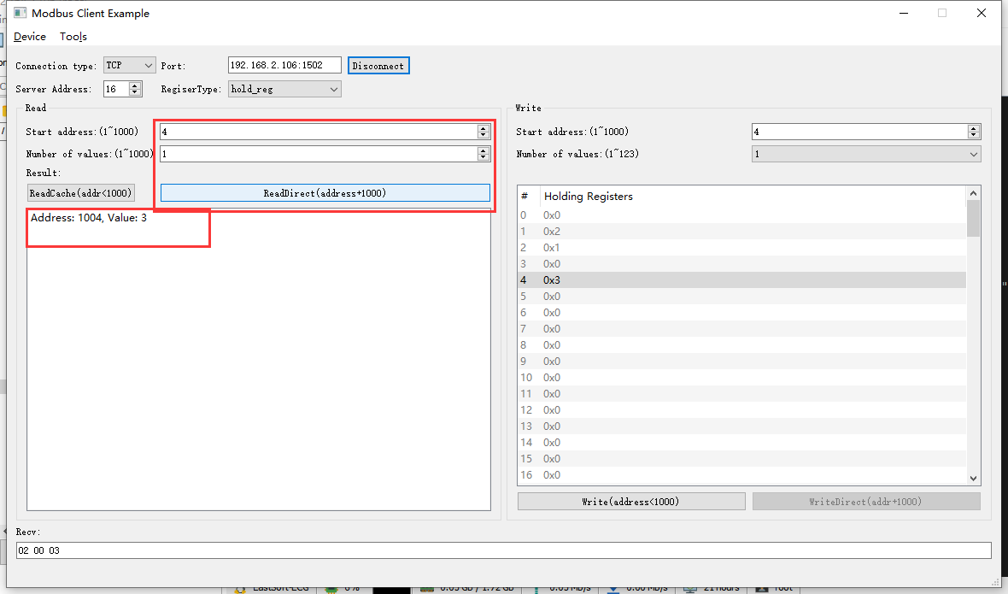2022-05-07 10:37:36 INFO mbTcpSvr.c:363: [mbTcpTransport]rcv from 192.168.2.110:58033:

[ 00 1a 00 00 00 06 10 03 03 ec 00 01 ]

2022-05-07 10:37:36 INFO main.cpp:709: on rcv mb request:

[ 00 1a 00 00 00 06 10 03 03 ec 00 01 ]

2022-05-07 10:37:36 INFO main.cpp:420: ---read 000047L1 start reg=40004, cnt=1

2022-05-07 10:37:36 INFO mbTcpSvr.c:451: [mbTcpTransport]snd to 192.168.2.110:58033:

[ 00 1a 00 00 00 05 10 03 02 00 03 ]

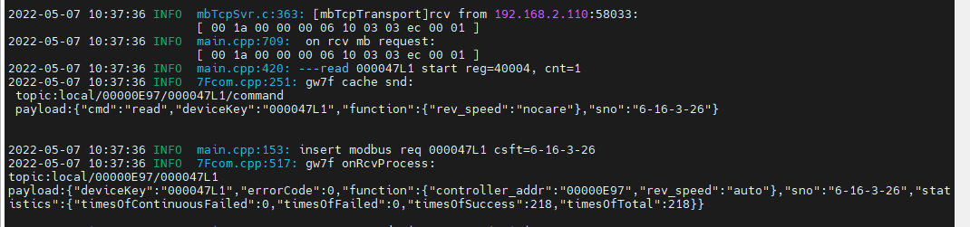

结果：读取为自动风速。

1. 读取缓存

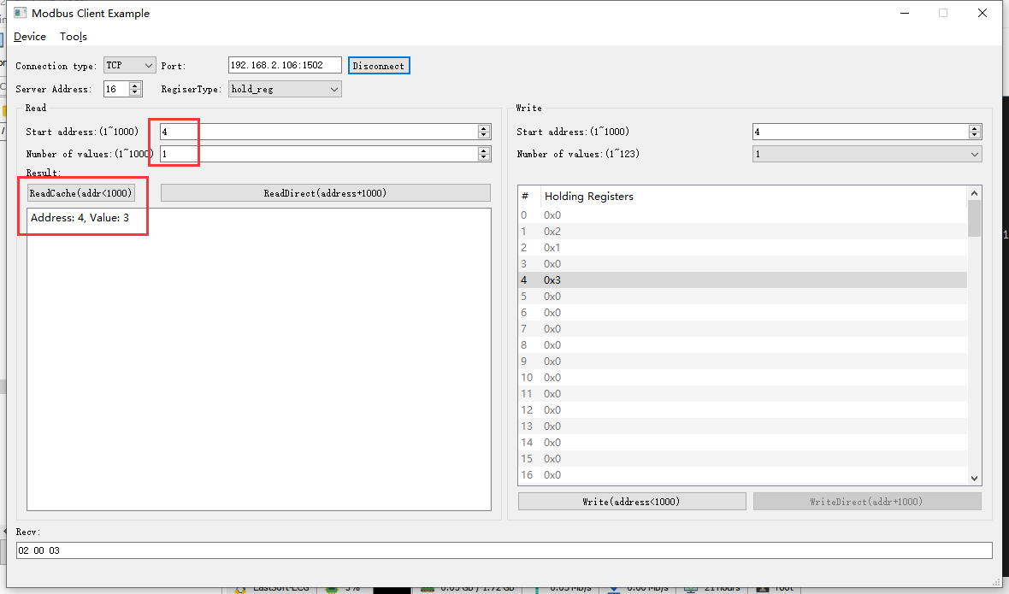2022-05-07 10:38:49 INFO mbTcpSvr.c:363: [mbTcpTransport]rcv from 192.168.2.110:58033:

[ 00 1b 00 00 00 06 10 03 00 04 00 01 ]

2022-05-07 10:38:49 INFO mbTcpSvr.c:451: [mbTcpTransport]snd to 192.168.2.110:58033:

[ 00 1b 00 00 00 05 10 03 02 00 03 ]

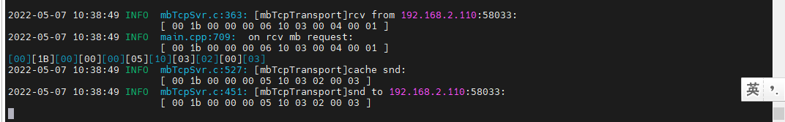结果：读取为自动风速。

## 设定温度ok

**使用的协议：**

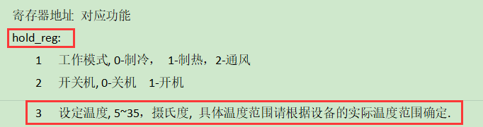

**说明：**当前设备配置的范围是16-30度

### 配置为4度

1. 写入

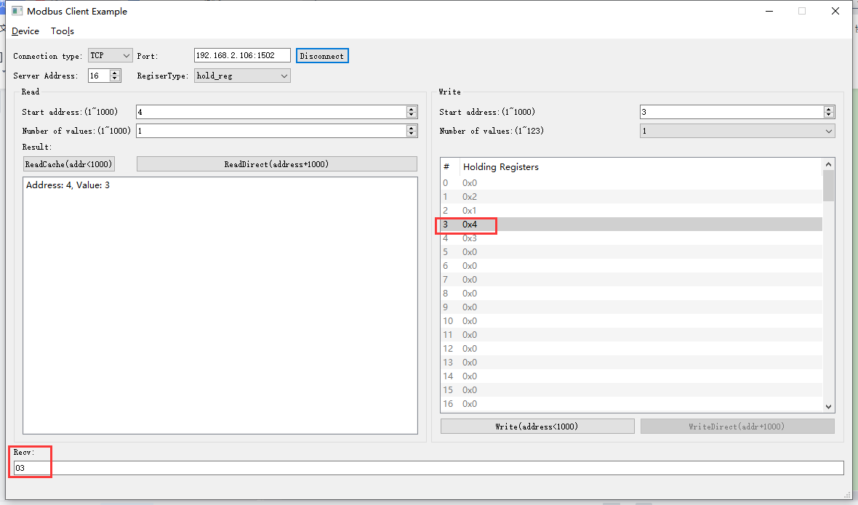2022-05-07 10:46:18 INFO mbTcpSvr.c:363: [mbTcpTransport]rcv from 192.168.2.110:58033:

[ 00 1d 00 00 00 06 10 06 00 03 00 04 ]

解析：06-写单个寄存器；00 03-写入的寄存器地址；00 04-数据，4度

2022-05-07 10:46:18 INFO main.cpp:709: on rcv mb request:

[ 00 1d 00 00 00 06 10 06 00 03 00 04 ]

2022-05-07 10:46:18 INFO main.cpp:420: ---write 000047L1 start reg=40003, cnt=1

2022-05-07 10:46:18 DEBUG main.cpp:504: write reg[40003] to 0x0004

2022-05-07 10:46:18 WARN devList.cpp:747: invalid value4.0000 to write temperature, range[5.0000, 35.0000] 解析：提示出超出范围

[00][1D][00][00][00][03][10][86][03]

2022-05-07 10:46:18 INFO mbTcpSvr.c:527: [mbTcpTransport]cache snd:

[ 00 1d 00 00 00 03 10 86 03 ]

2022-05-07 10:46:18 INFO mbTcpSvr.c:451: [mbTcpTransport]snd to 192.168.2.110:58033:

[ 00 1d 00 00 00 03 10 86 03 ]

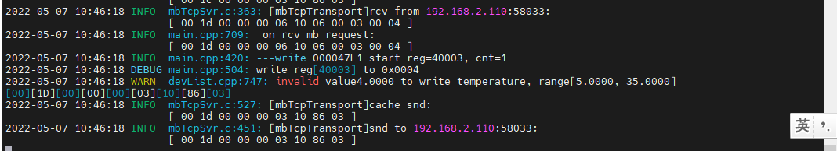

1. 直读

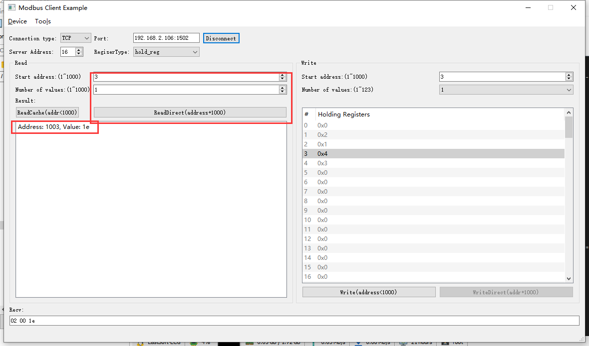2022-05-07 10:48:26 INFO mbTcpSvr.c:363: [mbTcpTransport]rcv from 192.168.2.110:58033:

[ 00 1f 00 00 00 06 10 03 03 eb 00 01 ]

解析：03 读取； 03 eb 直读起始地址1003； 00 01 读取一个寄存器；

2022-05-07 10:48:26 INFO main.cpp:709: on rcv mb request:

[ 00 1f 00 00 00 06 10 03 03 eb 00 01 ]

2022-05-07 10:48:26 INFO main.cpp:420: ---read 000047L1 start reg=40003, cnt=1

2022-05-07 10:48:26 INFO main.cpp:153: insert modbus req 000047L1 csft=6-16-3-31

2022-05-07 10:48:26 INFO 7Fcom.cpp:517: gw7f onRcvProcess:

topic:local/00000E97/000047L1

payload:{"deviceKey":"000047L1","errorCode":0,"function":{"controller_addr":"00000E97","temperature":30},"sno":"6-16-3-31","statistics":{"timesOfContinuousFailed":0,"timesOfFailed":0,"timesOfSuccess":221,"timesOfTotal":221}}

2022-05-07 10:48:26 INFO mbTcpSvr.c:451: [mbTcpTransport]snd to 192.168.2.110:58033:

[ 00 1f 00 00 00 05 10 03 02 00 1e ]

解析：03 读取； 02 长度； 00 1e 温度30度；

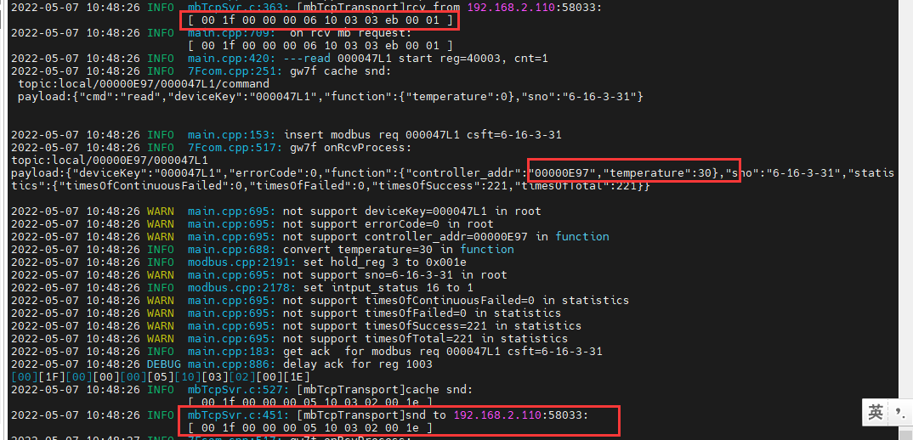

1. 读取缓存

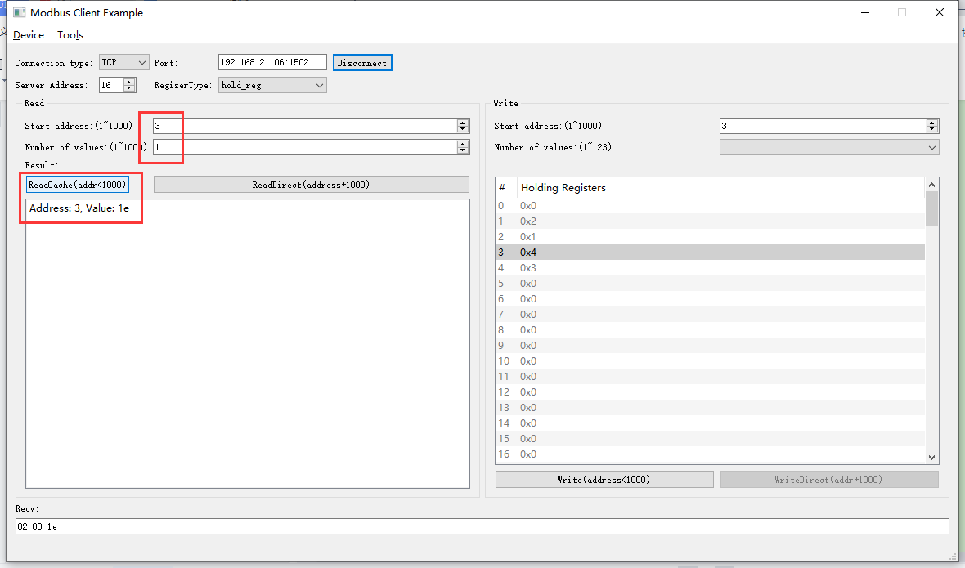

2022-05-07 10:57:20 INFO mbTcpSvr.c:363: [mbTcpTransport]rcv from 192.168.2.110:58033:

[ 00 20 00 00 00 06 10 03 00 03 00 01 ]

2022-05-07 10:57:20 INFO main.cpp:709: on rcv mb request:

[ 00 20 00 00 00 06 10 03 00 03 00 01 ]

[00][20][00][00][00][05][10][03][02][00][1E]

2022-05-07 10:57:20 INFO mbTcpSvr.c:527: [mbTcpTransport]cache snd:

[ 00 20 00 00 00 05 10 03 02 00 1e ]

2022-05-07 10:57:20 INFO mbTcpSvr.c:451: [mbTcpTransport]snd to 192.168.2.110:58033:

[ 00 20 00 00 00 05 10 03 02 00 1e ]

解析：读取温度为30度，写入超出范围的数据程序报错，并且不会影响原本的配置参数。

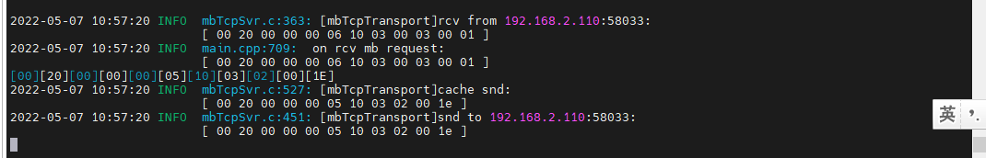

### 配置为5度

1. 写入

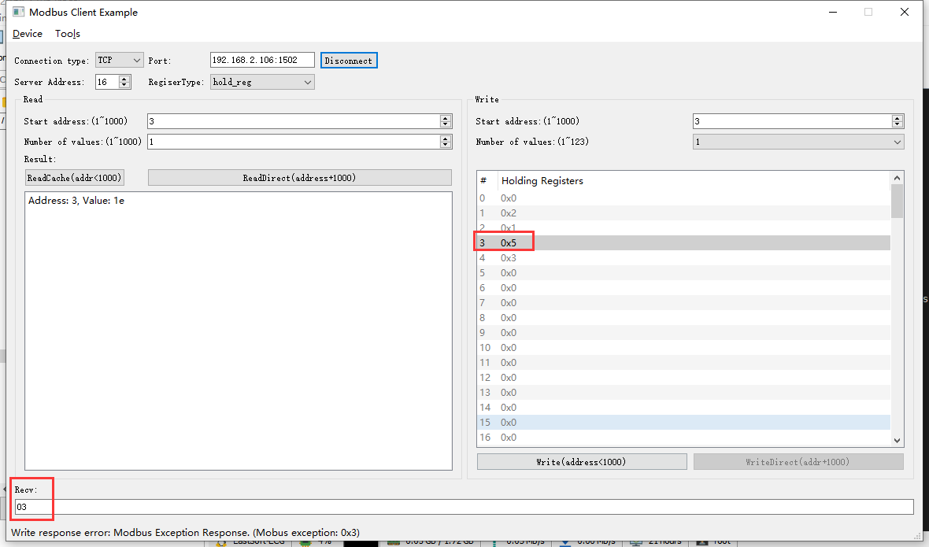2022-05-07 11:00:35 INFO mbTcpSvr.c:363: [mbTcpTransport]rcv from 192.168.2.110:58033:

[ 00 21 00 00 00 06 10 06 00 03 00 05 ] 写入5度

2022-05-07 11:00:35 INFO main.cpp:709: on rcv mb request:

[ 00 21 00 00 00 06 10 06 00 03 00 05 ]

2022-05-07 11:00:35 INFO main.cpp:420: ---write 000047L1 start reg=40003, cnt=1

2022-05-07 11:00:35 DEBUG main.cpp:504: write reg[40003] to 0x0005

2022-05-07 11:00:35 INFO mbTcpSvr.c:451: [mbTcpTransport]snd to 192.168.2.110:58033:

[ 00 21 00 00 00 03 10 86 03 ]解释：回复错误

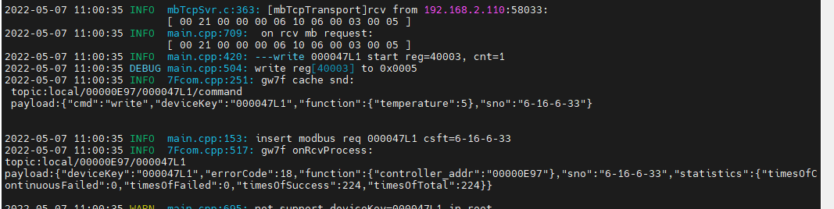

结果：当前设备本身配置的温度范围是16-30度，配置为5度超出设备的设定范围。

1. 直读

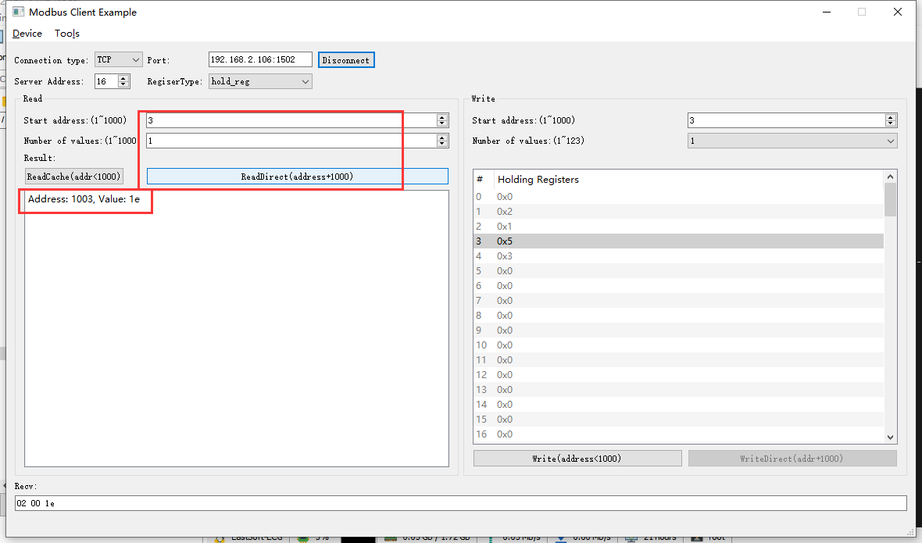

2022-05-07 11:03:45 INFO mbTcpSvr.c:363: [mbTcpTransport]rcv from 192.168.2.110:58033:

[ 00 22 00 00 00 06 10 03 03 eb 00 01 ]

2022-05-07 11:03:45 INFO main.cpp:709: on rcv mb request:

[ 00 22 00 00 00 06 10 03 03 eb 00 01 ]

2022-05-07 11:03:45 INFO main.cpp:420: ---read 000047L1 start reg=40003, cnt=1

2022-05-07 11:03:45 INFO mbTcpSvr.c:451: [mbTcpTransport]snd to 192.168.2.110:58033:

[ 00 22 00 00 00 05 10 03 02 00 1e ]

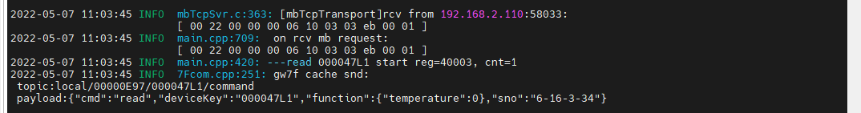

结果：设置超出设备温度范围的值，程序报错，并且不会影响原来的配置。

### 配置为16度

1. 写入

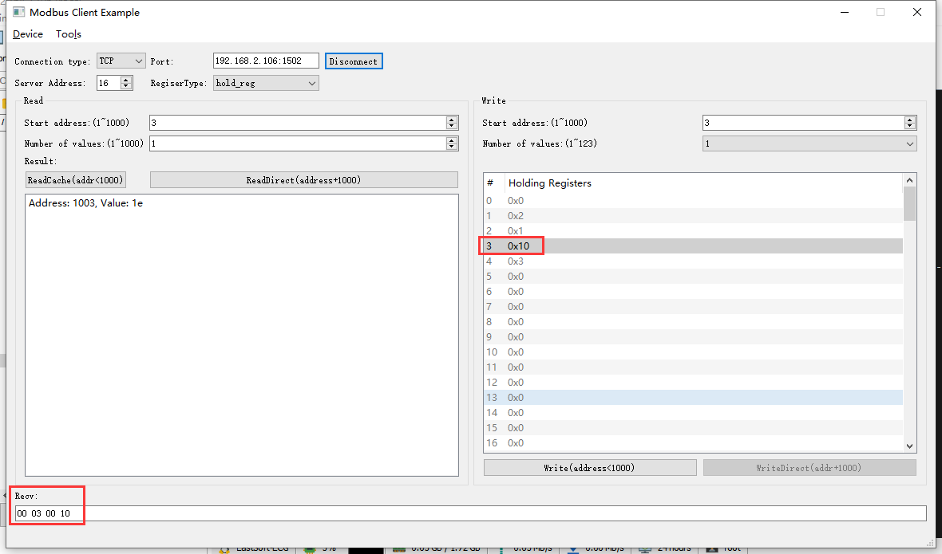2022-05-07 14:21:09 INFO mbTcpSvr.c:363: [mbTcpTransport]rcv from 192.168.2.104:63289:

[ 00 24 00 00 00 06 10 06 00 03 00 10 ]

2022-05-07 14:21:09 INFO main.cpp:709: on rcv mb request:

[ 00 24 00 00 00 06 10 06 00 03 00 10 ]

2022-05-07 14:21:09 INFO main.cpp:420: ---write 000047L1 start reg=40003, cnt=1

2022-05-07 14:21:09 DEBUG main.cpp:504: write reg[40003] to 0x0010

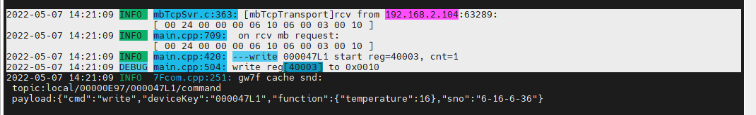2022-05-07 14:21:09 INFO mbTcpSvr.c:451: [mbTcpTransport]snd to 192.168.2.104:63289:

[ 00 24 00 00 00 06 10 06 00 03 00 10 ]

解释：写入0x16,16度

1. 直读

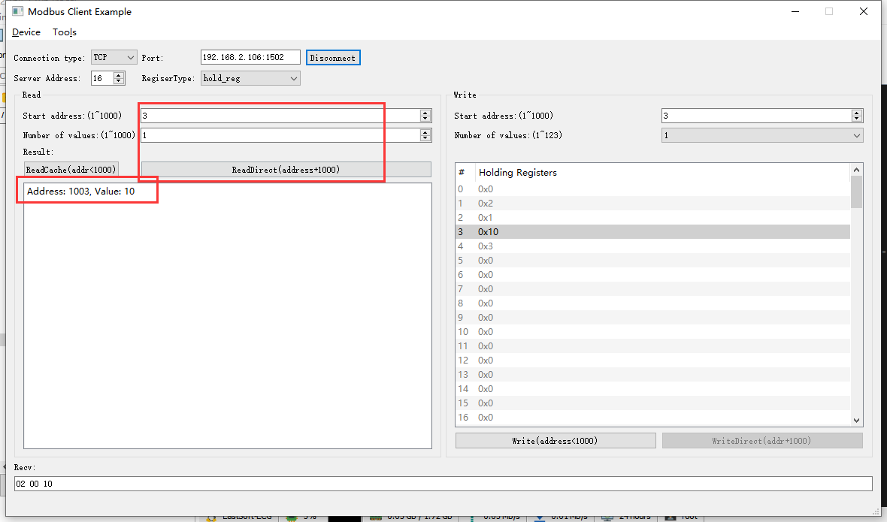2022-05-07 14:23:17 INFO mbTcpSvr.c:363: [mbTcpTransport]rcv from 192.168.2.104:63289:

[ 00 25 00 00 00 06 10 03 03 eb 00 01 ]

2022-05-07 14:23:17 INFO main.cpp:709: on rcv mb request:

[ 00 25 00 00 00 06 10 03 03 eb 00 01 ]

2022-05-07 14:23:17 INFO main.cpp:420: ---read 000047L1 start reg=40003, cnt=1

2022-05-07 14:23:17 INFO main.cpp:153: insert modbus req 000047L1 csft=6-16-3-37

2022-05-07 14:23:17 INFO 7Fcom.cpp:517: gw7f onRcvProcess:

topic:local/00000E97/000047L1

payload:{"deviceKey":"000047L1","errorCode":0,"function":{"controller_addr":"00000E97","temperature":16},"sno":"6-16-3-37","statistics":{"timesOfContinuousFailed":0,"timesOfFailed":0,"timesOfSuccess":263,"timesOfTotal":263}}

2022-05-07 14:23:17 INFO mbTcpSvr.c:451: [mbTcpTransport]snd to 192.168.2.104:63289:

[ 00 25 00 00 00 05 10 03 02 00 10 ]

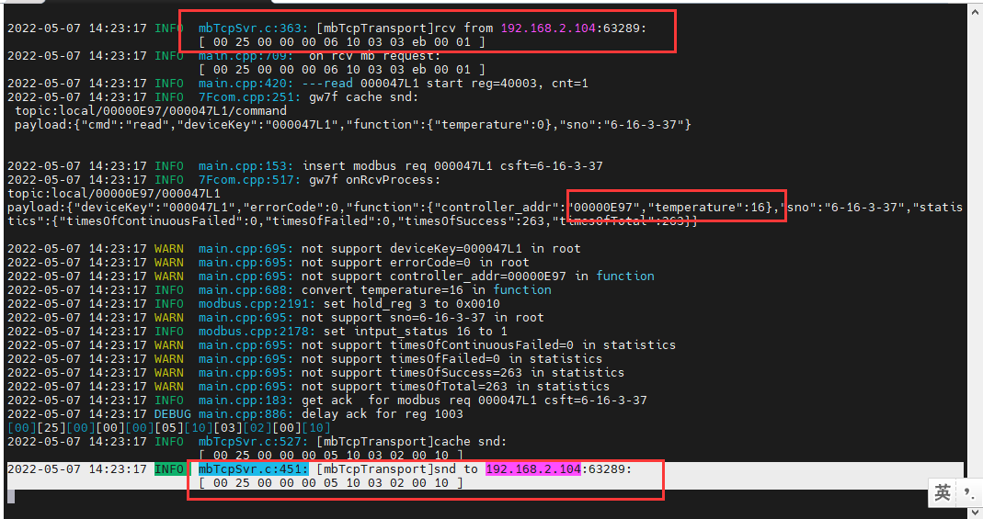

结果：读取到设置温度为16度，与配置的一致。

### 配置为30度

1. 写入

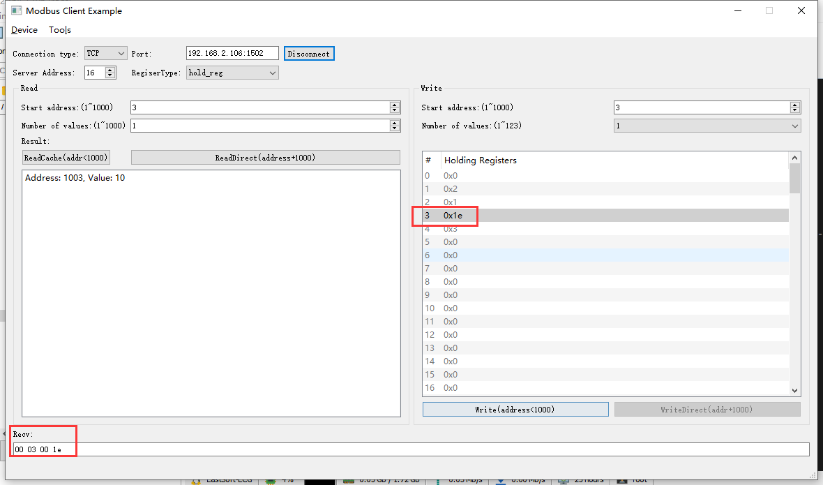2022-05-07 14:31:14 INFO mbTcpSvr.c:363: [mbTcpTransport]rcv from 192.168.2.104:63289:

[ 00 26 00 00 00 06 10 06 00 03 00 1e ]

2022-05-07 14:31:14 INFO main.cpp:709: on rcv mb request:

[ 00 26 00 00 00 06 10 06 00 03 00 1e ]

2022-05-07 14:31:14 INFO main.cpp:420: ---write 000047L1 start reg=40003, cnt=1

2022-05-07 14:31:14 DEBUG main.cpp:504: write reg[40003] to 0x001e

2022-05-07 14:31:14 INFO main.cpp:153: insert modbus req 000047L1 csft=6-16-6-38

2022-05-07 14:31:14 INFO 7Fcom.cpp:517: gw7f onRcvProcess:

topic:local/00000E97/000047L1

payload:{"deviceKey":"000047L1","errorCode":0,"function":{"controller_addr":"00000E97","temperature":30},"sno":"6-16-6-38","statistics":{"timesOfContinuousFailed":0,"timesOfFailed":0,"timesOfSuccess":265,"timesOfTotal":265}}

2022-05-07 14:31:14 INFO mbTcpSvr.c:451: [mbTcpTransport]snd to 192.168.2.104:63289:

[ 00 26 00 00 00 06 10 06 00 03 00 1e ]

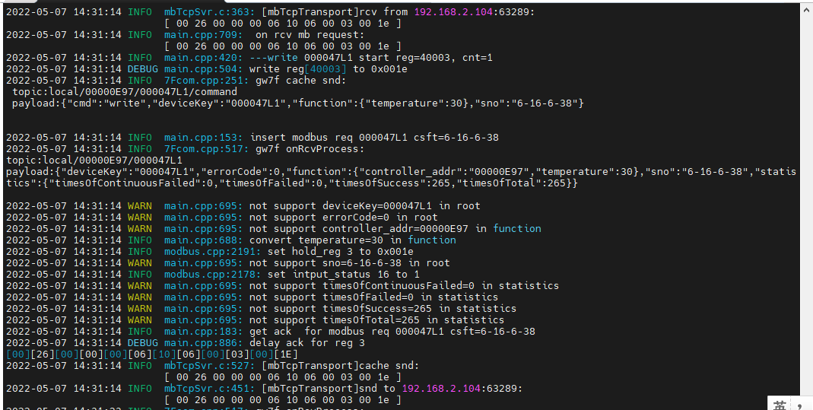

结果：写入30度成功。

1. 直读

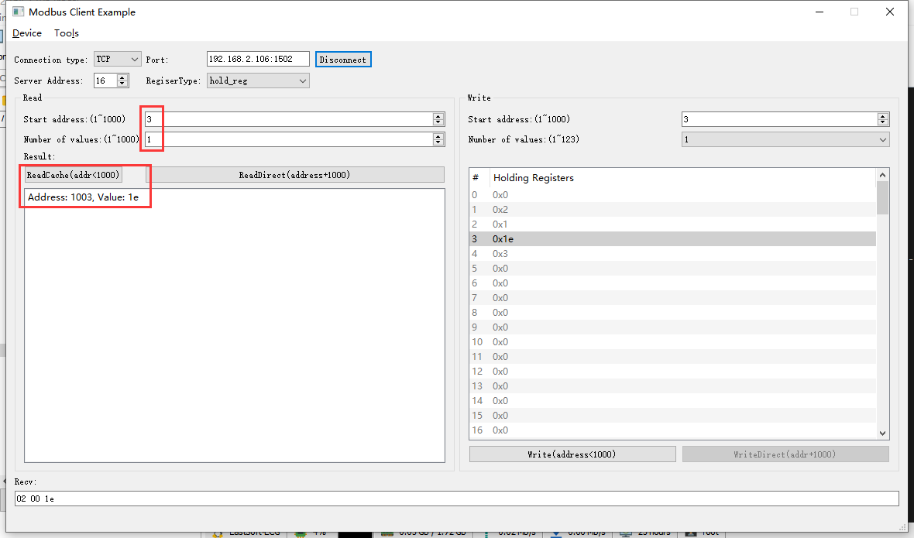2022-05-07 14:33:15 INFO mbTcpSvr.c:363: [mbTcpTransport]rcv from 192.168.2.104:63289:

[ 00 27 00 00 00 06 10 03 03 eb 00 01 ]

2022-05-07 14:33:15 INFO main.cpp:709: on rcv mb request:

[ 00 27 00 00 00 06 10 03 03 eb 00 01 ]

2022-05-07 14:33:15 INFO main.cpp:420: ---read 000047L1 start reg=40003, cnt=1

2022-05-07 14:33:16 INFO 7Fcom.cpp:517: gw7f onRcvProcess:

topic:local/00000E97/000047L1

payload:{"deviceKey":"000047L1","errorCode":0,"function":{"controller_addr":"00000E97","temperature":30},"sno":"6-16-3-39","statistics":{"timesOfContinuousFailed":0,"timesOfFailed":0,"timesOfSuccess":266,"timesOfTotal":266}}

2022-05-07 14:33:16 INFO mbTcpSvr.c:451: [mbTcpTransport]snd to 192.168.2.104:63289:

[ 00 27 00 00 00 05 10 03 02 00 1e ]

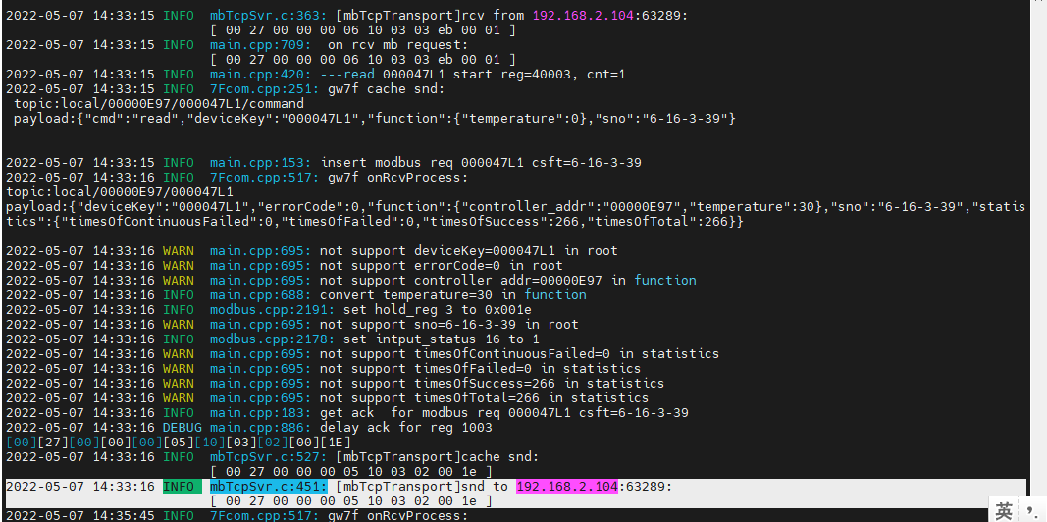

结果：读取到0x1e，十进制为30度。

### 配置为35度

**说明：**当前设备本身的温度设定范围是16-35度。



1. 写入

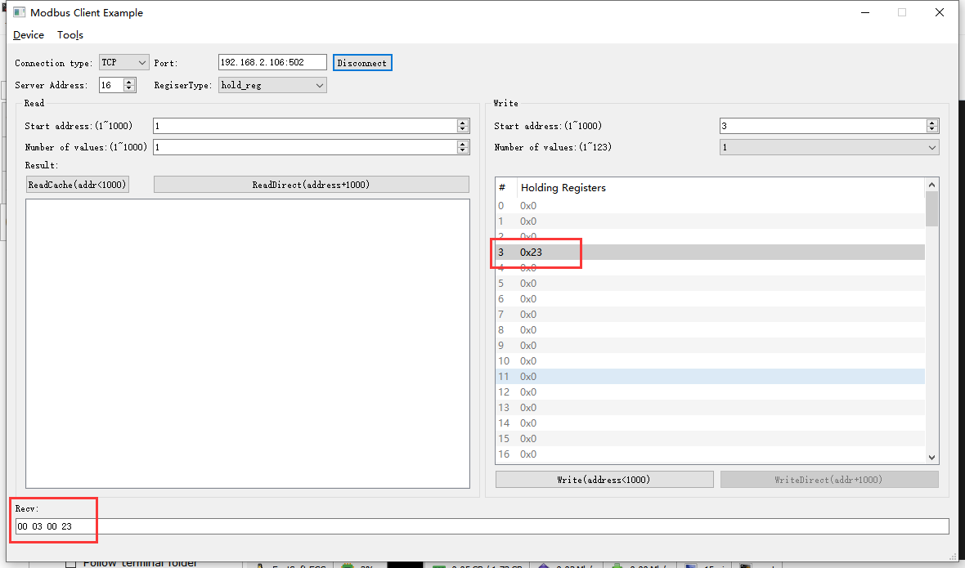2022-05-16 15:12:34 INFO mbTcpSvr.c:363: [mbTcpTransport]rcv from 192.168.2.104:56835:

[ 00 02 00 00 00 06 10 06 00 03 00 23 ]

2022-05-16 15:12:34 INFO main.cpp:709: on rcv mb request:

[ 00 02 00 00 00 06 10 06 00 03 00 23 ]

2022-05-16 15:12:34 INFO main.cpp:420: ---write 00009TMI start reg=40003, cnt=1

2022-05-16 15:12:34 DEBUG main.cpp:504: write reg[40003] to 0x0023

2022-05-16 15:12:34 INFO 7Fcom.cpp:517: gw7f onRcvProcess:

topic:local/00000E97/00009TMI

payload:{"cmd":"write","deviceKey":"00009TMI","errorCode":0,"function":{"controller_addr":"00000E97","temperature":35},"sno":"6-16-6-2","statistics":{"timesOfContinuousFailed":0,"timesOfFailed":0,"timesOfSuccess":3,"timesOfTotal":3}}

2022-05-16 15:12:34 INFO mbTcpSvr.c:451: [mbTcpTransport]snd to 192.168.2.104:56835:

[ 00 02 00 00 00 06 10 06 00 03 00 23 ]

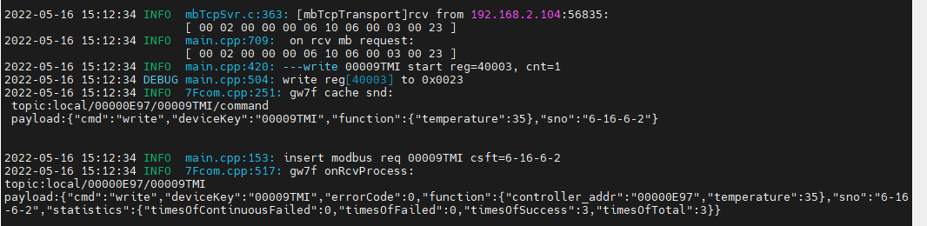

结果：写入成功。

1. 直读

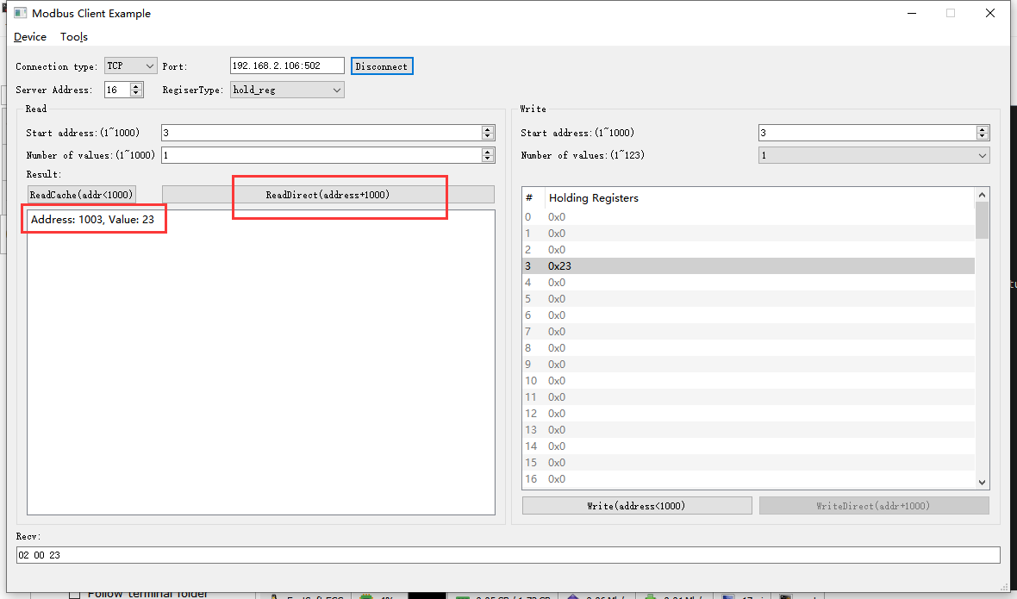

2022-05-16 15:14:24 INFO mbTcpSvr.c:363: [mbTcpTransport]rcv from 192.168.2.104:56835:

[ 00 03 00 00 00 06 10 03 03 eb 00 01 ]

2022-05-16 15:14:24 INFO main.cpp:709: on rcv mb request:

[ 00 03 00 00 00 06 10 03 03 eb 00 01 ]

2022-05-16 15:14:24 INFO main.cpp:420: ---read 00009TMI start reg=40003, cnt=1

2022-05-16 15:14:24 INFO 7Fcom.cpp:517: gw7f onRcvProcess:

topic:local/00000E97/00009TMI

payload:{"cmd":"read","deviceKey":"00009TMI","errorCode":0,"function":{"controller_addr":"00000E97","temperature":35},"sno":"6-16-3-3","statistics":{"timesOfContinuousFailed":0,"timesOfFailed":0,"timesOfSuccess":4,"timesOfTotal":4}}

2022-05-16 15:14:24 INFO mbTcpSvr.c:451: [mbTcpTransport]snd to 192.168.2.104:56835:

[ 00 03 00 00 00 05 10 03 02 00 23 ]

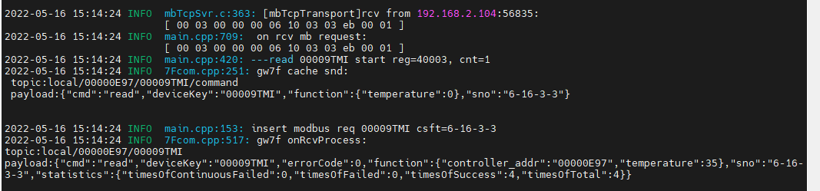

结果：读取到的值与写入的一致。

### 配置为36度

1. 写入

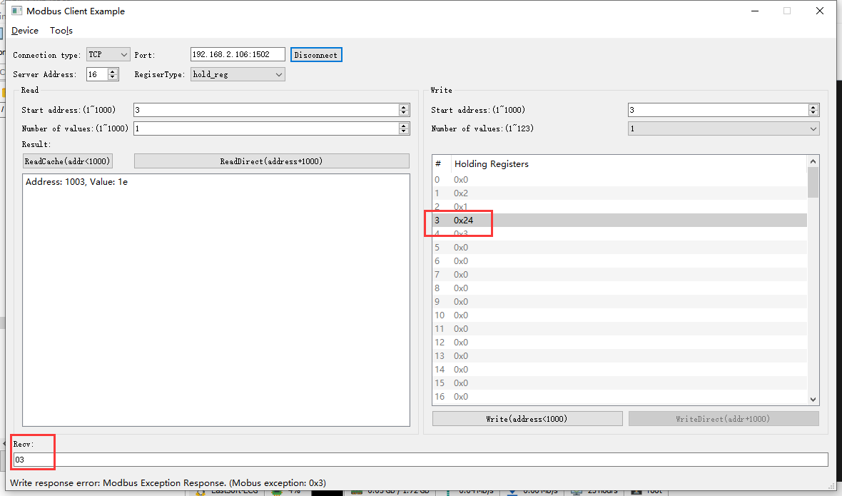2022-05-07 15:15:13 INFO mbTcpSvr.c:363: [mbTcpTransport]rcv from 192.168.2.104:63950:

[ 00 2b 00 00 00 06 10 06 00 03 00 24 ]

2022-05-07 15:15:13 INFO mbTcpSvr.c:451: [mbTcpTransport]snd to 192.168.2.104:63950:

[ 00 2b 00 00 00 03 10 86 03 ]

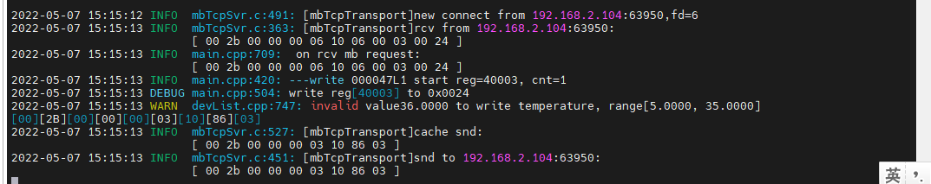

结果：写入超出范围的温度，程序回复错误。

1. 直读

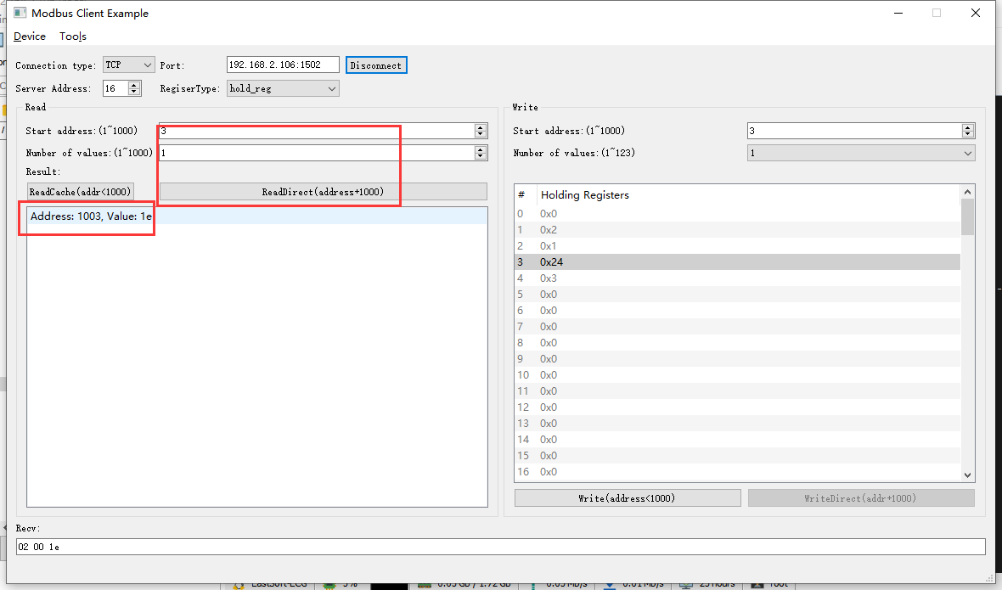2022-05-07 15:17:03 INFO mbTcpSvr.c:363: [mbTcpTransport]rcv from 192.168.2.104:63950:

[ 00 2c 00 00 00 06 10 03 03 eb 00 01 ]

2022-05-07 15:17:03 INFO main.cpp:709: on rcv mb request:

[ 00 2c 00 00 00 06 10 03 03 eb 00 01 ]

2022-05-07 15:17:03 INFO main.cpp:420: ---read 000047L1 start reg=40003, cnt=1

2022-05-07 15:17:04 INFO mbTcpSvr.c:451: [mbTcpTransport]snd to 192.168.2.104:63950:

[ 00 2c 00 00 00 05 10 03 02 00 1e ]

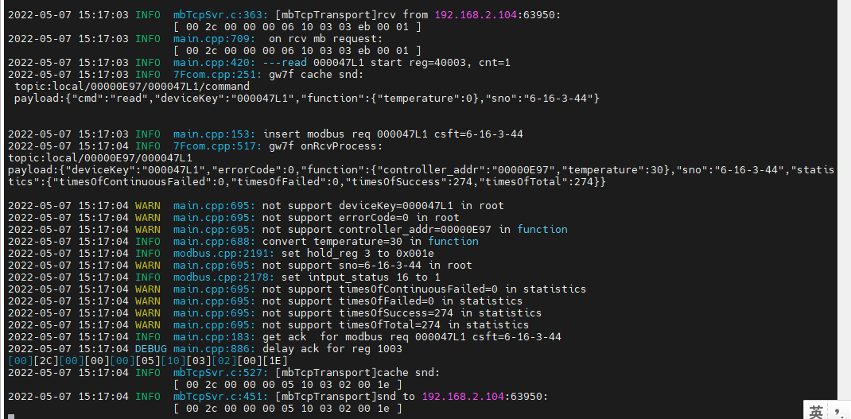结果：设置超出设备温度范围的值，程序报错，并且不会影响原来的配置。

## 低温保护ok

**使用的协议;**

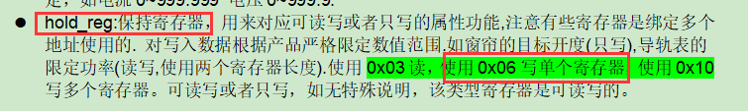

### 开启

1. 写入

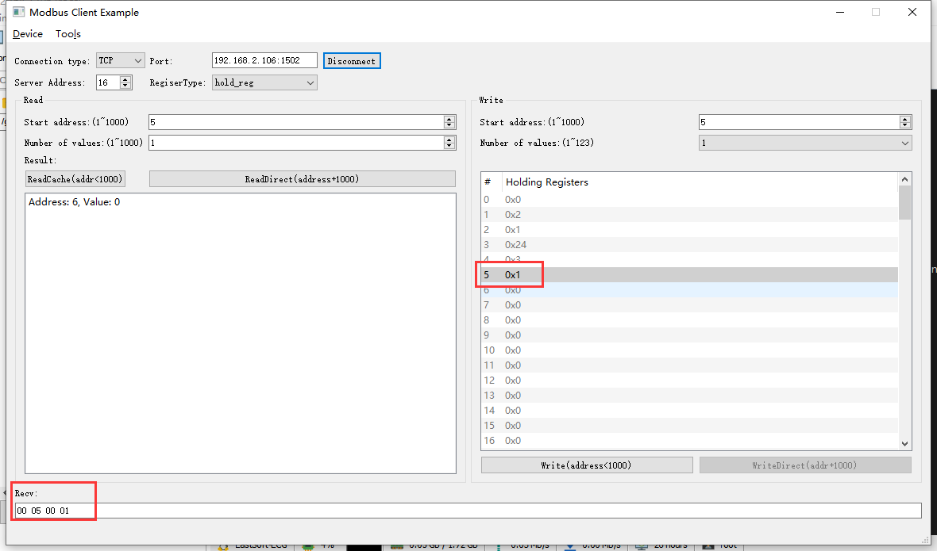2022-05-07 15:56:26 INFO mbTcpSvr.c:363: [mbTcpTransport]rcv from 192.168.2.104:64381:

[ 00 37 00 00 00 06 10 06 00 05 00 01 ]

解析：06 写单个寄存器； 00 05 寄存器地址； 00 01 数值1，低温保护开启；

2022-05-07 15:56:26 INFO main.cpp:709: on rcv mb request:

[ 00 37 00 00 00 06 10 06 00 05 00 01 ]

2022-05-07 15:56:26 INFO main.cpp:420: ---write 000047L1 start reg=40005, cnt=1

2022-05-07 15:56:26 DEBUG main.cpp:504: write reg[40005] to 0x0001

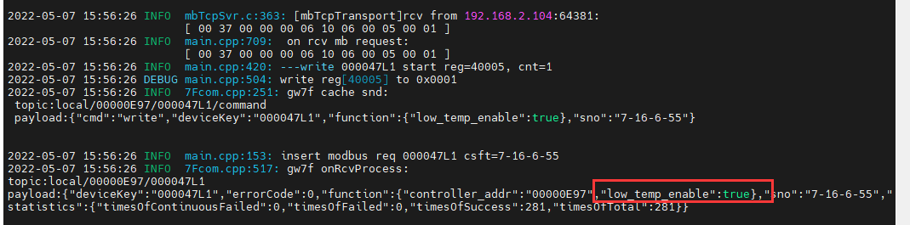2022-05-07 15:56:26 INFO mbTcpSvr.c:451: [mbTcpTransport]snd to 192.168.2.104:64381:

[ 00 37 00 00 00 06 10 06 00 05 00 01 ]



1. 直读

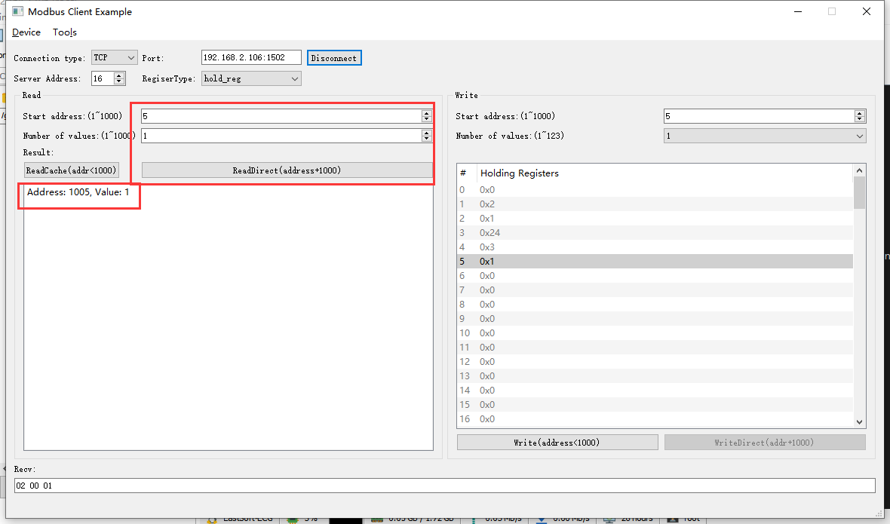2022-05-07 15:59:55 INFO mbTcpSvr.c:363: [mbTcpTransport]rcv from 192.168.2.104:64381:

[ 00 38 00 00 00 06 10 03 03 ed 00 01 ]

2022-05-07 15:59:55 INFO main.cpp:709: on rcv mb request:

[ 00 38 00 00 00 06 10 03 03 ed 00 01 ]

2022-05-07 15:59:55 INFO main.cpp:420: ---read 000047L1 start reg=40005, cnt=1

2022-05-07 15:59:55 INFO 7Fcom.cpp:517: gw7f onRcvProcess:

topic:local/00000E97/000047L1

payload:{"deviceKey":"000047L1","errorCode":0,"function":{"controller_addr":"00000E97","low_temp_enable":true},"sno":"7-16-3-56","statistics":{"timesOfContinuousFailed":0,"timesOfFailed":0,"timesOfSuccess":282,"timesOfTotal":282}}

2022-05-07 15:59:55 INFO mbTcpSvr.c:451: [mbTcpTransport]snd to 192.168.2.104:64381:

[ 00 38 00 00 00 05 10 03 02 00 01 ]

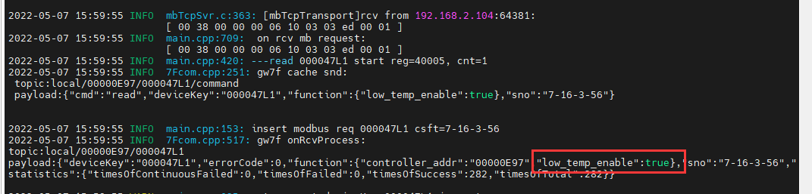

1. 读缓存

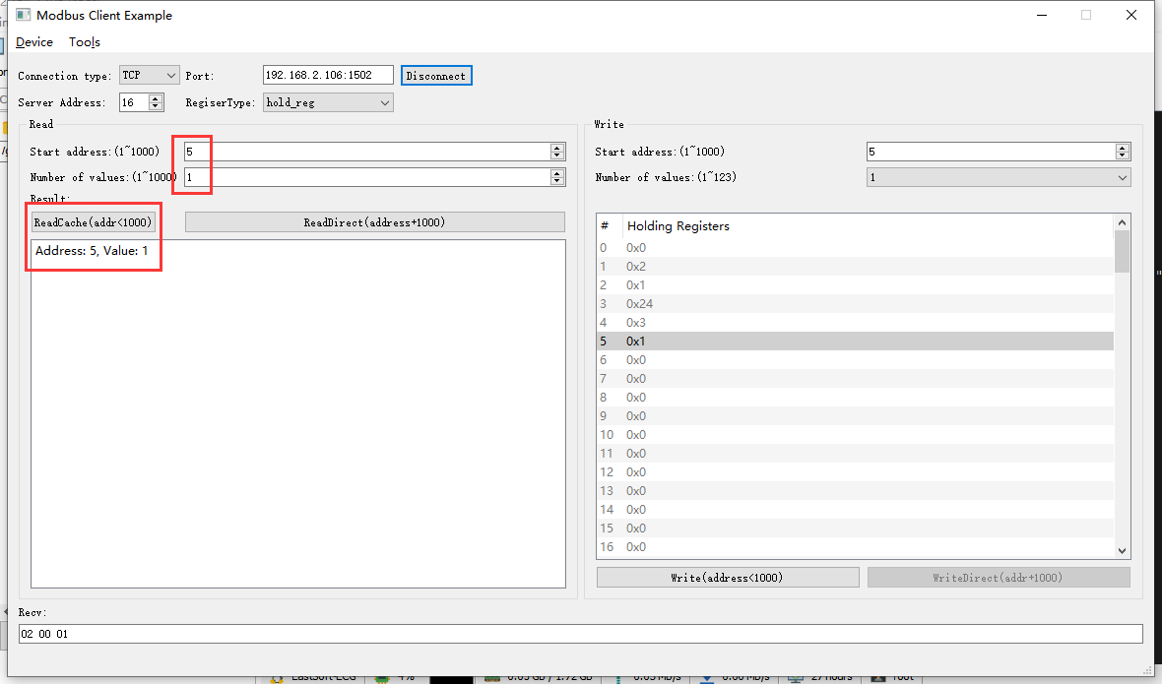2022-05-07 16:35:33 INFO mbTcpSvr.c:491: [mbTcpTransport]new connect from 192.168.2.104:65117,fd=6

2022-05-07 16:35:35 INFO mbTcpSvr.c:363: [mbTcpTransport]rcv from 192.168.2.104:65117:

[ 00 39 00 00 00 06 10 03 00 05 00 01 ]

2022-05-07 16:35:35 INFO mbTcpSvr.c:451: [mbTcpTransport]snd to 192.168.2.104:65117:

[ 00 39 00 00 00 05 10 03 02 00 01 ]

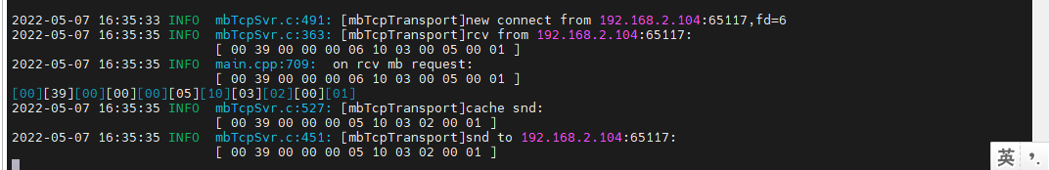

结果：读取结果与写入的一致

### 关闭

1. 写入

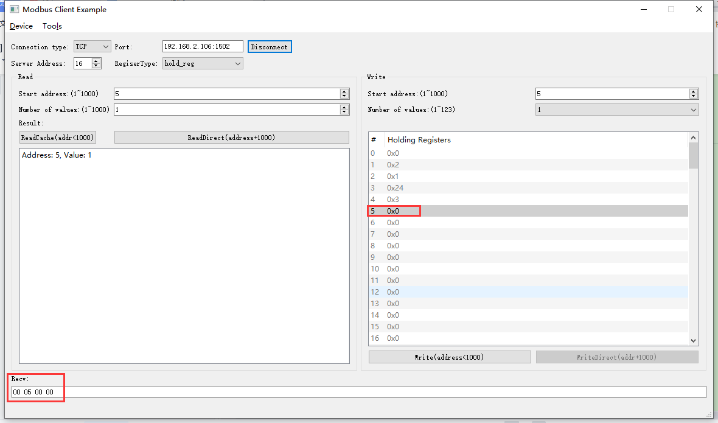

2022-05-07 16:40:49 INFO mbTcpSvr.c:363: [mbTcpTransport]rcv from 192.168.2.104:65117:

[ 00 3a 00 00 00 06 10 06 00 05 00 00 ]

2022-05-07 16:40:49 INFO main.cpp:709: on rcv mb request:

[ 00 3a 00 00 00 06 10 06 00 05 00 00 ]

2022-05-07 16:40:49 INFO main.cpp:420: ---write 000047L1 start reg=40005, cnt=1

2022-05-07 16:40:49 DEBUG main.cpp:504: write reg[40005] to 0x0000

2022-05-07 16:40:50 INFO mbTcpSvr.c:451: [mbTcpTransport]snd to 192.168.2.104:65117:

[ 00 3a 00 00 00 06 10 06 00 05 00 00 ]

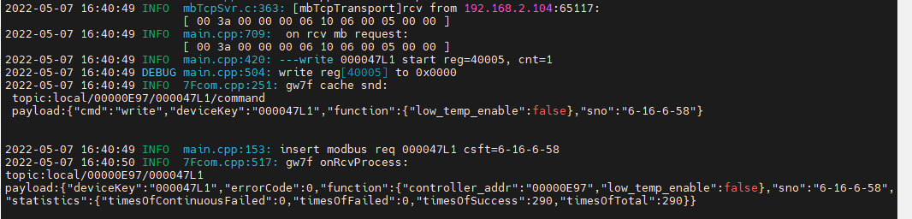

1. 直读

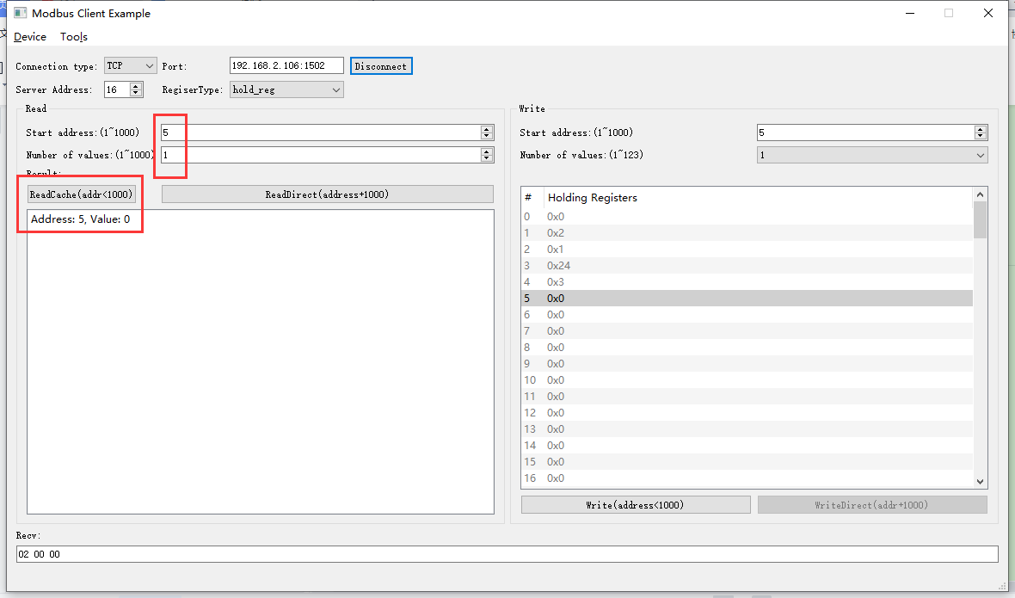2022-05-07 16:54:00 INFO mbTcpSvr.c:363: [mbTcpTransport]rcv from 192.168.2.104:65117:

[ 00 3c 00 00 00 06 10 03 00 05 00 01 ]

2022-05-07 16:54:00 INFO main.cpp:709: on rcv mb request:

[ 00 3c 00 00 00 06 10 03 00 05 00 01 ]

[00][3C][00][00][00][05][10][03][02][00][00]

2022-05-07 16:54:00 INFO mbTcpSvr.c:527: [mbTcpTransport]cache snd:

[ 00 3c 00 00 00 05 10 03 02 00 00 ]

2022-05-07 16:54:00 INFO mbTcpSvr.c:451: [mbTcpTransport]snd to 192.168.2.104:65117:

[ 00 3c 00 00 00 05 10 03 02 00 00 ]

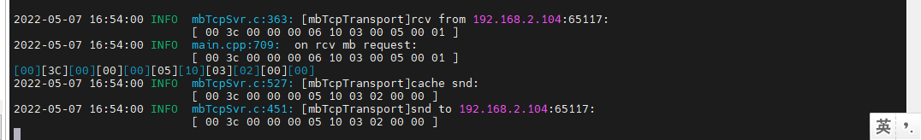

结果：读取结果与配置的一致。

## 面板锁定ok

**寄存器定义：**



### 开启

1. 写入

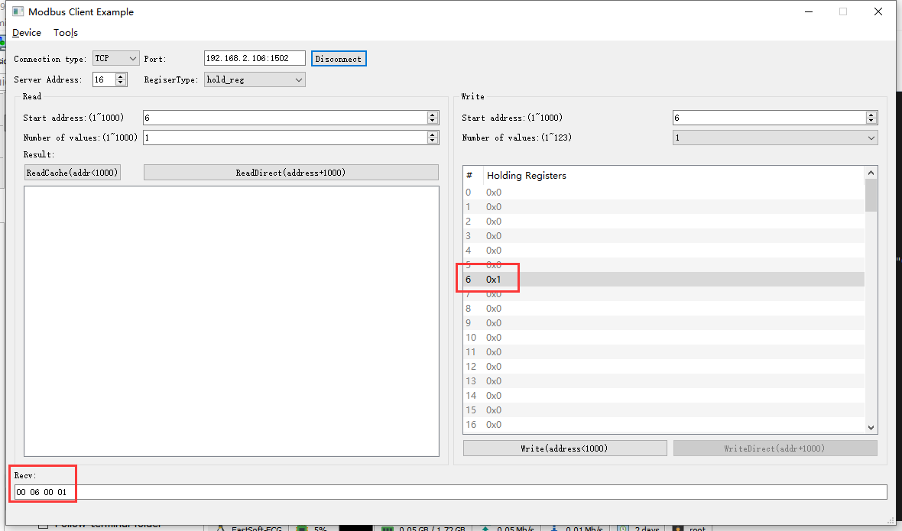2022-05-09 09:16:49 INFO mbTcpSvr.c:363: [mbTcpTransport]rcv from 192.168.2.104:50754:

[ 00 00 00 00 00 06 10 06 00 06 00 01 ]

2022-05-09 09:16:49 INFO main.cpp:709: on rcv mb request:

[ 00 00 00 00 00 06 10 06 00 06 00 01 ]

2022-05-09 09:16:49 INFO main.cpp:420: ---write 000047L1 start reg=40006, cnt=1

2022-05-09 09:16:49 DEBUG main.cpp:504: write reg[40006] to 0x0001

2022-05-09 09:16:49 INFO main.cpp:153: insert modbus req 000047L1 csft=6-16-6-0

2022-05-09 09:16:49 INFO 7Fcom.cpp:517: gw7f onRcvProcess:

topic:local/00000E97/000047L1

payload:{"deviceKey":"000047L1","errorCode":0,"function":{"controller_addr":"00000E97","lock_panel":true},"sno":"6-16-6-0","statistics":{"timesOfContinuousFailed":0,"timesOfFailed":0,"timesOfSuccess":719,"timesOfTotal":719}}

2022-05-09 09:16:49 INFO mbTcpSvr.c:451: [mbTcpTransport]snd to 192.168.2.104:50754:

[ 00 00 00 00 00 06 10 06 00 06 00 01 ]

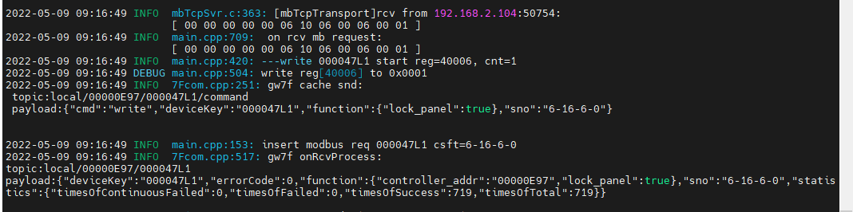

1. 直读

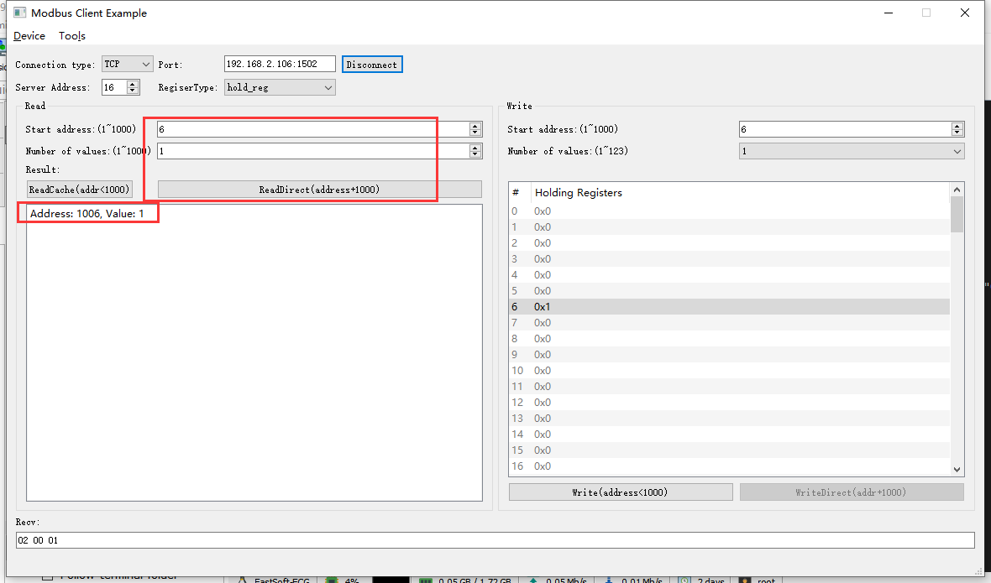

2022-05-09 09:21:10 INFO mbTcpSvr.c:363: [mbTcpTransport]rcv from 192.168.2.104:50754:

[ 00 01 00 00 00 06 10 03 03 ee 00 01 ]

2022-05-09 09:21:10 INFO main.cpp:709: on rcv mb request:

[ 00 01 00 00 00 06 10 03 03 ee 00 01 ]

2022-05-09 09:21:10 INFO main.cpp:420: ---read 000047L1 start reg=40006, cnt=1

2022-05-09 09:21:10 INFO mbTcpSvr.c:451: [mbTcpTransport]snd to 192.168.2.104:50754:

[ 00 01 00 00 00 05 10 03 02 00 01 ]

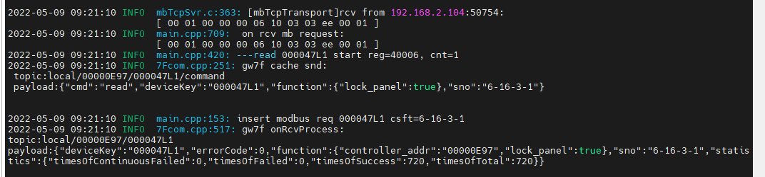

1. 读缓存

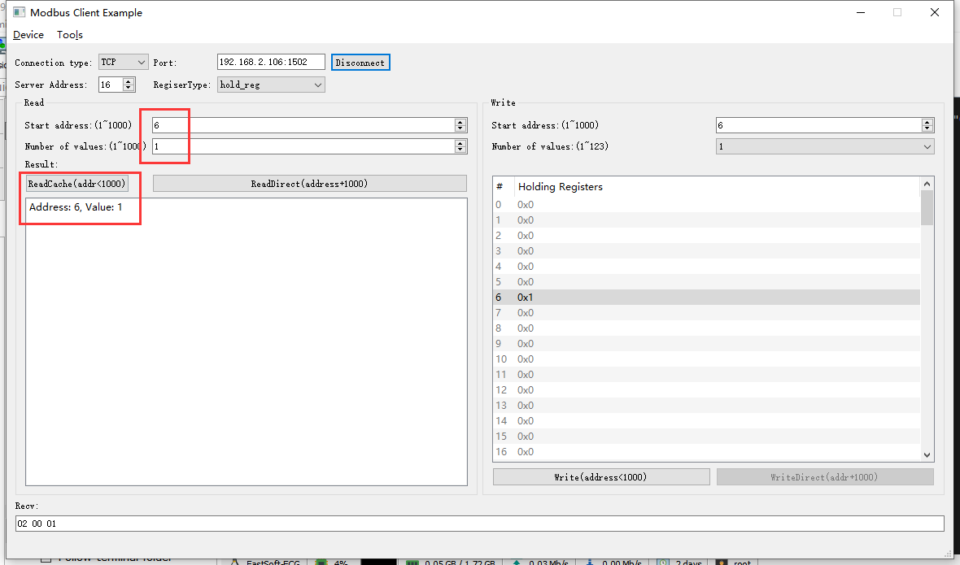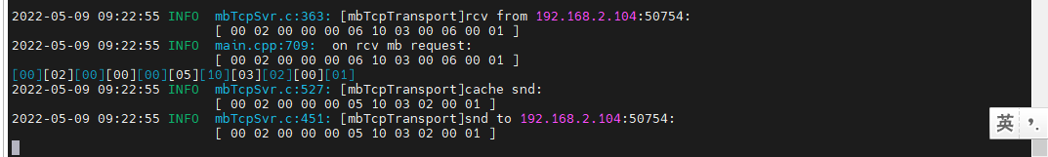

结果：读取值与写入的一致。

### 关闭

1. 写入

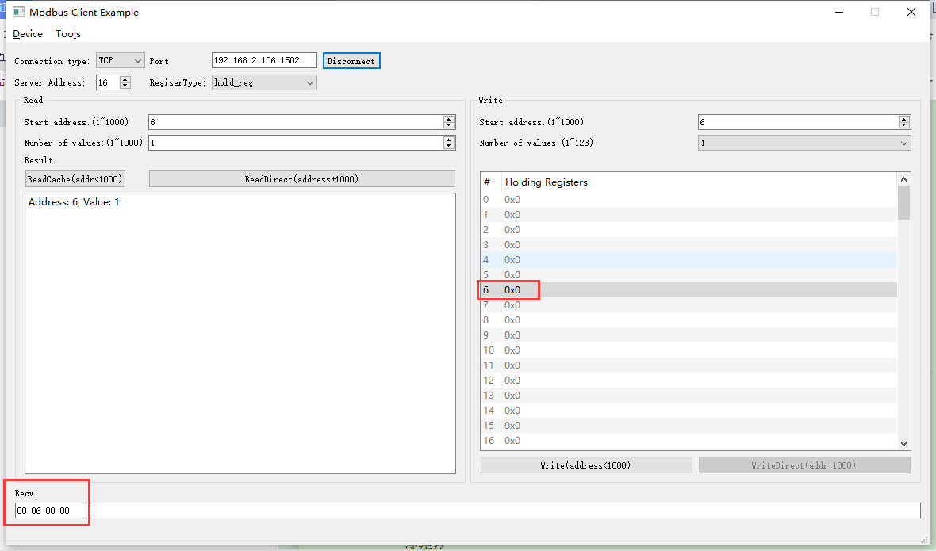2022-05-09 09:24:58 INFO mbTcpSvr.c:363: [mbTcpTransport]rcv from 192.168.2.104:50754:

[ 00 03 00 00 00 06 10 06 00 06 00 00 ]

2022-05-09 09:24:58 INFO main.cpp:709: on rcv mb request:

[ 00 03 00 00 00 06 10 06 00 06 00 00 ]

2022-05-09 09:24:58 INFO main.cpp:420: ---write 000047L1 start reg=40006, cnt=1

2022-05-09 09:24:58 DEBUG main.cpp:504: write reg[40006] to 0x0000

2022-05-09 09:24:58 INFO mbTcpSvr.c:451: [mbTcpTransport]snd to 192.168.2.104:50754:

[ 00 03 00 00 00 06 10 06 00 06 00 00 ]

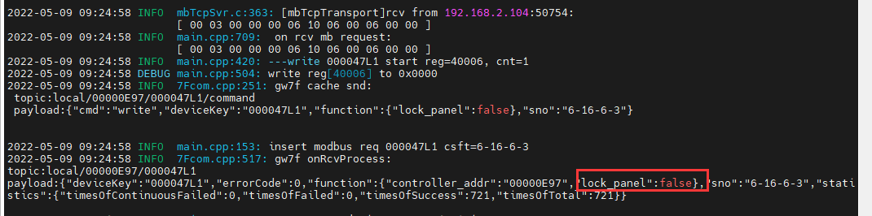

1. 直读

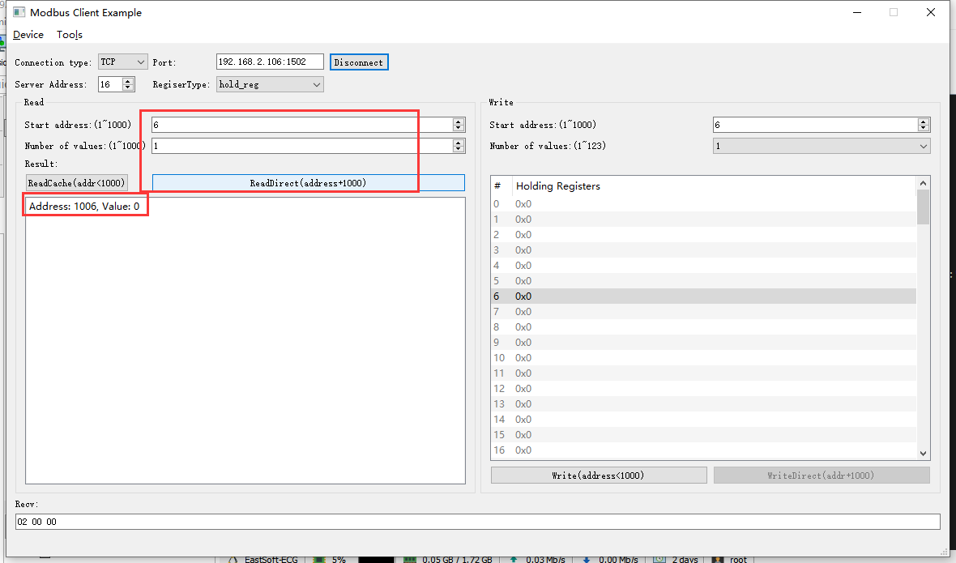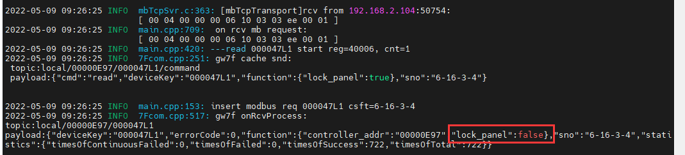

## 按键锁定ok

**协议寄存器定义：**



### 开启

1. 写入

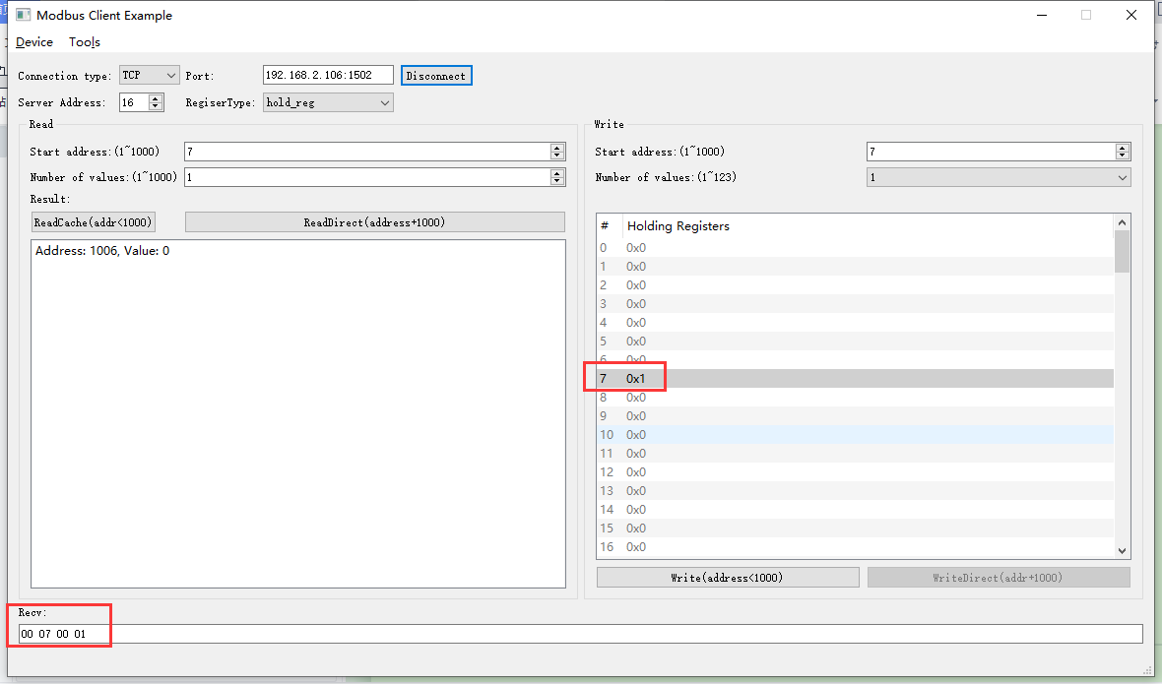2022-05-09 09:29:26 INFO mbTcpSvr.c:363: [mbTcpTransport]rcv from 192.168.2.104:50754:

[ 00 05 00 00 00 06 10 06 00 07 00 01 ]

2022-05-09 09:29:26 INFO main.cpp:709: on rcv mb request:

[ 00 05 00 00 00 06 10 06 00 07 00 01 ]

2022-05-09 09:29:26 INFO main.cpp:420: ---write 000047L1 start reg=40007, cnt=1

2022-05-09 09:29:26 DEBUG main.cpp:504: write reg[40007] to 0x0001

2022-05-09 09:29:26 INFO mbTcpSvr.c:451: [mbTcpTransport]snd to 192.168.2.104:50754:

[ 00 05 00 00 00 06 10 06 00 07 00 01 ]

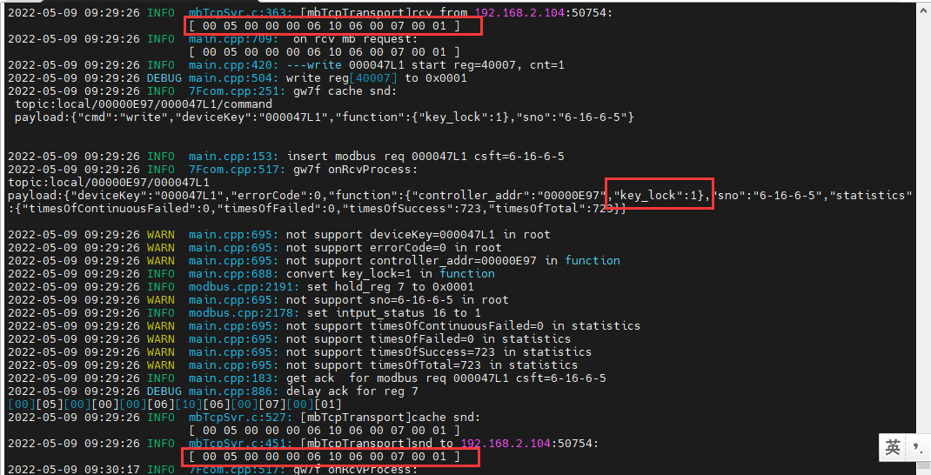

结果：此时操作设备按键无效。

1. 直读

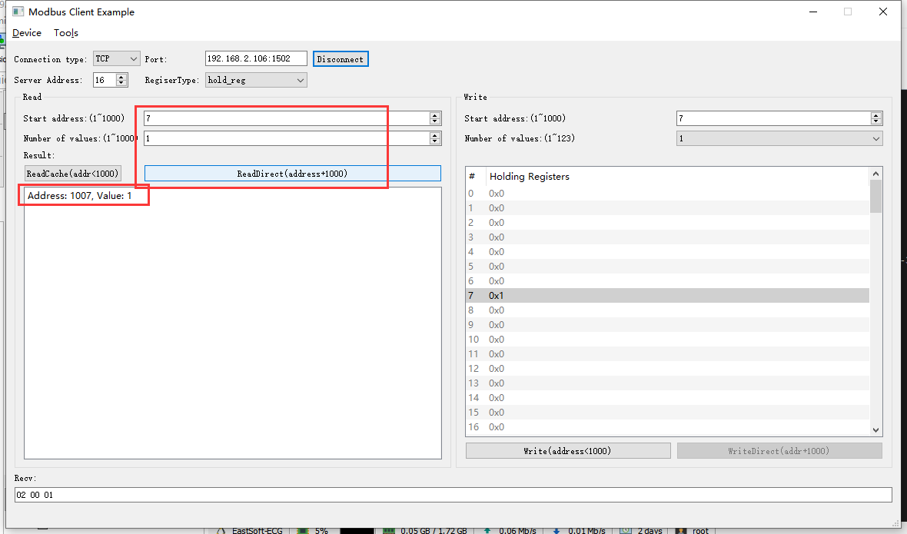2022-05-09 09:32:03 INFO mbTcpSvr.c:363: [mbTcpTransport]rcv from 192.168.2.104:50754:

[ 00 06 00 00 00 06 10 03 03 ef 00 01 ]

2022-05-09 09:32:03 INFO main.cpp:709: on rcv mb request:

[ 00 06 00 00 00 06 10 03 03 ef 00 01 ]

2022-05-09 09:32:03 INFO main.cpp:420: ---read 000047L1 start reg=40007, cnt=1

2022-05-09 09:32:03 INFO mbTcpSvr.c:451: [mbTcpTransport]snd to 192.168.2.104:50754:

[ 00 06 00 00 00 05 10 03 02 00 01 ]

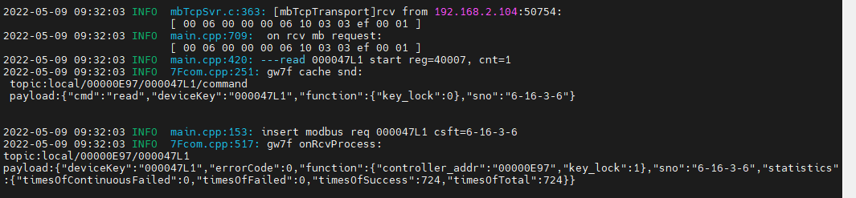

1. 读缓存

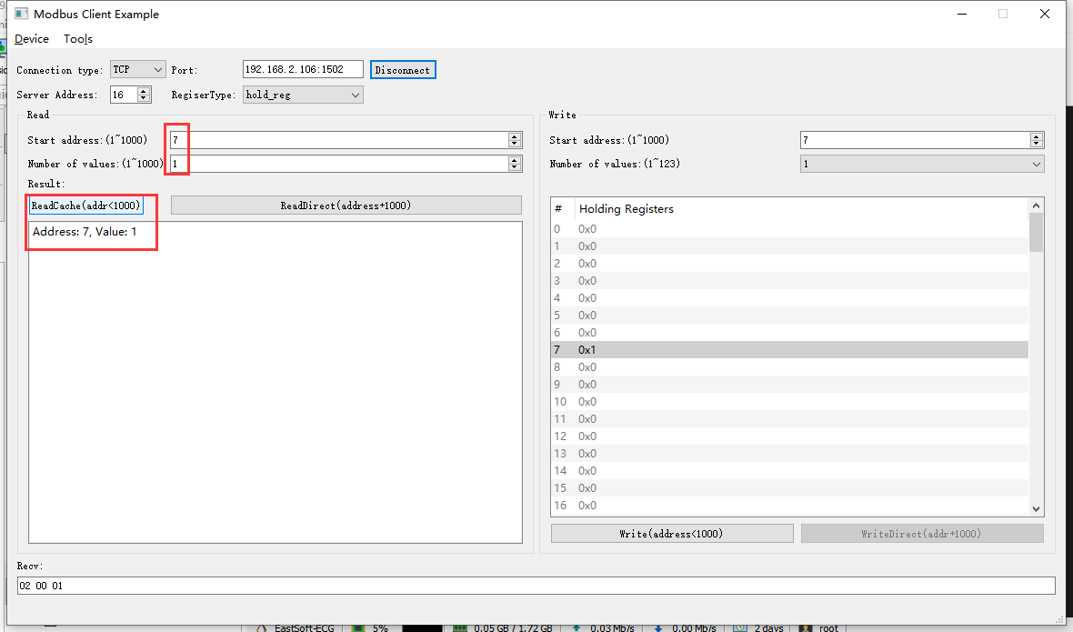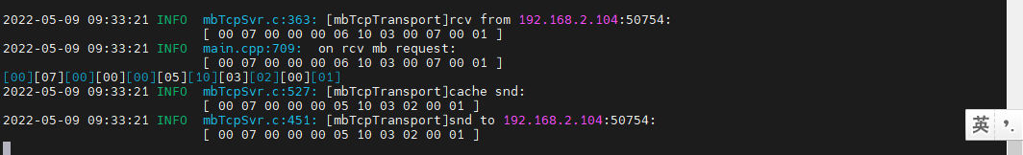

### 关闭

1. 写入

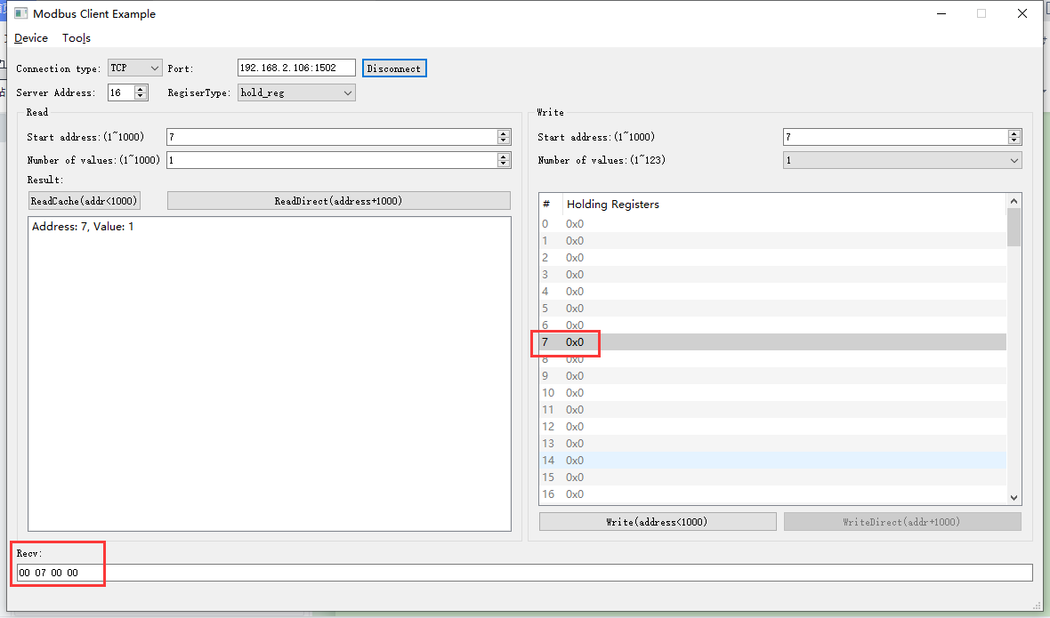2022-05-09 09:35:50 INFO mbTcpSvr.c:363: [mbTcpTransport]rcv from 192.168.2.104:50754:

[ 00 08 00 00 00 06 10 06 00 07 00 00 ]

2022-05-09 09:35:50 INFO main.cpp:709: on rcv mb request:

[ 00 08 00 00 00 06 10 06 00 07 00 00 ]

2022-05-09 09:35:50 INFO main.cpp:420: ---write 000047L1 start reg=40007, cnt=1

2022-05-09 09:35:50 DEBUG main.cpp:504: write reg[40007] to 0x0000

2022-05-09 09:35:50 INFO mbTcpSvr.c:451: [mbTcpTransport]snd to 192.168.2.104:50754:

[ 00 08 00 00 00 06 10 06 00 07 00 00 ]

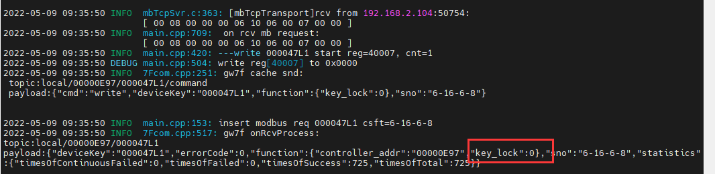

1. 直读

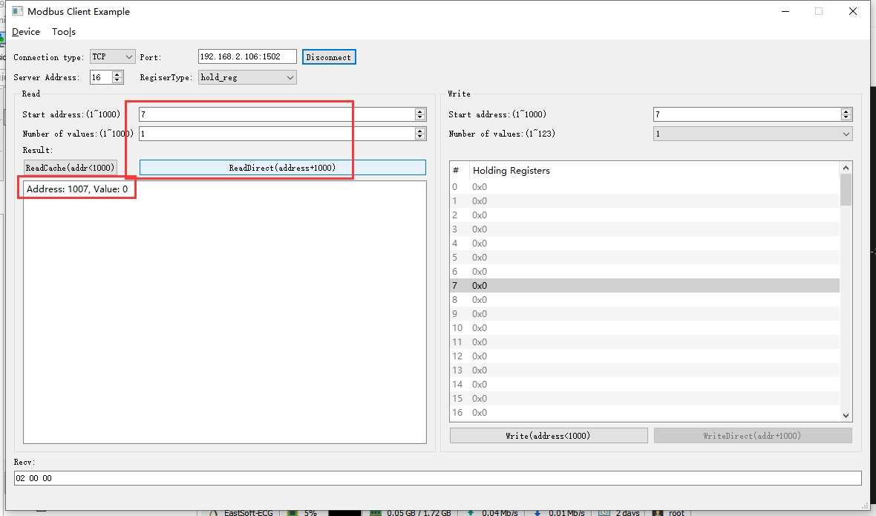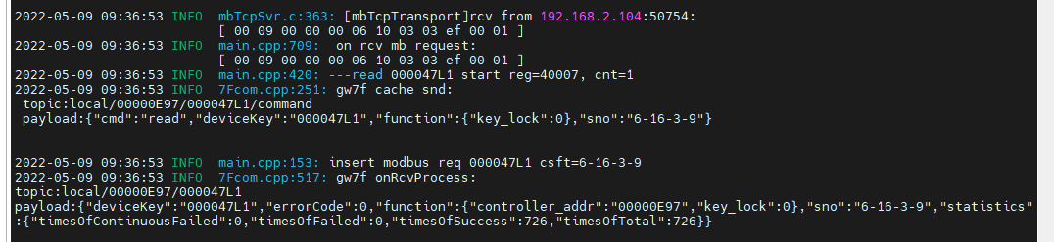

## 日期ok

**协议说明：**





### 读取日期

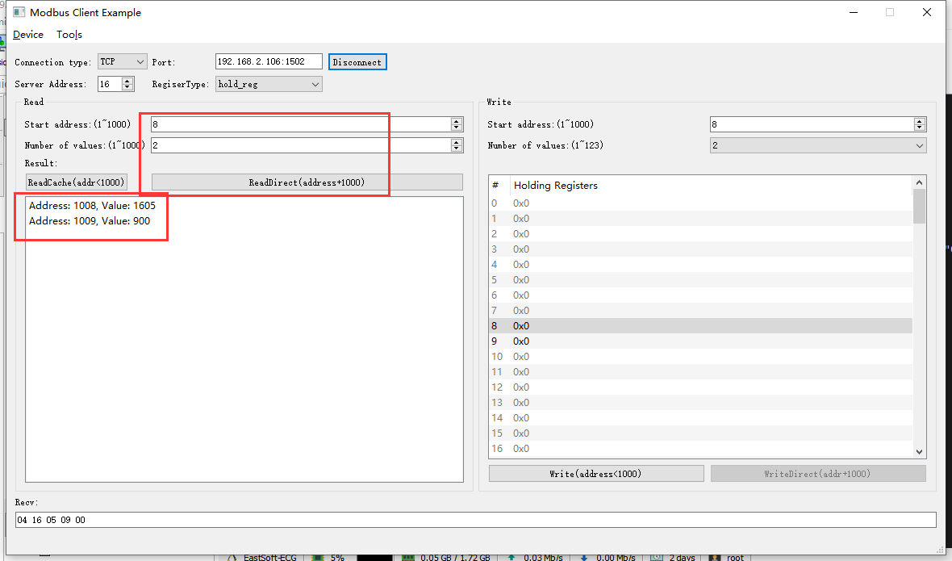2022-05-09 09:42:24 INFO mbTcpSvr.c:363: [mbTcpTransport]rcv from 192.168.2.104:50754:

[ 00 0a 00 00 00 06 10 03 03 f0 00 02 ]

2022-05-09 09:42:24 INFO main.cpp:709: on rcv mb request:

[ 00 0a 00 00 00 06 10 03 03 f0 00 02 ]

2022-05-09 09:42:24 INFO main.cpp:420: ---read 000047L1 start reg=40008, cnt=2

2022-05-09 09:42:24 INFO 7Fcom.cpp:517: gw7f onRcvProcess:

topic:local/00000E97/000047L1

payload:{"deviceKey":"000047L1","errorCode":0,"function":{"controller_addr":"00000E97","date":"22-05-09"},"sno":"6-16-3-10","statistics":{"timesOfContinuousFailed":0,"timesOfFailed":0,"timesOfSuccess":727,"timesOfTotal":727}}

2022-05-09 09:42:24 INFO mbTcpSvr.c:451: [mbTcpTransport]snd to 192.168.2.104:50754:

[ 00 0a 00 00 00 07 10 03 04 16 05 09 00 ]

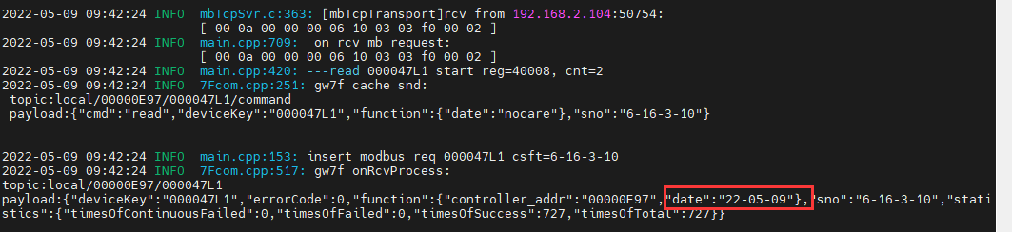

结果：读取到的时间正确。

### 读取不正确日期寄存器

**协议说明：**





#### 读取9-10

1. 直读

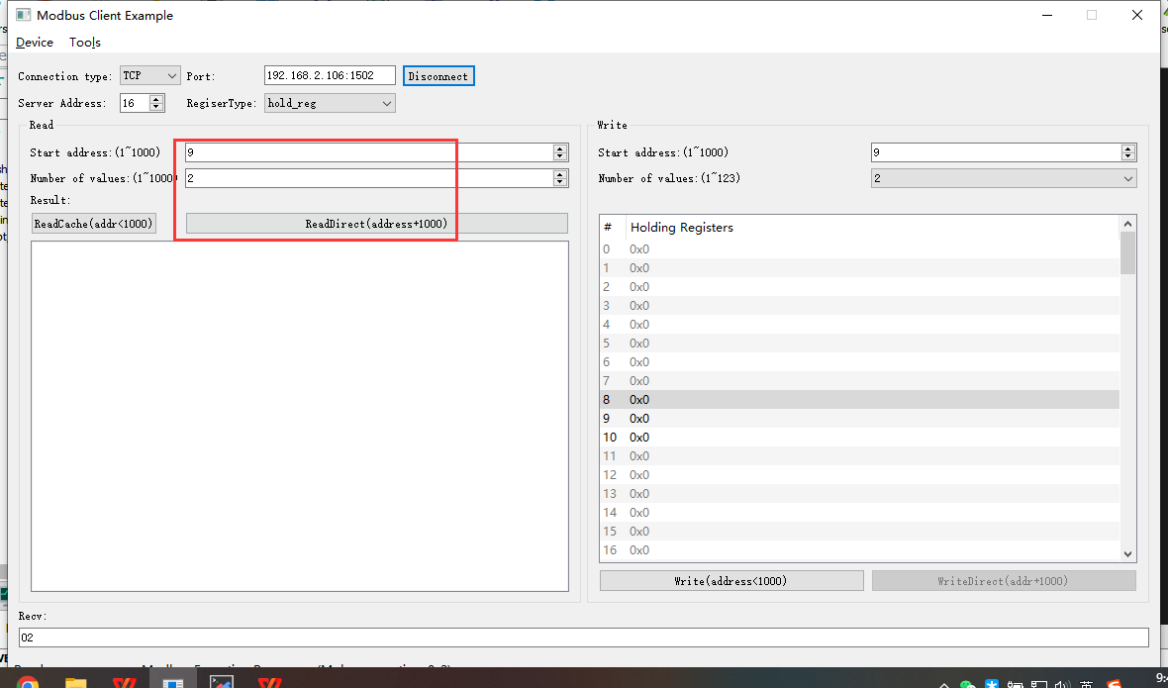2022-05-09 09:48:26 INFO mbTcpSvr.c:363: [mbTcpTransport]rcv from 192.168.2.104:50754:

[ 00 0b 00 00 00 06 10 03 03 f1 00 02 ]

2022-05-09 09:48:26 INFO mbTcpSvr.c:451: [mbTcpTransport]snd to 192.168.2.104:50754:

[ 00 0b 00 00 00 03 10 83 02 ]

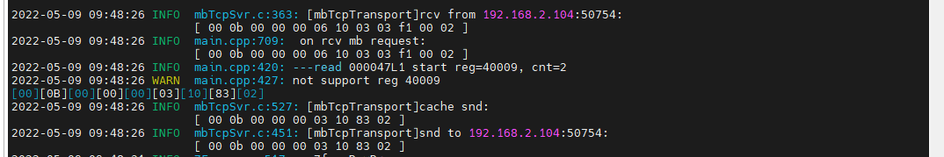

结果：返回错误。

1. 读缓存

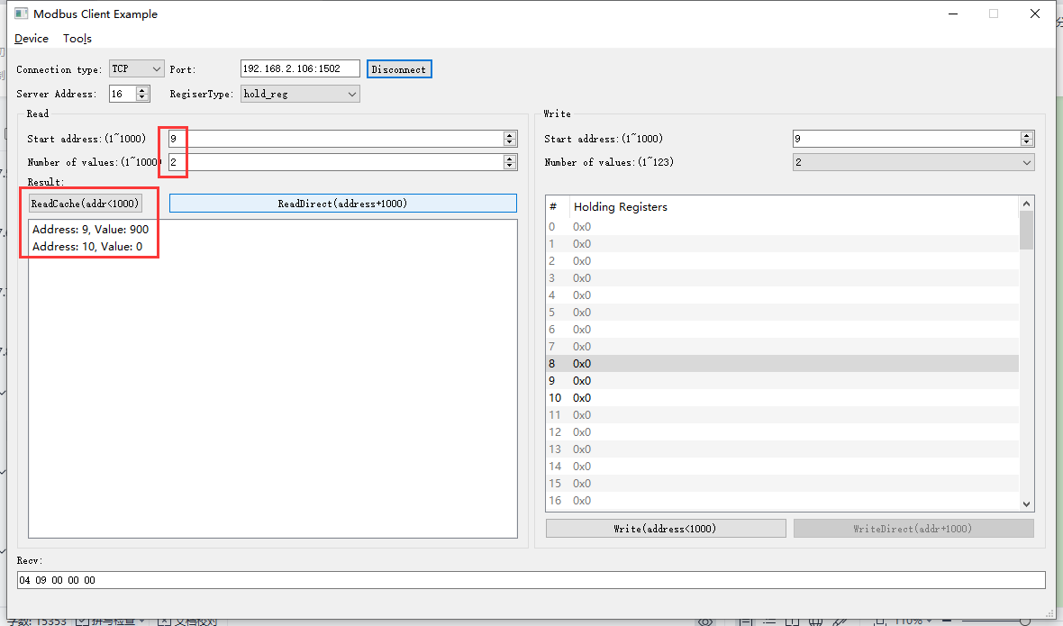2022-05-09 09:51:55 INFO mbTcpSvr.c:363: [mbTcpTransport]rcv from 192.168.2.104:50754:

[ 00 10 00 00 00 06 10 03 00 09 00 02 ]

2022-05-09 09:51:55 INFO main.cpp:709: on rcv mb request:

[ 00 10 00 00 00 06 10 03 00 09 00 02 ]

[00][10][00][00][00][07][10][03][04][09][00][00][00]

2022-05-09 09:51:55 INFO mbTcpSvr.c:527: [mbTcpTransport]cache snd:

[ 00 10 00 00 00 07 10 03 04 09 00 00 00 ]

2022-05-09 09:51:55 INFO mbTcpSvr.c:451: [mbTcpTransport]snd to 192.168.2.104:50754:

[ 00 10 00 00 00 07 10 03 04 09 00 00 00 ]

结果：读取缓存数据，读取到有数据存在，在读取时间日期缓存时，不判断寄存器组合。

#### 读取7-8

1. 直读

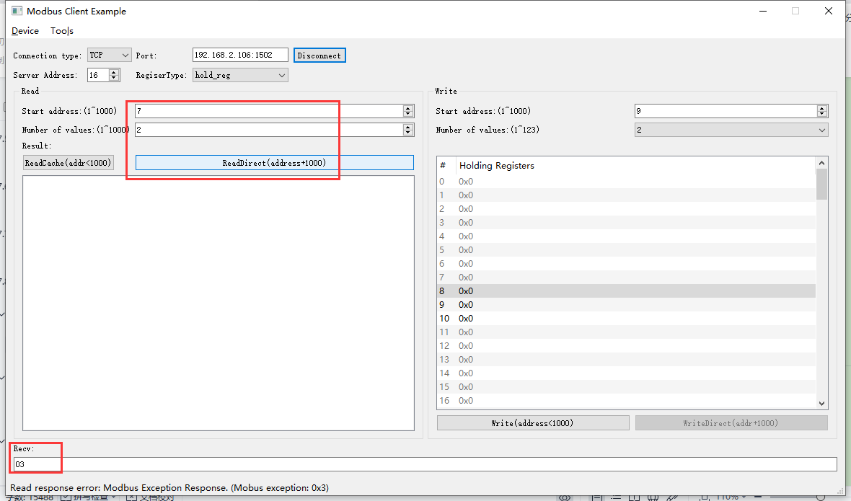2022-05-09 10:04:44 INFO mbTcpSvr.c:363: [mbTcpTransport]rcv from 192.168.2.104:50754:

[ 00 15 00 00 00 06 10 03 03 ef 00 02 ]

2022-05-09 10:04:45 INFO main.cpp:709: on rcv mb request:

[ 00 15 00 00 00 06 10 03 03 ef 00 02 ]

2022-05-09 10:04:45 INFO main.cpp:420: ---read 000047L1 start reg=40007, cnt=2

2022-05-09 10:04:45 WARN main.cpp:471: wrong regcnt 1 for reg 40008 , should more than 2

[00][15][00][00][00][03][10][83][03]

2022-05-09 10:04:45 INFO mbTcpSvr.c:527: [mbTcpTransport]cache snd:

[ 00 15 00 00 00 03 10 83 03 ]

2022-05-09 10:04:45 INFO mbTcpSvr.c:451: [mbTcpTransport]snd to 192.168.2.104:50754:

[ 00 15 00 00 00 03 10 83 03 ]

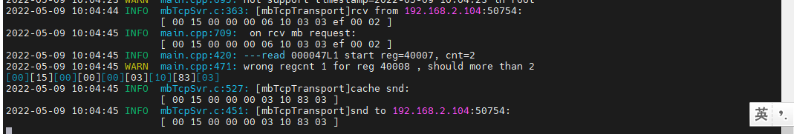

结果：返回寄存器组合错误。

#### 读取7-9

1. 直读

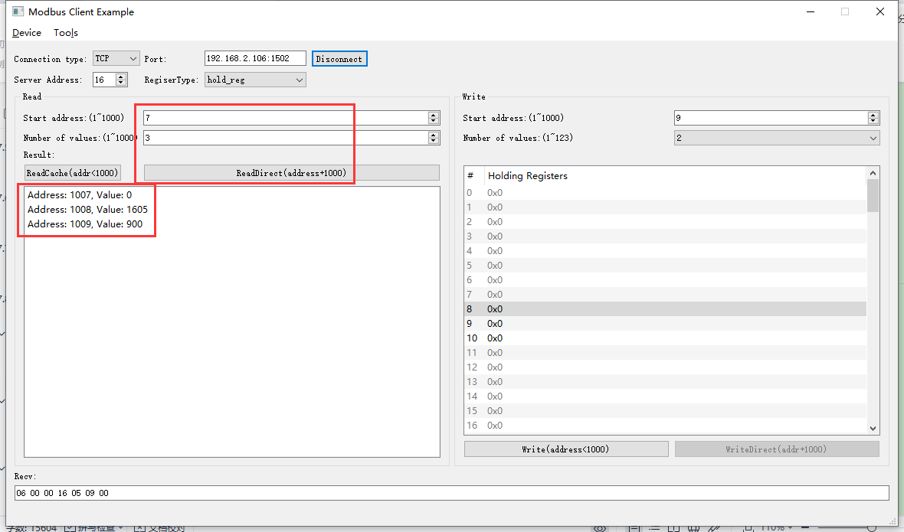2022-05-09 10:06:21 INFO mbTcpSvr.c:363: [mbTcpTransport]rcv from 192.168.2.104:50754:

[ 00 16 00 00 00 06 10 03 03 ef 00 03 ]

2022-05-09 10:06:21 INFO main.cpp:709: on rcv mb request:

[ 00 16 00 00 00 06 10 03 03 ef 00 03 ]

2022-05-09 10:06:21 INFO main.cpp:420: ---read 000047L1 start reg=40007, cnt=3

2022-05-09 10:06:21 INFO 7Fcom.cpp:517: gw7f onRcvProcess:

topic:local/00000E97/000047L1

payload:{"deviceKey":"000047L1","errorCode":0,"function":{"controller_addr":"00000E97","date":"22-05-09","key_lock":0},"sno":"6-16-3-22","statistics":{"timesOfContinuousFailed":0,"timesOfFailed":0,"timesOfSuccess":733,"timesOfTotal":733}}

2022-05-09 10:06:21 INFO mbTcpSvr.c:451: [mbTcpTransport]snd to 192.168.2.104:50754:

[ 00 16 00 00 00 09 10 03 06 00 00 16 05 09 00 ]

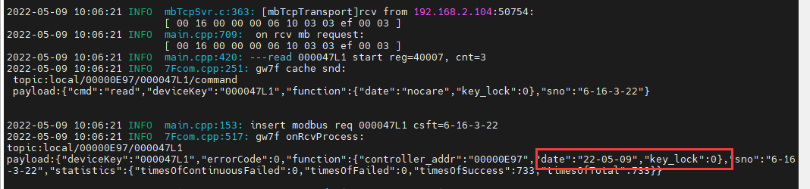

结果：返回了，寄存器7、寄存器8+9中的状态，即按键锁定，时间。

### 写入日期

1. 写入

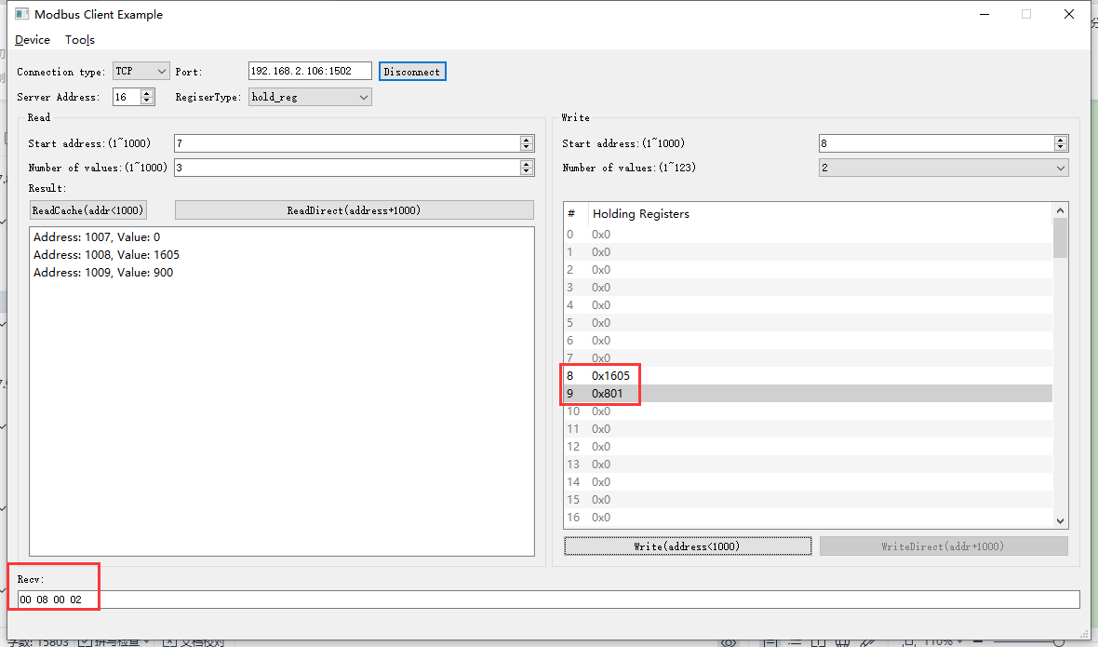

2022-05-09 10:12:34 INFO mbTcpSvr.c:363: [mbTcpTransport]rcv from 192.168.2.104:50754:

[ 00 18 00 00 00 0b 10 10 00 08 00 02 04 16 05 08 01 ]

2022-05-09 10:12:34 INFO main.cpp:709: on rcv mb request:

[ 00 18 00 00 00 0b 10 10 00 08 00 02 04 16 05 08 01 ]

2022-05-09 10:12:34 INFO main.cpp:420: ---write 000047L1 start reg=40008, cnt=2

2022-05-09 10:12:34 DEBUG main.cpp:525: write reg 40008 to:[hex]

[ 16 05 08 01 ]

2022-05-09 10:12:34 INFO devList.cpp:700: to set data to 22-5-8

2022-05-09 10:12:34 INFO 7Fcom.cpp:517: gw7f onRcvProcess:

topic:local/00000E97/000047L1

payload:{"deviceKey":"000047L1","errorCode":0,"function":{"controller_addr":"00000E97","date":"22-05-08"},"sno":"6-16-16-24","statistics":{"timesOfContinuousFailed":0,"timesOfFailed":0,"timesOfSuccess":736,"timesOfTotal":736}}

2022-05-09 10:12:34 INFO mbTcpSvr.c:451: [mbTcpTransport]snd to 192.168.2.104:50754:

[ 00 18 00 00 00 06 10 10 00 08 00 02 ]

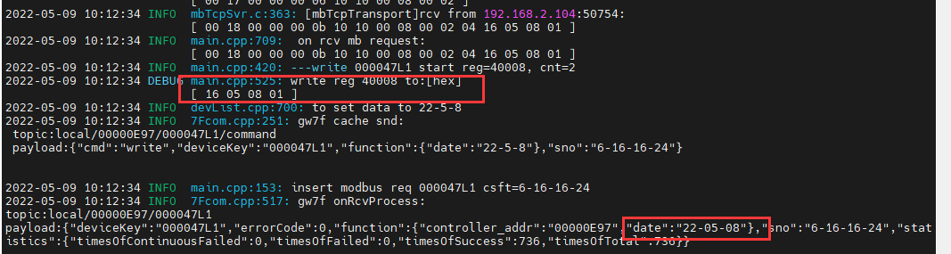

解释：写入时间22-05-08-01

1. 直读

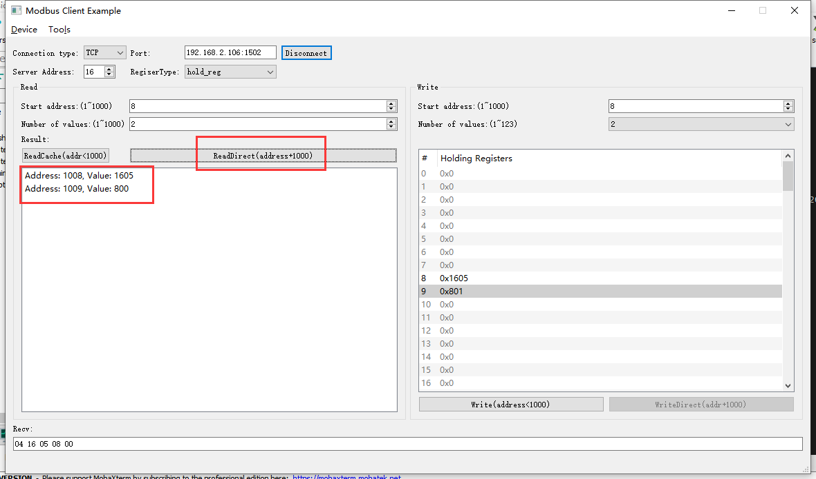2022-05-09 10:15:01 INFO mbTcpSvr.c:363: [mbTcpTransport]rcv from 192.168.2.104:50754:

[ 00 1a 00 00 00 06 10 03 03 f0 00 02 ]

2022-05-09 10:15:01 INFO main.cpp:709: on rcv mb request:

[ 00 1a 00 00 00 06 10 03 03 f0 00 02 ]

2022-05-09 10:15:01 INFO main.cpp:420: ---read 000047L1 start reg=40008, cnt=2

2022-05-09 10:15:01 INFO 7Fcom.cpp:517: gw7f onRcvProcess:

topic:local/00000E97/000047L1

payload:{"deviceKey":"000047L1","errorCode":0,"function":{"controller_addr":"00000E97","date":"22-05-08"},"sno":"6-16-3-26","statistics":{"timesOfContinuousFailed":0,"timesOfFailed":0,"timesOfSuccess":737,"timesOfTotal":737}}

2022-05-09 10:15:01 INFO mbTcpSvr.c:451: [mbTcpTransport]snd to 192.168.2.104:50754:

[ 00 1a 00 00 00 07 10 03 04 16 05 08 00 ]

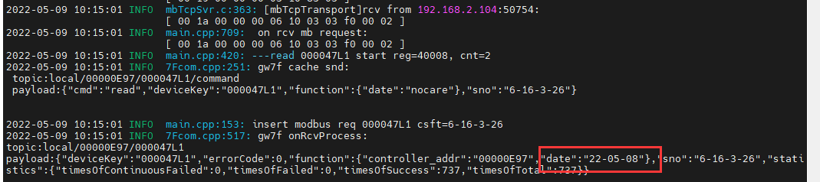

1. 读缓存

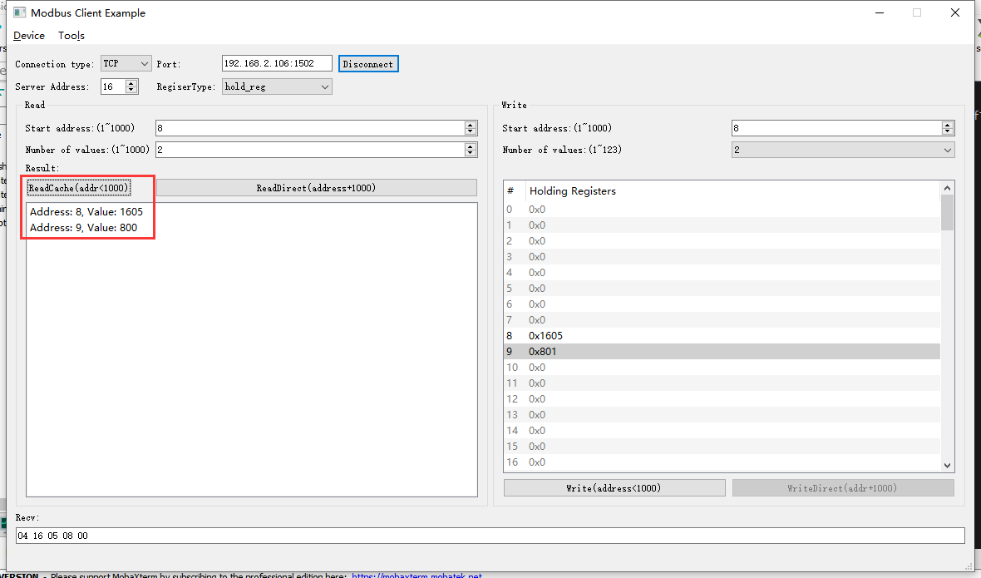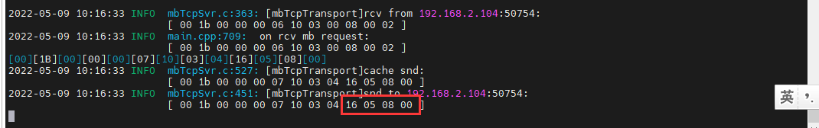

结果：读取到的时间与写入的一致。

### 写入不存在的日期

1. 写入

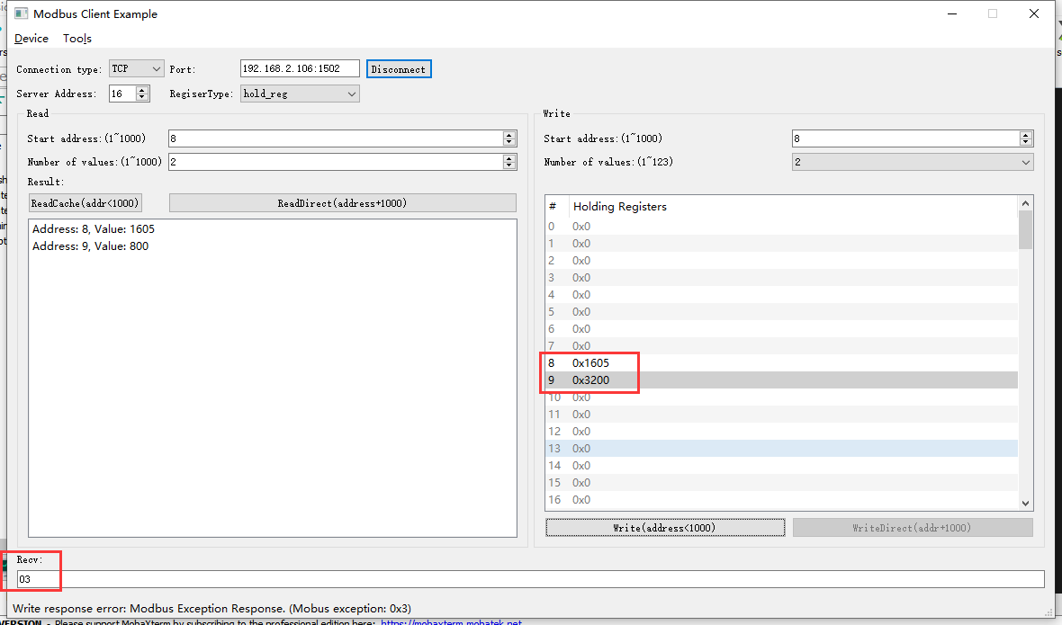2022-05-09 10:50:44 INFO mbTcpSvr.c:363: [mbTcpTransport]rcv from 192.168.2.104:52836:

[ 00 1c 00 00 00 0b 10 10 00 08 00 02 04 16 05 32 00 ]

2022-05-09 10:50:44 INFO main.cpp:709: on rcv mb request:

[ 00 1c 00 00 00 0b 10 10 00 08 00 02 04 16 05 32 00 ]

2022-05-09 10:50:44 INFO main.cpp:420: ---write 000047L1 start reg=40008, cnt=2

2022-05-09 10:50:44 DEBUG main.cpp:525: write reg 40008 to:[hex]

[ 16 05 32 00 ]

2022-05-09 10:50:44 WARN devList.cpp:696: wrong day!

[00][1C][00][00][00][03][10][90][03]

2022-05-09 10:50:44 INFO mbTcpSvr.c:527: [mbTcpTransport]cache snd:

[ 00 1c 00 00 00 03 10 90 03 ]

2022-05-09 10:50:44 INFO mbTcpSvr.c:451: [mbTcpTransport]snd to 192.168.2.104:52836:

[ 00 1c 00 00 00 03 10 90 03 ]

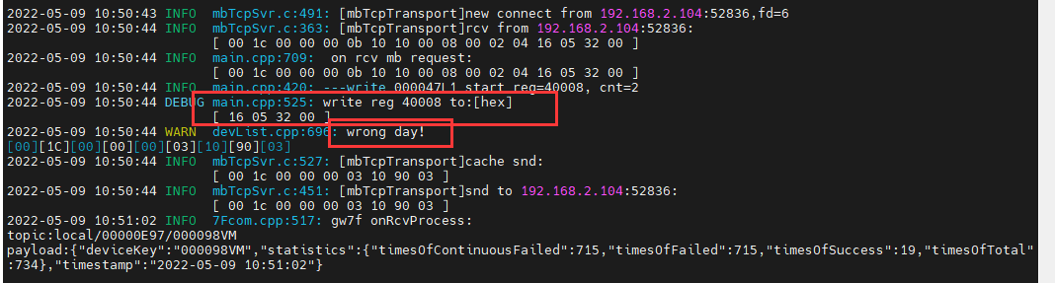

结果：回复错误。

1. 直读

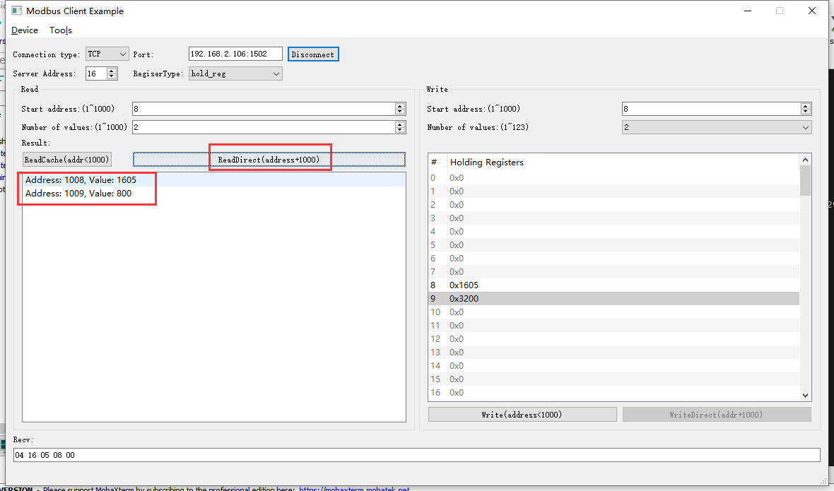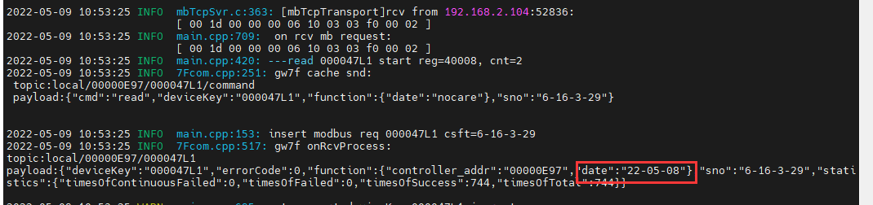

结果：错误时间无效，读取日期还是原来的日期。

## 时间ok

**协议说明：**





### 读取时间

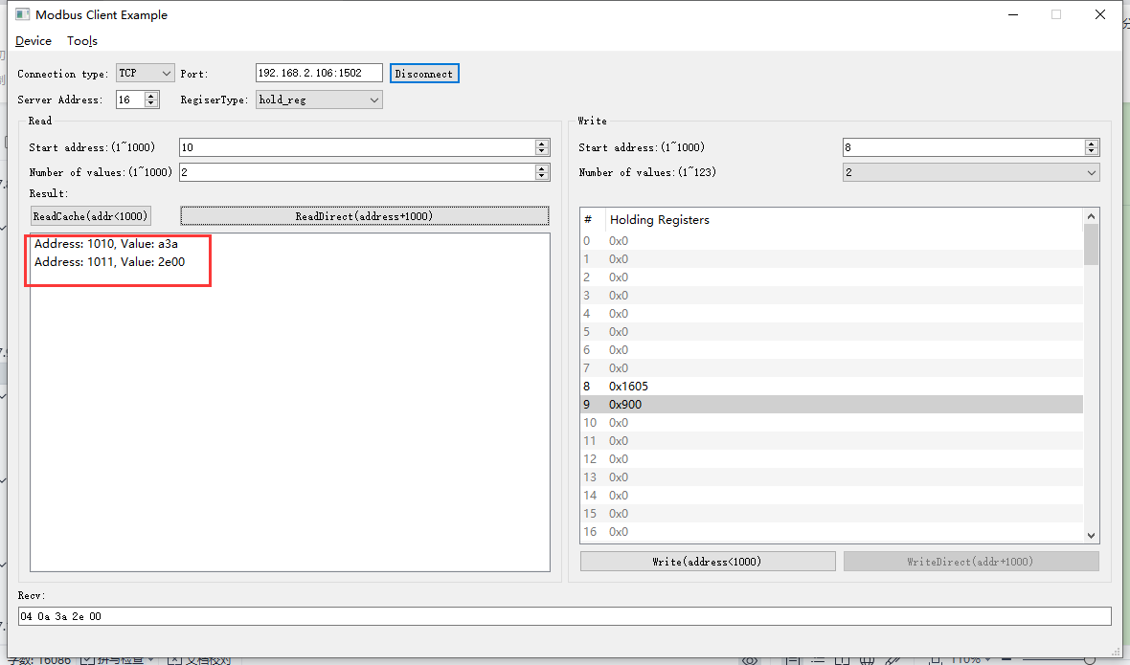2022-05-09 10:58:30 INFO mbTcpSvr.c:363: [mbTcpTransport]rcv from 192.168.2.104:52836:

[ 00 1f 00 00 00 06 10 03 03 f2 00 02 ]

2022-05-09 10:58:30 INFO main.cpp:709: on rcv mb request:

[ 00 1f 00 00 00 06 10 03 03 f2 00 02 ]

2022-05-09 10:58:30 INFO main.cpp:420: ---read 000047L1 start reg=40010, cnt=2

2022-05-09 10:58:30 INFO 7Fcom.cpp:517: gw7f onRcvProcess:

topic:local/00000E97/000047L1

payload:{"deviceKey":"000047L1","errorCode":0,"function":{"controller_addr":"00000E97","time":"10:58:46"},"sno":"6-16-3-31","statistics":{"timesOfContinuousFailed":0,"timesOfFailed":0,"timesOfSuccess":746,"timesOfTotal":746}}

2022-05-09 10:58:30 INFO mbTcpSvr.c:451: [mbTcpTransport]snd to 192.168.2.104:52836:

[ 00 1f 00 00 00 07 10 03 04 0a 3a 2e 00 ]

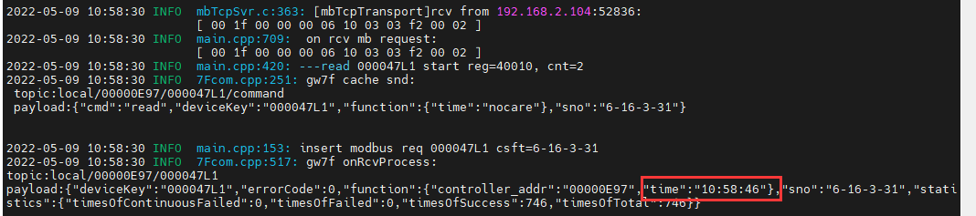

结果：读取时间正确。

### 读取不正确时间寄存器

#### 读取9-10

1. 直读

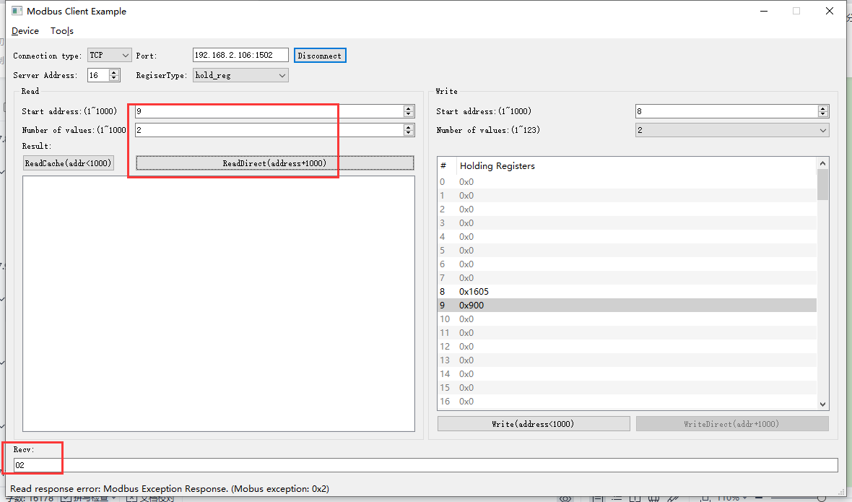2022-05-09 11:03:40 INFO mbTcpSvr.c:363: [mbTcpTransport]rcv from 192.168.2.104:52836:

[ 00 20 00 00 00 06 10 03 03 f1 00 02 ]

2022-05-09 11:03:40 INFO main.cpp:709: on rcv mb request:

[ 00 20 00 00 00 06 10 03 03 f1 00 02 ]

2022-05-09 11:03:40 INFO main.cpp:420: ---read 000047L1 start reg=40009, cnt=2

2022-05-09 11:03:40 INFO mbTcpSvr.c:527: [mbTcpTransport]cache snd:

[ 00 20 00 00 00 03 10 83 02 ]

2022-05-09 11:03:40 INFO mbTcpSvr.c:451: [mbTcpTransport]snd to 192.168.2.104:52836:

[ 00 20 00 00 00 03 10 83 02 ]

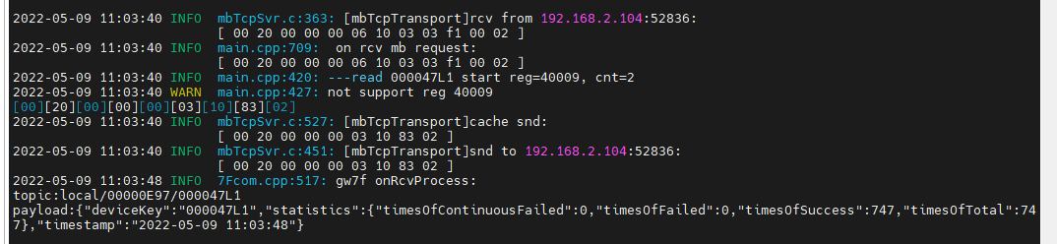

结果：回复错误

1. 读缓存

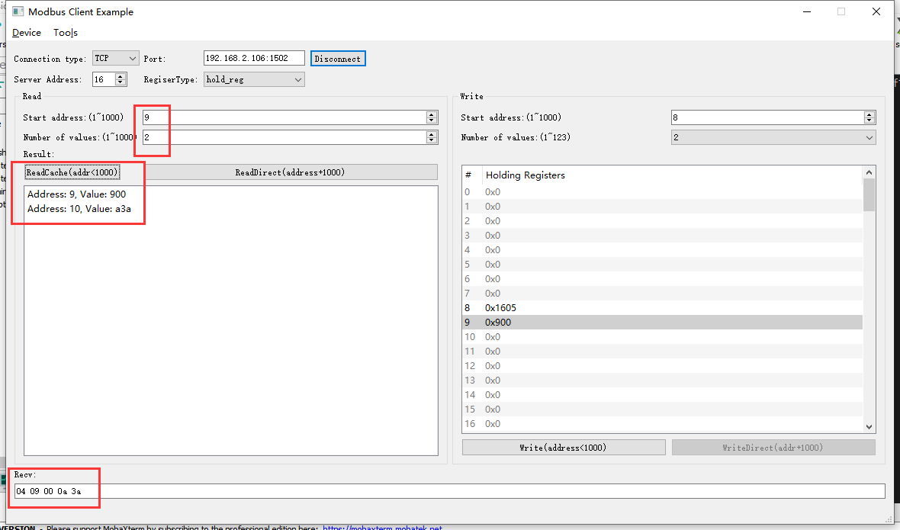2022-05-09 11:06:07 INFO mbTcpSvr.c:363: [mbTcpTransport]rcv from 192.168.2.104:52836:

[ 00 21 00 00 00 06 10 03 00 09 00 02 ]

2022-05-09 11:06:07 INFO main.cpp:709: on rcv mb request:

[ 00 21 00 00 00 06 10 03 00 09 00 02 ]

[00][21][00][00][00][07][10][03][04][09][00][0A][3A]

2022-05-09 11:06:07 INFO mbTcpSvr.c:527: [mbTcpTransport]cache snd:

[ 00 21 00 00 00 07 10 03 04 09 00 0a 3a ]

2022-05-09 11:06:07 INFO mbTcpSvr.c:451: [mbTcpTransport]snd to 192.168.2.104:52836:

[ 00 21 00 00 00 07 10 03 04 09 00 0a 3a ]

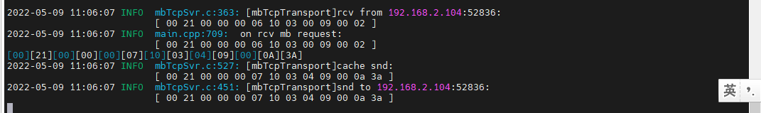

结果：读取到缓存内的数据，分别是日期的后半部分和时间的前半部分，读取缓存不判断寄存器绑定。

#### 读取11-12

1. 直读

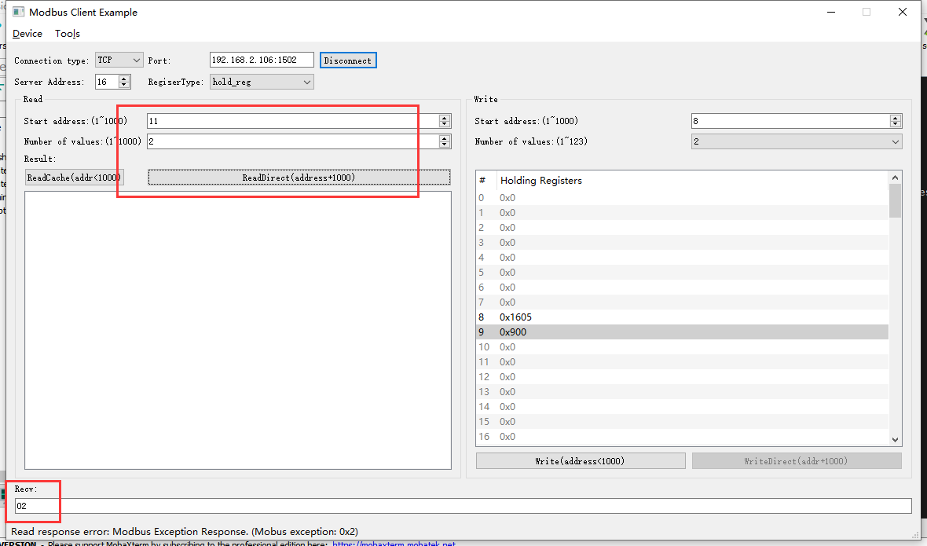2022-05-09 11:08:53 INFO mbTcpSvr.c:363: [mbTcpTransport]rcv from 192.168.2.104:52836:

[ 00 22 00 00 00 06 10 03 03 f3 00 02 ]

2022-05-09 11:08:53 INFO main.cpp:709: on rcv mb request:

[ 00 22 00 00 00 06 10 03 03 f3 00 02 ]

2022-05-09 11:08:53 INFO main.cpp:420: ---read 000047L1 start reg=40011, cnt=2

2022-05-09 11:08:53 WARN main.cpp:427: not support reg 40011

[00][22][00][00][00][03][10][83][02]

2022-05-09 11:08:53 INFO mbTcpSvr.c:527: [mbTcpTransport]cache snd:

[ 00 22 00 00 00 03 10 83 02 ]

2022-05-09 11:08:53 INFO mbTcpSvr.c:451: [mbTcpTransport]snd to 192.168.2.104:52836:

[ 00 22 00 00 00 03 10 83 02 ]

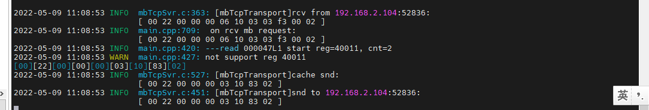

结果：回复错误。

#### 读取11-13

1. 直读

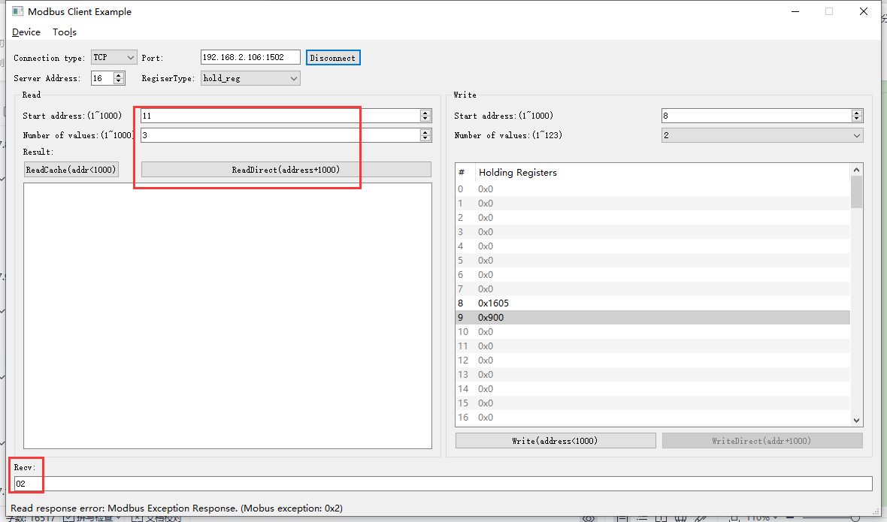2022-05-09 11:10:39 INFO mbTcpSvr.c:363: [mbTcpTransport]rcv from 192.168.2.104:52836:

[ 00 23 00 00 00 06 10 03 03 f3 00 03 ]

2022-05-09 11:10:39 INFO main.cpp:709: on rcv mb request:

[ 00 23 00 00 00 06 10 03 03 f3 00 03 ]

2022-05-09 11:10:39 INFO main.cpp:420: ---read 000047L1 start reg=40011, cnt=3

2022-05-09 11:10:39 WARN main.cpp:427: not support reg 40011

[00][23][00][00][00][03][10][83][02]

2022-05-09 11:10:39 INFO mbTcpSvr.c:527: [mbTcpTransport]cache snd:

[ 00 23 00 00 00 03 10 83 02 ]

2022-05-09 11:10:39 INFO mbTcpSvr.c:451: [mbTcpTransport]snd to 192.168.2.104:52836:

[ 00 23 00 00 00 03 10 83 02 ]

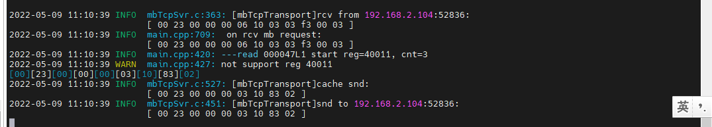

结果：回复错误。

### 写入时间

1. 写入

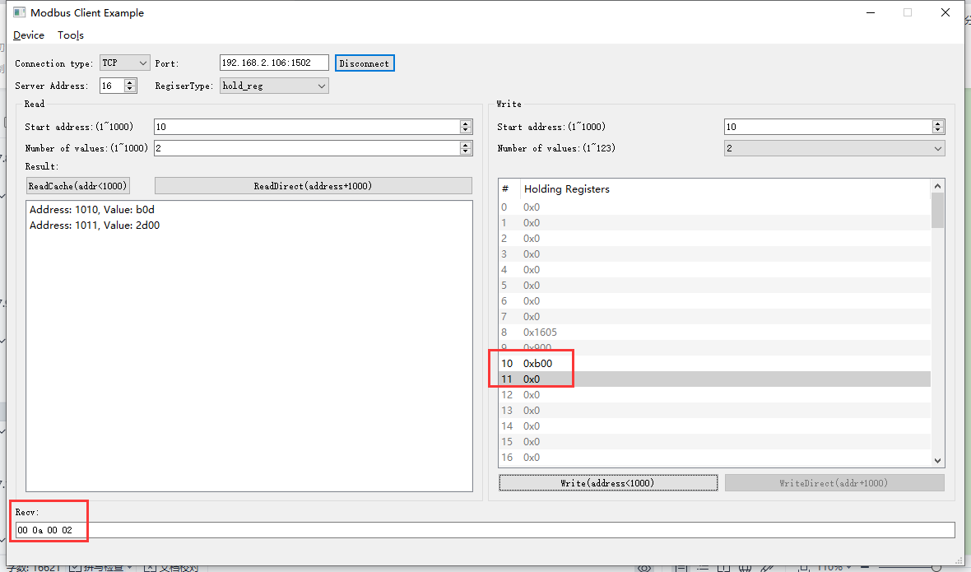2022-05-09 11:13:54 INFO mbTcpSvr.c:363: [mbTcpTransport]rcv from 192.168.2.104:52836:

[ 00 25 00 00 00 0b 10 10 00 0a 00 02 04 0b 00 00 00 ]

2022-05-09 11:13:54 INFO main.cpp:709: on rcv mb request:

[ 00 25 00 00 00 0b 10 10 00 0a 00 02 04 0b 00 00 00 ]

2022-05-09 11:13:54 INFO main.cpp:420: ---write 000047L1 start reg=40010, cnt=2

2022-05-09 11:13:54 DEBUG main.cpp:525: write reg 40010 to:[hex]

[ 0b 00 00 00 ]

2022-05-09 11:13:54 INFO devList.cpp:723: to set time to 11:0:0

2022-05-09 11:13:54 INFO 7Fcom.cpp:517: gw7f onRcvProcess:

topic:local/00000E97/000047L1

payload:{"deviceKey":"000047L1","errorCode":0,"function":{"controller_addr":"00000E97","time":"11:00:00"},"sno":"6-16-16-37","statistics":{"timesOfContinuousFailed":0,"timesOfFailed":0,"timesOfSuccess":750,"timesOfTotal":750}}

2022-05-09 11:13:54 INFO mbTcpSvr.c:451: [mbTcpTransport]snd to 192.168.2.104:52836:

[ 00 25 00 00 00 06 10 10 00 0a 00 02 ]

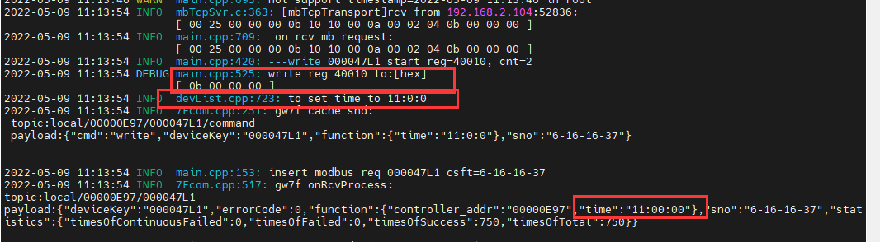

结果：写入成功。

1. 直读

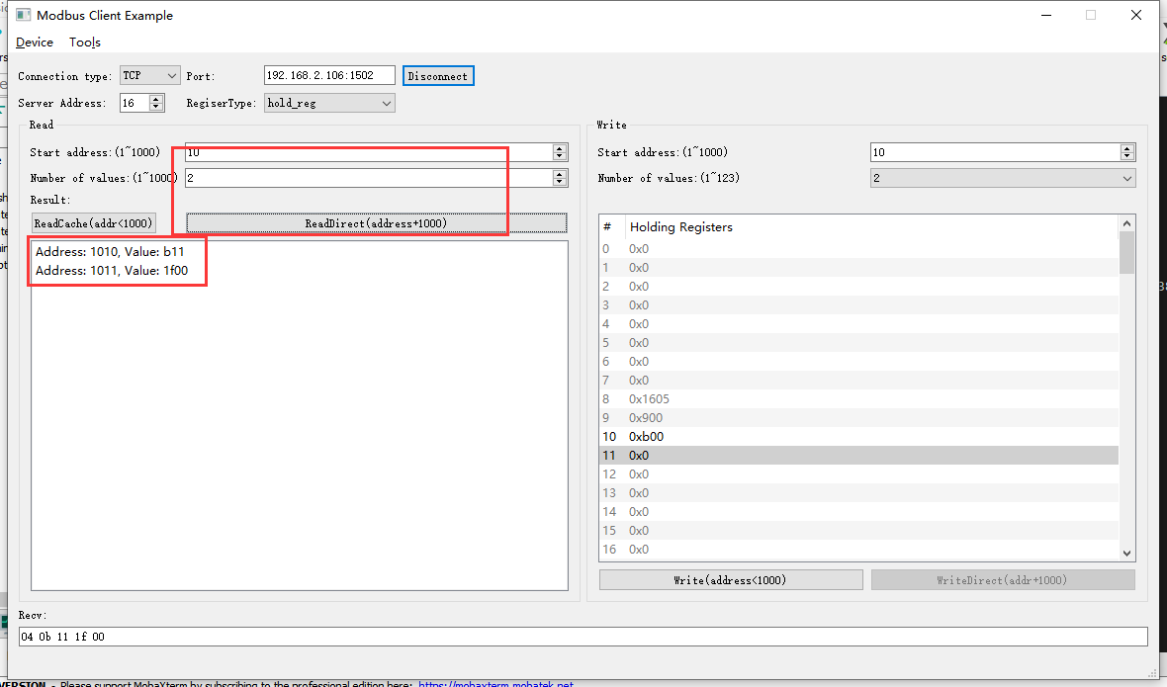2022-05-09 11:31:27 INFO mbTcpSvr.c:363: [mbTcpTransport]rcv from 192.168.2.104:52836:

[ 00 26 00 00 00 06 10 03 03 f2 00 02 ]

2022-05-09 11:31:27 INFO main.cpp:709: on rcv mb request:

[ 00 26 00 00 00 06 10 03 03 f2 00 02 ]

2022-05-09 11:31:27 INFO main.cpp:420: ---read 000047L1 start reg=40010, cnt=2

2022-05-09 11:31:28 INFO 7Fcom.cpp:517: gw7f onRcvProcess:

topic:local/00000E97/000047L1

payload:{"deviceKey":"000047L1","errorCode":0,"function":{"controller_addr":"00000E97","time":"11:17:31"},"sno":"6-16-3-38","statistics":{"timesOfContinuousFailed":0,"timesOfFailed":0,"timesOfSuccess":754,"timesOfTotal":754}}

2022-05-09 11:31:28 INFO mbTcpSvr.c:451: [mbTcpTransport]snd to 192.168.2.104:52836:

[ 00 26 00 00 00 07 10 03 04 0b 11 1f 00 ]

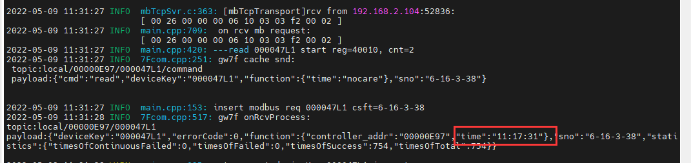

结果：设置时间后17 分钟再次读取时间，读取到当前时间为11:17，读取正确。

1. 读缓存

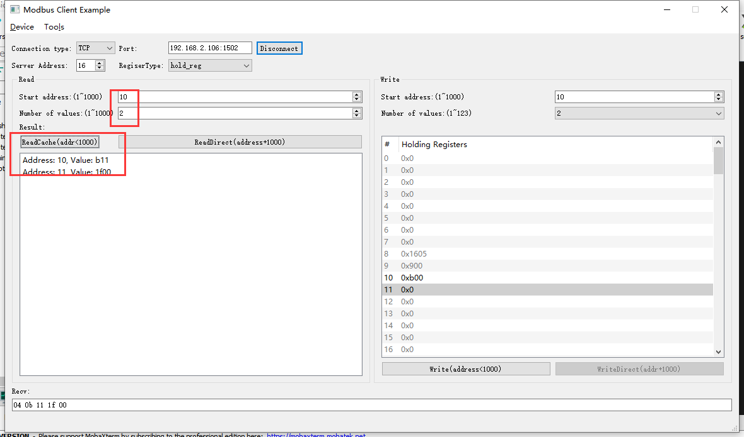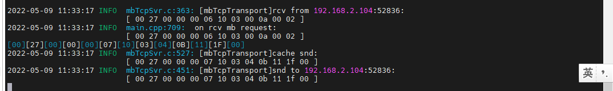

### 写入不存在的时间

1. 写入

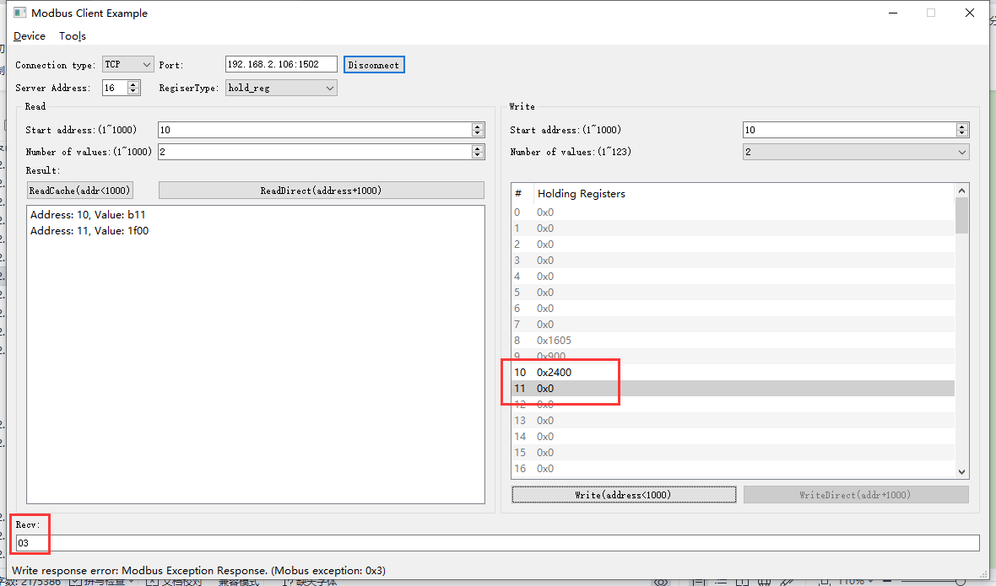2022-05-09 13:21:53 INFO mbTcpSvr.c:363: [mbTcpTransport]rcv from 192.168.2.104:56455:

[ 00 28 00 00 00 0b 10 10 00 0a 00 02 04 24 00 00 00 ]

2022-05-09 13:21:53 INFO main.cpp:709: on rcv mb request:

[ 00 28 00 00 00 0b 10 10 00 0a 00 02 04 24 00 00 00 ]

2022-05-09 13:21:53 INFO main.cpp:420: ---write 000047L1 start reg=40010, cnt=2

2022-05-09 13:21:53 DEBUG main.cpp:525: write reg 40010 to:[hex]

[ 24 00 00 00 ]

2022-05-09 13:21:53 WARN devList.cpp:709: wrong year!

[00][28][00][00][00][03][10][90][03]

2022-05-09 13:21:53 INFO mbTcpSvr.c:527: [mbTcpTransport]cache snd:

[ 00 28 00 00 00 03 10 90 03 ]

2022-05-09 13:21:53 INFO mbTcpSvr.c:451: [mbTcpTransport]snd to 192.168.2.104:56455:

[ 00 28 00 00 00 03 10 90 03 ]

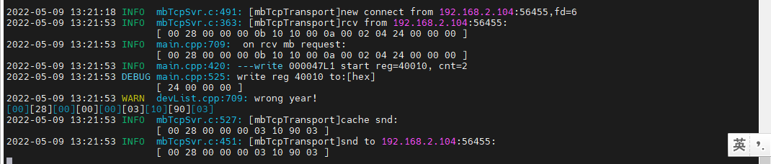

结果：回复错误。

1. 直读

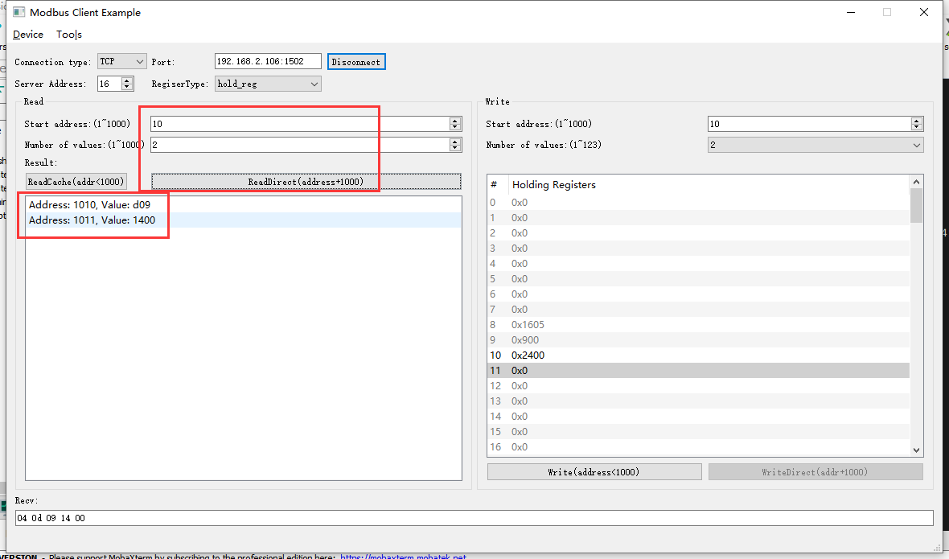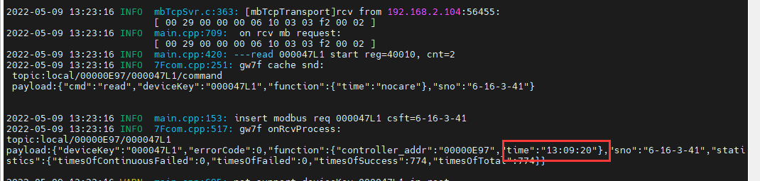

结果：配合错误时间无效，且不会影响原来的正确时间。

## 阀门开次数ok

**寄存器地址定义：**



1. 直读阀门开次数

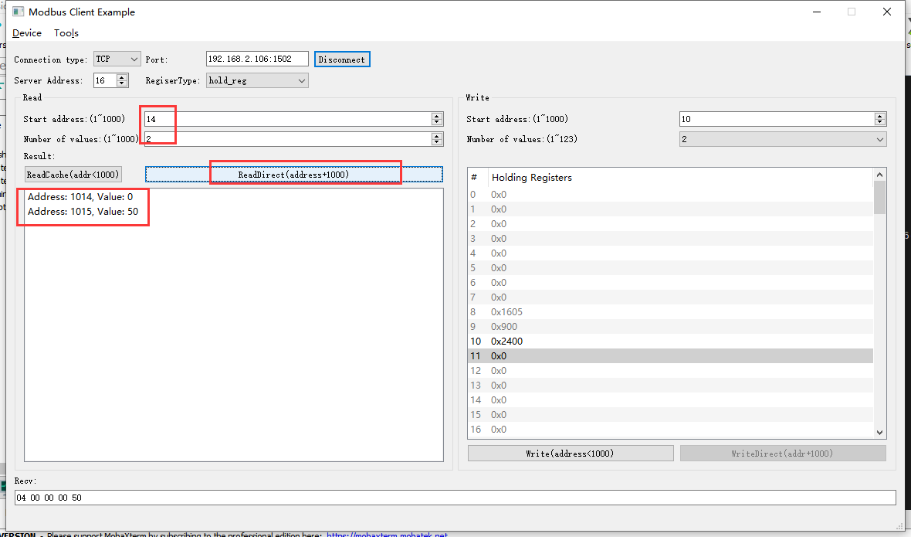2022-05-09 13:43:09 INFO mbTcpSvr.c:363: [mbTcpTransport]rcv from 192.168.2.104:56455:

[ 00 2a 00 00 00 06 10 03 03 f6 00 02 ]

2022-05-09 13:43:09 INFO main.cpp:709: on rcv mb request:

[ 00 2a 00 00 00 06 10 03 03 f6 00 02 ]

2022-05-09 13:43:09 INFO main.cpp:420: ---read 000047L1 start reg=40014, cnt=2

2022-05-09 13:43:09 INFO 7Fcom.cpp:517: gw7f onRcvProcess:

topic:local/00000E97/000047L1

payload:{"deviceKey":"000047L1","errorCode":0,"function":{"controller_addr":"00000E97","valve_opening_times":80},"sno":"6-16-3-42","statistics":{"timesOfContinuousFailed":0,"timesOfFailed":0,"timesOfSuccess":778,"timesOfTotal":778}}

2022-05-09 13:43:09 INFO mbTcpSvr.c:451: [mbTcpTransport]snd to 192.168.2.104:56455:

[ 00 2a 00 00 00 07 10 03 04 00 00 00 50 ]

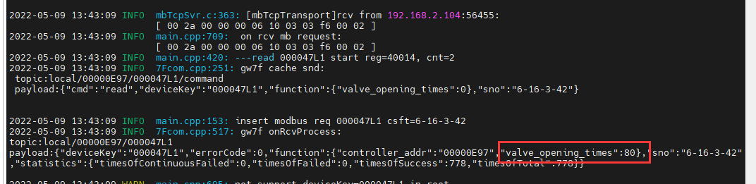

结果：读取到开机次数是80

1. 读缓存阀门开次数

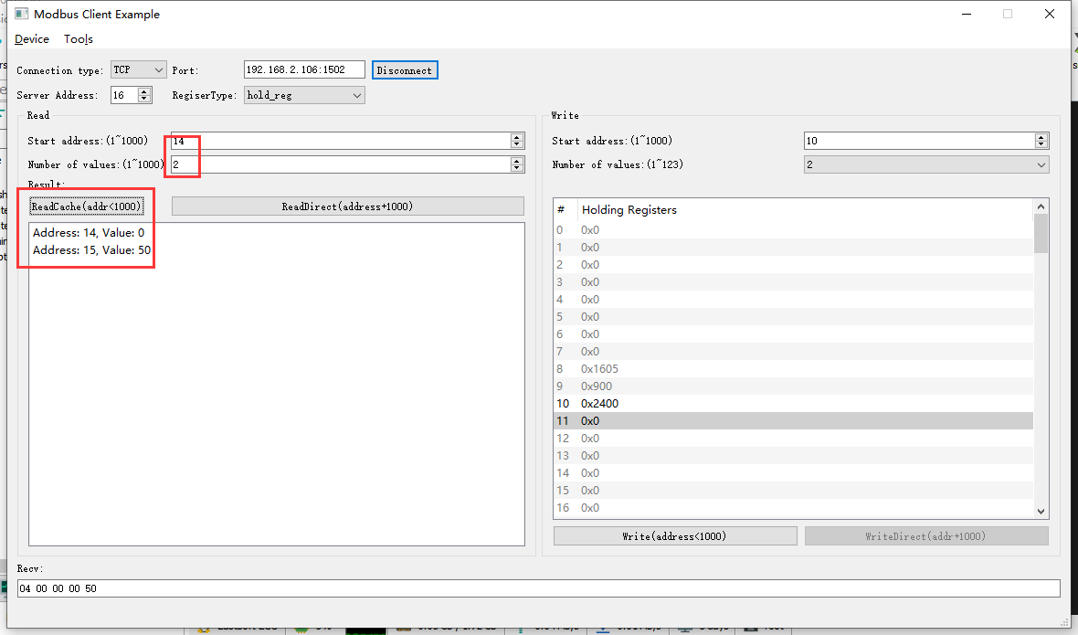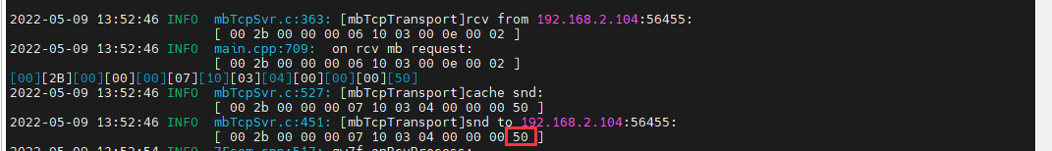

结果：读取到阀门开次数是80。

### 写-清零操作





1. 写清零

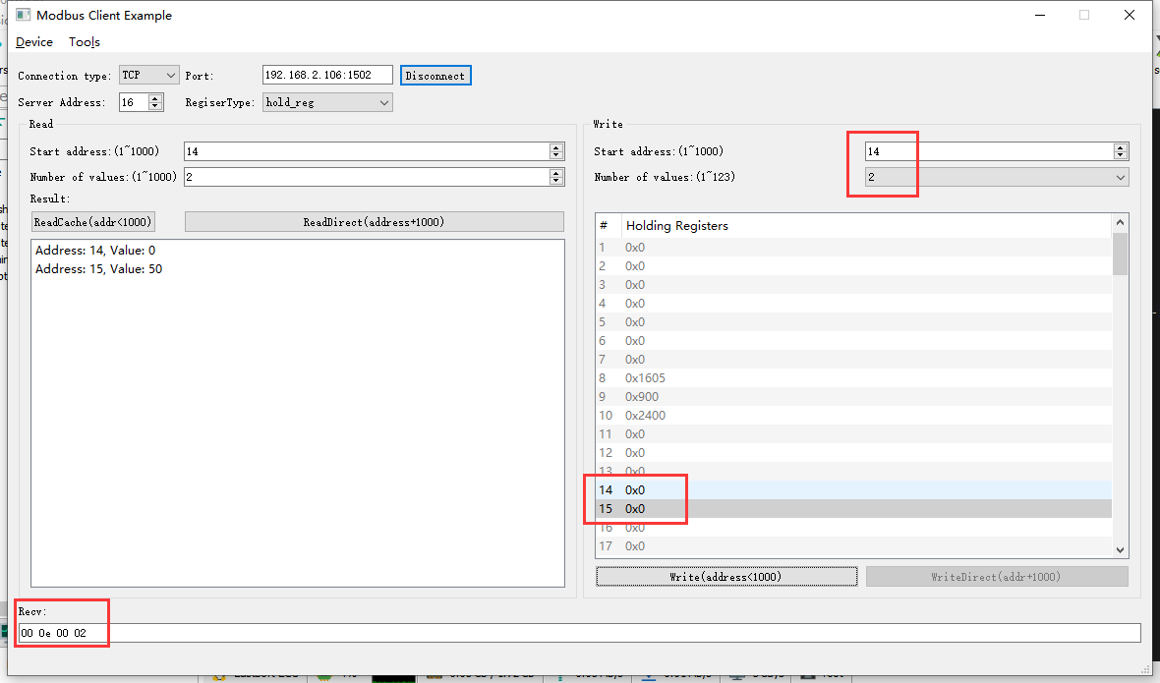

2022-05-09 14:01:17 INFO mbTcpSvr.c:363: [mbTcpTransport]rcv from 192.168.2.104:56455:

[ 00 2c 00 00 00 0b 10 10 00 0e 00 02 04 00 00 00 00 ]

2022-05-09 14:01:17 INFO main.cpp:709: on rcv mb request:

[ 00 2c 00 00 00 0b 10 10 00 0e 00 02 04 00 00 00 00 ]

2022-05-09 14:01:17 INFO main.cpp:420: ---write 000047L1 start reg=40014, cnt=2

2022-05-09 14:01:17 DEBUG main.cpp:525: write reg 40014 to:[hex]

[ 00 00 00 00 ]

2022-05-09 14:01:17 INFO 7Fcom.cpp:517: gw7f onRcvProcess:

topic:local/00000E97/000047L1

payload:{"deviceKey":"000047L1","errorCode":0,"function":{"controller_addr":"00000E97","valve_opening_times":0},"sno":"6-16-16-44","statistics":{"timesOfContinuousFailed":0,"timesOfFailed":0,"timesOfSuccess":782,"timesOfTotal":782}}

2022-05-09 14:01:17 INFO mbTcpSvr.c:451: [mbTcpTransport]snd to 192.168.2.104:56455:

[ 00 2c 00 00 00 06 10 10 00 0e 00 02 ]

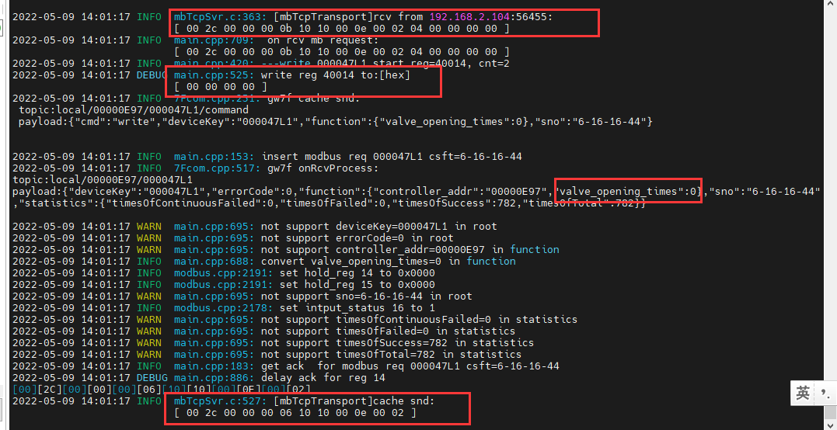

1. 直读开机次数

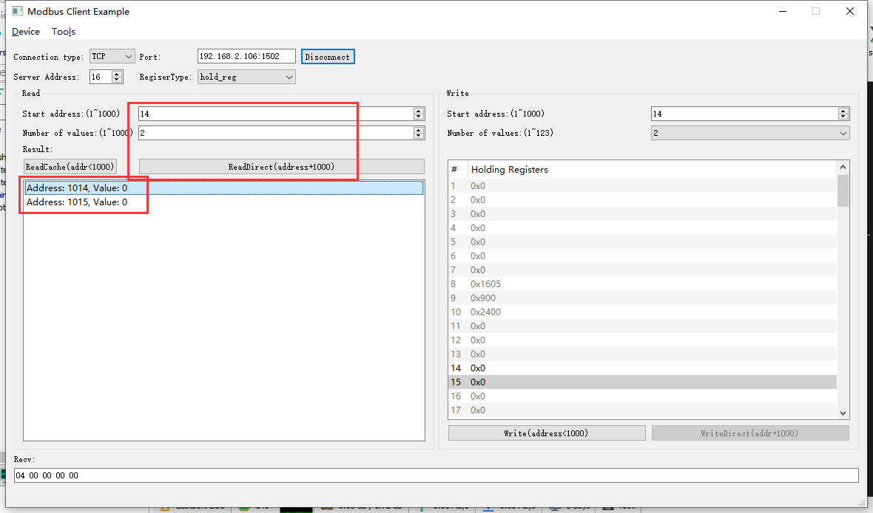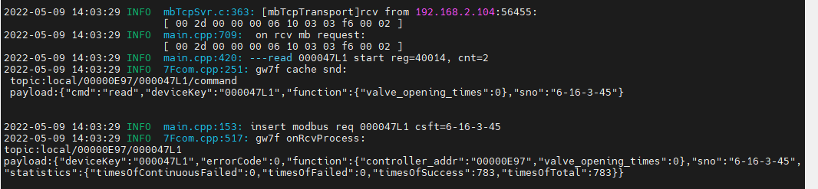

1. 读缓存开机次数

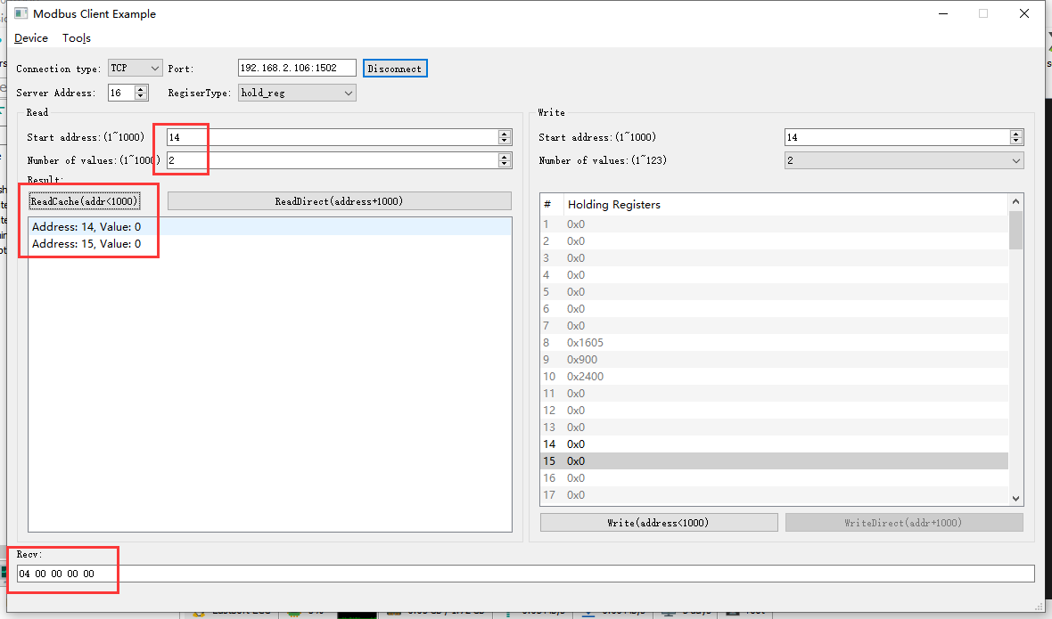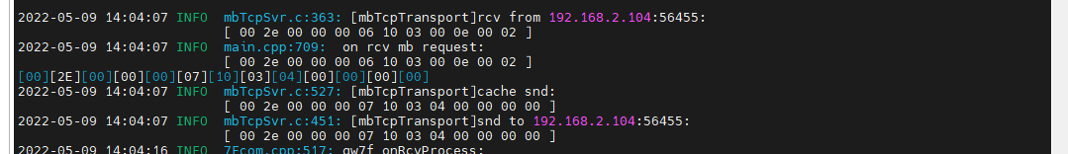

结果：读取到的开机次数已经清零，写入清零正常。

### 读取错误的地址

1. 读取寄存器14

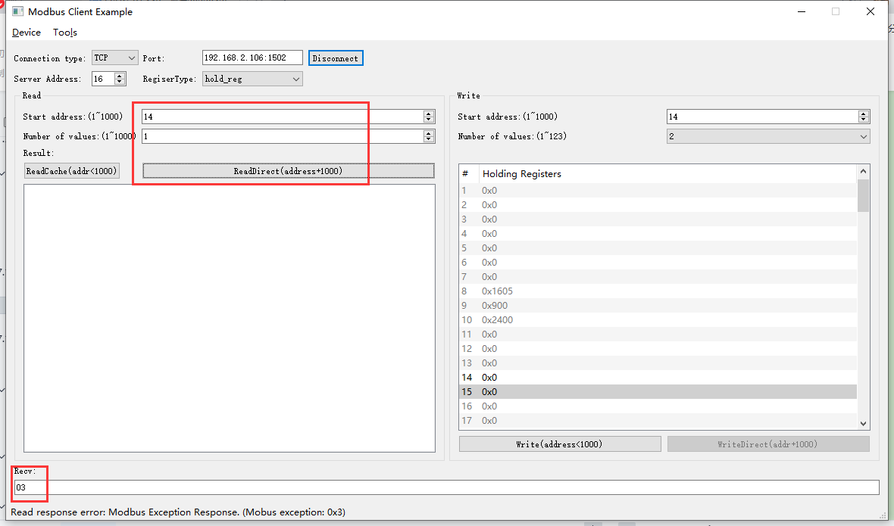2022-05-09 14:09:24 INFO mbTcpSvr.c:363: [mbTcpTransport]rcv from 192.168.2.104:56455:

[ 00 39 00 00 00 06 10 03 03 f6 00 01 ]

2022-05-09 14:09:24 INFO main.cpp:709: on rcv mb request:

[ 00 39 00 00 00 06 10 03 03 f6 00 01 ]

2022-05-09 14:09:24 INFO mbTcpSvr.c:527: [mbTcpTransport]cache snd:

[ 00 39 00 00 00 03 10 83 03 ]

2022-05-09 14:09:24 INFO mbTcpSvr.c:451: [mbTcpTransport]snd to 192.168.2.104:56455:

[ 00 39 00 00 00 03 10 83 03 ]

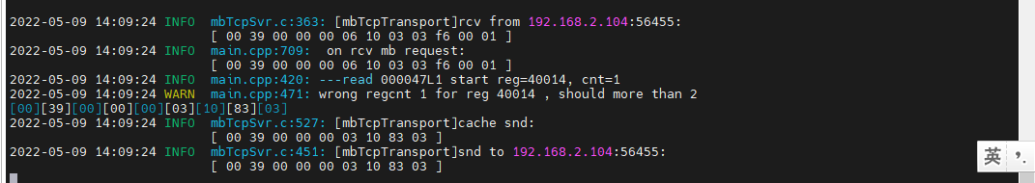

结果：读取后，回复错误。

1. 读取寄存器14-16

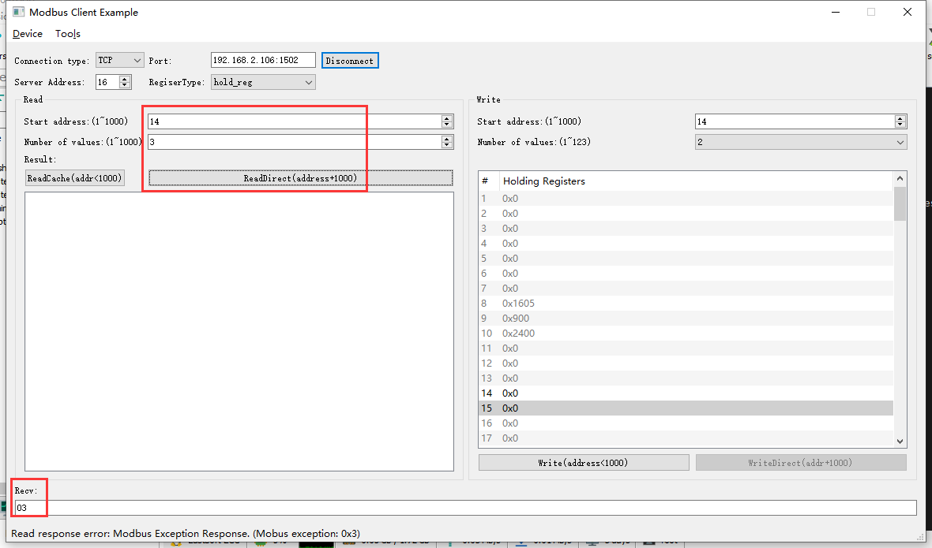

2022-05-09 14:10:45 INFO mbTcpSvr.c:363: [mbTcpTransport]rcv from 192.168.2.104:56455:

[ 00 3a 00 00 00 06 10 03 03 f6 00 03 ]

2022-05-09 14:10:45 INFO main.cpp:709: on rcv mb request:

[ 00 3a 00 00 00 06 10 03 03 f6 00 03 ]

2022-05-09 14:10:45 INFO main.cpp:420: ---read 000047L1 start reg=40014, cnt=3

2022-05-09 14:10:45 WARN main.cpp:471: wrong regcnt 1 for reg 40016 , should more than 2

[00][3A][00][00][00][03][10][83][03]

2022-05-09 14:10:45 INFO mbTcpSvr.c:527: [mbTcpTransport]cache snd:

[ 00 3a 00 00 00 03 10 83 03 ]

2022-05-09 14:10:45 INFO mbTcpSvr.c:451: [mbTcpTransport]snd to 192.168.2.104:56455:

[ 00 3a 00 00 00 03 10 83 03 ]

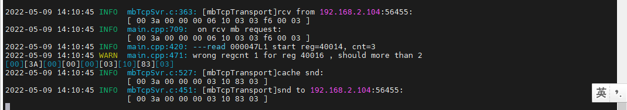结果：读取后，回复错误。

### 写错误地址

1. 写清零14

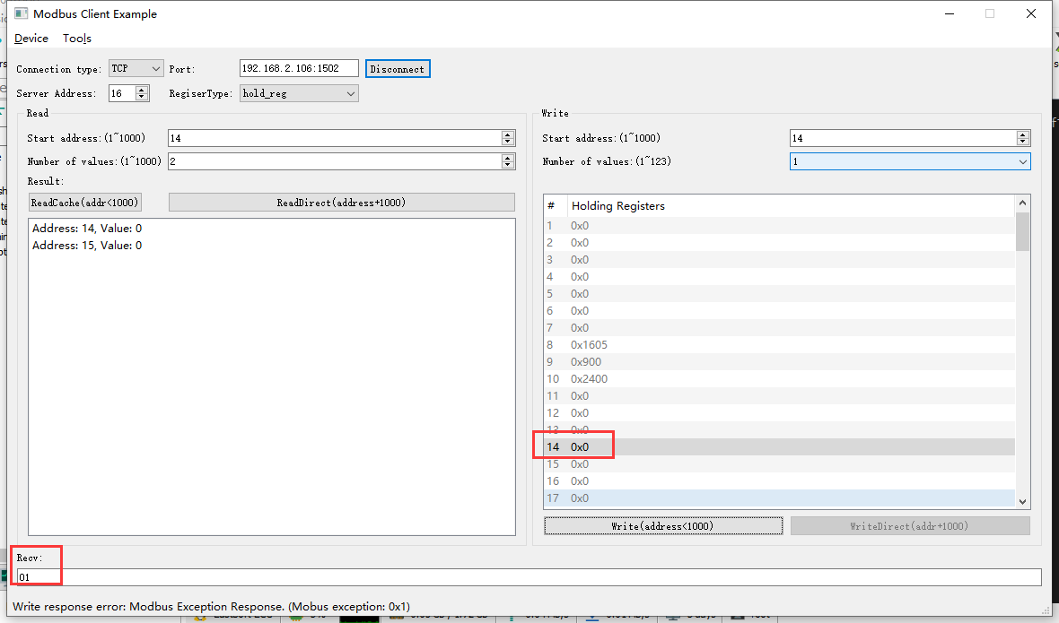2022-05-09 14:15:31 INFO mbTcpSvr.c:363: [mbTcpTransport]rcv from 192.168.2.104:56455:

[ 00 3d 00 00 00 06 10 06 00 0e 00 00 ]

2022-05-09 14:15:31 INFO main.cpp:709: on rcv mb request:

[ 00 3d 00 00 00 06 10 06 00 0e 00 00 ]

2022-05-09 14:15:31 INFO main.cpp:420: ---write 000047L1 start reg=40014, cnt=1

2022-05-09 14:15:31 WARN main.cpp:455: reg 40014 not support single or coil write

[00][3D][00][00][00][03][10][86][01]

2022-05-09 14:15:31 INFO mbTcpSvr.c:527: [mbTcpTransport]cache snd:

[ 00 3d 00 00 00 03 10 86 01 ]

2022-05-09 14:15:31 INFO mbTcpSvr.c:451: [mbTcpTransport]snd to 192.168.2.104:56455:

[ 00 3d 00 00 00 03 10 86 01 ]

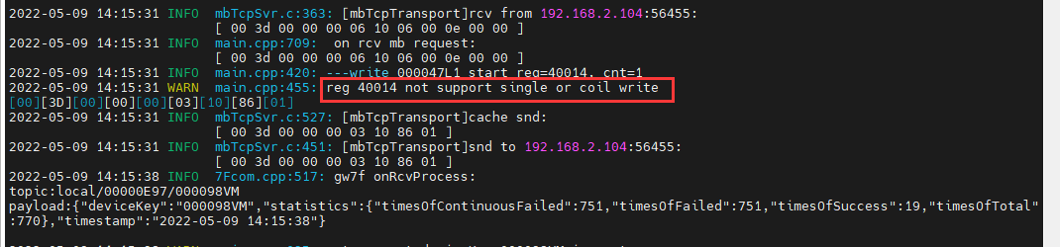

结果：此为绑定使用的寄存器，单独写入不被支持，回复错误。

1. 写清零14-16

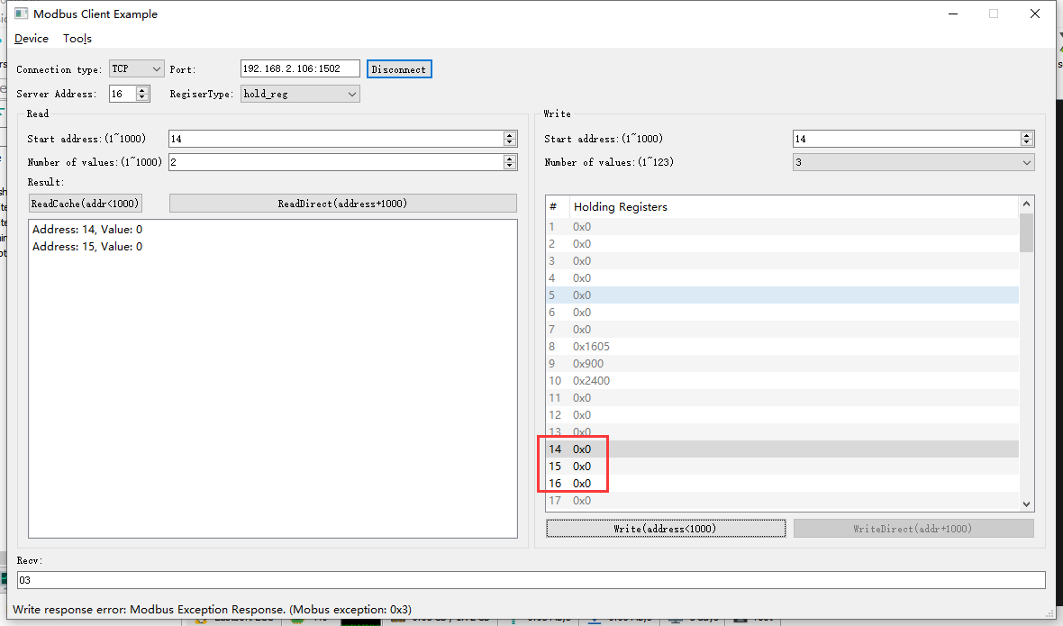2022-05-09 14:19:56 INFO mbTcpSvr.c:363: [mbTcpTransport]rcv from 192.168.2.104:56455:

[ 00 3e 00 00 00 0d 10 10 00 0e 00 03 06 00 00 00 00 00 00 ]

2022-05-09 14:19:56 INFO main.cpp:709: on rcv mb request:

[ 00 3e 00 00 00 0d 10 10 00 0e 00 03 06 00 00 00 00 00 00 ]

2022-05-09 14:19:56 INFO main.cpp:420: ---write 000047L1 start reg=40014, cnt=3

2022-05-09 14:19:56 DEBUG main.cpp:525: write reg 40014 to:[hex]

[ 00 00 00 00 ]

2022-05-09 14:19:56 WARN main.cpp:471: wrong regcnt 1 for reg 40016 , should more than 2

[00][3E][00][00][00][03][10][90][03]

2022-05-09 14:19:56 INFO mbTcpSvr.c:527: [mbTcpTransport]cache snd:

[ 00 3e 00 00 00 03 10 90 03 ]

2022-05-09 14:19:56 INFO mbTcpSvr.c:451: [mbTcpTransport]snd to 192.168.2.104:56455:

[ 00 3e 00 00 00 03 10 90 03 ]

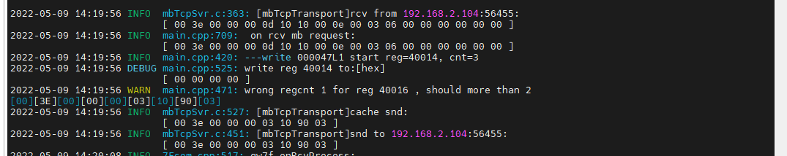

结果：回复错误。

## 开机次数ok

**寄存器地址定义：**



### 直读开机次数

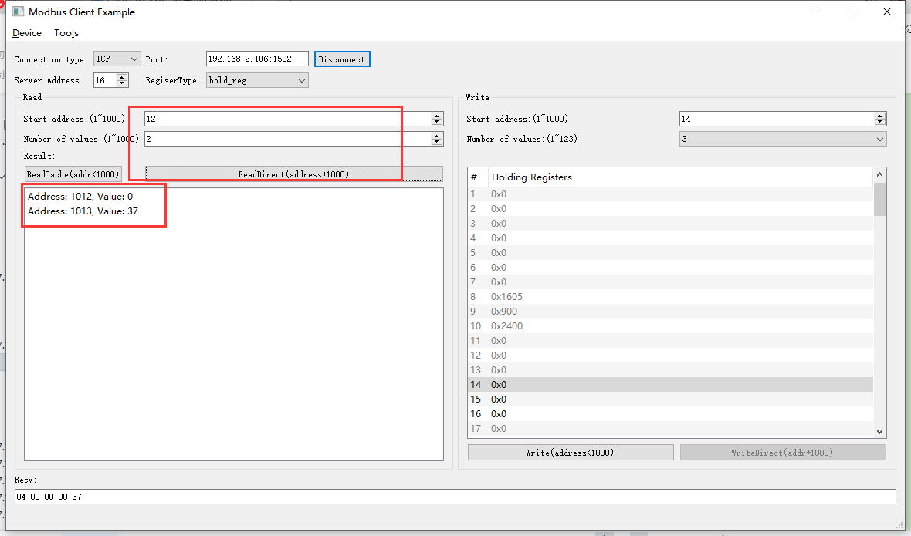2022-05-09 14:29:14 INFO mbTcpSvr.c:363: [mbTcpTransport]rcv from 192.168.2.104:56455:

[ 00 3f 00 00 00 06 10 03 03 f4 00 02 ]

2022-05-09 14:29:14 INFO main.cpp:709: on rcv mb request:

[ 00 3f 00 00 00 06 10 03 03 f4 00 02 ]

2022-05-09 14:29:14 INFO main.cpp:420: ---read 000047L1 start reg=40012, cnt=2

2022-05-09 14:29:15 INFO 7Fcom.cpp:517: gw7f onRcvProcess:

topic:local/00000E97/000047L1

payload:{"deviceKey":"000047L1","errorCode":0,"function":{"controller_addr":"00000E97","power_on_times":55},"sno":"6-16-3-63","statistics":{"timesOfContinuousFailed":0,"timesOfFailed":0,"timesOfSuccess":796,"timesOfTotal":796}}

2022-05-09 14:29:15 INFO mbTcpSvr.c:451: [mbTcpTransport]snd to 192.168.2.104:56455:

[ 00 3f 00 00 00 07 10 03 04 00 00 00 37 ]

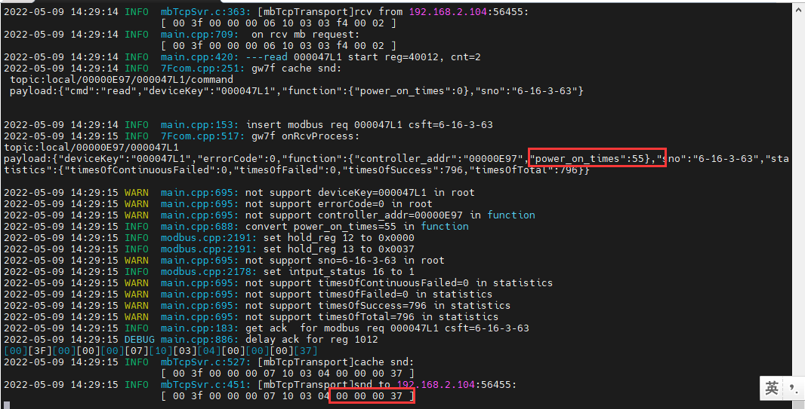

结果：读取到开机次数是55.

### 读缓存开机次数

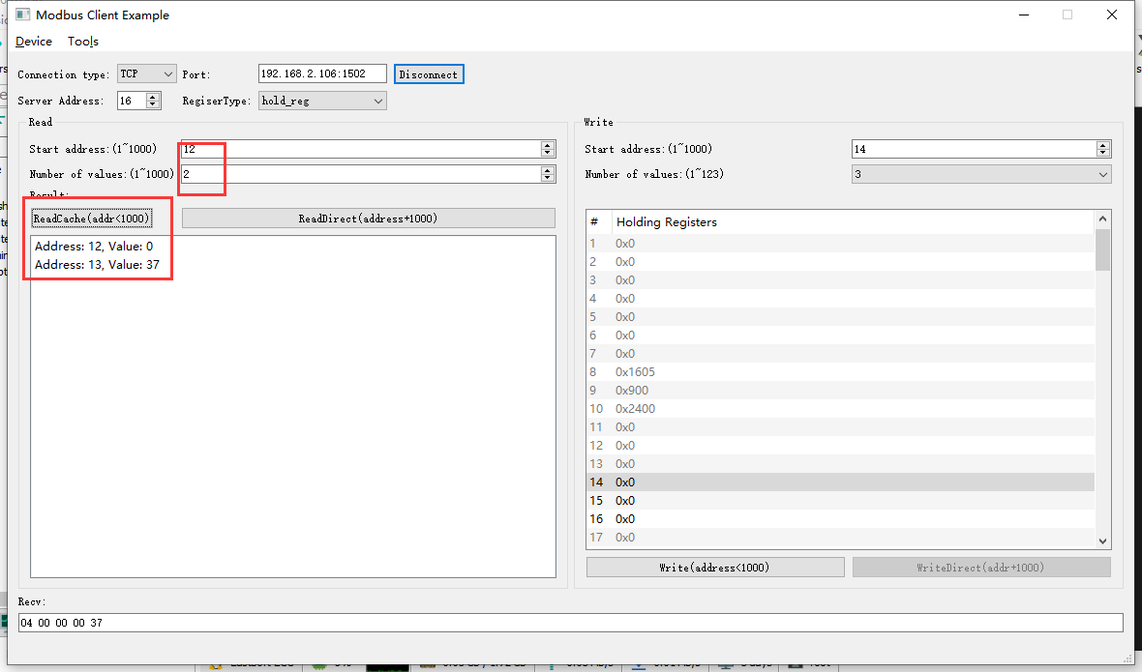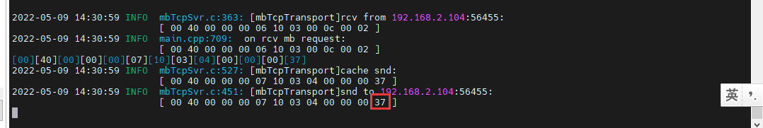

结果：读取到开机次数是55.

### 写-清零操作

1. 写入

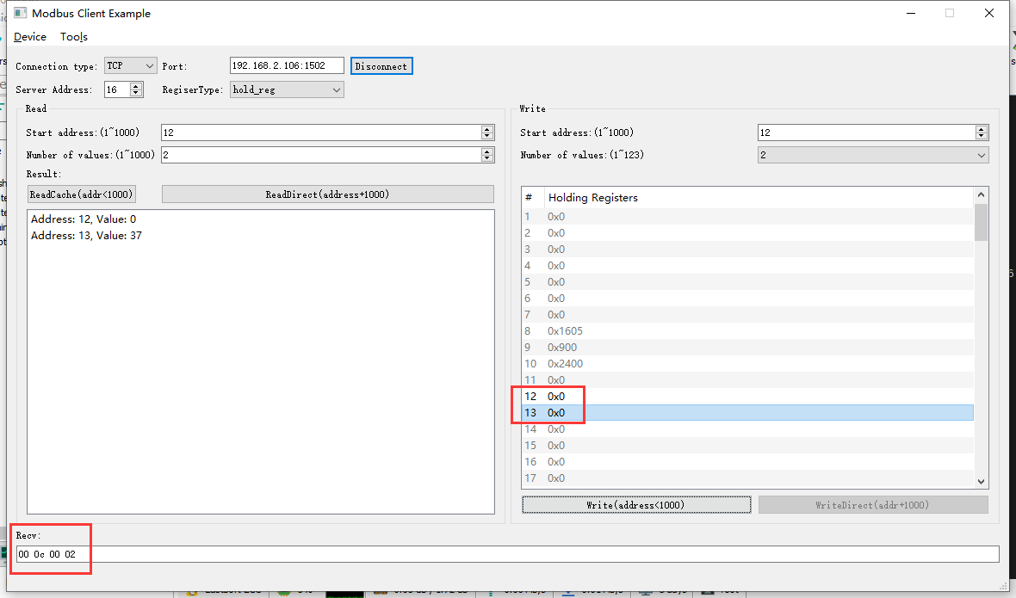2022-05-09 14:32:28 INFO mbTcpSvr.c:363: [mbTcpTransport]rcv from 192.168.2.104:56455:

[ 00 41 00 00 00 0b 10 10 00 0c 00 02 04 00 00 00 00 ]

2022-05-09 14:32:28 INFO main.cpp:709: on rcv mb request:

[ 00 41 00 00 00 0b 10 10 00 0c 00 02 04 00 00 00 00 ]

2022-05-09 14:32:28 INFO main.cpp:420: ---write 000047L1 start reg=40012, cnt=2

2022-05-09 14:32:28 DEBUG main.cpp:525: write reg 40012 to:[hex]

[ 00 00 00 00 ]

2022-05-09 14:32:28 INFO mbTcpSvr.c:451: [mbTcpTransport]snd to 192.168.2.104:56455:

[ 00 41 00 00 00 06 10 10 00 0c 00 02 ]

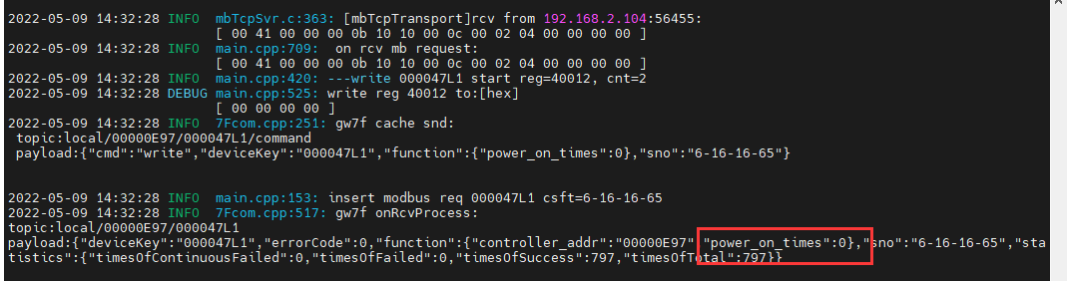

1. 直读开机次数

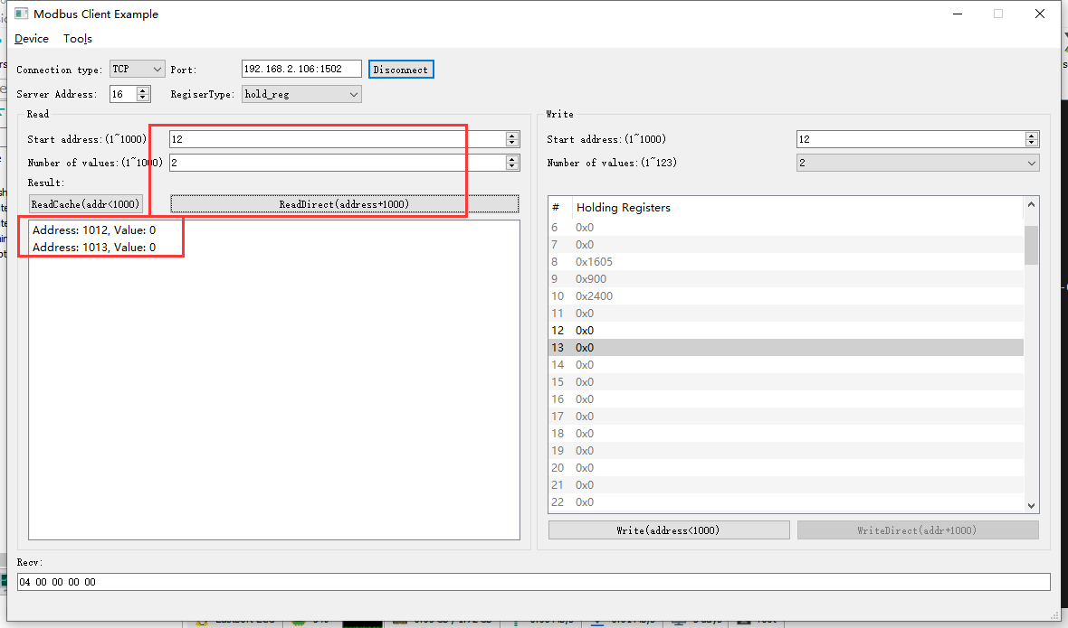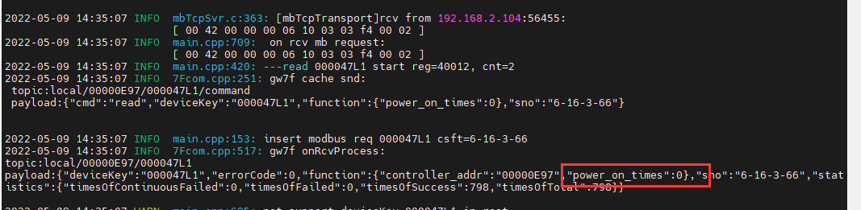

1. 读缓存开机次数

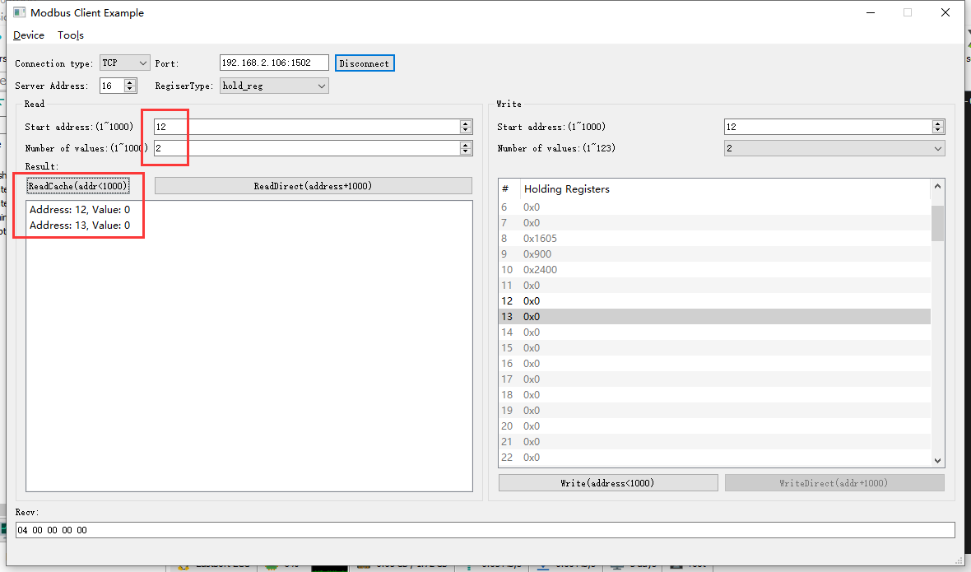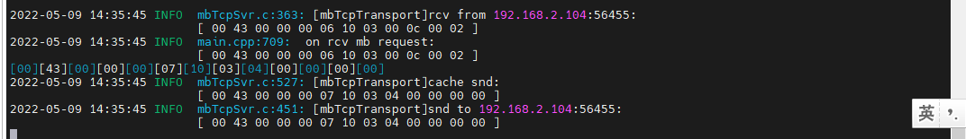

### 读取错误的地址

1. 读取寄存器12

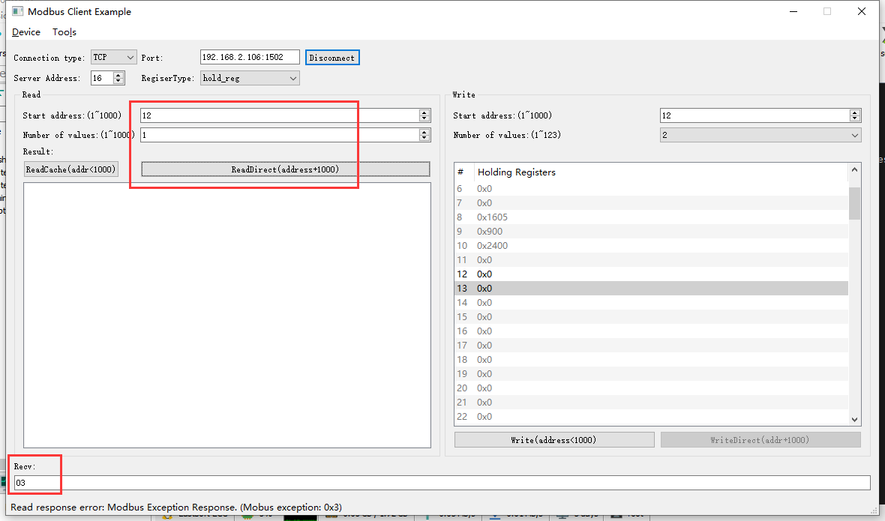2022-05-09 14:40:08 INFO mbTcpSvr.c:363: [mbTcpTransport]rcv from 192.168.2.104:56455:

[ 00 45 00 00 00 06 10 03 03 f4 00 01 ]

2022-05-09 14:40:08 INFO main.cpp:709: on rcv mb request:

[ 00 45 00 00 00 06 10 03 03 f4 00 01 ]

2022-05-09 14:40:08 INFO main.cpp:420: ---read 000047L1 start reg=40012, cnt=1

2022-05-09 14:40:08 WARN main.cpp:471: wrong regcnt 1 for reg 40012 , should more than 2

[00][45][00][00][00][03][10][83][03]

2022-05-09 14:40:08 INFO mbTcpSvr.c:527: [mbTcpTransport]cache snd:

[ 00 45 00 00 00 03 10 83 03 ]

2022-05-09 14:40:08 INFO mbTcpSvr.c:451: [mbTcpTransport]snd to 192.168.2.104:56455:

[ 00 45 00 00 00 03 10 83 03 ]

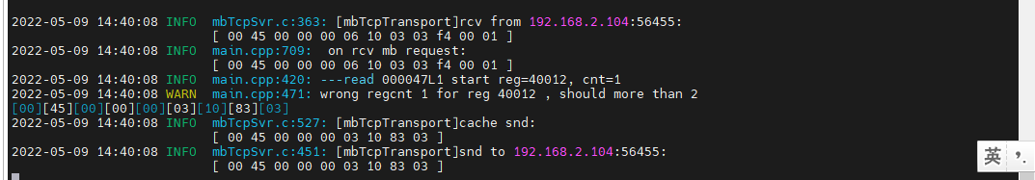

结果：回复错误，此数据为多个寄存器绑定数据。

1. 读取寄存器12-14

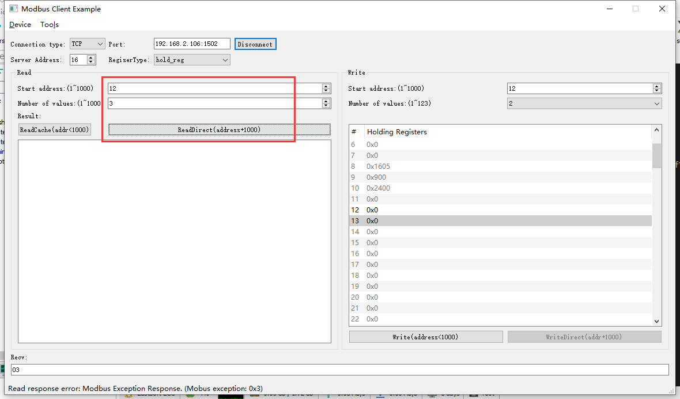

2022-05-09 14:40:59 INFO mbTcpSvr.c:363: [mbTcpTransport]rcv from 192.168.2.104:56455:

[ 00 46 00 00 00 06 10 03 03 f4 00 03 ]

2022-05-09 14:40:59 INFO main.cpp:709: on rcv mb request:

[ 00 46 00 00 00 06 10 03 03 f4 00 03 ]

2022-05-09 14:40:59 INFO main.cpp:420: ---read 000047L1 start reg=40012, cnt=3

2022-05-09 14:40:59 WARN main.cpp:471: wrong regcnt 1 for reg 40014 , should more than 2

[00][46][00][00][00][03][10][83][03]

2022-05-09 14:40:59 INFO mbTcpSvr.c:527: [mbTcpTransport]cache snd:

[ 00 46 00 00 00 03 10 83 03 ]

2022-05-09 14:40:59 INFO mbTcpSvr.c:451: [mbTcpTransport]snd to 192.168.2.104:56455:

[ 00 46 00 00 00 03 10 83 03 ]

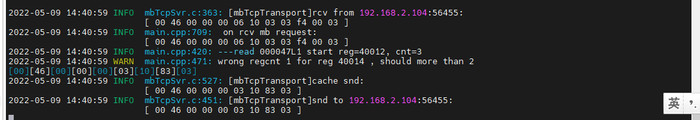

结果：回复错误，此数据为多个寄存器绑定数据。

### 写错误地址

1. 写清零12

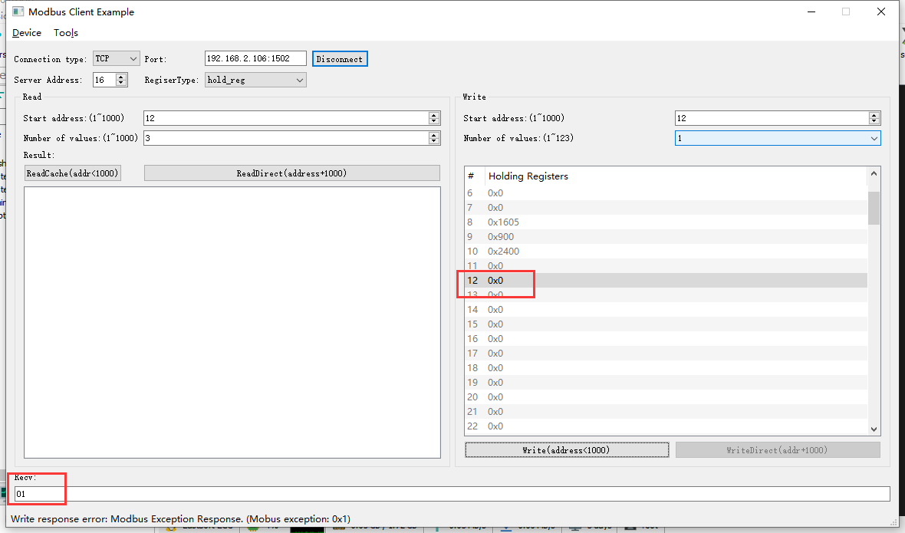

2022-05-09 14:42:15 INFO mbTcpSvr.c:363: [mbTcpTransport]rcv from 192.168.2.104:56455:

[ 00 47 00 00 00 06 10 06 00 0c 00 00 ]

2022-05-09 14:42:15 INFO main.cpp:709: on rcv mb request:

[ 00 47 00 00 00 06 10 06 00 0c 00 00 ]

2022-05-09 14:42:15 INFO main.cpp:420: ---write 000047L1 start reg=40012, cnt=1

2022-05-09 14:42:15 WARN main.cpp:455: reg 40012 not support single or coil write

[00][47][00][00][00][03][10][86][01]

2022-05-09 14:42:15 INFO mbTcpSvr.c:527: [mbTcpTransport]cache snd:

[ 00 47 00 00 00 03 10 86 01 ]

2022-05-09 14:42:15 INFO mbTcpSvr.c:451: [mbTcpTransport]snd to 192.168.2.104:56455:

[ 00 47 00 00 00 03 10 86 01 ]

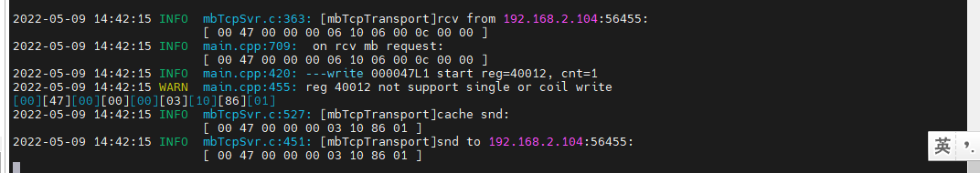

结果：回复错误，此数据需要绑定两个寄存器读取。

1. 写清零12-14

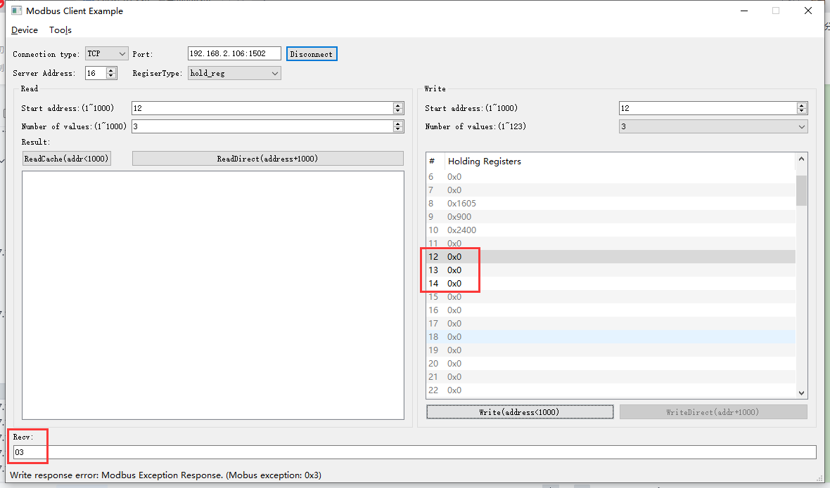

2022-05-09 14:44:34 INFO mbTcpSvr.c:363: [mbTcpTransport]rcv from 192.168.2.104:56455:

[ 00 48 00 00 00 0d 10 10 00 0c 00 03 06 00 00 00 00 00 00 ]

2022-05-09 14:44:34 INFO main.cpp:709: on rcv mb request:

[ 00 48 00 00 00 0d 10 10 00 0c 00 03 06 00 00 00 00 00 00 ]

2022-05-09 14:44:34 INFO main.cpp:420: ---write 000047L1 start reg=40012, cnt=3

2022-05-09 14:44:34 DEBUG main.cpp:525: write reg 40012 to:[hex]

[ 00 00 00 00 ]

2022-05-09 14:44:34 WARN main.cpp:471: wrong regcnt 1 for reg 40014 , should more than 2

[00][48][00][00][00][03][10][90][03]

2022-05-09 14:44:34 INFO mbTcpSvr.c:527: [mbTcpTransport]cache snd:

[ 00 48 00 00 00 03 10 90 03 ]

2022-05-09 14:44:34 INFO mbTcpSvr.c:451: [mbTcpTransport]snd to 192.168.2.104:56455:

[ 00 48 00 00 00 03 10 90 03 ]

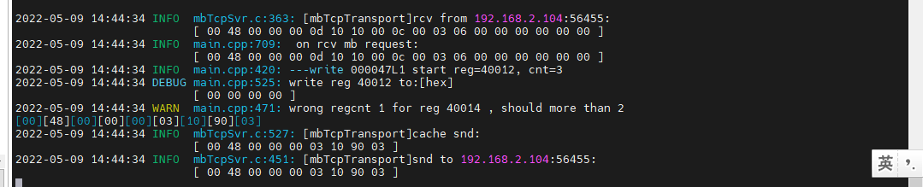

结果：回复错误，此数据需要绑定两个寄存器读取。

## 开机运行时间ok

**寄存器定义：**





### 直读开机运行时间

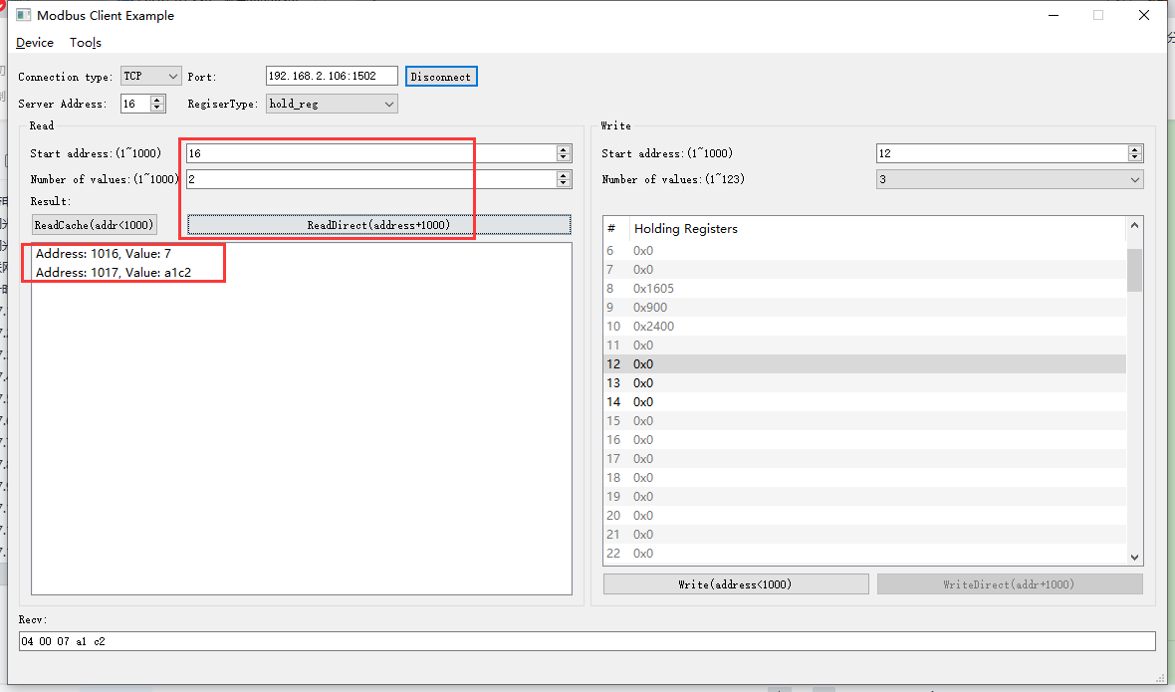

2022-05-09 14:48:09 INFO mbTcpSvr.c:363: [mbTcpTransport]rcv from 192.168.2.104:56455:

[ 00 4a 00 00 00 06 10 03 03 f8 00 02 ]

2022-05-09 14:48:09 INFO main.cpp:709: on rcv mb request:

[ 00 4a 00 00 00 06 10 03 03 f8 00 02 ]

2022-05-09 14:48:09 INFO main.cpp:420: ---read 000047L1 start reg=40016, cnt=2

2022-05-09 14:48:09 INFO 7Fcom.cpp:517: gw7f onRcvProcess:

topic:local/00000E97/000047L1

payload:{"deviceKey":"000047L1","errorCode":0,"function":{"controller_addr":"00000E97","run_time":500162},"sno":"6-16-3-74","statistics":{"timesOfContinuousFailed":0,"timesOfFailed":0,"timesOfSuccess":801,"timesOfTotal":801}}

2022-05-09 14:48:09 INFO mbTcpSvr.c:451: [mbTcpTransport]snd to 192.168.2.104:56455:

[ 00 4a 00 00 00 07 10 03 04 00 07 a1 c2 ]

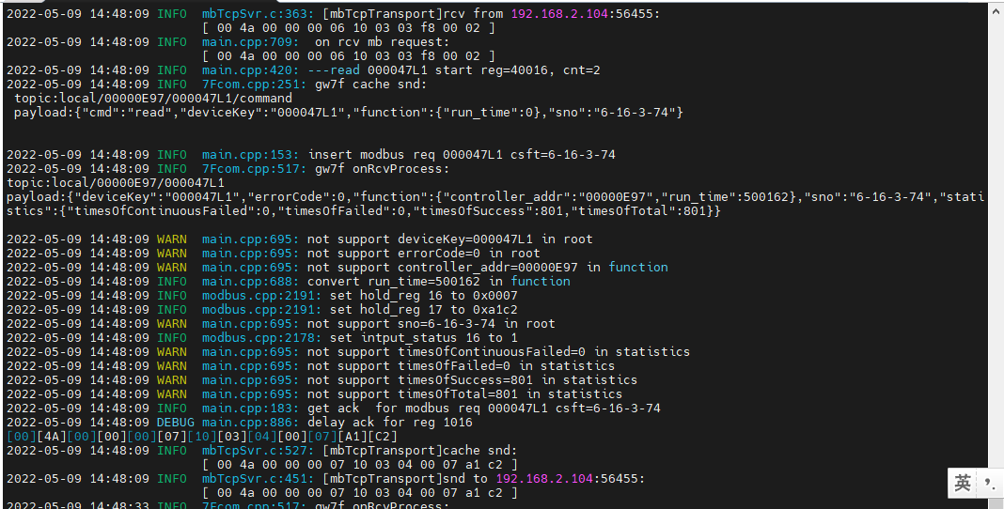



结果：与使用抄控器读取到的运行时间基本一致，手动操作有延迟。

### 读缓存开机运行时间

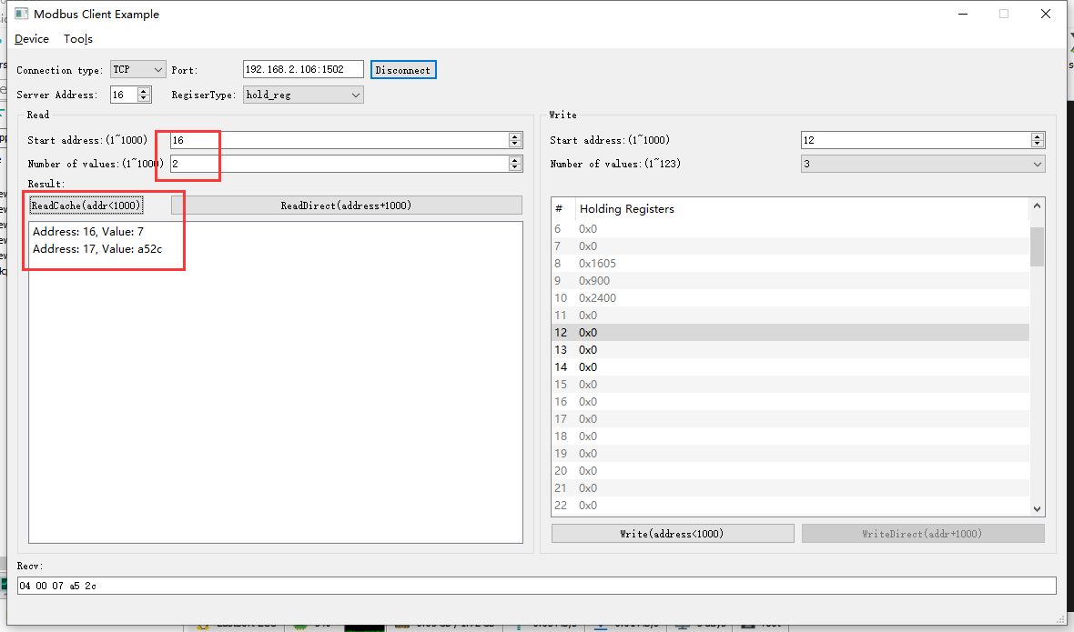

2022-05-09 15:02:49 INFO mbTcpSvr.c:363: [mbTcpTransport]rcv from 192.168.2.104:56455:

[ 00 4d 00 00 00 06 10 03 00 10 00 02 ]

2022-05-09 15:02:49 INFO main.cpp:709: on rcv mb request:

[ 00 4d 00 00 00 06 10 03 00 10 00 02 ]

[00][4D][00][00][00][07][10][03][04][00][07][A5][2C]

2022-05-09 15:02:49 INFO mbTcpSvr.c:527: [mbTcpTransport]cache snd:

[ 00 4d 00 00 00 07 10 03 04 00 07 a5 2c ]

2022-05-09 15:02:49 INFO mbTcpSvr.c:451: [mbTcpTransport]snd to 192.168.2.104:56455:

[ 00 4d 00 00 00 07 10 03 04 00 07 a5 2c ]

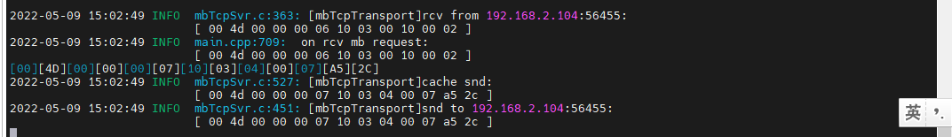

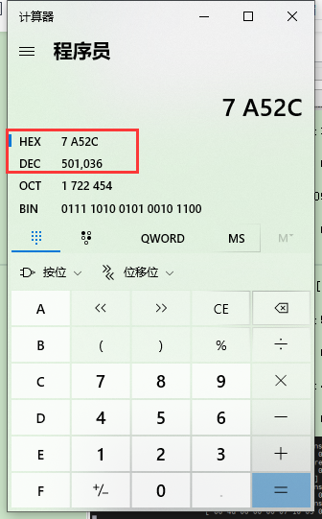

结果：与使用抄控器读取到的运行时间基本一致，手动操作有延迟。

### 写--清零操作

1. 写入

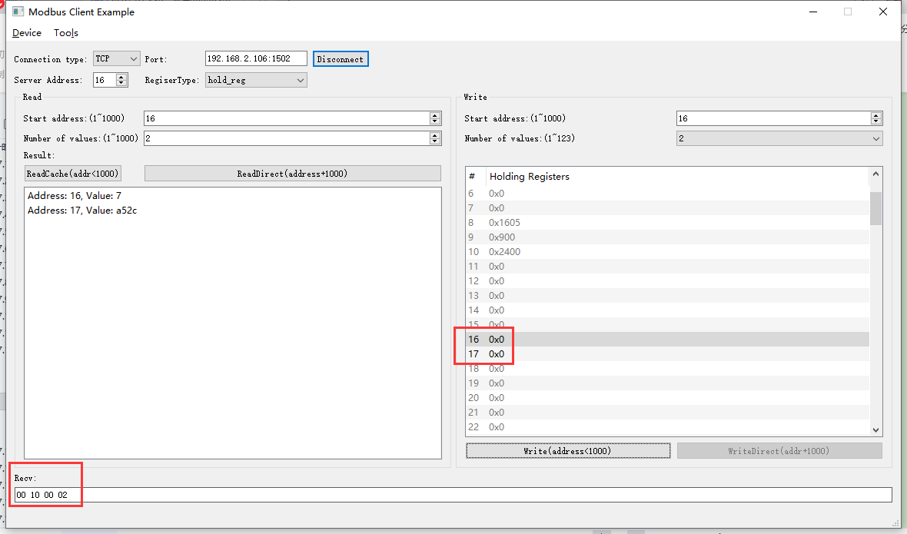

2022-05-09 15:59:41 INFO mbTcpSvr.c:363: [mbTcpTransport]rcv from 192.168.2.104:60103:

[ 00 4e 00 00 00 0b 10 10 00 10 00 02 04 00 00 00 00 ]

2022-05-09 15:59:41 INFO main.cpp:709: on rcv mb request:

[ 00 4e 00 00 00 0b 10 10 00 10 00 02 04 00 00 00 00 ]

2022-05-09 15:59:41 INFO main.cpp:420: ---write 000047L1 start reg=40016, cnt=2

2022-05-09 15:59:41 DEBUG main.cpp:525: write reg 40016 to:[hex]

[ 00 00 00 00 ]

2022-05-09 15:59:42 INFO 7Fcom.cpp:517: gw7f onRcvProcess:

topic:local/00000E97/000047L1

payload:{"deviceKey":"000047L1","errorCode":0,"function":{"controller_addr":"00000E97","run_time":0},"sno":"6-16-16-78","statistics":{"timesOfContinuousFailed":0,"timesOfFailed":0,"timesOfSuccess":815,"timesOfTotal":815}}

2022-05-09 15:59:42 INFO mbTcpSvr.c:451: [mbTcpTransport]snd to 192.168.2.104:60103:

[ 00 4e 00 00 00 06 10 10 00 10 00 02 ]

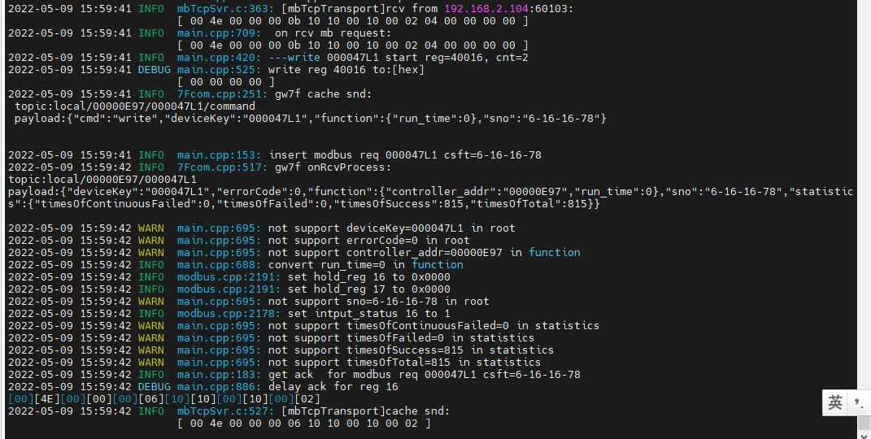

1. 直读

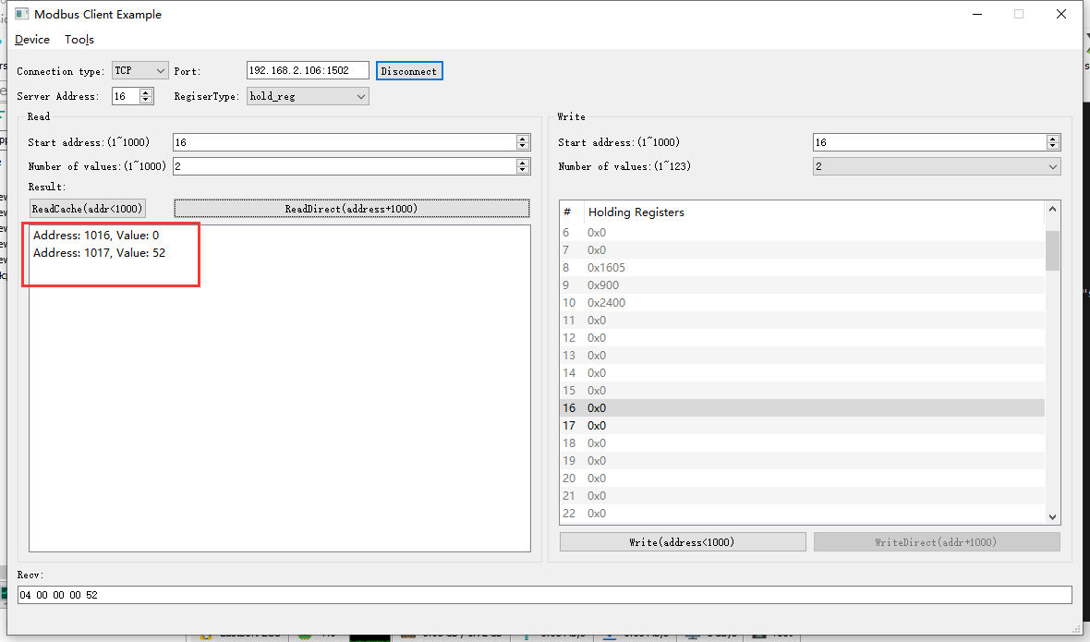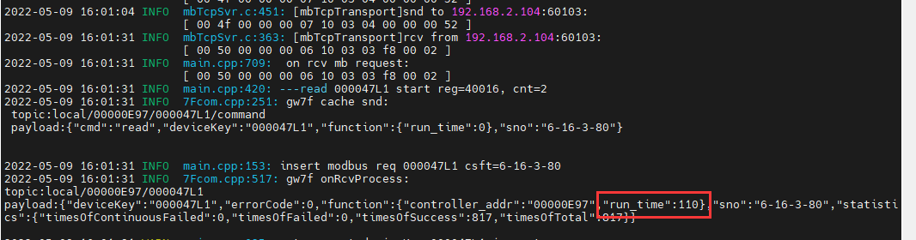

结果：读取的结果与抄控器基本一致。

### 读取错误地址

1. 读取寄存器16

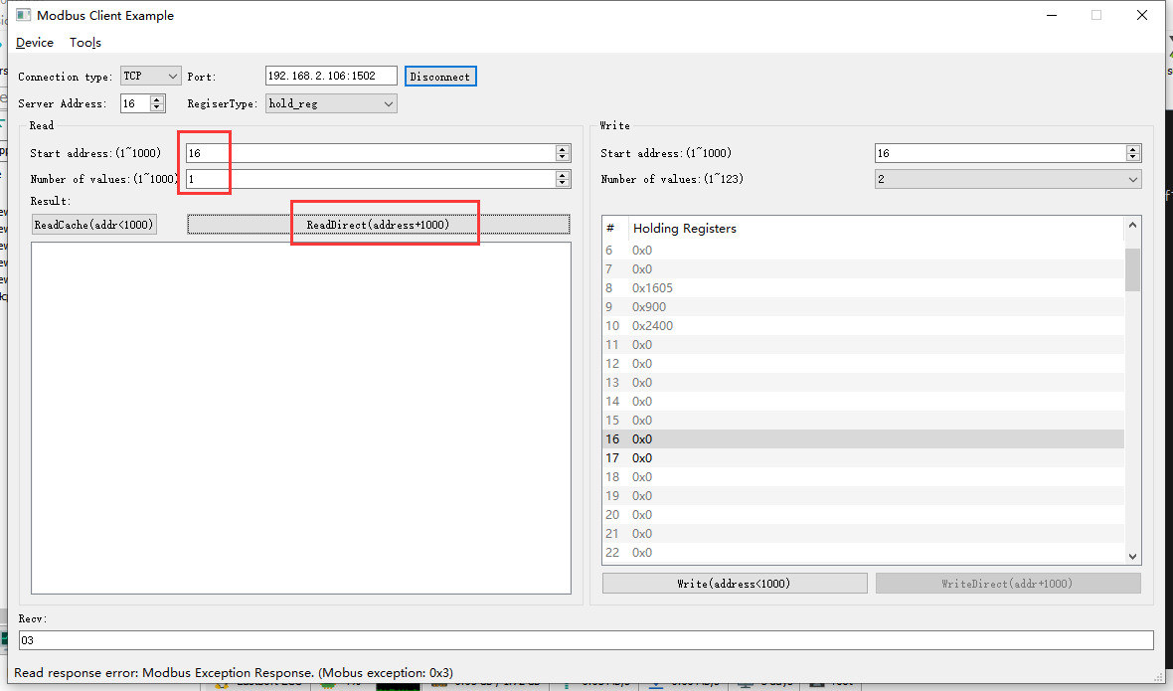

2022-05-09 16:03:27 INFO mbTcpSvr.c:363: [mbTcpTransport]rcv from 192.168.2.104:60103:

[ 00 51 00 00 00 06 10 03 03 f8 00 01 ]

2022-05-09 16:03:27 INFO main.cpp:709: on rcv mb request:

[ 00 51 00 00 00 06 10 03 03 f8 00 01 ]

2022-05-09 16:03:27 INFO main.cpp:420: ---read 000047L1 start reg=40016, cnt=1

2022-05-09 16:03:27 WARN main.cpp:471: wrong regcnt 1 for reg 40016 , should more than 2

[00][51][00][00][00][03][10][83][03]

2022-05-09 16:03:27 INFO mbTcpSvr.c:527: [mbTcpTransport]cache snd:

[ 00 51 00 00 00 03 10 83 03 ]

2022-05-09 16:03:27 INFO mbTcpSvr.c:451: [mbTcpTransport]snd to 192.168.2.104:60103:

[ 00 51 00 00 00 03 10 83 03 ]

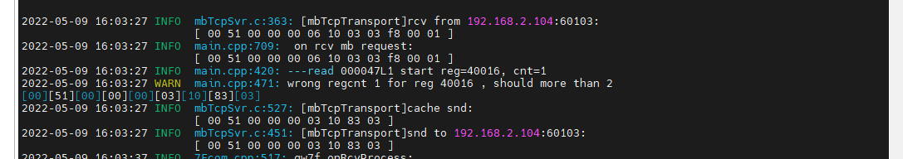

结果：回复错误，需要读取组合寄存器地址。

1. 读取寄存器16-18

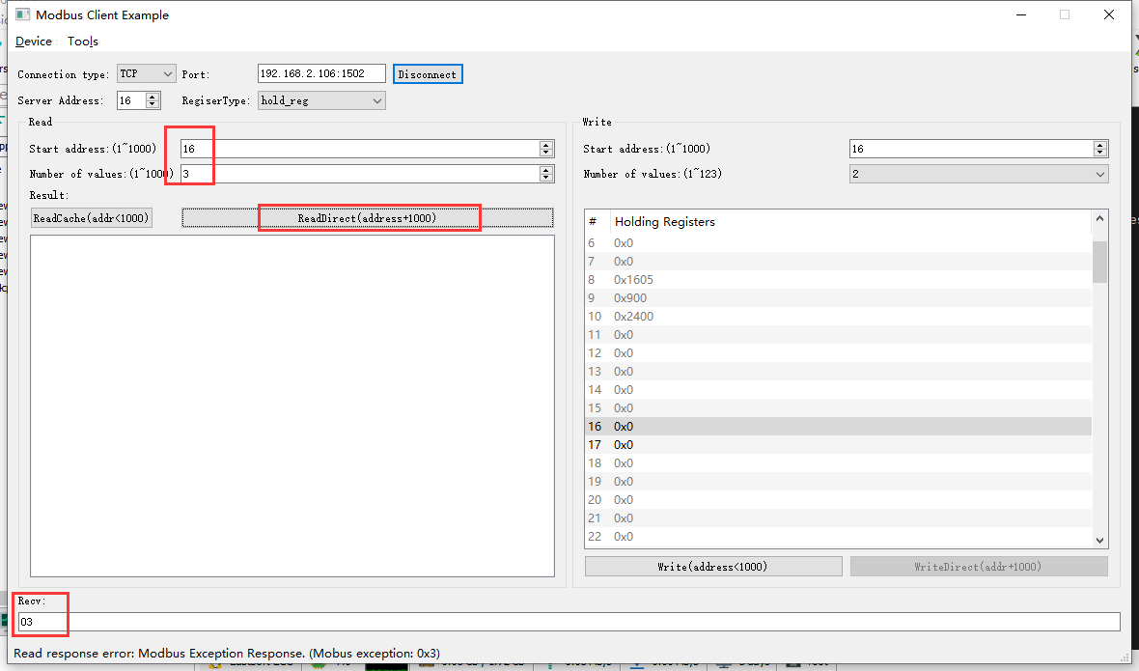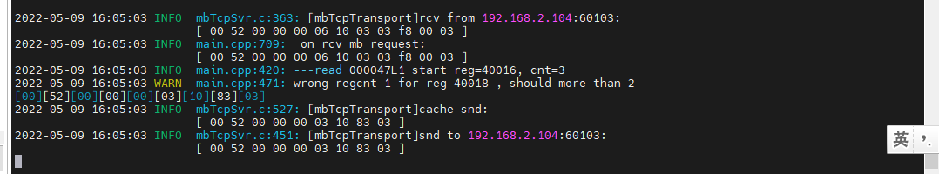结果：回复错误，需要读取组合寄存器地址。

### 写--错误地址

1. 写--清零16

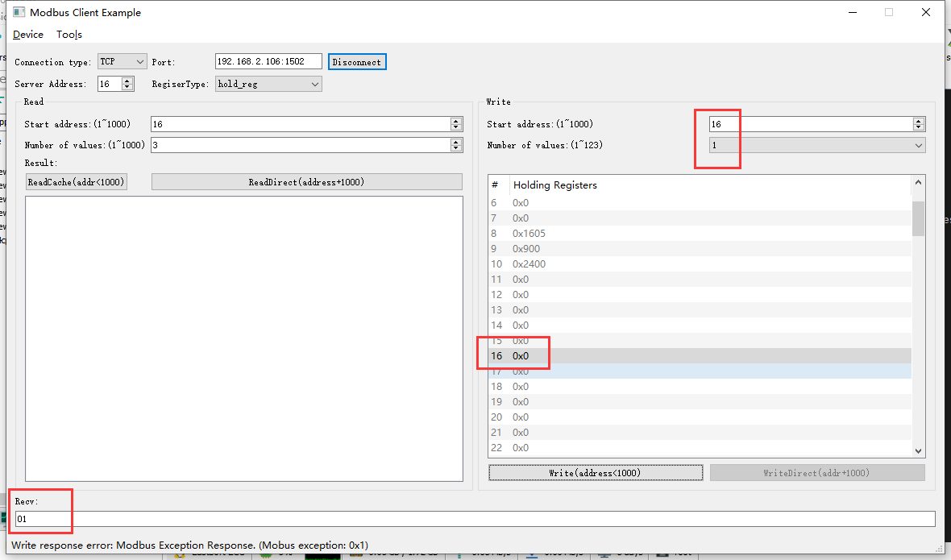

2022-05-09 16:10:13 INFO mbTcpSvr.c:363: [mbTcpTransport]rcv from 192.168.2.104:60103:

[ 00 53 00 00 00 06 10 06 00 10 00 00 ]

2022-05-09 16:10:13 INFO main.cpp:709: on rcv mb request:

[ 00 53 00 00 00 06 10 06 00 10 00 00 ]

2022-05-09 16:10:13 INFO main.cpp:420: ---write 000047L1 start reg=40016, cnt=1

2022-05-09 16:10:13 WARN main.cpp:455: reg 40016 not support single or coil write

[00][53][00][00][00][03][10][86][01]

2022-05-09 16:10:13 INFO mbTcpSvr.c:527: [mbTcpTransport]cache snd:

[ 00 53 00 00 00 03 10 86 01 ]

2022-05-09 16:10:13 INFO mbTcpSvr.c:451: [mbTcpTransport]snd to 192.168.2.104:60103:

[ 00 53 00 00 00 03 10 86 01 ]

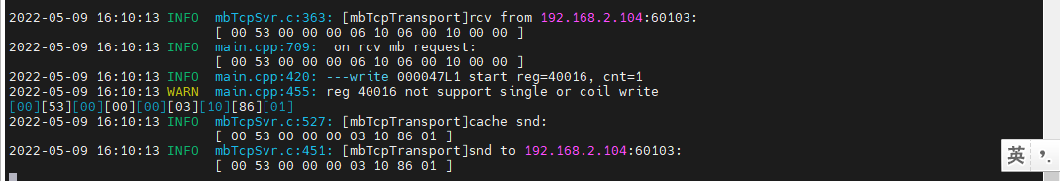

结果：回复错误，组合寄存器形式写入。

1. 写--清零16-18

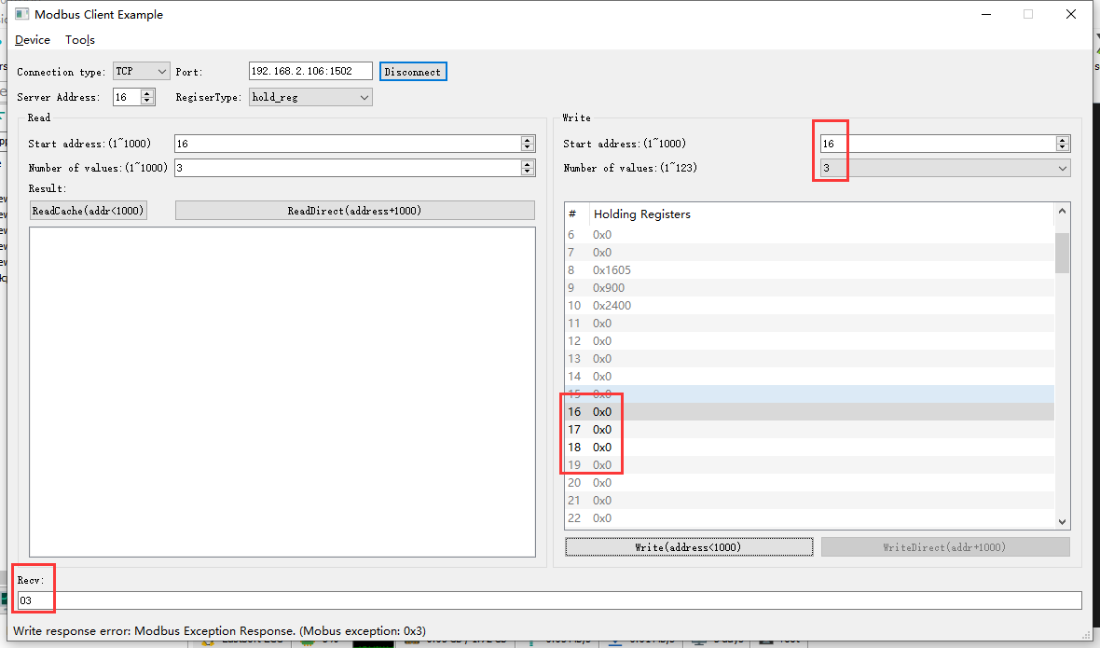

2022-05-09 16:11:50 INFO mbTcpSvr.c:363: [mbTcpTransport]rcv from 192.168.2.104:60103:

[ 00 54 00 00 00 0d 10 10 00 10 00 03 06 00 00 00 00 00 00 ]

2022-05-09 16:11:50 INFO main.cpp:709: on rcv mb request:

[ 00 54 00 00 00 0d 10 10 00 10 00 03 06 00 00 00 00 00 00 ]

2022-05-09 16:11:50 INFO main.cpp:420: ---write 000047L1 start reg=40016, cnt=3

2022-05-09 16:11:50 DEBUG main.cpp:525: write reg 40016 to:[hex]

[ 00 00 00 00 ]

2022-05-09 16:11:50 WARN main.cpp:471: wrong regcnt 1 for reg 40018 , should more than 2

[00][54][00][00][00][03][10][90][03]

2022-05-09 16:11:50 INFO mbTcpSvr.c:527: [mbTcpTransport]cache snd:

[ 00 54 00 00 00 03 10 90 03 ]

2022-05-09 16:11:50 INFO mbTcpSvr.c:451: [mbTcpTransport]snd to 192.168.2.104:60103:

[ 00 54 00 00 00 03 10 90 03 ]

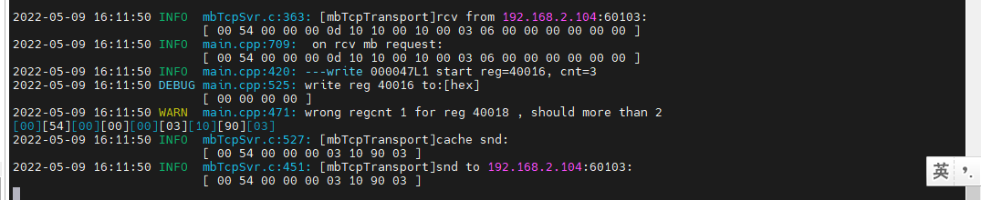

结果：回复错误。

## 阀门开运行时间ok

**寄存器定义：**



### 直读开机运行时间

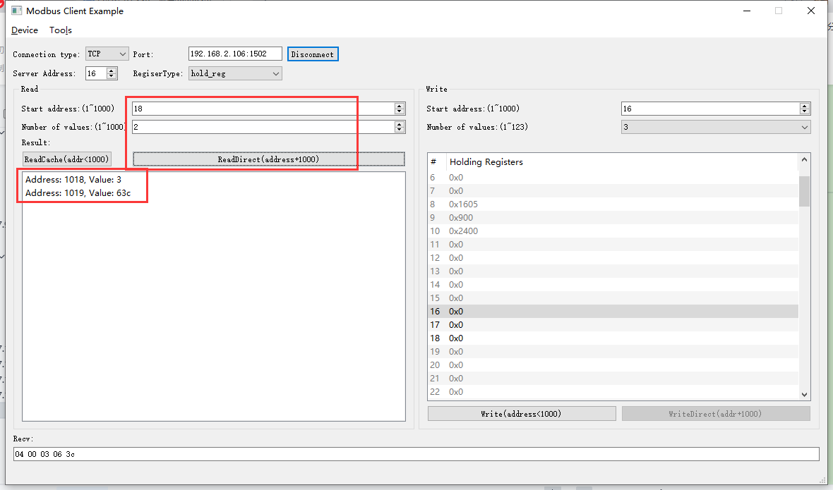

2022-05-09 16:14:17 INFO mbTcpSvr.c:363: [mbTcpTransport]rcv from 192.168.2.104:60103:

[ 00 55 00 00 00 06 10 03 03 fa 00 02 ]

2022-05-09 16:14:17 INFO main.cpp:709: on rcv mb request:

[ 00 55 00 00 00 06 10 03 03 fa 00 02 ]

2022-05-09 16:14:17 INFO 7Fcom.cpp:517: gw7f onRcvProcess:

topic:local/00000E97/000047L1

payload:{"deviceKey":"000047L1","errorCode":0,"function":{"controller_addr":"00000E97","valve_opening_run_time":198204},"sno":"6-16-3-85","statistics":{"timesOfContinuousFailed":0,"timesOfFailed":0,"timesOfSuccess":820,"timesOfTotal":820}}

2022-05-09 16:14:17 INFO main.cpp:420: ---read 000047L1 start reg=40018, cnt=2

2022-05-09 16:14:17 INFO mbTcpSvr.c:451: [mbTcpTransport]snd to 192.168.2.104:60103:

[ 00 55 00 00 00 07 10 03 04 00 03 06 3c ]

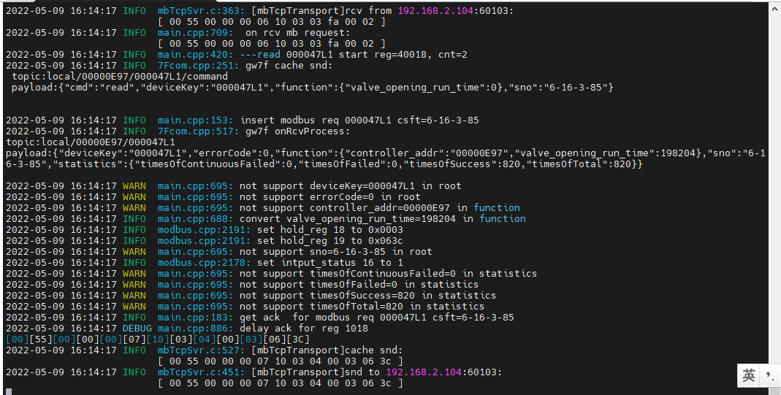

结果：读取到的时间与抄控器读取到的基本一致。

### 读缓存开机运行时间

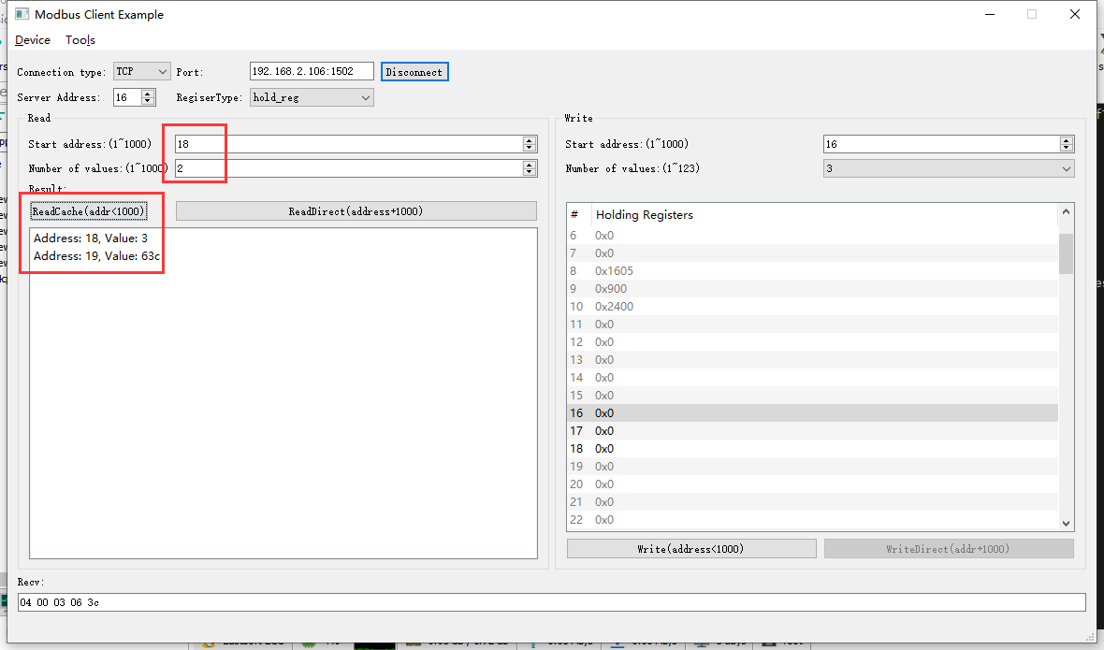

2022-05-09 16:30:15 INFO mbTcpSvr.c:363: [mbTcpTransport]rcv from 192.168.2.104:60103:

[ 00 56 00 00 00 06 10 03 00 12 00 02 ]

2022-05-09 16:30:15 INFO main.cpp:709: on rcv mb request:

[ 00 56 00 00 00 06 10 03 00 12 00 02 ]

[00][56][00][00][00][07][10][03][04][00][03][06][3C]

2022-05-09 16:30:15 INFO mbTcpSvr.c:527: [mbTcpTransport]cache snd:

[ 00 56 00 00 00 07 10 03 04 00 03 06 3c ]

2022-05-09 16:30:15 INFO mbTcpSvr.c:451: [mbTcpTransport]snd to 192.168.2.104:60103:

[ 00 56 00 00 00 07 10 03 04 00 03 06 3c ]

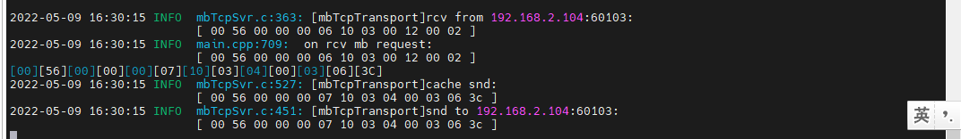

结果：读取到的时间与抄控器读取到的基本一致。

### 写--清零操作

1. 写入

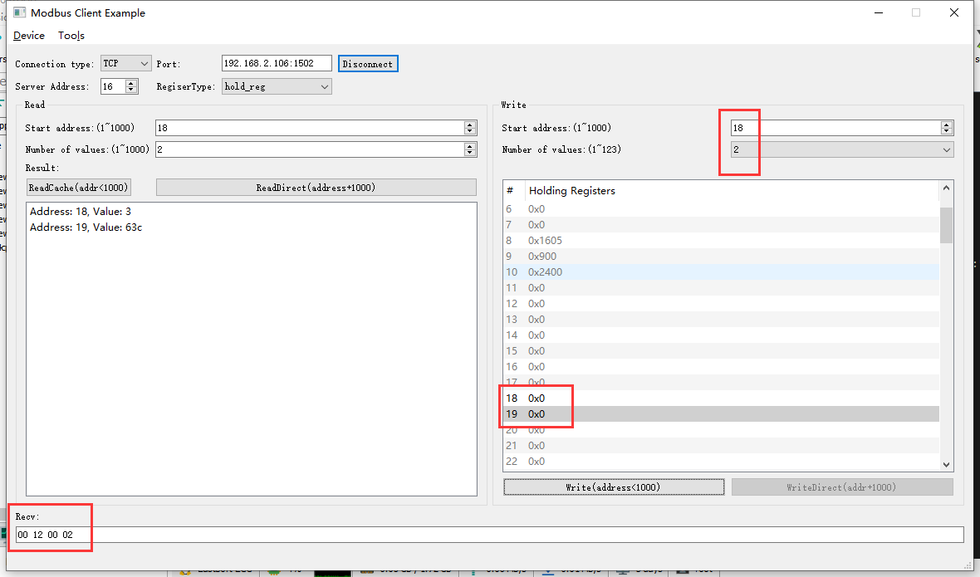

2022-05-09 16:37:20 INFO mbTcpSvr.c:363: [mbTcpTransport]rcv from 192.168.2.104:60103:

[ 00 58 00 00 00 0b 10 10 00 12 00 02 04 00 00 00 00 ]

2022-05-09 16:37:20 INFO main.cpp:709: on rcv mb request:

[ 00 58 00 00 00 0b 10 10 00 12 00 02 04 00 00 00 00 ]

2022-05-09 16:37:20 INFO main.cpp:420: ---write 000047L1 start reg=40018, cnt=2

2022-05-09 16:37:20 DEBUG main.cpp:525: write reg 40018 to:[hex]

[ 00 00 00 00 ]

2022-05-09 16:37:20 INFO 7Fcom.cpp:517: gw7f onRcvProcess:

topic:local/00000E97/000047L1

payload:{"deviceKey":"000047L1","errorCode":0,"function":{"controller_addr":"00000E97","valve_opening_run_time":0},"sno":"6-16-16-88","statistics":{"timesOfContinuousFailed":0,"timesOfFailed":0,"timesOfSuccess":825,"timesOfTotal":825}}

2022-05-09 16:37:20 INFO mbTcpSvr.c:451: [mbTcpTransport]snd to 192.168.2.104:60103:

[ 00 58 00 00 00 06 10 10 00 12 00 02 ]

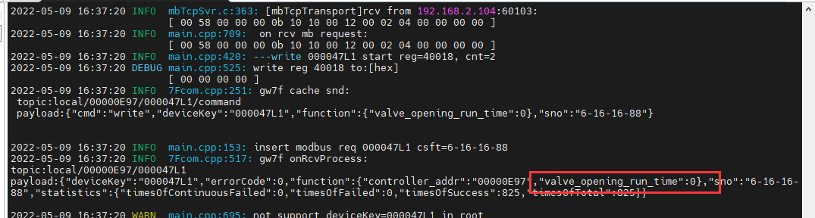

抄控器读取



1. 直读

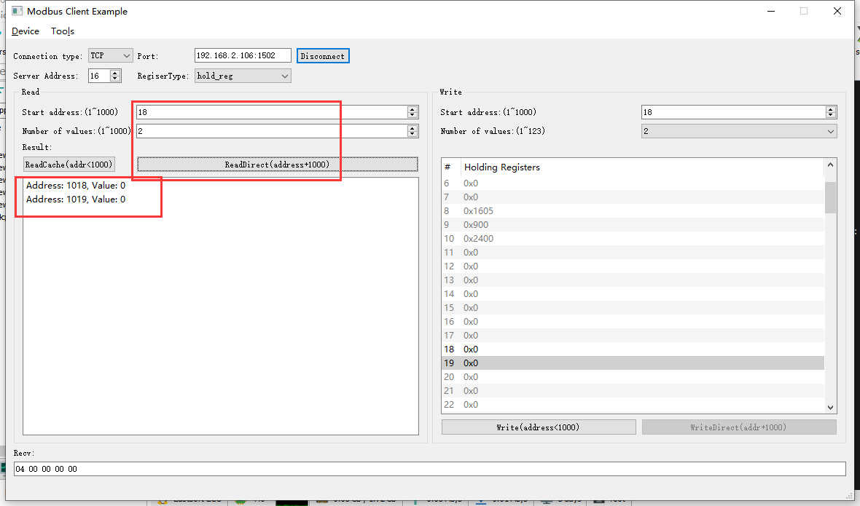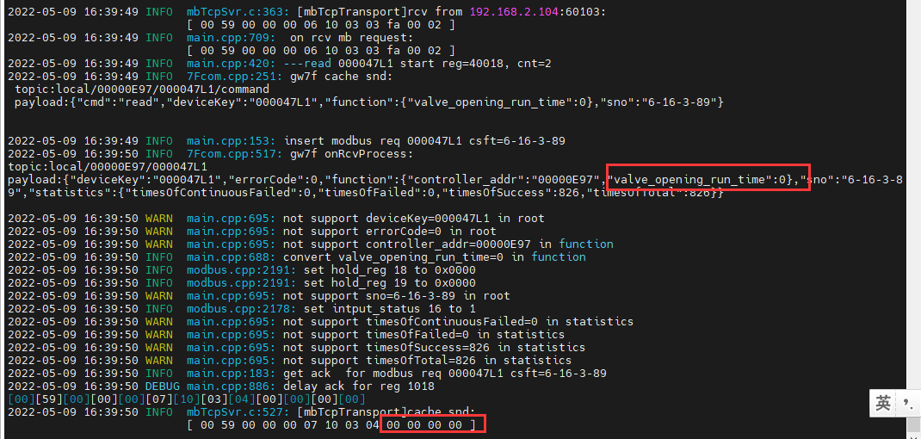

### 读取错误地址

1. 读取寄存器18

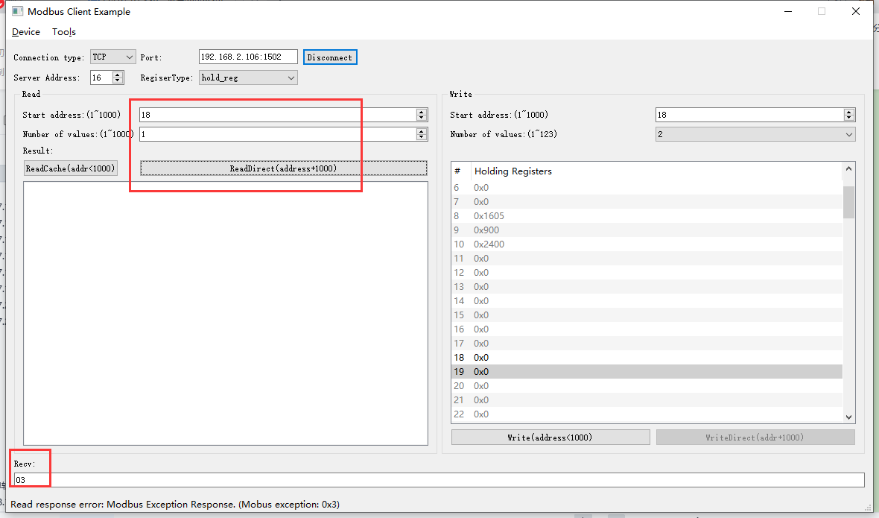

2022-05-09 16:39:50 INFO mbTcpSvr.c:451: [mbTcpTransport]snd to 192.168.2.104:60103:

[ 00 59 00 00 00 07 10 03 04 00 00 00 00 ]

2022-05-09 16:40:45 INFO mbTcpSvr.c:363: [mbTcpTransport]rcv from 192.168.2.104:60103:

[ 00 5a 00 00 00 06 10 03 03 fa 00 01 ]

2022-05-09 16:40:45 INFO main.cpp:709: on rcv mb request:

[ 00 5a 00 00 00 06 10 03 03 fa 00 01 ]

2022-05-09 16:40:45 INFO main.cpp:420: ---read 000047L1 start reg=40018, cnt=1

2022-05-09 16:40:45 WARN main.cpp:471: wrong regcnt 1 for reg 40018 , should more than 2

[00][5A][00][00][00][03][10][83][03]

2022-05-09 16:40:45 INFO mbTcpSvr.c:527: [mbTcpTransport]cache snd:

[ 00 5a 00 00 00 03 10 83 03 ]

2022-05-09 16:40:45 INFO mbTcpSvr.c:451: [mbTcpTransport]snd to 192.168.2.104:60103:

[ 00 5a 00 00 00 03 10 83 03 ]

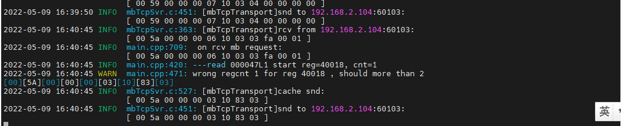

结果：回复错误

1. 读取寄存器18-20

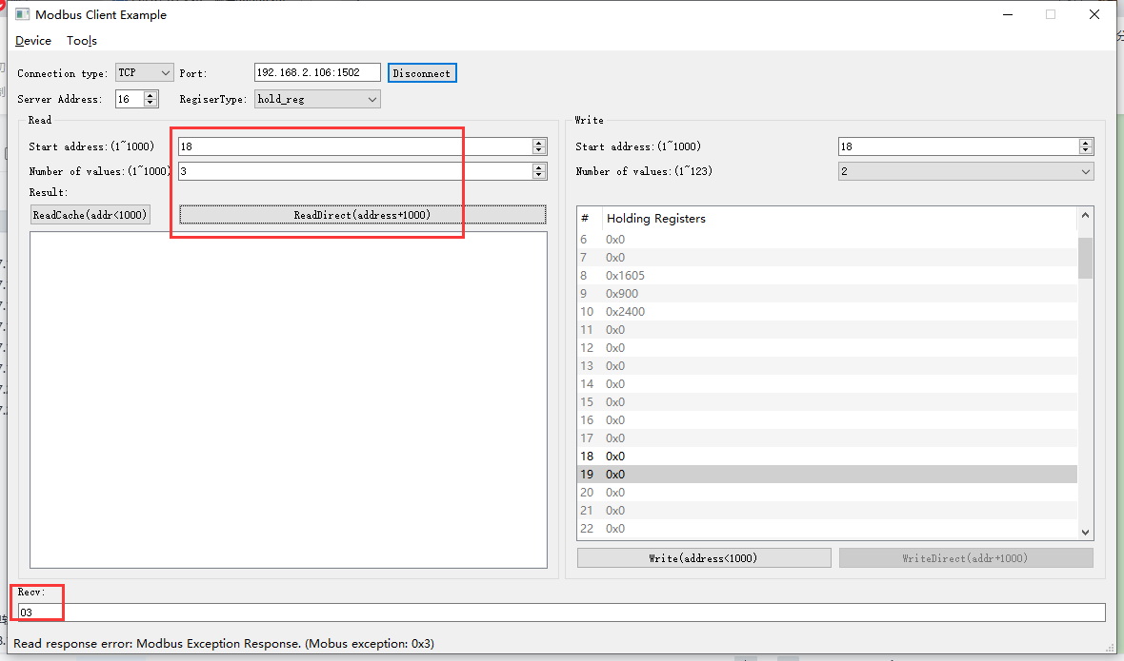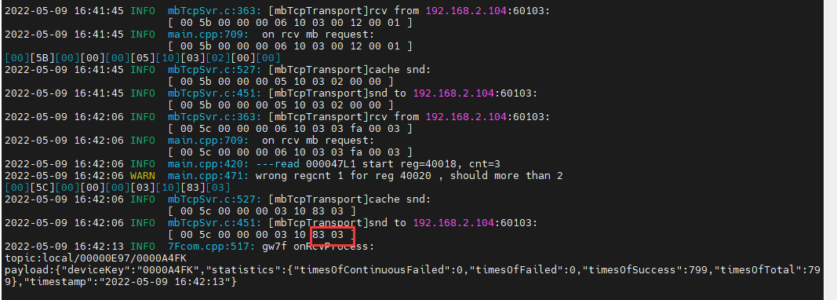结果：回复错误

### 写--错误地址

1. 写--清零18

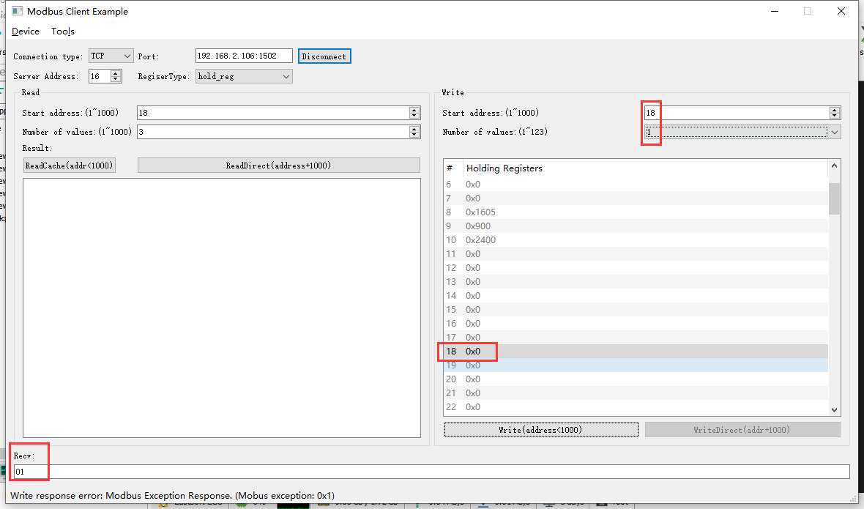

2022-05-09 16:42:49 INFO mbTcpSvr.c:363: [mbTcpTransport]rcv from 192.168.2.104:60103:

[ 00 5d 00 00 00 06 10 06 00 12 00 00 ]

2022-05-09 16:42:49 INFO main.cpp:709: on rcv mb request:

[ 00 5d 00 00 00 06 10 06 00 12 00 00 ]

2022-05-09 16:42:49 INFO main.cpp:420: ---write 000047L1 start reg=40018, cnt=1

2022-05-09 16:42:49 WARN main.cpp:455: reg 40018 not support single or coil write

[00][5D][00][00][00][03][10][86][01]

2022-05-09 16:42:49 INFO mbTcpSvr.c:527: [mbTcpTransport]cache snd:

[ 00 5d 00 00 00 03 10 86 01 ]

2022-05-09 16:42:49 INFO mbTcpSvr.c:451: [mbTcpTransport]snd to 192.168.2.104:60103:

[ 00 5d 00 00 00 03 10 86 01 ]

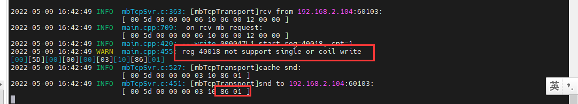

结果：回复错误

1. 写--清零18-20

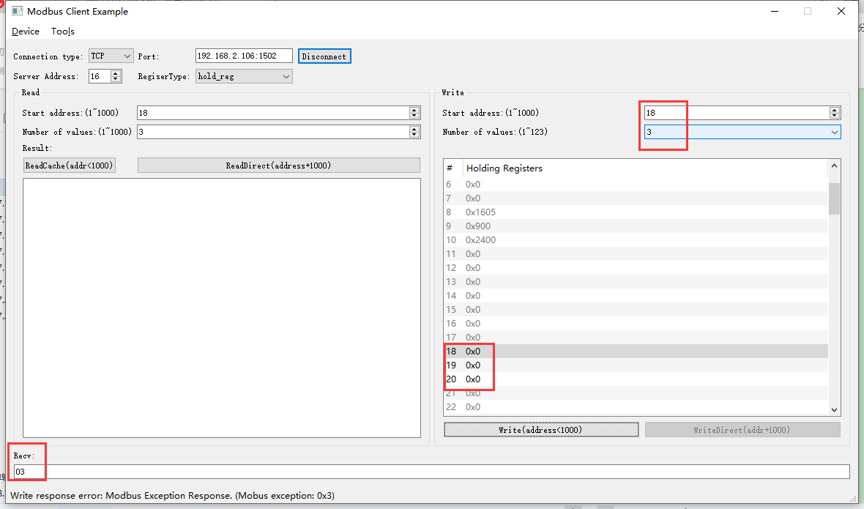

2022-05-09 16:44:14 INFO mbTcpSvr.c:363: [mbTcpTransport]rcv from 192.168.2.104:60103:

[ 00 5e 00 00 00 0d 10 10 00 12 00 03 06 00 00 00 00 00 00 ]

2022-05-09 16:44:14 INFO main.cpp:709: on rcv mb request:

[ 00 5e 00 00 00 0d 10 10 00 12 00 03 06 00 00 00 00 00 00 ]

2022-05-09 16:44:14 INFO main.cpp:420: ---write 000047L1 start reg=40018, cnt=3

2022-05-09 16:44:14 DEBUG main.cpp:525: write reg 40018 to:[hex]

[ 00 00 00 00 ]

2022-05-09 16:44:14 WARN main.cpp:471: wrong regcnt 1 for reg 40020 , should more than 2

[00][5E][00][00][00][03][10][90][03]

2022-05-09 16:44:14 INFO mbTcpSvr.c:527: [mbTcpTransport]cache snd:

[ 00 5e 00 00 00 03 10 90 03 ]

2022-05-09 16:44:14 INFO mbTcpSvr.c:451: [mbTcpTransport]snd to 192.168.2.104:60103:

[ 00 5e 00 00 00 03 10 90 03 ]

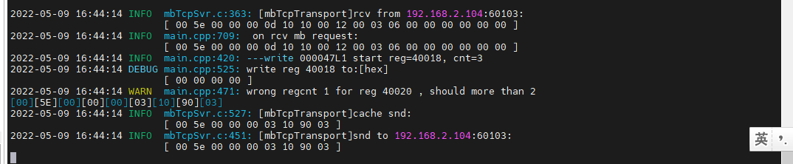

结果：回复错误

## 高风速运行时间

**寄存器定义：**





### 直读开机运行时间

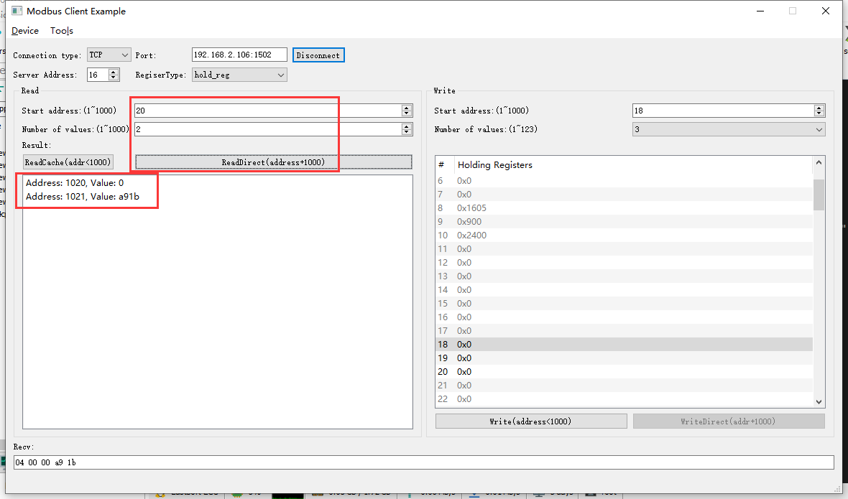

2022-05-09 17:03:18 INFO mbTcpSvr.c:363: [mbTcpTransport]rcv from 192.168.2.104:60103:

[ 00 5f 00 00 00 06 10 03 03 fc 00 02 ]

2022-05-09 17:03:18 INFO main.cpp:709: on rcv mb request:

[ 00 5f 00 00 00 06 10 03 03 fc 00 02 ]

2022-05-09 17:03:18 INFO main.cpp:420: ---read 000047L1 start reg=40020, cnt=2

2022-05-09 17:03:18 INFO 7Fcom.cpp:251: gw7f cache snd:

topic:local/00000E97/000047L1/command

payload:{"cmd":"read","deviceKey":"000047L1","function":{"high_speed_run_time":0},"sno":"6-16-3-95"}

2022-05-09 17:03:18 INFO main.cpp:153: insert modbus req 000047L1 csft=6-16-3-95

2022-05-09 17:03:18 INFO 7Fcom.cpp:517: gw7f onRcvProcess:

topic:local/00000E97/000047L1

payload:{"deviceKey":"000047L1","errorCode":0,"function":{"controller_addr":"00000E97","high_speed_run_time":43291},"sno":"6-16-3-95","statistics":{"timesOfContinuousFailed":0,"timesOfFailed":0,"timesOfSuccess":831,"timesOfTotal":831}}

2022-05-09 17:03:18 INFO mbTcpSvr.c:451: [mbTcpTransport]snd to 192.168.2.104:60103:

[ 00 5f 00 00 00 07 10 03 04 00 00 a9 1b ]

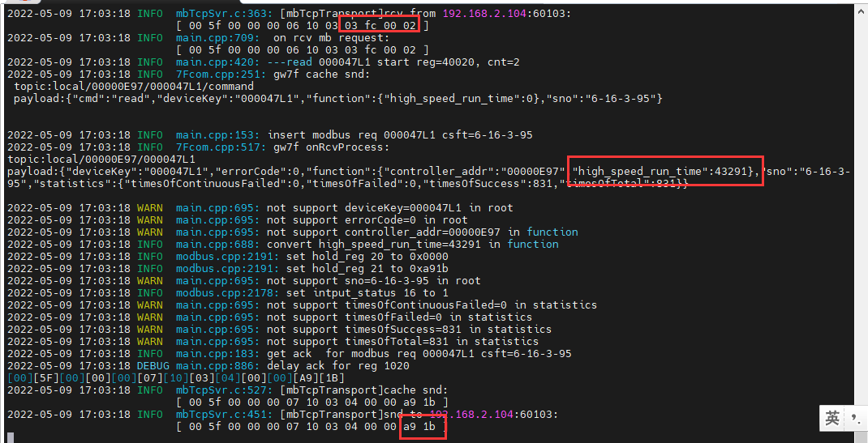

结果：读取数据与抄控器读取的一致

### 读缓存开机运行时间

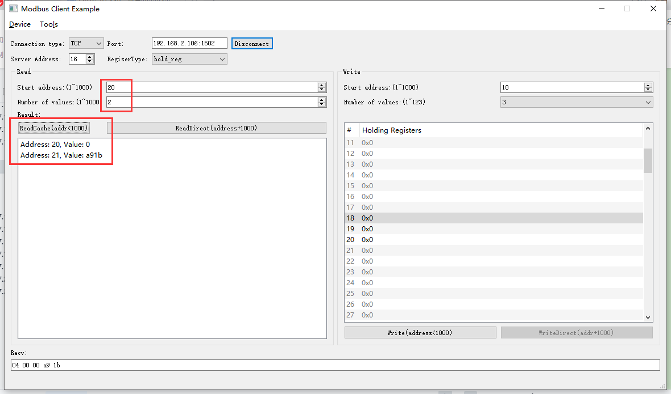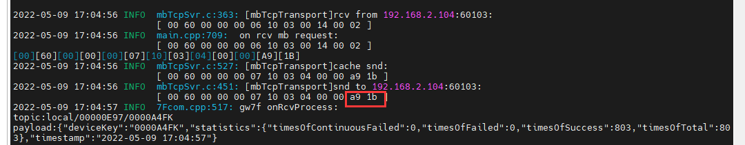结果：读取数据与抄控器读取的一致

### 写--清零操作

1. 写入

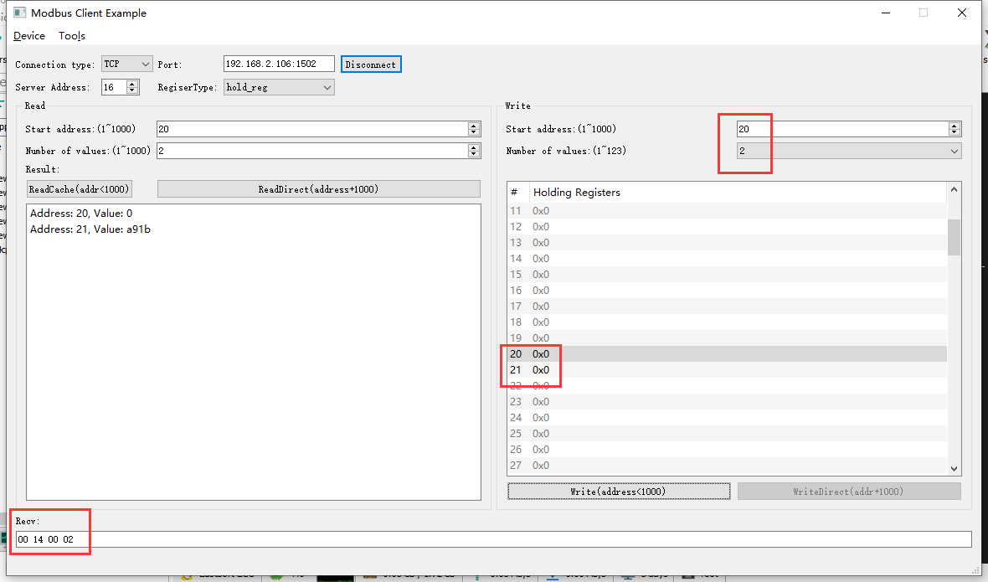

2022-05-09 17:06:39 INFO mbTcpSvr.c:363: [mbTcpTransport]rcv from 192.168.2.104:60103:

[ 00 61 00 00 00 0b 10 10 00 14 00 02 04 00 00 00 00 ]

2022-05-09 17:06:39 INFO main.cpp:709: on rcv mb request:

[ 00 61 00 00 00 0b 10 10 00 14 00 02 04 00 00 00 00 ]

2022-05-09 17:06:39 INFO main.cpp:420: ---write 000047L1 start reg=40020, cnt=2

2022-05-09 17:06:39 DEBUG main.cpp:525: write reg 40020 to:[hex]

[ 00 00 00 00 ]

2022-05-09 17:06:39 INFO 7Fcom.cpp:517: gw7f onRcvProcess:

topic:local/00000E97/000047L1

payload:{"deviceKey":"000047L1","errorCode":0,"function":{"controller_addr":"00000E97","high_speed_run_time":0},"sno":"6-16-16-97","statistics":{"timesOfContinuousFailed":0,"timesOfFailed":0,"timesOfSuccess":832,"timesOfTotal":832}}

2022-05-09 17:06:39 INFO mbTcpSvr.c:451: [mbTcpTransport]snd to 192.168.2.104:60103:

[ 00 61 00 00 00 06 10 10 00 14 00 02 ]

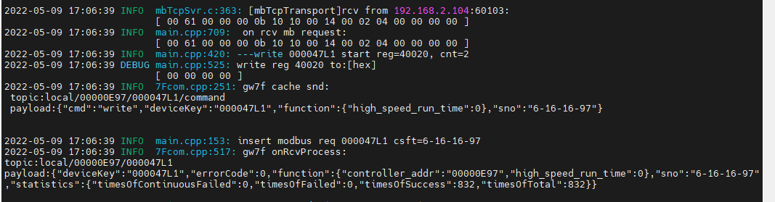

1. 直读

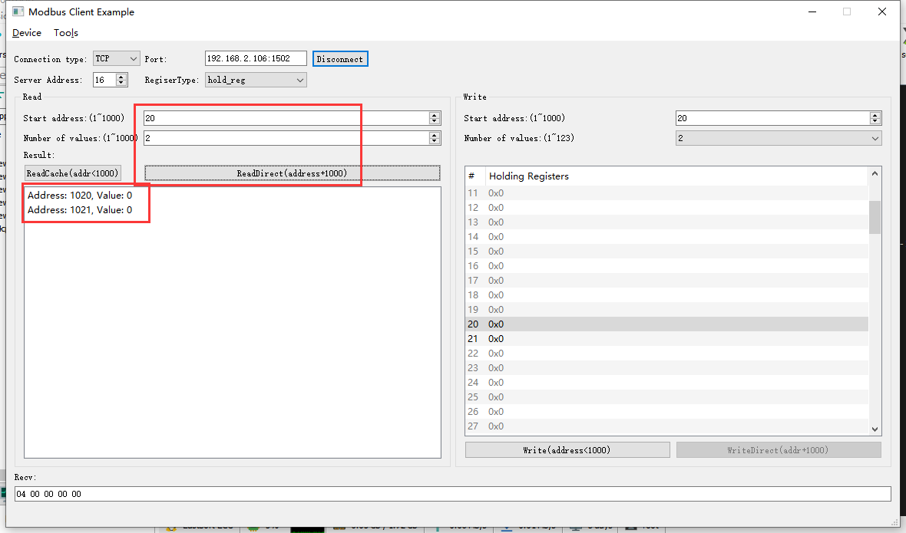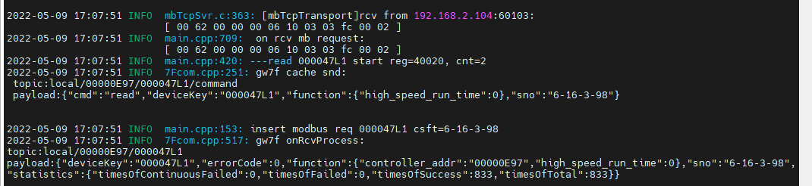

结果：与抄控器读取的数据一致。

### 读取错误地址

1. 读取寄存器20

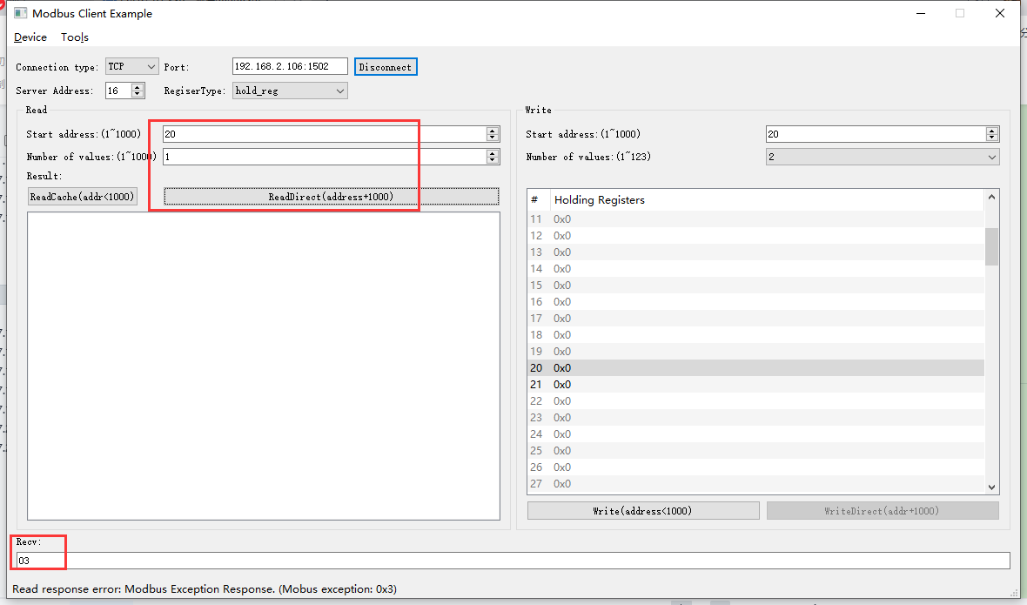

2022-05-09 17:09:30 INFO mbTcpSvr.c:363: [mbTcpTransport]rcv from 192.168.2.104:60103:

[ 00 63 00 00 00 06 10 03 03 fc 00 01 ]

2022-05-09 17:09:30 INFO main.cpp:709: on rcv mb request:

[ 00 63 00 00 00 06 10 03 03 fc 00 01 ]

2022-05-09 17:09:30 INFO main.cpp:420: ---read 000047L1 start reg=40020, cnt=1

2022-05-09 17:09:30 WARN main.cpp:471: wrong regcnt 1 for reg 40020 , should more than 2

[00][63][00][00][00][03][10][83][03]

2022-05-09 17:09:30 INFO mbTcpSvr.c:527: [mbTcpTransport]cache snd:

[ 00 63 00 00 00 03 10 83 03 ]

2022-05-09 17:09:30 INFO mbTcpSvr.c:451: [mbTcpTransport]snd to 192.168.2.104:60103:

[ 00 63 00 00 00 03 10 83 03 ]

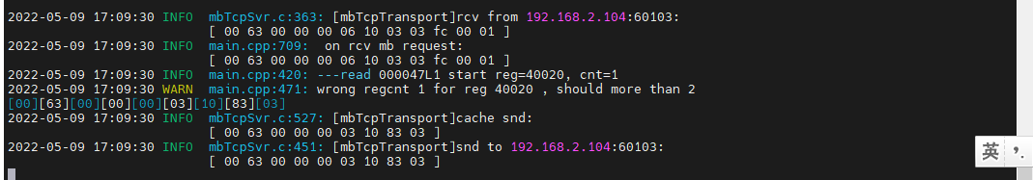

结果：回复错误。

1. 读取寄存器20-22

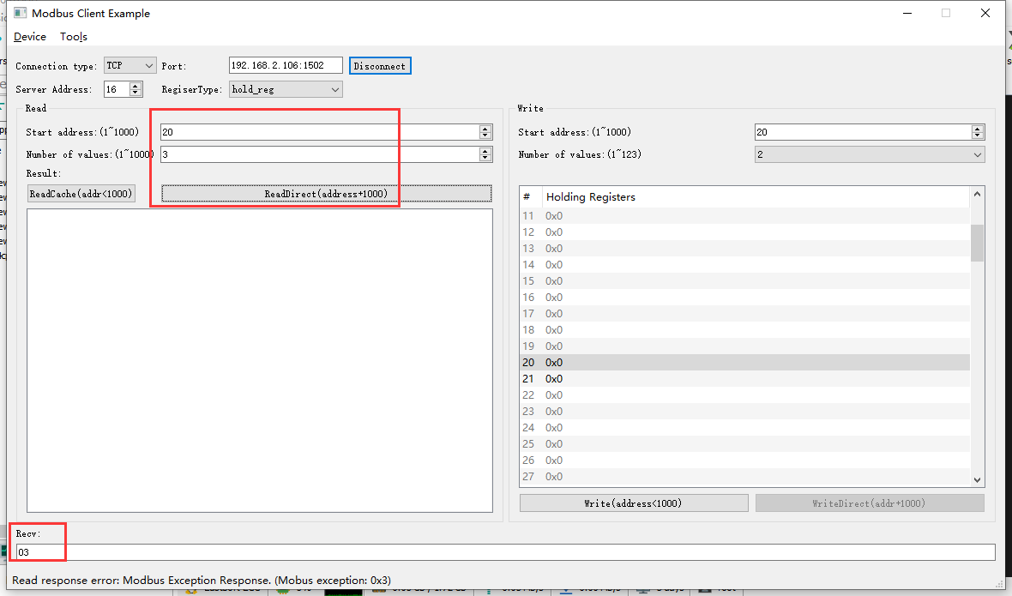

2022-05-09 17:10:20 INFO mbTcpSvr.c:363: [mbTcpTransport]rcv from 192.168.2.104:60103:

[ 00 64 00 00 00 06 10 03 03 fc 00 03 ]

2022-05-09 17:10:20 INFO main.cpp:709: on rcv mb request:

[ 00 64 00 00 00 06 10 03 03 fc 00 03 ]

2022-05-09 17:10:20 INFO main.cpp:420: ---read 000047L1 start reg=40020, cnt=3

2022-05-09 17:10:20 WARN main.cpp:471: wrong regcnt 1 for reg 40022 , should more than 2

[00][64][00][00][00][03][10][83][03]

2022-05-09 17:10:20 INFO mbTcpSvr.c:527: [mbTcpTransport]cache snd:

[ 00 64 00 00 00 03 10 83 03 ]

2022-05-09 17:10:20 INFO mbTcpSvr.c:451: [mbTcpTransport]snd to 192.168.2.104:60103:

[ 00 64 00 00 00 03 10 83 03 ]

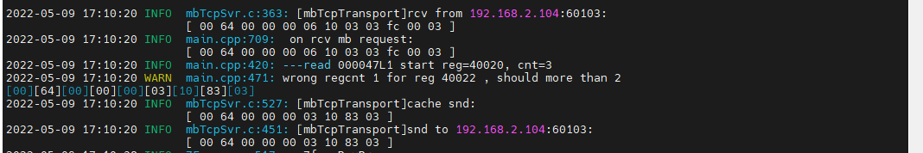结果：回复错误。

### 写--错误地址

1. 写--清零20

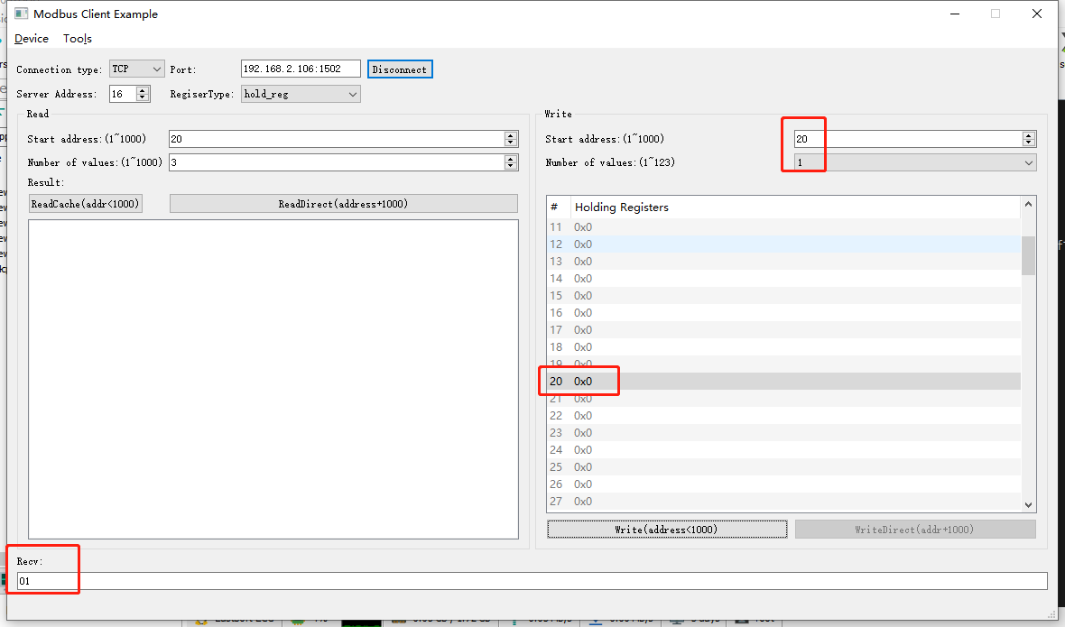

2022-05-09 17:11:12 INFO mbTcpSvr.c:363: [mbTcpTransport]rcv from 192.168.2.104:60103:

[ 00 65 00 00 00 06 10 06 00 14 00 00 ]

2022-05-09 17:11:12 INFO main.cpp:709: on rcv mb request:

[ 00 65 00 00 00 06 10 06 00 14 00 00 ]

2022-05-09 17:11:12 INFO main.cpp:420: ---write 000047L1 start reg=40020, cnt=1

2022-05-09 17:11:12 WARN main.cpp:455: reg 40020 not support single or coil write

[00][65][00][00][00][03][10][86][01]

2022-05-09 17:11:12 INFO mbTcpSvr.c:527: [mbTcpTransport]cache snd:

[ 00 65 00 00 00 03 10 86 01 ]

2022-05-09 17:11:12 INFO mbTcpSvr.c:451: [mbTcpTransport]snd to 192.168.2.104:60103:

[ 00 65 00 00 00 03 10 86 01 ]

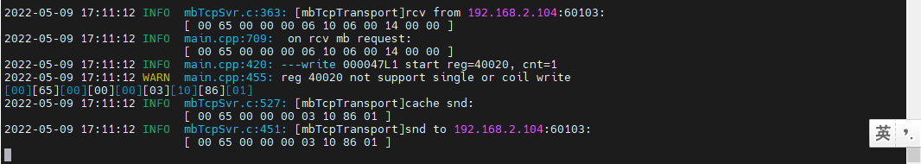

结果：回复错误。

1. 写--清零20-22

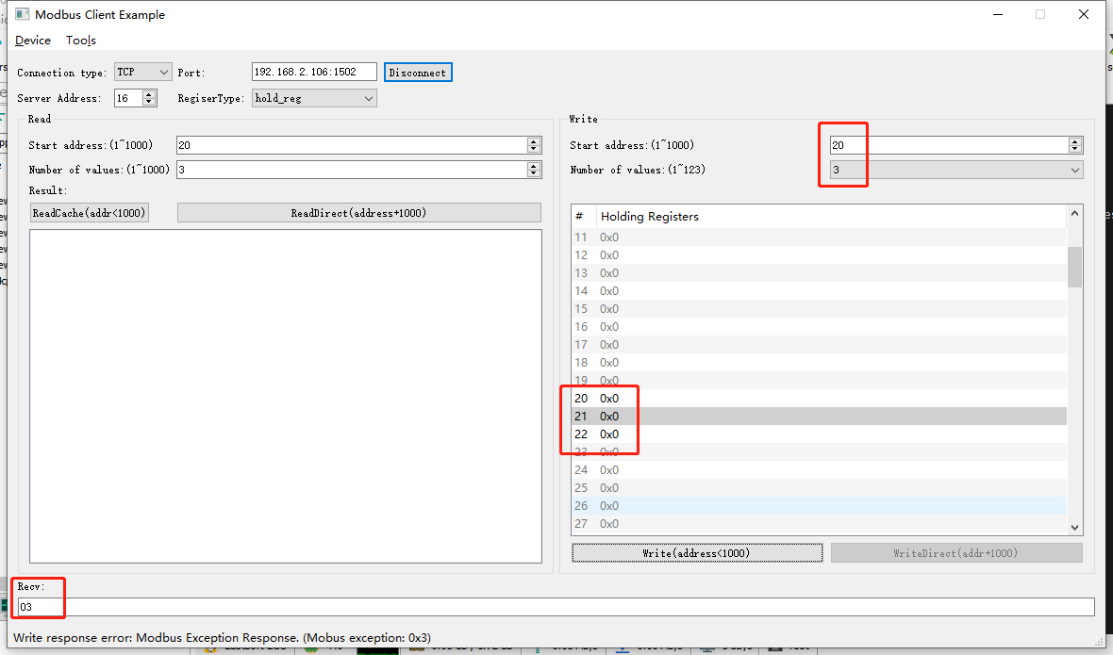

2022-05-09 17:12:11 INFO mbTcpSvr.c:363: [mbTcpTransport]rcv from 192.168.2.104:60103:

[ 00 66 00 00 00 0d 10 10 00 14 00 03 06 00 00 00 00 00 00 ]

2022-05-09 17:12:11 INFO main.cpp:709: on rcv mb request:

[ 00 66 00 00 00 0d 10 10 00 14 00 03 06 00 00 00 00 00 00 ]

2022-05-09 17:12:11 INFO main.cpp:420: ---write 000047L1 start reg=40020, cnt=3

2022-05-09 17:12:11 DEBUG main.cpp:525: write reg 40020 to:[hex]

[ 00 00 00 00 ]

2022-05-09 17:12:11 WARN main.cpp:471: wrong regcnt 1 for reg 40022 , should more than 2

[00][66][00][00][00][03][10][90][03]

2022-05-09 17:12:11 INFO mbTcpSvr.c:527: [mbTcpTransport]cache snd:

[ 00 66 00 00 00 03 10 90 03 ]

2022-05-09 17:12:11 INFO mbTcpSvr.c:451: [mbTcpTransport]snd to 192.168.2.104:60103:

[ 00 66 00 00 00 03 10 90 03 ]

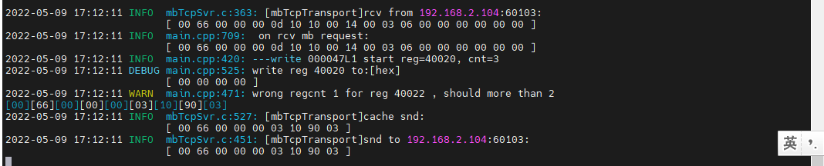

结果：回复错误。

## 中风速运行时间

**寄存器定义：**



### 直读开机运行时间

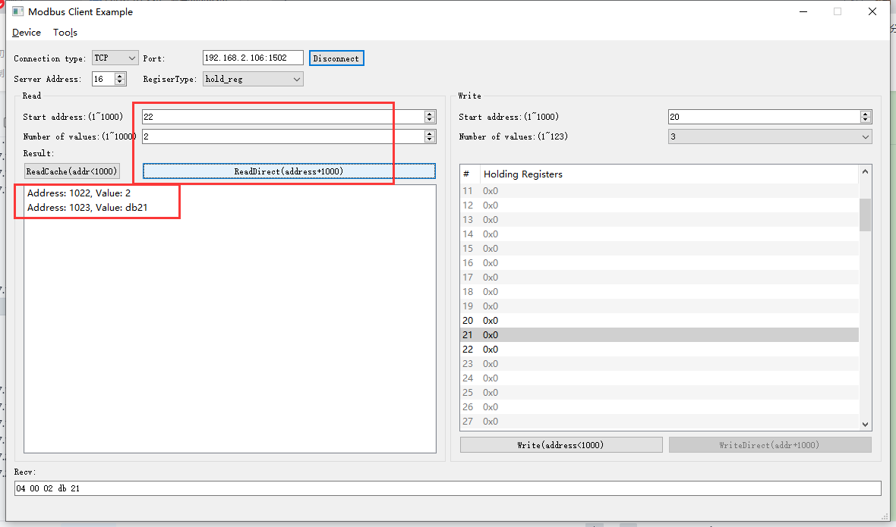

2022-05-09 17:16:32 INFO mbTcpSvr.c:363: [mbTcpTransport]rcv from 192.168.2.104:60103:

[ 00 67 00 00 00 06 10 03 03 fe 00 02 ]

2022-05-09 17:16:32 INFO main.cpp:709: on rcv mb request:

[ 00 67 00 00 00 06 10 03 03 fe 00 02 ]

2022-05-09 17:16:32 INFO main.cpp:420: ---read 000047L1 start reg=40022, cnt=2

2022-05-09 17:16:32 INFO 7Fcom.cpp:517: gw7f onRcvProcess:

topic:local/00000E97/000047L1

payload:{"deviceKey":"000047L1","errorCode":0,"function":{"controller_addr":"00000E97","middle_speed_run_time":187169},"sno":"6-16-3-103","statistics":{"timesOfContinuousFailed":0,"timesOfFailed":0,"timesOfSuccess":835,"timesOfTotal":835}}

2022-05-09 17:16:32 INFO mbTcpSvr.c:451: [mbTcpTransport]snd to 192.168.2.104:60103:

[ 00 67 00 00 00 07 10 03 04 00 02 db 21 ]

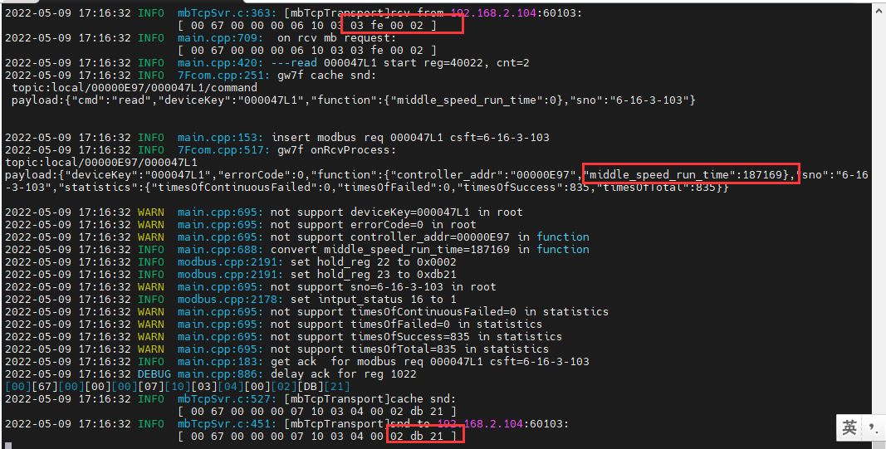

结果：与抄控器读取一致

### 读缓存开机运行时间

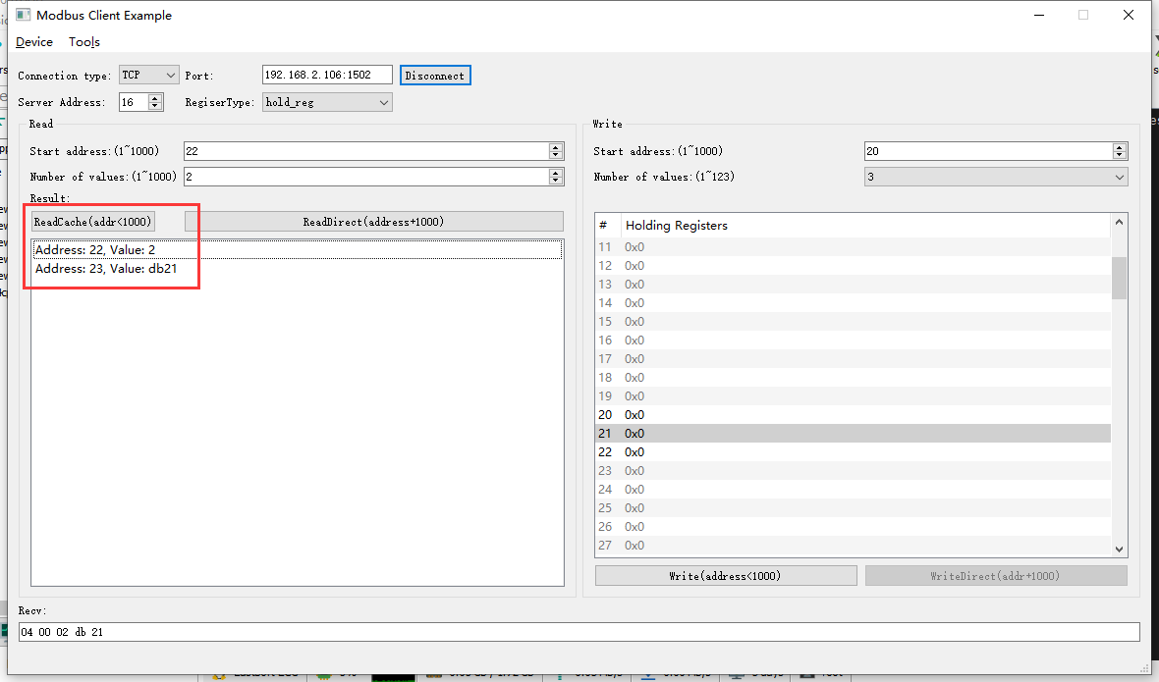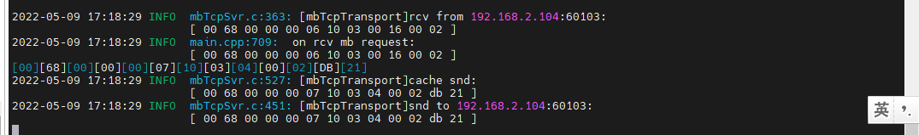

### 写--清零操作

1. 写入

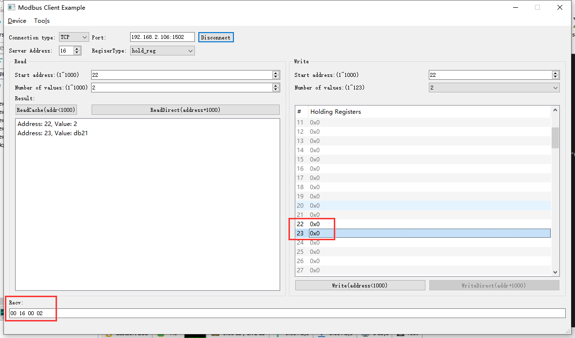

2022-05-09 17:23:30 INFO mbTcpSvr.c:363: [mbTcpTransport]rcv from 192.168.2.104:60103:

[ 00 6a 00 00 00 0b 10 10 00 16 00 02 04 00 00 00 00 ]

2022-05-09 17:23:30 INFO main.cpp:709: on rcv mb request:

[ 00 6a 00 00 00 0b 10 10 00 16 00 02 04 00 00 00 00 ]

2022-05-09 17:23:30 INFO main.cpp:420: ---write 000047L1 start reg=40022, cnt=2

2022-05-09 17:23:30 DEBUG main.cpp:525: write reg 40022 to:[hex]

[ 00 00 00 00 ]

2022-05-09 17:23:31 INFO 7Fcom.cpp:517: gw7f onRcvProcess:

topic:local/00000E97/000047L1

payload:{"deviceKey":"000047L1","errorCode":0,"function":{"controller_addr":"00000E97","middle_speed_run_time":0},"sno":"6-16-16-106","statistics":{"timesOfContinuousFailed":0,"timesOfFailed":0,"timesOfSuccess":837,"timesOfTotal":837}}

2022-05-09 17:23:31 INFO mbTcpSvr.c:451: [mbTcpTransport]snd to 192.168.2.104:60103:

[ 00 6a 00 00 00 06 10 10 00 16 00 02 ]

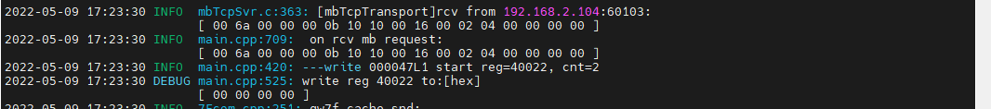

1. 直读

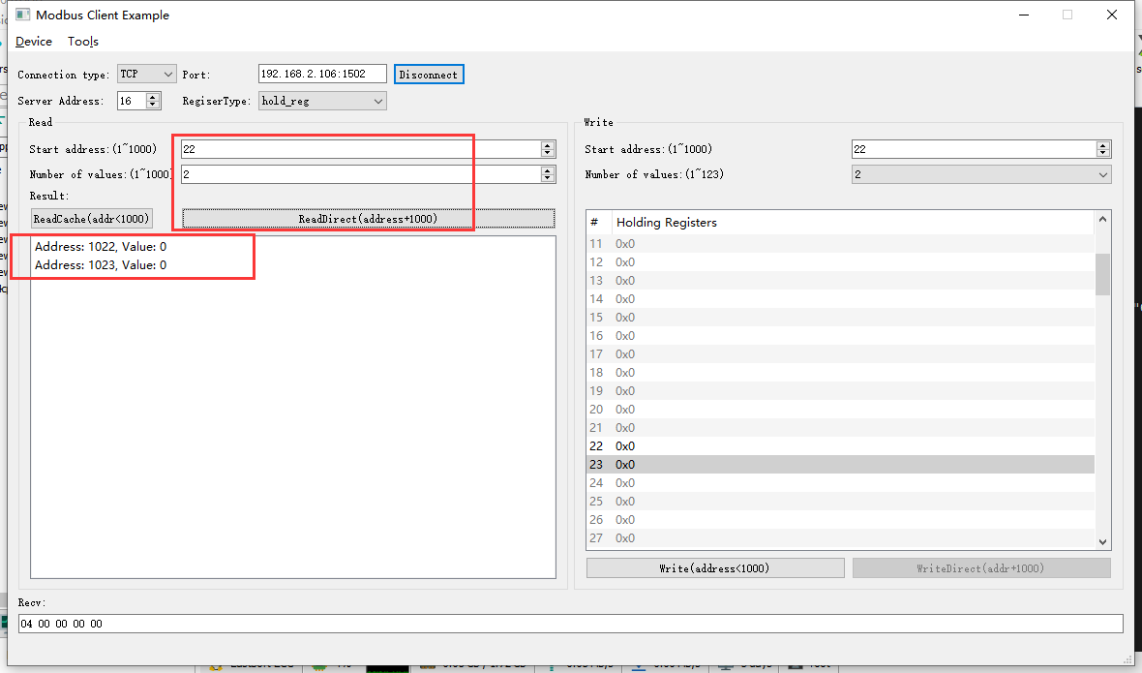

2022-05-09 17:25:05 INFO mbTcpSvr.c:363: [mbTcpTransport]rcv from 192.168.2.104:60103:

[ 00 6b 00 00 00 06 10 03 03 fe 00 02 ]

2022-05-09 17:25:05 INFO main.cpp:709: on rcv mb request:

[ 00 6b 00 00 00 06 10 03 03 fe 00 02 ]

2022-05-09 17:25:05 INFO main.cpp:420: ---read 000047L1 start reg=40022, cnt=2

2022-05-09 17:25:05 INFO 7Fcom.cpp:517: gw7f onRcvProcess:

topic:local/00000E97/000047L1

payload:{"deviceKey":"000047L1","errorCode":0,"function":{"controller_addr":"00000E97","middle_speed_run_time":0},"sno":"6-16-3-107","statistics":{"timesOfContinuousFailed":0,"timesOfFailed":0,"timesOfSuccess":838,"timesOfTotal":838}}

2022-05-09 17:25:05 INFO mbTcpSvr.c:451: [mbTcpTransport]snd to 192.168.2.104:60103:

[ 00 6b 00 00 00 07 10 03 04 00 00 00 00 ]

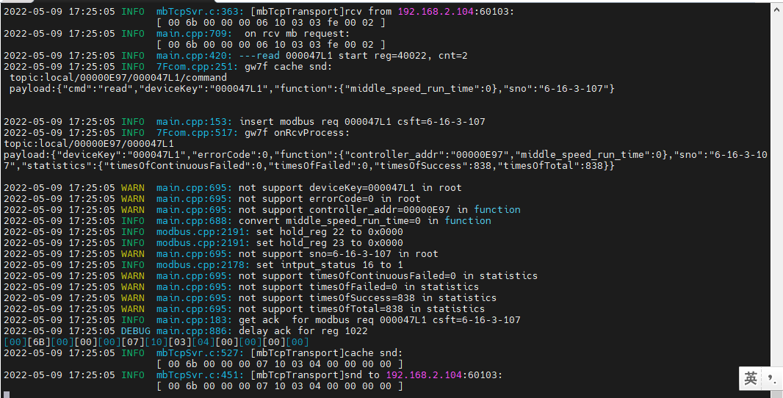

结果：与写入的数据一致。

### 读取错误地址

1. 读取寄存器22

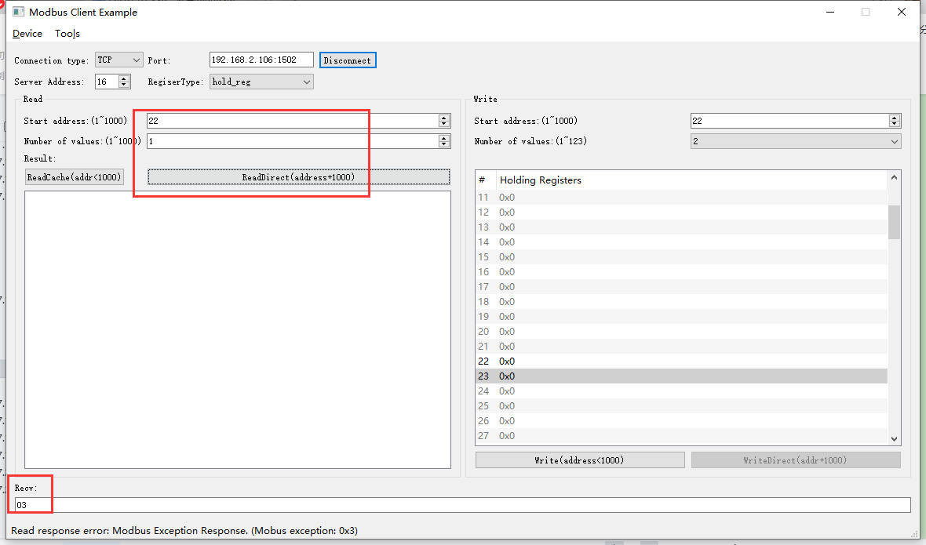

2022-05-10 09:39:57 INFO mbTcpSvr.c:363: [mbTcpTransport]rcv from 192.168.2.104:63686:

[ 00 6c 00 00 00 06 10 03 03 fe 00 01 ]

2022-05-10 09:39:57 INFO main.cpp:709: on rcv mb request:

[ 00 6c 00 00 00 06 10 03 03 fe 00 01 ]

2022-05-10 09:39:57 INFO main.cpp:420: ---read 000047L1 start reg=40022, cnt=1

2022-05-10 09:39:57 WARN main.cpp:471: wrong regcnt 1 for reg 40022 , should more than 2

[00][6C][00][00][00][03][10][83][03]

2022-05-10 09:39:57 INFO mbTcpSvr.c:527: [mbTcpTransport]cache snd:

[ 00 6c 00 00 00 03 10 83 03 ]

2022-05-10 09:39:57 INFO mbTcpSvr.c:451: [mbTcpTransport]snd to 192.168.2.104:63686:

[ 00 6c 00 00 00 03 10 83 03 ]

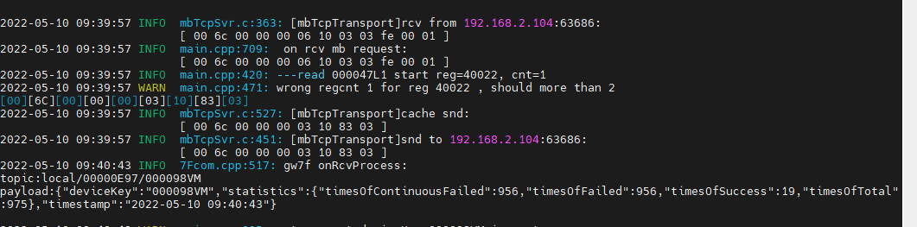

结果：绑定使用的寄存器，单独读取回复错误。

1. 读取寄存器22-24

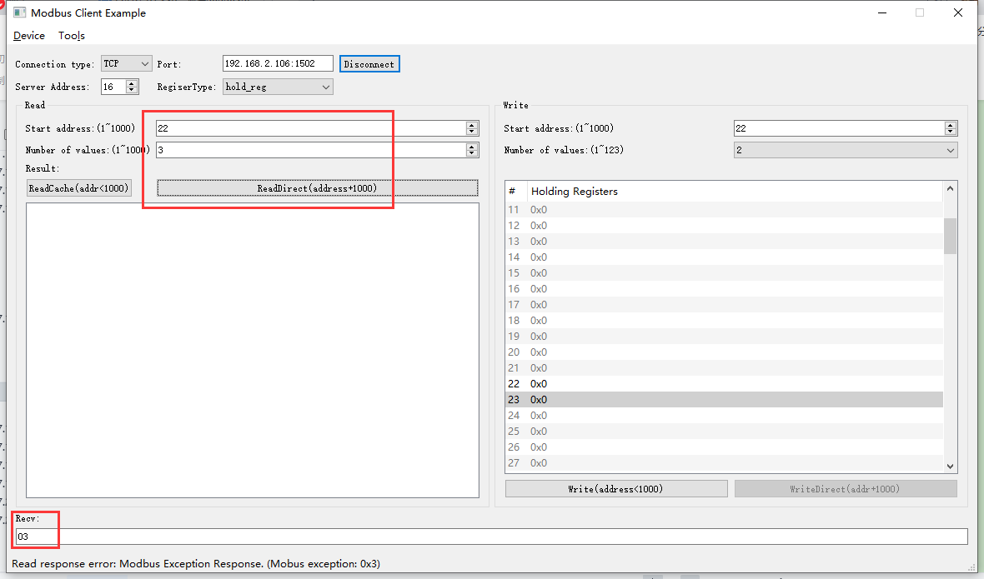

2022-05-10 09:42:04 INFO mbTcpSvr.c:363: [mbTcpTransport]rcv from 192.168.2.104:63686:

[ 00 6d 00 00 00 06 10 03 03 fe 00 03 ]

2022-05-10 09:42:04 INFO main.cpp:709: on rcv mb request:

[ 00 6d 00 00 00 06 10 03 03 fe 00 03 ]

2022-05-10 09:42:04 INFO main.cpp:420: ---read 000047L1 start reg=40022, cnt=3

2022-05-10 09:42:04 WARN main.cpp:471: wrong regcnt 1 for reg 40024 , should more than 2

[00][6D][00][00][00][03][10][83][03]

2022-05-10 09:42:04 INFO mbTcpSvr.c:527: [mbTcpTransport]cache snd:

[ 00 6d 00 00 00 03 10 83 03 ]

2022-05-10 09:42:04 INFO mbTcpSvr.c:451: [mbTcpTransport]snd to 192.168.2.104:63686:

[ 00 6d 00 00 00 03 10 83 03 ]

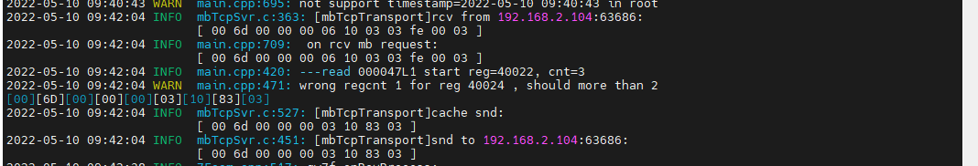

结果：回复错误。

### 写--错误地址

1. 写--清零22

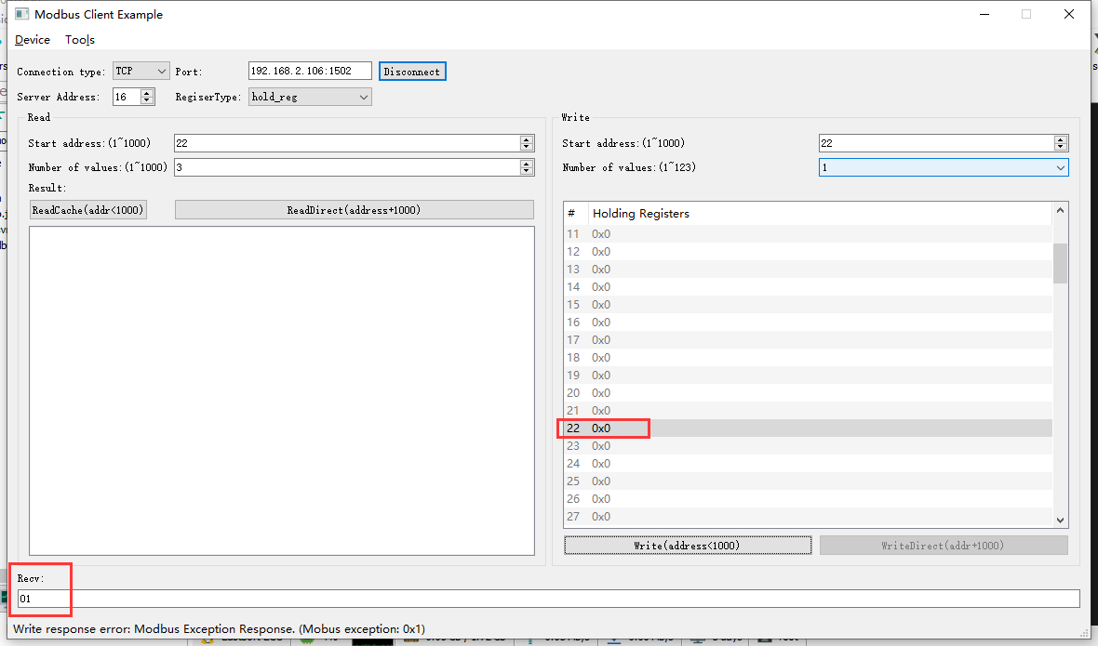

2022-05-10 09:45:25 INFO mbTcpSvr.c:363: [mbTcpTransport]rcv from 192.168.2.104:63686:

[ 00 6f 00 00 00 06 10 06 00 16 00 00 ]

2022-05-10 09:45:25 INFO main.cpp:709: on rcv mb request:

[ 00 6f 00 00 00 06 10 06 00 16 00 00 ]

2022-05-10 09:45:25 INFO main.cpp:420: ---write 000047L1 start reg=40022, cnt=1

2022-05-10 09:45:25 WARN main.cpp:455: reg 40022 not support single or coil write

[00][6F][00][00][00][03][10][86][01]

2022-05-10 09:45:25 INFO mbTcpSvr.c:527: [mbTcpTransport]cache snd:

[ 00 6f 00 00 00 03 10 86 01 ]

2022-05-10 09:45:25 INFO mbTcpSvr.c:451: [mbTcpTransport]snd to 192.168.2.104:63686:

[ 00 6f 00 00 00 03 10 86 01 ]

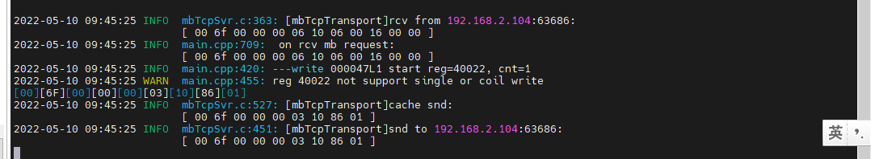

结果：回复错误。

1. 写--清零22-24

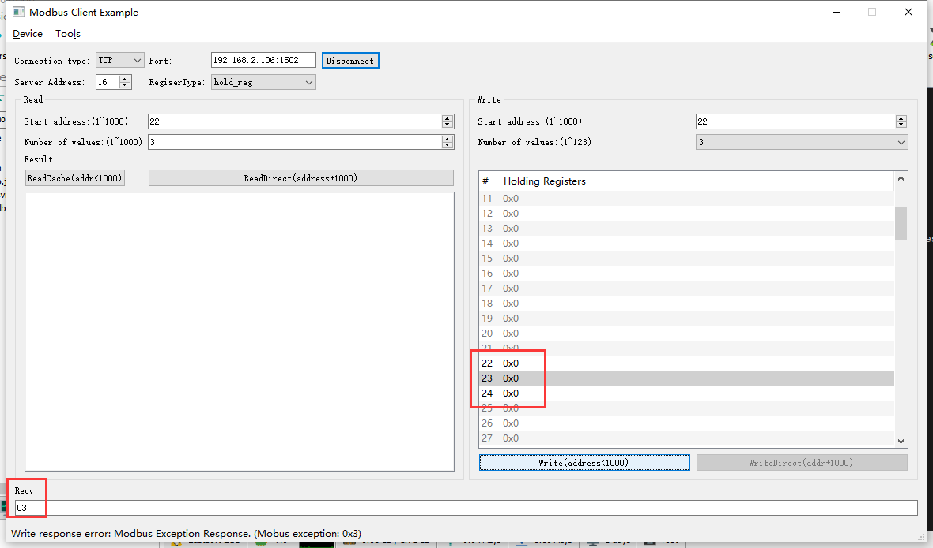

2022-05-10 09:46:26 INFO mbTcpSvr.c:363: [mbTcpTransport]rcv from 192.168.2.104:63686:

[ 00 70 00 00 00 0d 10 10 00 16 00 03 06 00 00 00 00 00 00 ]

2022-05-10 09:46:27 INFO main.cpp:709: on rcv mb request:

[ 00 70 00 00 00 0d 10 10 00 16 00 03 06 00 00 00 00 00 00 ]

2022-05-10 09:46:27 INFO main.cpp:420: ---write 000047L1 start reg=40022, cnt=3

2022-05-10 09:46:27 DEBUG main.cpp:525: write reg 40022 to:[hex]

[ 00 00 00 00 ]

2022-05-10 09:46:27 WARN main.cpp:471: wrong regcnt 1 for reg 40024 , should more than 2

[00][70][00][00][00][03][10][90][03]

2022-05-10 09:46:27 INFO mbTcpSvr.c:527: [mbTcpTransport]cache snd:

[ 00 70 00 00 00 03 10 90 03 ]

2022-05-10 09:46:27 INFO mbTcpSvr.c:451: [mbTcpTransport]snd to 192.168.2.104:63686:

[ 00 70 00 00 00 03 10 90 03 ]

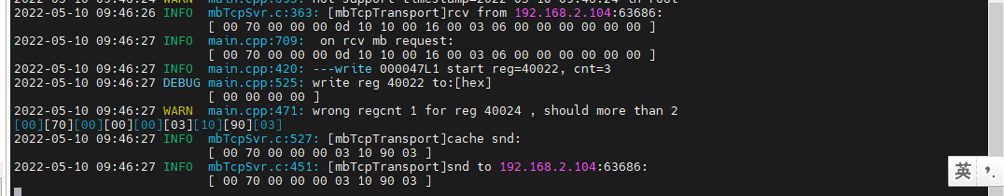

结果：回复错误。

## 低风速运行时间

**寄存器定义：**





### 直读开机运行时间

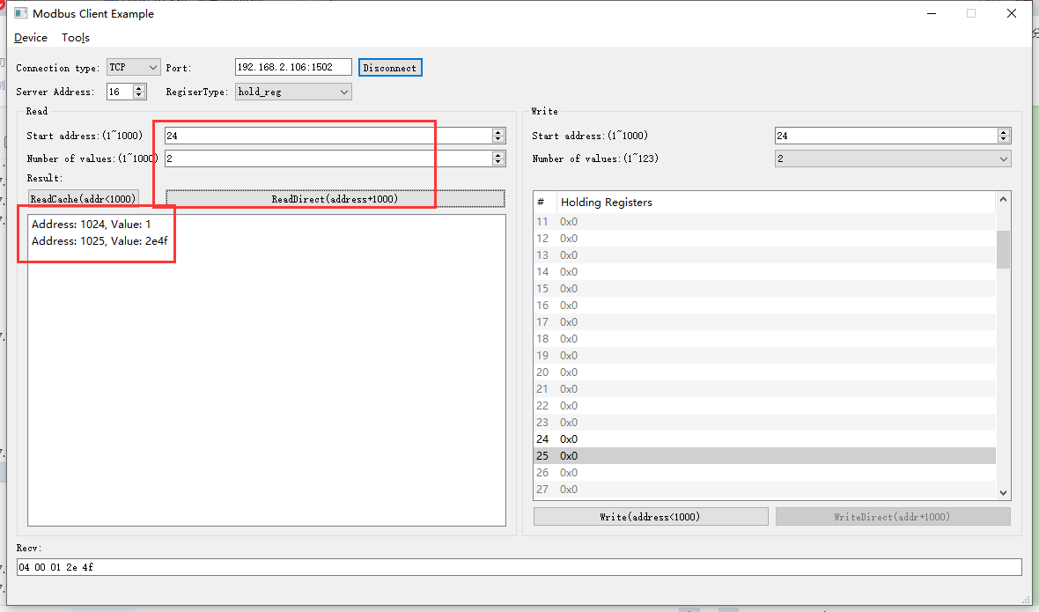

2022-05-10 10:03:28 INFO mbTcpSvr.c:363: [mbTcpTransport]rcv from 192.168.2.104:63686:

[ 00 71 00 00 00 06 10 03 04 00 00 02 ]

2022-05-10 10:03:28 INFO main.cpp:709: on rcv mb request:

[ 00 71 00 00 00 06 10 03 04 00 00 02 ]

2022-05-10 10:03:28 INFO main.cpp:420: ---read 000047L1 start reg=40024, cnt=2

2022-05-10 10:03:28 INFO 7Fcom.cpp:517: gw7f onRcvProcess:

topic:local/00000E97/000047L1

payload:{"deviceKey":"000047L1","errorCode":0,"function":{"controller_addr":"00000E97","low_speed_run_time":77391},"sno":"6-16-3-113","statistics":{"timesOfContinuousFailed":0,"timesOfFailed":0,"timesOfSuccess":1014,"timesOfTotal":1014}}

2022-05-10 10:03:28 INFO mbTcpSvr.c:451: [mbTcpTransport]snd to 192.168.2.104:63686:

[ 00 71 00 00 00 07 10 03 04 00 01 2e 4f ]

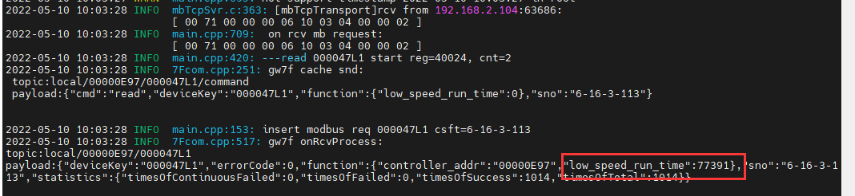

结果：读取到的数据与抄控器读取的一致。

### 读缓存开机运行时间

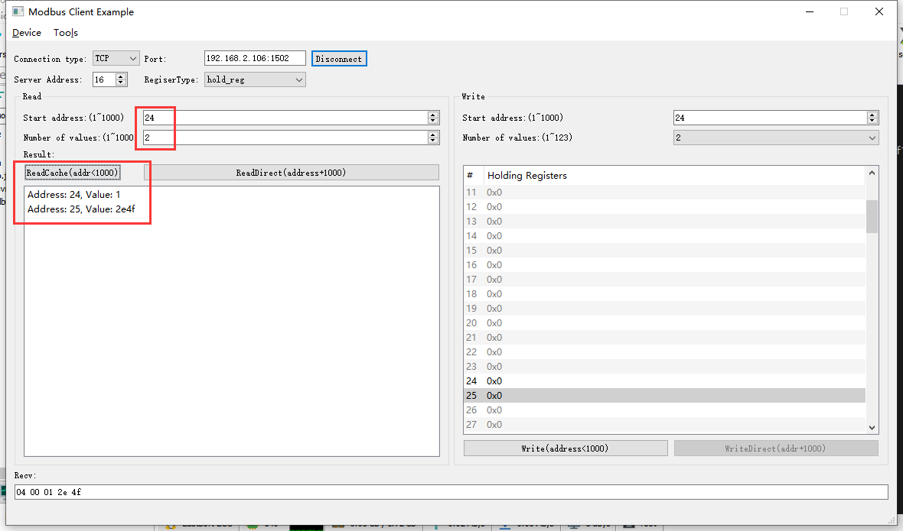

2022-05-10 10:08:53 INFO mbTcpSvr.c:363: [mbTcpTransport]rcv from 192.168.2.104:63686:

[ 00 72 00 00 00 06 10 03 00 18 00 02 ]

2022-05-10 10:08:53 INFO main.cpp:709: on rcv mb request:

[ 00 72 00 00 00 06 10 03 00 18 00 02 ]

[00][72][00][00][00][07][10][03][04][00][01][2E][4F]

2022-05-10 10:08:53 INFO mbTcpSvr.c:527: [mbTcpTransport]cache snd:

[ 00 72 00 00 00 07 10 03 04 00 01 2e 4f ]

2022-05-10 10:08:53 INFO mbTcpSvr.c:451: [mbTcpTransport]snd to 192.168.2.104:63686:

[ 00 72 00 00 00 07 10 03 04 00 01 2e 4f ]



结果：与直读数据，抄控器数据一致。

### 写--清零操作

1. 写入

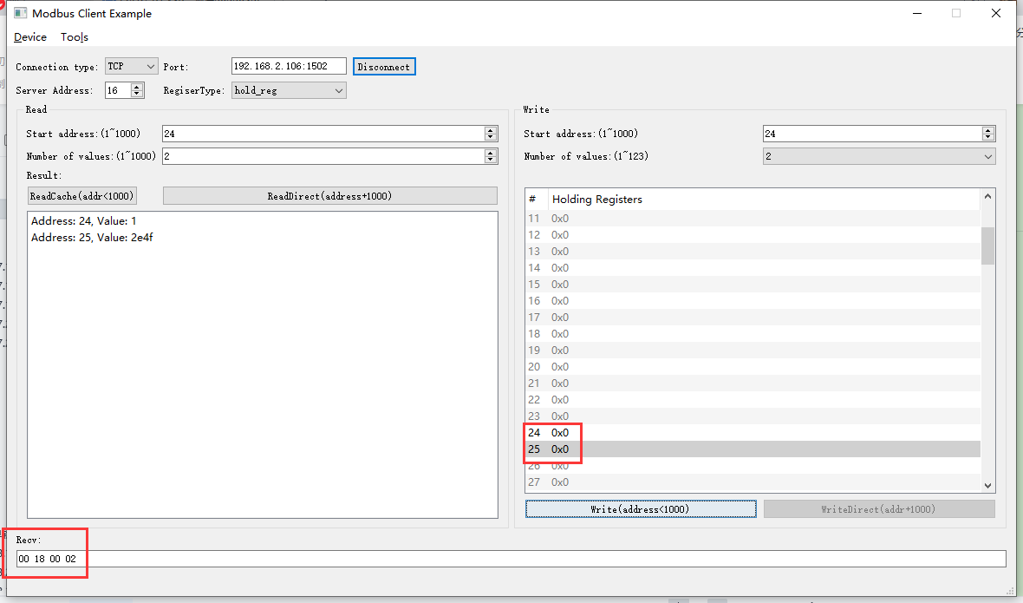

2022-05-10 10:12:25 INFO mbTcpSvr.c:363: [mbTcpTransport]rcv from 192.168.2.104:63686:

[ 00 73 00 00 00 0b 10 10 00 18 00 02 04 00 00 00 00 ]

2022-05-10 10:12:25 INFO main.cpp:709: on rcv mb request:

[ 00 73 00 00 00 0b 10 10 00 18 00 02 04 00 00 00 00 ]

2022-05-10 10:12:25 INFO main.cpp:420: ---write 000047L1 start reg=40024, cnt=2

2022-05-10 10:12:25 DEBUG main.cpp:525: write reg 40024 to:[hex]

[ 00 00 00 00 ]

2022-05-10 10:12:26 INFO 7Fcom.cpp:517: gw7f onRcvProcess:

topic:local/00000E97/000047L1

payload:{"deviceKey":"000047L1","errorCode":0,"function":{"controller_addr":"00000E97","low_speed_run_time":0},"sno":"6-16-16-115","statistics":{"timesOfContinuousFailed":0,"timesOfFailed":0,"timesOfSuccess":1016,"timesOfTotal":1016}}

2022-05-10 10:12:26 INFO mbTcpSvr.c:451: [mbTcpTransport]snd to 192.168.2.104:63686:

[ 00 73 00 00 00 06 10 10 00 18 00 02 ]

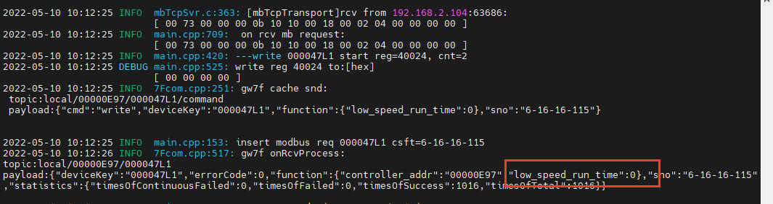

1. 直读

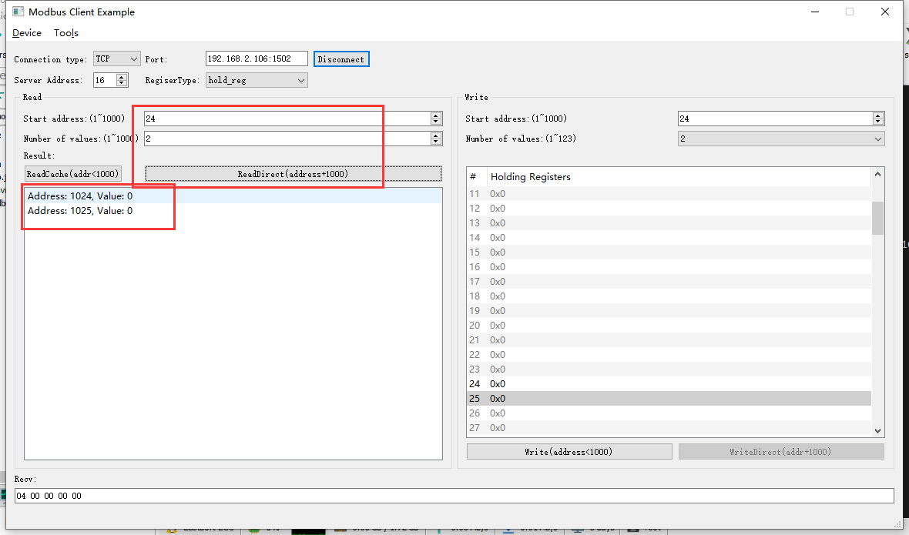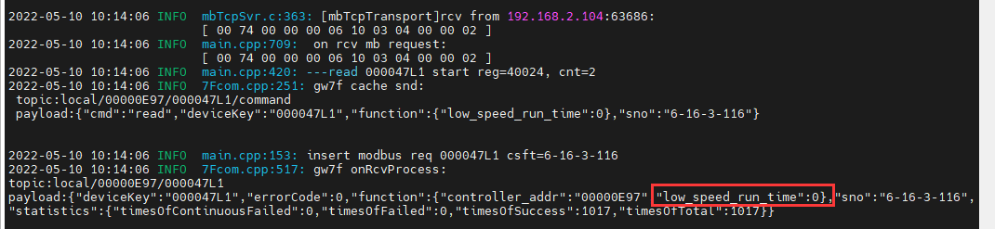

结果：读取与写入的一致。

### 读取错误地址

1. 读取寄存器24

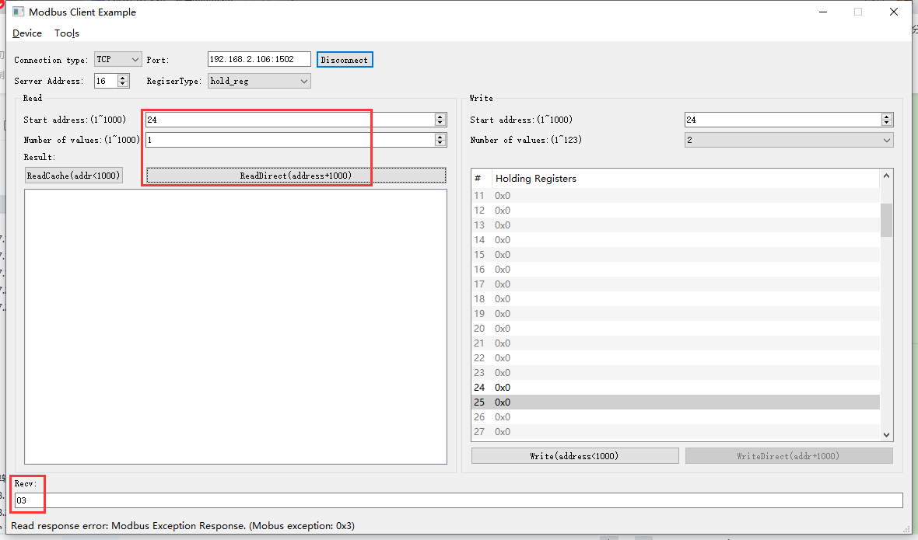

2022-05-10 10:15:14 INFO mbTcpSvr.c:363: [mbTcpTransport]rcv from 192.168.2.104:63686:

[ 00 75 00 00 00 06 10 03 04 00 00 01 ]

2022-05-10 10:15:14 INFO main.cpp:709: on rcv mb request:

[ 00 75 00 00 00 06 10 03 04 00 00 01 ]

2022-05-10 10:15:14 INFO main.cpp:420: ---read 000047L1 start reg=40024, cnt=1

2022-05-10 10:15:14 WARN main.cpp:471: wrong regcnt 1 for reg 40024 , should more than 2

[00][75][00][00][00][03][10][83][03]

2022-05-10 10:15:14 INFO mbTcpSvr.c:527: [mbTcpTransport]cache snd:

[ 00 75 00 00 00 03 10 83 03 ]

2022-05-10 10:15:14 INFO mbTcpSvr.c:451: [mbTcpTransport]snd to 192.168.2.104:63686:

[ 00 75 00 00 00 03 10 83 03 ]

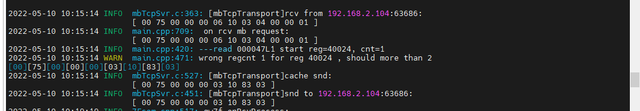

1. 读取寄存器24-26

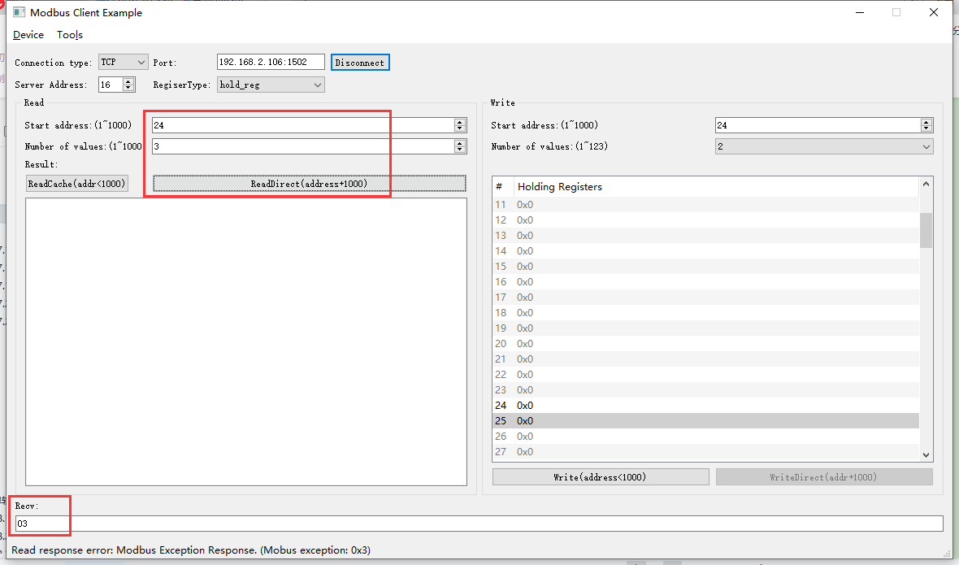

2022-05-10 11:02:56 INFO mbTcpSvr.c:363: [mbTcpTransport]rcv from 192.168.2.104:64807:

[ 00 76 00 00 00 06 10 03 04 00 00 03 ]

2022-05-10 11:02:56 INFO main.cpp:709: on rcv mb request:

[ 00 76 00 00 00 06 10 03 04 00 00 03 ]

2022-05-10 11:02:56 INFO main.cpp:420: ---read 000047L1 start reg=40024, cnt=3

2022-05-10 11:02:56 WARN main.cpp:471: wrong regcnt 1 for reg 40026 , should more than 2

[00][76][00][00][00][03][10][83][03]

2022-05-10 11:02:56 INFO mbTcpSvr.c:527: [mbTcpTransport]cache snd:

[ 00 76 00 00 00 03 10 83 03 ]

2022-05-10 11:02:56 INFO mbTcpSvr.c:451: [mbTcpTransport]snd to 192.168.2.104:64807:

[ 00 76 00 00 00 03 10 83 03 ]

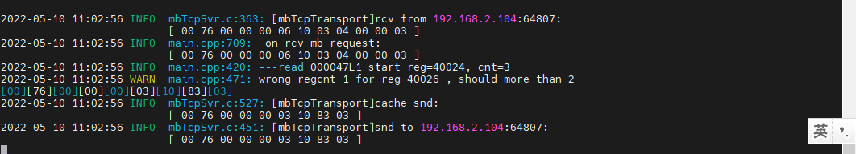

### 写--错误地址

1. 写--清零24

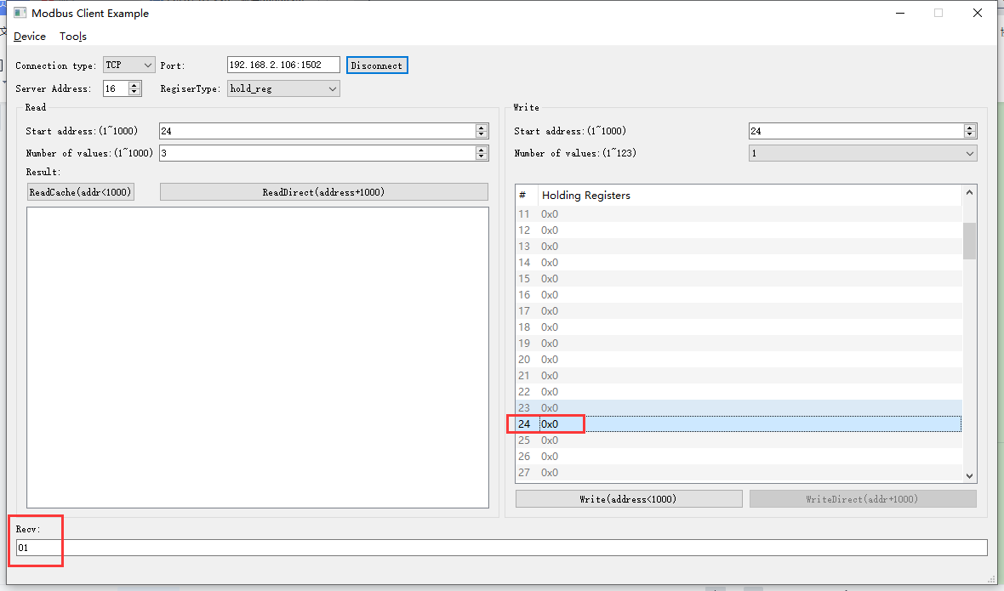

2022-05-10 11:03:47 INFO mbTcpSvr.c:363: [mbTcpTransport]rcv from 192.168.2.104:64807:

[ 00 77 00 00 00 06 10 06 00 18 00 00 ]

2022-05-10 11:03:47 INFO main.cpp:709: on rcv mb request:

[ 00 77 00 00 00 06 10 06 00 18 00 00 ]

2022-05-10 11:03:47 INFO main.cpp:420: ---write 000047L1 start reg=40024, cnt=1

2022-05-10 11:03:47 WARN main.cpp:455: reg 40024 not support single or coil write

[00][77][00][00][00][03][10][86][01]

2022-05-10 11:03:47 INFO mbTcpSvr.c:527: [mbTcpTransport]cache snd:

[ 00 77 00 00 00 03 10 86 01 ]

2022-05-10 11:03:47 INFO mbTcpSvr.c:451: [mbTcpTransport]snd to 192.168.2.104:64807:

[ 00 77 00 00 00 03 10 86 01 ]

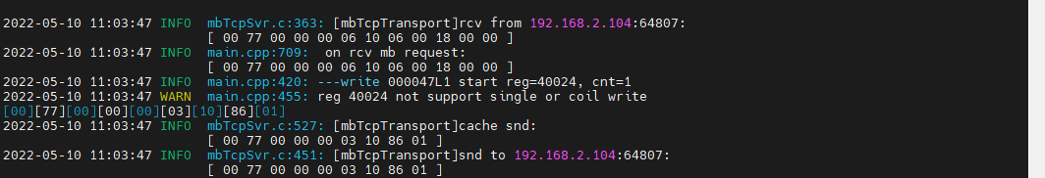

1. 写--清零24-26

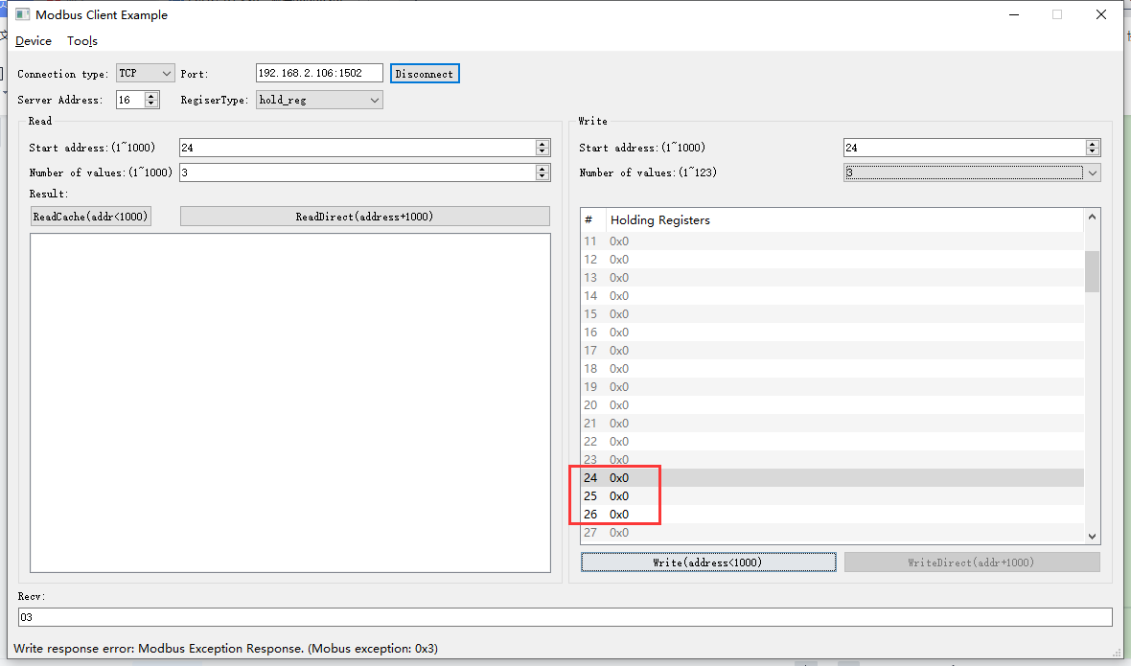2022-05-10 11:05:16 INFO mbTcpSvr.c:363: [mbTcpTransport]rcv from 192.168.2.104:64807:

[ 00 78 00 00 00 0d 10 10 00 18 00 03 06 00 00 00 00 00 00 ]

2022-05-10 11:05:16 INFO main.cpp:709: on rcv mb request:

[ 00 78 00 00 00 0d 10 10 00 18 00 03 06 00 00 00 00 00 00 ]

2022-05-10 11:05:16 INFO main.cpp:420: ---write 000047L1 start reg=40024, cnt=3

2022-05-10 11:05:16 DEBUG main.cpp:525: write reg 40024 to:[hex]

[ 00 00 00 00 ]

2022-05-10 11:05:16 WARN main.cpp:471: wrong regcnt 1 for reg 40026 , should more than 2

[00][78][00][00][00][03][10][90][03]

2022-05-10 11:05:16 INFO mbTcpSvr.c:527: [mbTcpTransport]cache snd:

[ 00 78 00 00 00 03 10 90 03 ]

2022-05-10 11:05:16 INFO mbTcpSvr.c:451: [mbTcpTransport]snd to 192.168.2.104:64807:

[ 00 78 00 00 00 03 10 90 03 ]

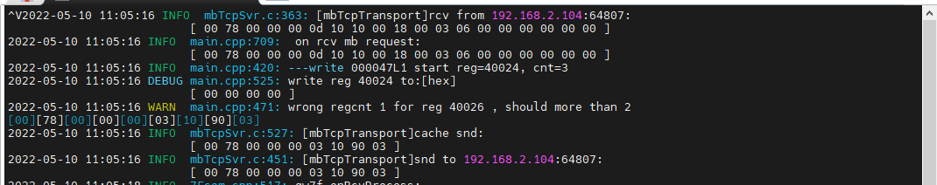

## 高风速运行时间/min计费

**寄存器定义：**



### 直读开机运行时间

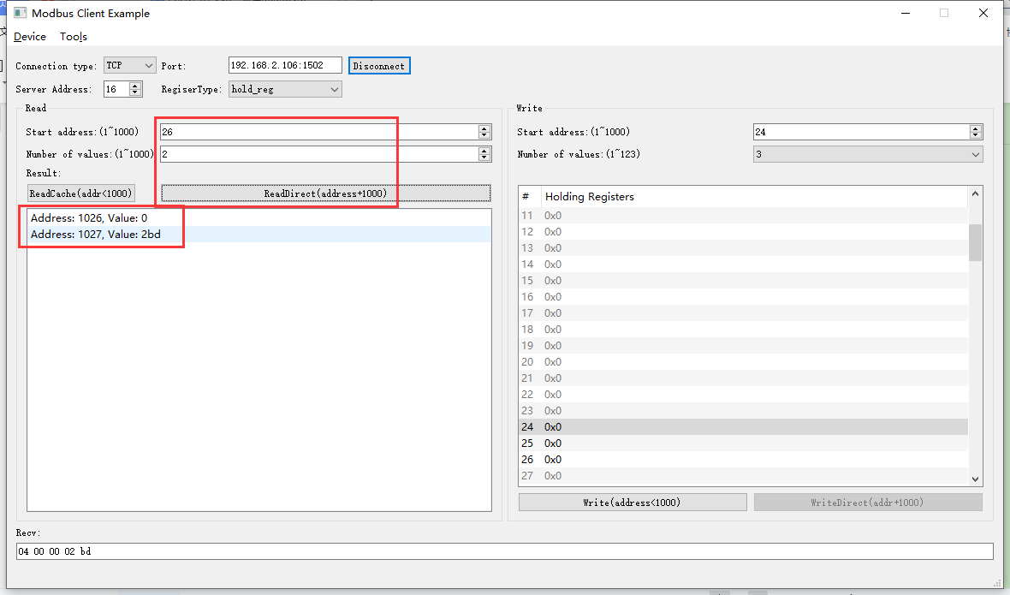2022-05-10 11:11:04 INFO mbTcpSvr.c:363: [mbTcpTransport]rcv from 192.168.2.104:64807:

[ 00 79 00 00 00 06 10 03 04 02 00 02 ]

2022-05-10 11:11:04 INFO main.cpp:709: on rcv mb request:

[ 00 79 00 00 00 06 10 03 04 02 00 02 ]

2022-05-10 11:11:04 INFO main.cpp:420: ---read 000047L1 start reg=40026, cnt=2

2022-05-10 11:11:04 INFO 7Fcom.cpp:517: gw7f onRcvProcess:

topic:local/00000E97/000047L1

payload:{"deviceKey":"000047L1","errorCode":0,"function":{"controller_addr":"00000E97","high_speed_run_time_minute":701},"sno":"6-16-3-121","statistics":{"timesOfContinuousFailed":0,"timesOfFailed":0,"timesOfSuccess":1028,"timesOfTotal":1028}}

2022-05-10 11:11:04 INFO mbTcpSvr.c:451: [mbTcpTransport]snd to 192.168.2.104:64807:

[ 00 79 00 00 00 07 10 03 04 00 00 02 bd ]

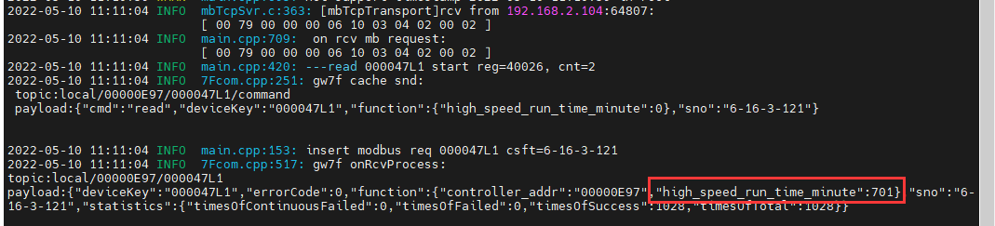

结果：与抄控器读取的一致。

### 读缓存开机运行时间

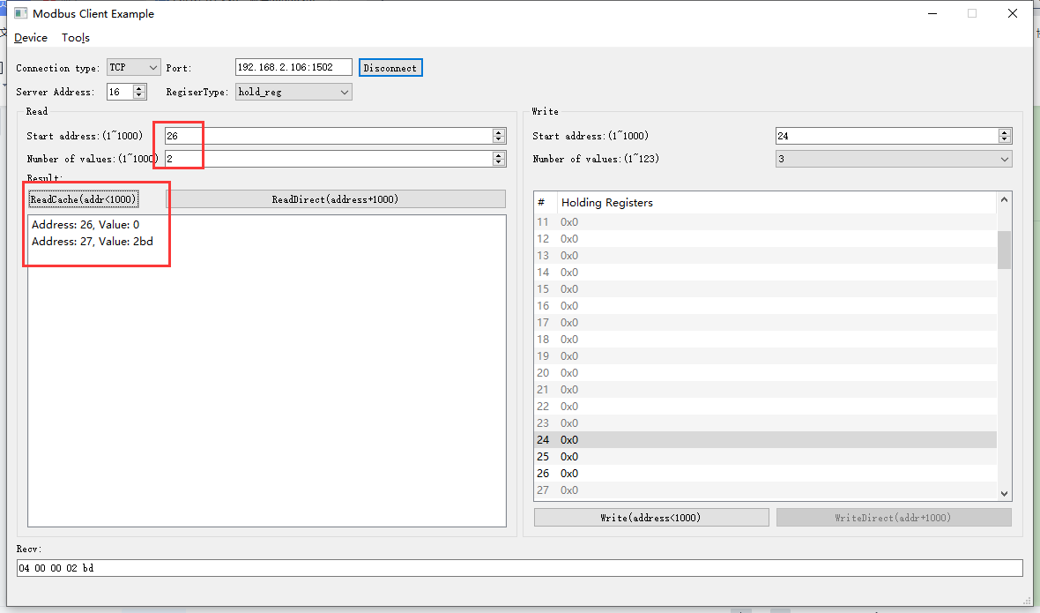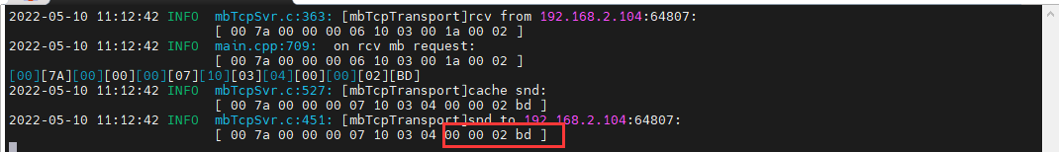

### 写--清零操作



1. 写入

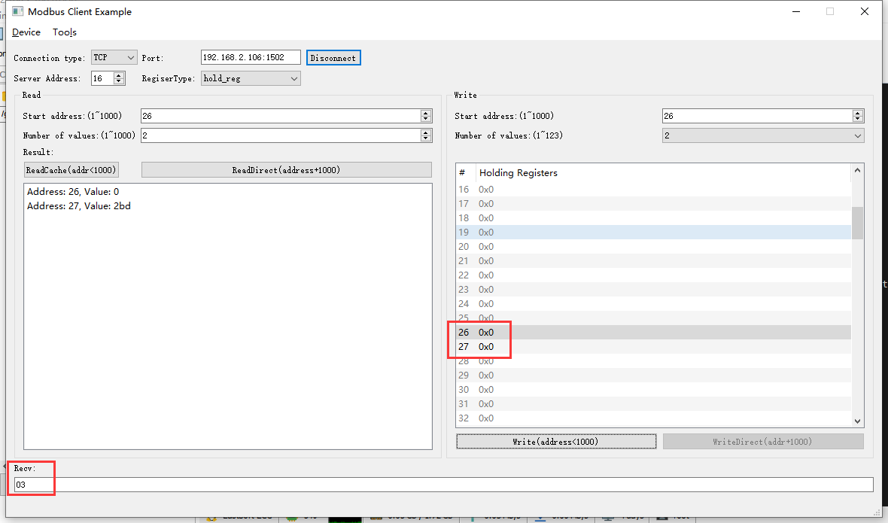

2022-05-10 13:29:39 INFO mbTcpSvr.c:491: [mbTcpTransport]new connect from 192.168.2.104:51611,fd=6

2022-05-10 13:29:40 INFO mbTcpSvr.c:363: [mbTcpTransport]rcv from 192.168.2.104:51611:

[ 00 7f 00 00 00 0b 10 10 00 1a 00 02 04 00 00 00 00 ]

2022-05-10 13:29:40 INFO main.cpp:709: on rcv mb request:

[ 00 7f 00 00 00 0b 10 10 00 1a 00 02 04 00 00 00 00 ]

2022-05-10 13:29:40 INFO main.cpp:420: ---write 000047L1 start reg=40026, cnt=2

2022-05-10 13:29:40 DEBUG main.cpp:525: write reg 40026 to:[hex]

[ 00 00 00 00 ]

2022-05-10 13:29:41 INFO 7Fcom.cpp:517: gw7f onRcvProcess:

topic:local/00000E97/000047L1

payload:{"deviceKey":"000047L1","errorCode":18,"function":{"controller_addr":"00000E97"},"sno":"6-16-16-127","statistics":{"timesOfContinuousFailed":0,"timesOfFailed":0,"timesOfSuccess":1055,"timesOfTotal":1055}}

2022-05-10 13:29:41 INFO mbTcpSvr.c:451: [mbTcpTransport]snd to 192.168.2.104:51611:

[ 00 7f 00 00 00 03 10 90 03 ]

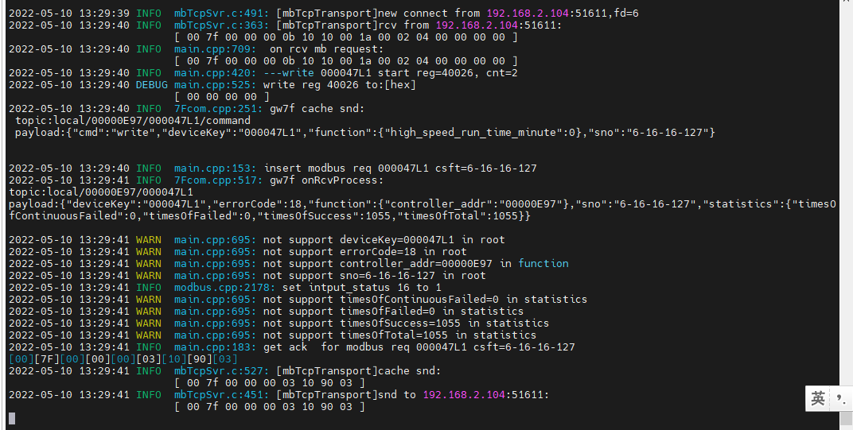

解释：此数据是计费数据，设备端不允许清零，所以返回错误。

1. 直读

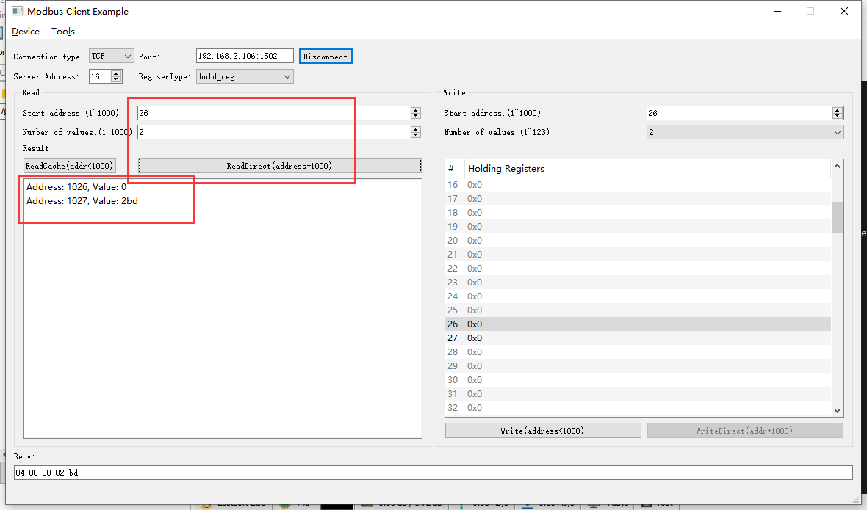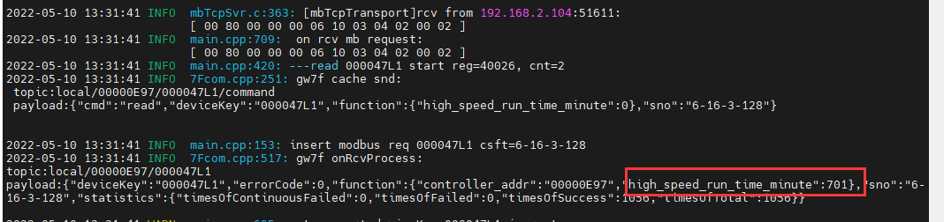

结果：读取结果未发生变化。

### 读取错误地址

1. 读取寄存器25

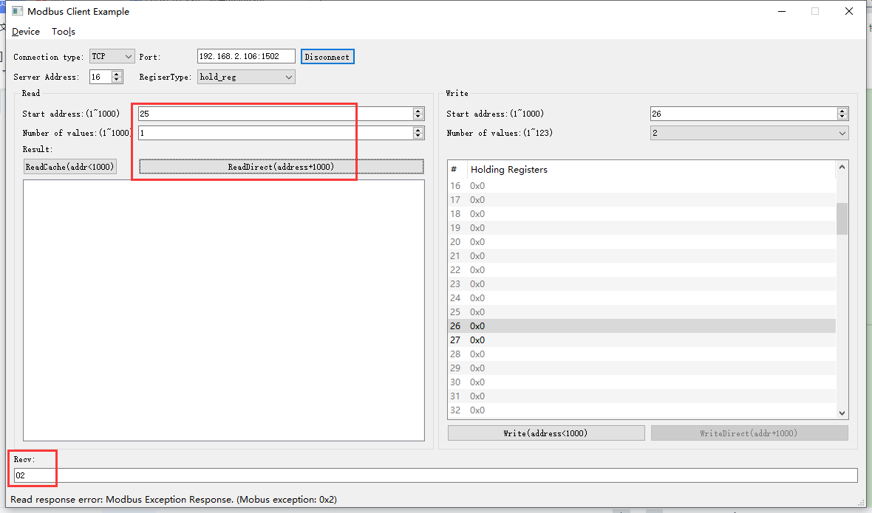

2022-05-10 13:33:34 INFO mbTcpSvr.c:363: [mbTcpTransport]rcv from 192.168.2.104:51611:

[ 00 82 00 00 00 06 10 03 04 01 00 01 ]

2022-05-10 13:33:34 INFO main.cpp:709: on rcv mb request:

[ 00 82 00 00 00 06 10 03 04 01 00 01 ]

2022-05-10 13:33:34 INFO main.cpp:420: ---read 000047L1 start reg=40025, cnt=1

2022-05-10 13:33:34 WARN main.cpp:427: not support reg 40025

[00][82][00][00][00][03][10][83][02]

2022-05-10 13:33:34 INFO mbTcpSvr.c:527: [mbTcpTransport]cache snd:

[ 00 82 00 00 00 03 10 83 02 ]

2022-05-10 13:33:34 INFO mbTcpSvr.c:451: [mbTcpTransport]snd to 192.168.2.104:51611:

[ 00 82 00 00 00 03 10 83 02 ]

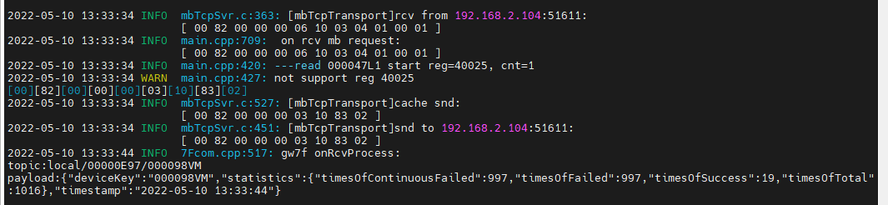

结果：回复错误。

1. 读取寄存器25-28

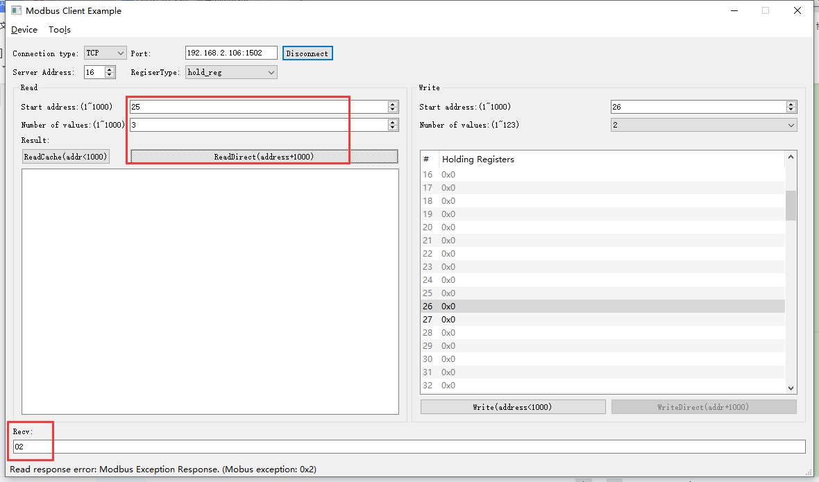2022-05-10 13:34:33 INFO mbTcpSvr.c:363: [mbTcpTransport]rcv from 192.168.2.104:51611:

[ 00 83 00 00 00 06 10 03 04 01 00 03 ]

2022-05-10 13:34:33 INFO main.cpp:709: on rcv mb request:

[ 00 83 00 00 00 06 10 03 04 01 00 03 ]

2022-05-10 13:34:33 INFO main.cpp:420: ---read 000047L1 start reg=40025, cnt=3

2022-05-10 13:34:33 WARN main.cpp:427: not support reg 40025

[00][83][00][00][00][03][10][83][02]

2022-05-10 13:34:33 INFO mbTcpSvr.c:527: [mbTcpTransport]cache snd:

[ 00 83 00 00 00 03 10 83 02 ]

2022-05-10 13:34:33 INFO mbTcpSvr.c:451: [mbTcpTransport]snd to 192.168.2.104:51611:

[ 00 83 00 00 00 03 10 83 02 ]

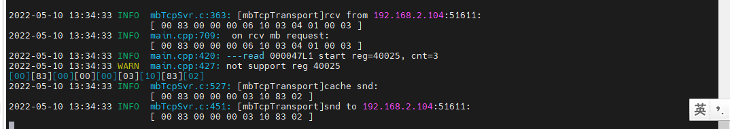结果：回复错误。

## 中风速运行时间/min计费

**寄存器定义：**



### 直读开机运行时间

### 读缓存开机运行时间

### 写--清零操作

解释：此数据是计费数据，设备端不允许清零，设备端返回错误，已经在高风计费中测试，不再赘述。

### 读取错误地址

1. 读取寄存器28

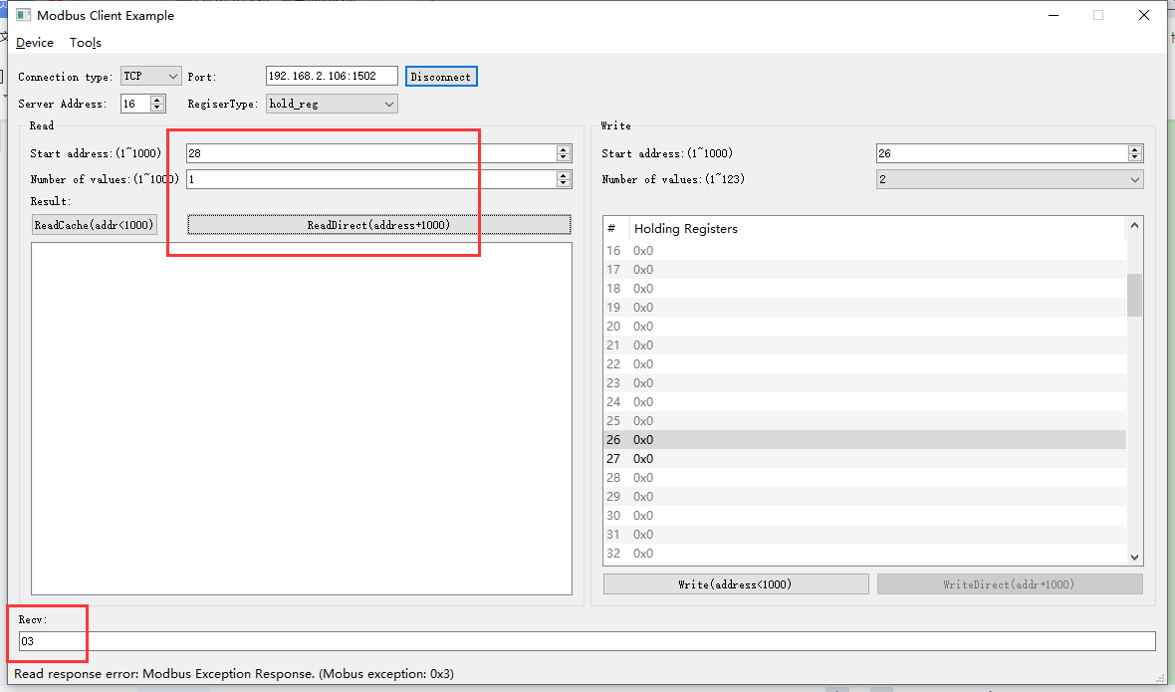2022-05-10 13:38:09 INFO mbTcpSvr.c:363: [mbTcpTransport]rcv from 192.168.2.104:51611:

[ 00 84 00 00 00 06 10 03 04 04 00 01 ]

2022-05-10 13:38:09 INFO main.cpp:709: on rcv mb request:

[ 00 84 00 00 00 06 10 03 04 04 00 01 ]

2022-05-10 13:38:09 INFO main.cpp:420: ---read 000047L1 start reg=40028, cnt=1

2022-05-10 13:38:09 WARN main.cpp:471: wrong regcnt 1 for reg 40028 , should more than 2

[00][84][00][00][00][03][10][83][03]

2022-05-10 13:38:09 INFO mbTcpSvr.c:527: [mbTcpTransport]cache snd:

[ 00 84 00 00 00 03 10 83 03 ]

2022-05-10 13:38:09 INFO mbTcpSvr.c:451: [mbTcpTransport]snd to 192.168.2.104:51611:

[ 00 84 00 00 00 03 10 83 03 ]

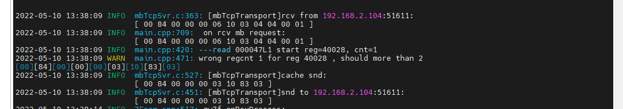

1. 读取寄存器28-30

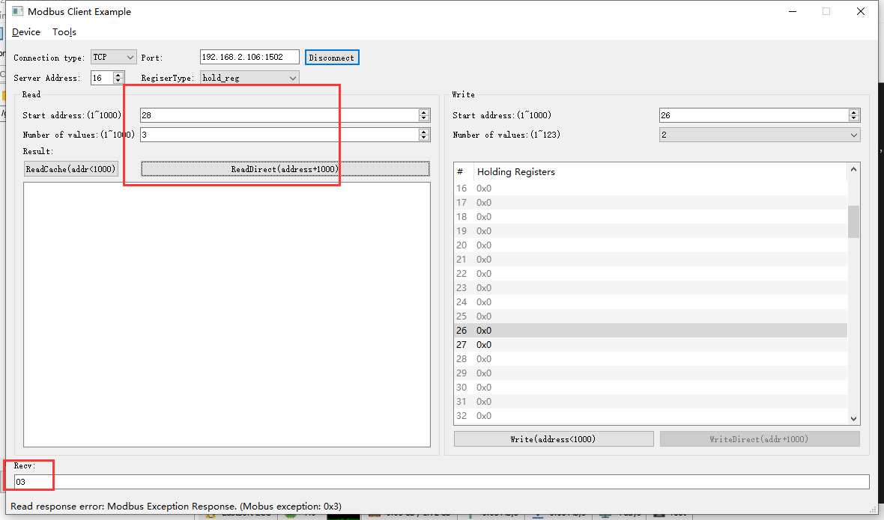2022-05-10 13:38:59 INFO mbTcpSvr.c:363: [mbTcpTransport]rcv from 192.168.2.104:51611:

[ 00 85 00 00 00 06 10 03 04 04 00 03 ]

2022-05-10 13:38:59 INFO main.cpp:709: on rcv mb request:

[ 00 85 00 00 00 06 10 03 04 04 00 03 ]

2022-05-10 13:38:59 INFO main.cpp:420: ---read 000047L1 start reg=40028, cnt=3

2022-05-10 13:38:59 WARN main.cpp:471: wrong regcnt 1 for reg 40030 , should more than 2

[00][85][00][00][00][03][10][83][03]

2022-05-10 13:38:59 INFO mbTcpSvr.c:527: [mbTcpTransport]cache snd:

[ 00 85 00 00 00 03 10 83 03 ]

2022-05-10 13:38:59 INFO mbTcpSvr.c:451: [mbTcpTransport]snd to 192.168.2.104:51611:

[ 00 85 00 00 00 03 10 83 03 ]

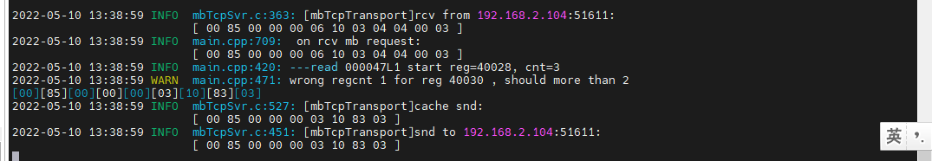

## 低风速运行时间/min计费

**寄存器定义：**



### 直读开机运行时间

### 读缓存开机运行时间

### 写--清零操作

解释：此数据是计费数据，设备端不允许清零，设备端返回错误，已经在高风计费中测试，不再赘述。

### 读取错误地址

1. 读取寄存器30

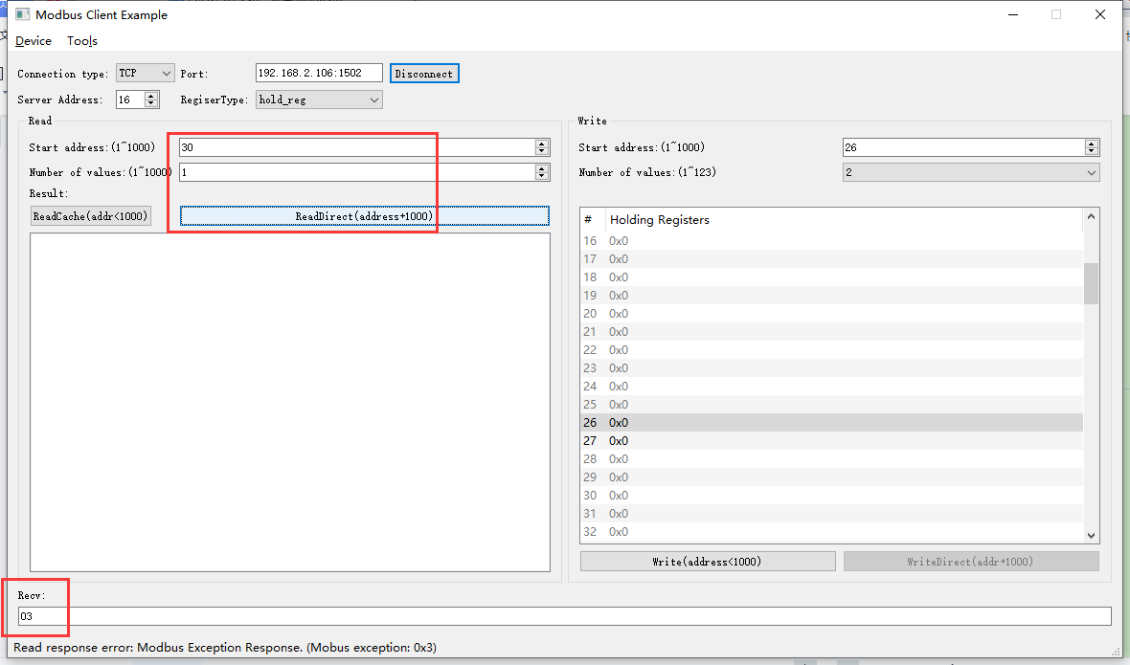2022-05-10 13:46:34 INFO mbTcpSvr.c:363: [mbTcpTransport]rcv from 192.168.2.104:51611:

[ 00 86 00 00 00 06 10 03 04 06 00 01 ]

2022-05-10 13:46:34 INFO main.cpp:709: on rcv mb request:

[ 00 86 00 00 00 06 10 03 04 06 00 01 ]

2022-05-10 13:46:34 INFO main.cpp:420: ---read 000047L1 start reg=40030, cnt=1

2022-05-10 13:46:34 WARN main.cpp:471: wrong regcnt 1 for reg 40030 , should more than 2

[00][86][00][00][00][03][10][83][03]

2022-05-10 13:46:34 INFO mbTcpSvr.c:527: [mbTcpTransport]cache snd:

[ 00 86 00 00 00 03 10 83 03 ]

2022-05-10 13:46:34 INFO mbTcpSvr.c:451: [mbTcpTransport]snd to 192.168.2.104:51611:

[ 00 86 00 00 00 03 10 83 03 ]

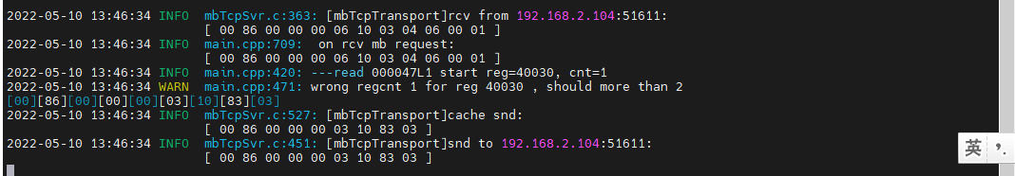

1. 读取寄存器30-32

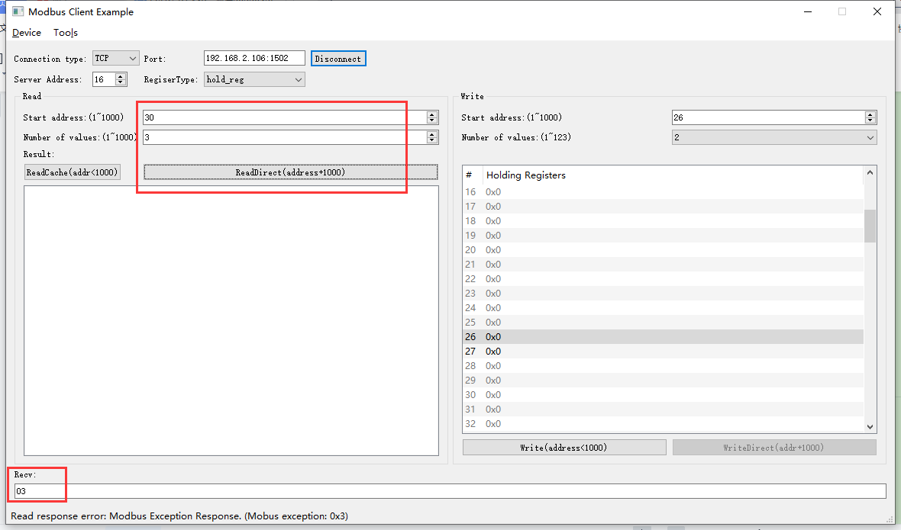2022-05-10 13:47:22 INFO mbTcpSvr.c:363: [mbTcpTransport]rcv from 192.168.2.104:51611:

[ 00 87 00 00 00 06 10 03 04 06 00 03 ]

2022-05-10 13:47:22 INFO main.cpp:709: on rcv mb request:

[ 00 87 00 00 00 06 10 03 04 06 00 03 ]

2022-05-10 13:47:22 INFO main.cpp:420: ---read 000047L1 start reg=40030, cnt=3

2022-05-10 13:47:22 WARN main.cpp:471: wrong regcnt 1 for reg 40032 , should more than 2

[00][87][00][00][00][03][10][83][03]

2022-05-10 13:47:22 INFO mbTcpSvr.c:527: [mbTcpTransport]cache snd:

[ 00 87 00 00 00 03 10 83 03 ]

2022-05-10 13:47:22 INFO mbTcpSvr.c:451: [mbTcpTransport]snd to 192.168.2.104:51611:

[ 00 87 00 00 00 03 10 83 03 ]

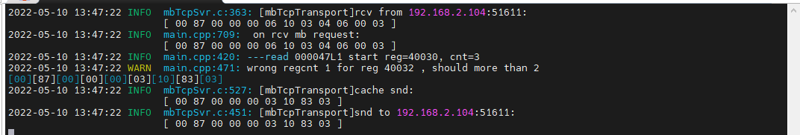

## 当量时间/min计费

**寄存器定义：**



### 直读开机运行时间

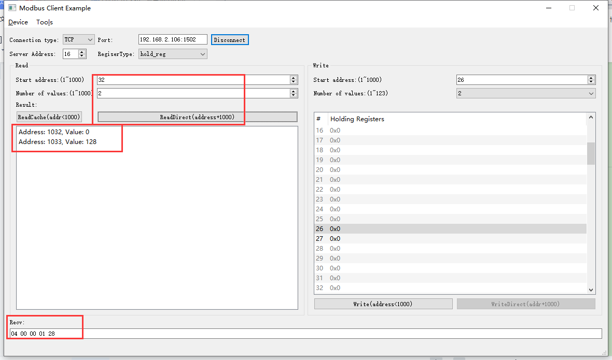2022-05-10 13:48:50 INFO mbTcpSvr.c:363: [mbTcpTransport]rcv from 192.168.2.104:51611:

[ 00 88 00 00 00 06 10 03 04 08 00 02 ]

2022-05-10 13:48:50 INFO main.cpp:709: on rcv mb request:

[ 00 88 00 00 00 06 10 03 04 08 00 02 ]

2022-05-10 13:48:50 INFO main.cpp:420: ---read 000047L1 start reg=40032, cnt=2

2022-05-10 13:48:50 INFO 7Fcom.cpp:251: gw7f cache snd:

topic:local/00000E97/000047L1/command

payload:{"cmd":"read","deviceKey":"000047L1","function":{"equivalent_time_minute":0},"sno":"6-16-3-136"}

2022-05-10 13:48:50 INFO main.cpp:153: insert modbus req 000047L1 csft=6-16-3-136

2022-05-10 13:48:50 INFO 7Fcom.cpp:517: gw7f onRcvProcess:

topic:local/00000E97/000047L1

payload:{"deviceKey":"000047L1","errorCode":0,"function":{"controller_addr":"00000E97","equivalent_time_minute":296},"sno":"6-16-3-136","statistics":{"timesOfContinuousFailed":0,"timesOfFailed":0,"timesOfSuccess":1060,"timesOfTotal":1060}}

2022-05-10 13:48:50 INFO mbTcpSvr.c:451: [mbTcpTransport]snd to 192.168.2.104:51611:

[ 00 88 00 00 00 07 10 03 04 00 00 01 28 ]

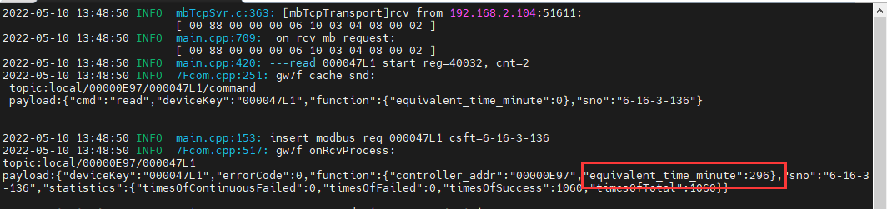

### 读缓存开机运行时间

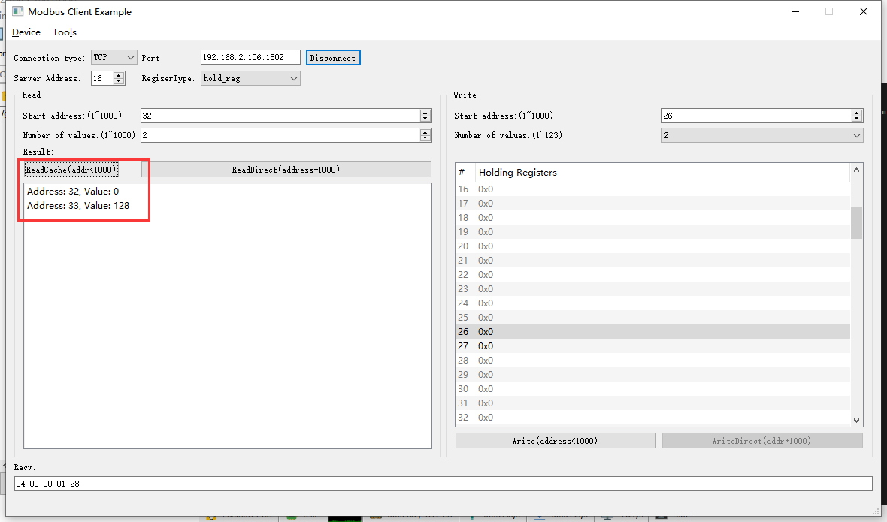2022-05-10 13:51:40 INFO mbTcpSvr.c:363: [mbTcpTransport]rcv from 192.168.2.104:51611:

[ 00 89 00 00 00 06 10 03 00 20 00 02 ]

2022-05-10 13:51:40 INFO main.cpp:709: on rcv mb request:

[ 00 89 00 00 00 06 10 03 00 20 00 02 ]

[00][89][00][00][00][07][10][03][04][00][00][01][28]

2022-05-10 13:51:40 INFO mbTcpSvr.c:527: [mbTcpTransport]cache snd:

[ 00 89 00 00 00 07 10 03 04 00 00 01 28 ]

2022-05-10 13:51:40 INFO mbTcpSvr.c:451: [mbTcpTransport]snd to 192.168.2.104:51611:

[ 00 89 00 00 00 07 10 03 04 00 00 01 28 ]

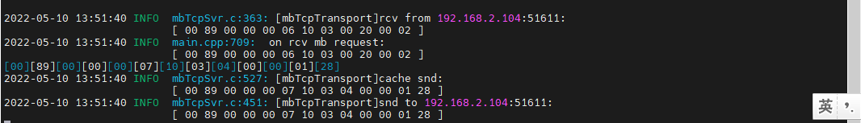

### 写--清零操作

解释：此数据是计费数据，设备端不允许清零，设备端返回错误，已经在高风计费中测试，不再赘述。

### 读取错误地址

1. 读取寄存器32

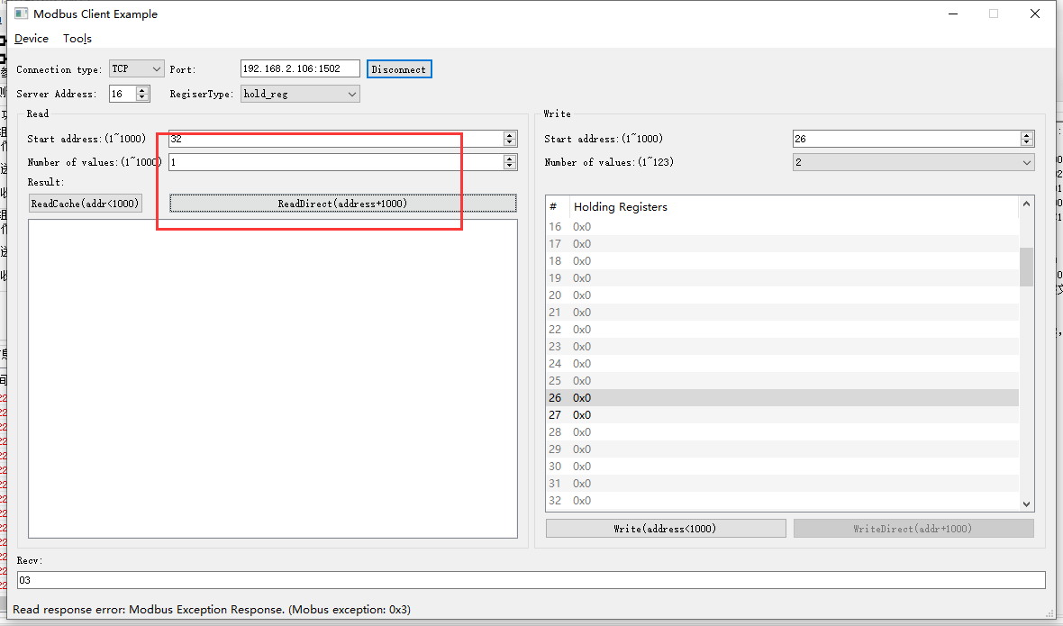2022-05-10 13:52:33 INFO mbTcpSvr.c:363: [mbTcpTransport]rcv from 192.168.2.104:51611:

[ 00 8a 00 00 00 06 10 03 04 08 00 01 ]

2022-05-10 13:52:33 INFO main.cpp:709: on rcv mb request:

[ 00 8a 00 00 00 06 10 03 04 08 00 01 ]

2022-05-10 13:52:33 INFO main.cpp:420: ---read 000047L1 start reg=40032, cnt=1

2022-05-10 13:52:33 WARN main.cpp:471: wrong regcnt 1 for reg 40032 , should more than 2

[00][8A][00][00][00][03][10][83][03]

2022-05-10 13:52:33 INFO mbTcpSvr.c:527: [mbTcpTransport]cache snd:

[ 00 8a 00 00 00 03 10 83 03 ]

2022-05-10 13:52:33 INFO mbTcpSvr.c:451: [mbTcpTransport]snd to 192.168.2.104:51611:

[ 00 8a 00 00 00 03 10 83 03 ]

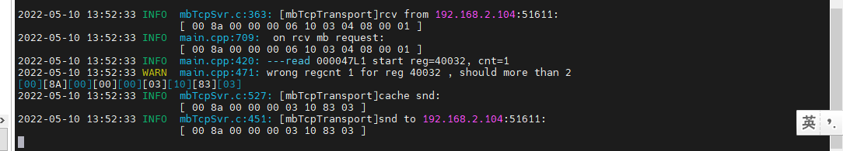

1. 读取寄存器32-34

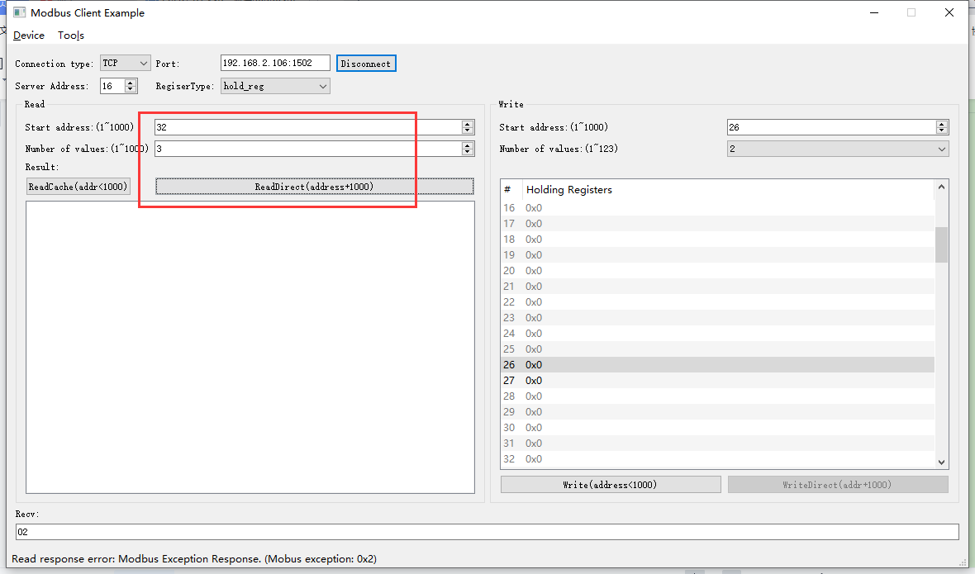

2022-05-10 13:54:19 INFO mbTcpSvr.c:363: [mbTcpTransport]rcv from 192.168.2.104:51611:

[ 00 8c 00 00 00 06 10 03 04 08 00 03 ]

2022-05-10 13:54:19 INFO main.cpp:709: on rcv mb request:

[ 00 8c 00 00 00 06 10 03 04 08 00 03 ]

Illegal data address 0x23 in read_registers

[00][8C][00][00][00][03][10][83][02]

2022-05-10 13:54:19 INFO mbTcpSvr.c:527: [mbTcpTransport]cache snd:

[ 00 8c 00 00 00 03 10 83 02 ]

2022-05-10 13:54:19 INFO mbTcpSvr.c:451: [mbTcpTransport]snd to 192.168.2.104:51611:

[ 00 8c 00 00 00 03 10 83 02 ]

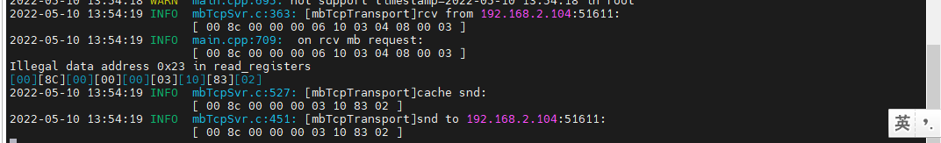

## 设备只读状态

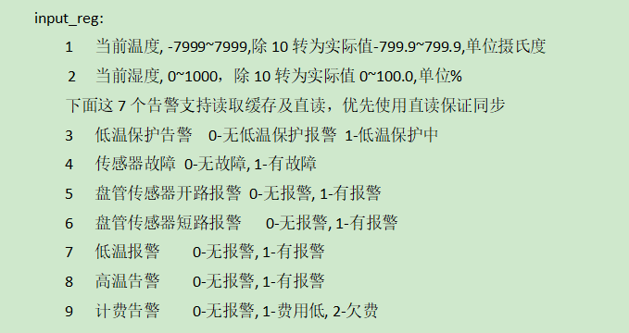

**说明：**使用抄控器读取设备状态用以对比。

### 当前温度·1

1. 直读

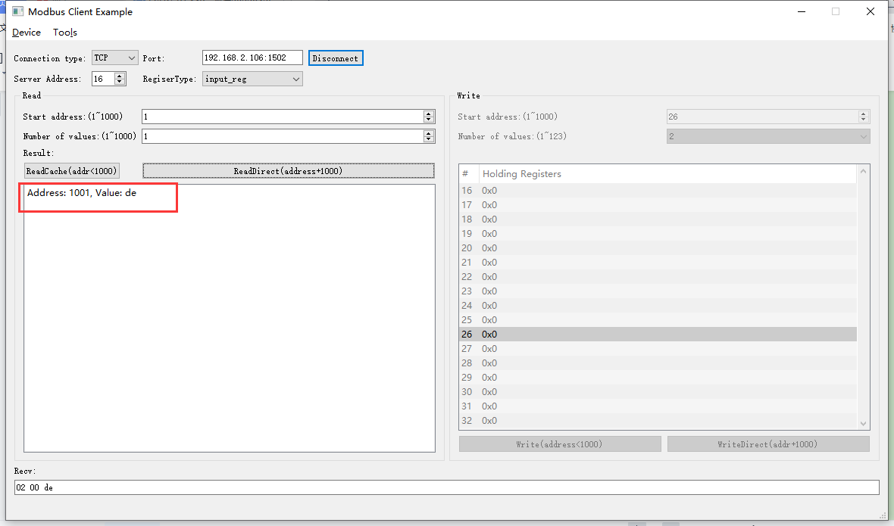2022-05-10 13:58:25 INFO mbTcpSvr.c:363: [mbTcpTransport]rcv from 192.168.2.104:51611:

[ 00 8d 00 00 00 06 10 04 03 e9 00 01 ]

2022-05-10 13:58:25 INFO main.cpp:709: on rcv mb request:

[ 00 8d 00 00 00 06 10 04 03 e9 00 01 ]

2022-05-10 13:58:25 INFO main.cpp:420: ---read 000047L1 start reg=30001, cnt=1

2022-05-10 13:58:25 INFO 7Fcom.cpp:517: gw7f onRcvProcess:

topic:local/00000E97/000047L1

payload:{"deviceKey":"000047L1","errorCode":0,"function":{"controller_addr":"00000E97","current_temp":22.20},"sno":"6-16-4-141","statistics":{"timesOfContinuousFailed":0,"timesOfFailed":0,"timesOfSuccess":1062,"timesOfTotal":1062}}

2022-05-10 13:58:25 INFO mbTcpSvr.c:451: [mbTcpTransport]snd to 192.168.2.104:51611:

[ 00 8d 00 00 00 05 10 04 02 00 de ]

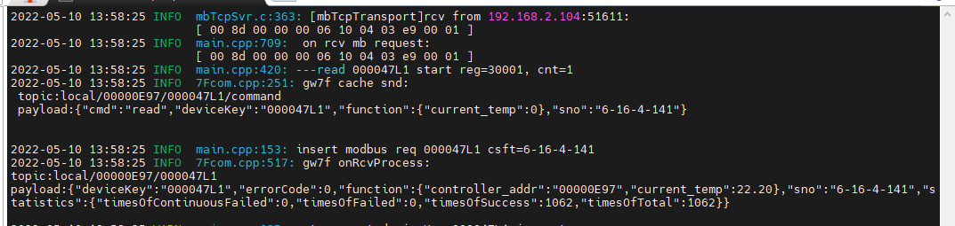

1. 读缓存

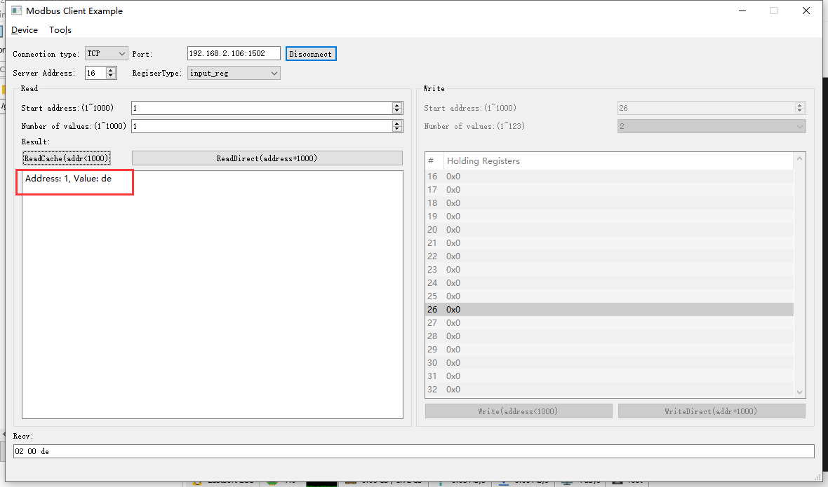2022-05-10 13:59:52 INFO mbTcpSvr.c:363: [mbTcpTransport]rcv from 192.168.2.104:51611:

[ 00 8e 00 00 00 06 10 04 00 01 00 01 ]

2022-05-10 13:59:52 INFO main.cpp:709: on rcv mb request:

[ 00 8e 00 00 00 06 10 04 00 01 00 01 ]

[00][8E][00][00][00][05][10][04][02][00][DE]

2022-05-10 13:59:52 INFO mbTcpSvr.c:527: [mbTcpTransport]cache snd:

[ 00 8e 00 00 00 05 10 04 02 00 de ]

2022-05-10 13:59:52 INFO mbTcpSvr.c:451: [mbTcpTransport]snd to 192.168.2.104:51611:

[ 00 8e 00 00 00 05 10 04 02 00 de ]

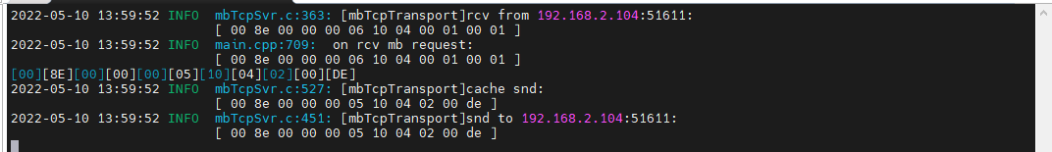



结果：与直读数据一致，22.20度。

### 当前湿度·2

1. 直读

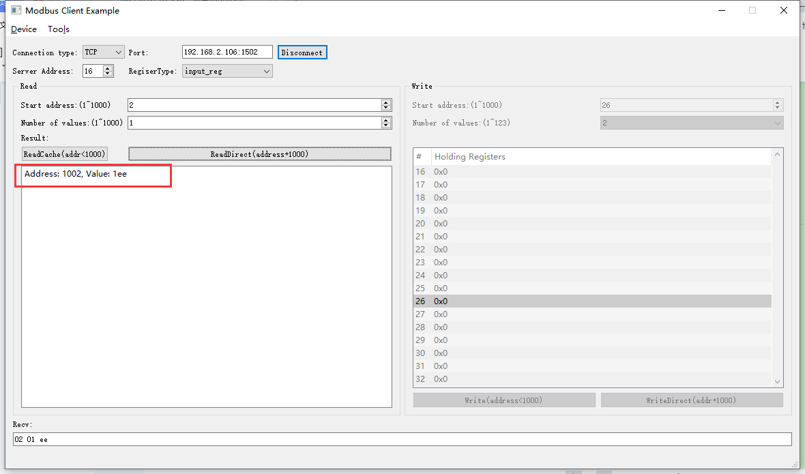2022-05-10 14:03:11 INFO mbTcpSvr.c:363: [mbTcpTransport]rcv from 192.168.2.104:51611:

[ 00 8f 00 00 00 06 10 04 03 ea 00 01 ]

2022-05-10 14:03:11 INFO main.cpp:709: on rcv mb request:

[ 00 8f 00 00 00 06 10 04 03 ea 00 01 ]

2022-05-10 14:03:11 INFO main.cpp:420: ---read 000047L1 start reg=30002, cnt=1

2022-05-10 14:03:11 INFO 7Fcom.cpp:251: gw7f cache snd:

topic:local/00000E97/000047L1/command

payload:{"cmd":"read","deviceKey":"000047L1","function":{"humidness":0},"sno":"6-16-4-143"}

2022-05-10 14:03:11 INFO main.cpp:153: insert modbus req 000047L1 csft=6-16-4-143

2022-05-10 14:03:11 INFO 7Fcom.cpp:517: gw7f onRcvProcess:

topic:local/00000E97/000047L1

payload:{"deviceKey":"000047L1","errorCode":0,"function":{"controller_addr":"00000E97","humidness":49.40},"sno":"6-16-4-143","statistics":{"timesOfContinuousFailed":0,"timesOfFailed":0,"timesOfSuccess":1063,"timesOfTotal":1063}}

2022-05-10 14:03:11 INFO mbTcpSvr.c:451: [mbTcpTransport]snd to 192.168.2.104:51611:

[ 00 8f 00 00 00 05 10 04 02 01 ee ]

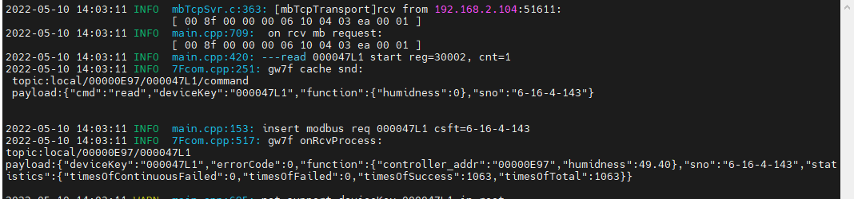

1. 读缓存

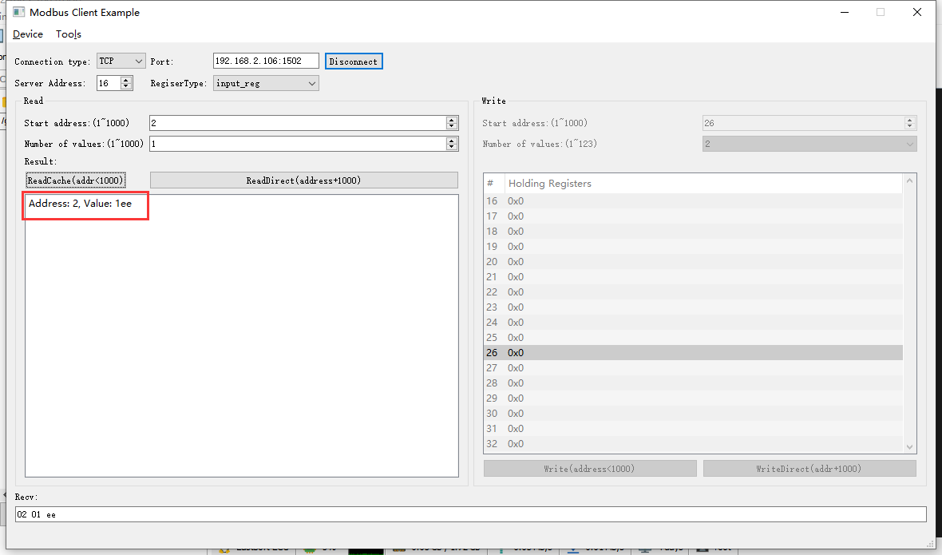2022-05-10 14:04:14 INFO mbTcpSvr.c:363: [mbTcpTransport]rcv from 192.168.2.104:51611:

[ 00 90 00 00 00 06 10 04 00 02 00 01 ]

2022-05-10 14:04:14 INFO main.cpp:709: on rcv mb request:

[ 00 90 00 00 00 06 10 04 00 02 00 01 ]

[00][90][00][00][00][05][10][04][02][01][EE]

2022-05-10 14:04:14 INFO mbTcpSvr.c:527: [mbTcpTransport]cache snd:

[ 00 90 00 00 00 05 10 04 02 01 ee ]

2022-05-10 14:04:14 INFO mbTcpSvr.c:451: [mbTcpTransport]snd to 192.168.2.104:51611:

[ 00 90 00 00 00 05 10 04 02 01 ee ]

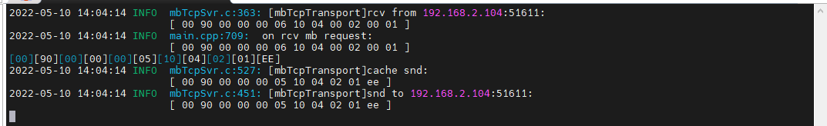

结果：直读，缓存，抄控器读取数据均一致。

### 低温保护告警·3

**测试方法：**使用抄控器校准逐步校准设备温度，使其满足进入低温告警的条件，然后直读、读缓存、抄控器读取设备状态做对比。

#### 告警时的读取

说明：使用抄控器进行校准后设备屏幕显示err06，说明进入了低温告警状态。

1. 抄控器读取



1. 直读

不支持读取

1. 读缓存

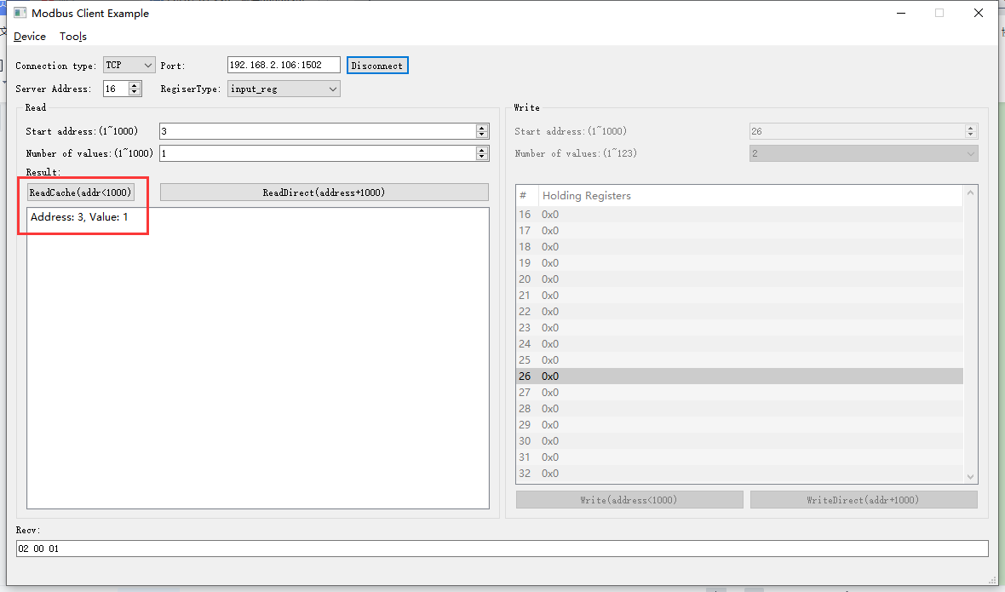2022-05-10 15:16:50 INFO mbTcpSvr.c:491: [mbTcpTransport]new connect from 192.168.2.104:53539,fd=6

2022-05-10 15:16:51 INFO mbTcpSvr.c:363: [mbTcpTransport]rcv from 192.168.2.104:53539:

[ 00 97 00 00 00 06 10 04 00 03 00 01 ]

2022-05-10 15:16:51 INFO main.cpp:709: on rcv mb request:

[ 00 97 00 00 00 06 10 04 00 03 00 01 ]

[00][97][00][00][00][05][10][04][02][00][01]

2022-05-10 15:16:51 INFO mbTcpSvr.c:527: [mbTcpTransport]cache snd:

[ 00 97 00 00 00 05 10 04 02 00 01 ]

2022-05-10 15:16:51 INFO mbTcpSvr.c:451: [mbTcpTransport]snd to 192.168.2.104:53539:

[ 00 97 00 00 00 05 10 04 02 00 01 ]

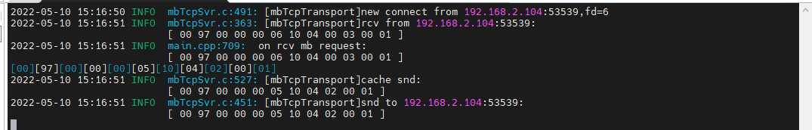

#### 非告警状态下的读取

**说明：**从告警状态转换到非告警状态。恢复设备温度，使其回复正常。

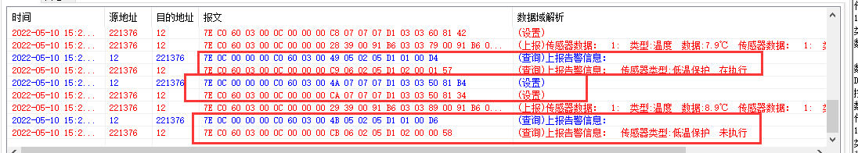

1. 抄控器读取



1. 读缓存

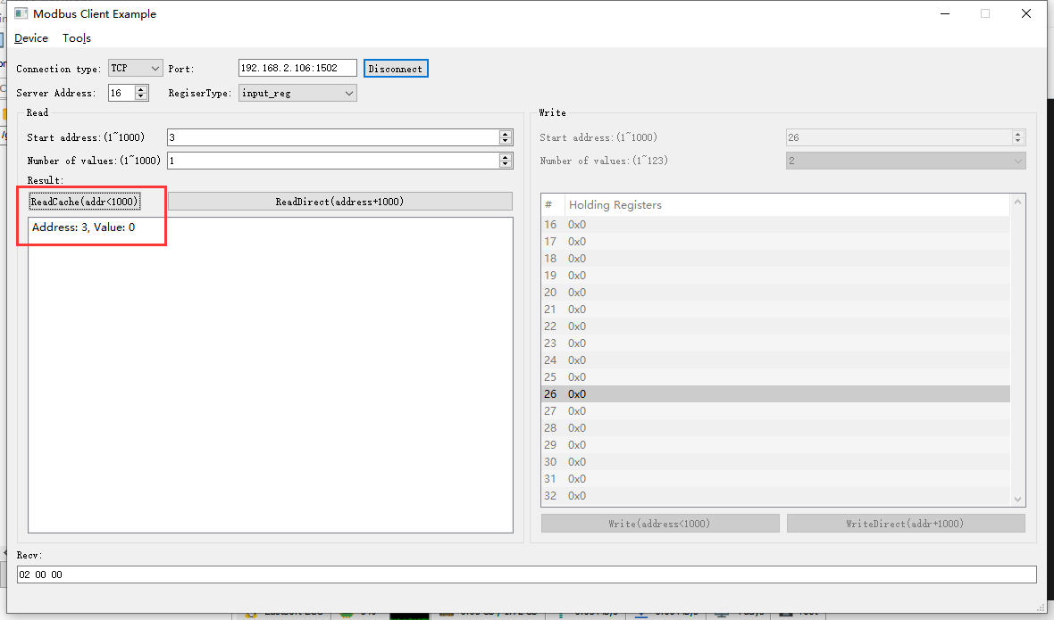

2022-05-10 15:23:28 INFO mbTcpSvr.c:363: [mbTcpTransport]rcv from 192.168.2.104:53539:

[ 00 98 00 00 00 06 10 04 00 03 00 01 ]

2022-05-10 15:23:28 INFO main.cpp:709: on rcv mb request:

[ 00 98 00 00 00 06 10 04 00 03 00 01 ]

[00][98][00][00][00][05][10][04][02][00][00]

2022-05-10 15:23:28 INFO mbTcpSvr.c:527: [mbTcpTransport]cache snd:

[ 00 98 00 00 00 05 10 04 02 00 00 ]

2022-05-10 15:23:28 INFO mbTcpSvr.c:451: [mbTcpTransport]snd to 192.168.2.104:53539:

[ 00 98 00 00 00 05 10 04 02 00 00 ]

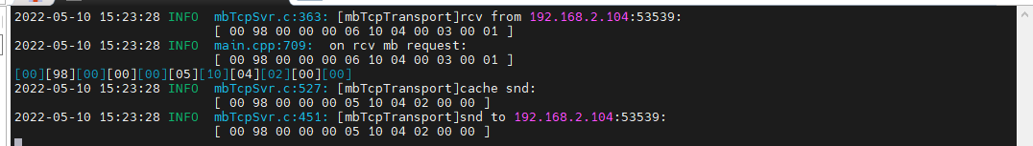

结果：读取到数据为0，即无告警上报。

1. 直读

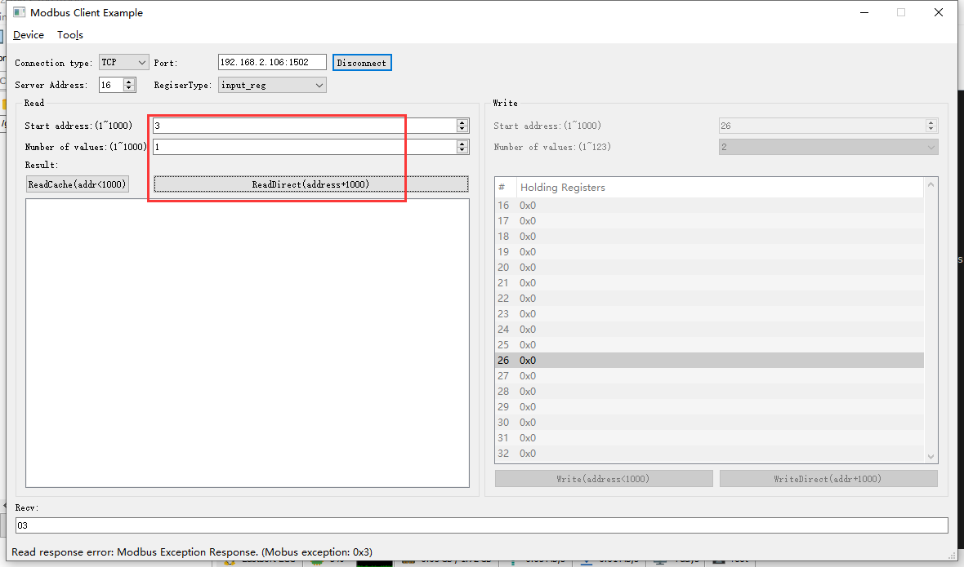2022-05-10 14:25:11 INFO mbTcpSvr.c:363: [mbTcpTransport]rcv from 192.168.2.104:51611:

[ 00 95 00 00 00 06 10 04 03 eb 00 01 ]

2022-05-10 14:25:11 INFO main.cpp:709: on rcv mb request:

[ 00 95 00 00 00 06 10 04 03 eb 00 01 ]

2022-05-10 14:25:11 INFO main.cpp:420: ---read 000047L1 start reg=30003, cnt=1

2022-05-10 14:25:11 INFO 7Fcom.cpp:251: gw7f cache snd:

topic:local/00000E97/000047L1/command

payload:{"alarm":{"low_temperature_protection":true},"cmd":"read","deviceKey":"000047L1","sno":"6-16-4-149"}

2022-05-10 14:25:11 INFO main.cpp:153: insert modbus req 000047L1 csft=6-16-4-149

2022-05-10 14:25:11 INFO 7Fcom.cpp:517: gw7f onRcvProcess:

topic:local/00000E97/000047L1

payload:{"deviceKey":"000047L1","errorCode":9,"function":{"controller_addr":"00000E97"},"sno":"6-16-4-149","statistics":{"timesOfContinuousFailed":0,"timesOfFailed":0,"timesOfSuccess":1066,"timesOfTotal":1066}}

2022-05-10 14:25:11 INFO mbTcpSvr.c:451: [mbTcpTransport]snd to 192.168.2.104:51611:

[ 00 95 00 00 00 03 10 84 03 ]

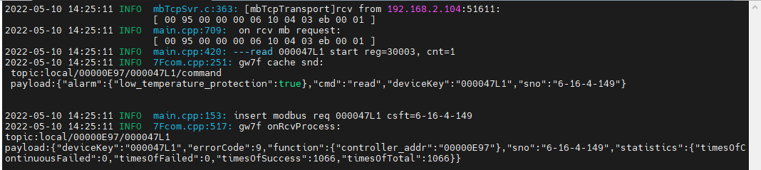

结果：直读返回错误。

### 传感器故障·4

说明：此传感器故障指的是设备本身的传感器，而非ntc传感器。

**测试方法：**直读、读缓存、抄控器读取设备状态做对比。

#### 告警状态

1. 抄控器读取D105 02



1. 读取缓存

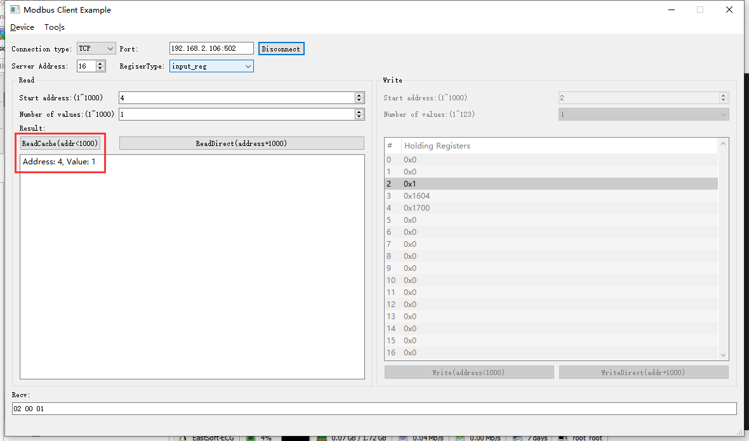

2022-05-13 14:00:21 INFO mbTcpSvr.c:363: [mbTcpTransport]rcv from 192.168.2.104:52505:

[ 00 d3 00 00 00 06 10 04 00 04 00 01 ]

2022-05-13 14:00:21 INFO main.cpp:709: on rcv mb request:

[ 00 d3 00 00 00 06 10 04 00 04 00 01 ]

[00][D3][00][00][00][05][10][04][02][00][01]

2022-05-13 14:00:21 INFO mbTcpSvr.c:527: [mbTcpTransport]cache snd:

[ 00 d3 00 00 00 05 10 04 02 00 01 ]

2022-05-13 14:00:21 INFO mbTcpSvr.c:451: [mbTcpTransport]snd to 192.168.2.104:52505:

[ 00 d3 00 00 00 05 10 04 02 00 01 ]

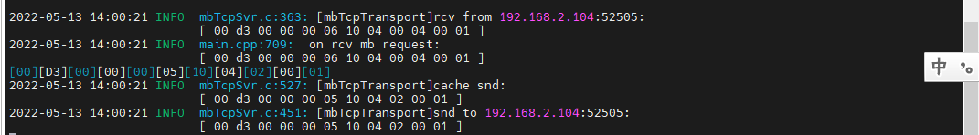

结果：读取到告警状态为1.

1. 直读

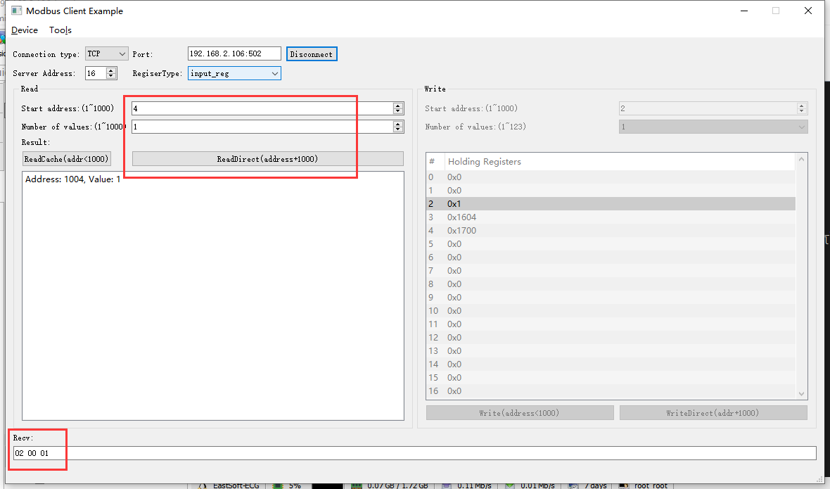

2022-05-13 13:55:36 INFO mbTcpSvr.c:363: [mbTcpTransport]rcv from 192.168.2.104:52505:

[ 00 d2 00 00 00 06 10 04 03 ec 00 01 ]

2022-05-13 13:55:36 INFO main.cpp:709: on rcv mb request:

[ 00 d2 00 00 00 06 10 04 03 ec 00 01 ]

2022-05-13 13:55:36 INFO main.cpp:420: ---read 000047L1 start reg=30004, cnt=1

2022-05-13 13:55:36 INFO 7Fcom.cpp:517: gw7f onRcvProcess:

topic:local/00000E97/000047L1

payload:{"alarm":{"sensor_fault":true},"cmd":"read","deviceKey":"000047L1","errorCode":0,"function":{"controller_addr":"00000E97"},"sno":"6-16-4-210","statistics":{"timesOfContinuousFailed":0,"timesOfFailed":0,"timesOfSuccess":11,"timesOfTotal":11}}

2022-05-13 13:55:36 INFO 7Fcom.cpp:517: gw7f onRcvProcess:

topic:local/00000E97/000047L1

payload:{"alarm":{"sensor_fault":true},"cmd":"read","deviceKey":"000047L1","errorCode":0,"function":{"controller_addr":"00000E97"},"sno":"6-16-4-210","statistics":{"timesOfContinuousFailed":0,"timesOfFailed":0,"timesOfSuccess":11,"timesOfTotal":11}}

2022-05-13 13:55:36 INFO mbTcpSvr.c:451: [mbTcpTransport]snd to 192.168.2.104:52505:

[ 00 d2 00 00 00 05 10 04 02 00 01 ]

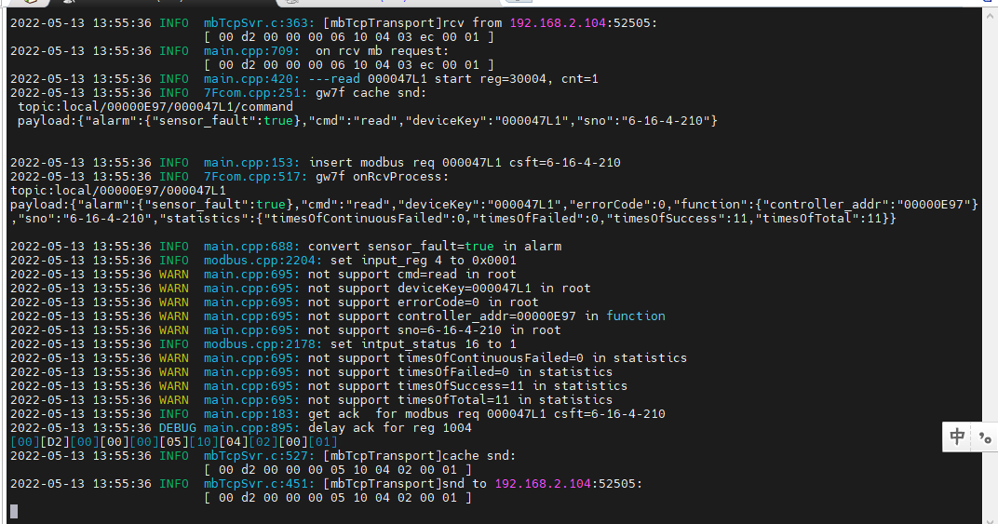

结果：直读状态与设备升级状态一致。

#### 非告警状态

1. 抄控器读取D105 02



1. 读取缓存

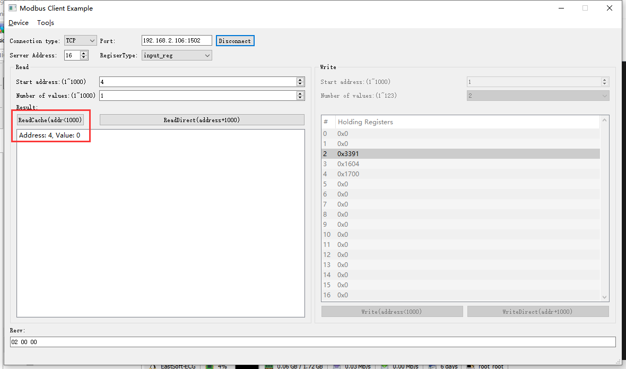

2022-05-13 10:55:26 INFO mbTcpSvr.c:363: [mbTcpTransport]rcv from 192.168.2.104:49499:

[ 00 a2 00 00 00 06 10 04 00 04 00 01 ]

2022-05-13 10:55:26 INFO main.cpp:709: on rcv mb request:

[ 00 a2 00 00 00 06 10 04 00 04 00 01 ]

[00][A2][00][00][00][05][10][04][02][00][00]

2022-05-13 10:55:26 INFO mbTcpSvr.c:527: [mbTcpTransport]cache snd:

[ 00 a2 00 00 00 05 10 04 02 00 00 ]

2022-05-13 10:55:26 INFO mbTcpSvr.c:451: [mbTcpTransport]snd to 192.168.2.104:49499:

[ 00 a2 00 00 00 05 10 04 02 00 00 ]

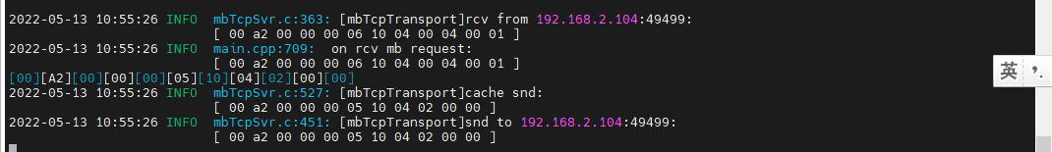

1. 直读

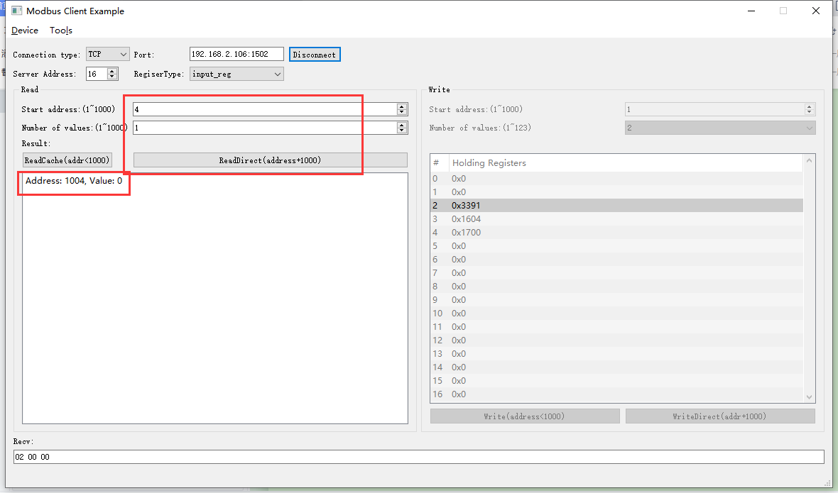

2022-05-13 10:53:01 INFO mbTcpSvr.c:363: [mbTcpTransport]rcv from 192.168.2.104:49499:

[ 00 a1 00 00 00 06 10 04 03 ec 00 01 ]

2022-05-13 10:53:01 INFO main.cpp:709: on rcv mb request:

[ 00 a1 00 00 00 06 10 04 03 ec 00 01 ]

2022-05-13 10:53:01 INFO main.cpp:420: ---read 000047L1 start reg=30004, cnt=1

2022-05-13 10:53:02 INFO 7Fcom.cpp:517: gw7f onRcvProcess:

topic:local/00000E97/000047L1

payload:{"alarm":{"sensor_fault":false},"cmd":"read","deviceKey":"000047L1","errorCode":0,"function":{"controller_addr":"00000E97"},"sno":"6-16-4-161","statistics":{"timesOfContinuousFailed":0,"timesOfFailed":0,"timesOfSuccess":6,"timesOfTotal":6}}

2022-05-13 10:53:02 INFO mbTcpSvr.c:451: [mbTcpTransport]snd to 192.168.2.104:49499:

[ 00 a1 00 00 00 05 10 04 02 00 00 ]

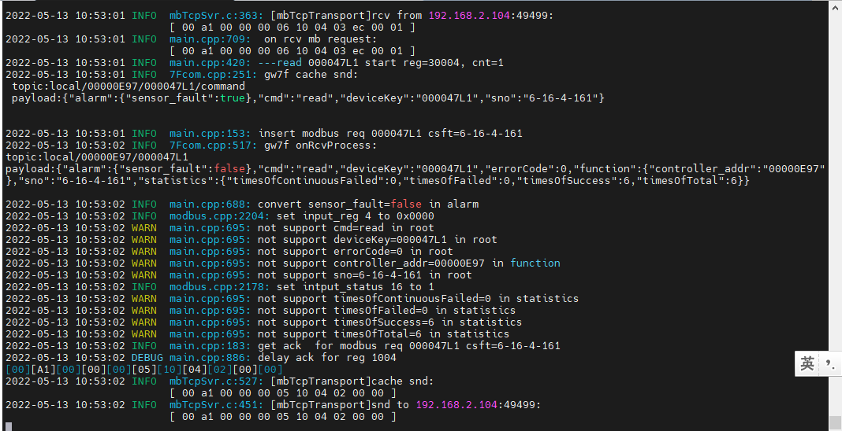

结果：直读回复00无告警，正常。

### 盘管传感器开路报警·5

注：计时联网温控器当前版本（ESTK-05-FC-CT-A(v1.0)-20220412）不支持读取如下图所示的数据标识。将在后续版本（ESTK-05-FC-CT-A(v1.0b)-20220414）中增加允许读取。

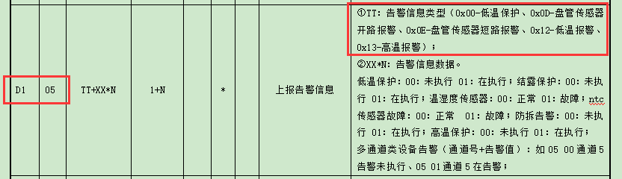

**测试方法：**直读、读缓存、抄控器读取设备状态做对比。

1. 设备配置

将设备配置为本地联动计费模式，同时未连接NTC传感器。



1. 抄控器读取

当设备显示err03时，说明开路报警启动，抄控器读取设备状态



设备向网关上报告警

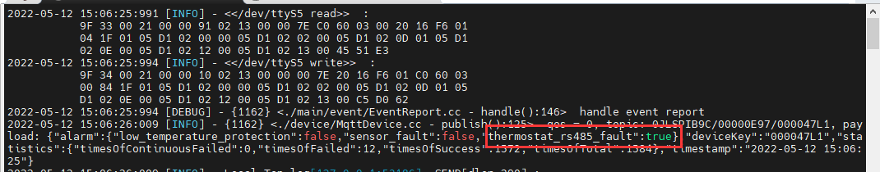

1. 直读

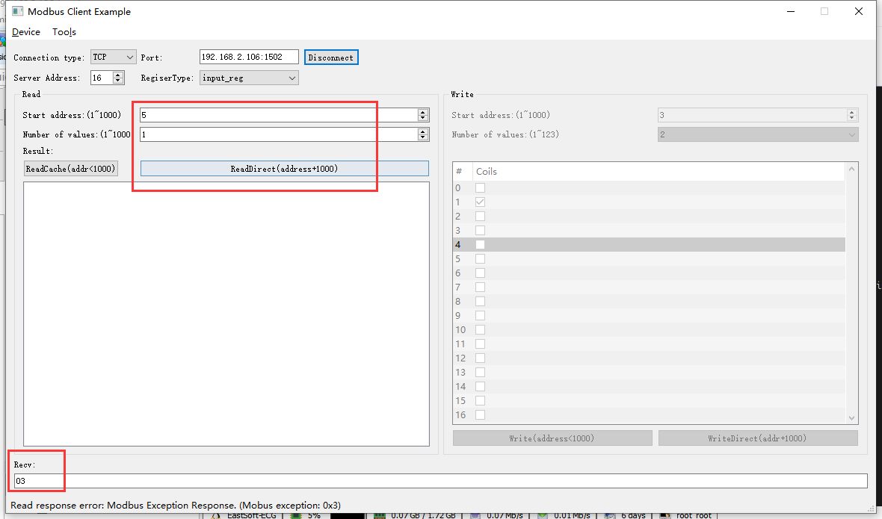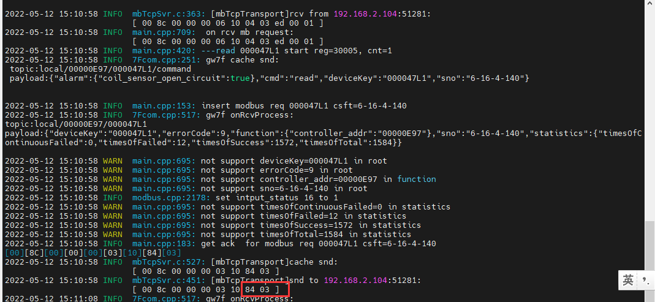

结果：直读回复错误

1. 读取缓存

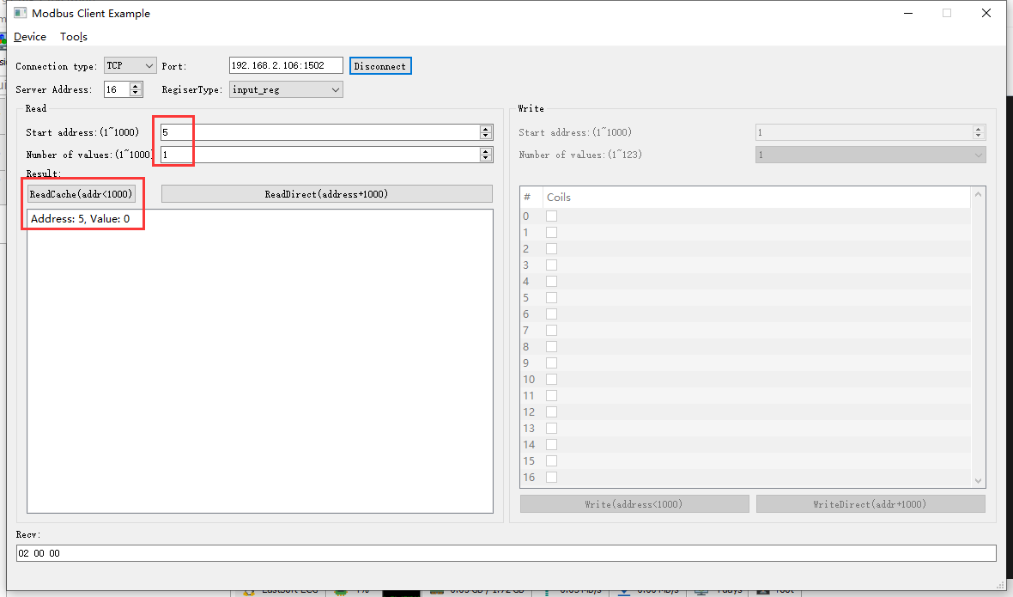2022-05-12 15:12:19 INFO mbTcpSvr.c:363: [mbTcpTransport]rcv from 192.168.2.104:51281:

[ 00 8d 00 00 00 06 10 04 00 05 00 01 ]

2022-05-12 15:12:19 INFO main.cpp:709: on rcv mb request:

[ 00 8d 00 00 00 06 10 04 00 05 00 01 ]

[00][8D][00][00][00][05][10][04][02][00][00]

2022-05-12 15:12:19 INFO mbTcpSvr.c:527: [mbTcpTransport]cache snd:

[ 00 8d 00 00 00 05 10 04 02 00 00 ]

2022-05-12 15:12:19 INFO mbTcpSvr.c:451: [mbTcpTransport]snd to 192.168.2.104:51281:

[ 00 8d 00 00 00 05 10 04 02 00 00 ]

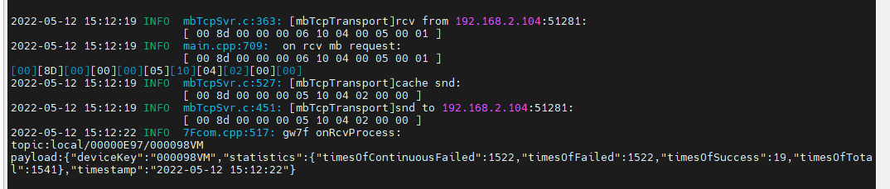

### 盘管传感器短路报警·6

注：计时联网温控器当前版本（ESTK-05-FC-CT-A(v1.0)-20220412）不支持读取如下图所示的数据标识。将在后续版本（ESTK-05-FC-CT-A(v1.0b)-20220414）中增加允许读取。



**测试方法：**直读、读缓存、抄控器读取设备状态做对比。

告警时的读取

非告警状态下的读取

### 低温报警·7

注：计时联网温控器当前版本（ESTK-05-FC-CT-A(v1.0)-20220412）不支持读取如下图所示的数据标识。将在后续版本（ESTK-05-FC-CT-A(v1.0b)-20220414）中增加允许读取。



**测试方法：**直读、读缓存、抄控器读取设备状态做对比。

读取缓存

### 高温告警·8

注：计时联网温控器当前版本（ESTK-05-FC-CT-A(v1.0)-20220412）不支持读取如下图所示的数据标识。将在后续版本（ESTK-05-FC-CT-A(v1.0b)-20220414）中增加允许读取。



**测试方法：**直读、读缓存、抄控器读取设备状态做对比。

告警时的读取

非告警状态下的读取

### 计费告警·9

注：计费告警是平台下发的状态，无上报。计时联网温控器当前版本（ESTK-05-FC-CT-A(v1.0)-20220412）不支持读取如下图所示的数据标识。将在后续版本（ESTK-05-FC-CT-A(v1.0b)-20220414）中增加允许读取。



# 四寸智能终端ok

**说明：**根据转换程序锁支持的设备，典型选取一种测试。

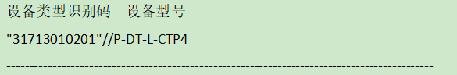

**寄存器定义：**

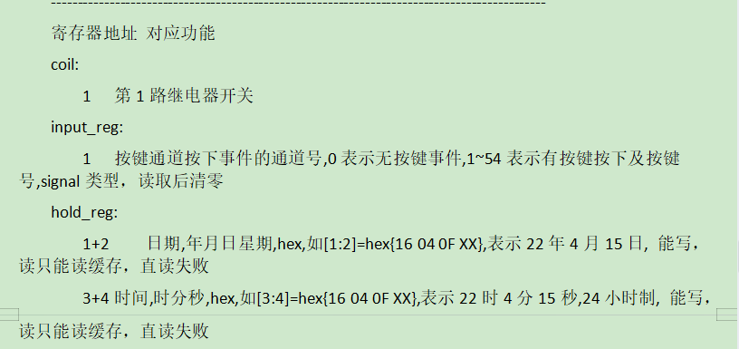

**说明：**先添加设备到网关，修改map.json文件，进行测试。

查询设备modbus地址--17，设备类型31713010201，添加完成后启动线程，正常情况下，程序可找到设备

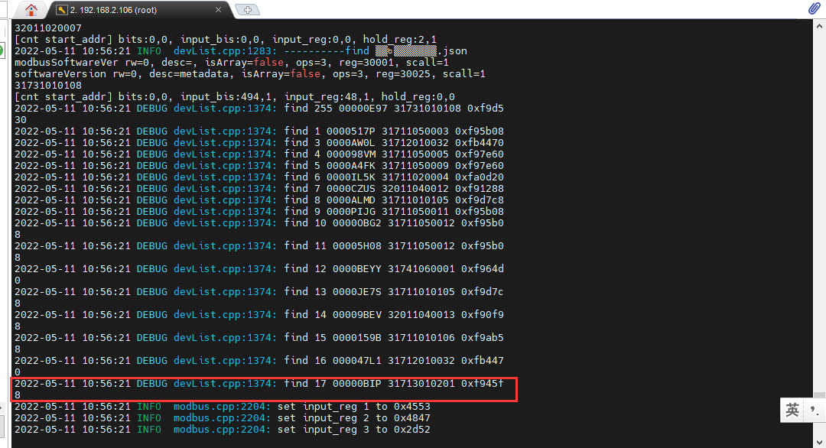

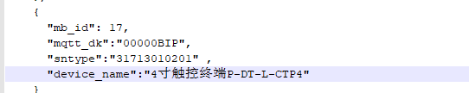

## 继电器控制

**寄存器定义：**



### 继电器开

1. 写开

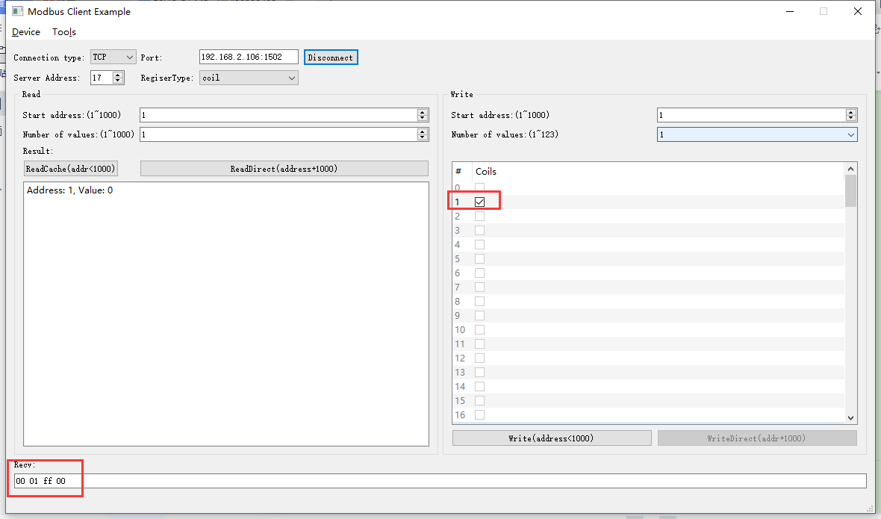2022-05-11 11:06:40 INFO mbTcpSvr.c:363: [mbTcpTransport]rcv from 192.168.2.104:53052:

[ 00 10 00 00 00 06 11 05 00 01 ff 00 ]

2022-05-11 11:06:40 INFO main.cpp:709: on rcv mb request:

[ 00 10 00 00 00 06 11 05 00 01 ff 00 ]

2022-05-11 11:06:40 INFO main.cpp:420: ---write 00000BIP start reg=1, cnt=1

2022-05-11 11:06:40 DEBUG main.cpp:496: write coil[1] to 0x0101

2022-05-11 11:06:40 INFO 7Fcom.cpp:517: gw7f onRcvProcess:

topic:local/00000E97/00000BIP

payload:{"deviceKey":"00000BIP","errorCode":0,"function":{"controller_addr":"00000E97","switch_ch1":true},"sno":"6-17-5-16","statistics":{"timesOfContinuousFailed":0,"timesOfFailed":0,"timesOfSuccess":14,"timesOfTotal":14}}

2022-05-11 11:06:40 INFO mbTcpSvr.c:451: [mbTcpTransport]snd to 192.168.2.104:53052:

[ 00 10 00 00 00 06 11 05 00 01 ff 00 ]

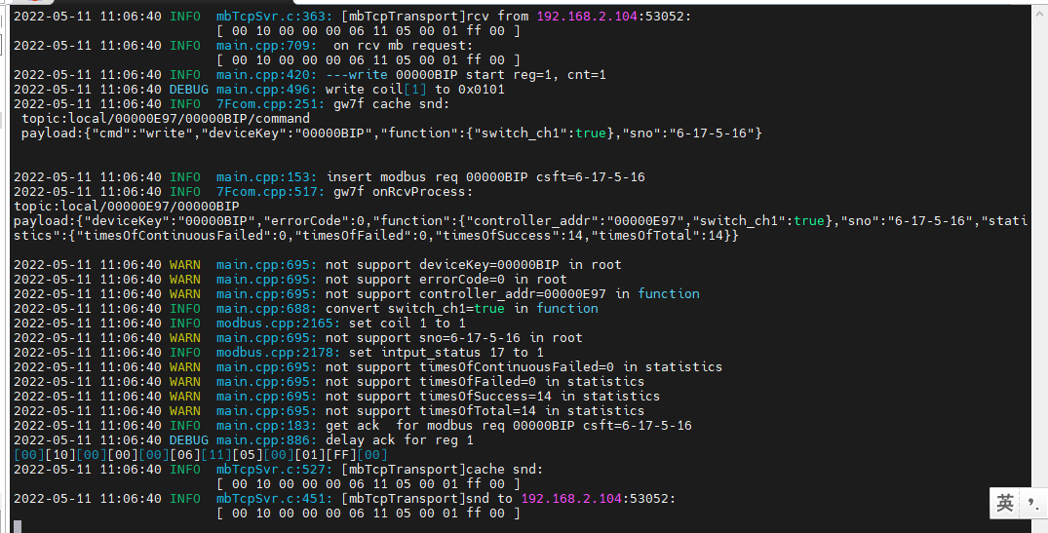

1. 直读继电器

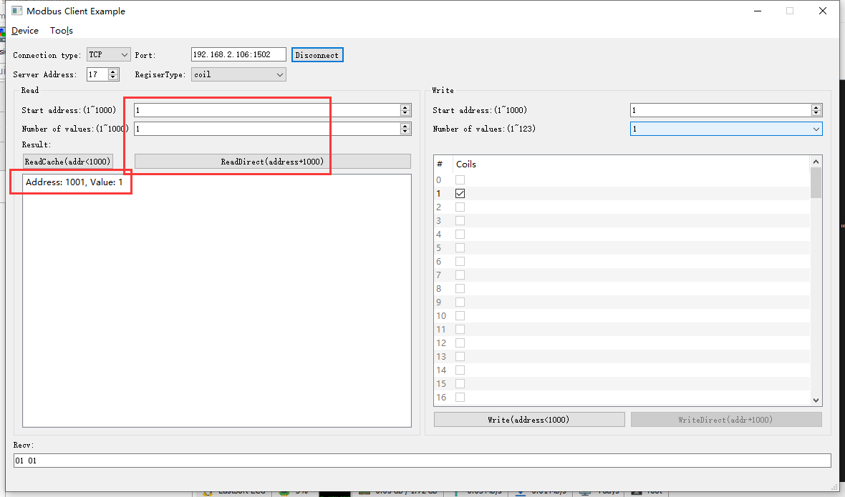2022-05-11 11:08:39 INFO mbTcpSvr.c:363: [mbTcpTransport]rcv from 192.168.2.104:53052:

[ 00 11 00 00 00 06 11 01 03 e9 00 01 ]

2022-05-11 11:08:39 INFO main.cpp:709: on rcv mb request:

[ 00 11 00 00 00 06 11 01 03 e9 00 01 ]

2022-05-11 11:08:39 INFO main.cpp:420: ---read 00000BIP start reg=1, cnt=1

2022-05-11 11:08:39 INFO 7Fcom.cpp:517: gw7f onRcvProcess:

topic:local/00000E97/00000BIP

payload:{"deviceKey":"00000BIP","errorCode":0,"function":{"controller_addr":"00000E97","switch_ch1":true},"sno":"6-17-1-17","statistics":{"timesOfContinuousFailed":0,"timesOfFailed":0,"timesOfSuccess":15,"timesOfTotal":15}}

2022-05-11 11:08:39 INFO mbTcpSvr.c:451: [mbTcpTransport]snd to 192.168.2.104:53052:

[ 00 11 00 00 00 04 11 01 01 01 ]

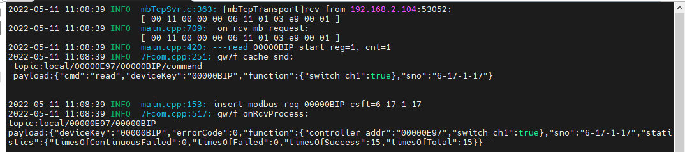

结果：读取为01，与实际状态一致。

1. 读取缓存

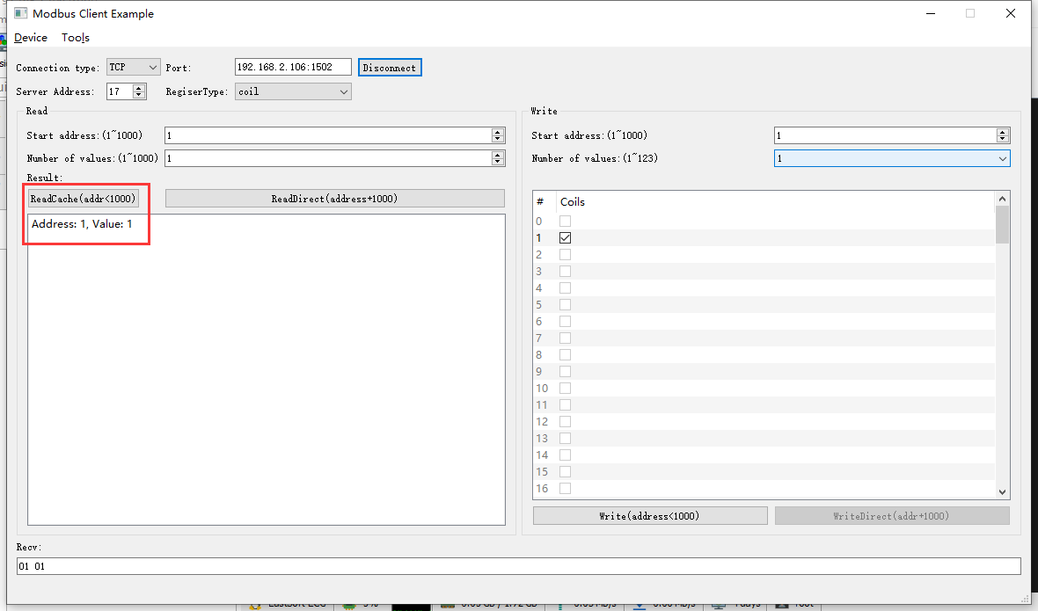2022-05-11 11:11:10 INFO mbTcpSvr.c:363: [mbTcpTransport]rcv from 192.168.2.104:53052:

[ 00 12 00 00 00 06 11 01 00 01 00 01 ]

2022-05-11 11:11:10 INFO main.cpp:709: on rcv mb request:

[ 00 12 00 00 00 06 11 01 00 01 00 01 ]

[00][12][00][00][00][04][11][01][01][01]

2022-05-11 11:11:10 INFO mbTcpSvr.c:527: [mbTcpTransport]cache snd:

[ 00 12 00 00 00 04 11 01 01 01 ]

2022-05-11 11:11:10 INFO mbTcpSvr.c:451: [mbTcpTransport]snd to 192.168.2.104:53052:

[ 00 12 00 00 00 04 11 01 01 01 ]

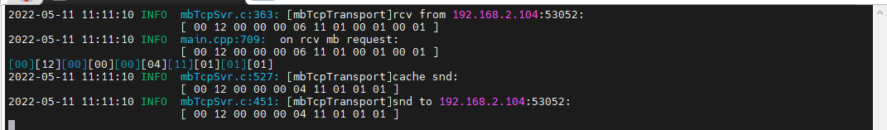结果：读取为01，与实际状态一致。

### 继电器关

1. 写关

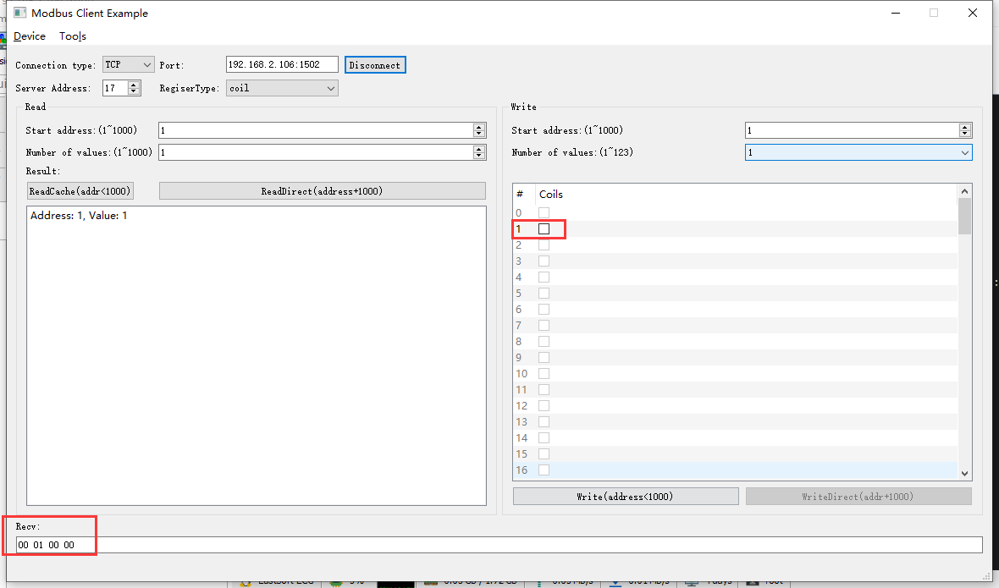2022-05-11 11:12:05 INFO mbTcpSvr.c:363: [mbTcpTransport]rcv from 192.168.2.104:53052:

[ 00 13 00 00 00 06 11 05 00 01 00 00 ]

2022-05-11 11:12:05 INFO main.cpp:709: on rcv mb request:

[ 00 13 00 00 00 06 11 05 00 01 00 00 ]

2022-05-11 11:12:05 INFO main.cpp:420: ---write 00000BIP start reg=1, cnt=1

2022-05-11 11:12:05 DEBUG main.cpp:496: write coil[1] to 0x0000

2022-05-11 11:12:05 INFO 7Fcom.cpp:517: gw7f onRcvProcess:

topic:local/00000E97/00000BIP

payload:{"deviceKey":"00000BIP","errorCode":0,"function":{"controller_addr":"00000E97","switch_ch1":false},"sno":"6-17-5-19","statistics":{"timesOfContinuousFailed":0,"timesOfFailed":0,"timesOfSuccess":16,"timesOfTotal":16}}

2022-05-11 11:12:05 INFO mbTcpSvr.c:451: [mbTcpTransport]snd to 192.168.2.104:53052:

[ 00 13 00 00 00 06 11 05 00 01 00 00 ]

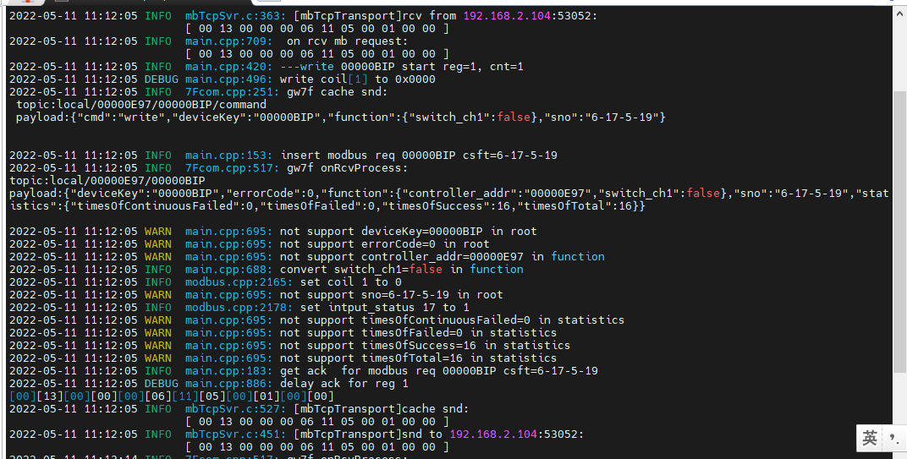

1. 直读继电器

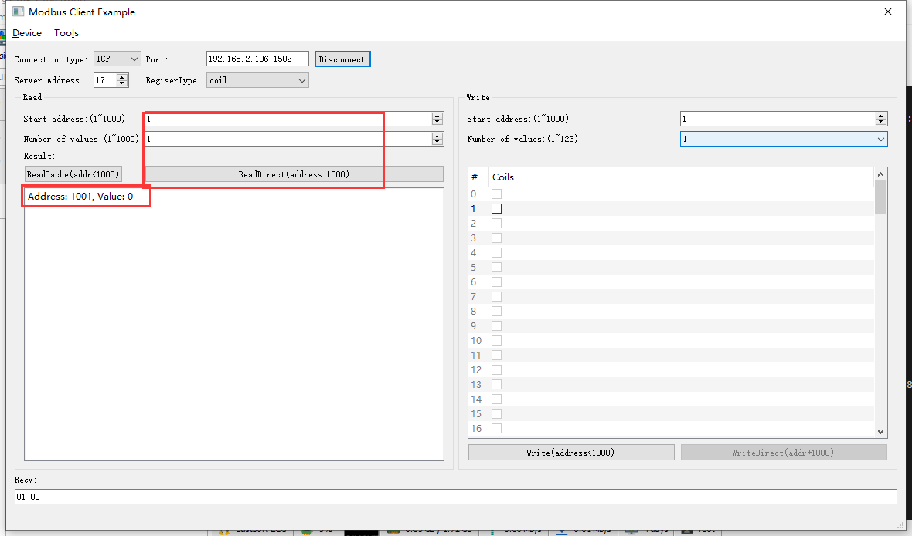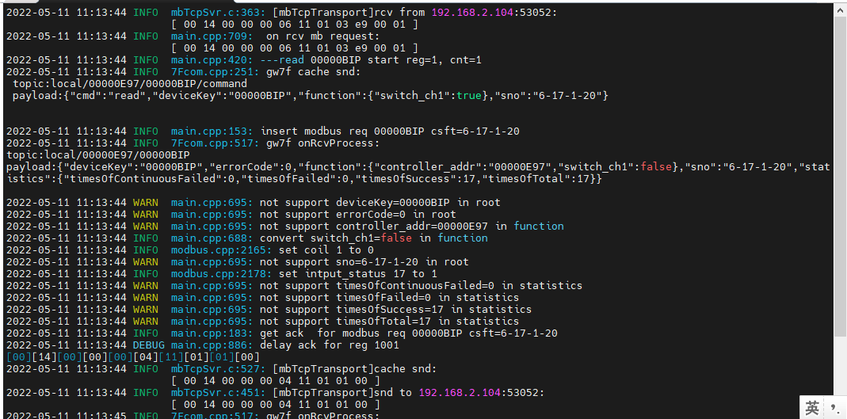

结果：读取值与实际一致。

## 按键按下事件

**寄存器定义：**

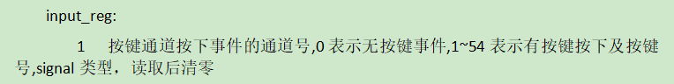

**测试方法（暂时）：**通过手机APP配置4寸触控终端多种按键类型，然后读取配置及按键触发信号。

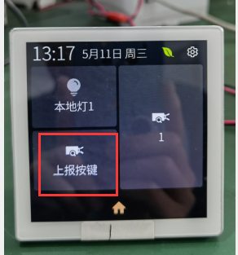

点击设备触发上报

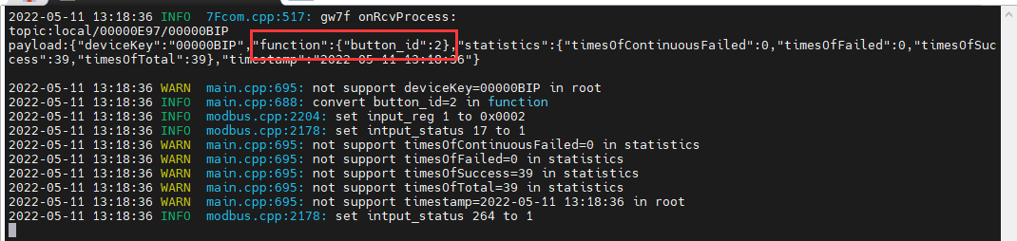

读取缓存

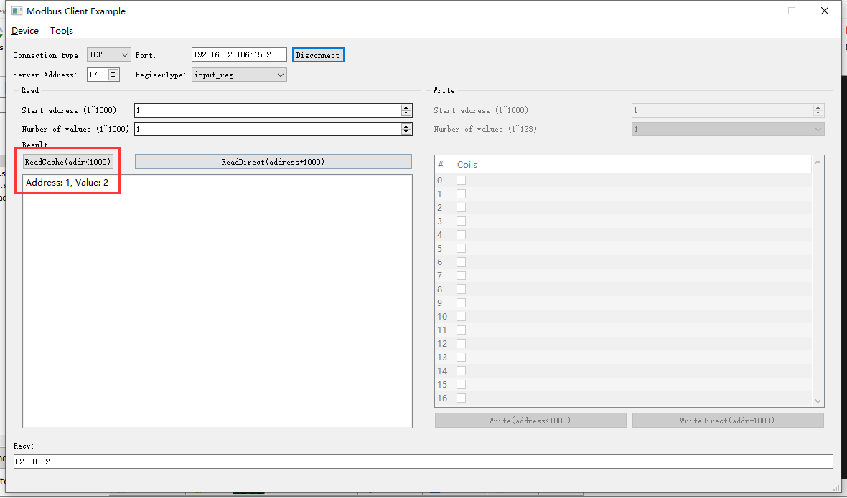2022-05-11 13:19:07 INFO mbTcpSvr.c:363: [mbTcpTransport]rcv from 192.168.2.104:55147:

[ 00 27 00 00 00 06 11 04 00 01 00 01 ]

2022-05-11 13:19:07 INFO main.cpp:709: on rcv mb request:

[ 00 27 00 00 00 06 11 04 00 01 00 01 ]

2022-05-11 13:19:07 INFO main.cpp:237: clear signal reg 1 after read

[00][27][00][00][00][05][11][04][02][00][02]

2022-05-11 13:19:07 INFO mbTcpSvr.c:527: [mbTcpTransport]cache snd:

[ 00 27 00 00 00 05 11 04 02 00 02 ]

2022-05-11 13:19:07 INFO mbTcpSvr.c:451: [mbTcpTransport]snd to 192.168.2.104:55147:

[ 00 27 00 00 00 05 11 04 02 00 02 ]

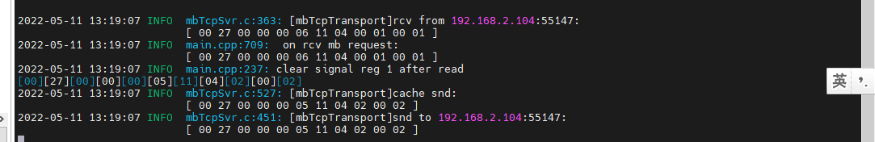

直读

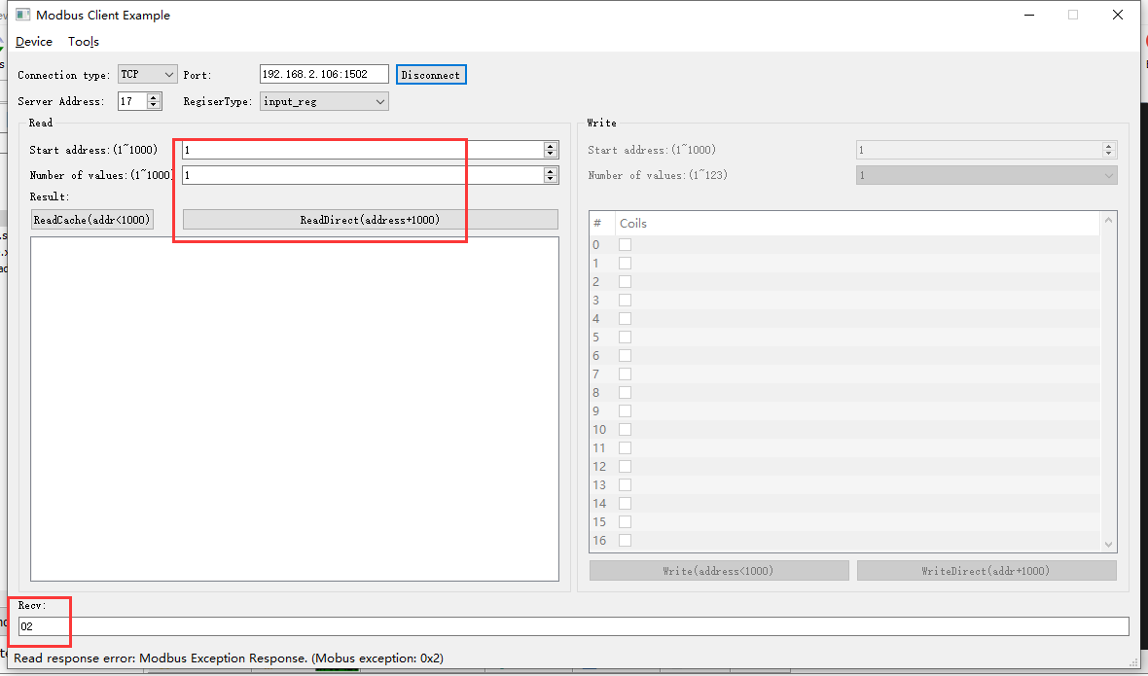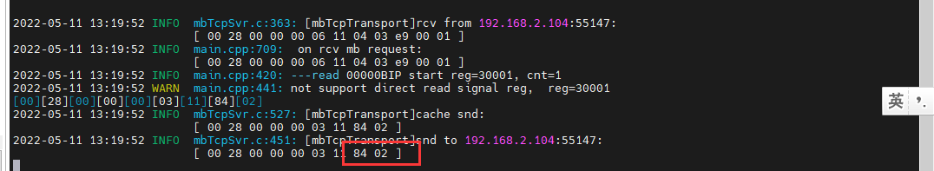

结果：回复错误。

再次读取缓存清零

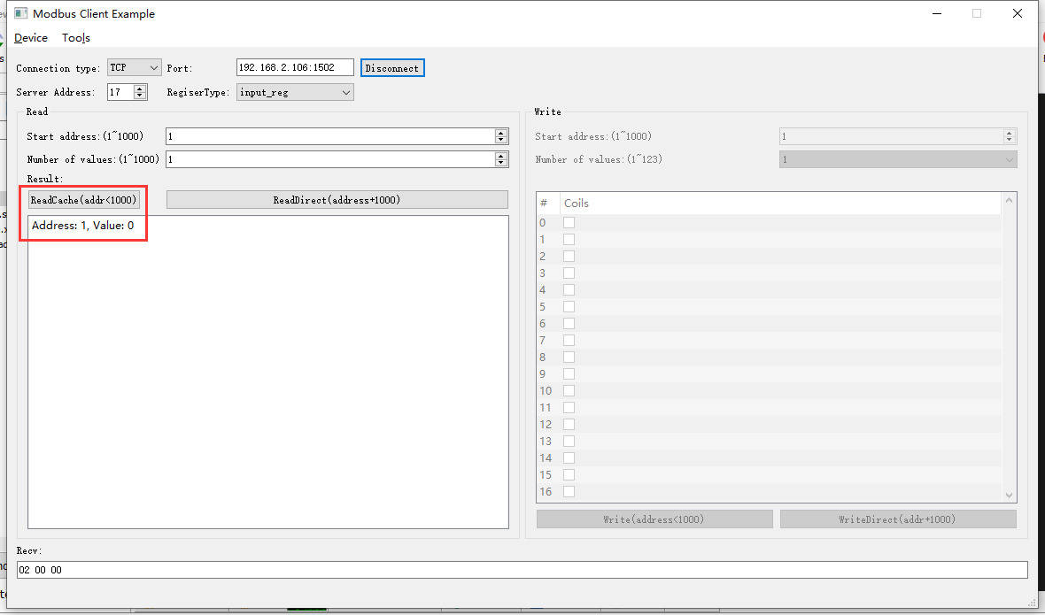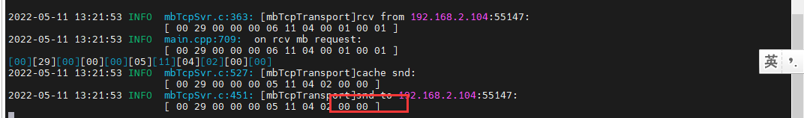

## 日期

**协议说明：**

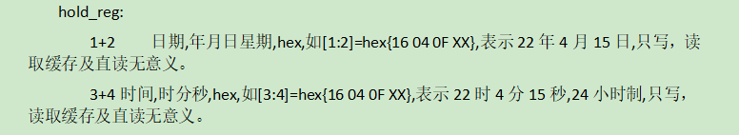

注意：4寸触控终端设备端日期、时间不支持读取。

### 读取日期

1. 读取缓存

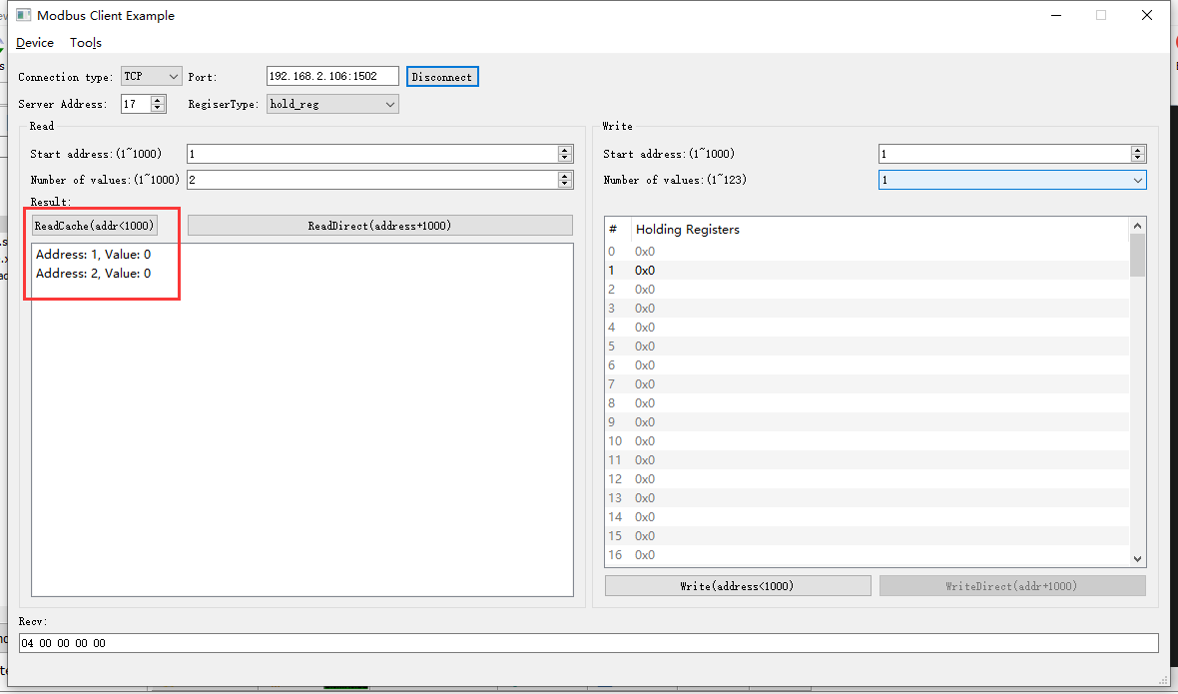2022-05-11 13:33:27 INFO mbTcpSvr.c:363: [mbTcpTransport]rcv from 192.168.2.104:55147:

[ 00 3b 00 00 00 06 11 03 00 01 00 02 ]

2022-05-11 13:33:27 INFO main.cpp:709: on rcv mb request:

[ 00 3b 00 00 00 06 11 03 00 01 00 02 ]

[00][3B][00][00][00][07][11][03][04][00][00][00][00]

2022-05-11 13:33:27 INFO mbTcpSvr.c:527: [mbTcpTransport]cache snd:

[ 00 3b 00 00 00 07 11 03 04 00 00 00 00 ]

2022-05-11 13:33:27 INFO mbTcpSvr.c:451: [mbTcpTransport]snd to 192.168.2.104:55147:

[ 00 3b 00 00 00 07 11 03 04 00 00 00 00 ]

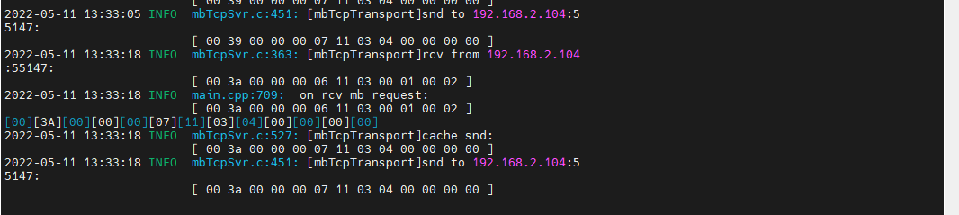

问题:读取缓存时间为0

1. 直读

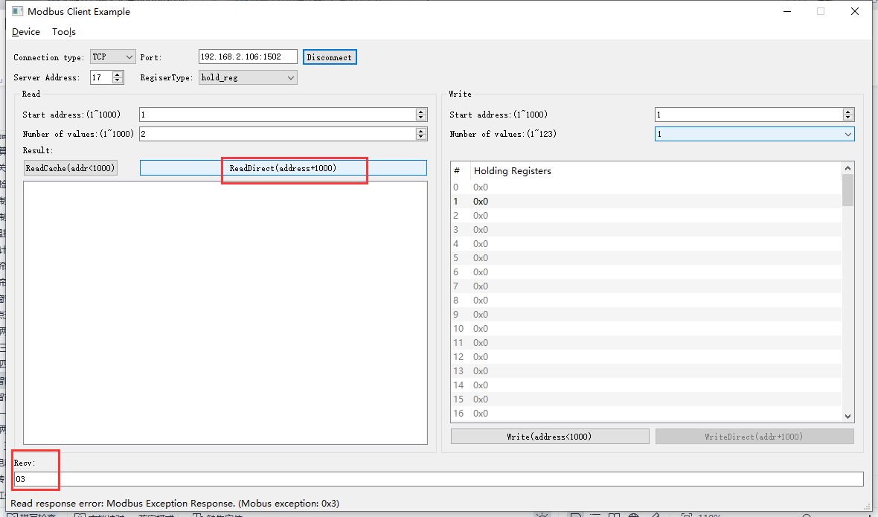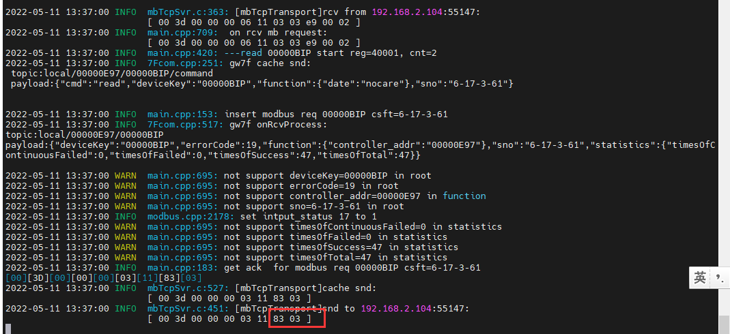

结果：直读提示错误。

### 读取不正确日期寄存器



#### 读取1-3

#### 读取2-3

#### 读取1

#### 读取2

### 写入日期

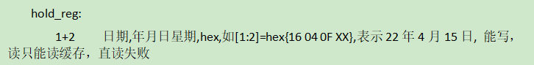

#### 写入

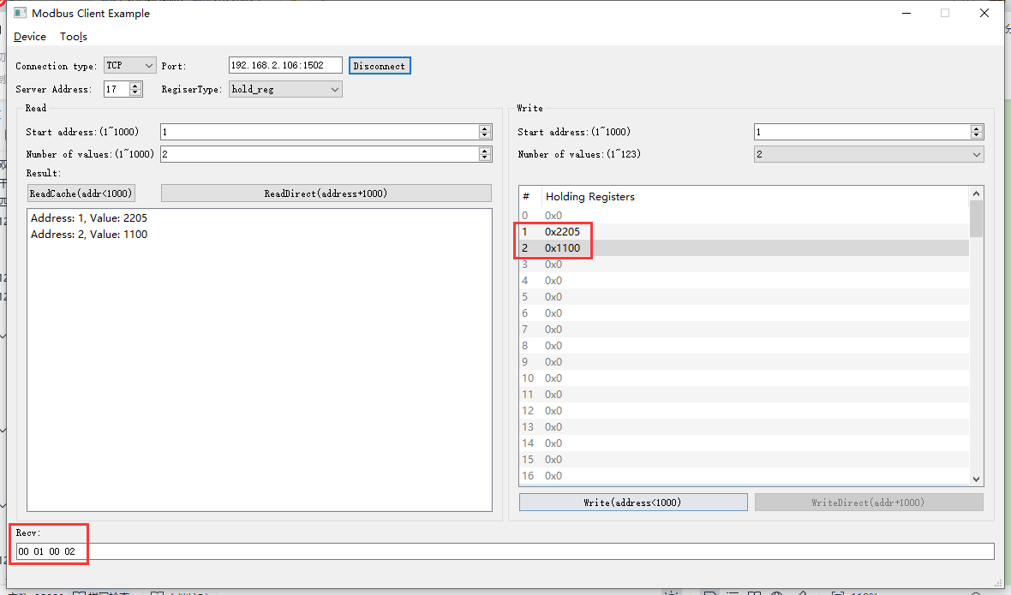2022-05-11 13:47:54 INFO mbTcpSvr.c:363: [mbTcpTransport]rcv from 192.168.2.104:55147:

[ 00 57 00 00 00 0b 11 10 00 01 00 02 04 22 05 11 00 ]

2022-05-11 13:47:54 INFO main.cpp:709: on rcv mb request:

[ 00 57 00 00 00 0b 11 10 00 01 00 02 04 22 05 11 00 ]

2022-05-11 13:47:54 INFO main.cpp:420: ---write 00000BIP start reg=40001, cnt=2

2022-05-11 13:47:54 DEBUG main.cpp:525: write reg 40001 to:[hex]

[ 22 05 11 00 ]

2022-05-11 13:47:54 INFO 7Fcom.cpp:517: gw7f onRcvProcess:

topic:local/00000E97/00000BIP

payload:{"deviceKey":"00000BIP","errorCode":0,"function":{"controller_addr":"00000E97","date":"34-05-17"},"sno":"6-17-16-87","statistics":{"timesOfContinuousFailed":0,"timesOfFailed":0,"timesOfSuccess":56,"timesOfTotal":56}}

2022-05-11 13:47:54 INFO mbTcpSvr.c:451: [mbTcpTransport]snd to 192.168.2.104:55147:

[ 00 57 00 00 00 06 11 10 00 01 00 02 ]

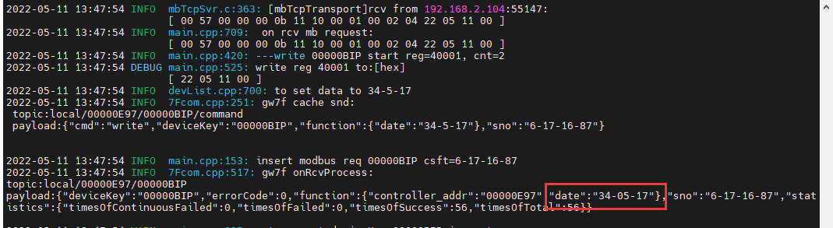

结果：写入成功。

#### 直读

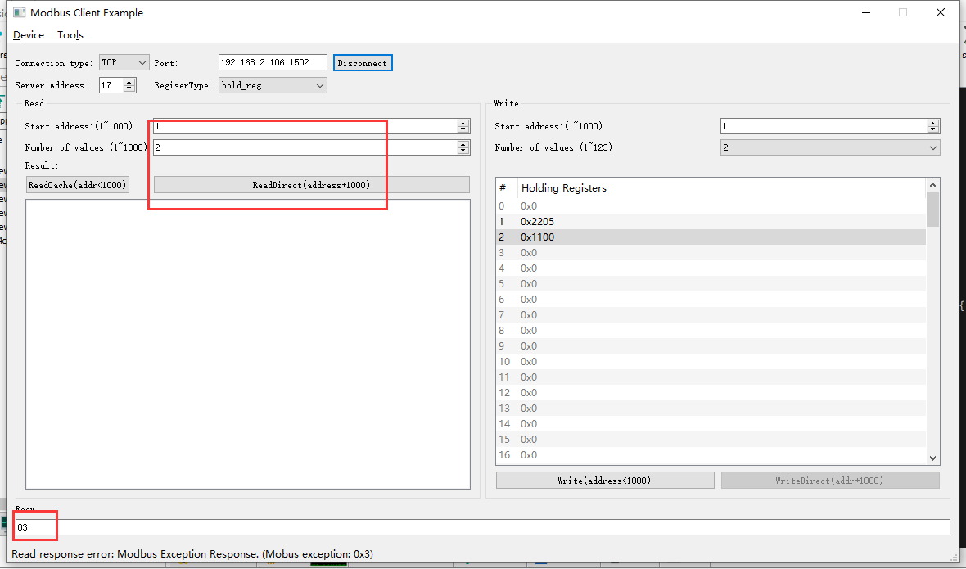2022-05-11 13:50:15 INFO mbTcpSvr.c:363: [mbTcpTransport]rcv from 192.168.2.104:55147:

[ 00 58 00 00 00 06 11 03 03 e9 00 02 ]

2022-05-11 13:50:15 INFO main.cpp:709: on rcv mb request:

[ 00 58 00 00 00 06 11 03 03 e9 00 02 ]

2022-05-11 13:50:15 INFO main.cpp:420: ---read 00000BIP start reg=40001, cnt=2

2022-05-11 13:50:15 INFO 7Fcom.cpp:517: gw7f onRcvProcess:

topic:local/00000E97/00000BIP

payload:{"deviceKey":"00000BIP","errorCode":19,"function":{"controller_addr":"00000E97"},"sno":"6-17-3-88","statistics":{"timesOfContinuousFailed":0,"timesOfFailed":0,"timesOfSuccess":57,"timesOfTotal":57}}

2022-05-11 13:50:15 INFO mbTcpSvr.c:451: [mbTcpTransport]snd to 192.168.2.104:55147:

[ 00 58 00 00 00 03 11 83 03 ]

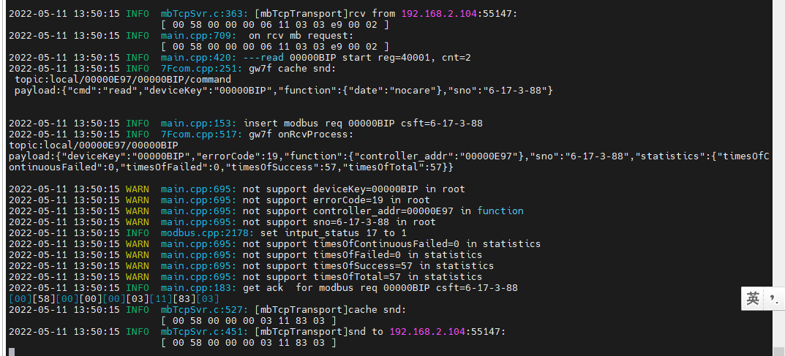

结果：直读时异常，网关回复err19，did不支持。

#### 读缓存

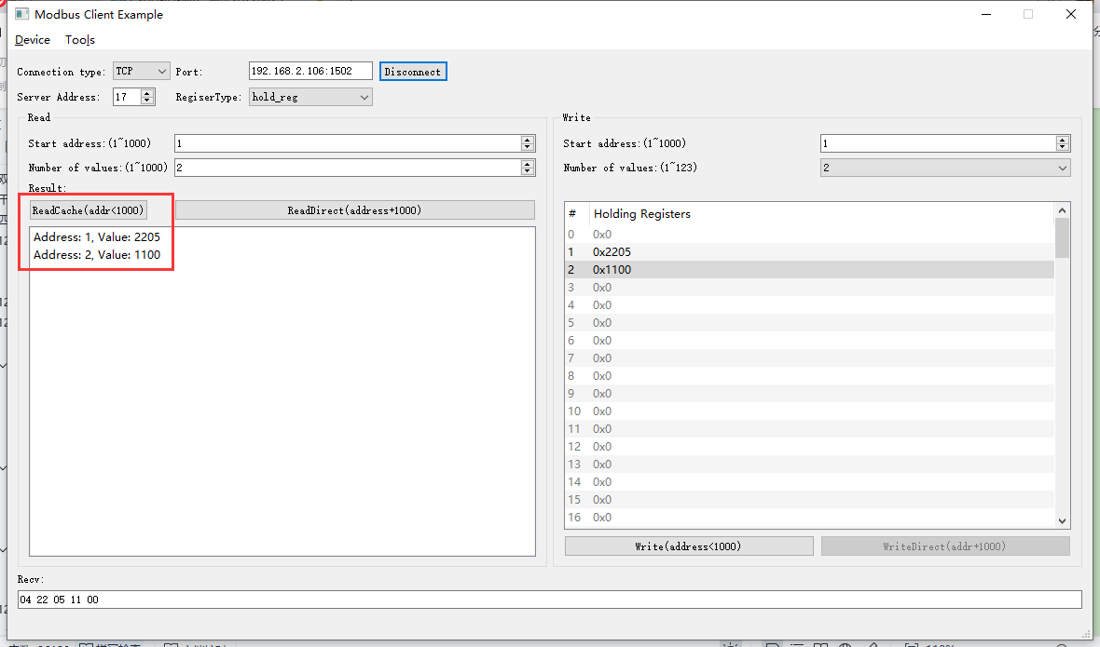2022-05-11 13:53:02 INFO mbTcpSvr.c:363: [mbTcpTransport]rcv from 192.168.2.104:55147:

[ 00 59 00 00 00 06 11 03 00 01 00 02 ]

2022-05-11 13:53:02 INFO main.cpp:709: on rcv mb request:

[ 00 59 00 00 00 06 11 03 00 01 00 02 ]

[00][59][00][00][00][07][11][03][04][22][05][11][00]

2022-05-11 13:53:02 INFO mbTcpSvr.c:527: [mbTcpTransport]cache snd:

[ 00 59 00 00 00 07 11 03 04 22 05 11 00 ]

2022-05-11 13:53:02 INFO mbTcpSvr.c:451: [mbTcpTransport]snd to 192.168.2.104:55147:

[ 00 59 00 00 00 07 11 03 04 22 05 11 00 ]

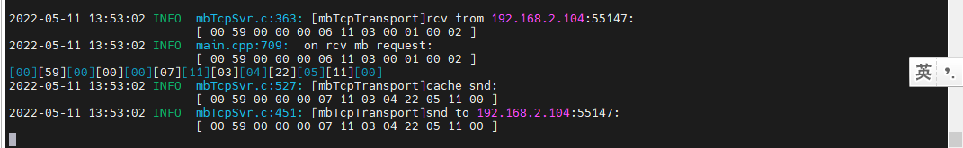

### 写入不存在的日期

#### 写入

#### 直读

## 时间

注意：4寸触控终端设备端日期、时间不支持读取。

**寄存器定义：**



### 读取不正确时间寄存器

#### 读取时间

1. 直读

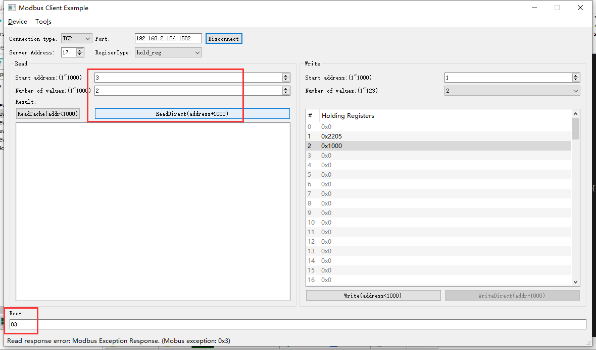2022-05-11 14:00:16 INFO mbTcpSvr.c:363: [mbTcpTransport]rcv from 192.168.2.104:55147:

[ 00 5e 00 00 00 06 11 03 03 eb 00 02 ]

2022-05-11 14:00:16 INFO main.cpp:709: on rcv mb request:

[ 00 5e 00 00 00 06 11 03 03 eb 00 02 ]

2022-05-11 14:00:16 INFO main.cpp:420: ---read 00000BIP start reg=40003, cnt=2

2022-05-11 14:00:16 INFO 7Fcom.cpp:517: gw7f onRcvProcess:

topic:local/00000E97/00000BIP

payload:{"deviceKey":"00000BIP","errorCode":19,"function":{"controller_addr":"00000E97"},"sno":"6-17-3-94","statistics":{"timesOfContinuousFailed":0,"timesOfFailed":0,"timesOfSuccess":60,"timesOfTotal":60}}

2022-05-11 14:00:16 INFO mbTcpSvr.c:451: [mbTcpTransport]snd to 192.168.2.104:55147:

[ 00 5e 00 00 00 03 11 83 03 ]

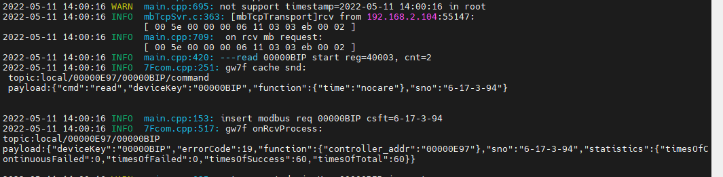

结果：设备端不支持读取时间

1. 读取缓存

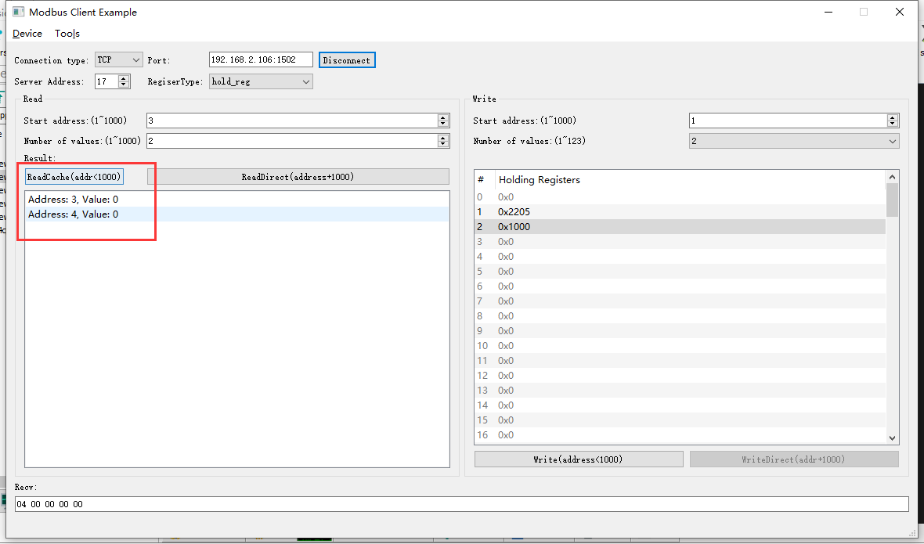2022-05-11 14:02:34 INFO mbTcpSvr.c:363: [mbTcpTransport]rcv from 192.168.2.104:55147:

[ 00 5f 00 00 00 06 11 03 00 03 00 02 ]

2022-05-11 14:02:34 INFO main.cpp:709: on rcv mb request:

[ 00 5f 00 00 00 06 11 03 00 03 00 02 ]

[00][5F][00][00][00][07][11][03][04][00][00][00][00]

2022-05-11 14:02:34 INFO mbTcpSvr.c:527: [mbTcpTransport]cache snd:

[ 00 5f 00 00 00 07 11 03 04 00 00 00 00 ]

2022-05-11 14:02:34 INFO mbTcpSvr.c:451: [mbTcpTransport]snd to 192.168.2.104:55147:

[ 00 5f 00 00 00 07 11 03 04 00 00 00 00 ]

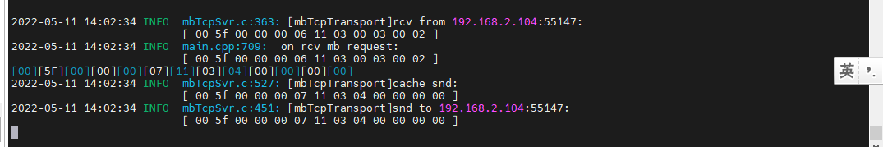

#### 读取8-9

#### 读取10-11

#### 读取9-11

### 写入时间



#### 写入

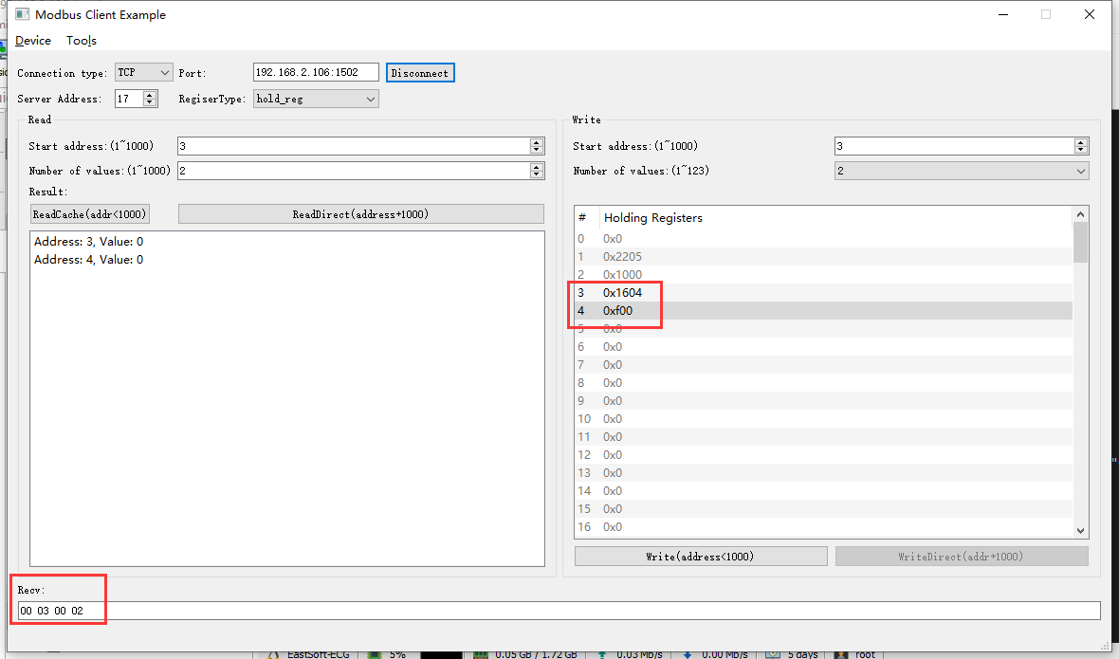2022-05-11 14:07:33 INFO mbTcpSvr.c:363: [mbTcpTransport]rcv from 192.168.2.104:55147:

[ 00 61 00 00 00 0b 11 10 00 03 00 02 04 16 04 0f 00 ]

2022-05-11 14:07:33 INFO main.cpp:709: on rcv mb request:

[ 00 61 00 00 00 0b 11 10 00 03 00 02 04 16 04 0f 00 ]

2022-05-11 14:07:33 INFO main.cpp:420: ---write 00000BIP start reg=40003, cnt=2

2022-05-11 14:07:33 DEBUG main.cpp:525: write reg 40003 to:[hex]

[ 16 04 0f 00 ]

2022-05-11 14:07:33 INFO devList.cpp:723: to set time to 22:4:15

2022-05-11 14:07:34 INFO 7Fcom.cpp:517: gw7f onRcvProcess:

topic:local/00000E97/00000BIP

payload:{"deviceKey":"00000BIP","errorCode":0,"function":{"controller_addr":"00000E97","time":"22:04:15"},"sno":"6-17-16-97","statistics":{"timesOfContinuousFailed":0,"timesOfFailed":0,"timesOfSuccess":63,"timesOfTotal":63}}

2022-05-11 14:07:34 INFO mbTcpSvr.c:451: [mbTcpTransport]snd to 192.168.2.104:55147:

[ 00 61 00 00 00 06 11 10 00 03 00 02 ]

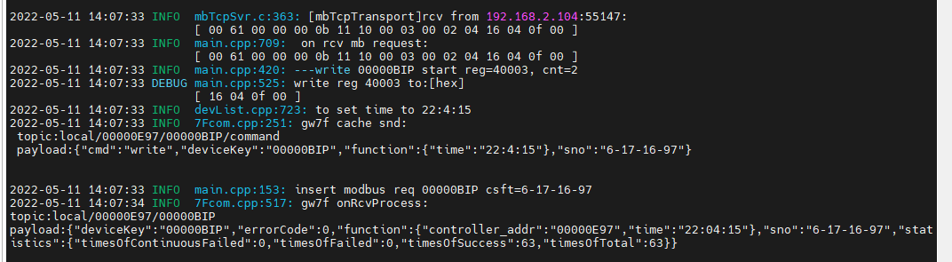

结果：写入成功。

#### 直读

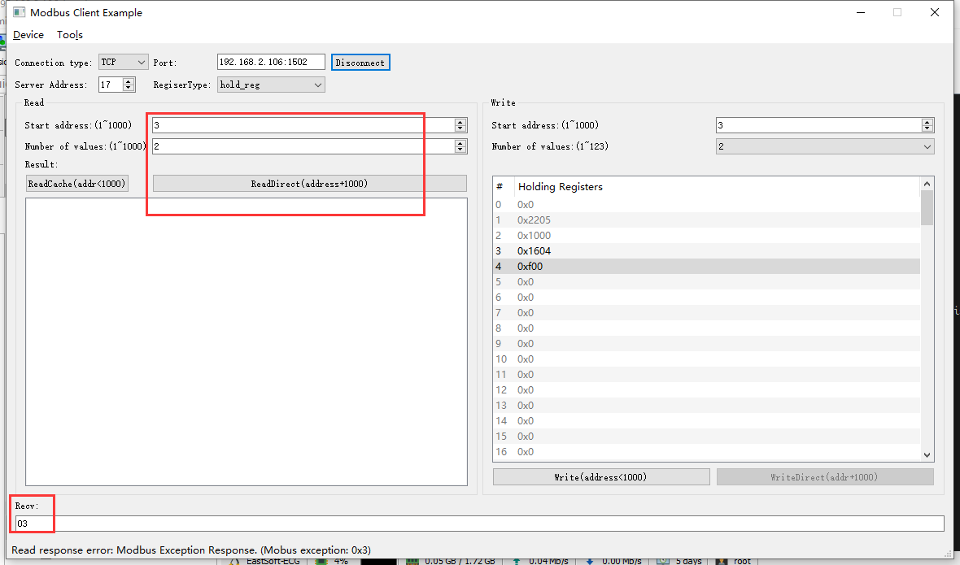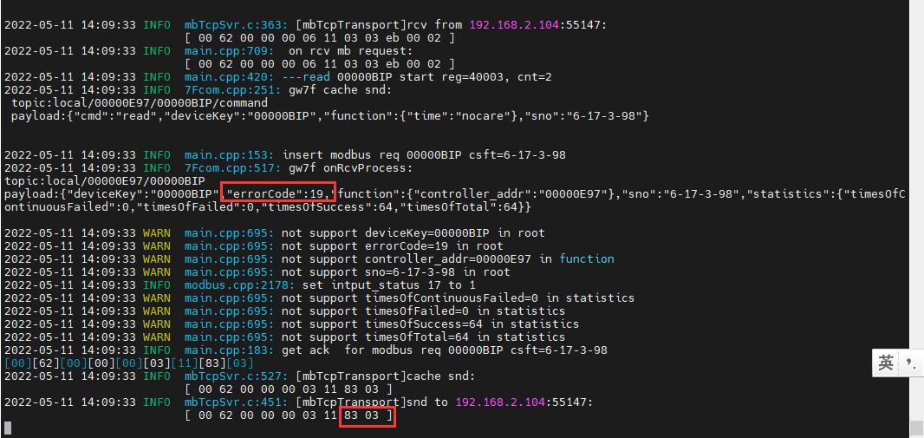

结果：直读回复错误，设备端时间不支持读取

#### 读缓存

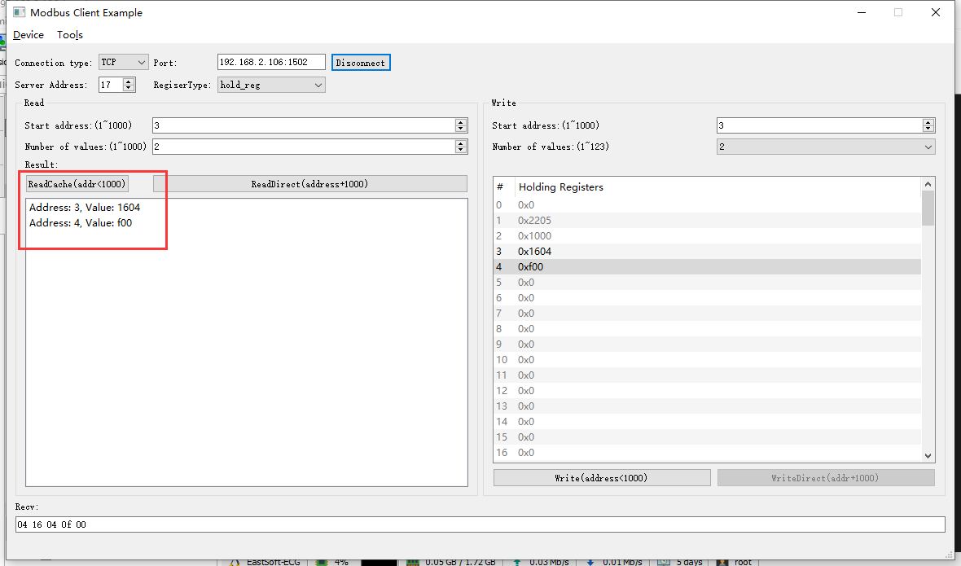2022-05-11 14:11:02 INFO mbTcpSvr.c:363: [mbTcpTransport]rcv from 192.168.2.104:55147:

[ 00 63 00 00 00 06 11 03 00 03 00 02 ]

2022-05-11 14:11:02 INFO main.cpp:709: on rcv mb request:

[ 00 63 00 00 00 06 11 03 00 03 00 02 ]

[00][63][00][00][00][07][11][03][04][16][04][0F][00]

2022-05-11 14:11:02 INFO mbTcpSvr.c:527: [mbTcpTransport]cache snd:

[ 00 63 00 00 00 07 11 03 04 16 04 0f 00 ]

2022-05-11 14:11:02 INFO mbTcpSvr.c:451: [mbTcpTransport]snd to 192.168.2.104:55147:

[ 00 63 00 00 00 07 11 03 04 16 04 0f 00 ]

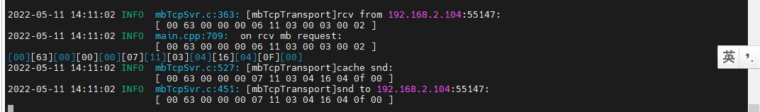

结果：四寸触控终端写入时间，读取缓存与写入时间一致。

### 写入不存在的时间

#### 写入

#### 直读

注：设备端不支持读取时间、日期的操作。

# PLC转485模块（无设备）

此设备未验证

**说明：**根据转换程序所支持的设备，典型选取一种测试。

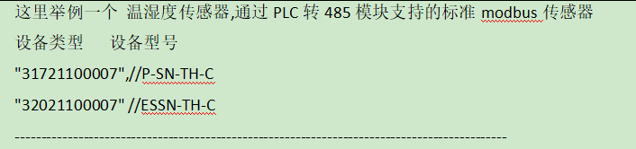

**寄存器定义：**

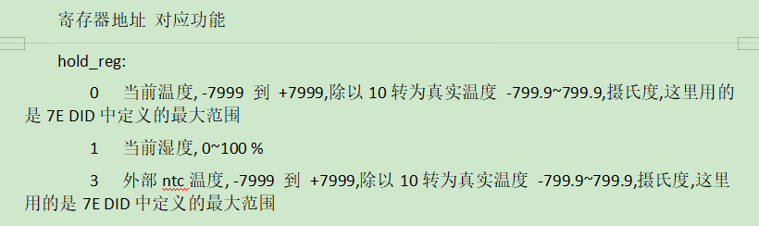

## 当前温度

### 直读

### 读缓存

### 写入

直读

## 当前湿度

### 直读

### 读缓存

### 写入

直读

## 外部ntc温度

### 直读

### 读缓存

### 写入

直读

# 单轨窗帘控制模块（无开度控制）（无设备）

此设备未验证

**说明：**根据转换程序锁支持的设备，典型选取一种测试。

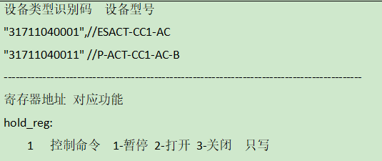

## 打开

## 暂停

## 关闭

# 单轨窗帘控制模块（支持开度控制）ok

**说明：**根据转换程序锁支持的设备，典型选取一种测试。

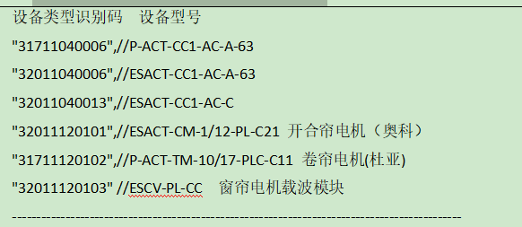

**寄存器定义：**

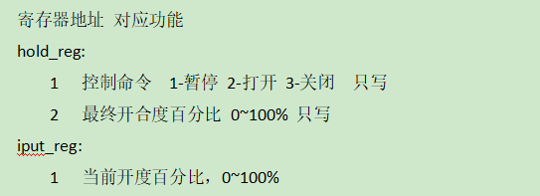

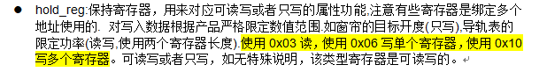

查询设备modbus地址--50

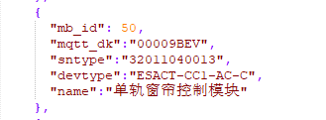

此处使用如上图中的设备做典型验证。

## 控制

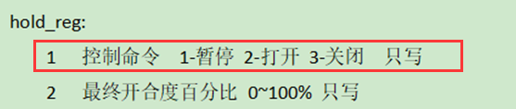

### 打开

只写0x06

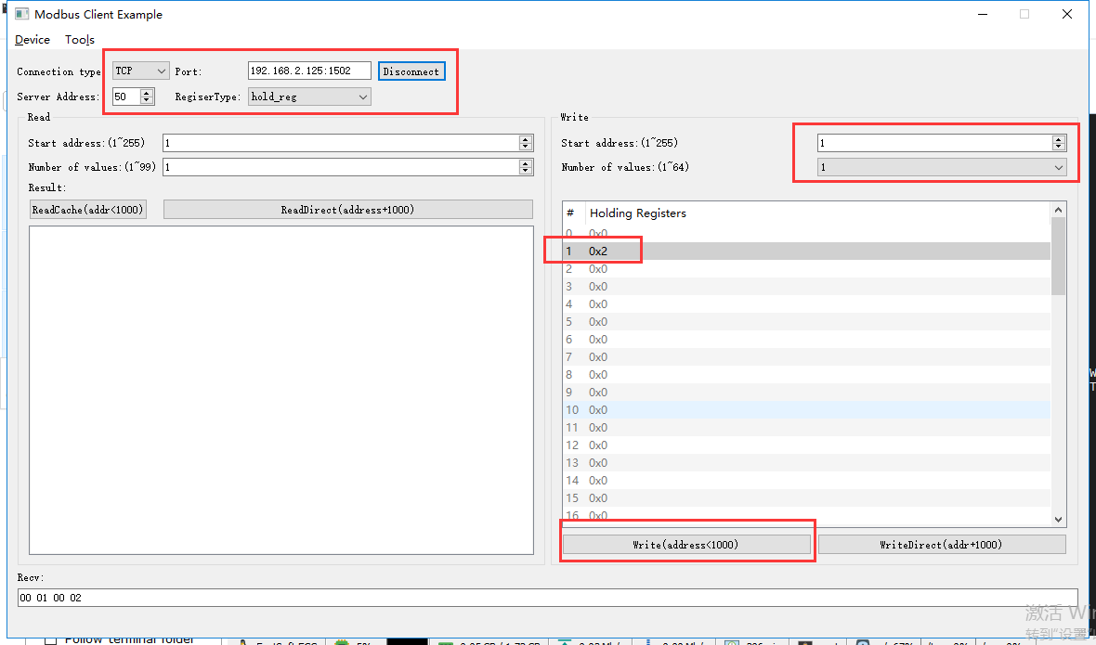

rcv from 192.168.2.113:64707:

[ 00 00 00 00 00 06 32 06 00 01 00 02 ]

snd to 192.168.2.113:64707:

[ 00 00 00 00 00 06 32 06 00 01 00 02 ]

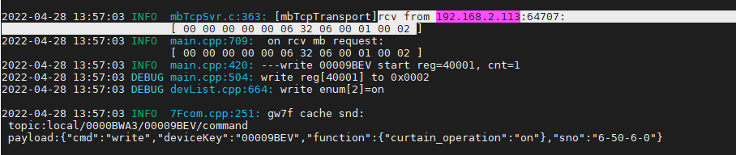

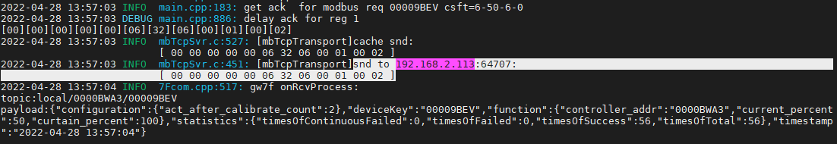

可读写0x03

读取当前状态

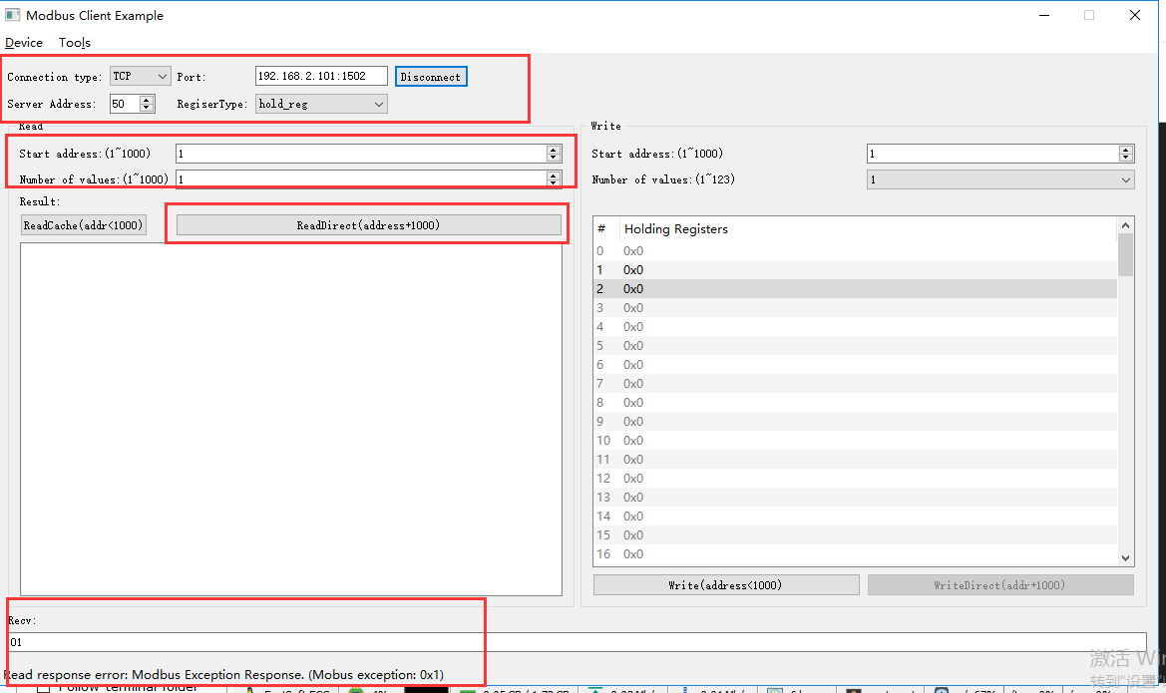

rcv from 192.168.2.113:53414:

[ 00 05 00 00 00 06 32 03 03 e9 00 01 ]

snd to 192.168.2.113:53414:

[ 00 05 00 00 00 03 32 83 01 ]

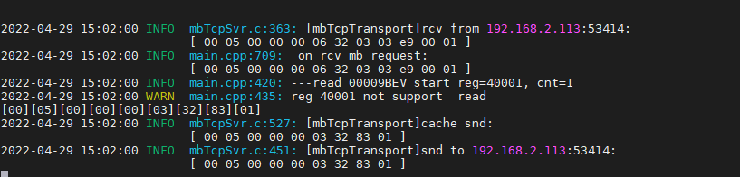

回复错误

多个寄存器0x10

反转+开度100%（矛盾任务）

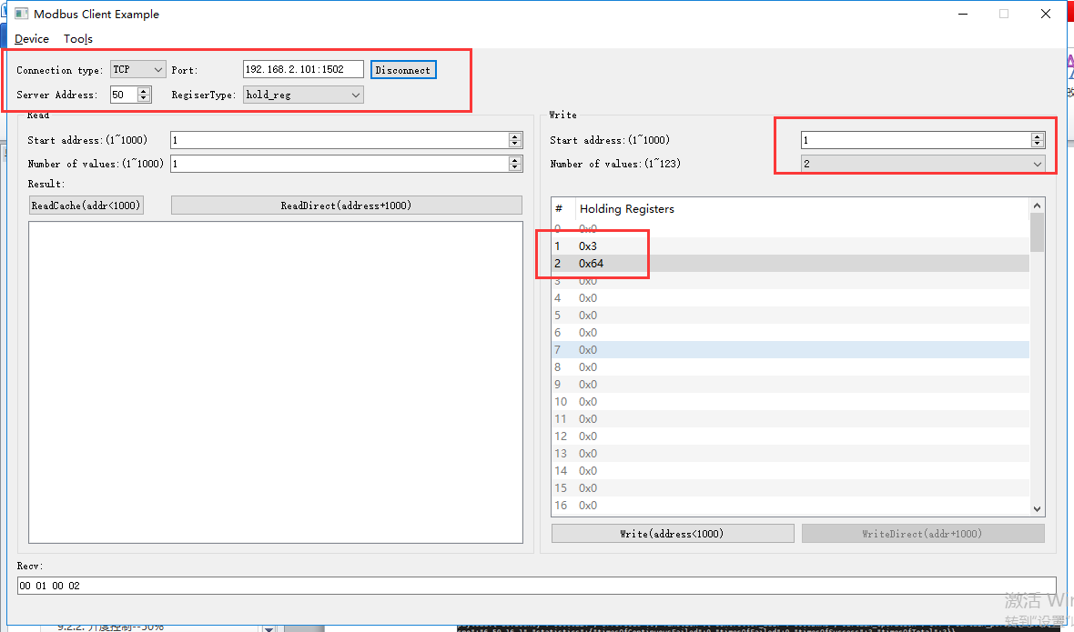

rcv from 192.168.2.113:53414:

[ 00 01 00 00 00 0b 32 10 00 01 00 02 04 00 03 00 64 ]

snd to 192.168.2.113:53414:

[ 00 01 00 00 00 06 32 10 00 01 00 02 ]

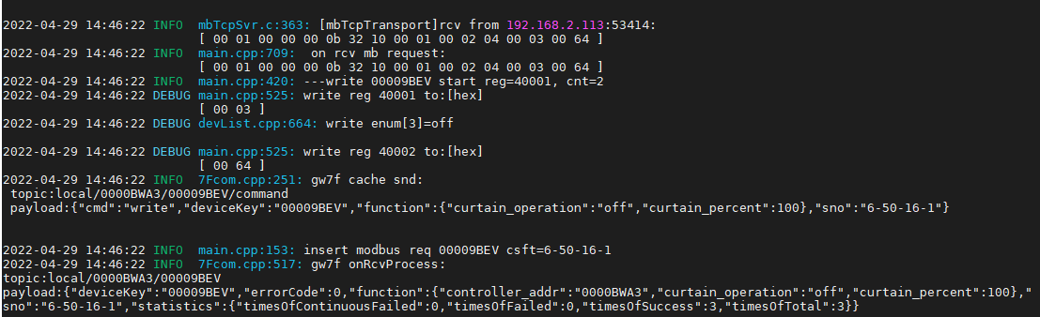

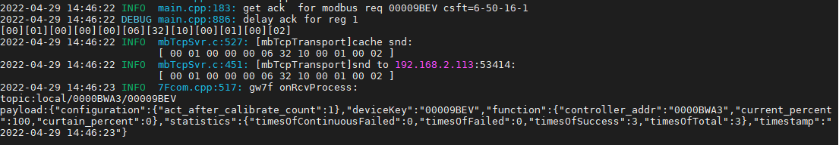

响应反转指令

### 暂停

只写0x06

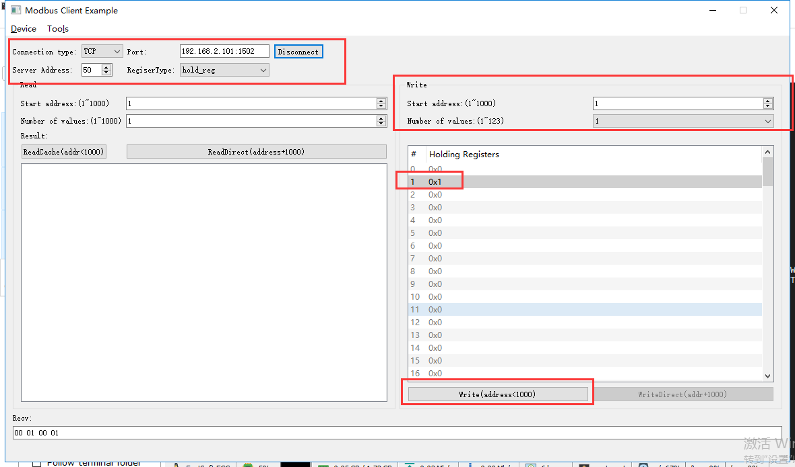

rcv from 192.168.2.113:53414:

[ 00 07 00 00 00 06 32 06 00 01 00 01 ]

snd to 192.168.2.113:53414:

[ 00 07 00 00 00 06 32 06 00 01 00 01 ]

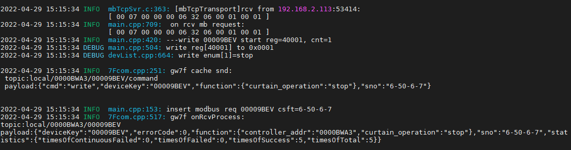

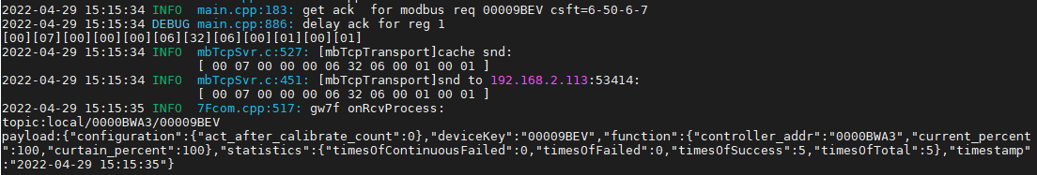

可读写0x03

读取当前状态

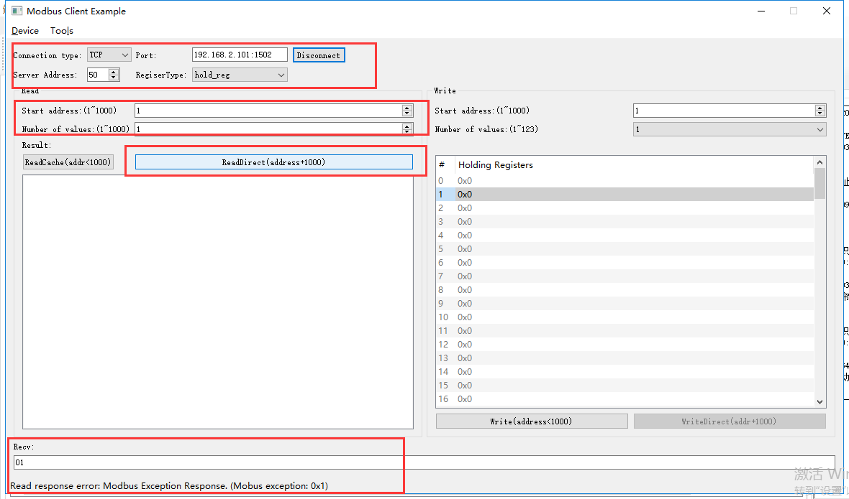

rcv from 192.168.2.113:53414:

[ 00 08 00 00 00 06 32 03 03 e9 00 01 ]

snd to 192.168.2.113:53414:

[ 00 08 00 00 00 03 32 83 01 ]

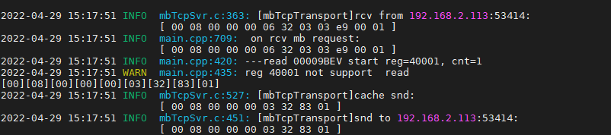

回复错误

多个寄存器0x10

正转+开度0%（矛盾任务）

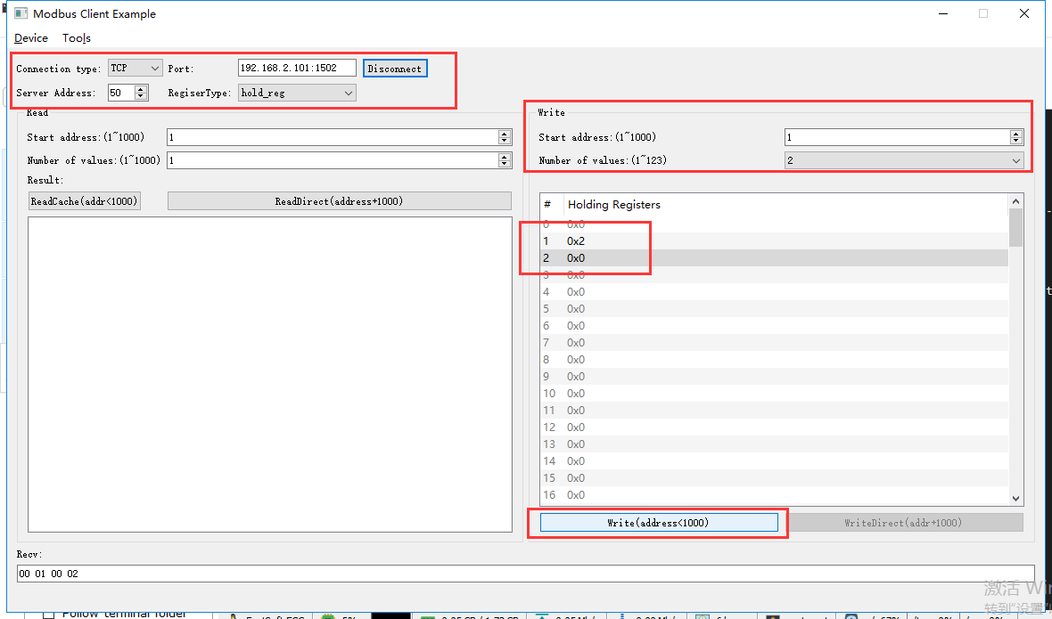

rcv from 192.168.2.113:53414:

[ 00 09 00 00 00 0b 32 10 00 01 00 02 04 00 02 00 00 ]

snd to 192.168.2.113:53414:

[ 00 09 00 00 00 06 32 10 00 01 00 02 ]

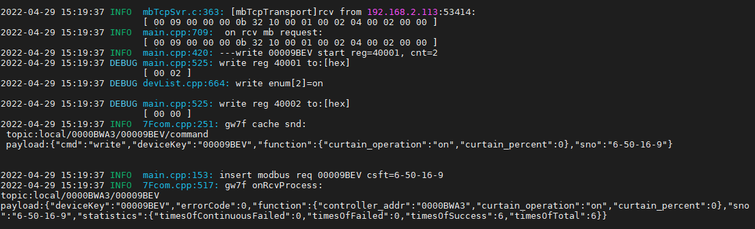

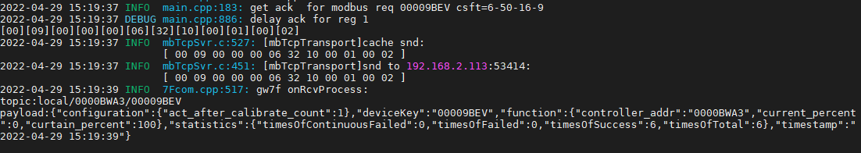

响应正转指令

### 关闭

只写0x06

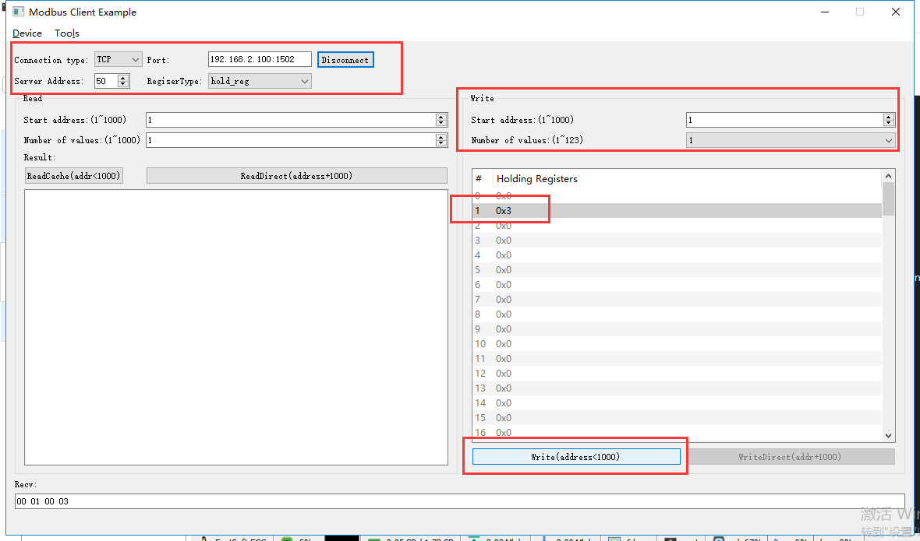

rcv from 192.168.2.113:62550:

[ 00 09 00 00 00 06 32 06 00 01 00 03 ]

snd to 192.168.2.113:62550:

[ 00 09 00 00 00 06 32 06 00 01 00 03 ]

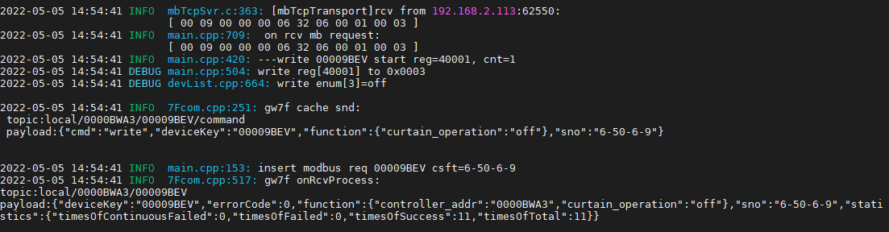



可读写0x03

读取当前状态

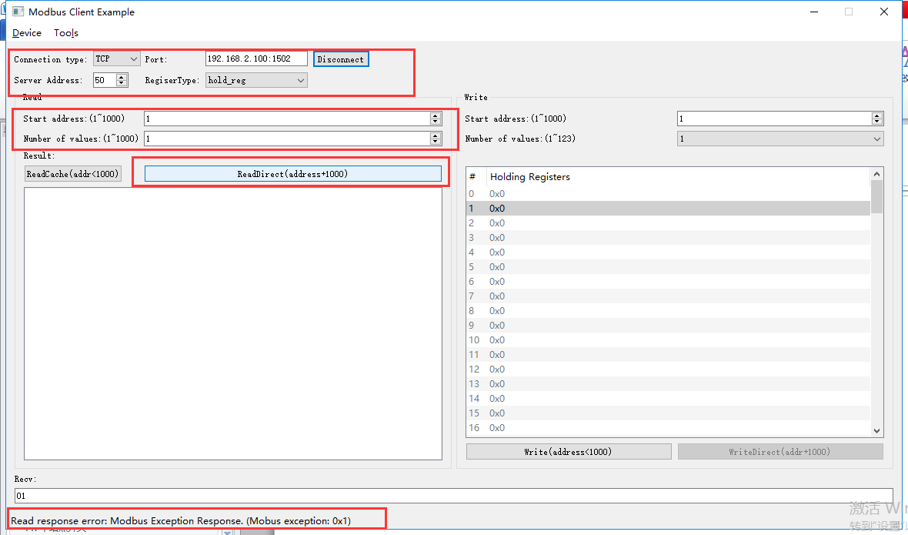

rcv from 192.168.2.113:62550:

[ 00 0a 00 00 00 06 32 03 03 e9 00 01 ]

snd to 192.168.2.113:62550:

[ 00 0a 00 00 00 03 32 83 01 ]

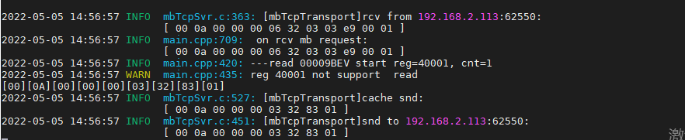

回复错误

多个寄存器0x10

反转+开度100%（矛盾任务）

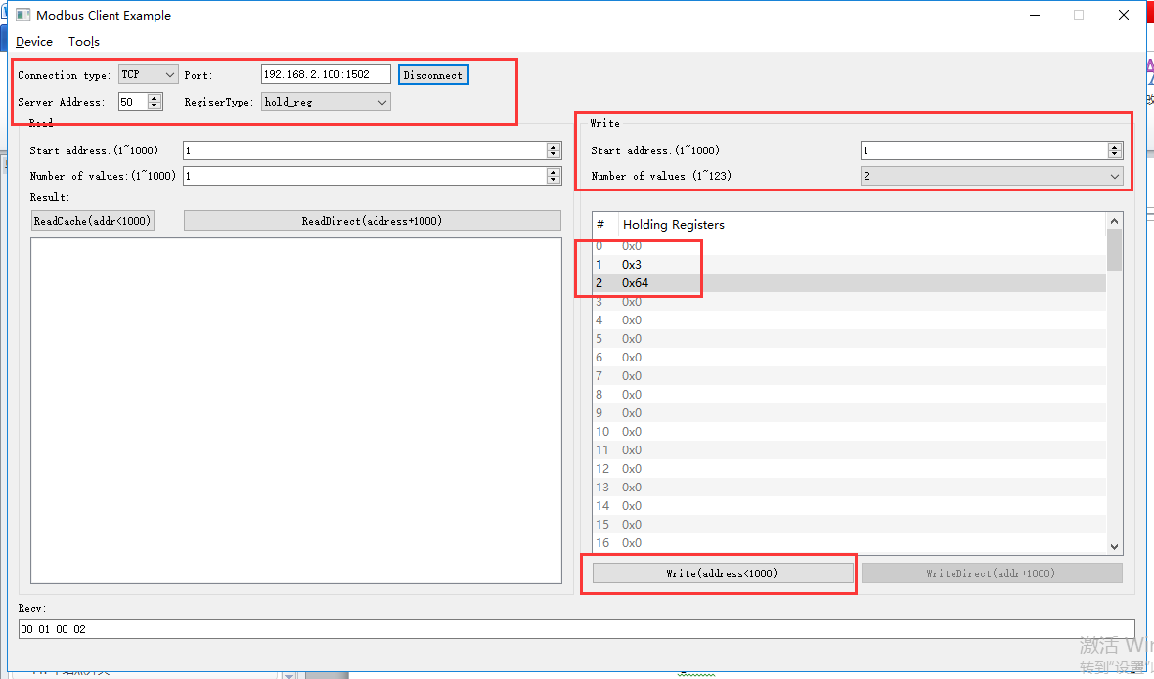

rcv from 192.168.2.113:62550:

[ 00 0d 00 00 00 0b 32 10 00 01 00 02 04 00 03 00 64 ]

snd to 192.168.2.113:62550:

[ 00 0d 00 00 00 06 32 10 00 01 00 02 ]

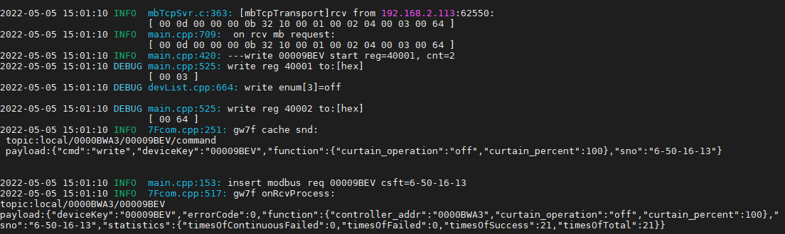

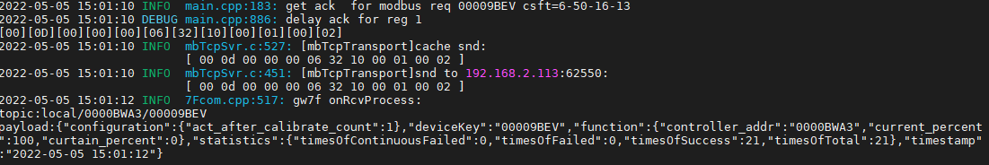

响应反转指令

## 开度控制与读取



**写开度：**

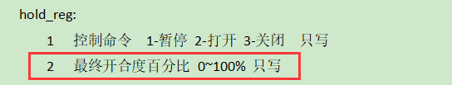

**读开度：**



### 开度控制--1%

写开度

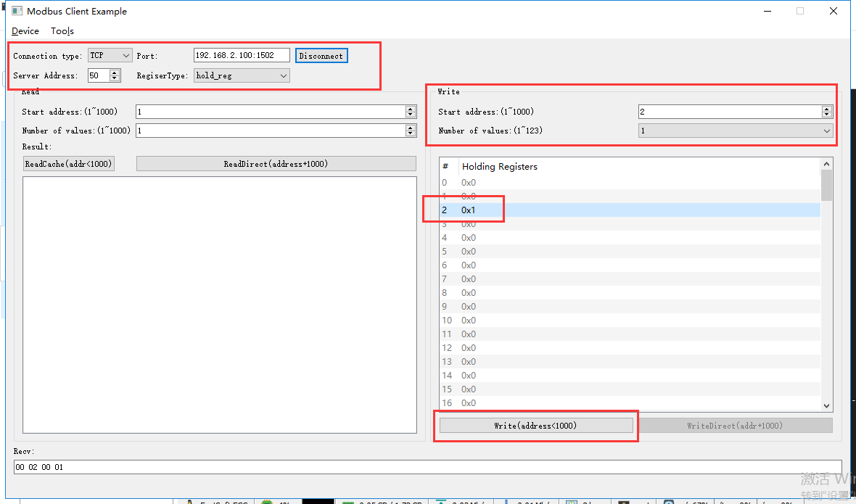

rcv from 192.168.2.113:51799:

[ 00 0e 00 00 00 06 32 06 00 02 00 01 ]

snd to 192.168.2.113:51799:

[ 00 0e 00 00 00 06 32 06 00 02 00 01 ]

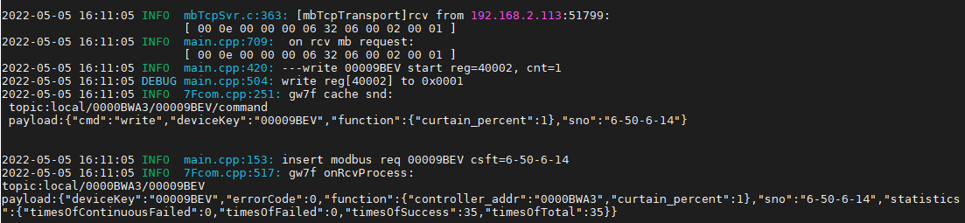

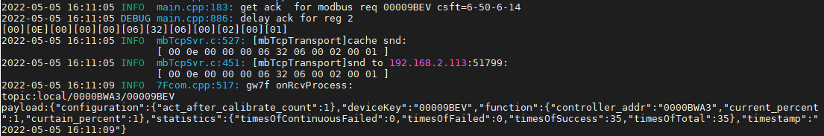

直读开度

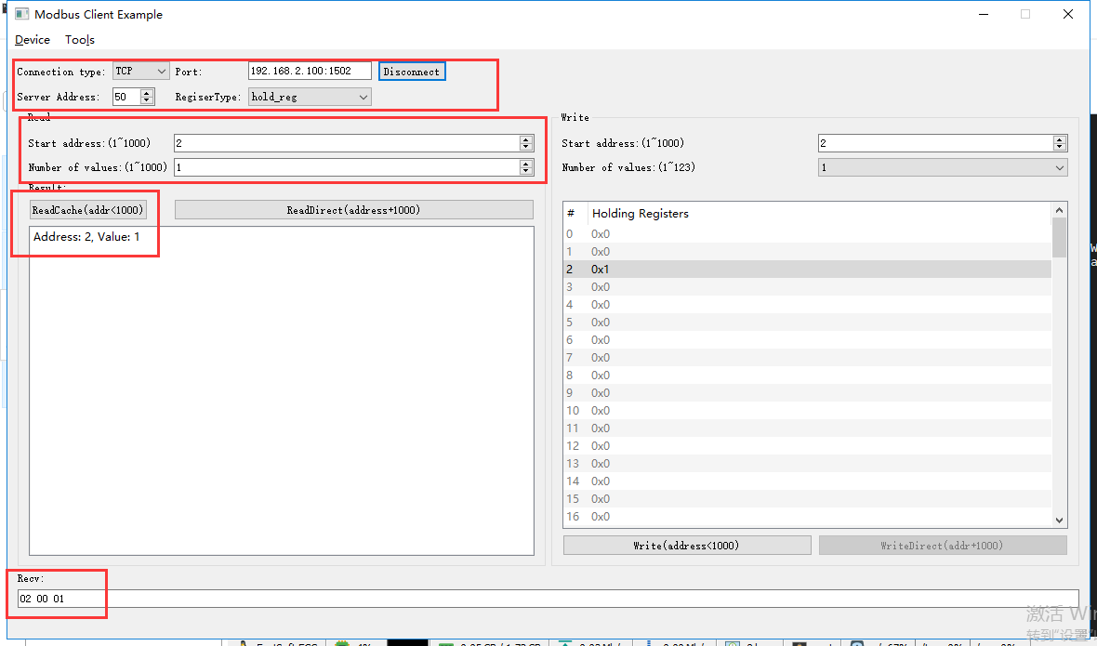

rcv from 192.168.2.113:51799:

[ 00 19 00 00 00 06 32 03 00 02 00 01 ]

]snd to 192.168.2.113:51799:

[ 00 19 00 00 00 05 32 03 02 00 01 ]

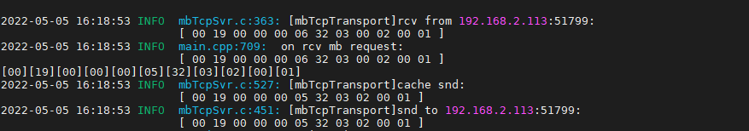

### 开度控制--50%

写开度

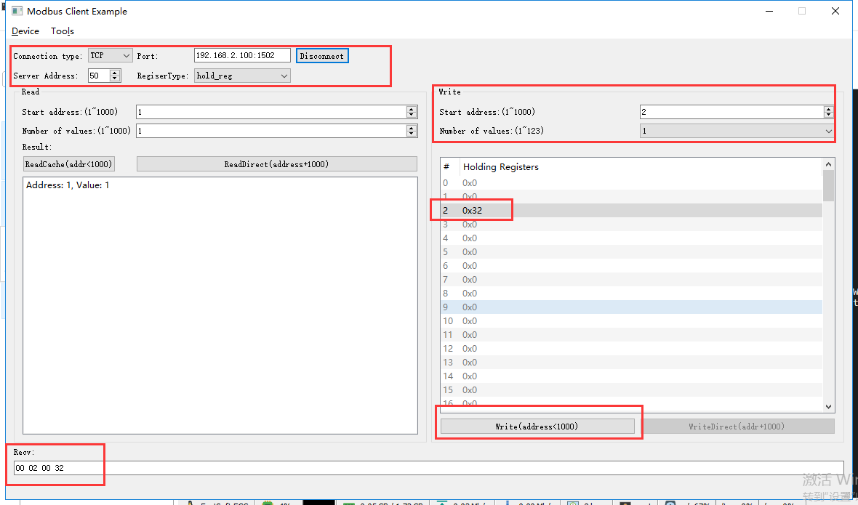

rcv from 192.168.2.113:51799:

[ 00 12 00 00 00 06 32 06 00 02 00 32 ]

]snd to 192.168.2.113:51799:

[ 00 12 00 00 00 06 32 06 00 02 00 32 ]

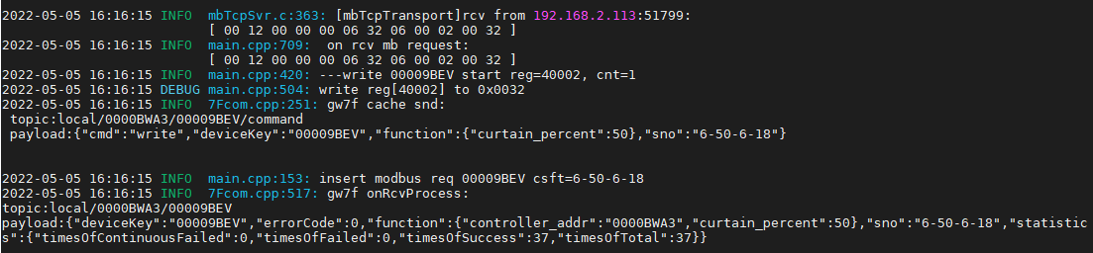

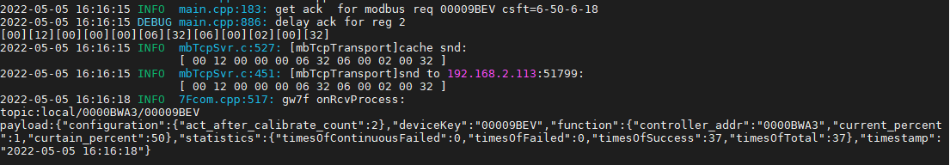

直读开度

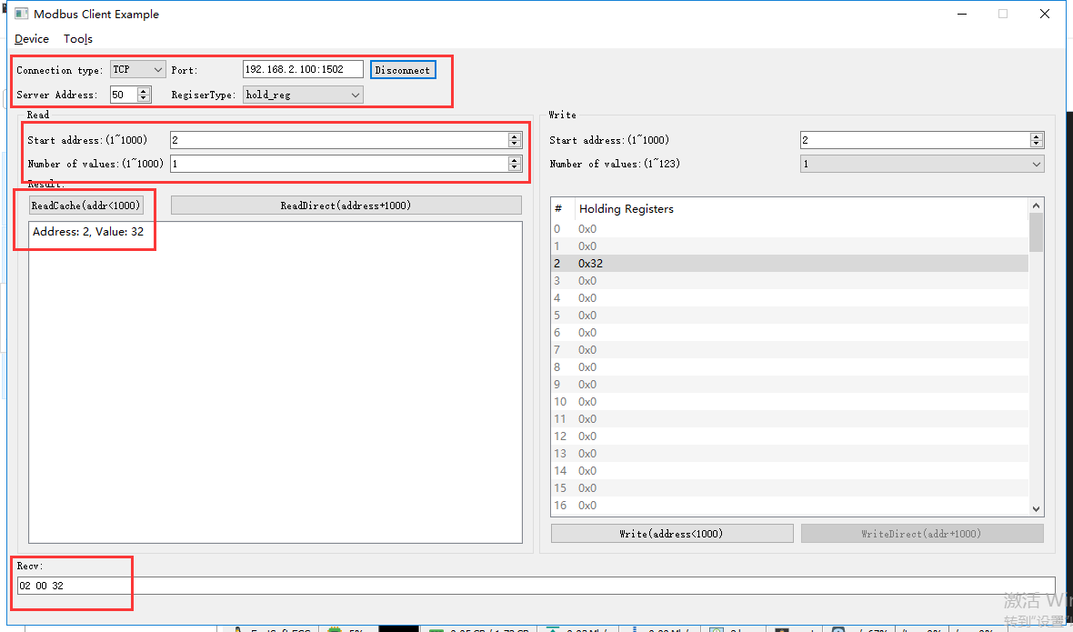

rcv from 192.168.2.113:51812:

[ 00 1b 00 00 00 06 32 03 00 02 00 01 ]

snd to 192.168.2.113:51812:

[ 00 1b 00 00 00 05 32 03 02 00 32 ]

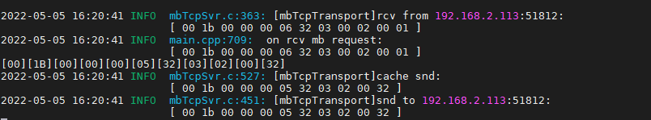

### 开度控制--100%

写开度

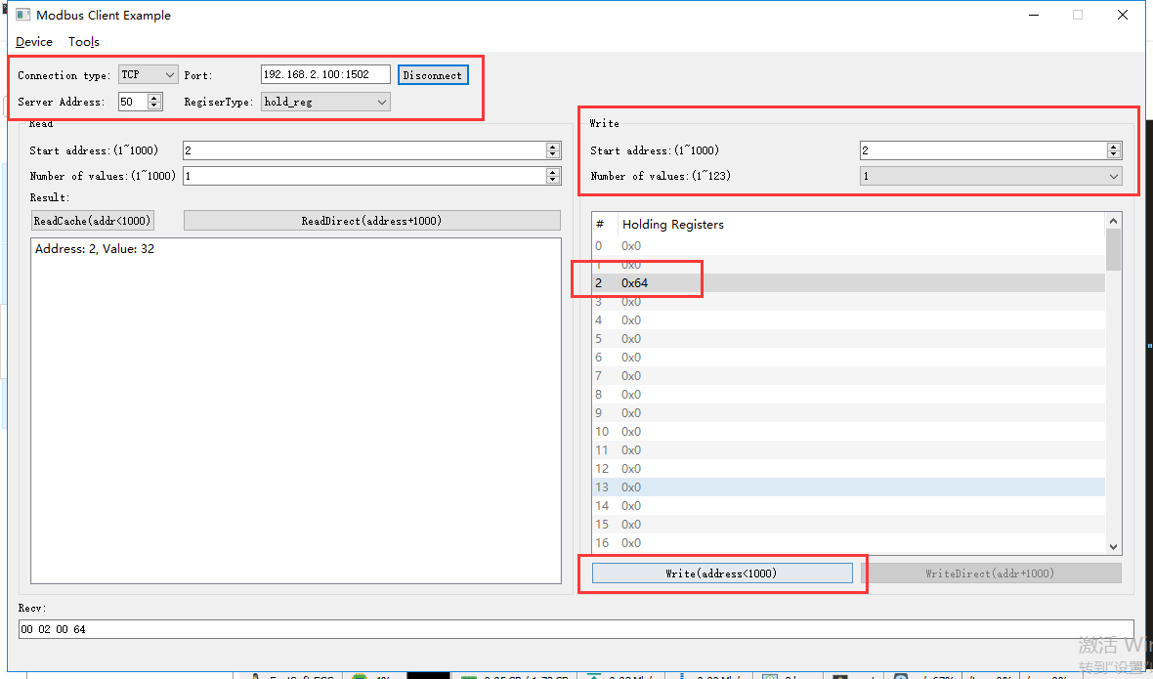

rcv from 192.168.2.113:51812:

[ 00 1c 00 00 00 06 32 06 00 02 00 64 ]

snd to 192.168.2.113:51812:

[ 00 1c 00 00 00 06 32 06 00 02 00 64 ]

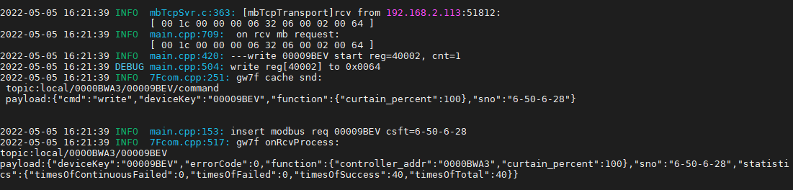

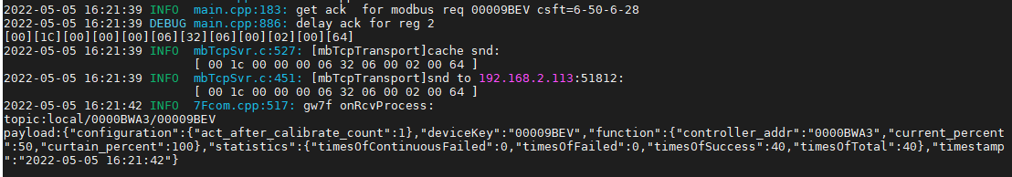

直读开度

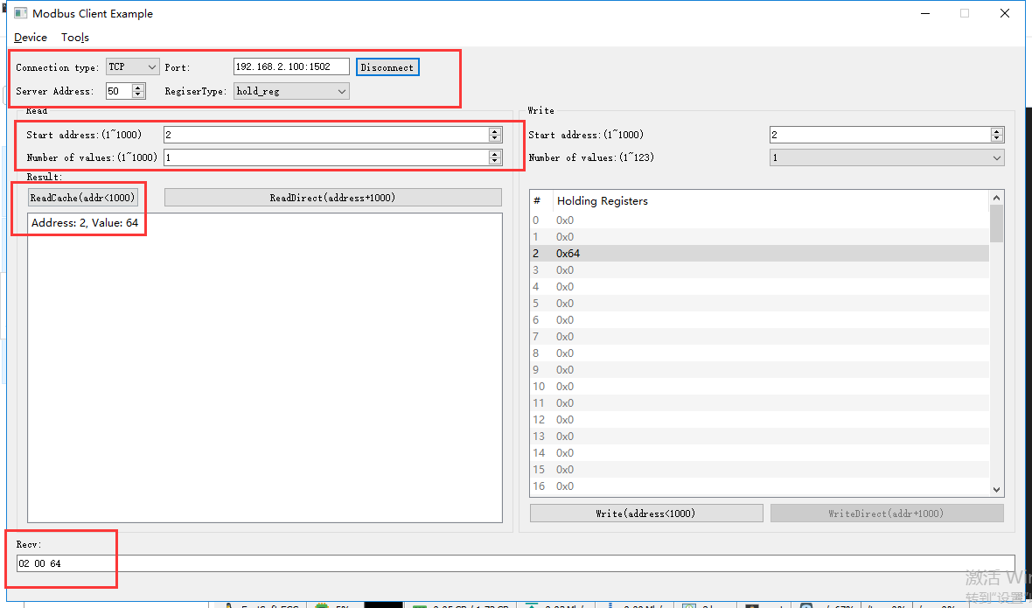

]rcv from 192.168.2.113:51812:

[ 00 21 00 00 00 06 32 03 00 02 00 01 ]

snd to 192.168.2.113:51812:

[ 00 21 00 00 00 05 32 03 02 00 64 ]

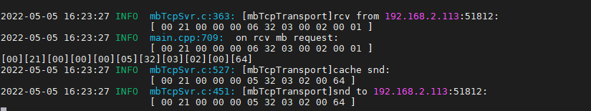

### 开度控制--101%

写开度

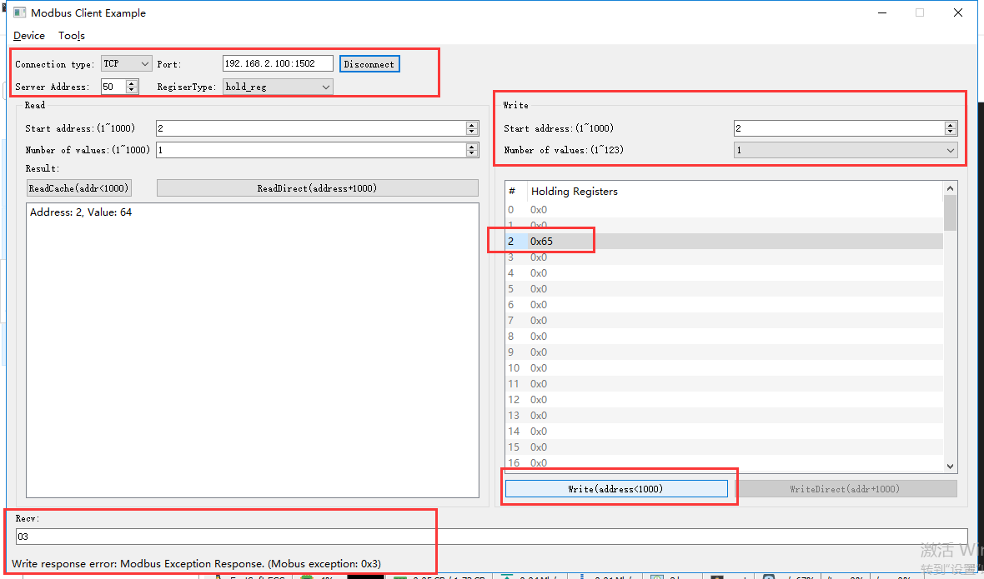

rcv from 192.168.2.113:51812:

[ 00 22 00 00 00 06 32 06 00 02 00 65 ]

snd to 192.168.2.113:51812:

[ 00 22 00 00 00 03 32 86 03 ]

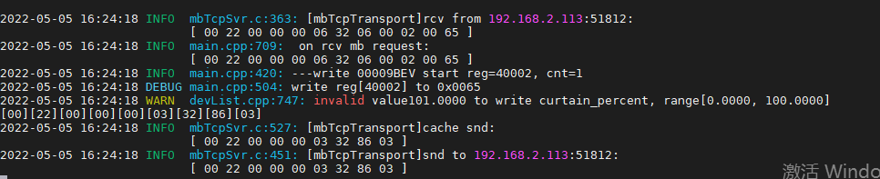

直读开度

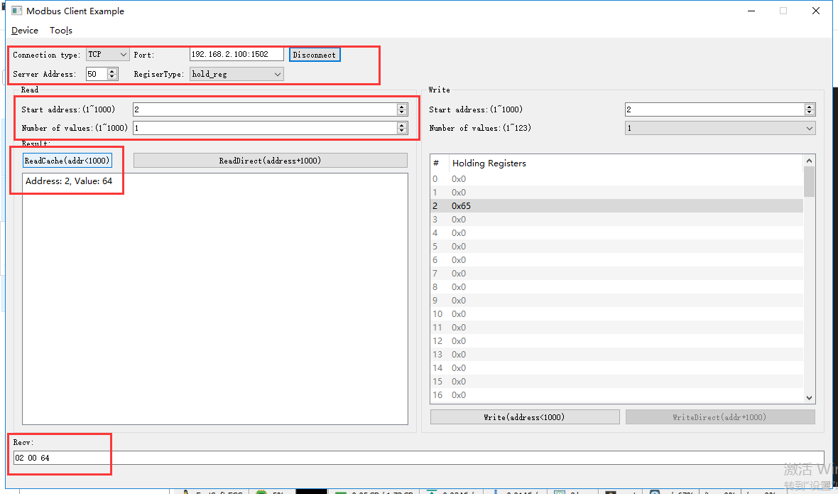

rcv from 192.168.2.113:51812:

[ 00 23 00 00 00 06 32 03 00 02 00 01 ]

snd to 192.168.2.113:51812:

[ 00 23 00 00 00 05 32 03 02 00 64 ]

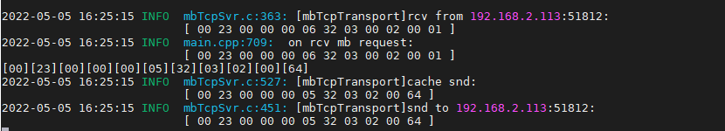

开度仍然是100%

# 双轨窗帘控制模块ok

**说明：**根据转换程序锁支持的设备，典型选取一种测试。

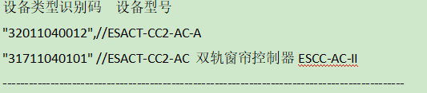

**寄存器定义：**

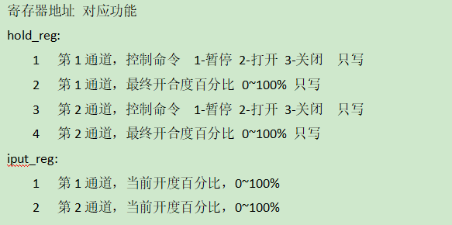



查询设备modbus地址--51

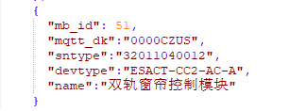

此处使用如上图中的设备做典型验证。

## 通道1

### 打开

只写0x06

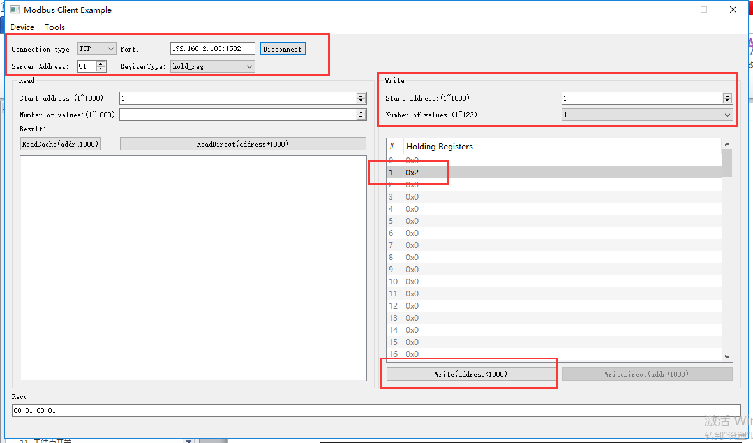

rcv from 192.168.2.113:52184:

[ 00 02 00 00 00 06 33 06 00 01 00 02 ]

snd to 192.168.2.113:52184:

[ 00 02 00 00 00 06 33 06 00 01 00 02 ]

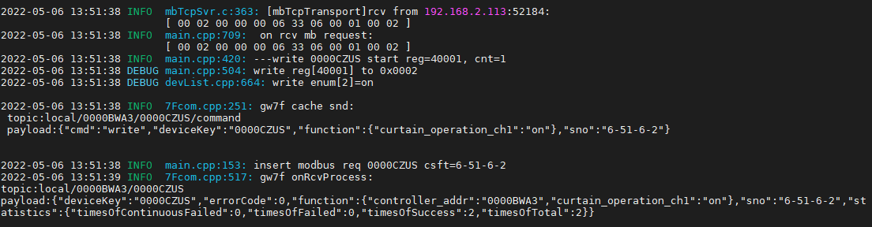

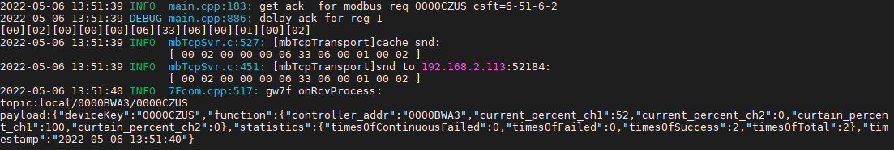

可读写0x03

读取当前状态

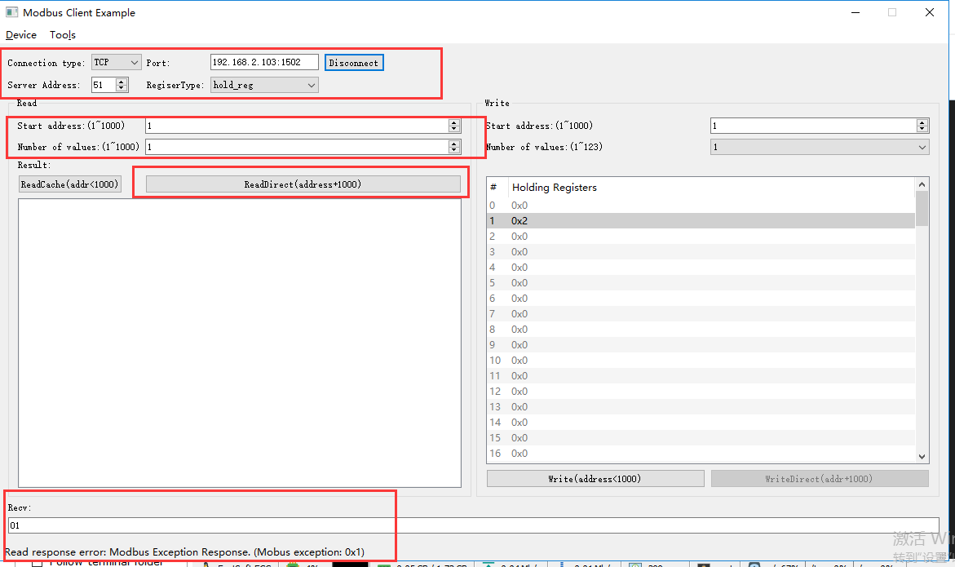

rcv from 192.168.2.113:52184:

[ 00 03 00 00 00 06 33 03 03 e9 00 01 ]

snd to 192.168.2.113:52184:

[ 00 03 00 00 00 03 33 83 01 ]

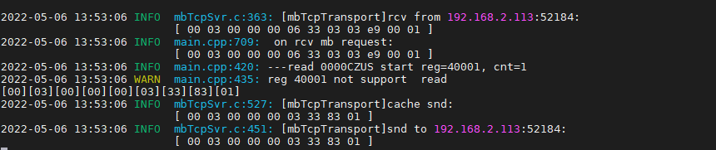

回复错误

多个寄存器0x10

反转+开度100%（矛盾任务）

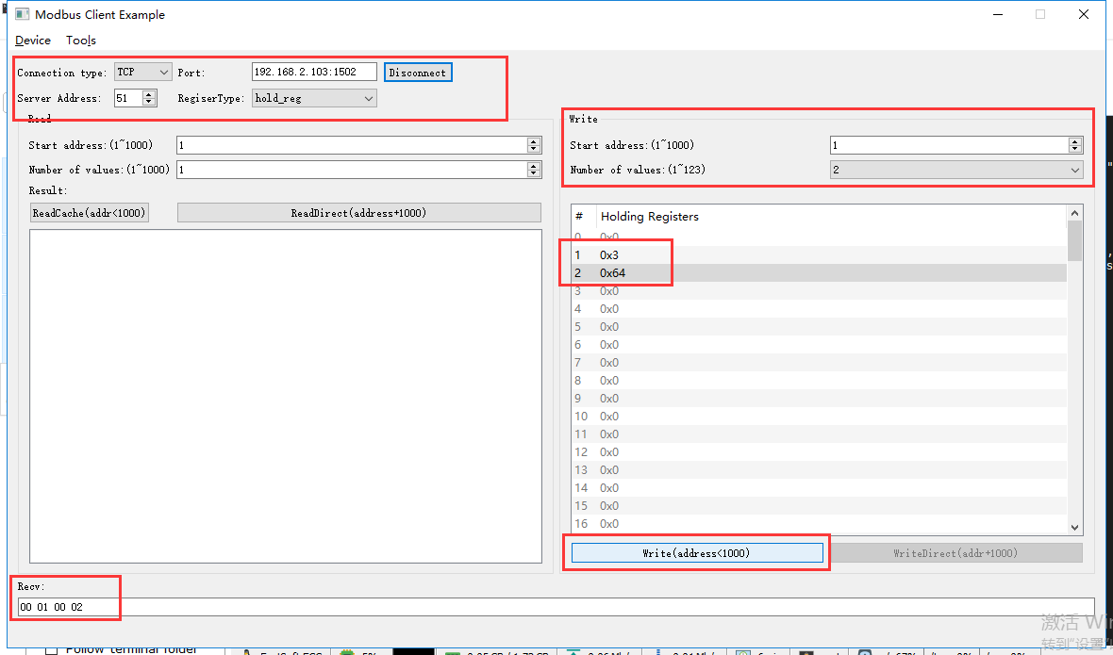

rcv from 192.168.2.113:52184:

[ 00 04 00 00 00 0b 33 10 00 01 00 02 04 00 03 00 64 ]

snd to 192.168.2.113:52184:

[ 00 04 00 00 00 06 33 10 00 01 00 02 ]

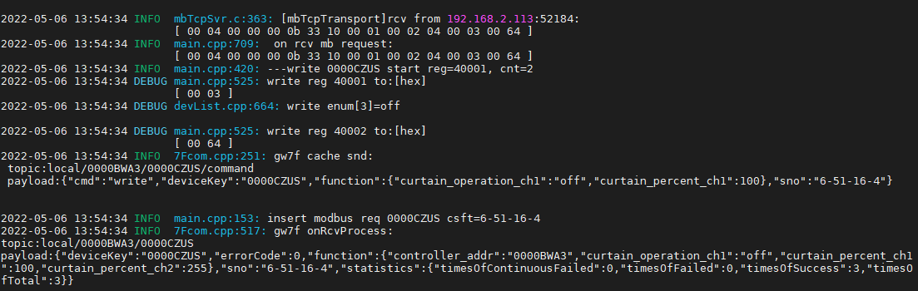

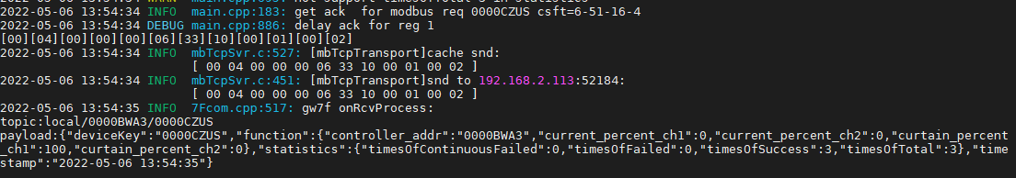

响应反转指令

### 暂停

只写0x06

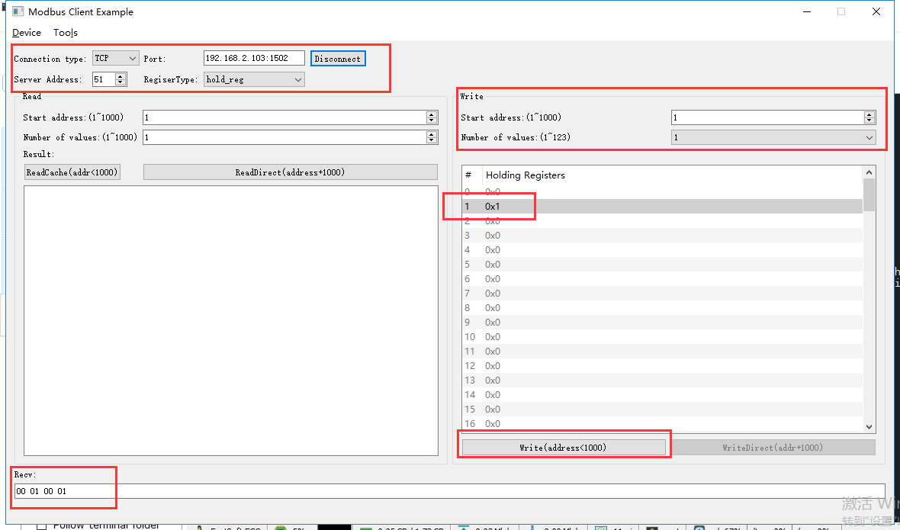

rcv from 192.168.2.113:52184:

[ 00 06 00 00 00 06 33 06 00 01 00 01 ]

snd to 192.168.2.113:52184:

[ 00 06 00 00 00 06 33 06 00 01 00 01 ]

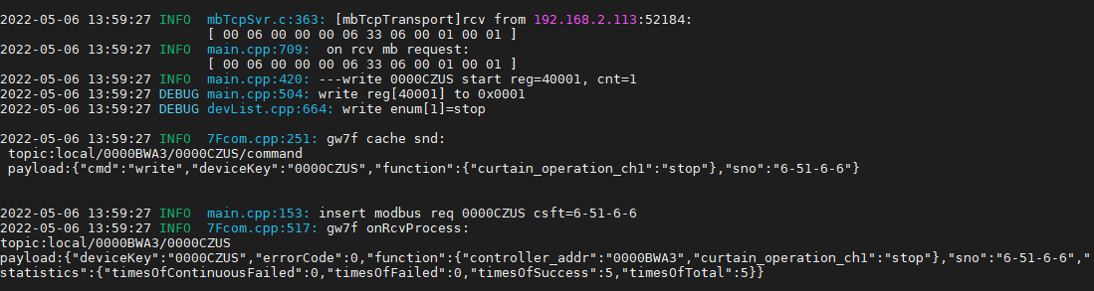

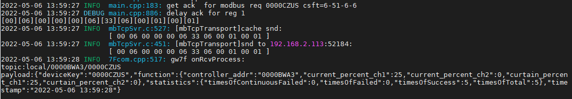

可读写0x03

读取当前状态

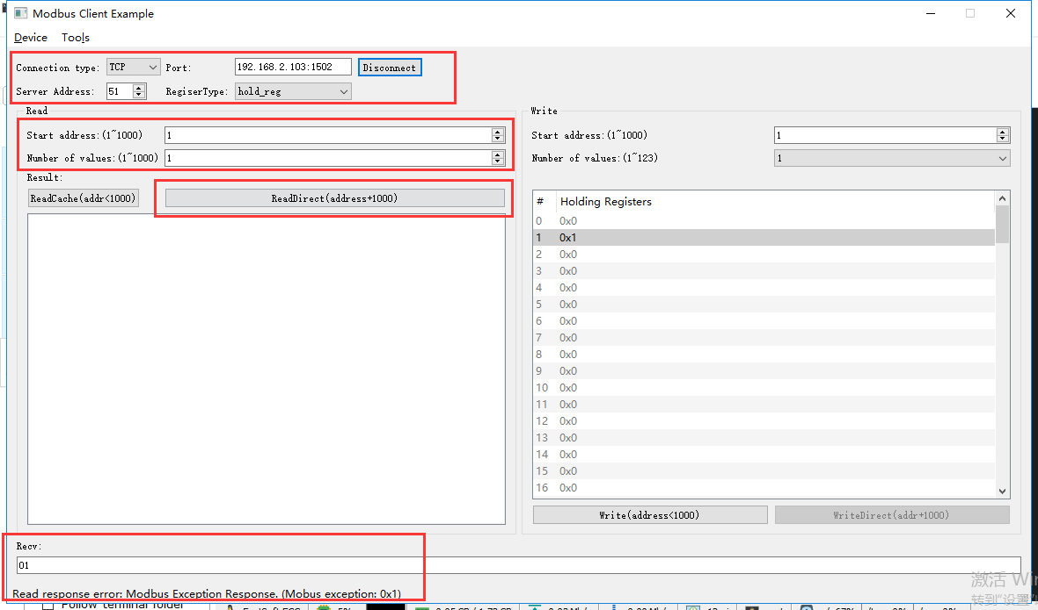

rcv from 192.168.2.113:52184:

[ 00 07 00 00 00 06 33 03 03 e9 00 01 ]

snd to 192.168.2.113:52184:

[ 00 07 00 00 00 03 33 83 01 ]

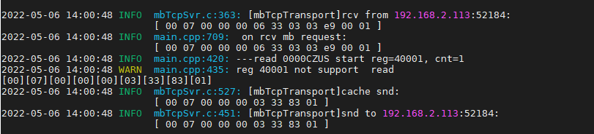

回复错误

多个寄存器0x10

正转+开度0%（矛盾任务）

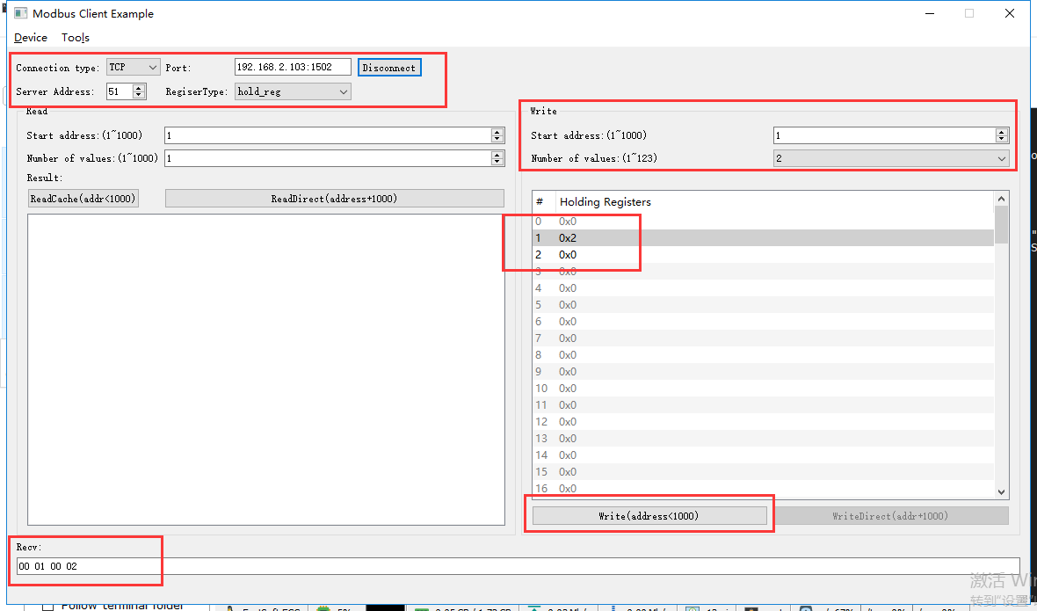

rcv from 192.168.2.113:52184:

[ 00 08 00 00 00 0b 33 10 00 01 00 02 04 00 02 00 00 ]

snd to 192.168.2.113:52184:

[ 00 08 00 00 00 06 33 10 00 01 00 02 ]

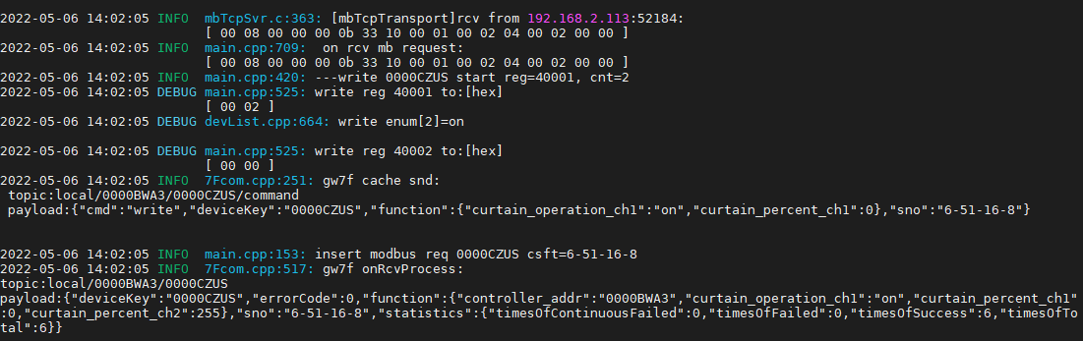

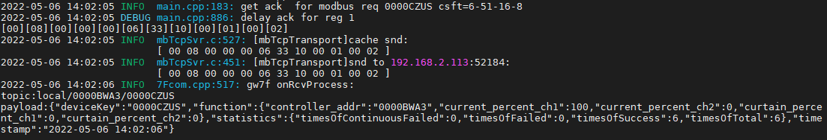

响应正转指令

### 关闭

只写0x06

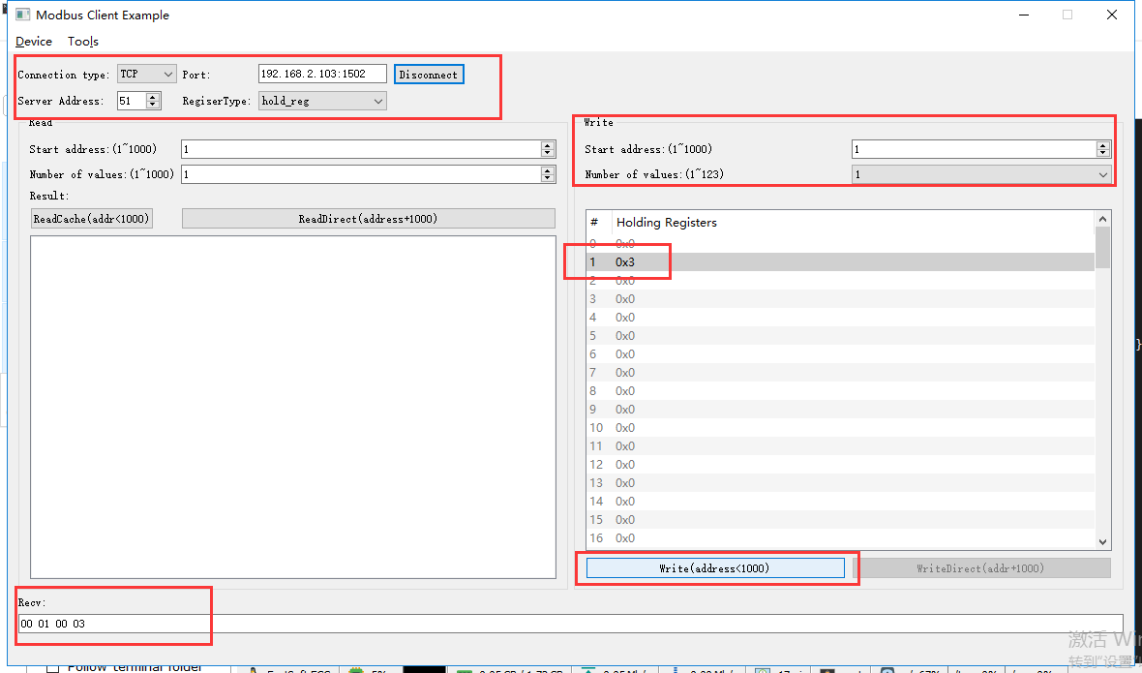

rcv from 192.168.2.113:52184:

[ 00 09 00 00 00 06 33 06 00 01 00 03 ]

snd to 192.168.2.113:52184:

[ 00 09 00 00 00 06 33 06 00 01 00 03 ]

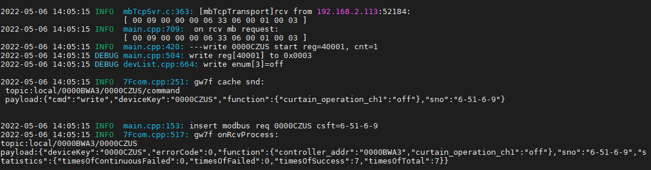

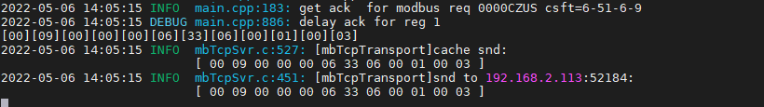

可读写0x03

读取当前状态

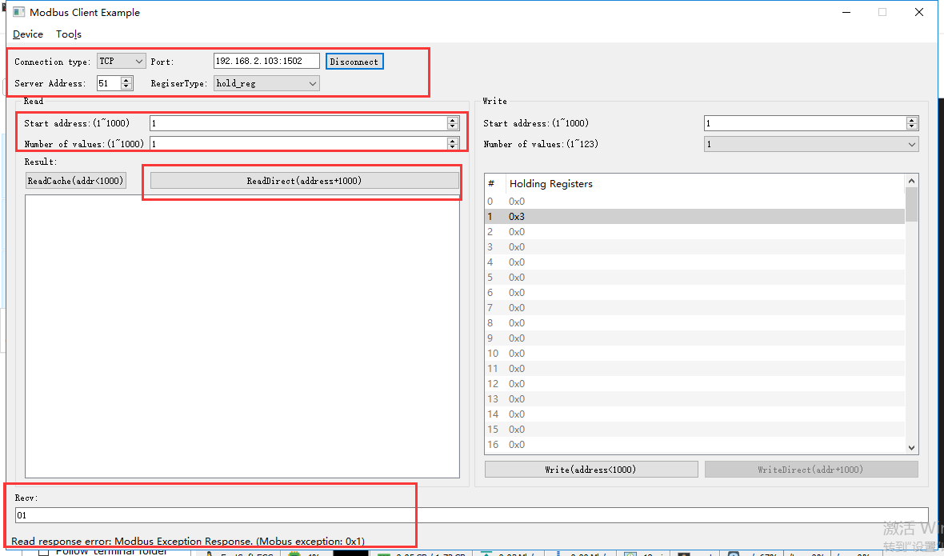

rcv from 192.168.2.113:52184:

[ 00 0a 00 00 00 06 33 03 03 e9 00 01 ]

snd to 192.168.2.113:52184:

[ 00 0a 00 00 00 03 33 83 01 ]

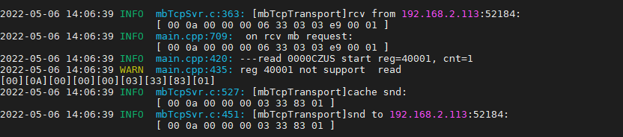

回复错误

多个寄存器0x10

反转+开度100%（矛盾任务）

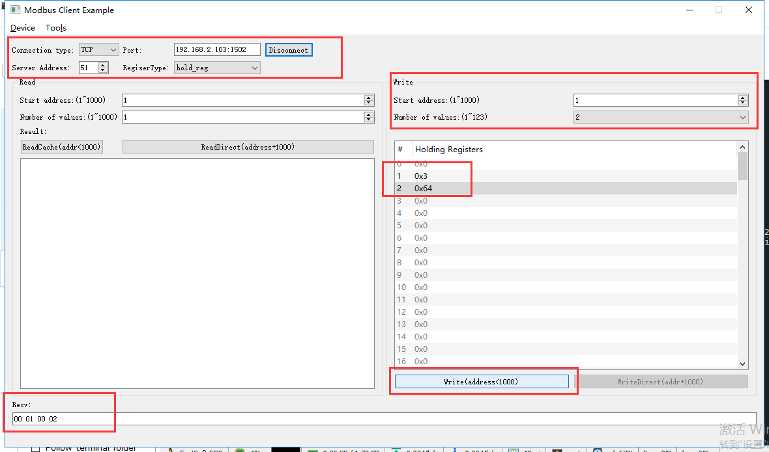

rcv from 192.168.2.113:52184:

[ 00 0b 00 00 00 0b 33 10 00 01 00 02 04 00 03 00 64 ]

snd to 192.168.2.113:52184:

[ 00 0b 00 00 00 06 33 10 00 01 00 02 ]

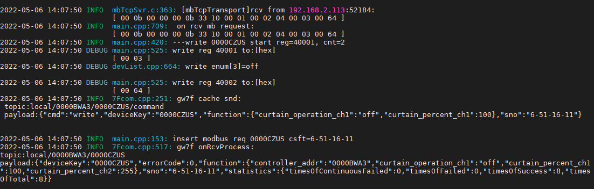

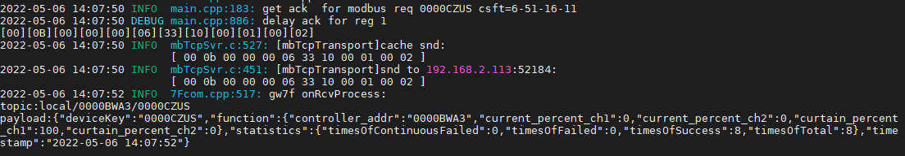

响应反转指令

### 开度控制

#### 开度控制--1%

写开度

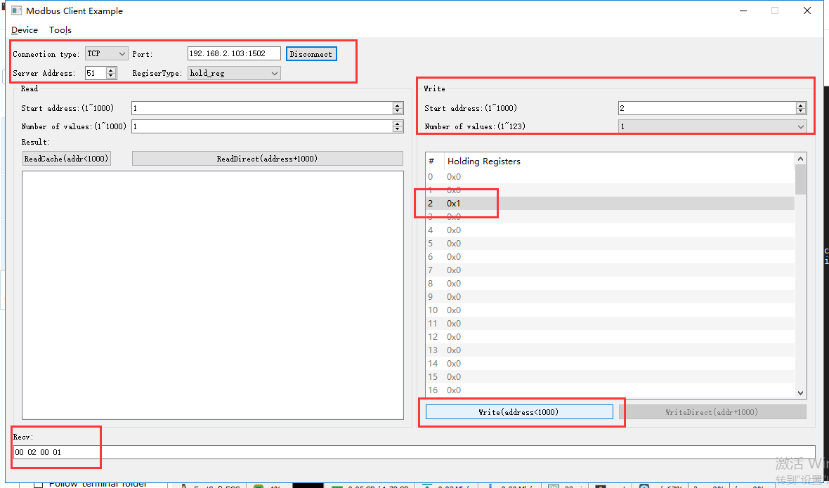

rcv from 192.168.2.113:52184:

[ 00 0c 00 00 00 06 33 06 00 02 00 01 ]

snd to 192.168.2.113:52184:

[ 00 0c 00 00 00 06 33 06 00 02 00 01 ]

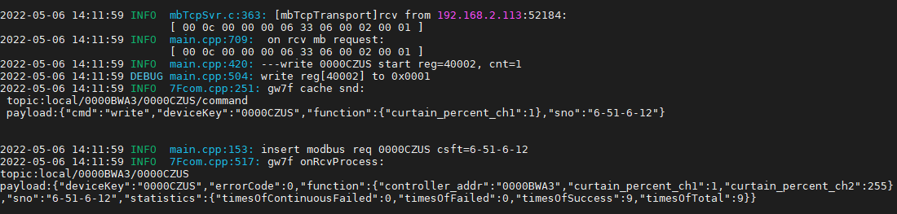

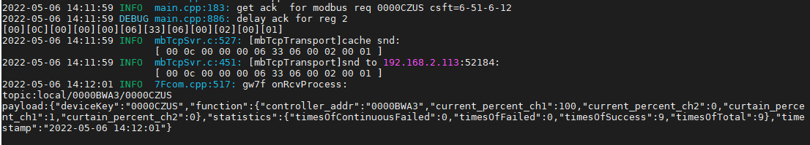

直读开度

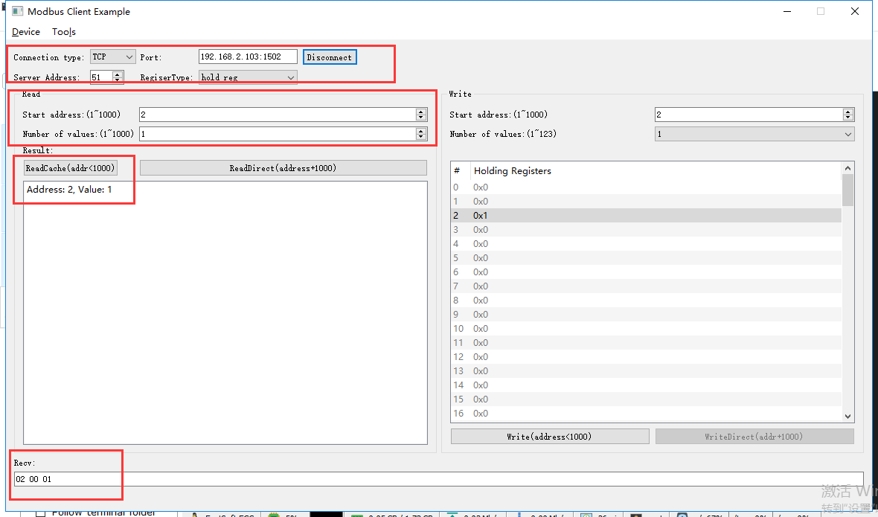

rcv from 192.168.2.113:52184:

[ 00 0e 00 00 00 06 33 03 00 02 00 01 ]

snd to 192.168.2.113:52184:

[ 00 0e 00 00 00 05 33 03 02 00 01 ]

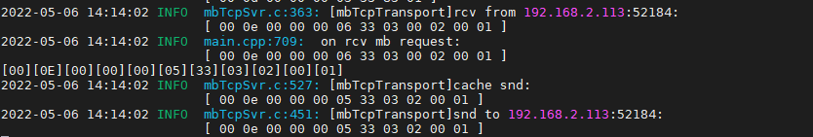

#### 开度控制--50%

写开度

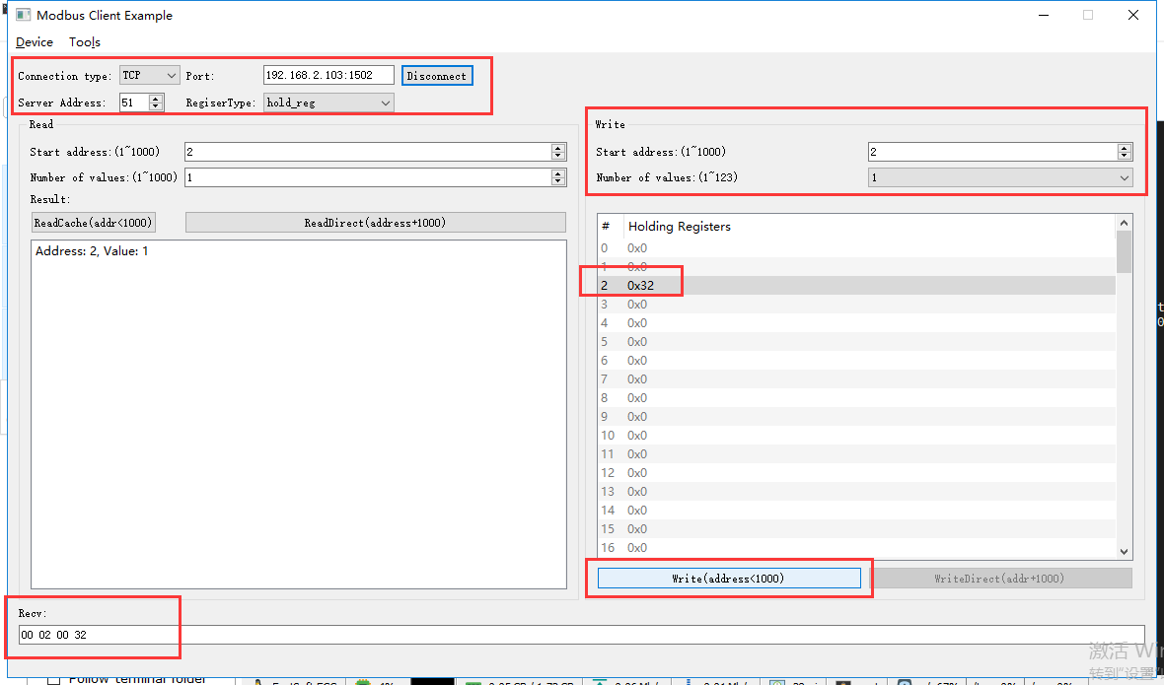

rcv from 192.168.2.113:52184:

[ 00 0f 00 00 00 06 33 06 00 02 00 32 ]

snd to 192.168.2.113:52184:

[ 00 0f 00 00 00 06 33 06 00 02 00 32 ]

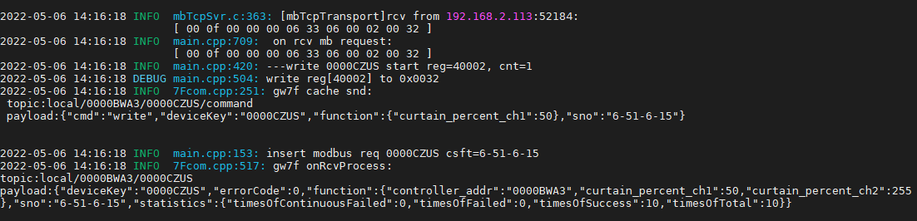

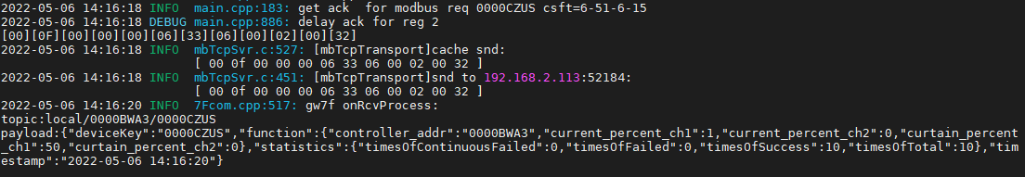

直读开度

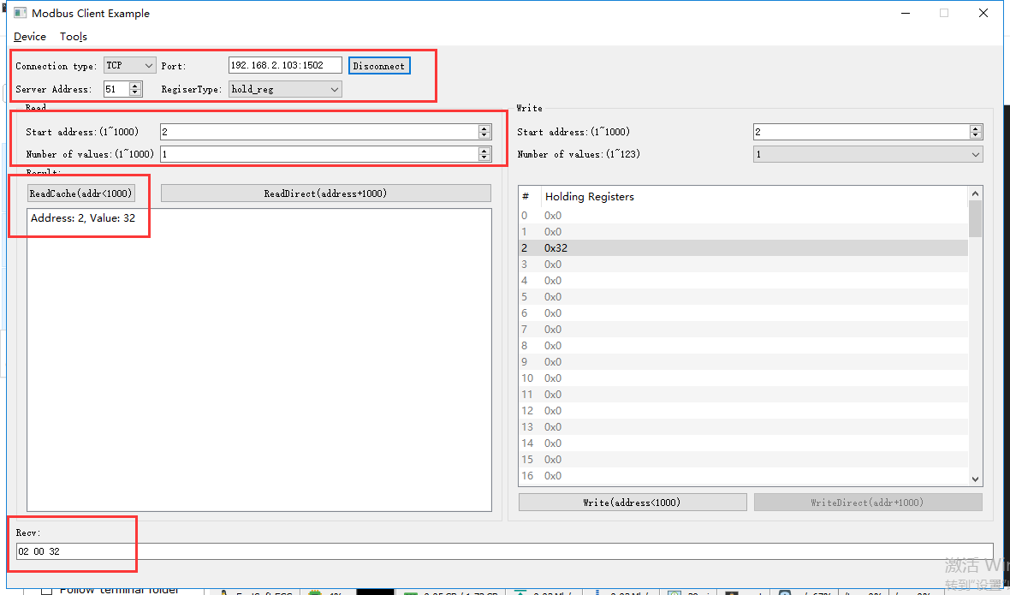

rcv from 192.168.2.113:52184:

[ 00 10 00 00 00 06 33 03 00 02 00 01 ]

snd to 192.168.2.113:52184:

[ 00 10 00 00 00 05 33 03 02 00 32 ]

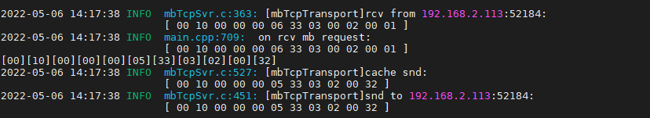

#### 开度控制--100%

写开度

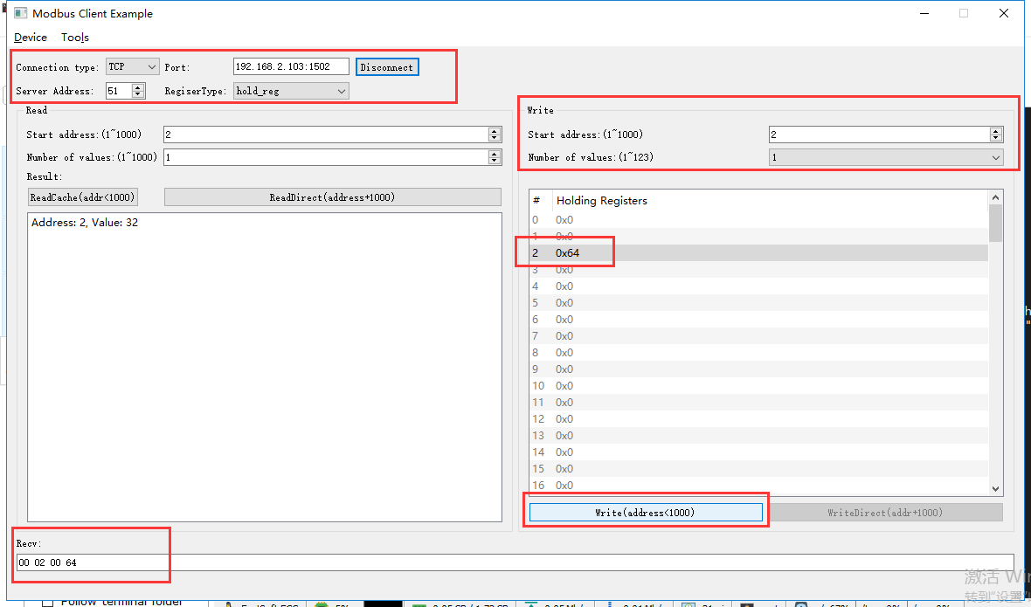

rcv from 192.168.2.113:52184:

[ 00 11 00 00 00 06 33 06 00 02 00 64 ]

snd to 192.168.2.113:52184:

[ 00 11 00 00 00 06 33 06 00 02 00 64 ]

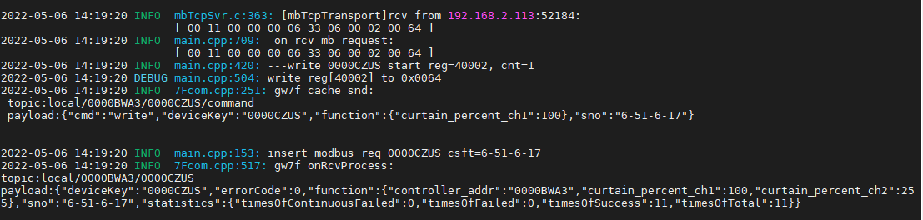

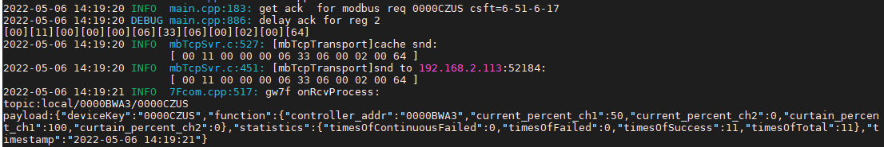

直读开度

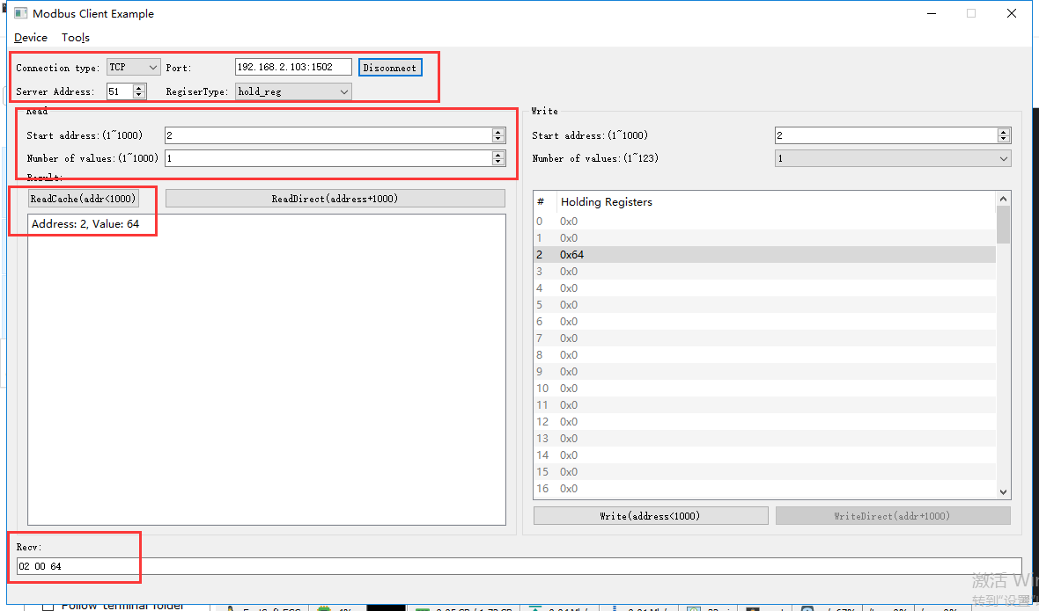

rcv from 192.168.2.113:52184:

[ 00 12 00 00 00 06 33 03 00 02 00 01 ]

snd to 192.168.2.113:52184:

[ 00 12 00 00 00 05 33 03 02 00 64 ]

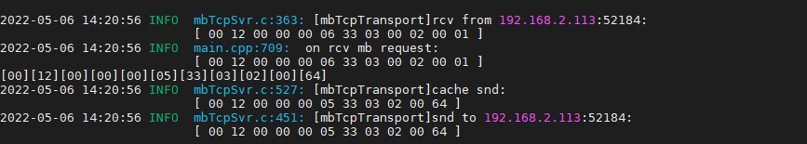

#### 开度控制--101%

写开度

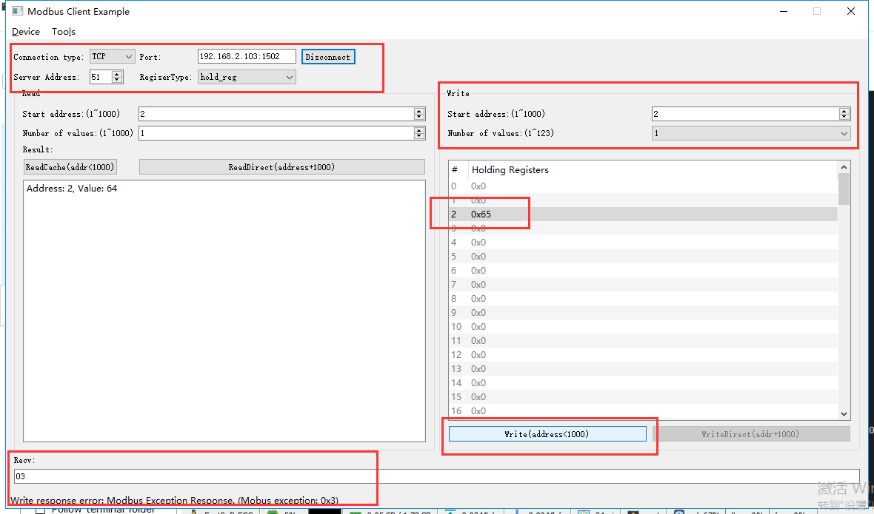

rcv from 192.168.2.113:52184:

[ 00 13 00 00 00 06 33 06 00 02 00 65 ]

snd to 192.168.2.113:52184:

[ 00 13 00 00 00 03 33 86 03 ]

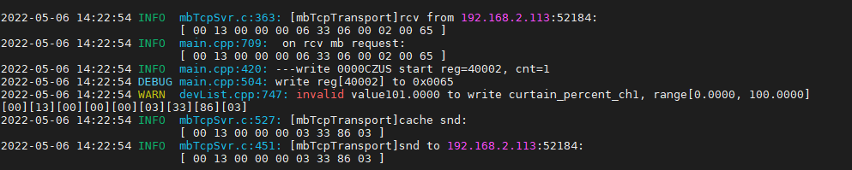

直读开度

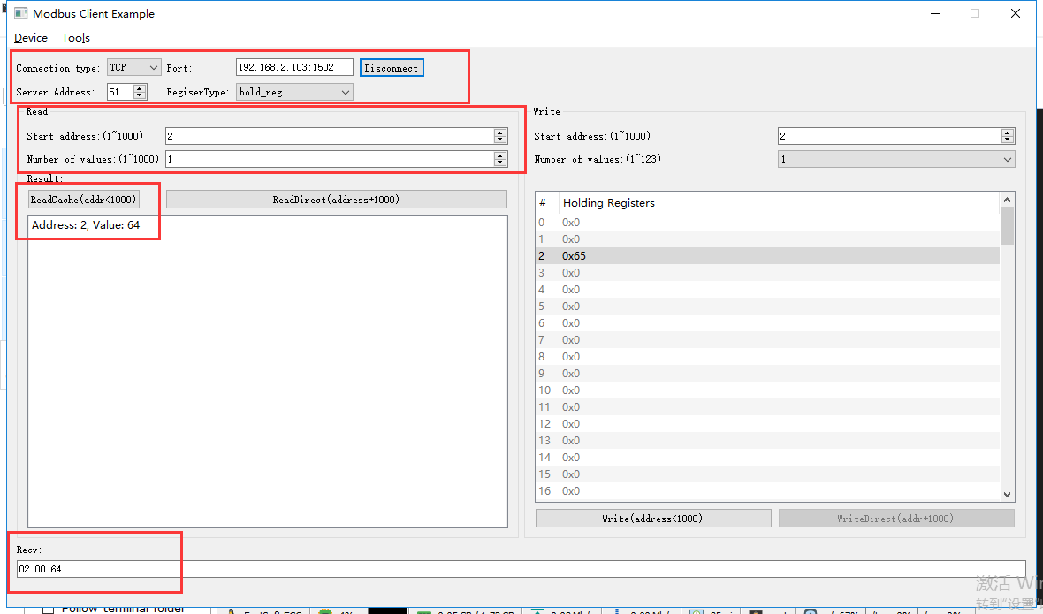

rcv from 192.168.2.113:52184:

[ 00 14 00 00 00 06 33 03 00 02 00 01 ]

snd to 192.168.2.113:52184:

[ 00 14 00 00 00 05 33 03 02 00 64 ]

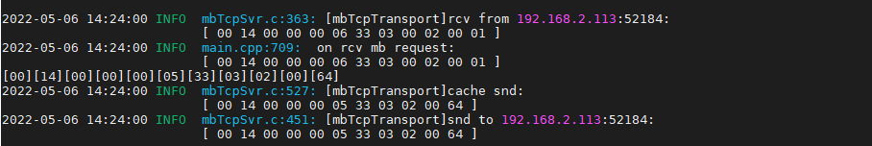

开度仍然是100%

## 通道2

### 打开

只写0x06

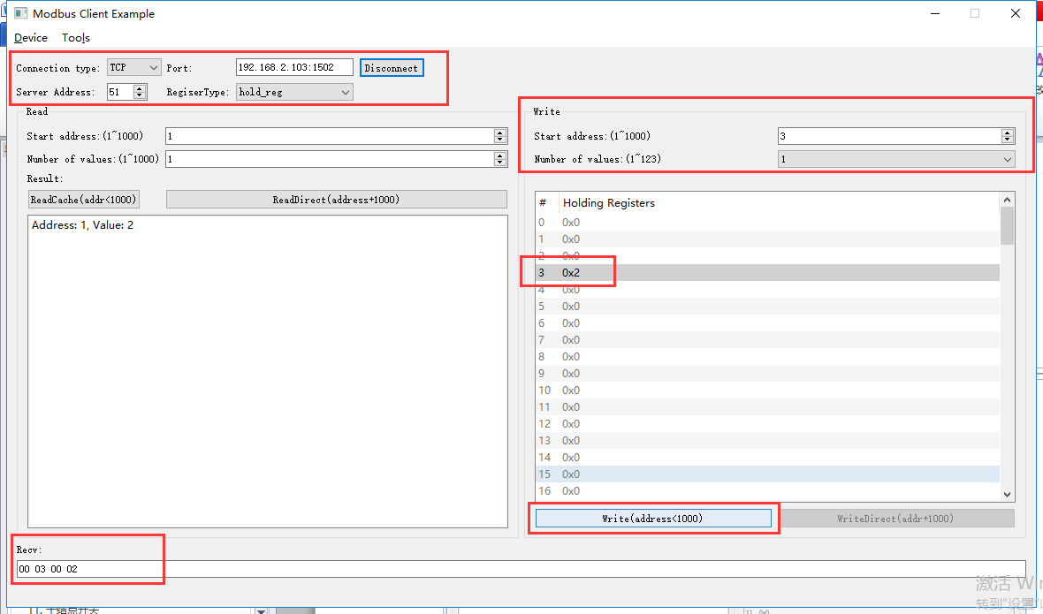

rcv from 192.168.2.113:52184:

[ 00 16 00 00 00 06 33 06 00 03 00 02 ]

snd to 192.168.2.113:52184:

[ 00 16 00 00 00 06 33 06 00 03 00 02 ]

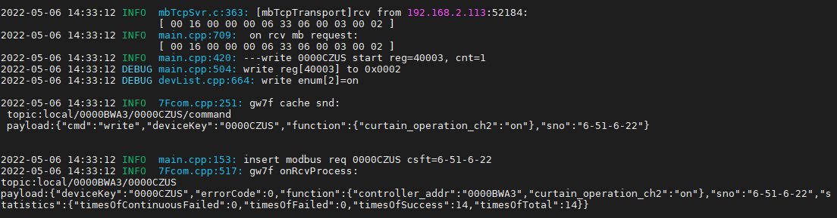

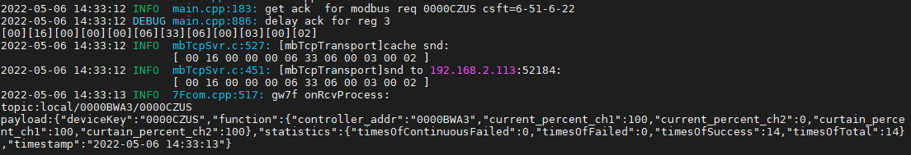

可读写0x03

读取当前状态

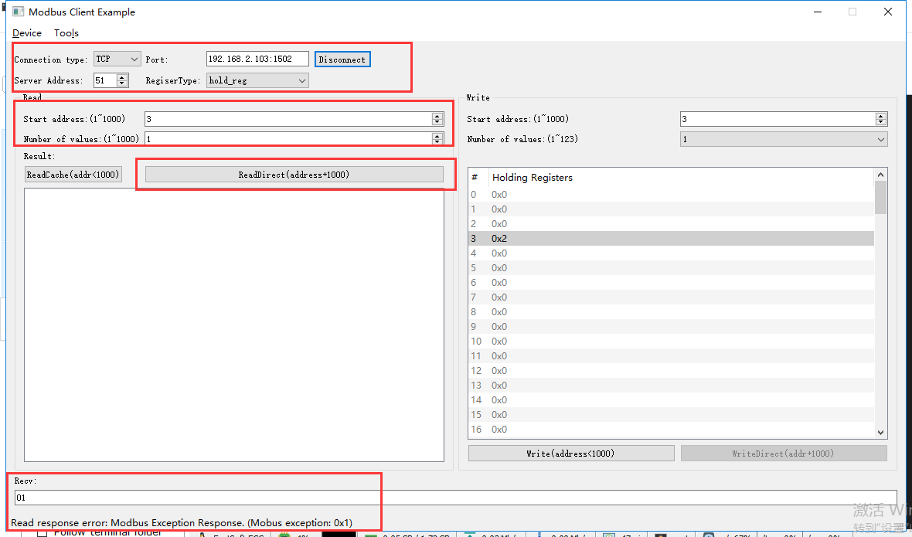

rcv from 192.168.2.113:52184:

[ 00 19 00 00 00 06 33 03 03 eb 00 01 ]

snd to 192.168.2.113:52184:

[ 00 19 00 00 00 03 33 83 01 ]

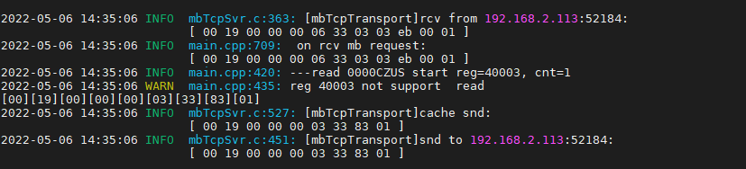

回复错误

多个寄存器0x10

反转+开度100%（矛盾任务）

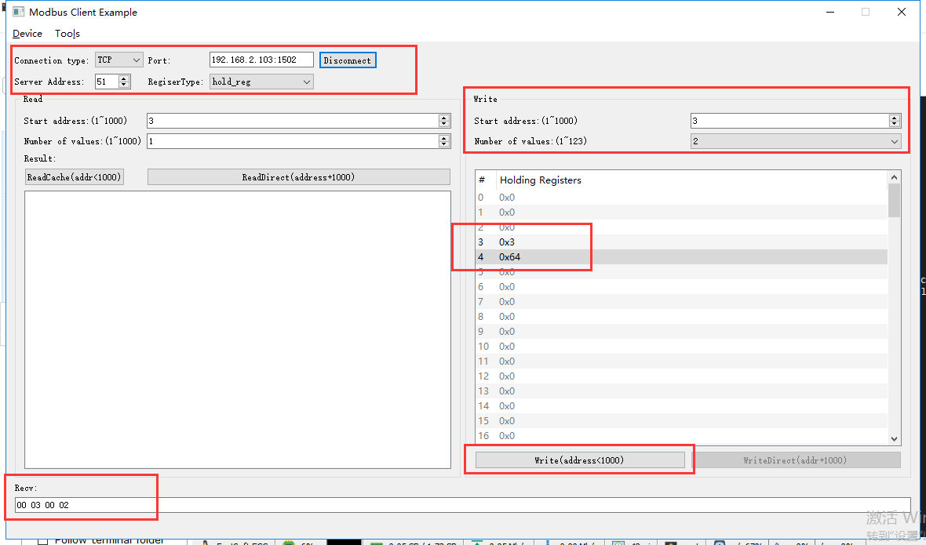

rcv from 192.168.2.113:52184:

[ 00 1a 00 00 00 0b 33 10 00 03 00 02 04 00 03 00 64 ]

snd to 192.168.2.113:52184:

[ 00 1a 00 00 00 06 33 10 00 03 00 02 ]

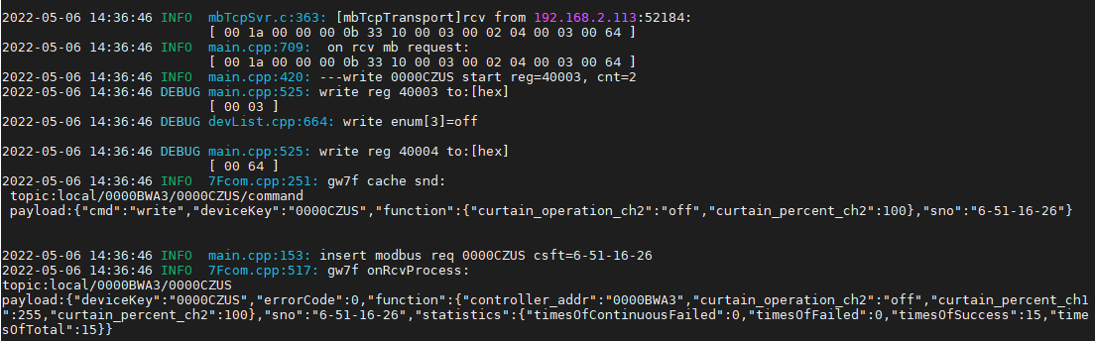

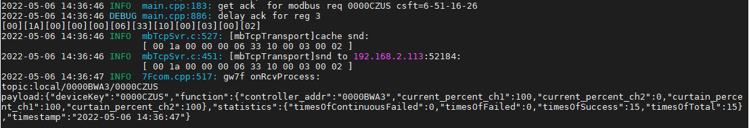

响应反转指令

### 暂停

只写0x06

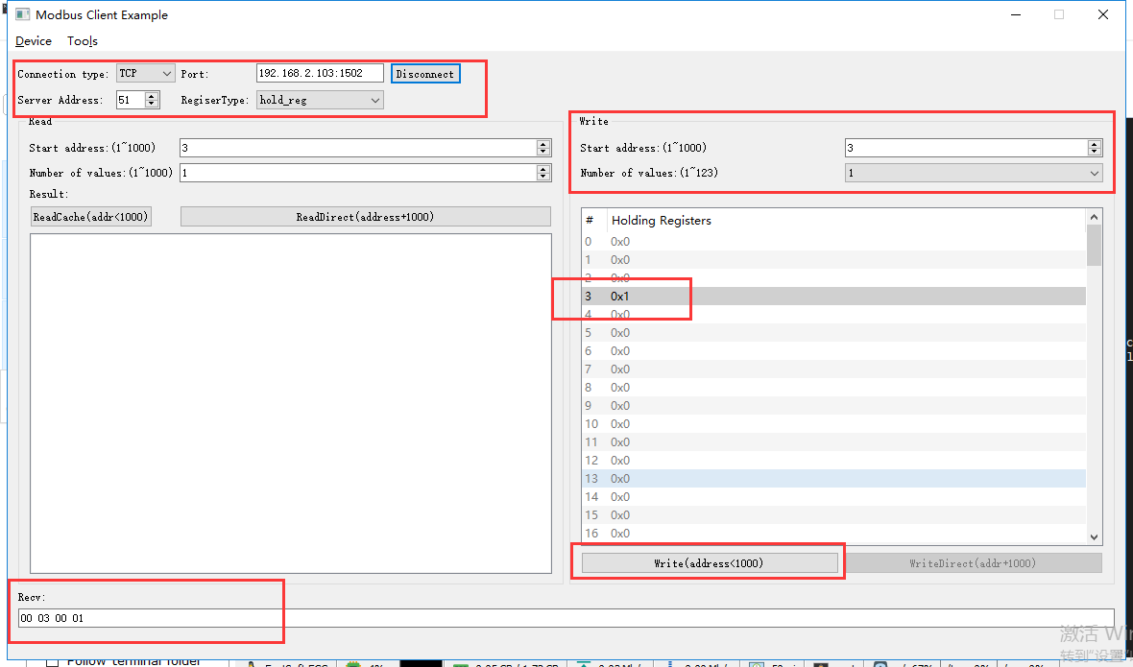

rcv from 192.168.2.113:52184:

[ 00 1d 00 00 00 06 33 06 00 03 00 01 ]

snd to 192.168.2.113:52184:

[ 00 1d 00 00 00 06 33 06 00 03 00 01 ]

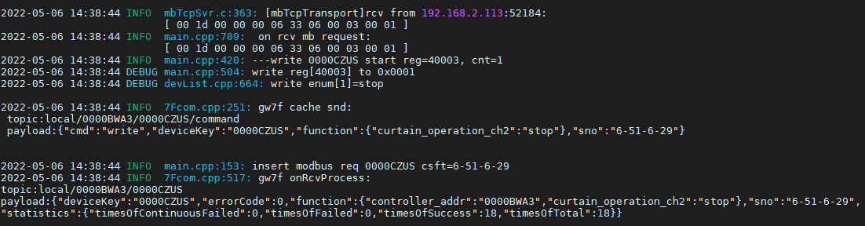

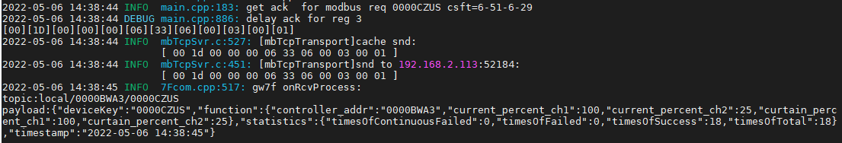

可读写0x03

读取当前状态

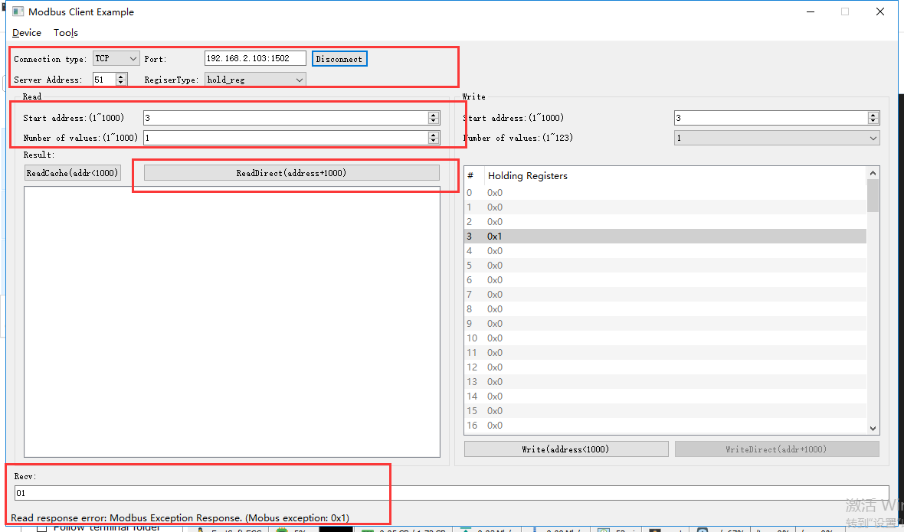

rcv from 192.168.2.113:52184:

[ 00 1e 00 00 00 06 33 03 03 eb 00 01 ]

snd to 192.168.2.113:52184:

[ 00 1e 00 00 00 03 33 83 01 ]

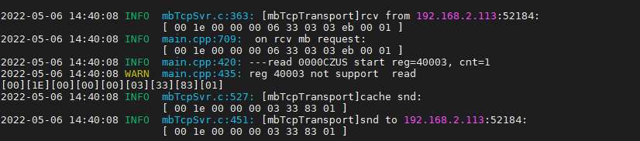

回复错误

多个寄存器0x10

正转+开度0%（矛盾任务）

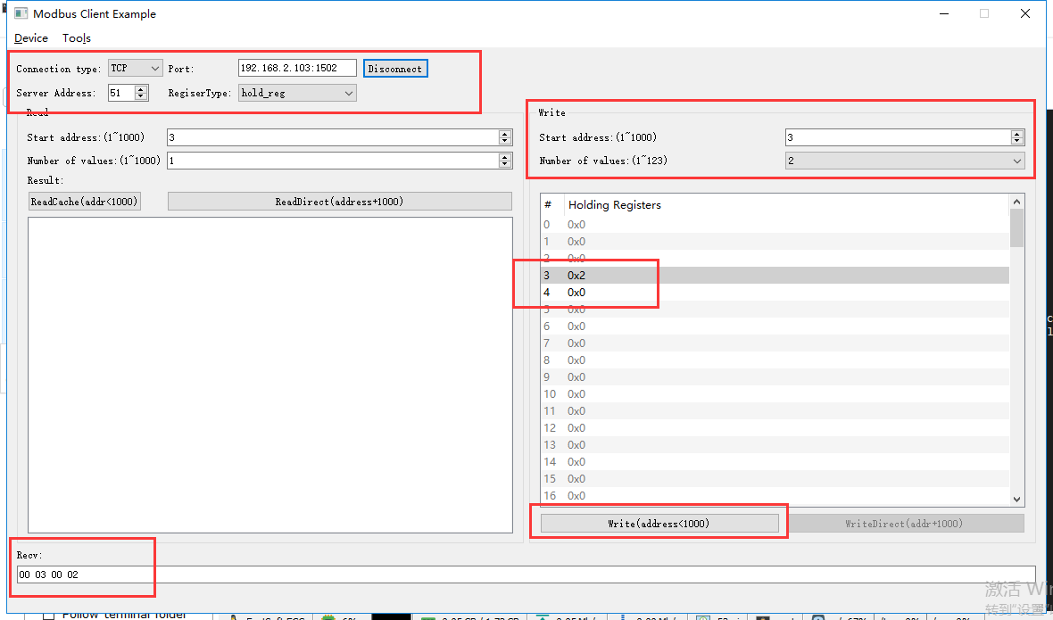

rcv from 192.168.2.113:52184:

[ 00 1f 00 00 00 0b 33 10 00 03 00 02 04 00 02 00 00 ]

snd to 192.168.2.113:52184:

[ 00 1f 00 00 00 06 33 10 00 03 00 02 ]

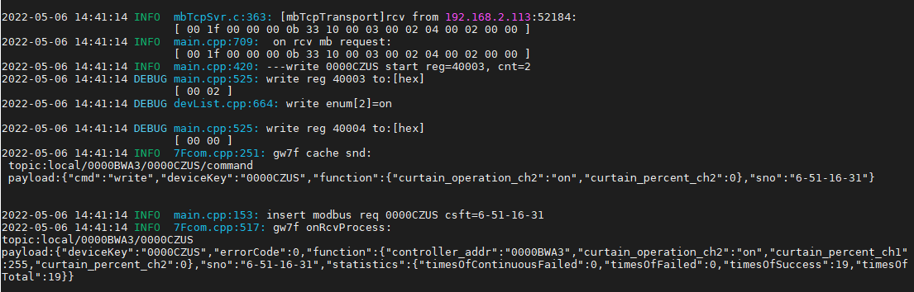

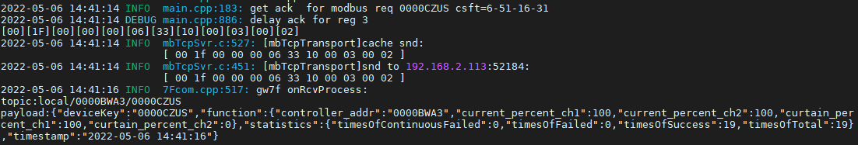

响应正转指令

### 关闭

只写0x06

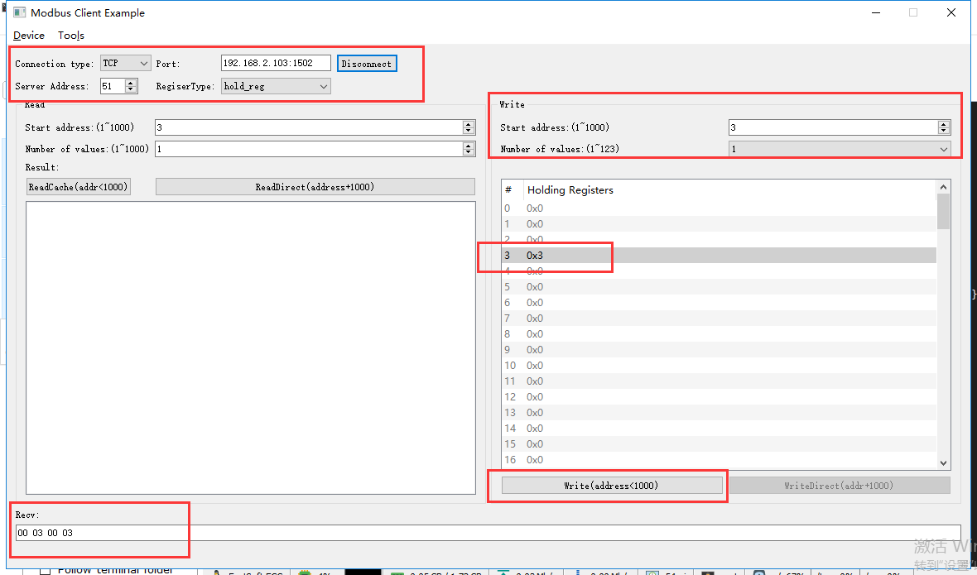

rcv from 192.168.2.113:52184:

[ 00 20 00 00 00 06 33 06 00 03 00 03 ]

snd to 192.168.2.113:52184:

[ 00 20 00 00 00 06 33 06 00 03 00 03 ]

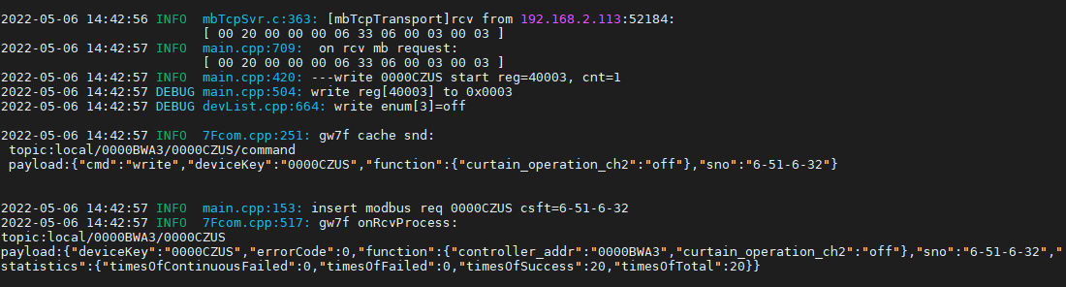

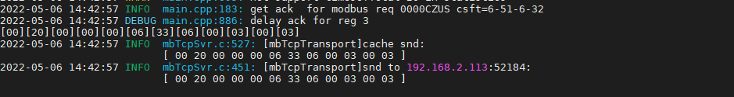

可读写0x03

读取当前状态

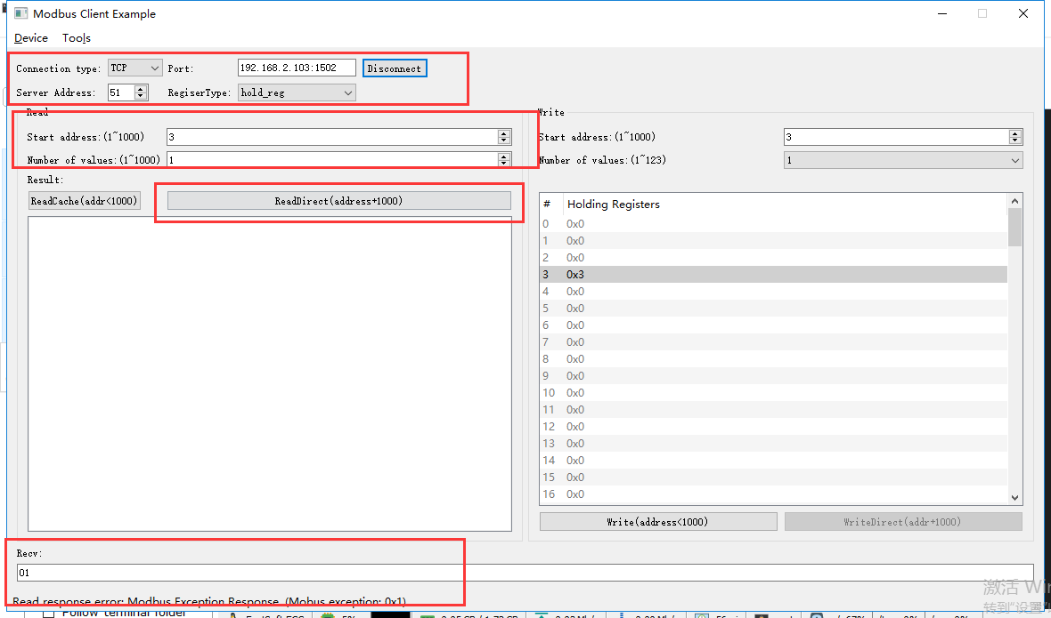

rcv from 192.168.2.113:52184:

[ 00 21 00 00 00 06 33 03 03 eb 00 01 ]

snd to 192.168.2.113:52184:

[ 00 21 00 00 00 03 33 83 01 ]

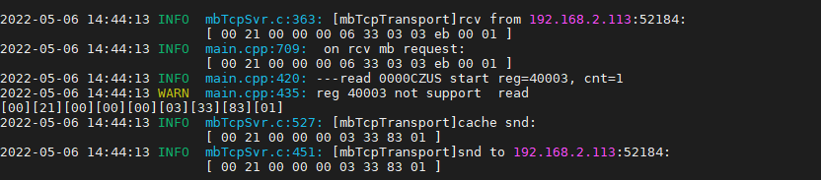

回复错误

多个寄存器0x10

反转+开度100%（矛盾任务）

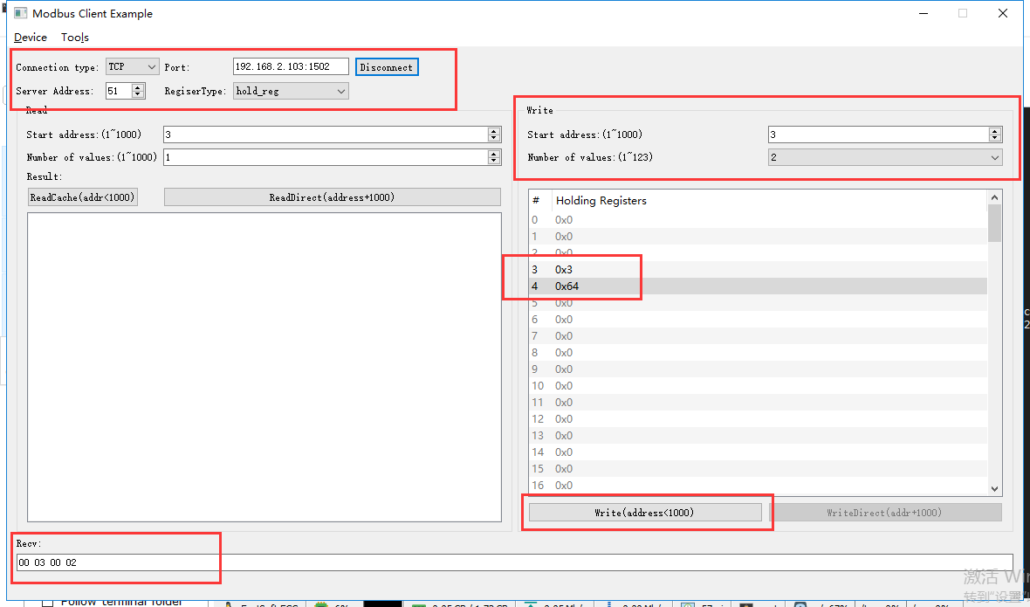

rcv from 192.168.2.113:52184:

[ 00 22 00 00 00 0b 33 10 00 03 00 02 04 00 03 00 64 ]

snd to 192.168.2.113:52184:

[ 00 22 00 00 00 06 33 10 00 03 00 02 ]

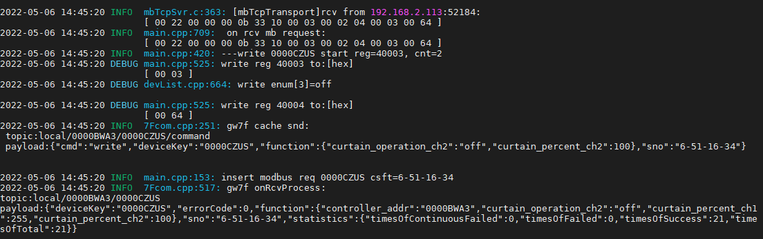

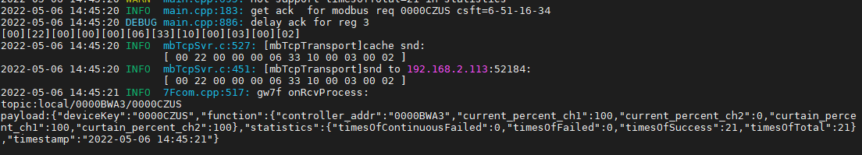

响应反转指令

### 开度控制

#### 开度控制--1%

写开度

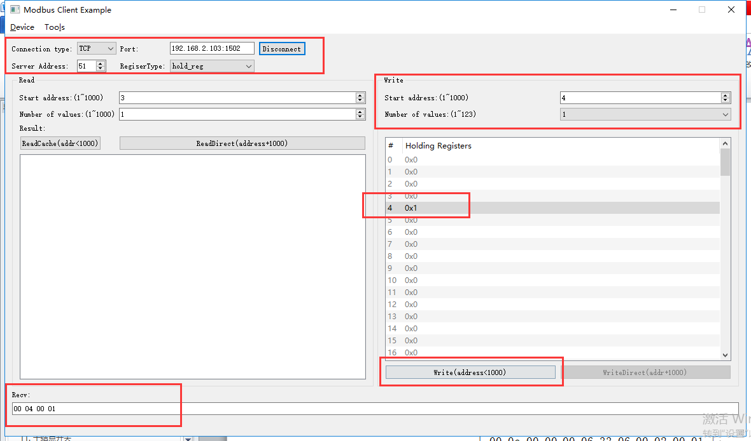

rcv from 192.168.2.113:52184:

[ 00 23 00 00 00 06 33 06 00 04 00 01 ]

snd to 192.168.2.113:52184:

[ 00 23 00 00 00 06 33 06 00 04 00 01 ]

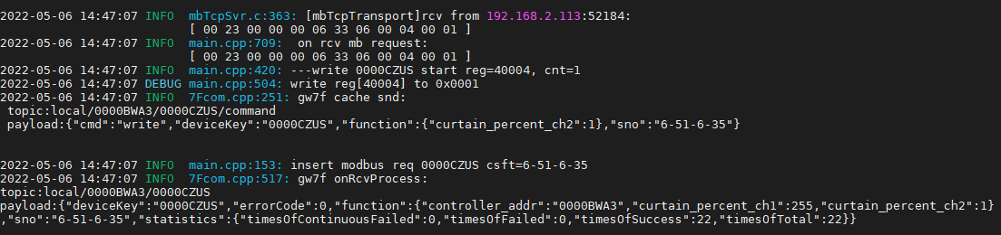

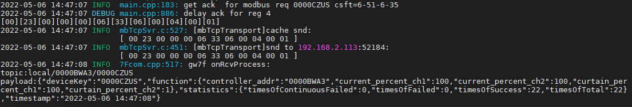

直读开度

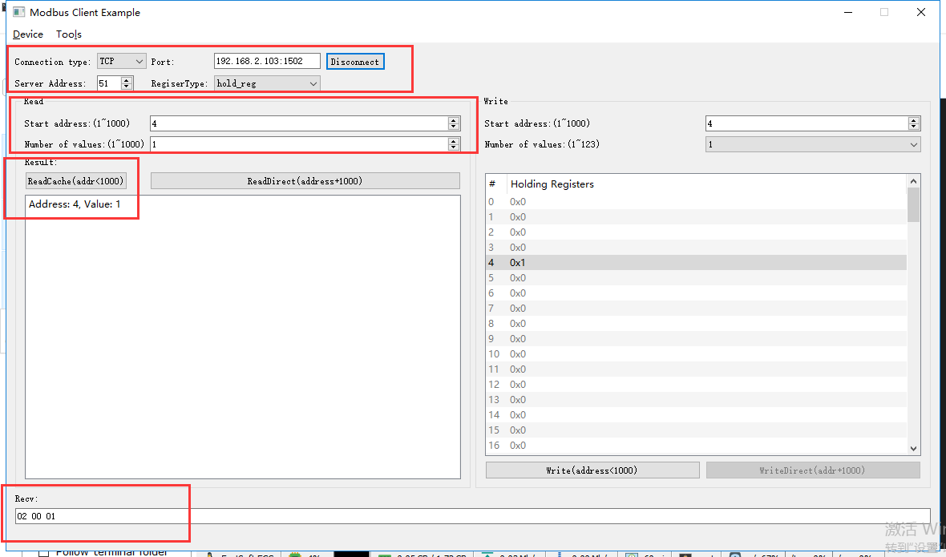

rcv from 192.168.2.113:52184:

[ 00 25 00 00 00 06 33 03 00 04 00 01 ]

snd to 192.168.2.113:52184:

[ 00 25 00 00 00 05 33 03 02 00 01 ]



#### 开度控制--50%

写开度

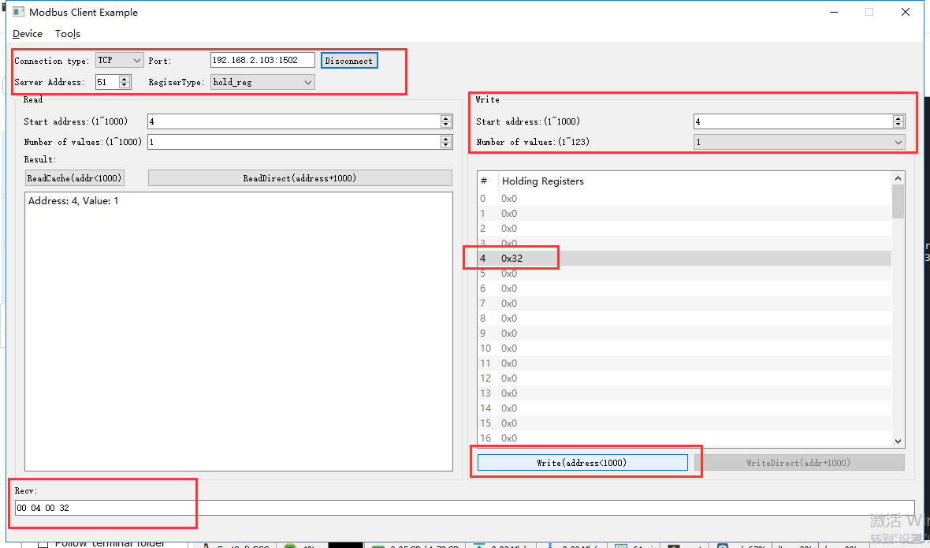

rcv from 192.168.2.113:52184:

[ 00 26 00 00 00 06 33 06 00 04 00 32 ]

snd to 192.168.2.113:52184:

[ 00 26 00 00 00 06 33 06 00 04 00 32 ]

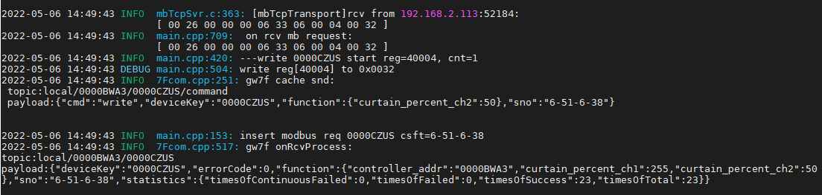

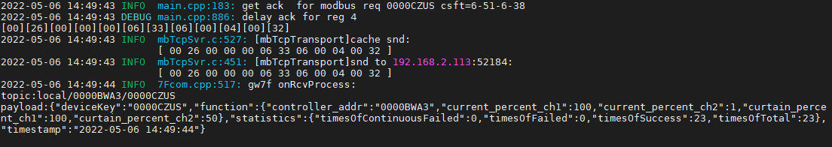

直读开度

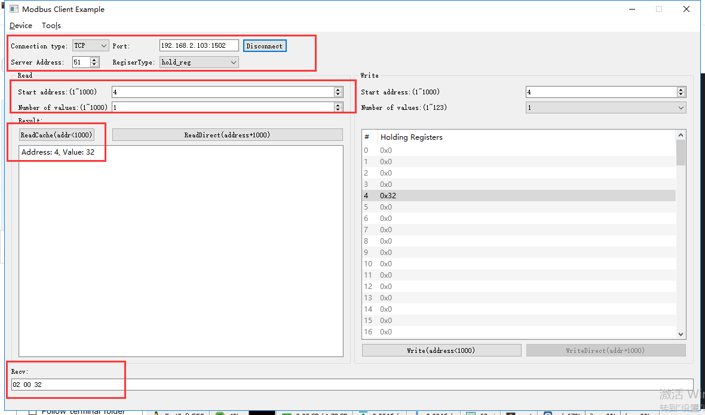

rcv from 192.168.2.113:52184:

[ 00 27 00 00 00 06 33 03 00 04 00 01 ]

snd to 192.168.2.113:52184:

[ 00 27 00 00 00 05 33 03 02 00 32 ]

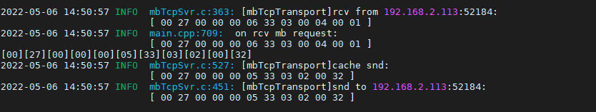

#### 开度控制--100%

写开度

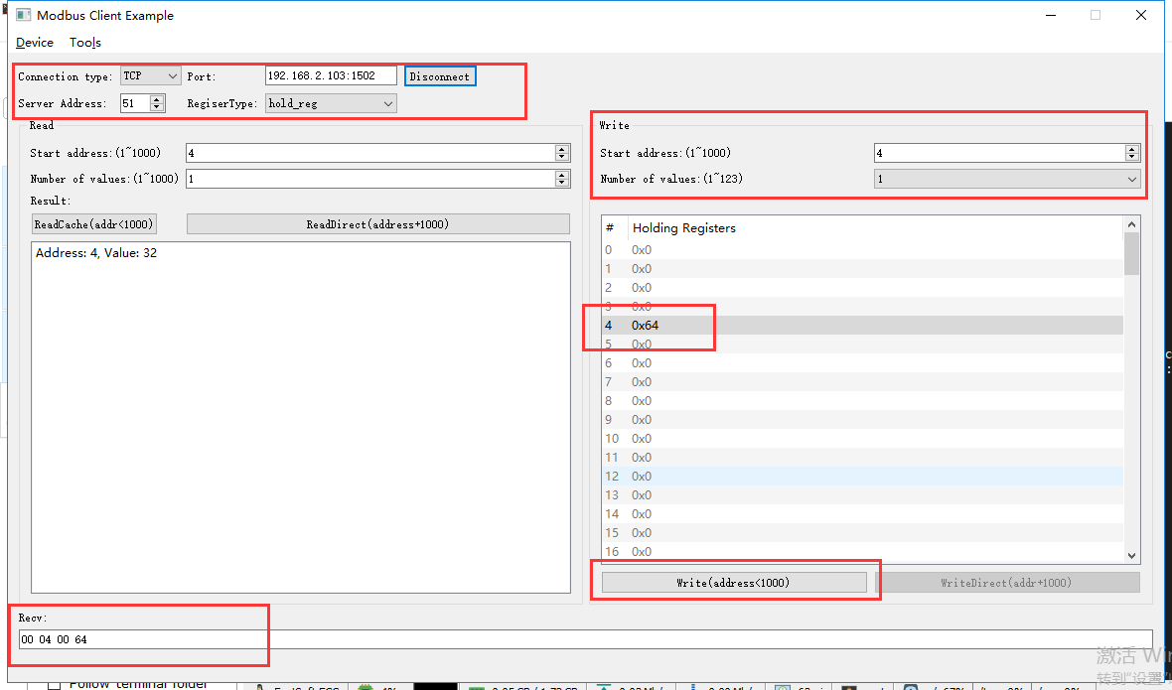

rcv from 192.168.2.113:52184:

[ 00 28 00 00 00 06 33 06 00 04 00 64 ]

snd to 192.168.2.113:52184:

[ 00 28 00 00 00 06 33 06 00 04 00 64 ]

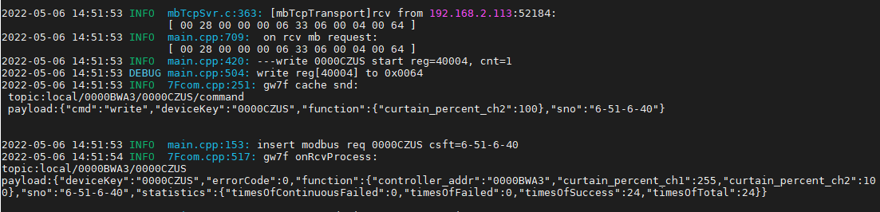

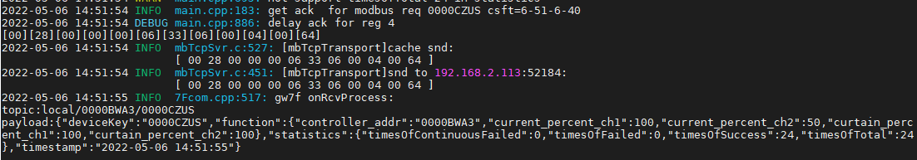

直读开度

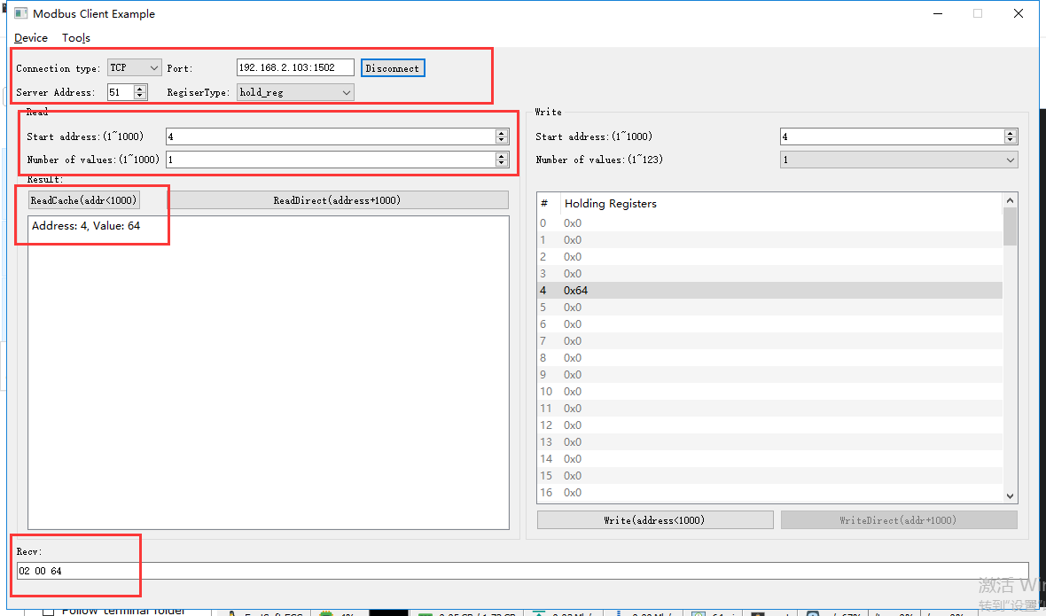

rcv from 192.168.2.113:52184:

[ 00 29 00 00 00 06 33 03 00 04 00 01 ]

snd to 192.168.2.113:52184:

[ 00 29 00 00 00 05 33 03 02 00 64 ]

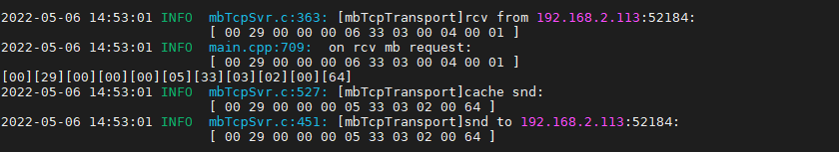

#### 开度控制--101%

写开度

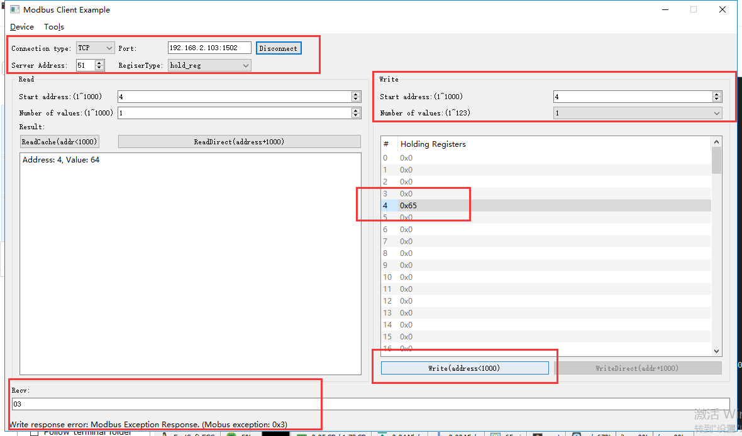

rcv from 192.168.2.113:52184:

[ 00 2a 00 00 00 06 33 06 00 04 00 65 ]

snd to 192.168.2.113:52184:

[ 00 2a 00 00 00 03 33 86 03 ]

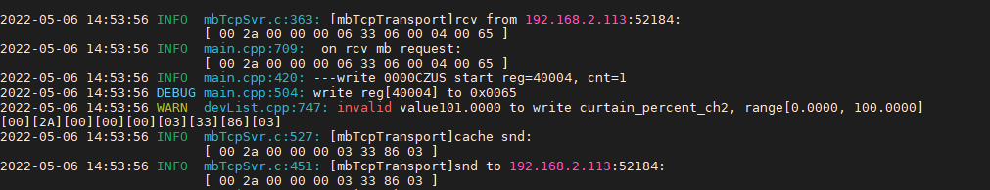

直读开度

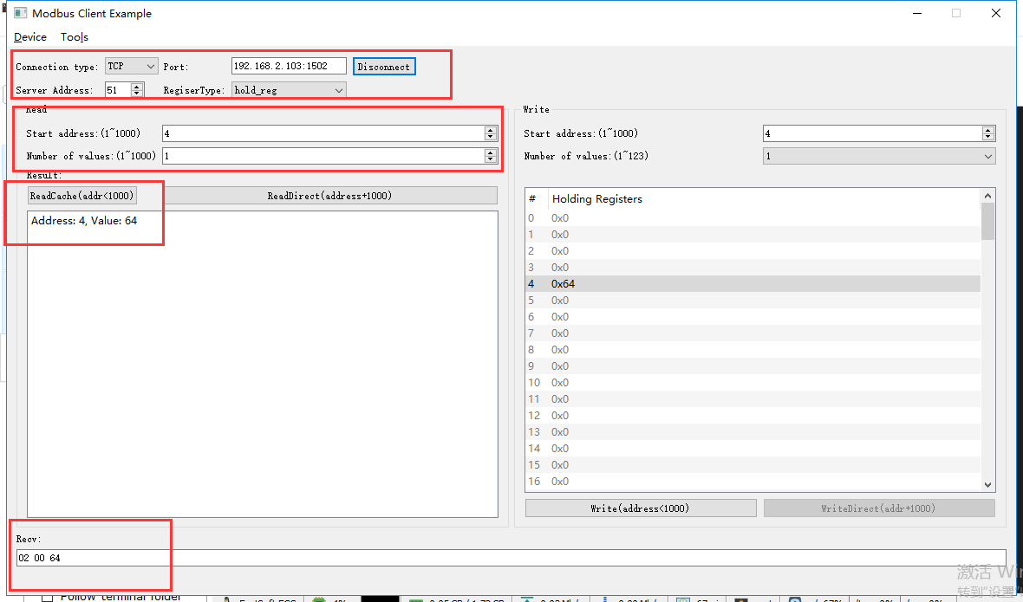

rcv from 192.168.2.113:52346:

[ 00 2e 00 00 00 06 33 03 00 04 00 01 ]

snd to 192.168.2.113:52346:

[ 00 2e 00 00 00 05 33 03 02 00 64 ]

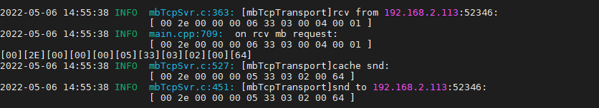

开度仍然是100%

# 调光控制模块ok

**说明：**根据转换程序所支持的设备，典型选取一种测试。

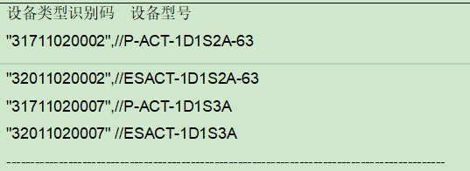

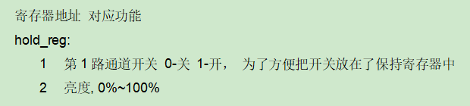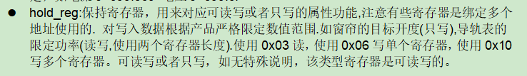

## 通道开

### 写入开

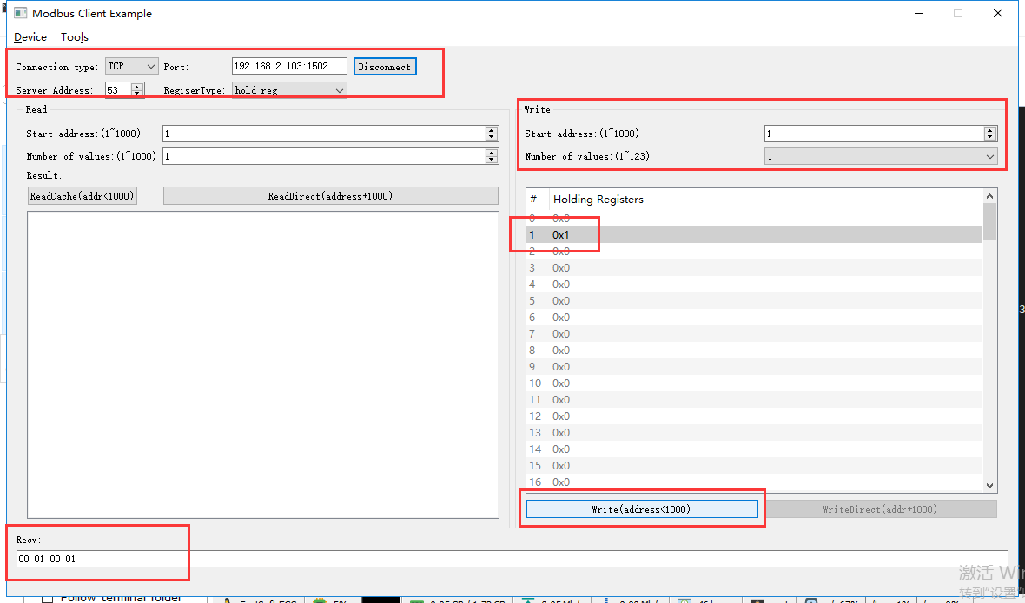

rcv from 192.168.2.113:54542:

[ 00 0a 00 00 00 06 35 06 00 01 00 01 ]

snd to 192.168.2.113:54542:

[ 00 0a 00 00 00 06 35 06 00 01 00 01 ]

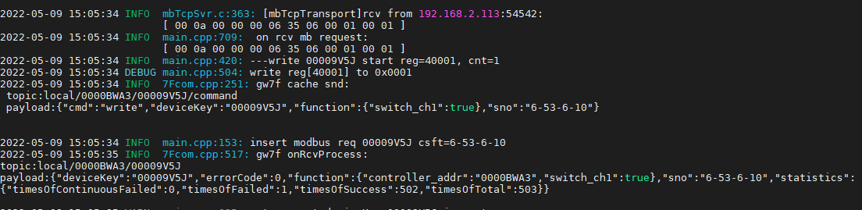



### 直读

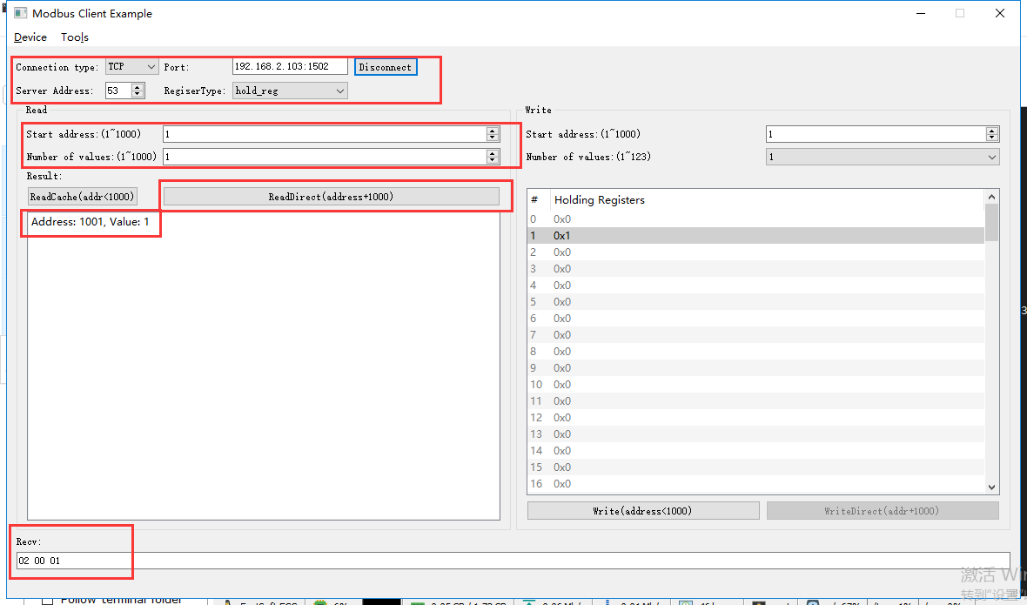

rcv from 192.168.2.113:54542:

[ 00 0b 00 00 00 06 35 03 03 e9 00 01 ]

snd to 192.168.2.113:54542:

[ 00 0b 00 00 00 05 35 03 02 00 01 ]

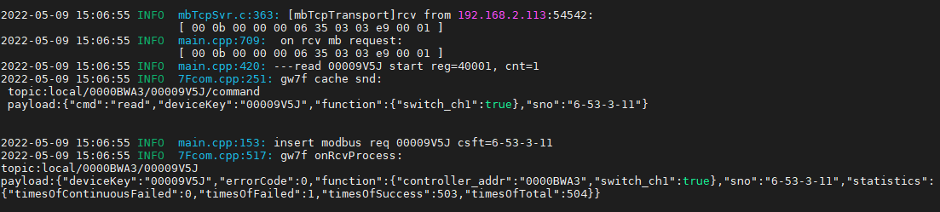

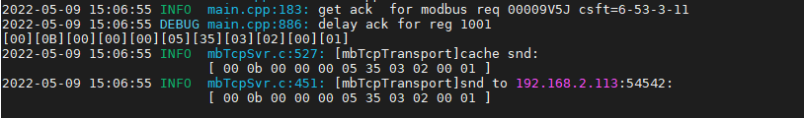

### 读缓存

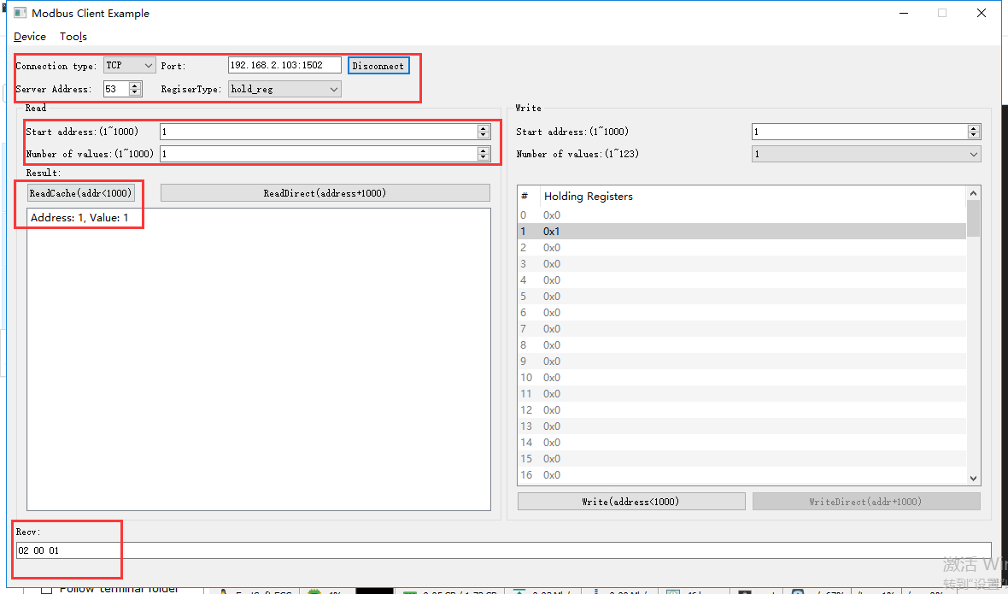

rcv from 192.168.2.113:54542:

[ 00 0c 00 00 00 06 35 03 00 01 00 01 ]

snd to 192.168.2.113:54542:

[ 00 0c 00 00 00 05 35 03 02 00 01 ]

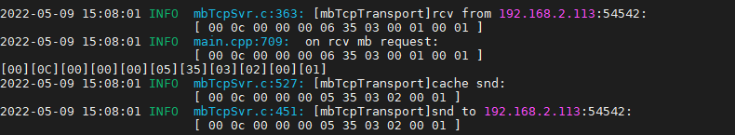

## 通道关

### 写入关

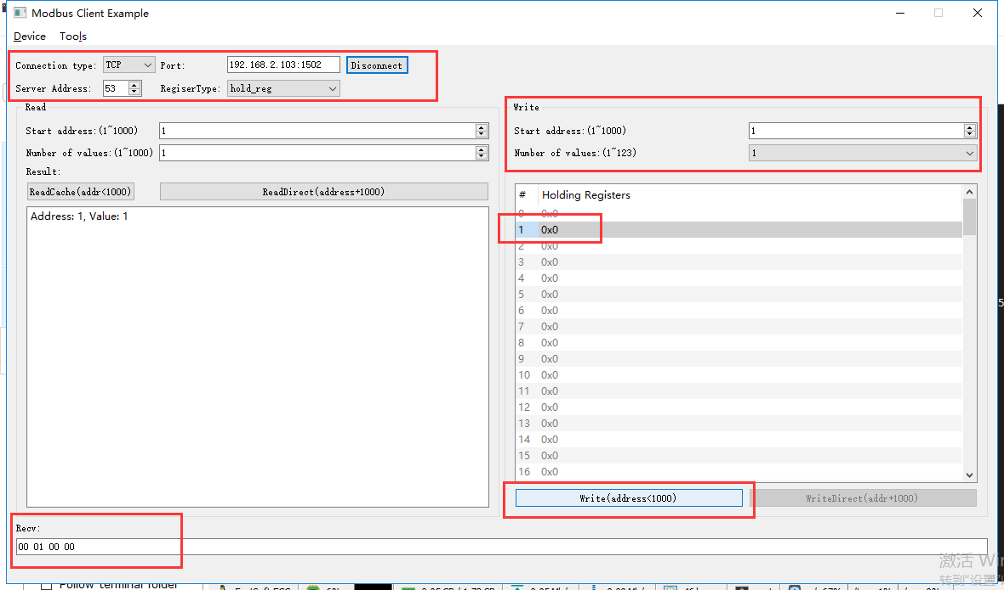

rcv from 192.168.2.113:54542:

[ 00 0d 00 00 00 06 35 06 00 01 00 00 ]

snd to 192.168.2.113:54542:

[ 00 0d 00 00 00 06 35 06 00 01 00 00 ]

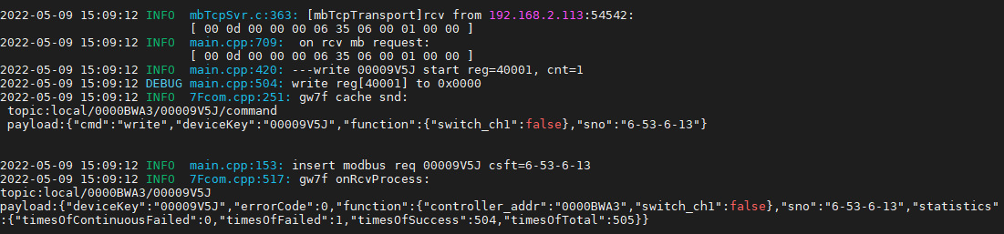

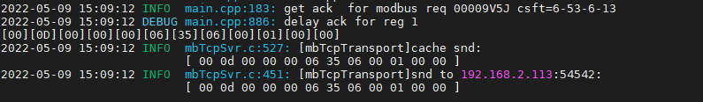

### 直读

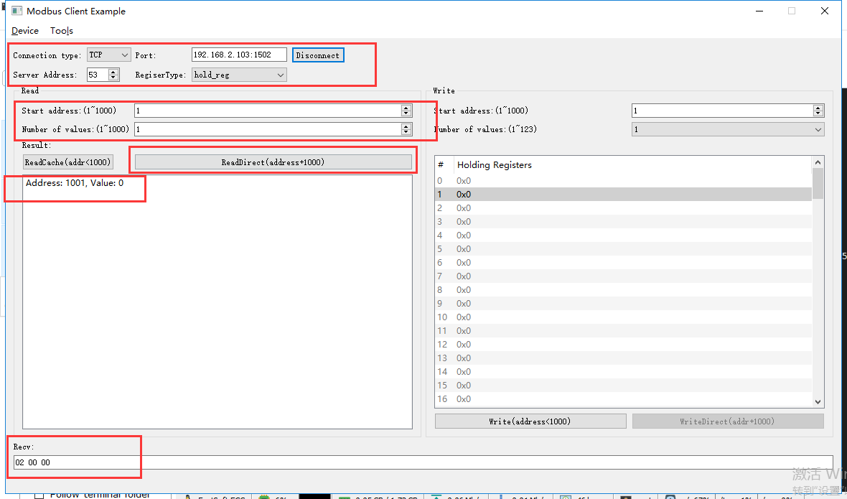

rcv from 192.168.2.113:54542:

[ 00 0e 00 00 00 06 35 03 03 e9 00 01 ]

snd to 192.168.2.113:54542:

[ 00 0e 00 00 00 05 35 03 02 00 00 ]

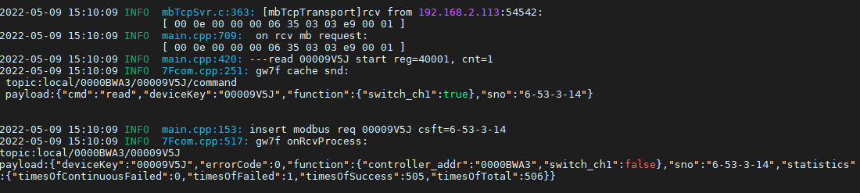

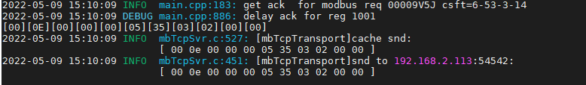

### 读缓存

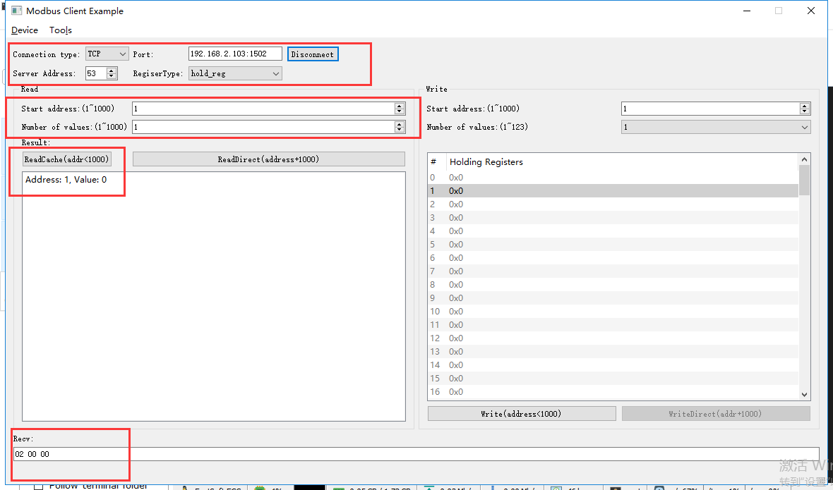

rcv from 192.168.2.113:54542:

[ 00 0f 00 00 00 06 35 03 00 01 00 01 ]

snd to 192.168.2.113:54542:

[ 00 0f 00 00 00 05 35 03 02 00 00 ]

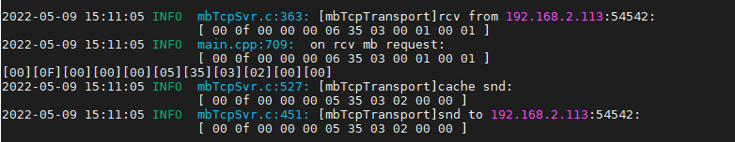

## 亮度控制

### 写入亮度1%

#### 写入

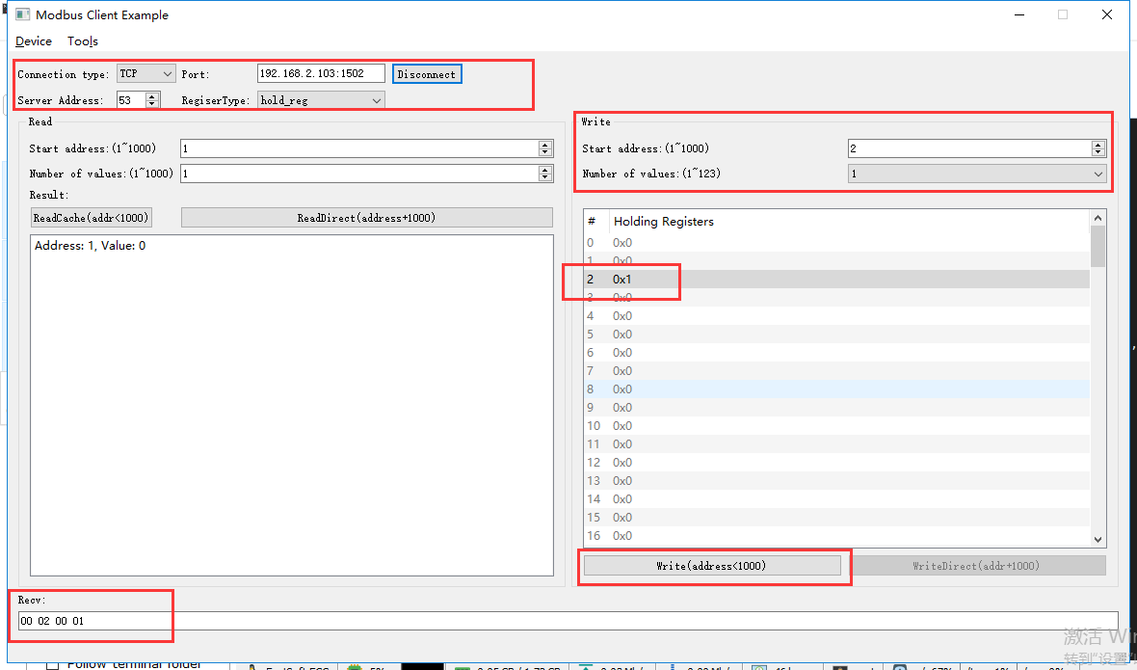

rcv from 192.168.2.113:54542:

[ 00 10 00 00 00 06 35 06 00 02 00 01 ]

snd to 192.168.2.113:54542:

[ 00 10 00 00 00 06 35 06 00 02 00 01 ]

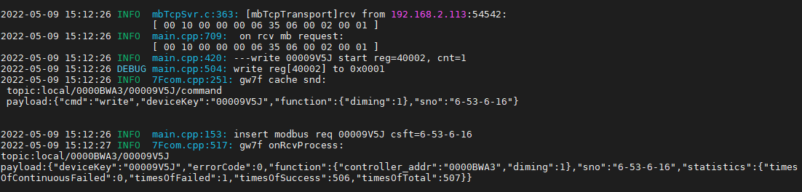

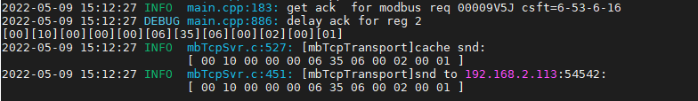

#### 直读

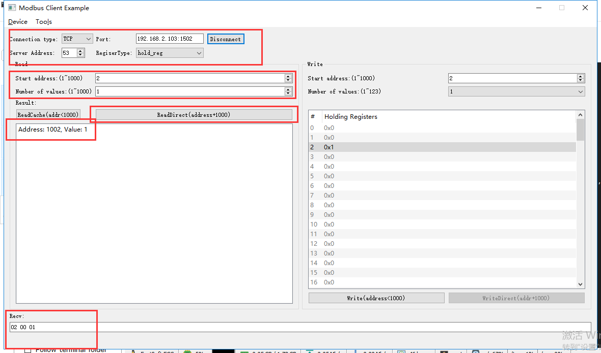

rcv from 192.168.2.113:54542:

[ 00 11 00 00 00 06 35 03 03 ea 00 01 ]

snd to 192.168.2.113:54542:

[ 00 11 00 00 00 05 35 03 02 00 01 ]

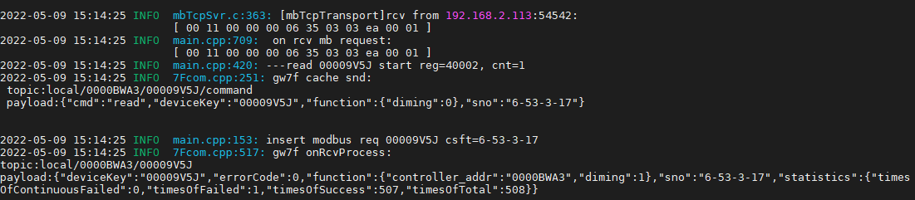

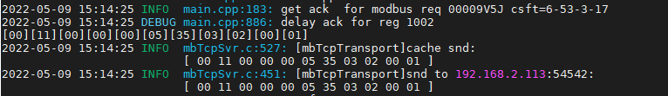

#### 读取缓存

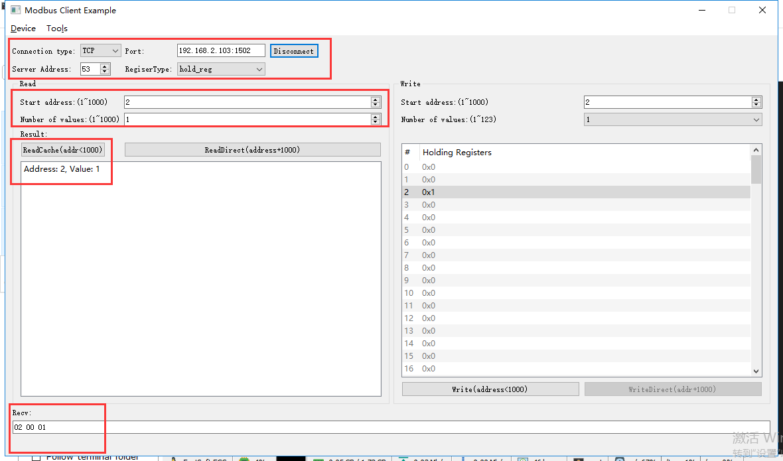

rcv from 192.168.2.113:54542:

[ 00 12 00 00 00 06 35 03 00 02 00 01 ]

snd to 192.168.2.113:54542:

[ 00 12 00 00 00 05 35 03 02 00 01 ]

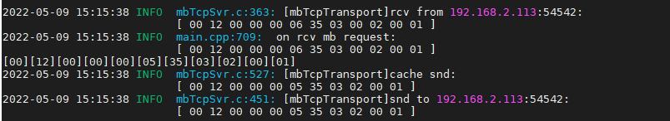

### 写入亮度0%

#### 写入

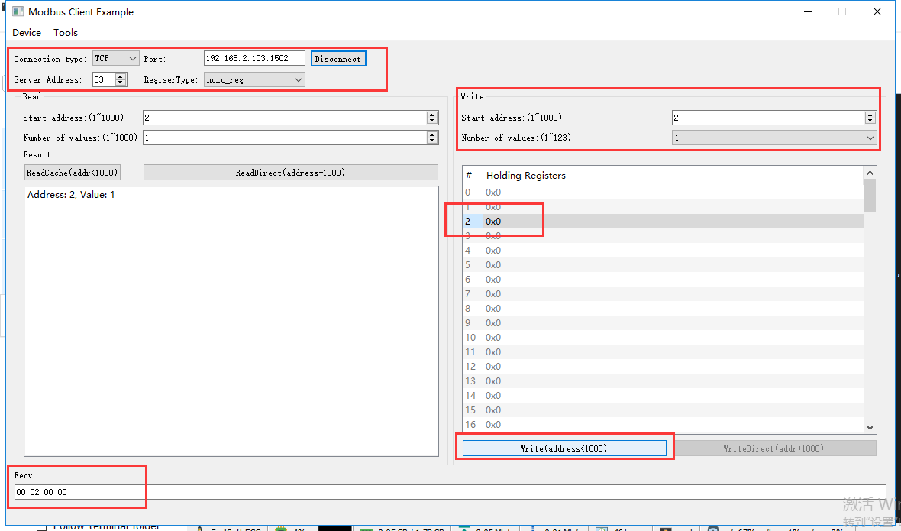

rcv from 192.168.2.113:54542:

[ 00 13 00 00 00 06 35 06 00 02 00 00 ]

snd to 192.168.2.113:54542:

[ 00 13 00 00 00 06 35 06 00 02 00 00 ]

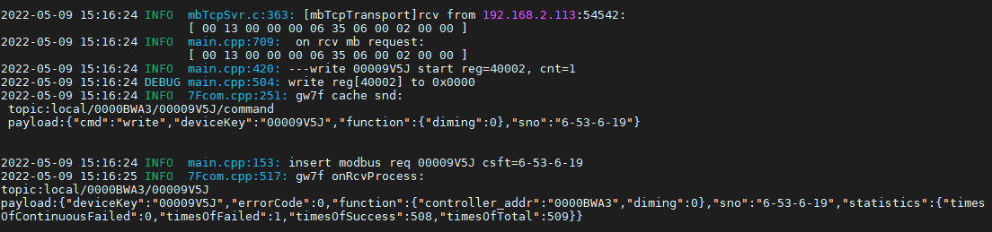

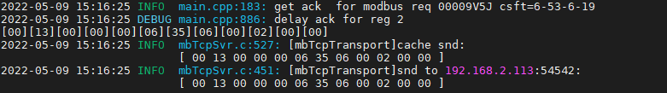

#### 直读

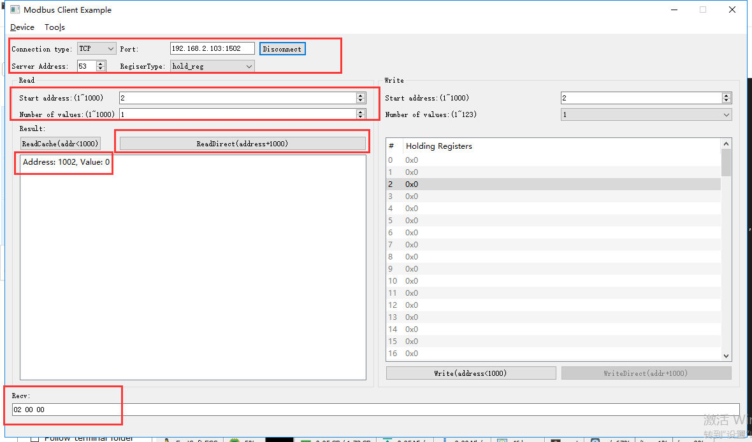

rcv from 192.168.2.113:54542:

[ 00 14 00 00 00 06 35 03 03 ea 00 01 ]

snd to 192.168.2.113:54542:

[ 00 14 00 00 00 05 35 03 02 00 00 ]

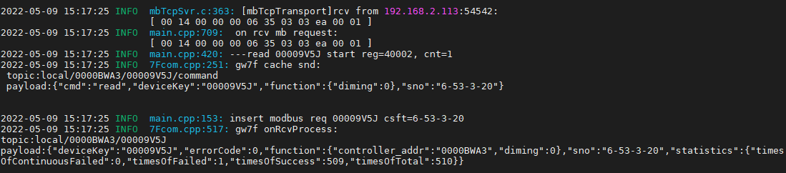



#### 读缓存

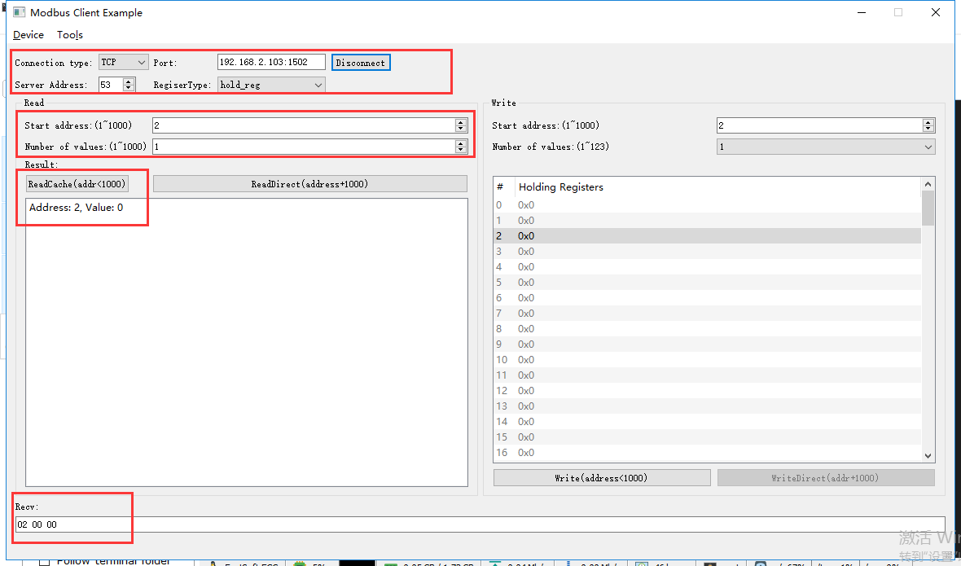

rcv from 192.168.2.113:54542:

[ 00 15 00 00 00 06 35 03 00 02 00 01 ]

snd to 192.168.2.113:54542:

[ 00 15 00 00 00 05 35 03 02 00 00 ]

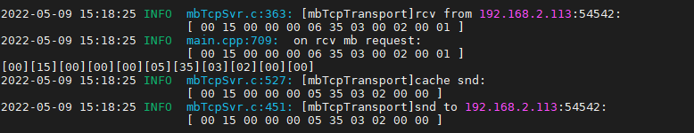

### 写入亮度50%

#### 写入

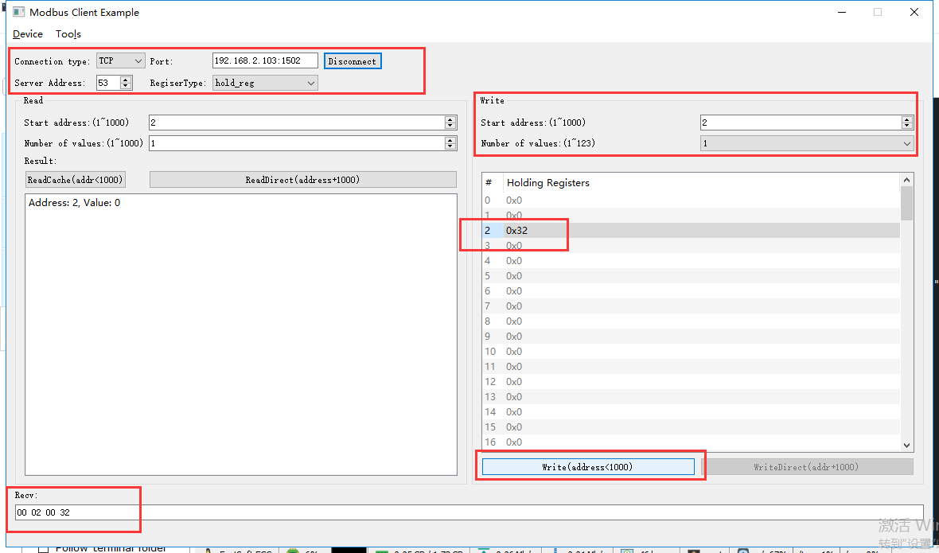

rcv from 192.168.2.113:54542:

[ 00 16 00 00 00 06 35 06 00 02 00 32 ]

snd to 192.168.2.113:54542:

[ 00 16 00 00 00 06 35 06 00 02 00 32 ]

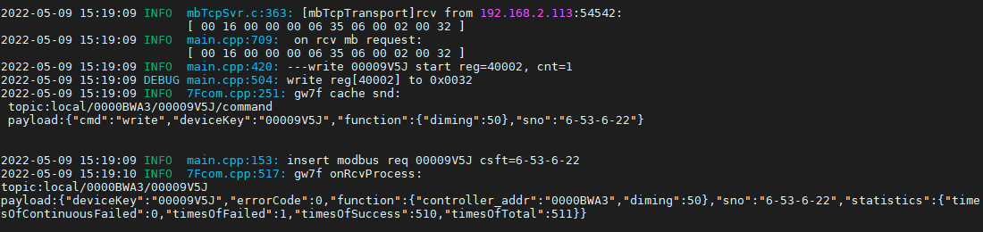

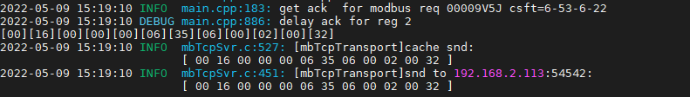

#### 直读

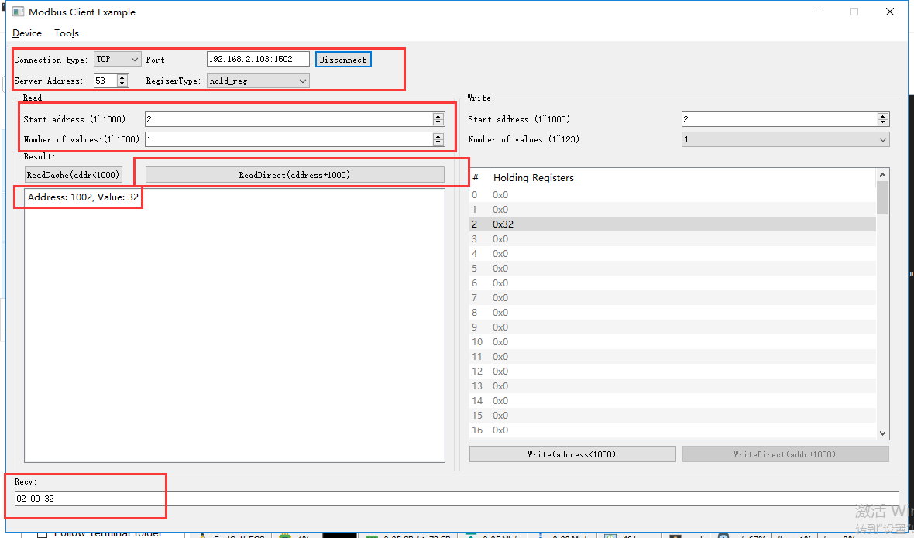

rcv from 192.168.2.113:54542:

[ 00 17 00 00 00 06 35 03 03 ea 00 01 ]

snd to 192.168.2.113:54542:

[ 00 17 00 00 00 05 35 03 02 00 32 ]

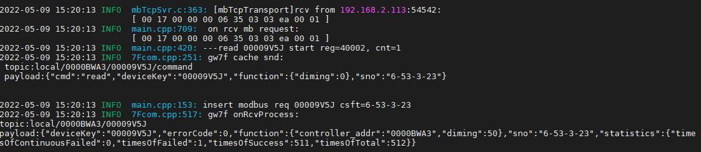

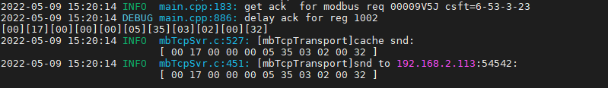

#### 读缓存

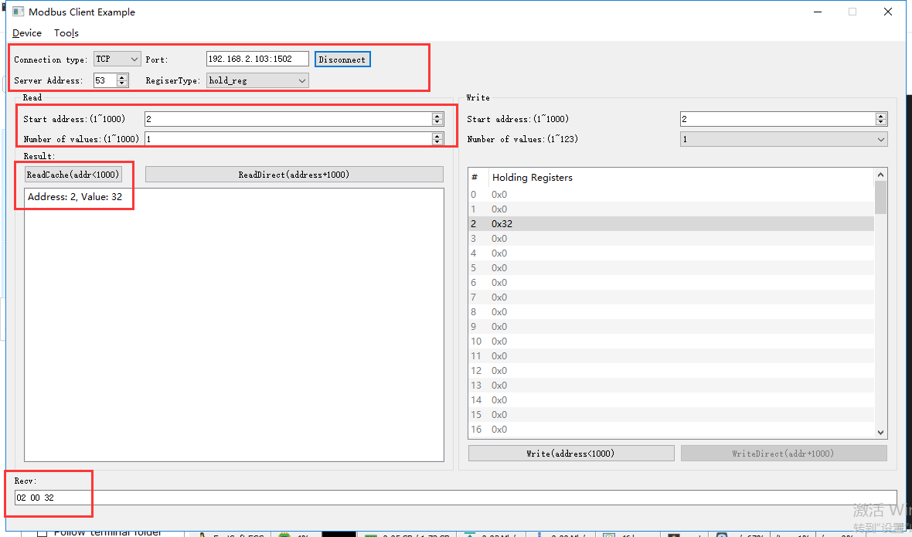

rcv from 192.168.2.113:54542:

[ 00 18 00 00 00 06 35 03 00 02 00 01 ]

snd to 192.168.2.113:54542:

[ 00 18 00 00 00 05 35 03 02 00 32 ]

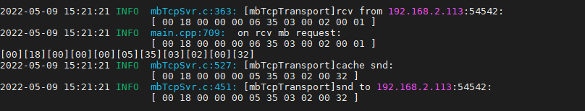

### 写入亮度100%

#### 写入

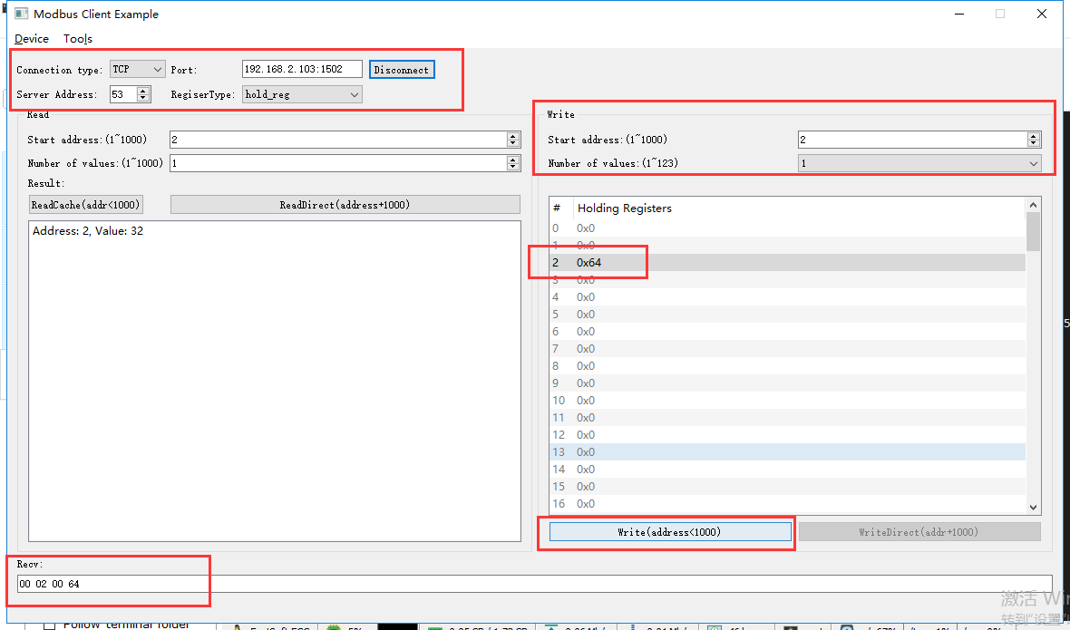

rcv from 192.168.2.113:54542:

[ 00 19 00 00 00 06 35 06 00 02 00 64 ]

snd to 192.168.2.113:54542:

[ 00 19 00 00 00 06 35 06 00 02 00 64 ]

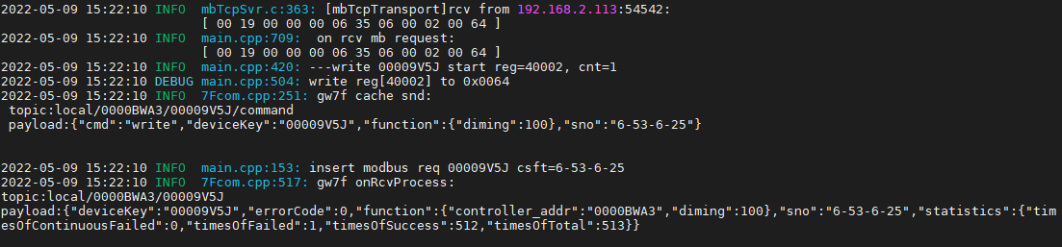

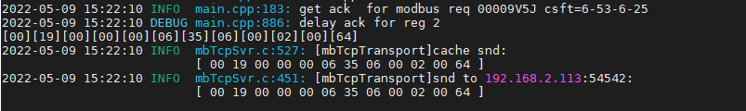

#### 直读

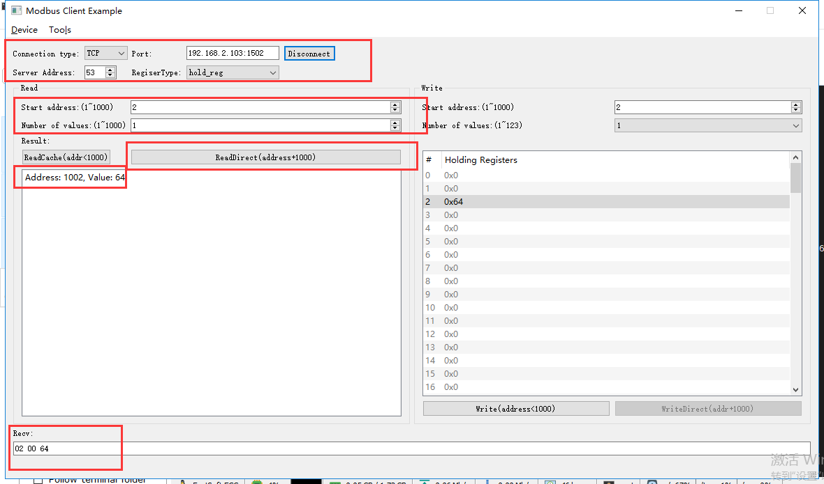

rcv from 192.168.2.113:54542:

[ 00 1a 00 00 00 06 35 03 03 ea 00 01 ]

snd to 192.168.2.113:54542:

[ 00 1a 00 00 00 05 35 03 02 00 64 ]

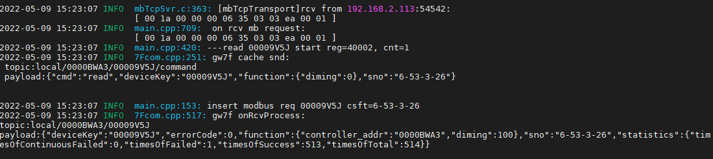



#### 读缓存

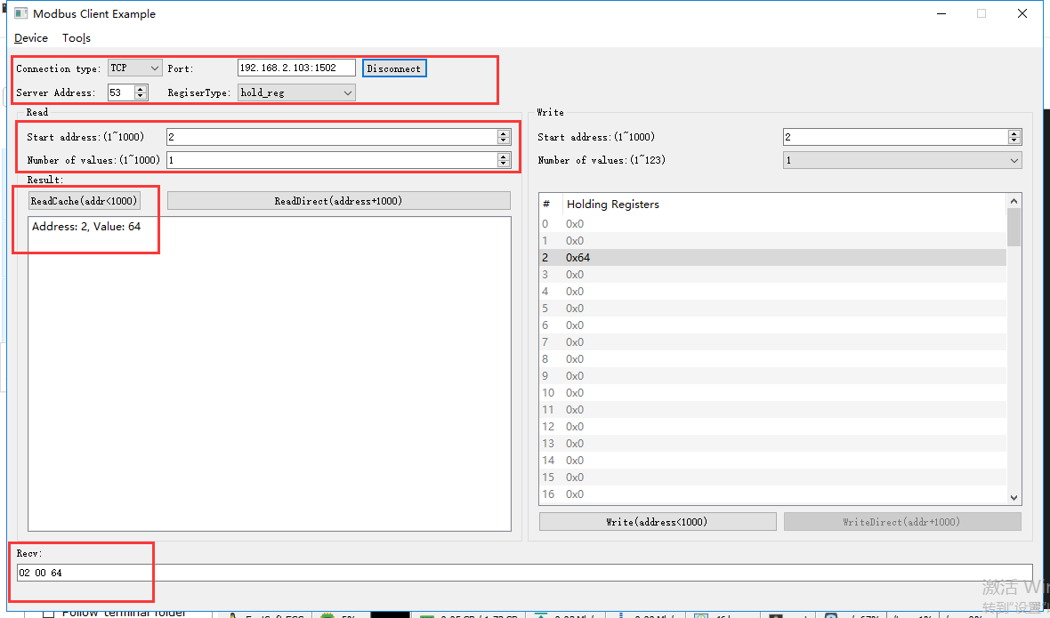

rcv from 192.168.2.113:54542:

[ 00 1b 00 00 00 06 35 03 00 02 00 01 ]

snd to 192.168.2.113:54542:

[ 00 1b 00 00 00 05 35 03 02 00 64 ]

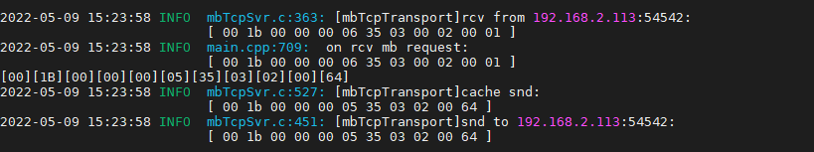

# 调光控制器ok

**说明：**根据转换程序锁支持的设备，典型选取一种测试。

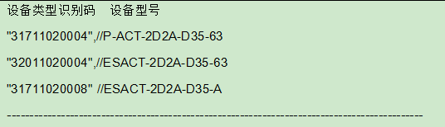

**寄存器定义：**

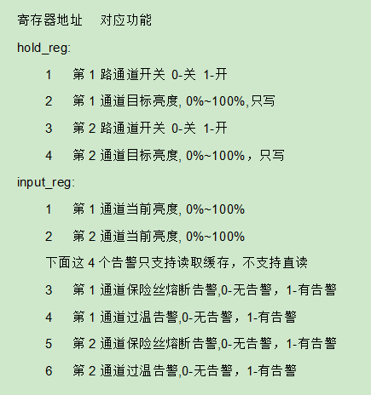

## 通道1

### 打开

只写0x06

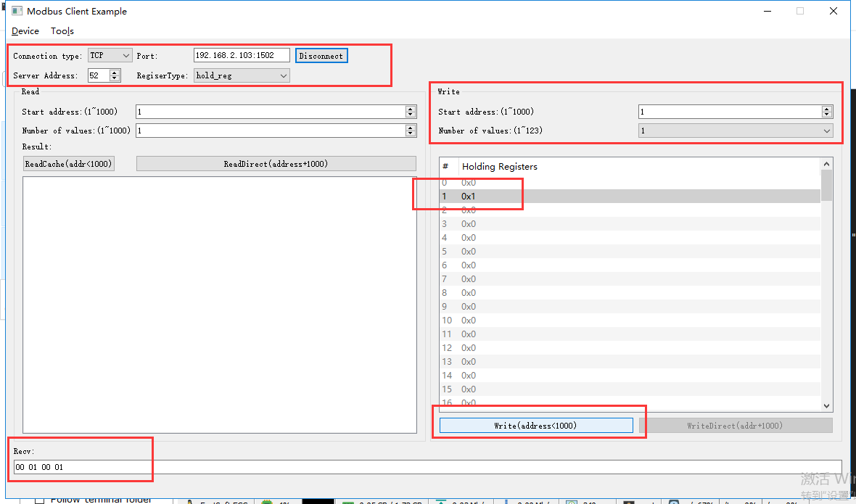

rcv from 192.168.2.113:52645:

[ 00 0c 00 00 00 06 34 06 00 01 00 01 ]

snd to 192.168.2.113:52645:

[ 00 0c 00 00 00 06 34 06 00 01 00 01 ]

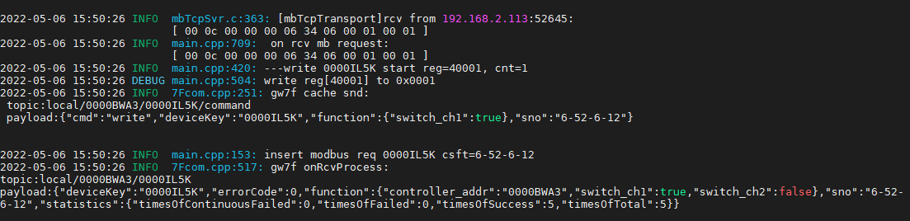

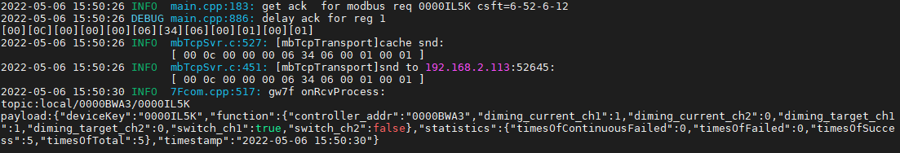

#### 直读开关状态

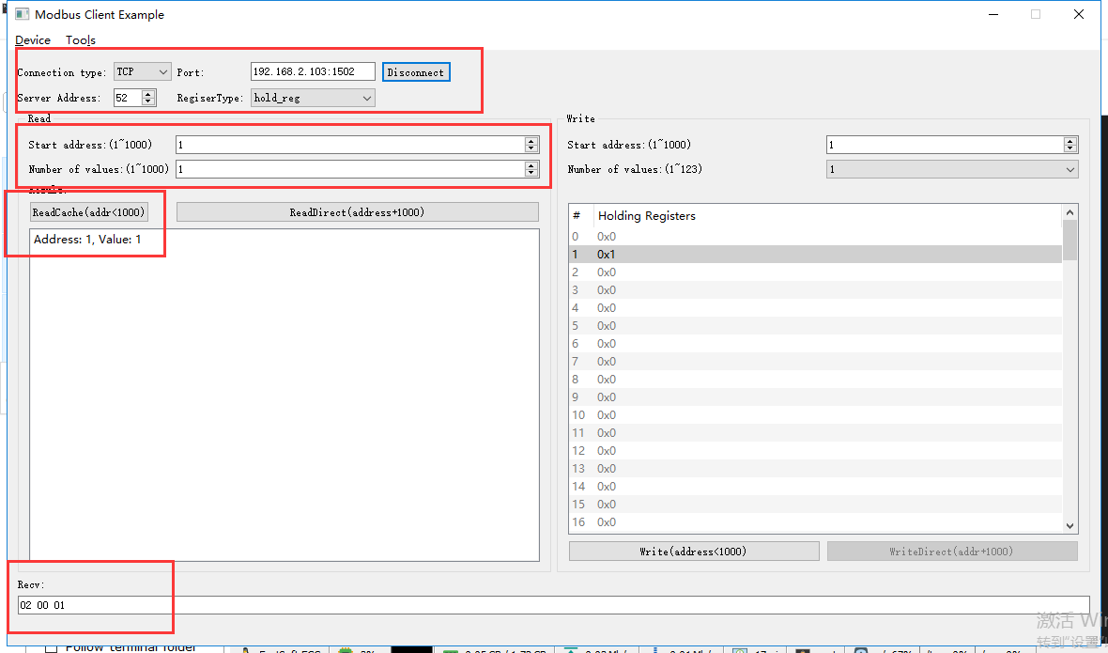

rcv from 192.168.2.113:52645:

[ 00 1f 00 00 00 06 34 03 00 01 00 01 ]

snd to 192.168.2.113:52645:

[ 00 1f 00 00 00 05 34 03 02 00 01 ]

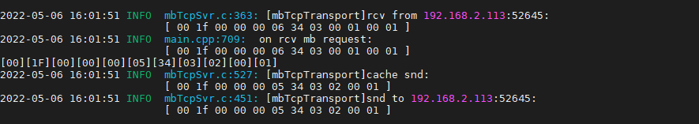

#### 读缓存开关状态

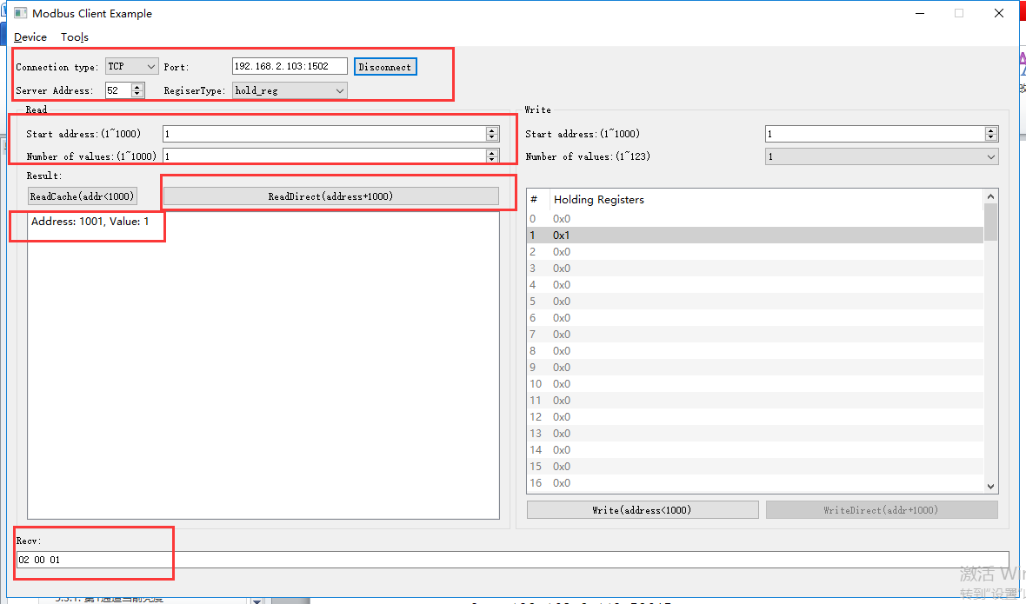

rcv from 192.168.2.113:52645:

[ 00 20 00 00 00 06 34 03 03 e9 00 01 ]

snd to 192.168.2.113:52645:

[ 00 20 00 00 00 05 34 03 02 00 01 ]

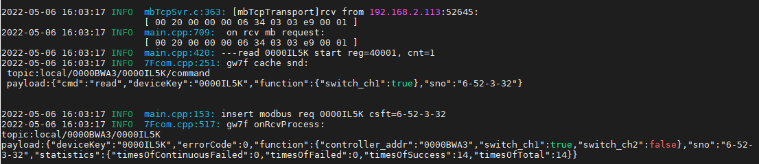



#### 直读亮度

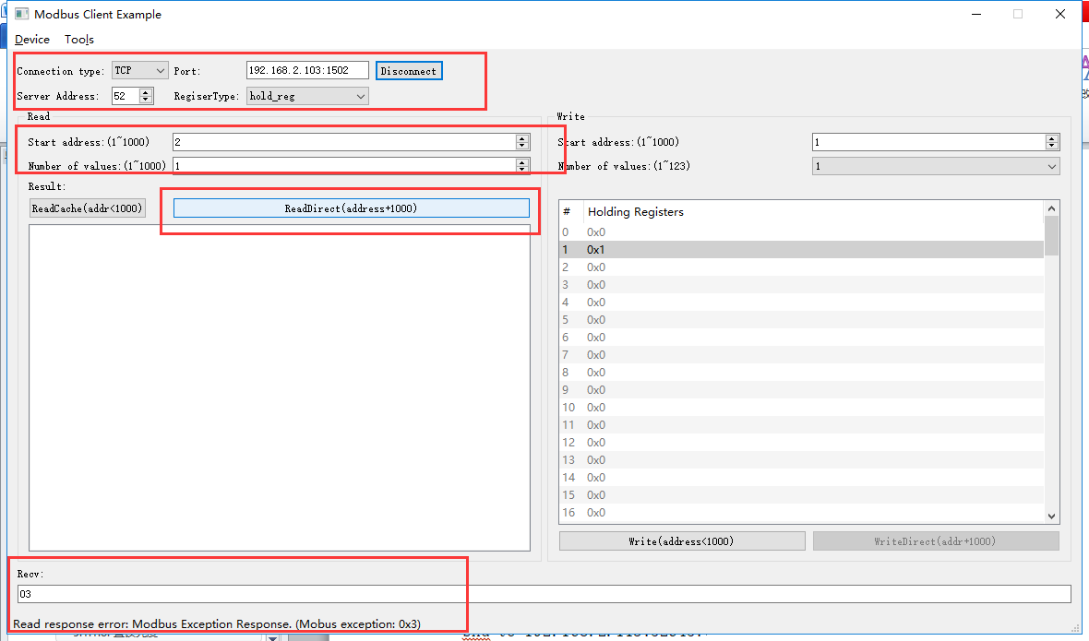

rcv from 192.168.2.113:52162:

[ 00 03 00 00 00 06 34 03 03 ea 00 01 ]

snd to 192.168.2.113:52162:

[ 00 03 00 00 00 03 34 83 03 ]

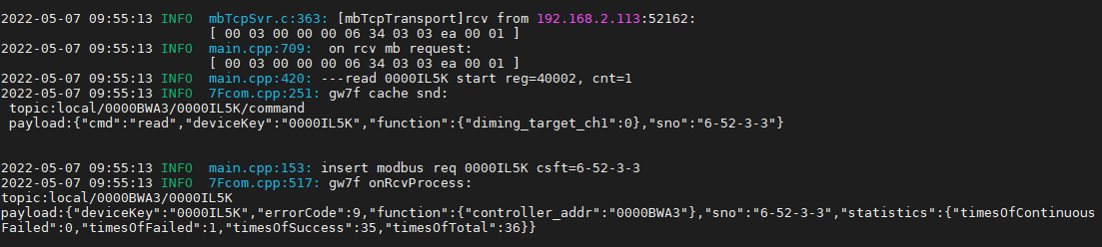



因网关限制，无法直读亮度。

#### 读缓存亮度

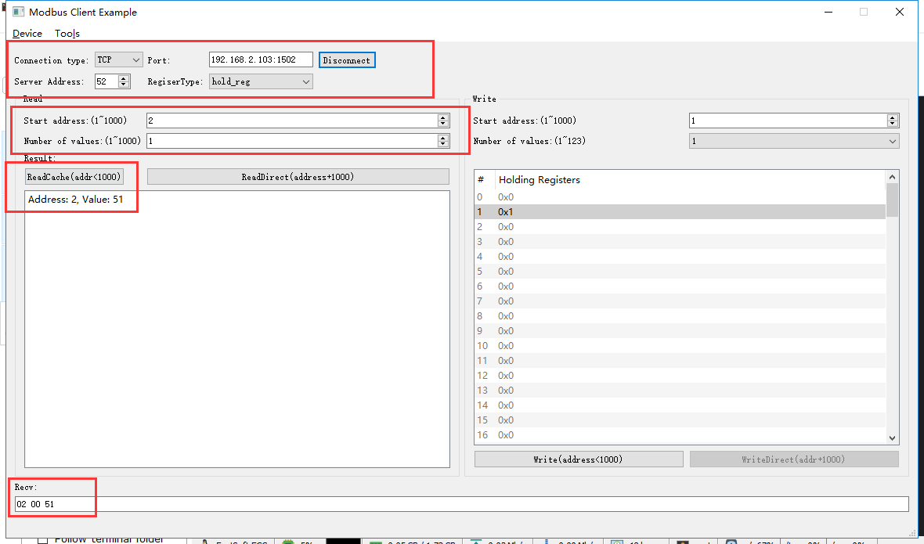

rcv from 192.168.2.113:52162:

[ 00 04 00 00 00 06 34 03 00 02 00 01 ]

snd to 192.168.2.113:52162:

[ 00 04 00 00 00 05 34 03 02 00 51 ]

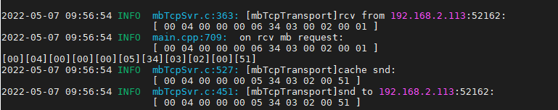

#### 写亮度--1%

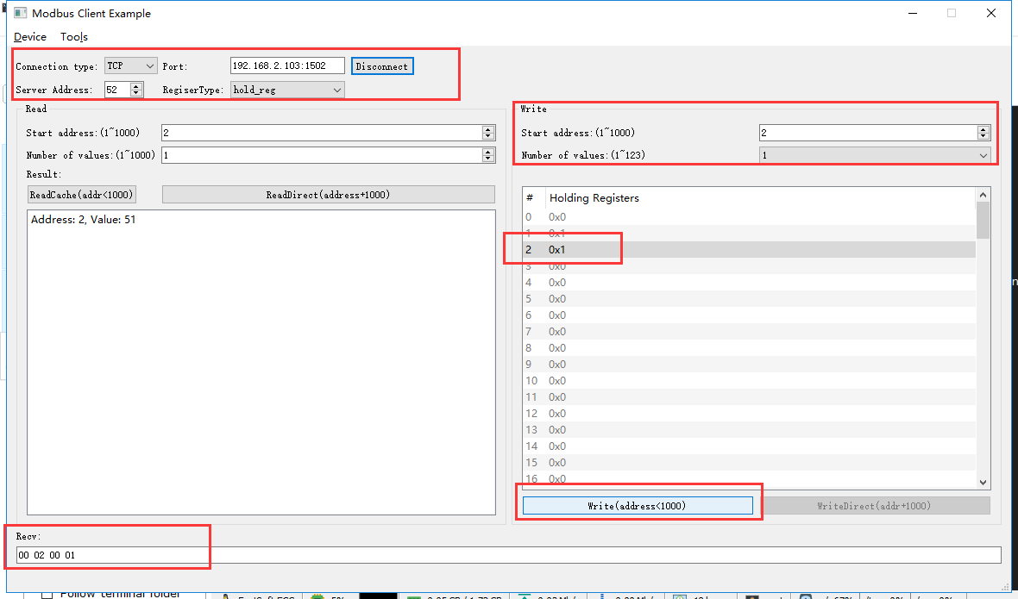

rcv from 192.168.2.113:52162:

[ 00 05 00 00 00 06 34 06 00 02 00 01 ]

snd to 192.168.2.113:52162:

[ 00 05 00 00 00 06 34 06 00 02 00 01 ]

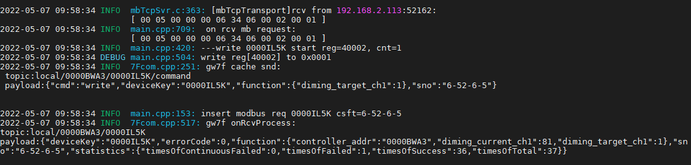

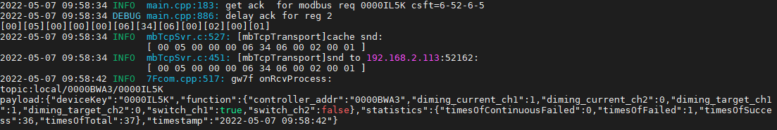

#### 读缓存亮度

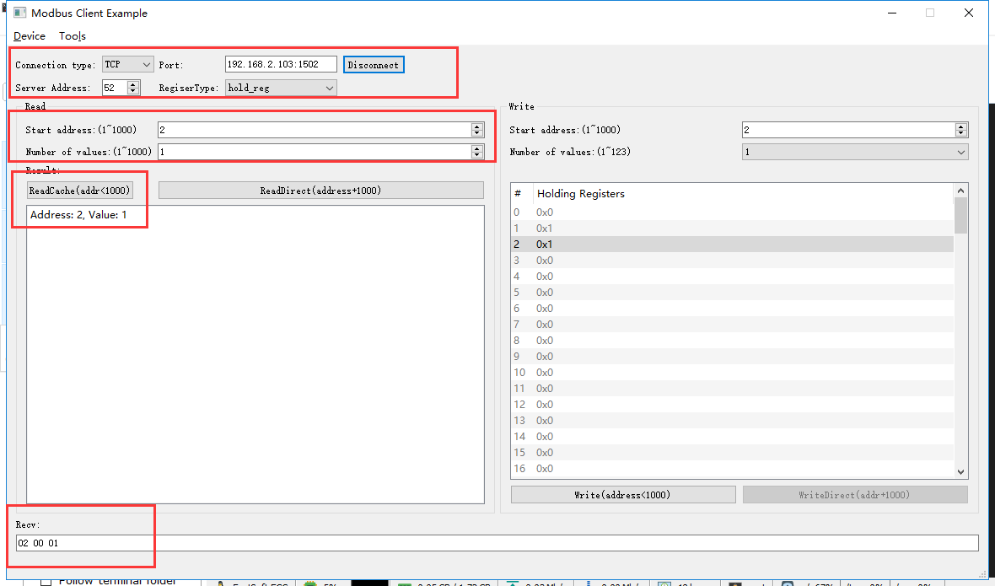

rcv from 192.168.2.113:52162:

[ 00 08 00 00 00 06 34 03 00 02 00 01 ]

snd to 192.168.2.113:52162:

[ 00 08 00 00 00 05 34 03 02 00 01 ]

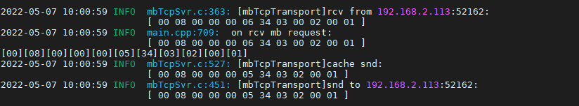

#### 写亮度--0%

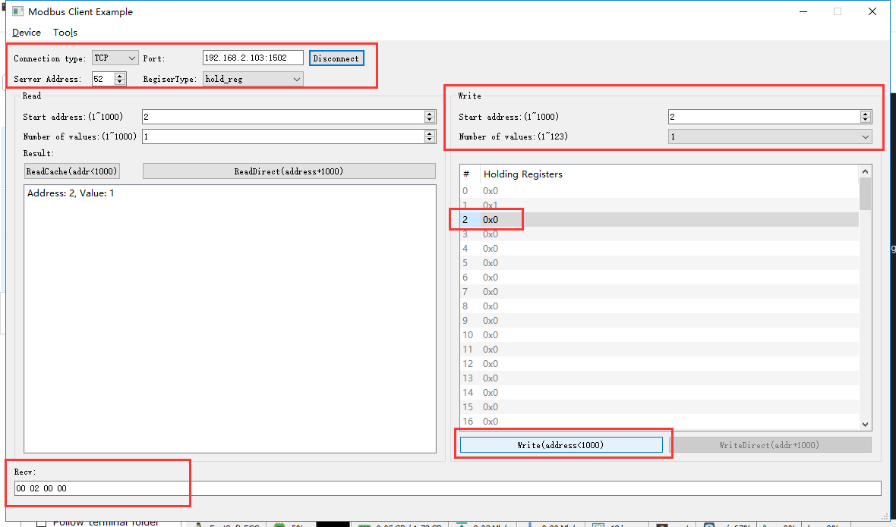

rcv from 192.168.2.113:52162:

[ 00 09 00 00 00 06 34 06 00 02 00 00 ]

snd to 192.168.2.113:52162:

[ 00 09 00 00 00 06 34 06 00 02 00 00 ]

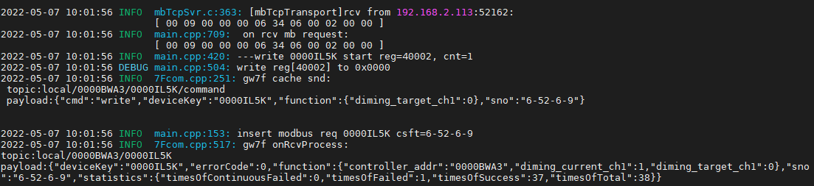

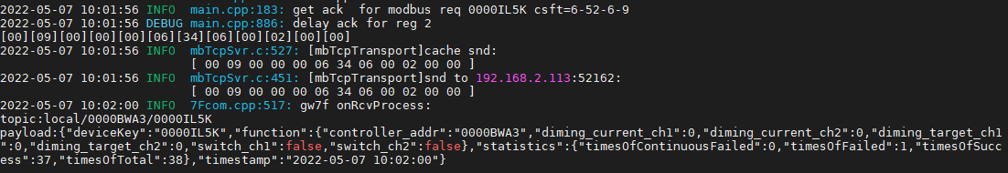

#### 读缓存亮度

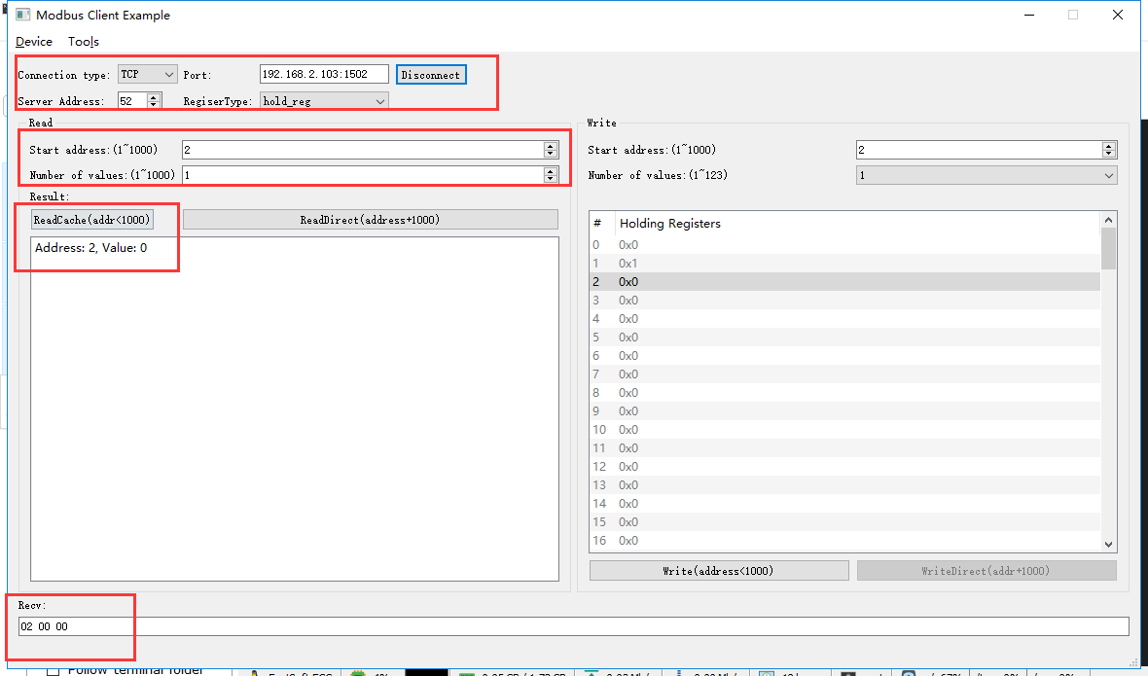

rcv from 192.168.2.113:52162:

[ 00 0a 00 00 00 06 34 03 00 02 00 01 ]

snd to 192.168.2.113:52162:

[ 00 0a 00 00 00 05 34 03 02 00 00 ]



#### 写亮度--50%

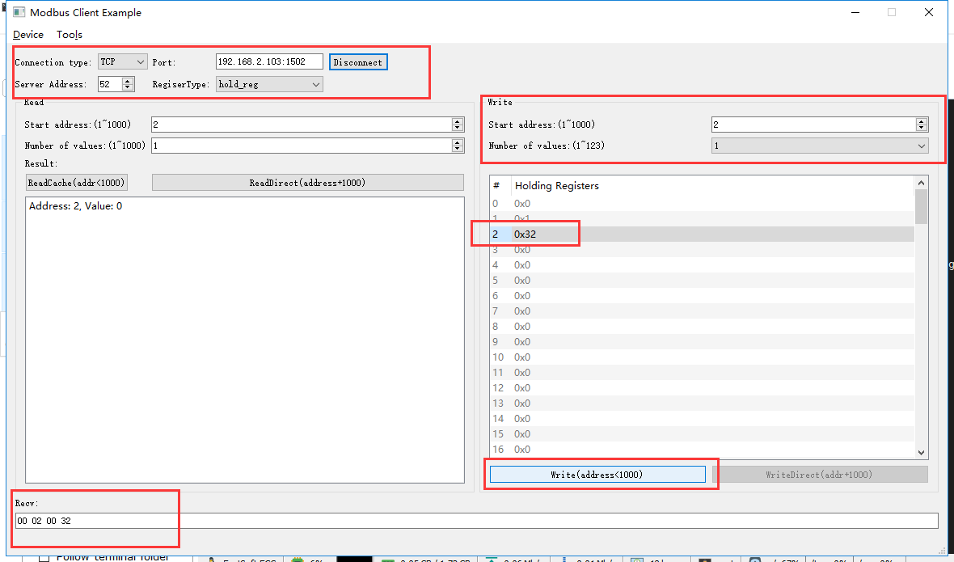

rcv from 192.168.2.113:52162:

[ 00 0b 00 00 00 06 34 06 00 02 00 32 ]

snd to 192.168.2.113:52162:

[ 00 0b 00 00 00 06 34 06 00 02 00 32 ]

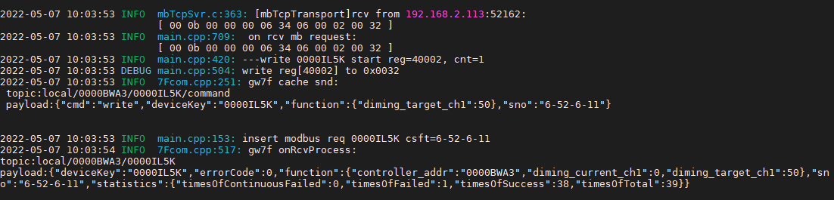

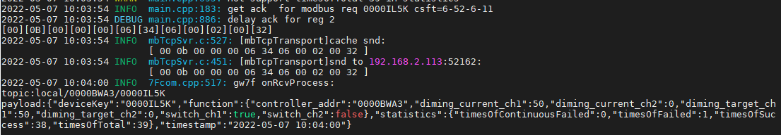

#### 读缓存亮度

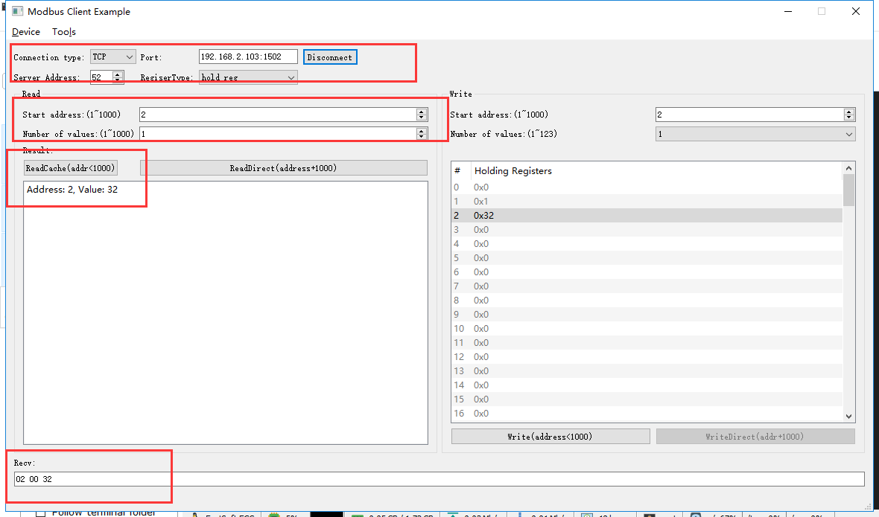

rcv from 192.168.2.113:52162:

[ 00 0c 00 00 00 06 34 03 00 02 00 01 ]

snd to 192.168.2.113:52162:

[ 00 0c 00 00 00 05 34 03 02 00 32 ]

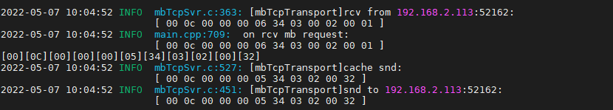

#### 写亮度--100%

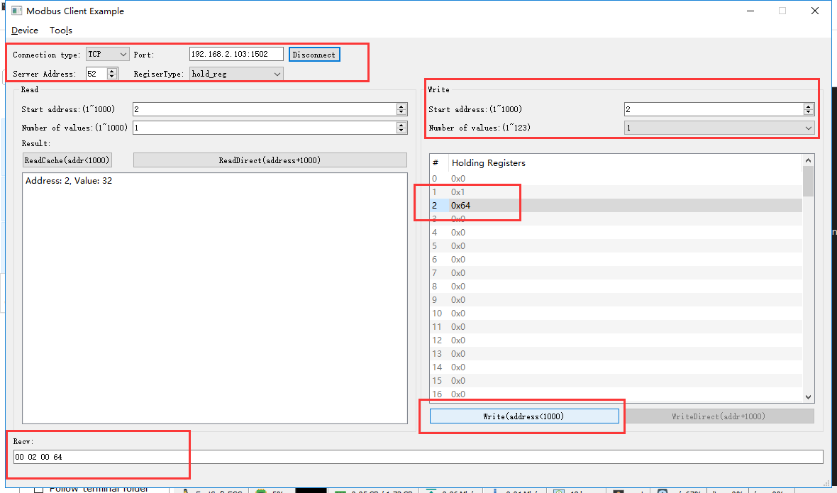

rcv from 192.168.2.113:52162:

[ 00 0d 00 00 00 06 34 06 00 02 00 64 ]

snd to 192.168.2.113:52162:

[ 00 0d 00 00 00 06 34 06 00 02 00 64 ]

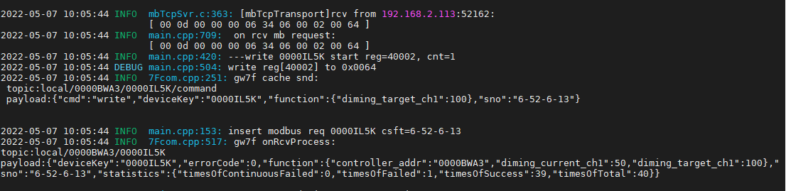

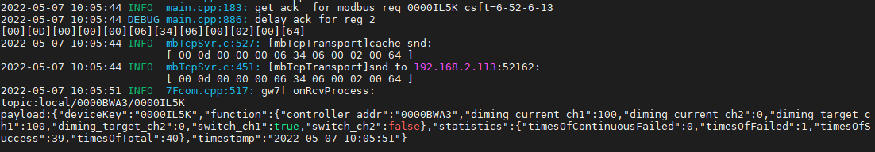

#### 读缓存亮度

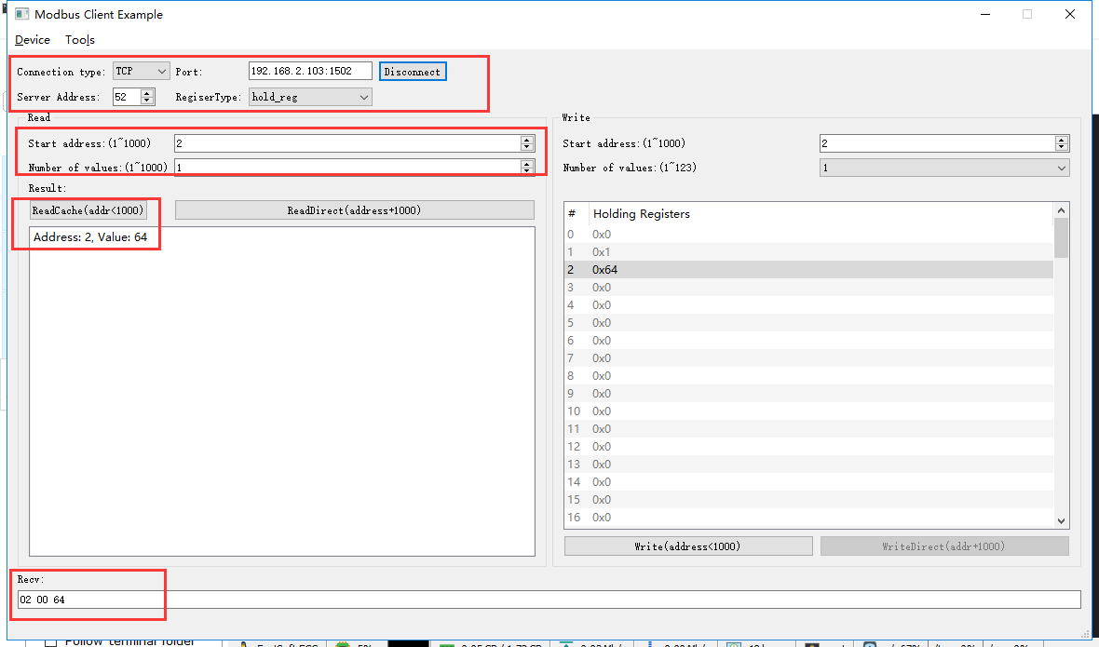

rcv from 192.168.2.113:52162:

[ 00 0e 00 00 00 06 34 03 00 02 00 01 ]

snd to 192.168.2.113:52162:

[ 00 0e 00 00 00 05 34 03 02 00 64 ]

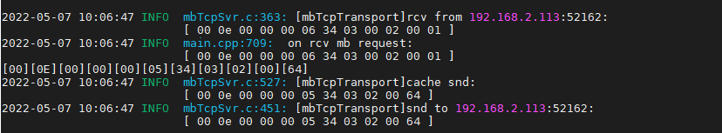

#### 写亮度--101%

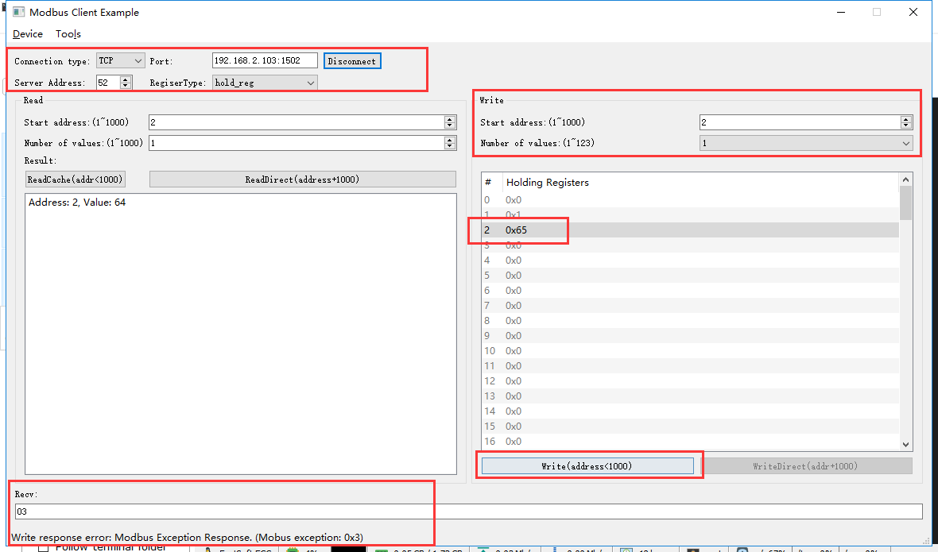

rcv from 192.168.2.113:52162:

[ 00 0f 00 00 00 06 34 06 00 02 00 65 ]

snd to 192.168.2.113:52162:

[ 00 0f 00 00 00 03 34 86 03 ]

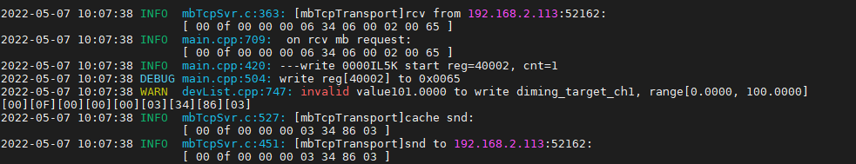

### 关闭

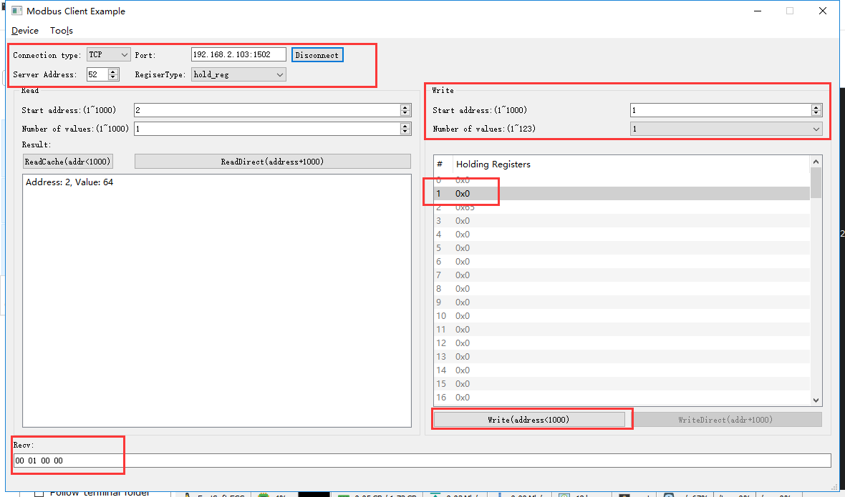

rcv from 192.168.2.113:52162:

[ 00 10 00 00 00 06 34 06 00 01 00 00 ]

snd to 192.168.2.113:52162:

[ 00 10 00 00 00 06 34 06 00 01 00 00 ]

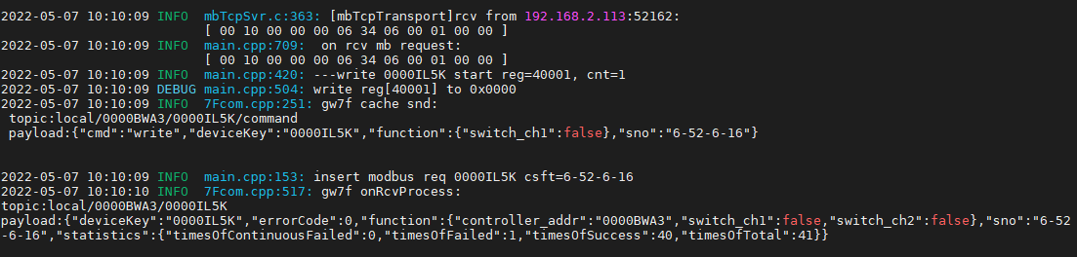

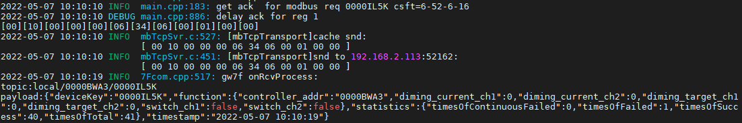

#### 直读开关状态

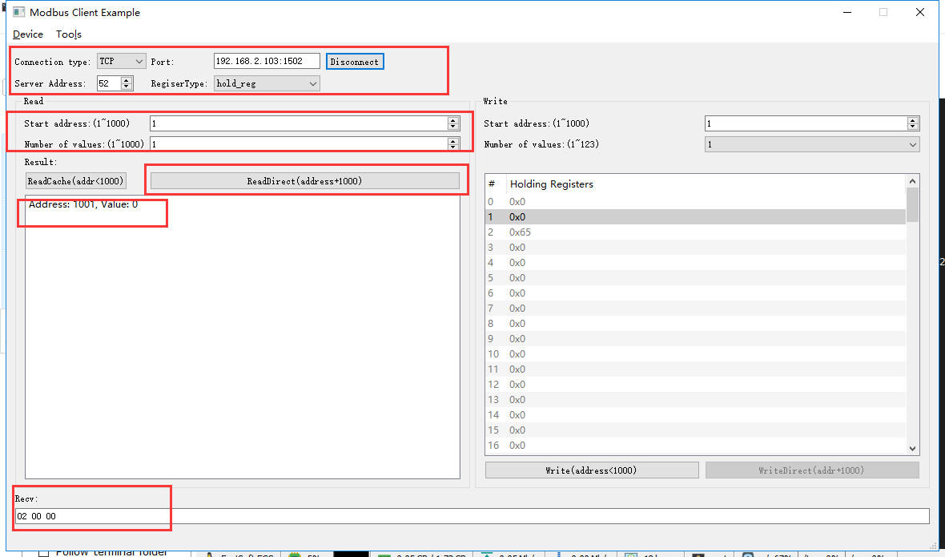

rcv from 192.168.2.113:52162:

[ 00 11 00 00 00 06 34 03 03 e9 00 01 ]

snd to 192.168.2.113:52162:

[ 00 11 00 00 00 05 34 03 02 00 00 ]

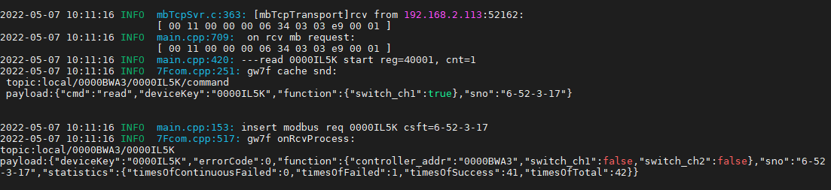



## 通道2

### 打开

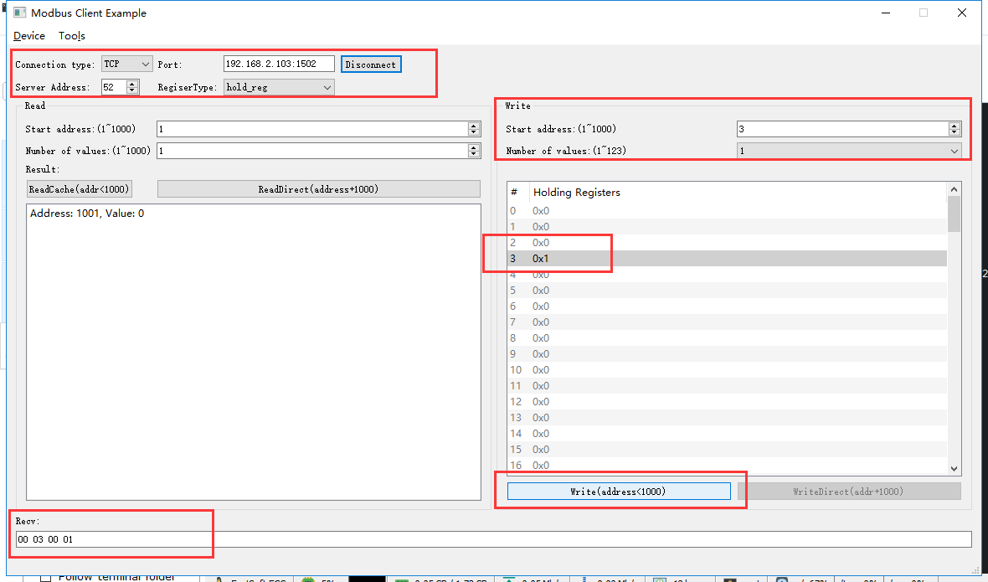

rcv from 192.168.2.113:52162:

[ 00 12 00 00 00 06 34 06 00 03 00 01 ]

snd to 192.168.2.113:52162:

[ 00 12 00 00 00 06 34 06 00 03 00 01 ]

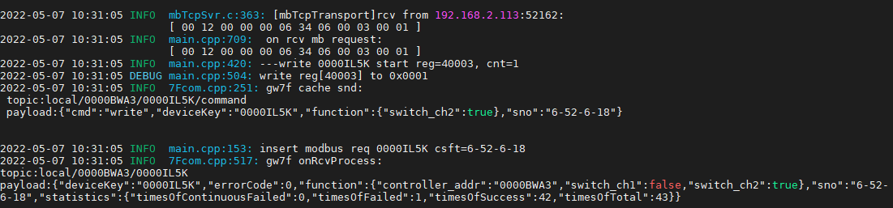

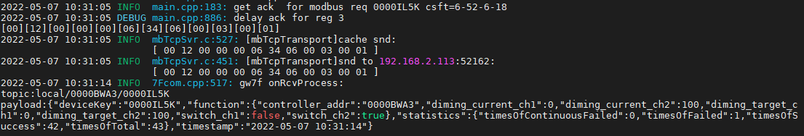

#### 直读开关状态

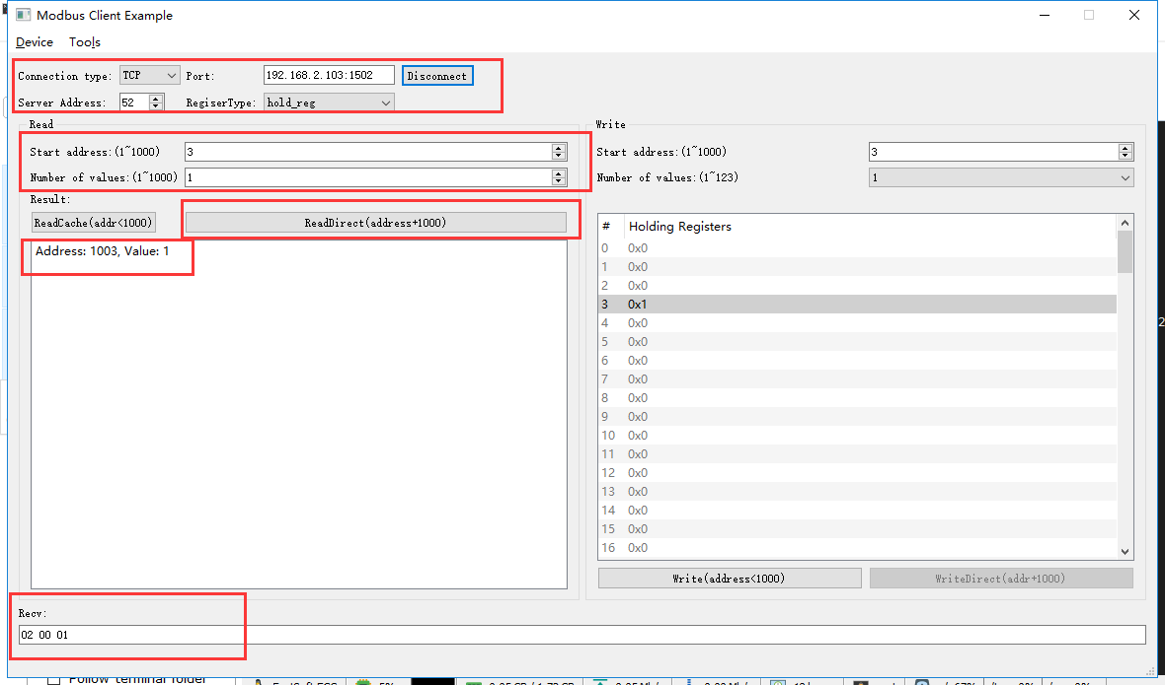

rcv from 192.168.2.113:52162:

[ 00 13 00 00 00 06 34 03 03 eb 00 01 ]

snd to 192.168.2.113:52162:

[ 00 13 00 00 00 05 34 03 02 00 01 ]

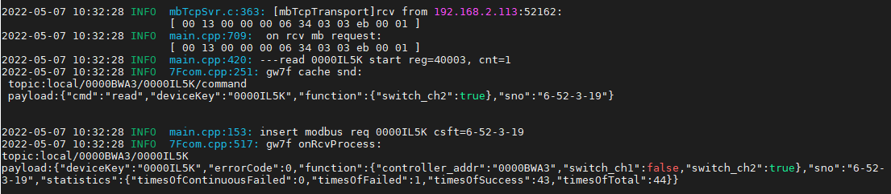



#### 读缓存开关状态

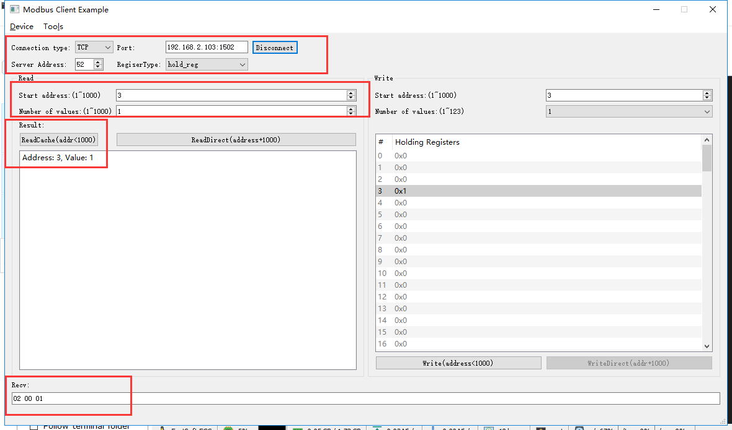

rcv from 192.168.2.113:52162:

[ 00 14 00 00 00 06 34 03 00 03 00 01 ]

snd to 192.168.2.113:52162:

[ 00 14 00 00 00 05 34 03 02 00 01 ]

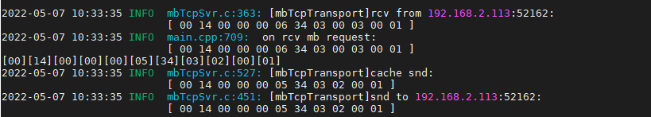

#### 直读亮度

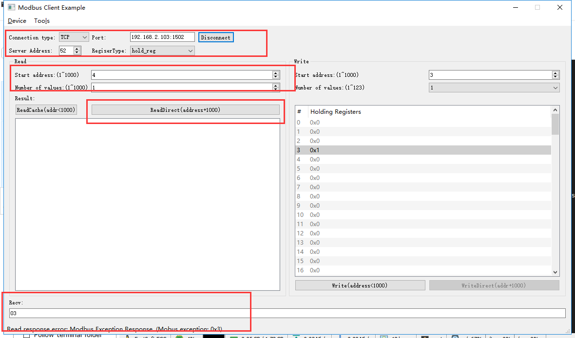

rcv from 192.168.2.113:52162:

[ 00 15 00 00 00 06 34 03 03 ec 00 01 ]

snd to 192.168.2.113:52162:

[ 00 15 00 00 00 03 34 83 03 ]

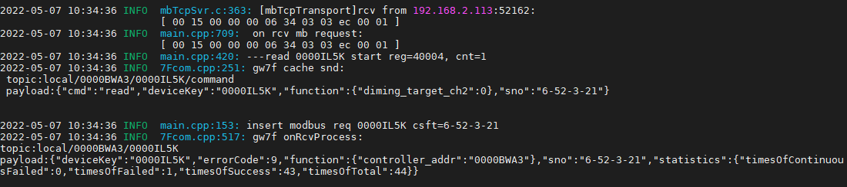



因网关限制，无法直读亮度。

#### 读缓存亮度

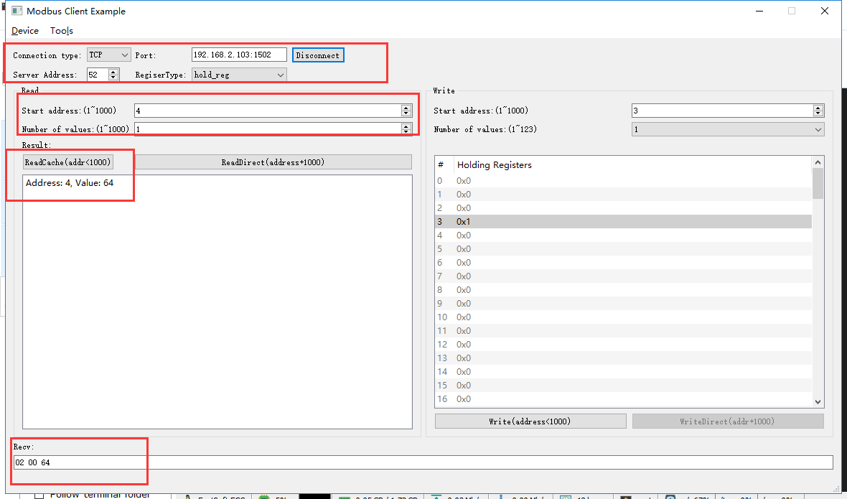

rcv from 192.168.2.113:52162:

[ 00 16 00 00 00 06 34 03 00 04 00 01 ]

snd to 192.168.2.113:52162:

[ 00 16 00 00 00 05 34 03 02 00 64 ]

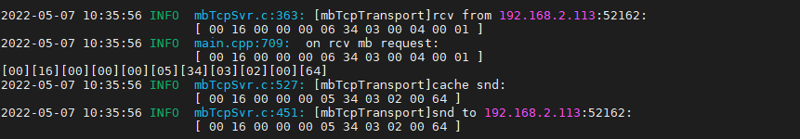

#### 写亮度--1%

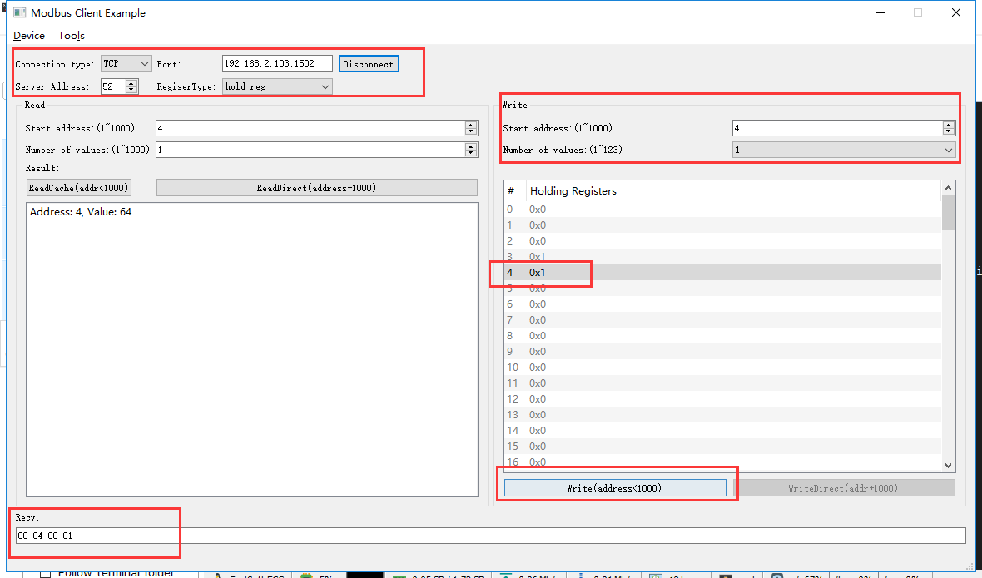

rcv from 192.168.2.113:52162:

[ 00 17 00 00 00 06 34 06 00 04 00 01 ]

snd to 192.168.2.113:52162:

[ 00 17 00 00 00 06 34 06 00 04 00 01 ]

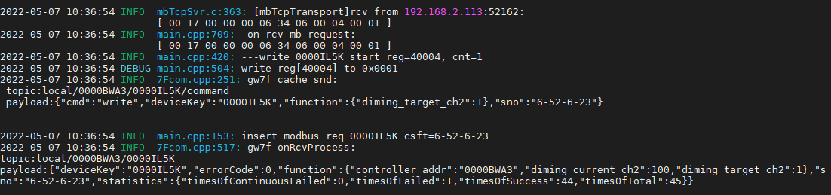

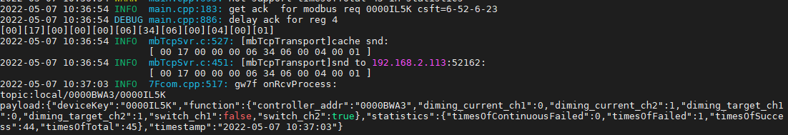

#### 读缓存亮度

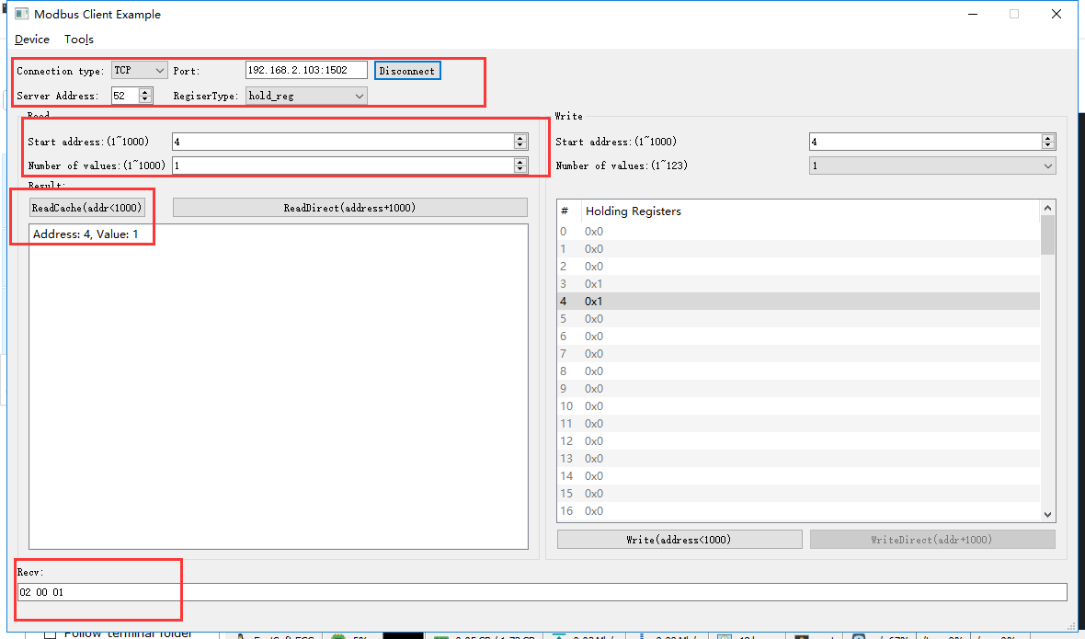

rcv from 192.168.2.113:52162:

[ 00 18 00 00 00 06 34 03 00 04 00 01 ]

snd to 192.168.2.113:52162:

[ 00 18 00 00 00 05 34 03 02 00 01 ]

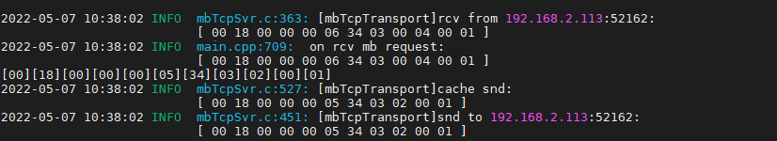

#### 写亮度--0%

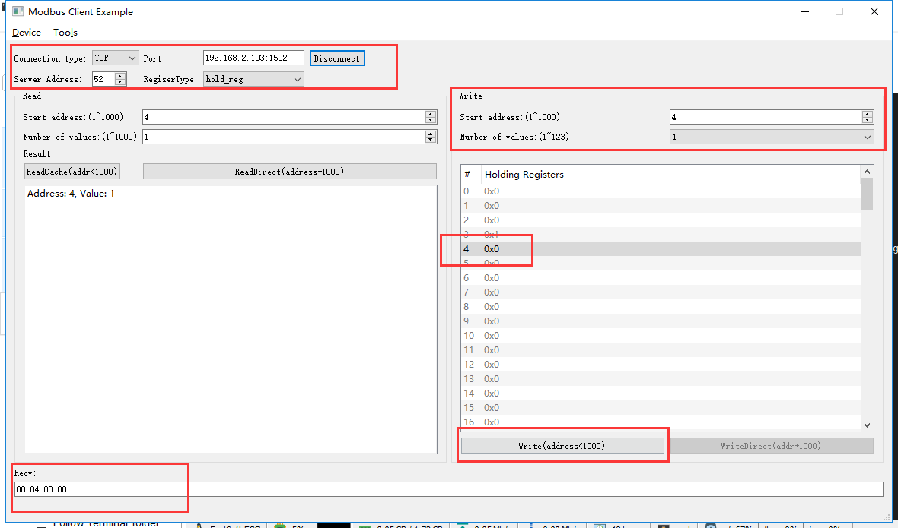

rcv from 192.168.2.113:52162:

[ 00 1b 00 00 00 06 34 06 00 04 00 00 ]

snd to 192.168.2.113:52162:

[ 00 1b 00 00 00 06 34 06 00 04 00 00 ]

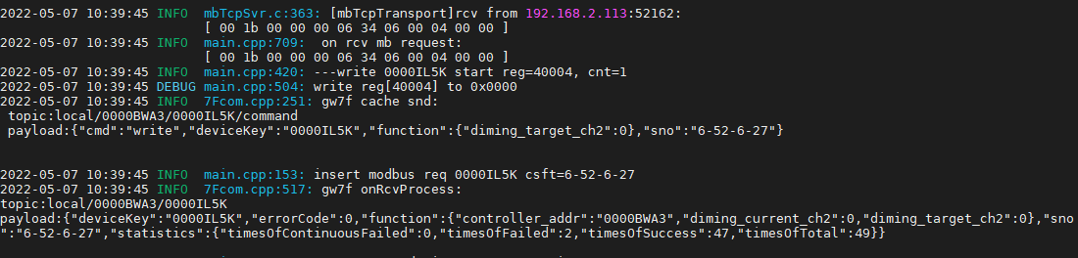

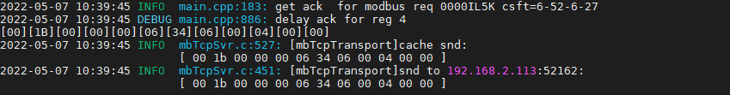

#### 读缓存亮度

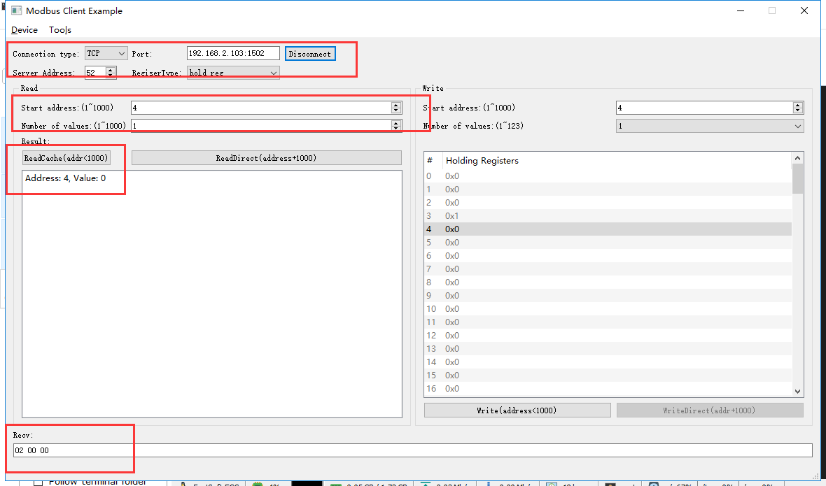

rcv from 192.168.2.113:52162:

[ 00 1c 00 00 00 06 34 03 00 04 00 01 ]

snd to 192.168.2.113:52162:

[ 00 1c 00 00 00 05 34 03 02 00 00 ]

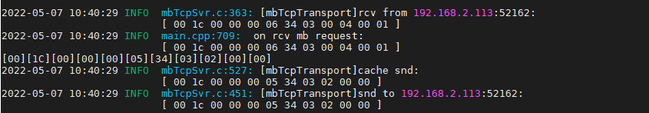

#### 写亮度--50%

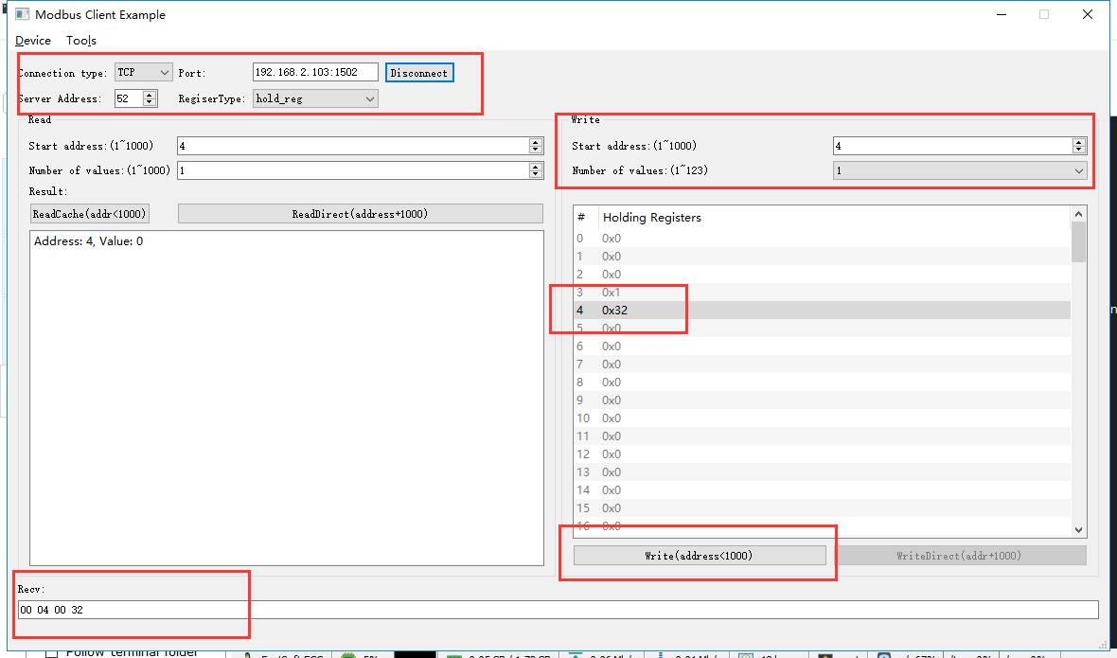

rcv from 192.168.2.113:52162:

[ 00 1f 00 00 00 06 34 06 00 04 00 32 ]

snd to 192.168.2.113:52162:

[ 00 1f 00 00 00 06 34 06 00 04 00 32 ]

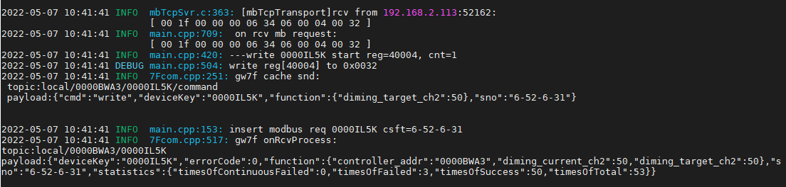

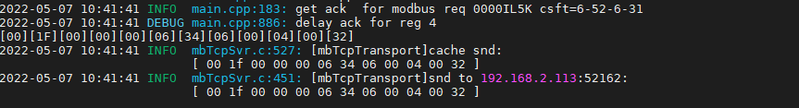

#### 读缓存亮度

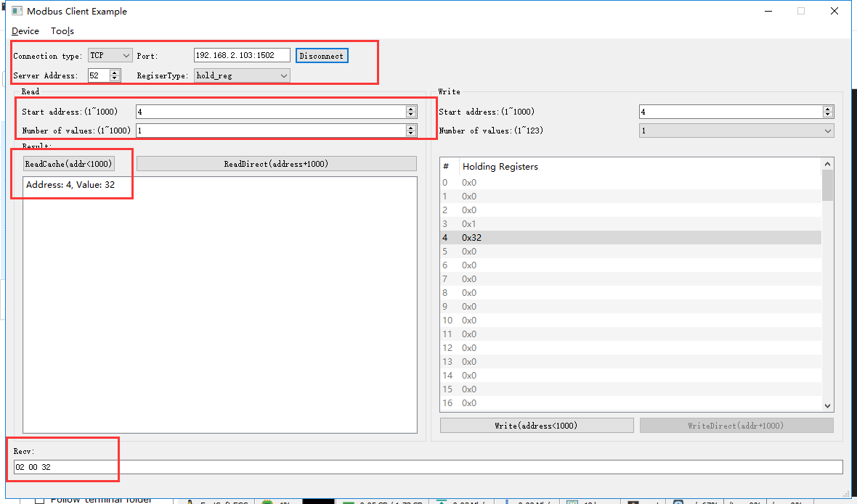

rcv from 192.168.2.113:52162:

[ 00 20 00 00 00 06 34 03 00 04 00 01 ]

snd to 192.168.2.113:52162:

[ 00 20 00 00 00 05 34 03 02 00 32 ]

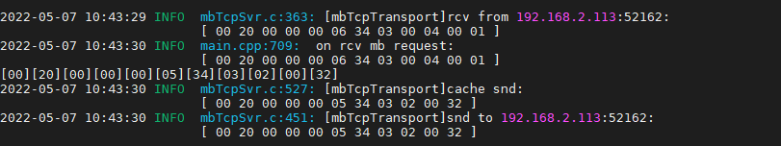

#### 写亮度--100%

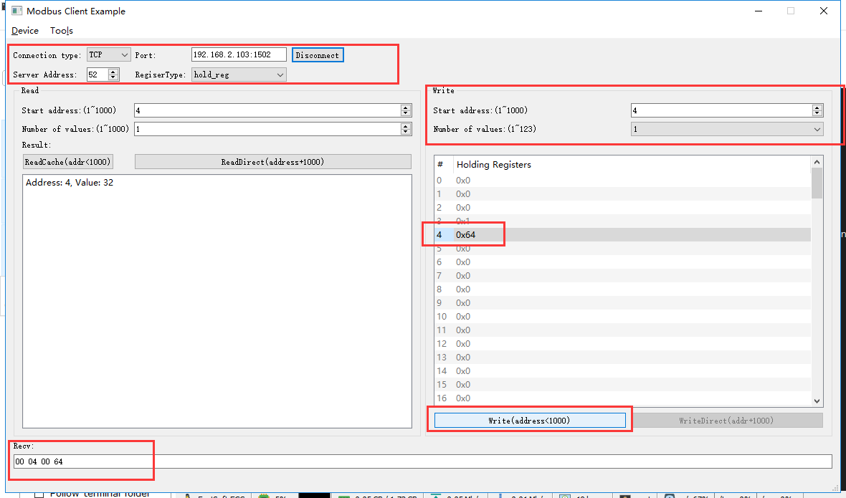

rcv from 192.168.2.113:52162:

[ 00 21 00 00 00 06 34 06 00 04 00 64 ]

snd to 192.168.2.113:52162:

[ 00 21 00 00 00 06 34 06 00 04 00 64 ]

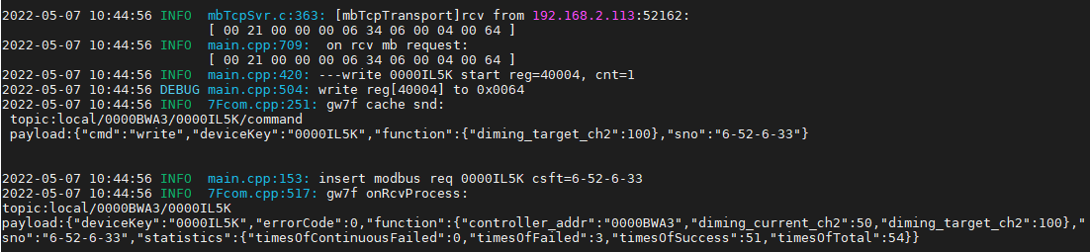

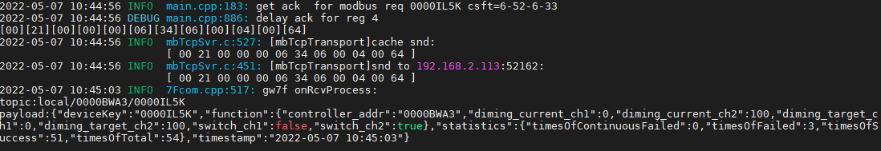

#### 读缓存亮度

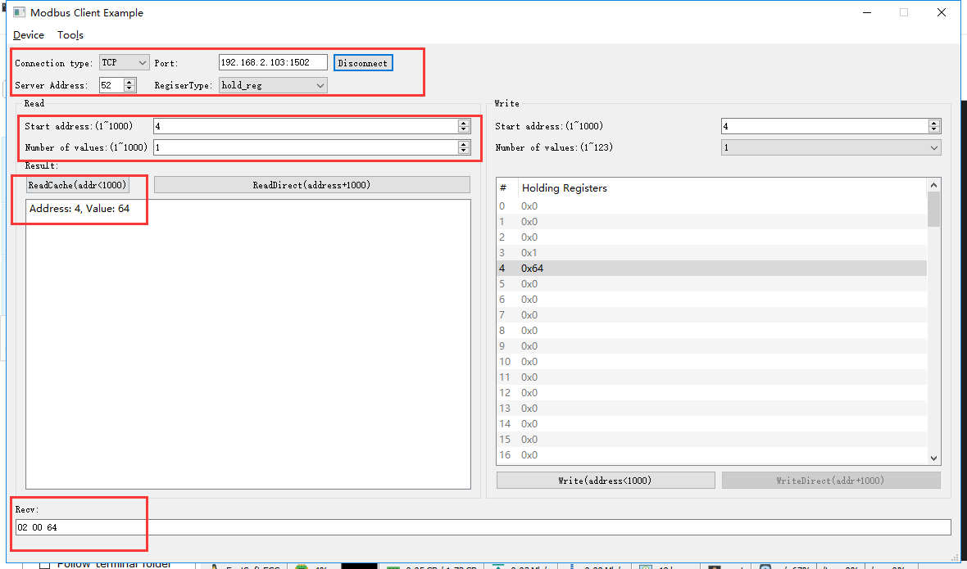

rcv from 192.168.2.113:52162:

[ 00 22 00 00 00 06 34 03 00 04 00 01 ]

snd to 192.168.2.113:52162:

[ 00 22 00 00 00 05 34 03 02 00 64 ]

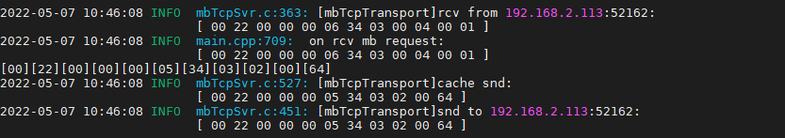

#### 写亮度--101%

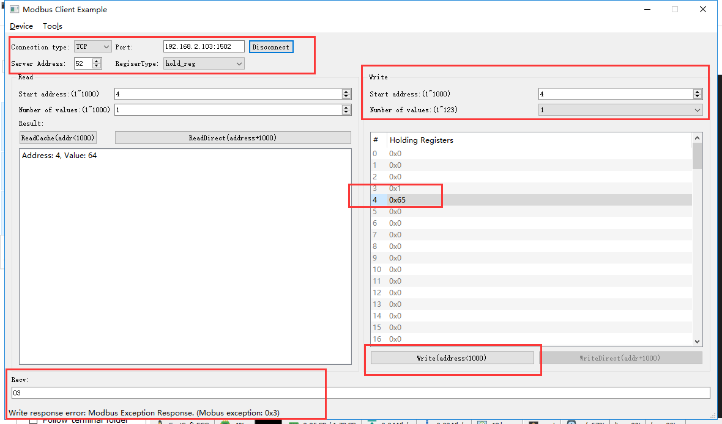

rcv from 192.168.2.113:52162:

[ 00 23 00 00 00 06 34 06 00 04 00 65 ]

snd to 192.168.2.113:52162:

[ 00 23 00 00 00 03 34 86 03 ]

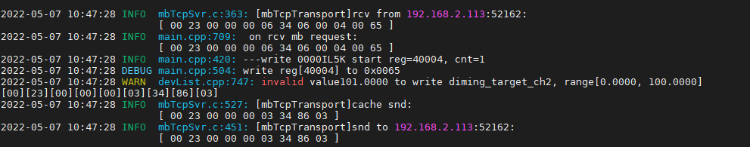

### 关闭

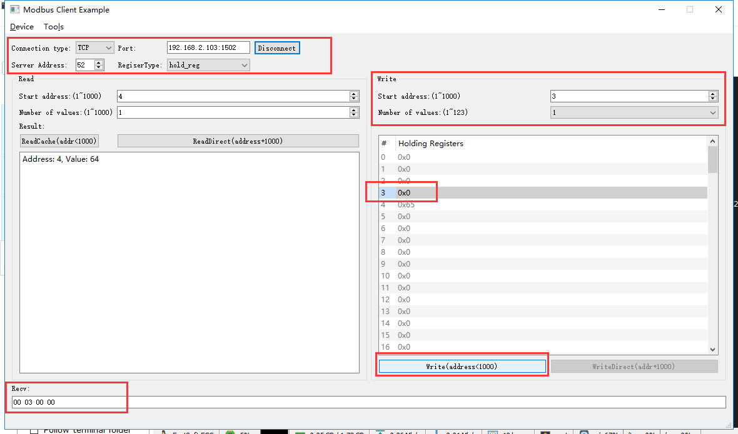

rcv from 192.168.2.113:52162:

[ 00 24 00 00 00 06 34 06 00 03 00 00 ]

snd to 192.168.2.113:52162:

[ 00 24 00 00 00 06 34 06 00 03 00 00 ]

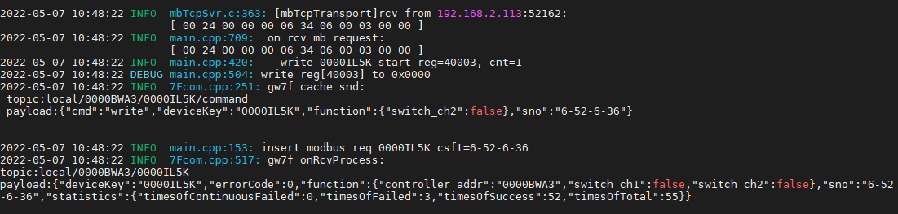

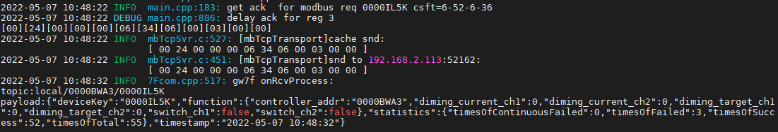

#### 直读开关状态

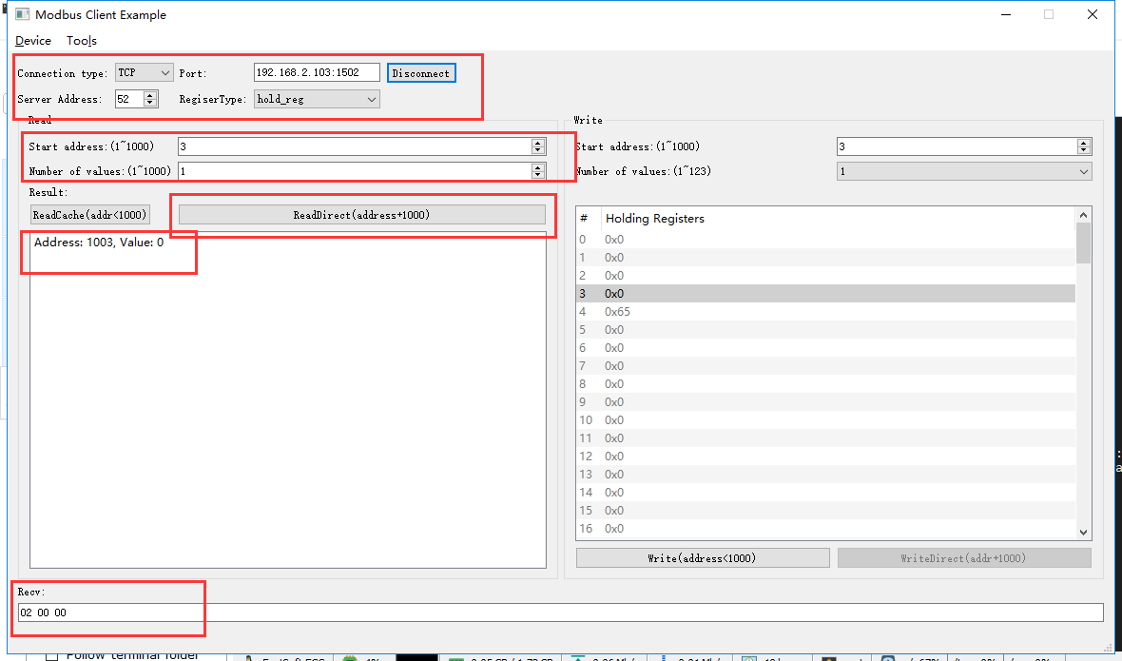

rcv from 192.168.2.113:52162:

[ 00 26 00 00 00 06 34 03 03 eb 00 01 ]

snd to 192.168.2.113:52162:

[ 00 26 00 00 00 05 34 03 02 00 00 ]

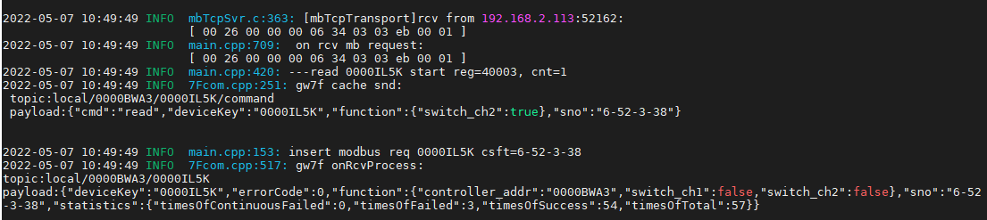

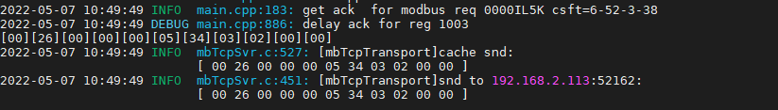

## 设备只读状态

### 第1通道当前亮度

直读

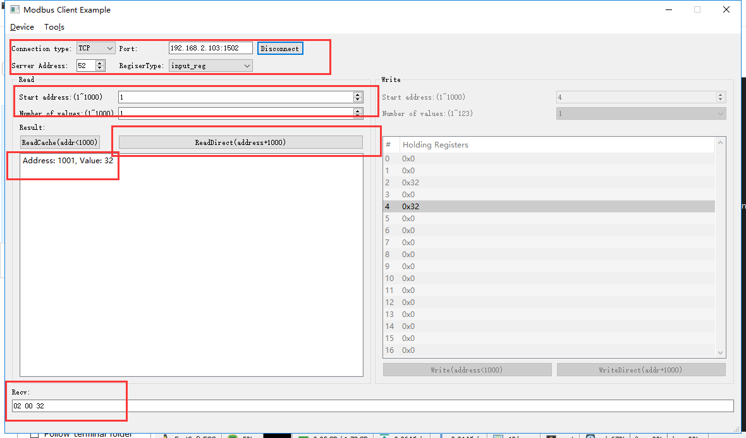

rcv from 192.168.2.113:52162:

[ 00 2d 00 00 00 06 34 04 03 e9 00 01 ]

snd to 192.168.2.113:52162:

[ 00 2d 00 00 00 05 34 04 02 00 32 ]

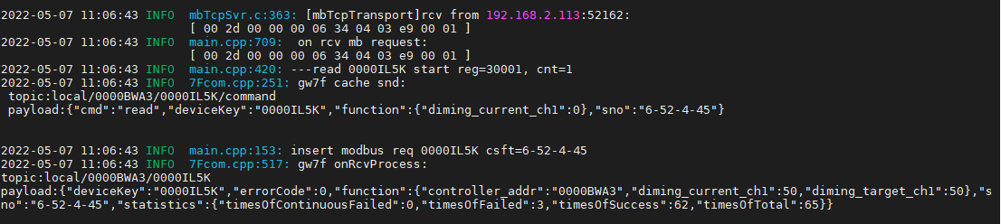

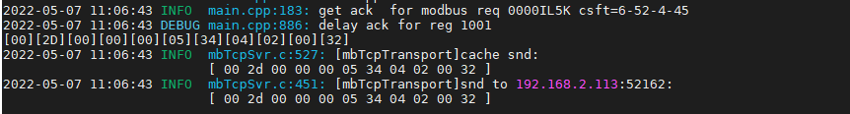

读缓存

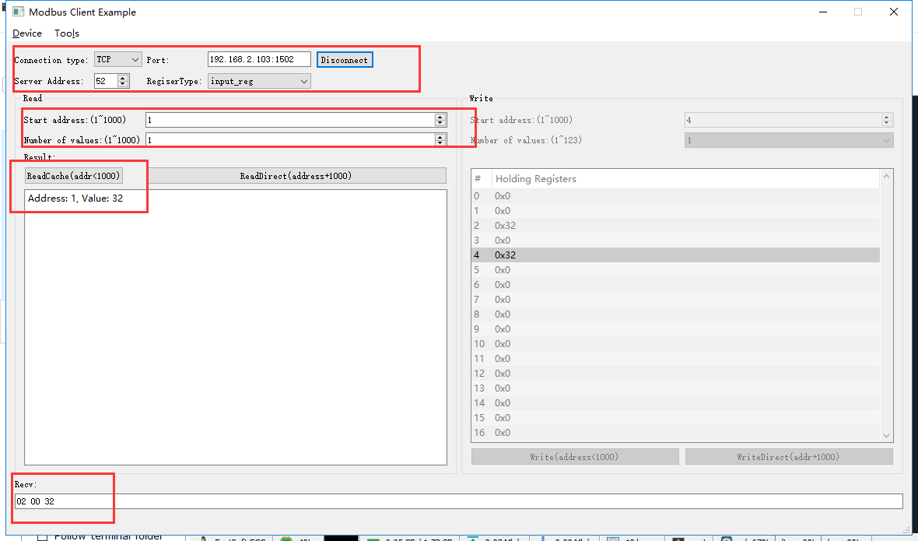

rcv from 192.168.2.113:52162:

[ 00 2e 00 00 00 06 34 04 00 01 00 01 ]

snd to 192.168.2.113:52162:

[ 00 2e 00 00 00 05 34 04 02 00 32 ]

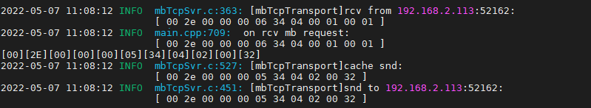

### 第2通道当前亮度

直读

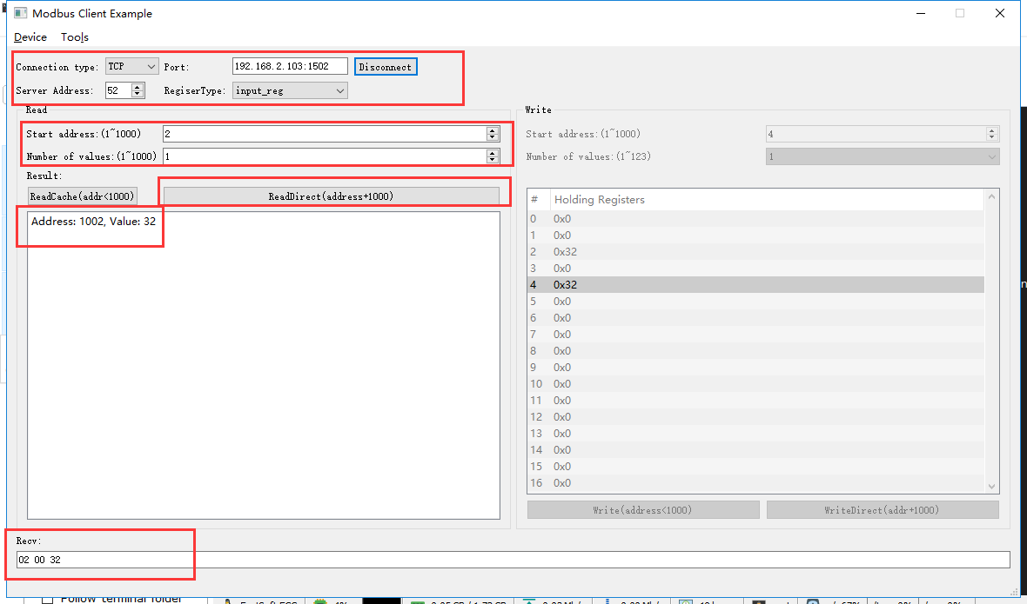

rcv from 192.168.2.113:52162:

[ 00 2f 00 00 00 06 34 04 03 ea 00 01 ]

snd to 192.168.2.113:52162:

[ 00 2f 00 00 00 05 34 04 02 00 32 ]

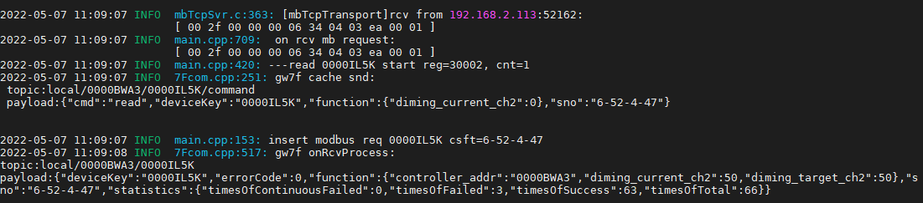

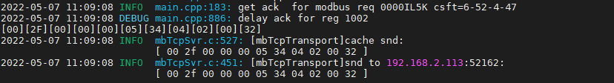

读缓存

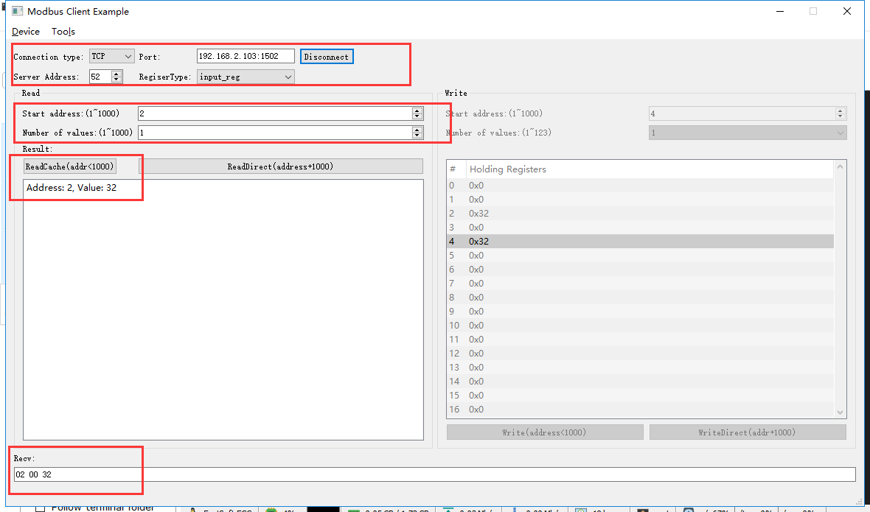

rcv from 192.168.2.113:52162:

[ 00 30 00 00 00 06 34 04 00 02 00 01 ]

snd to 192.168.2.113:52162:

[ 00 30 00 00 00 05 34 04 02 00 32 ]

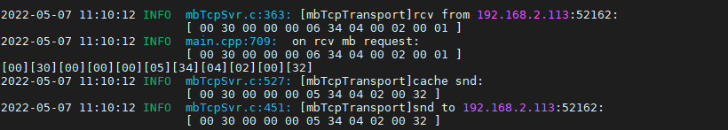

### 第1通道保险丝熔断告警

**测试方法：**人为拆、装保险丝使设备上报

#### 告警时

直读

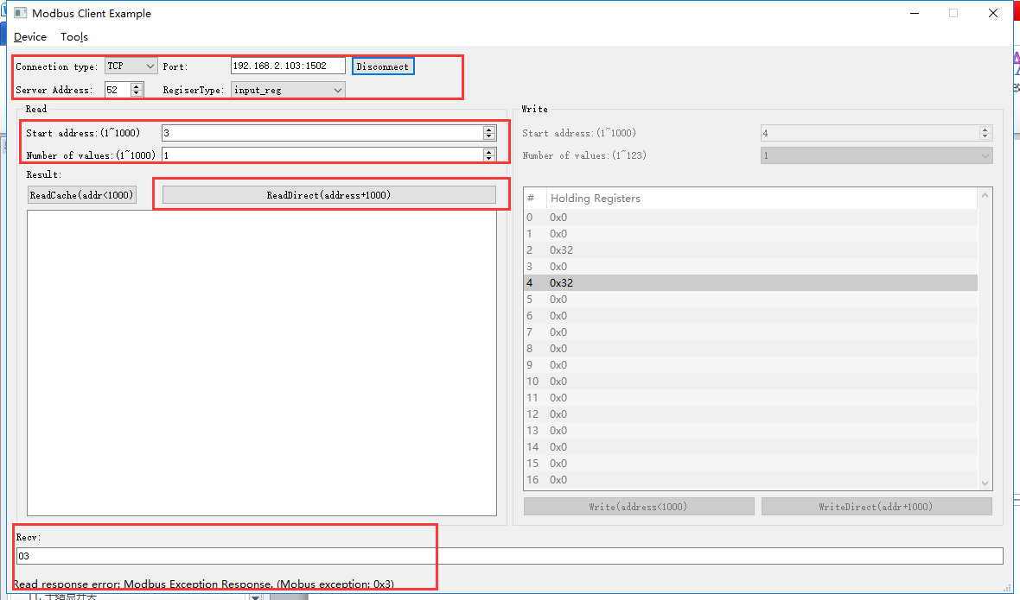

rcv from 192.168.2.113:52162:

[ 00 34 00 00 00 06 34 04 03 eb 00 01 ]

snd to 192.168.2.113:52162:

[ 00 34 00 00 00 03 34 84 03 ]

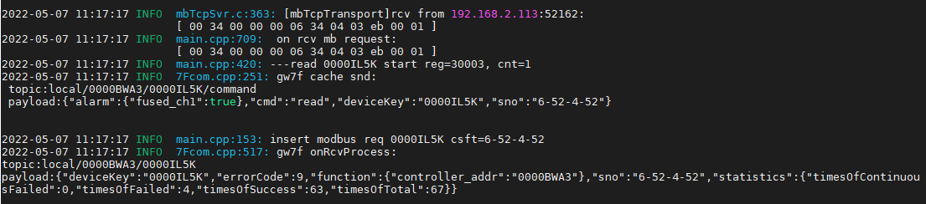



因网关限制，无法直读保险丝熔断告警。

读缓存

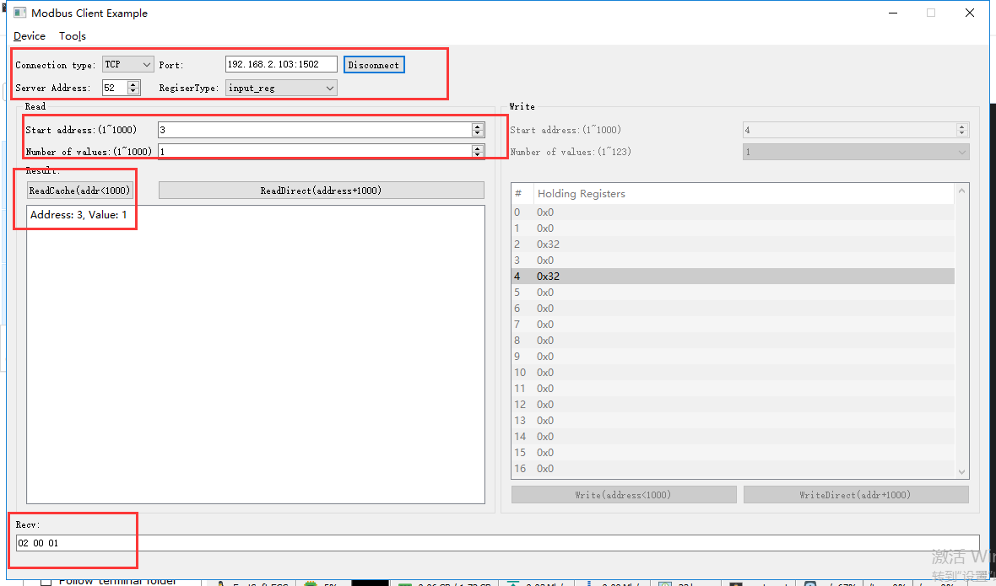

rcv from 192.168.2.113:58803:

[ 00 fe 00 00 00 06 34 04 00 03 00 01 ]

snd to 192.168.2.113:58803:

[ 00 fe 00 00 00 05 34 04 02 00 01 ]

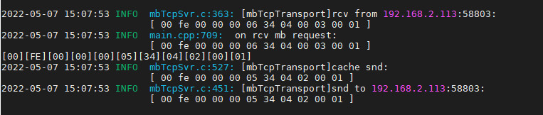

#### 无告警时

直读

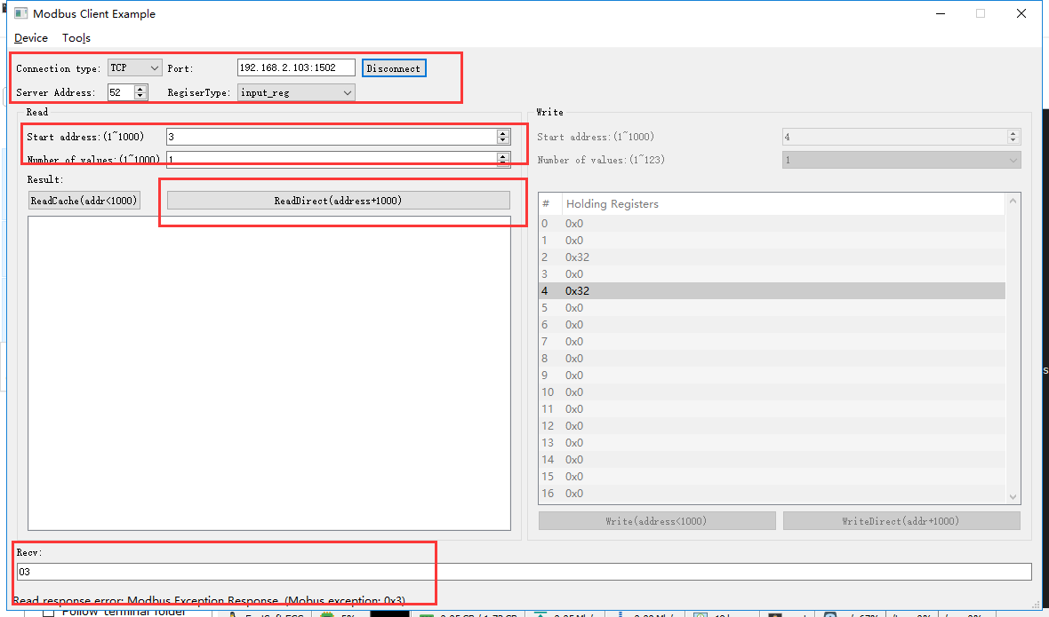

rcv from 192.168.2.113:52162:

[ 00 38 00 00 00 06 34 04 03 eb 00 01 ]

snd to 192.168.2.113:52162:

[ 00 38 00 00 00 03 34 84 03 ]

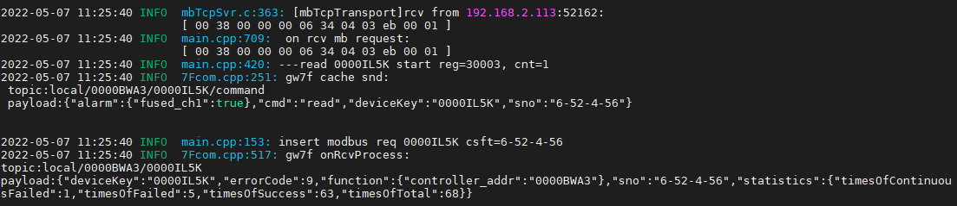

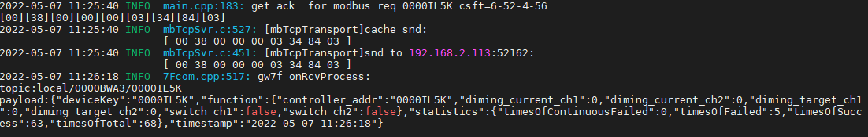

因网关限制，无法直读保险丝熔断告警。

读缓存

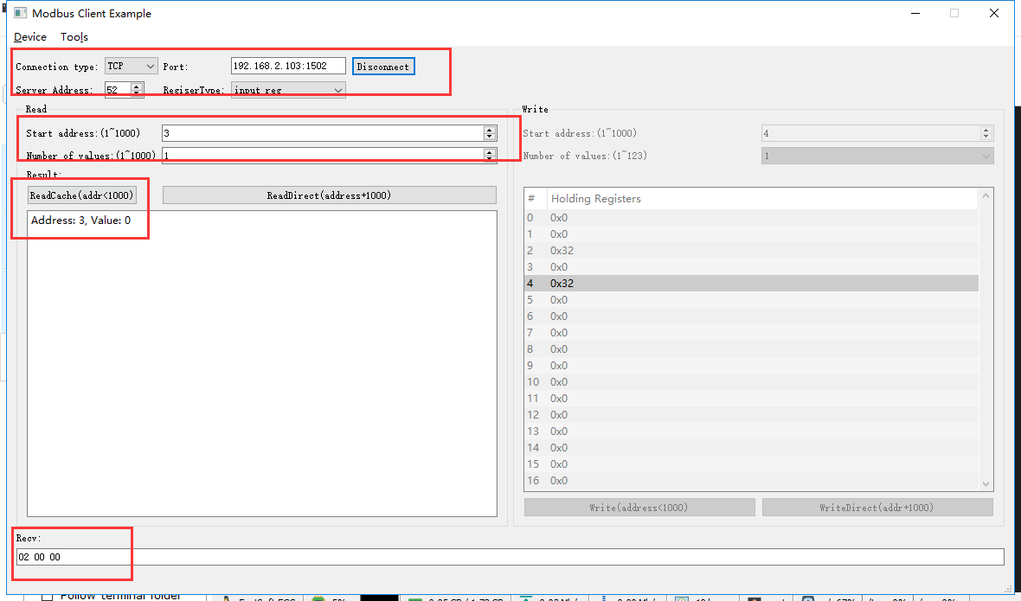

rcv from 192.168.2.113:52162:

[ 00 39 00 00 00 06 34 04 00 03 00 01 ]

snd to 192.168.2.113:52162:

[ 00 39 00 00 00 05 34 04 02 00 00 ]

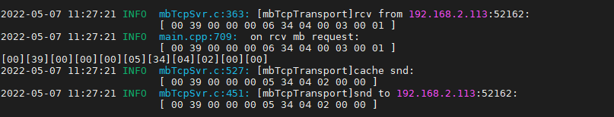

### 第1通道过温告警

#### 告警时

直读

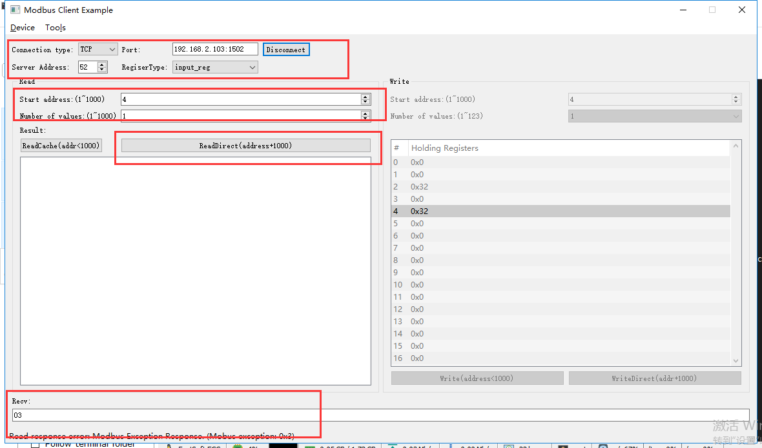

rcv from 192.168.2.113:62612:

[ 00 c2 00 00 00 06 34 04 03 ec 00 01 ]

snd to 192.168.2.113:62612:

[ 00 c2 00 00 00 03 34 84 03 ]

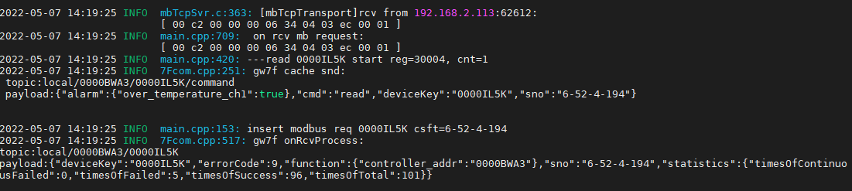



因网关限制，无法直读过温告警。

读缓存

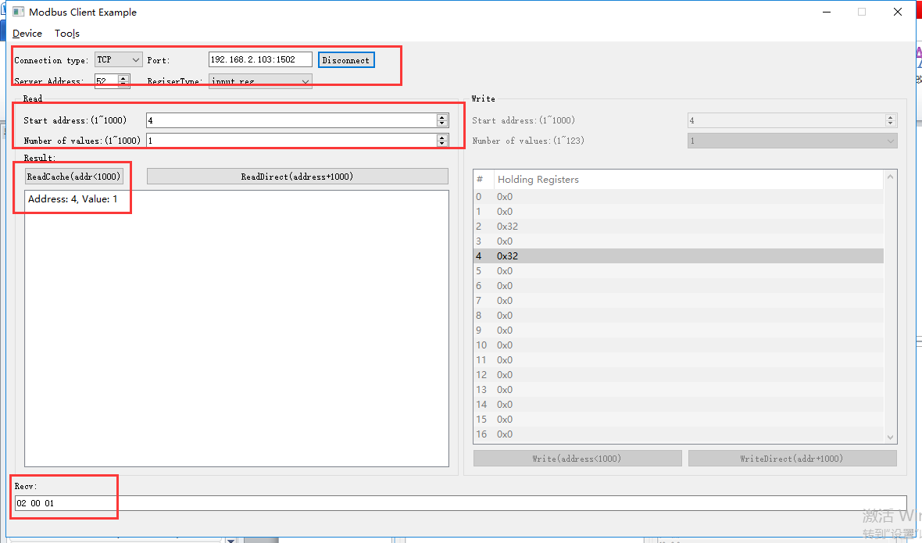

rcv from 192.168.2.113:58803:

[ 01 01 00 00 00 06 34 04 00 04 00 01 ]

snd to 192.168.2.113:58803:

[ 01 01 00 00 00 05 34 04 02 00 01 ]

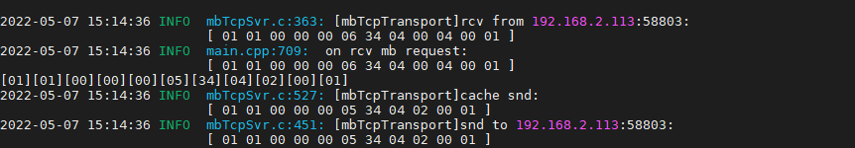

#### 无告警时

直读

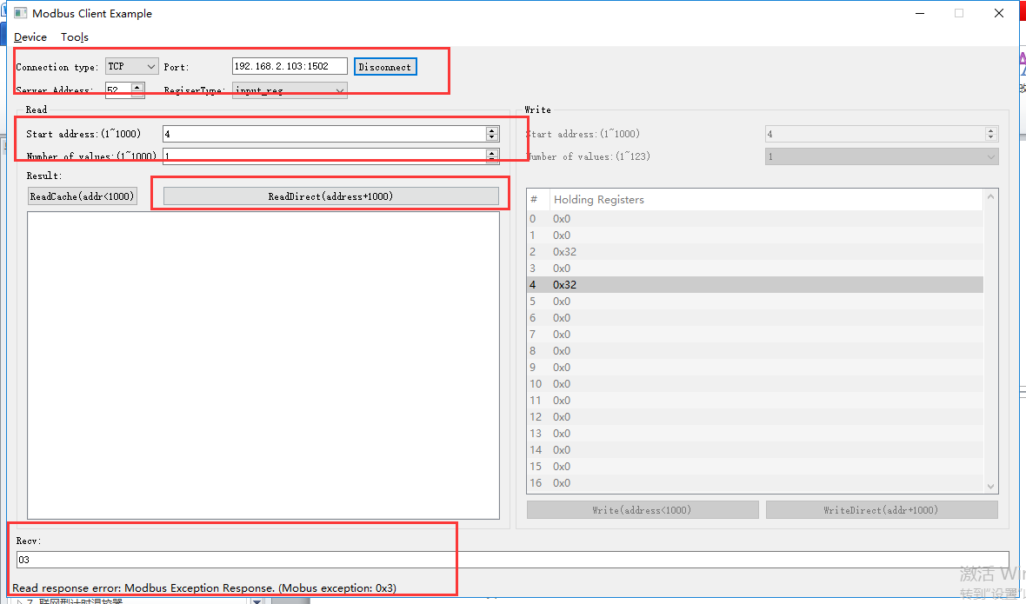

rcv from 192.168.2.113:62612:

[ 00 3c 00 00 00 06 34 04 03 ec 00 01 ]

snd to 192.168.2.113:62612:

[ 00 3c 00 00 00 03 34 84 03 ]

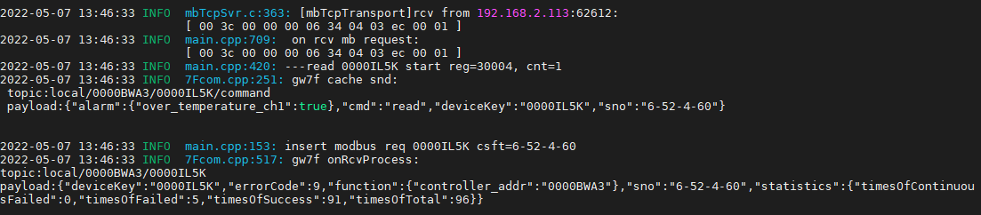



因网关限制，无法直读过温告警。

读缓存

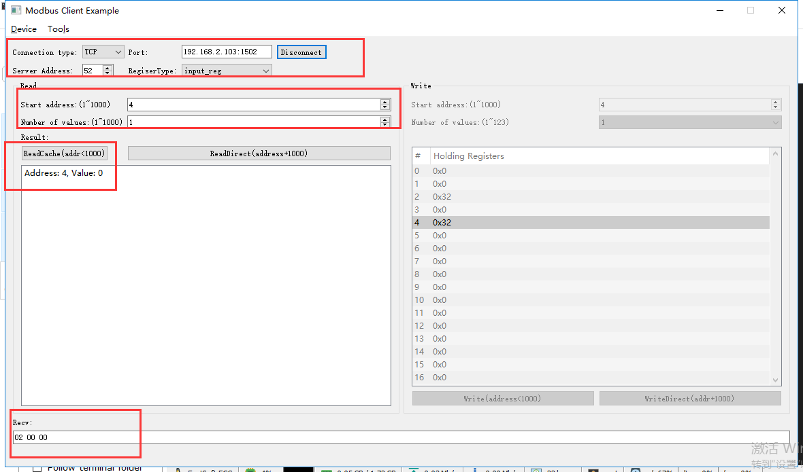

rcv from 192.168.2.113:62612:

[ 00 3d 00 00 00 06 34 04 00 04 00 01 ]

snd to 192.168.2.113:62612:

[ 00 3d 00 00 00 05 34 04 02 00 00 ]

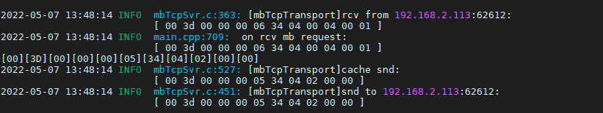

### 第2通道保险丝熔断告警

#### 告警时

直读

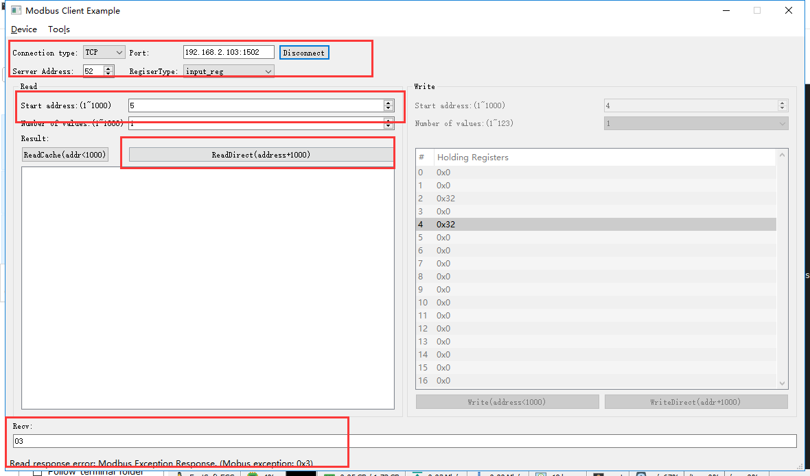

rcv from 192.168.2.113:52162:

[ 00 36 00 00 00 06 34 04 03 ed 00 01 ]

snd to 192.168.2.113:52162:

[ 00 36 00 00 00 03 34 84 03 ]

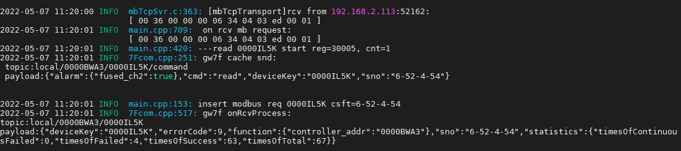

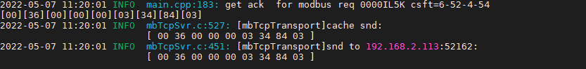

因网关限制，无法直读保险丝熔断告警。

读缓存

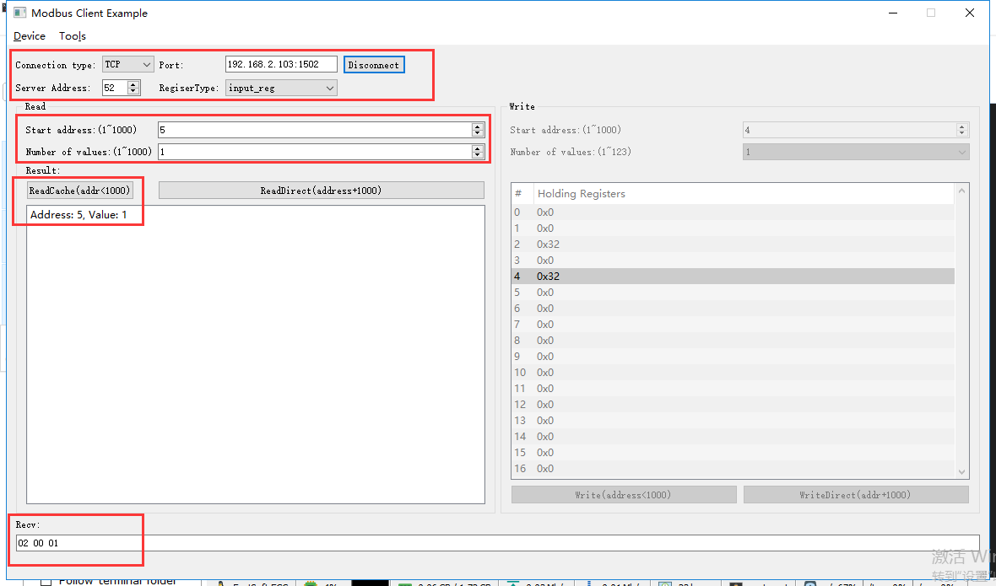

rcv from 192.168.2.113:58803:

[ 01 00 00 00 00 06 34 04 00 05 00 01 ]

snd to 192.168.2.113:58803:

[ 01 00 00 00 00 05 34 04 02 00 01 ]

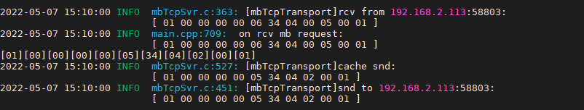

#### 无告警时

直读

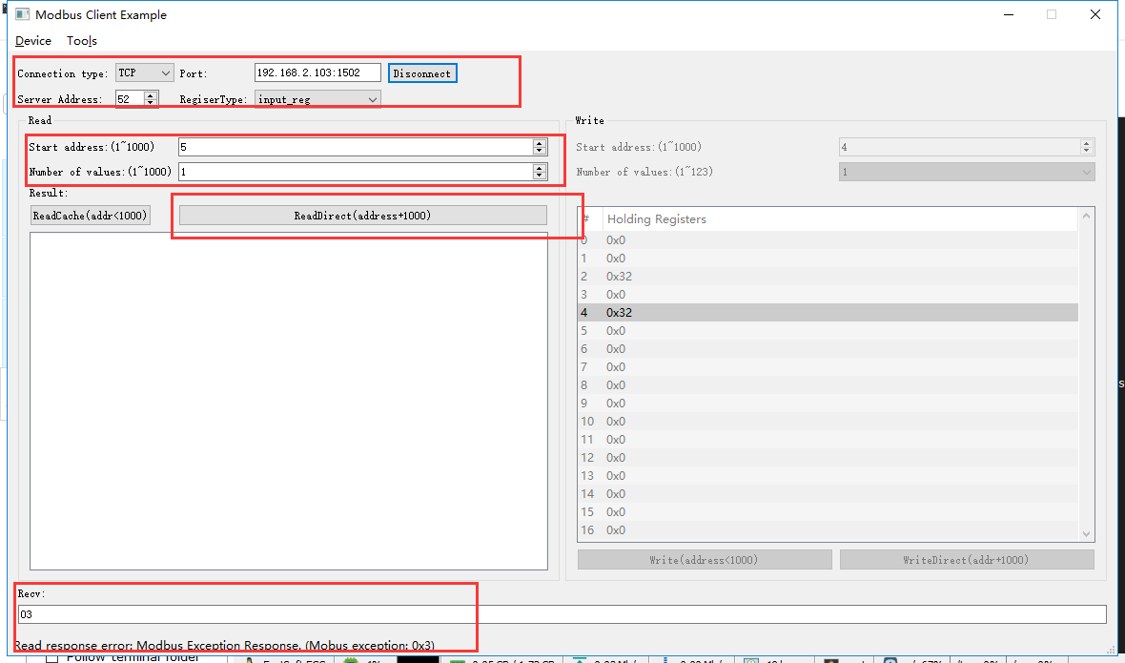

rcv from 192.168.2.113:52162:

[ 00 3a 00 00 00 06 34 04 03 ed 00 01 ]

snd to 192.168.2.113:52162:

[ 00 3a 00 00 00 03 34 84 03 ]

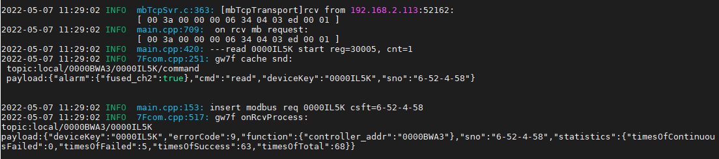



因网关限制，无法直读保险丝熔断告警。

读缓存

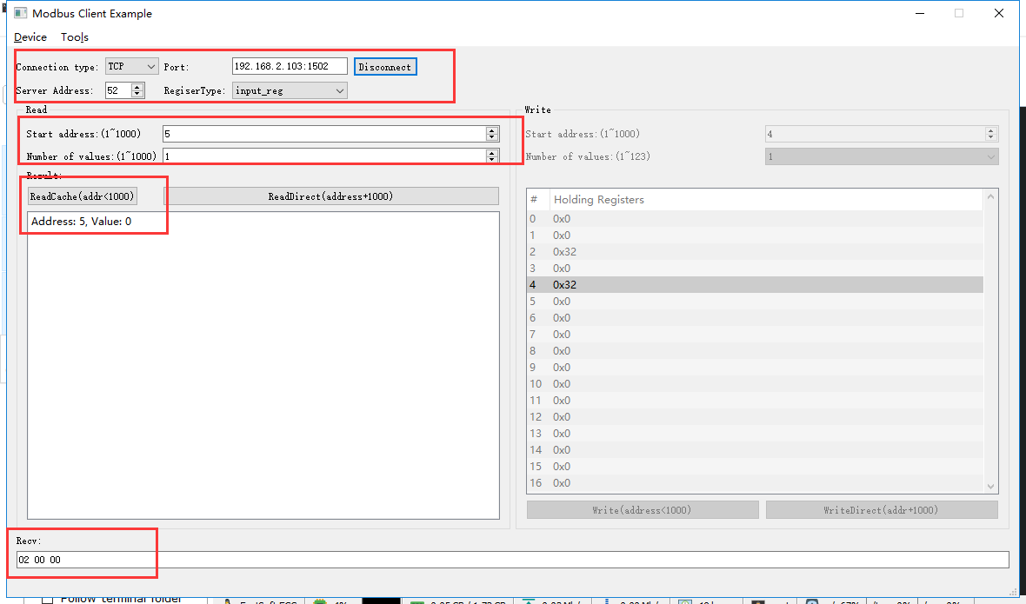

rcv from 192.168.2.113:52162:

[ 00 3b 00 00 00 06 34 04 00 05 00 01 ]

snd to 192.168.2.113:52162:

[ 00 3b 00 00 00 05 34 04 02 00 00 ]

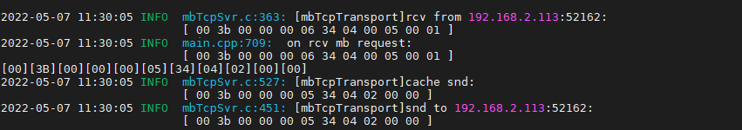

### 第2通道过温告警

#### 告警时

直读

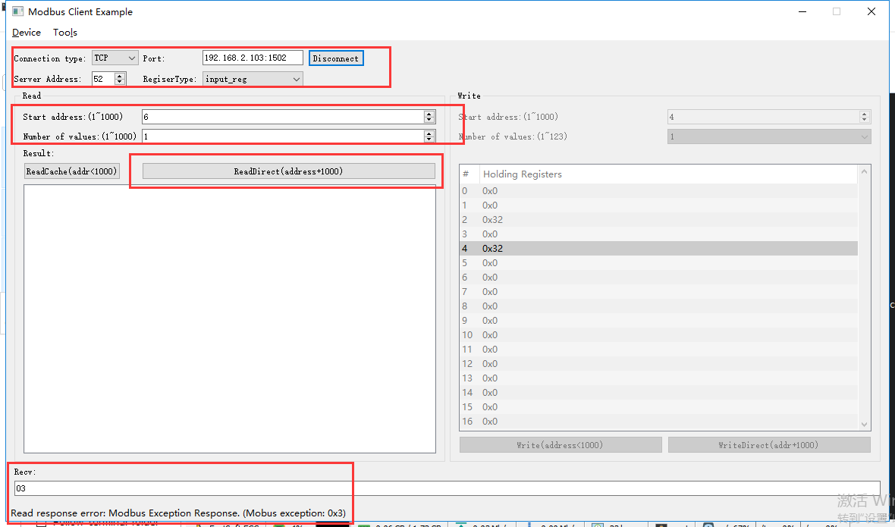

rcv from 192.168.2.113:58803:

[ 01 03 00 00 00 06 34 04 03 ee 00 01 ]

snd to 192.168.2.113:58803:

[ 01 03 00 00 00 03 34 84 03 ]

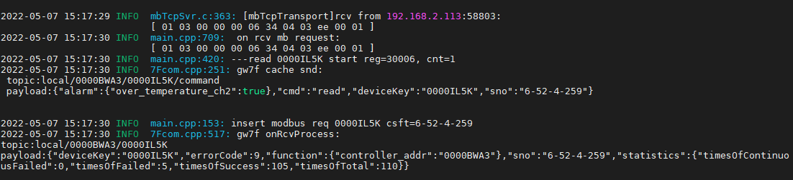



读缓存

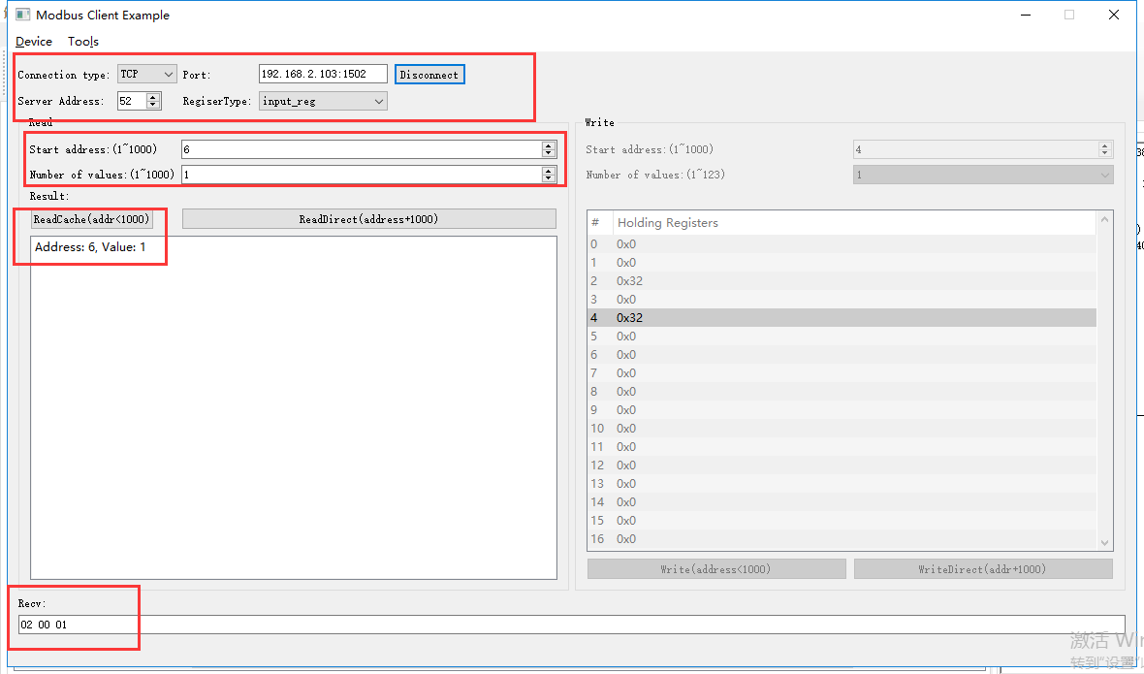

rcv from 192.168.2.113:58803:

[ 01 04 00 00 00 06 34 04 00 06 00 01 ]

snd to 192.168.2.113:58803:

[ 01 04 00 00 00 05 34 04 02 00 01 ]

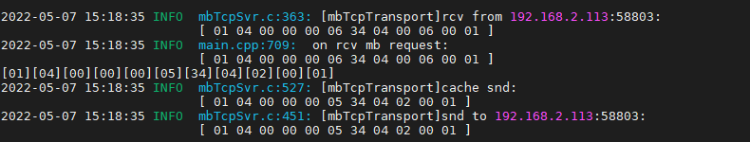

#### 无告警时

直读

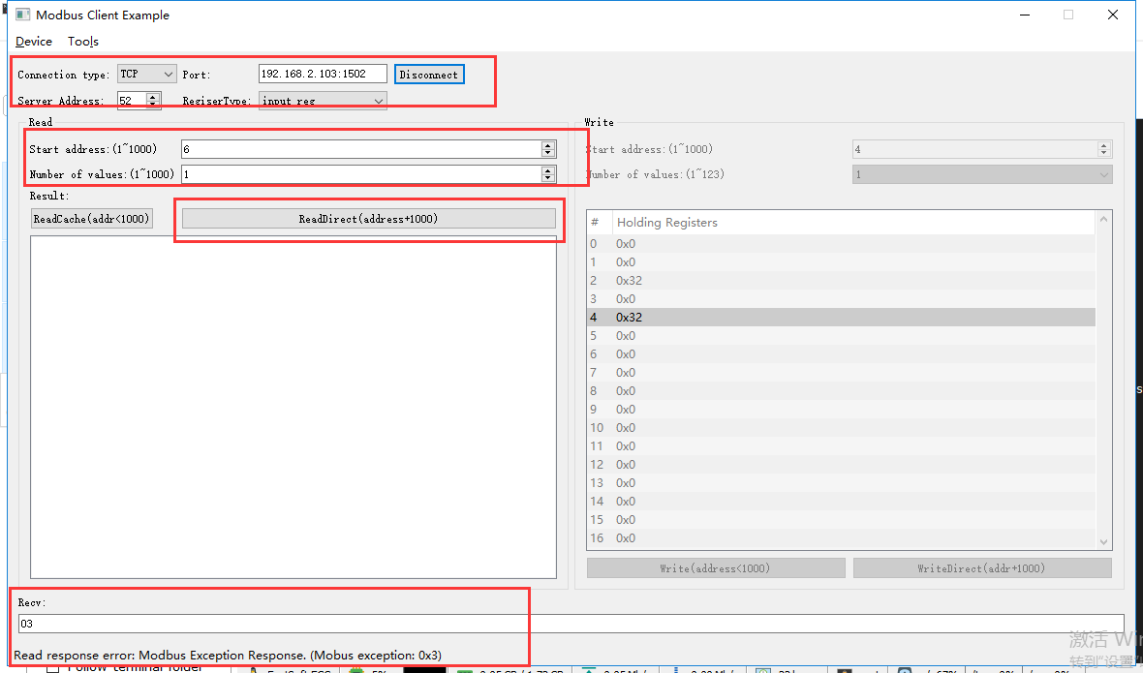

rcv from 192.168.2.113:62612:

[ 00 3e 00 00 00 06 34 04 03 ee 00 01 ]

snd to 192.168.2.113:62612:

[ 00 3e 00 00 00 03 34 84 03 ]

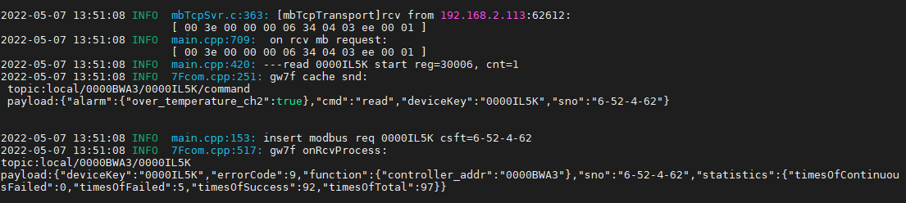

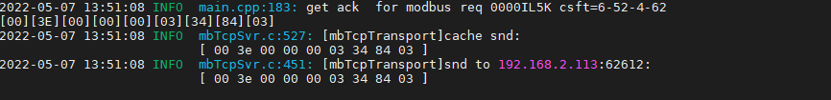

读缓存

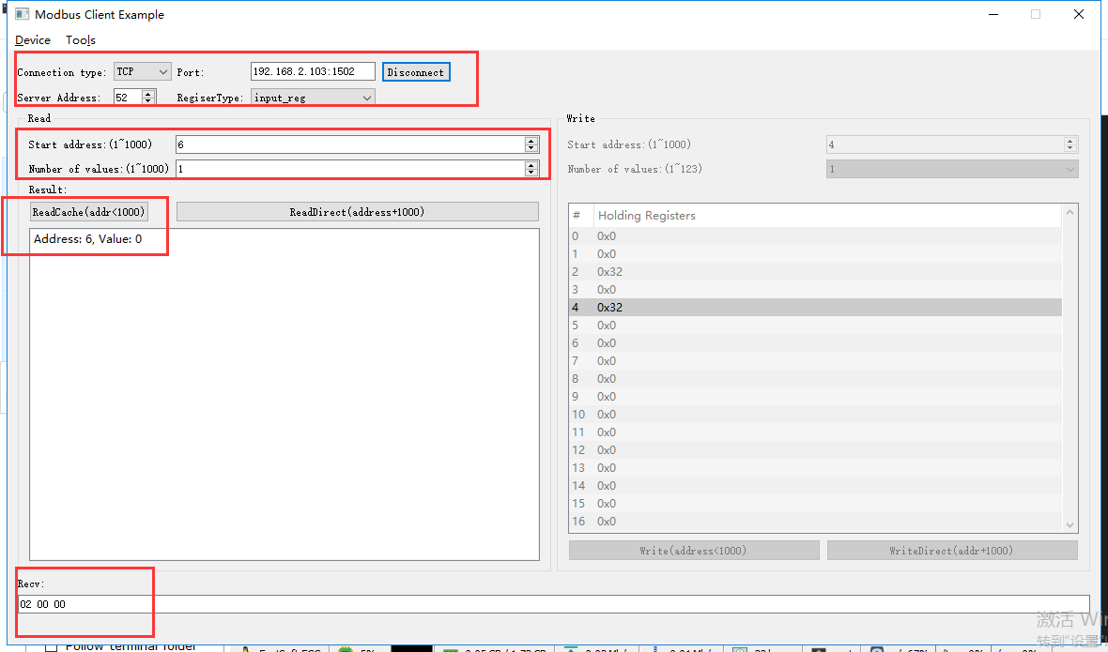

rcv from 192.168.2.113:62612:

[ 00 3f 00 00 00 06 34 04 00 06 00 01 ]

snd to 192.168.2.113:62612:

[ 00 3f 00 00 00 05 34 04 02 00 00 ]

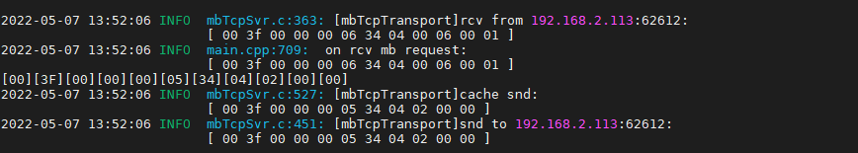

# 载波电能表ok

**说明：**根据转换程序所支持的设备，典型选取一种测试。

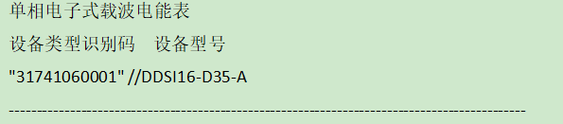

**寄存器定义：**

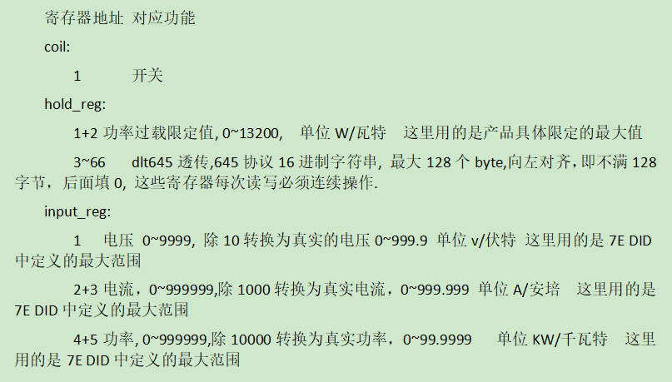

## 开关控制

### 控制开

写开

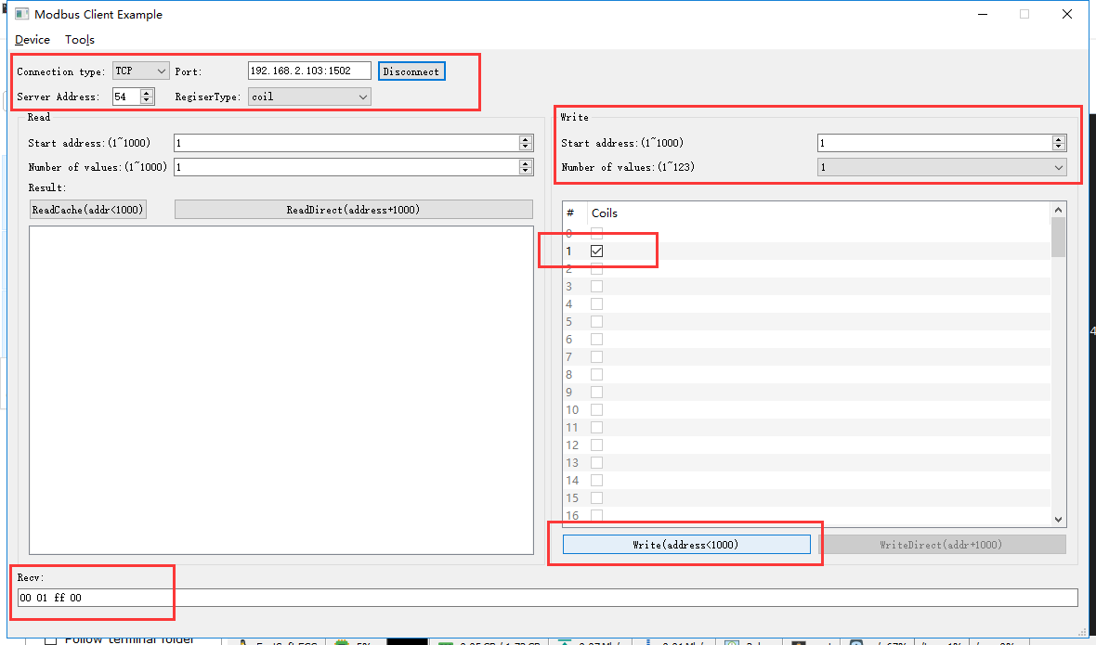

rcv from 192.168.2.113:62716:

[ 00 02 00 00 00 06 36 05 00 01 ff 00 ]

snd to 192.168.2.113:62716:

[ 00 02 00 00 00 06 36 05 00 01 ff 00 ]

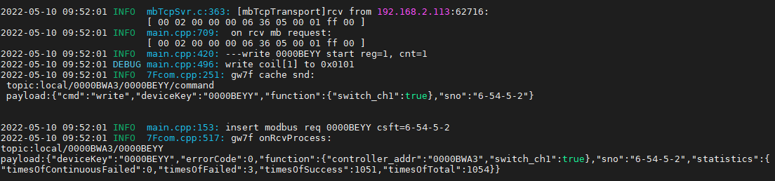

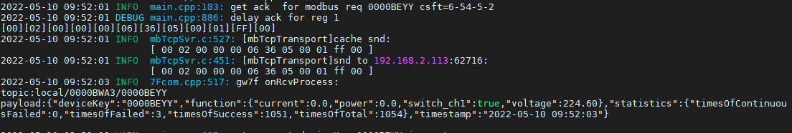

直读

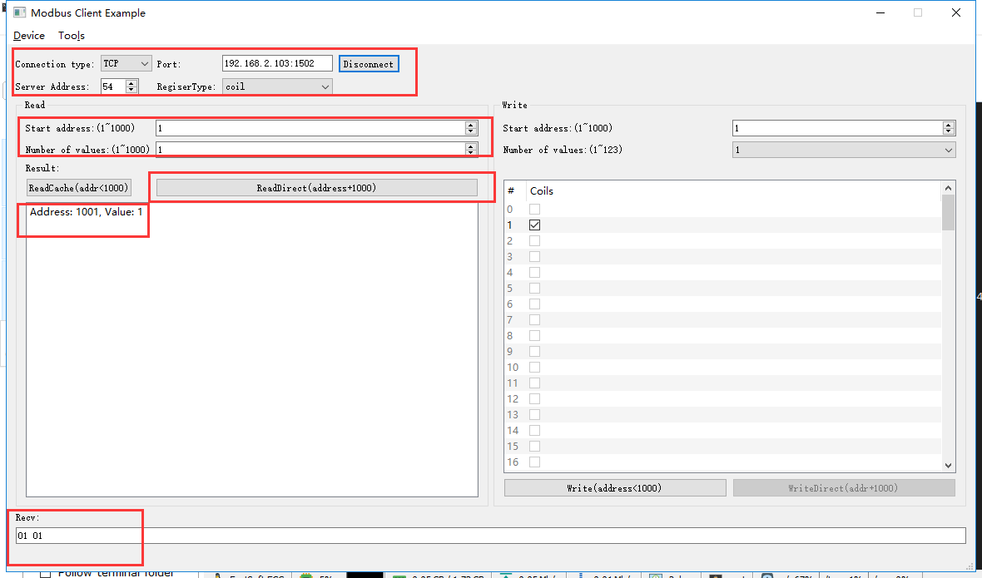

rcv from 192.168.2.113:62716:

[ 00 03 00 00 00 06 36 01 03 e9 00 01 ]

snd to 192.168.2.113:62716:

[ 00 03 00 00 00 04 36 01 01 01 ]

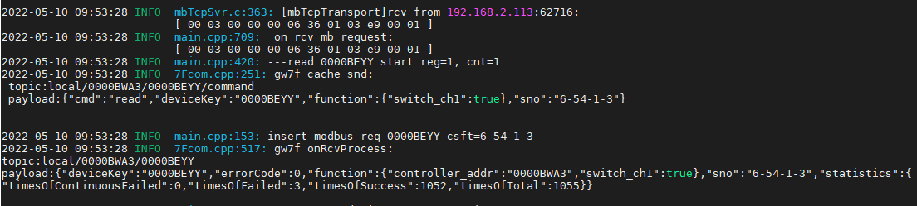

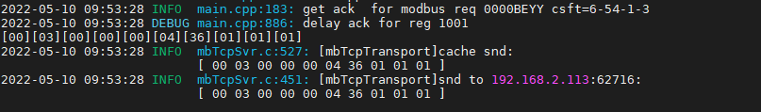

读缓存

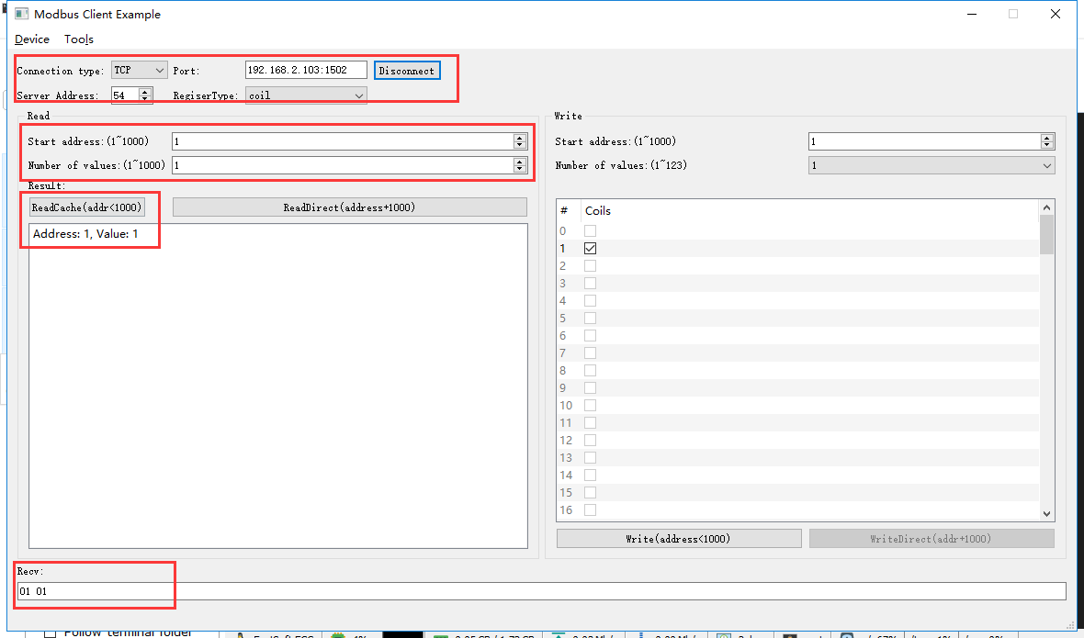

rcv from 192.168.2.113:62716:

[ 00 04 00 00 00 06 36 01 00 01 00 01 ]

snd to 192.168.2.113:62716:

[ 00 04 00 00 00 04 36 01 01 01 ]

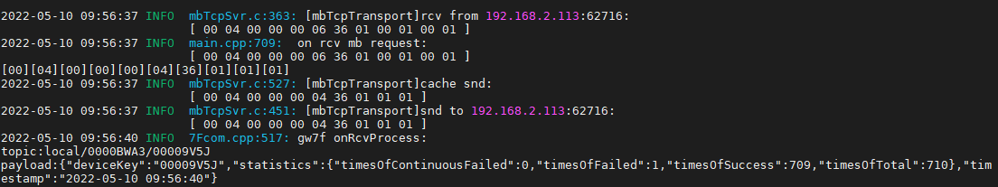

### 控制关

写关

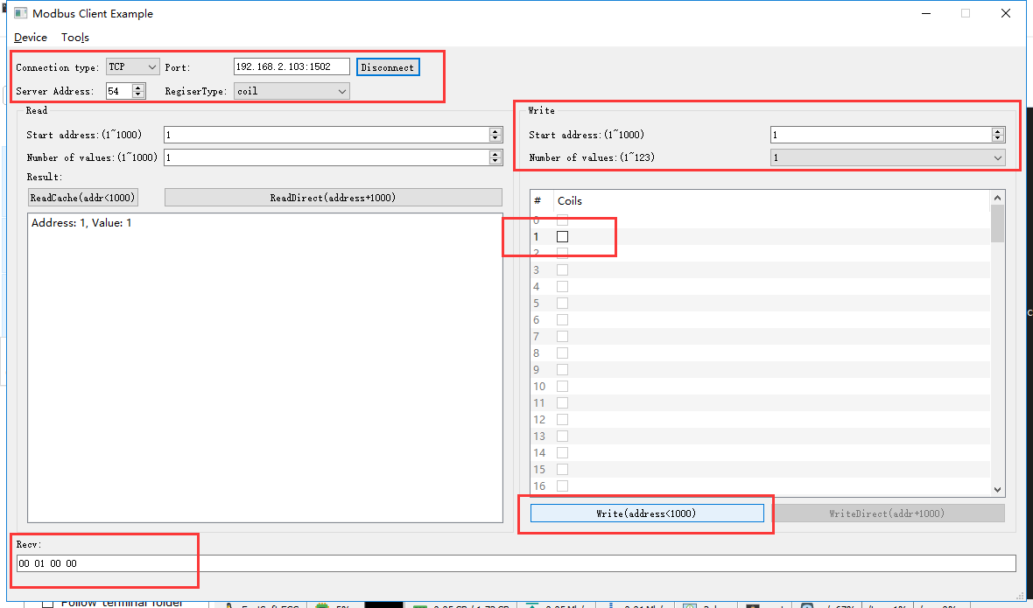

rcv from 192.168.2.113:62716:

[ 00 05 00 00 00 06 36 05 00 01 00 00 ]

snd to 192.168.2.113:62716:

[ 00 05 00 00 00 06 36 05 00 01 00 00 ]

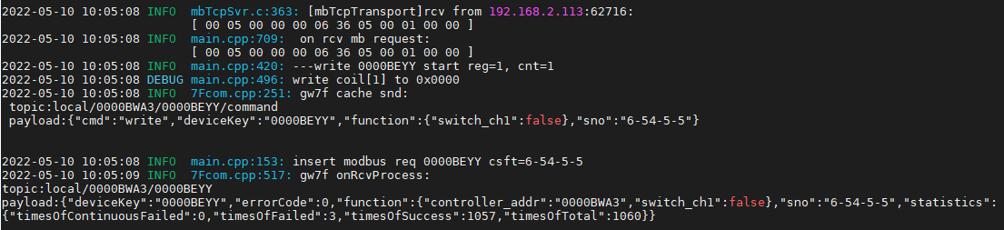

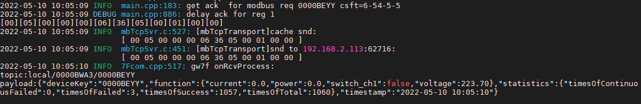

直读

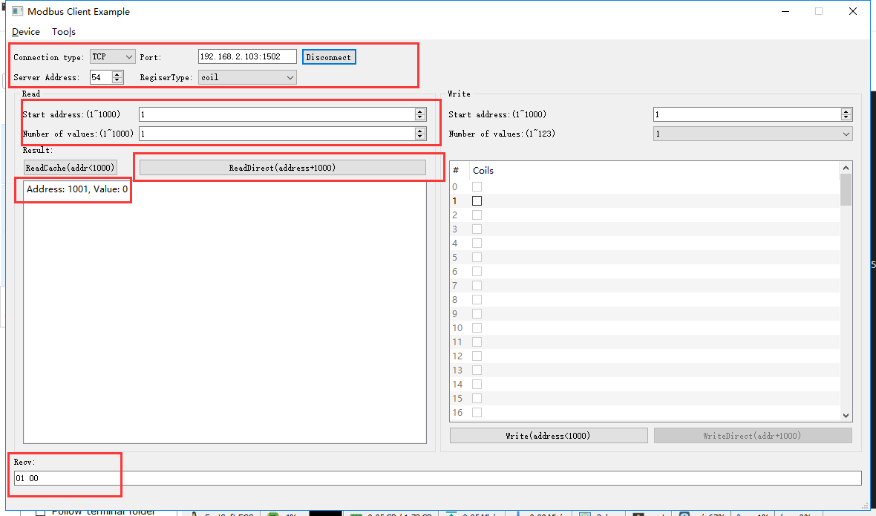

rcv from 192.168.2.113:62716:

[ 00 06 00 00 00 06 36 01 03 e9 00 01 ]

snd to 192.168.2.113:62716:

[ 00 06 00 00 00 04 36 01 01 00 ]

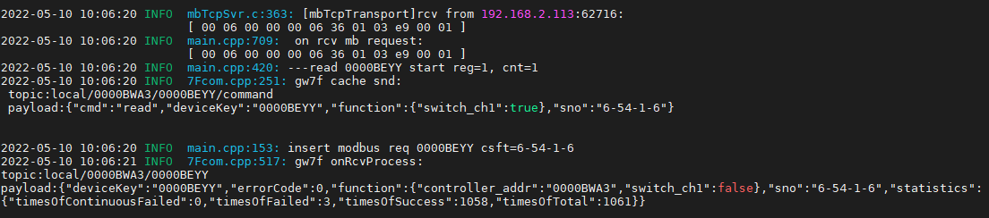



读缓存

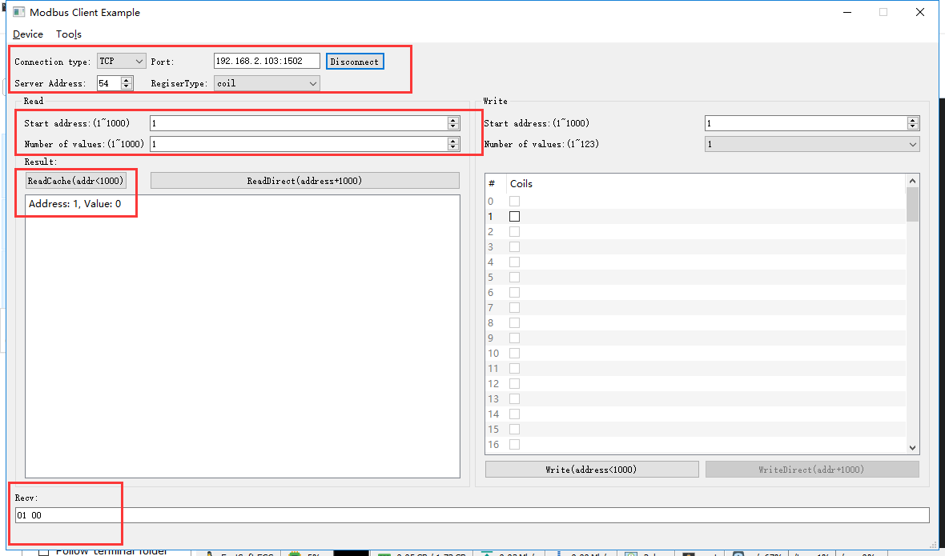

rcv from 192.168.2.113:62716:

[ 00 07 00 00 00 06 36 01 00 01 00 01 ]

snd to 192.168.2.113:62716:

[ 00 07 00 00 00 04 36 01 01 00 ]

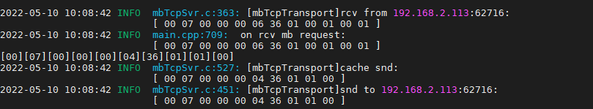

## 过载功率

先通过抄控器，将电表的过载功率设置成10k

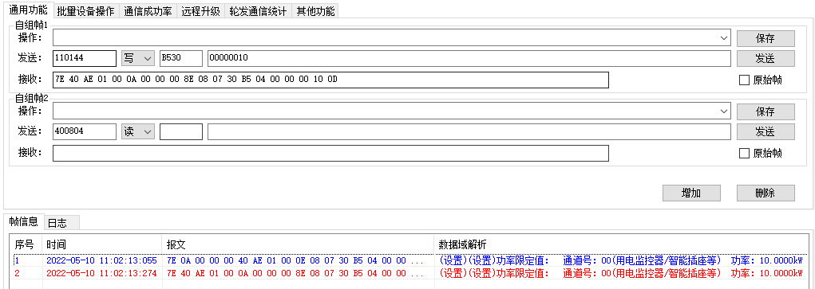

### 直读过载功率

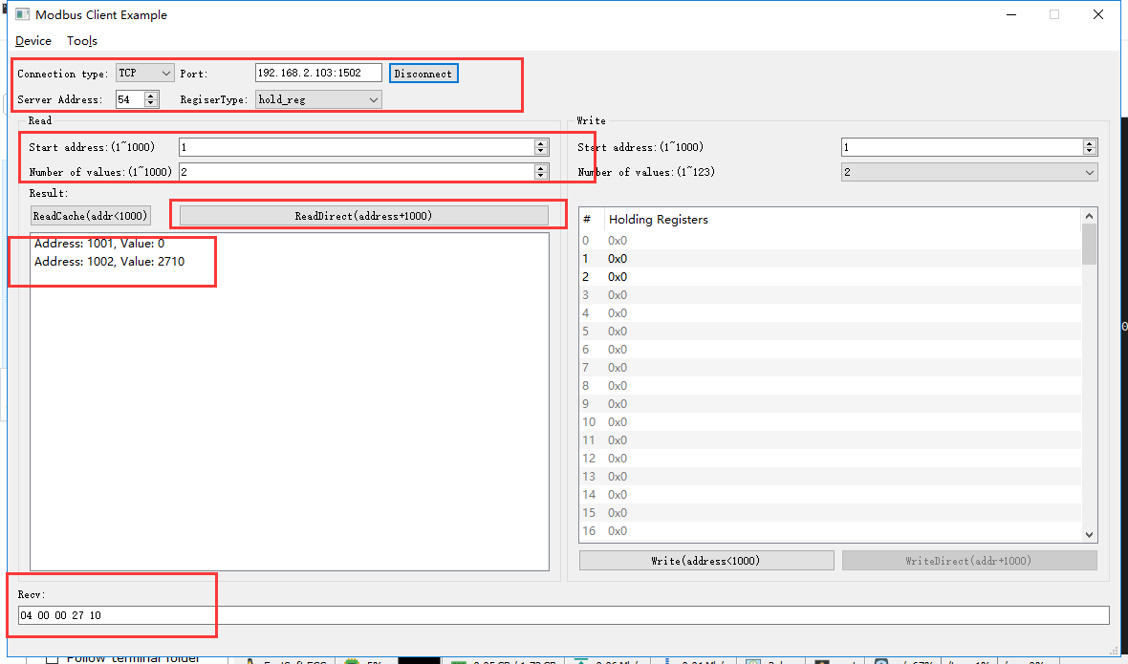

rcv from 192.168.2.113:62716:

[ 00 19 00 00 00 06 36 03 03 e9 00 02 ]

snd to 192.168.2.113:62716:

[ 00 19 00 00 00 07 36 03 04 00 00 27 10 ]

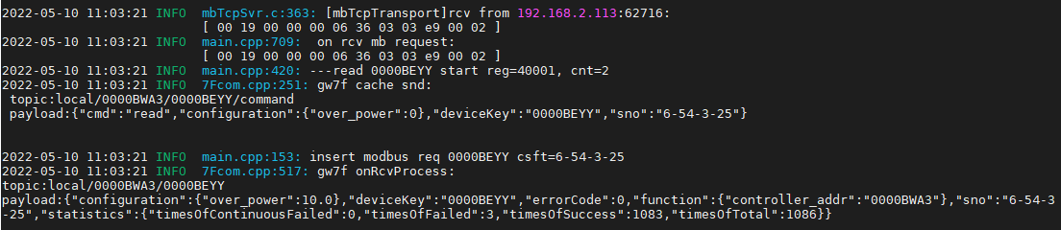

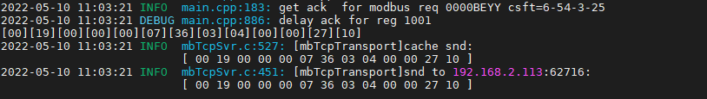



### 读缓存过载功率

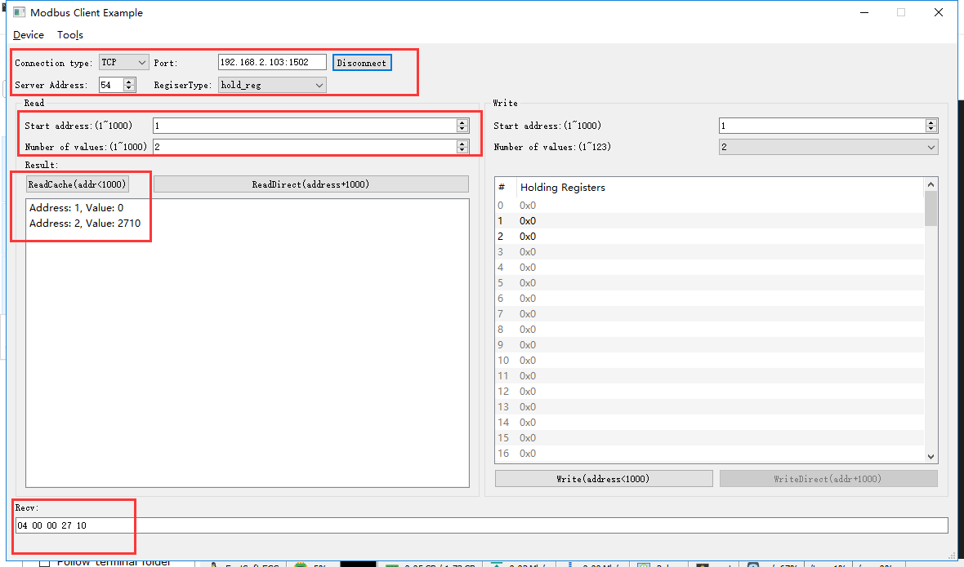

rcv from 192.168.2.113:62716:

[ 00 1a 00 00 00 06 36 03 00 01 00 02 ]

snd to 192.168.2.113:62716:

[ 00 1a 00 00 00 07 36 03 04 00 00 27 10 ]

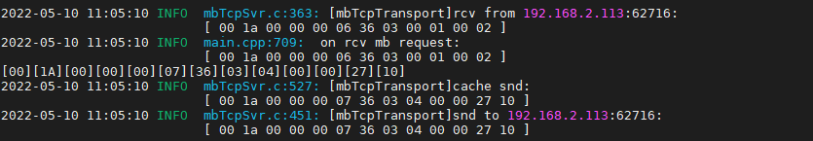

### 写入过载功率

#### 一般功率

写入

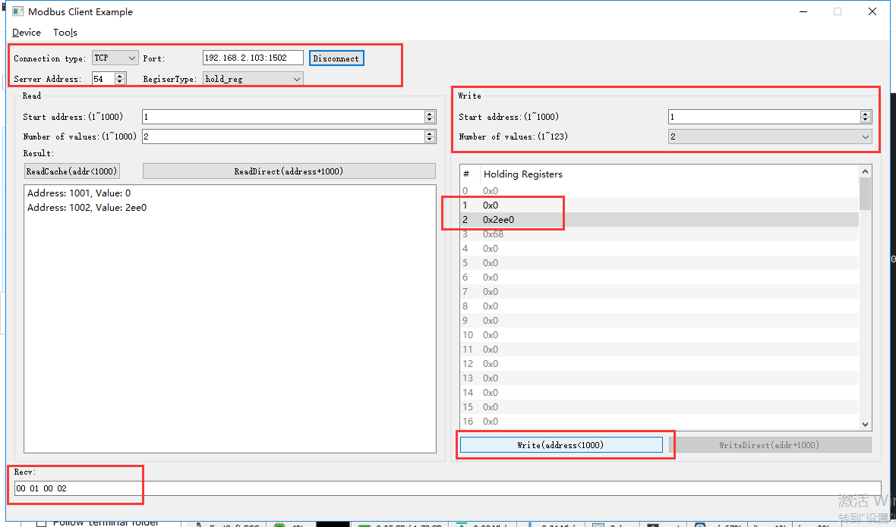

rcv from 192.168.2.113:63416:

[ 00 35 00 00 00 0b 36 10 00 01 00 02 04 00 00 2e e0 ]

snd to 192.168.2.113:63416:

[ 00 35 00 00 00 06 36 10 00 01 00 02 ]

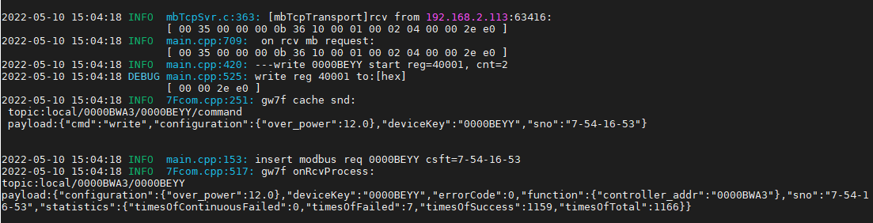



直读

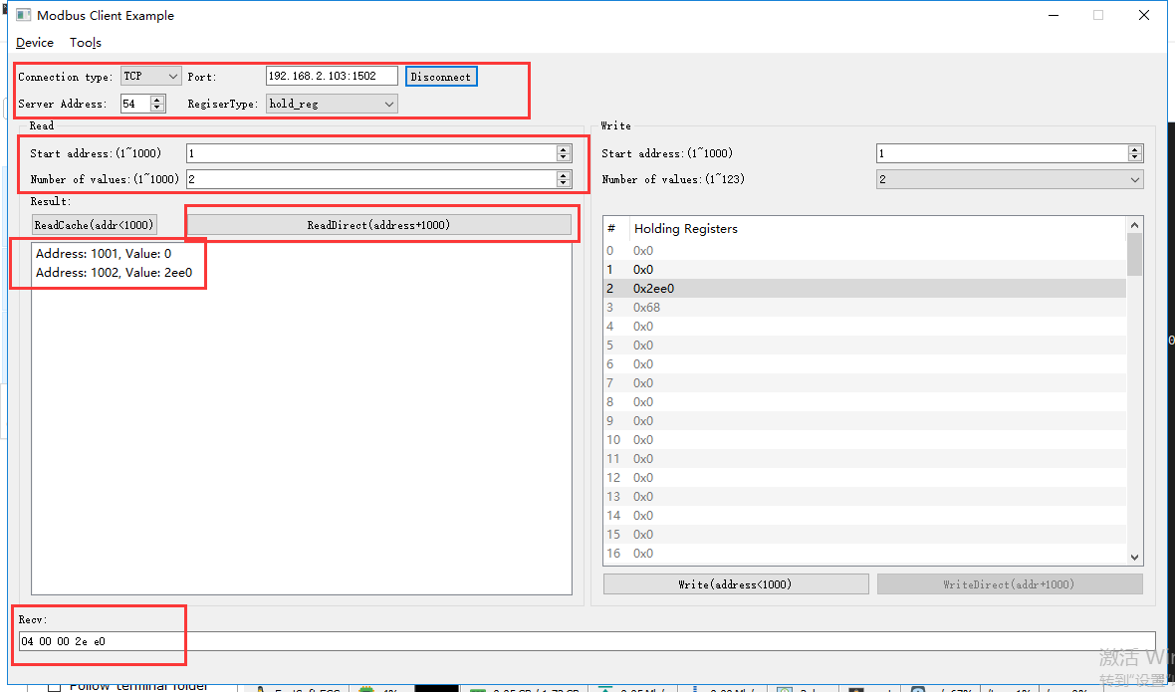

rcv from 192.168.2.113:63416:

[ 00 36 00 00 00 06 36 03 03 e9 00 02 ]

snd to 192.168.2.113:63416:

[ 00 36 00 00 00 07 36 03 04 00 00 2e e0 ]

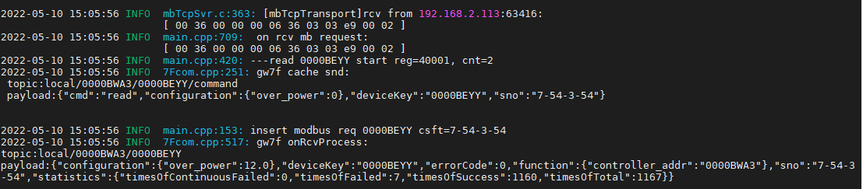

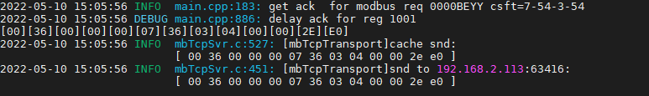

读缓存

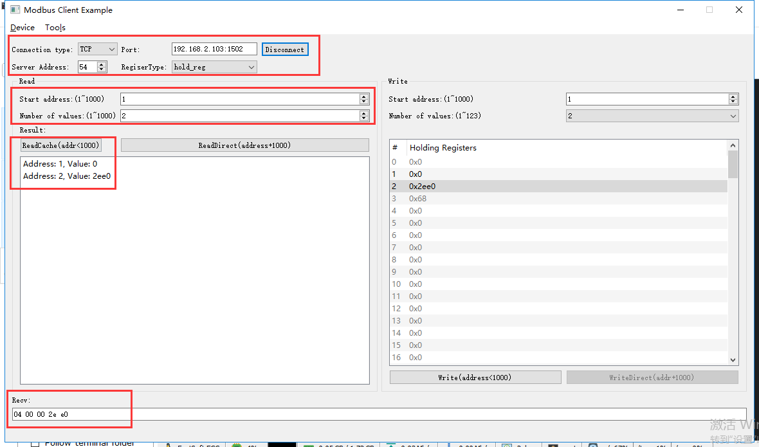

rcv from 192.168.2.113:63416:

[ 00 37 00 00 00 06 36 03 00 01 00 02 ]

snd to 192.168.2.113:63416:

[ 00 37 00 00 00 07 36 03 04 00 00 2e e0 ]

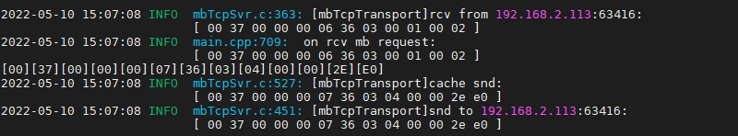

#### 最大过载功率

**说明：**单相载波电能表可配置的过载功率最大13.2kw

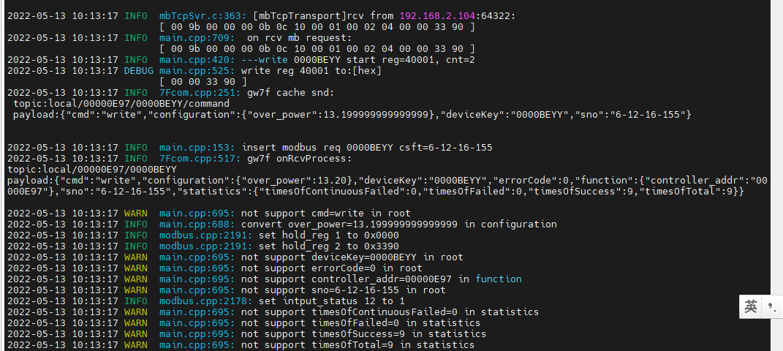

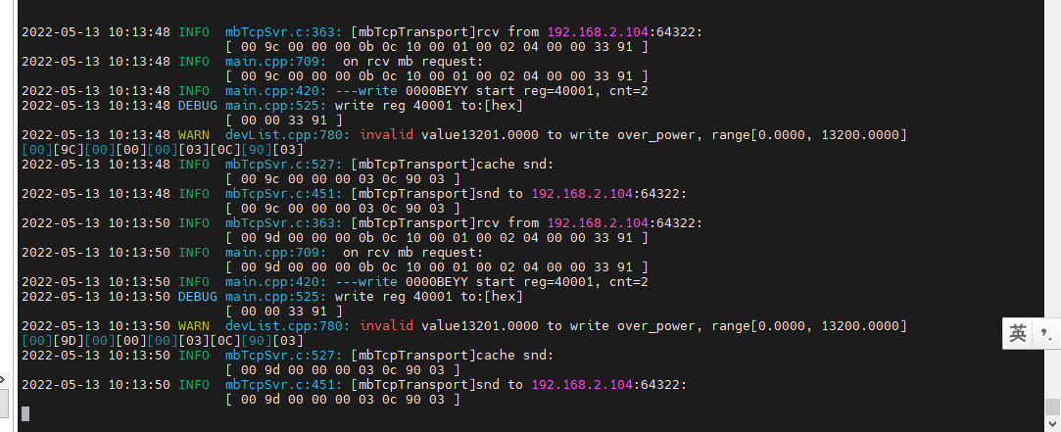

结果：配置为13.2成功，配置为13.21失败，测试合格。

## 645透传

说明：因hold_reg默认为“写”操作，在进行645透传读操作时，仍会下发07（写），故无法进行读取操作。研发在ESHG-RJ-MBSVR-T3(v1.1)-20220510版本时，删除了645透传功能。

## 变量读取

### 电压

直读

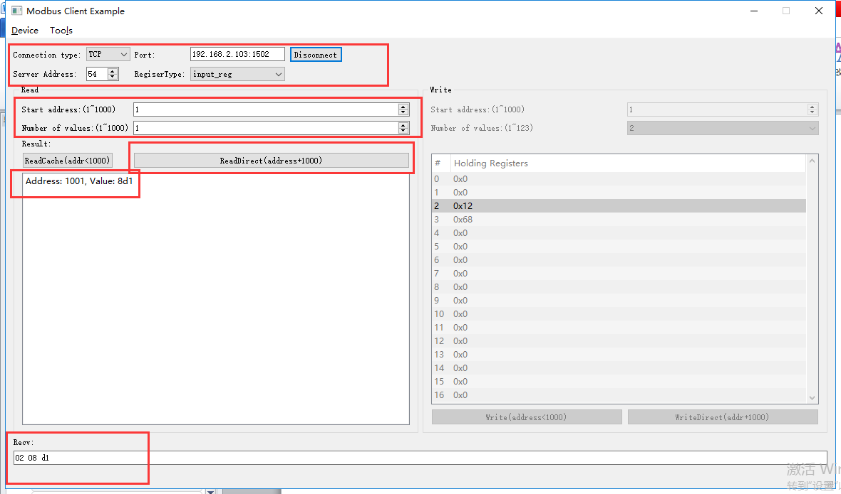

rcv from 192.168.2.113:62890:

[ 00 26 00 00 00 06 36 04 03 e9 00 01 ]

snd to 192.168.2.113:62890:

[ 00 26 00 00 00 05 36 04 02 08 d1 ]

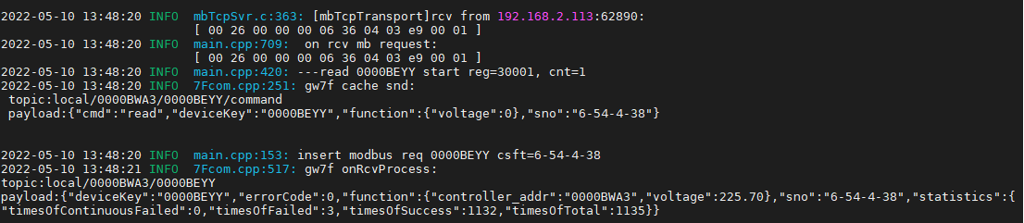

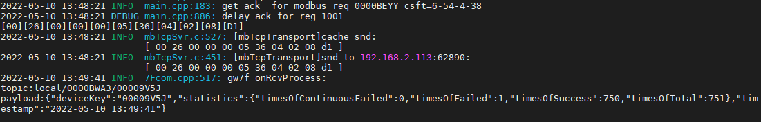

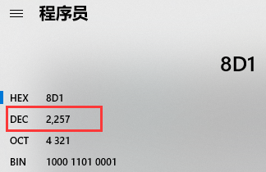

读缓存

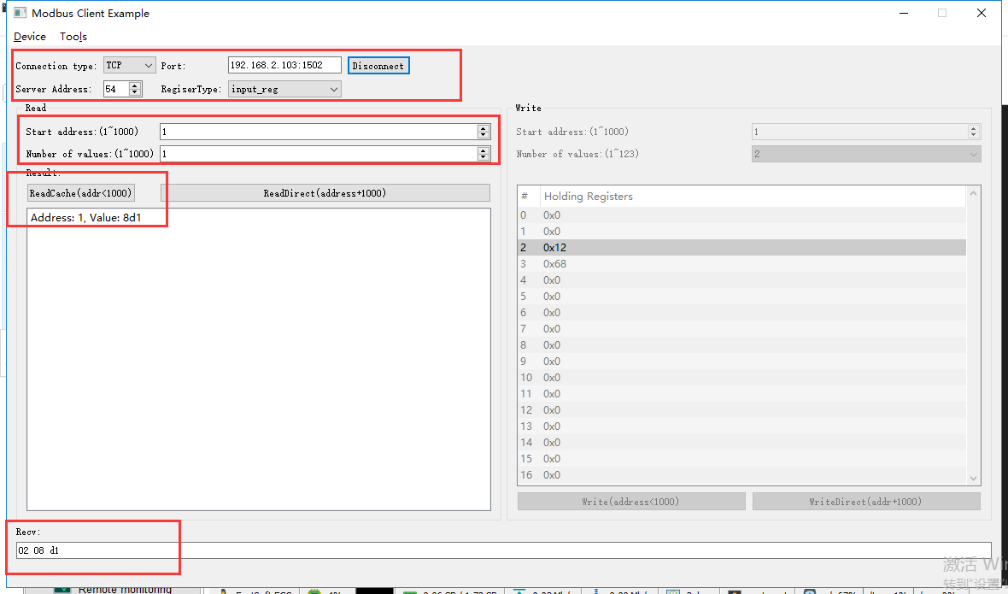

rcv from 192.168.2.113:62890:

[ 00 28 00 00 00 06 36 04 00 01 00 01 ]

snd to 192.168.2.113:62890:

[ 00 28 00 00 00 05 36 04 02 08 d1 ]

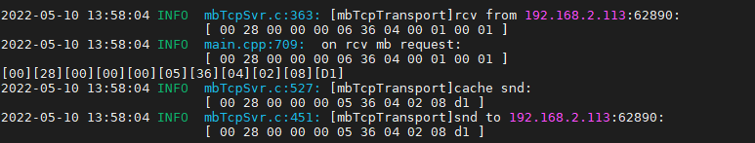

### 电流

直读

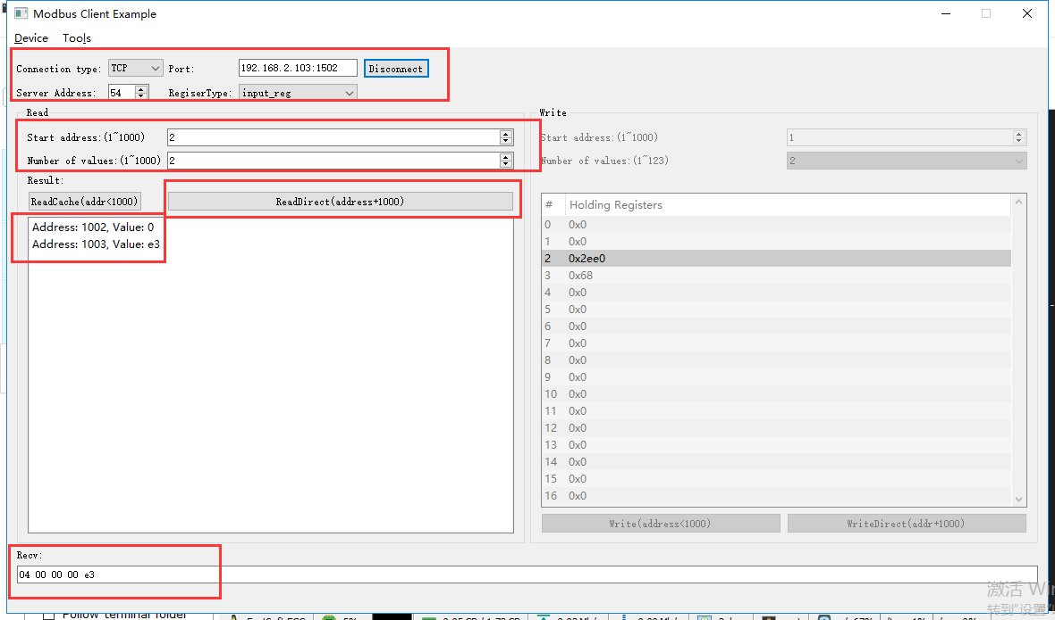

rcv from 192.168.2.113:63416:

[ 00 38 00 00 00 06 36 04 03 ea 00 02 ]

snd to 192.168.2.113:63416:

[ 00 38 00 00 00 07 36 04 04 00 00 00 e3 ]

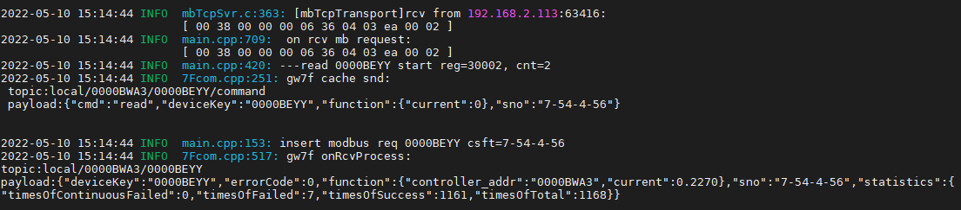

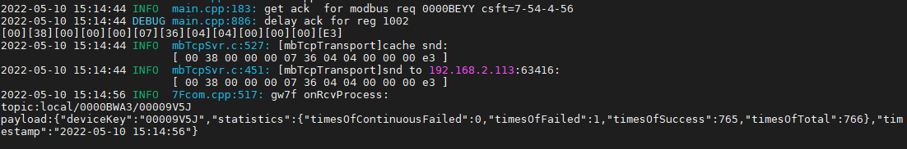



读缓存

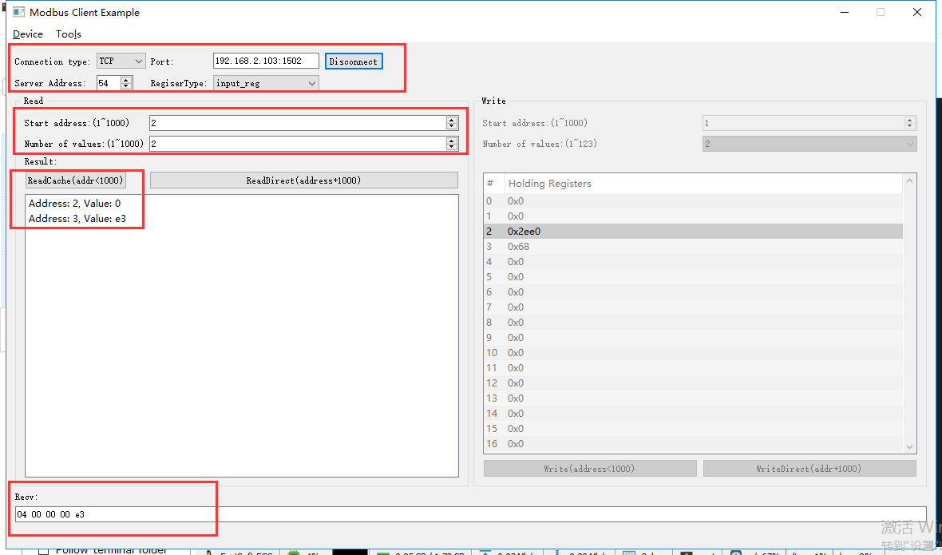

rcv from 192.168.2.113:63416:

[ 00 39 00 00 00 06 36 04 00 02 00 02 ]

snd to 192.168.2.113:63416:

[ 00 39 00 00 00 07 36 04 04 00 00 00 e3 ]

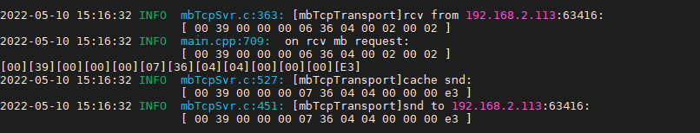

读错误地址2

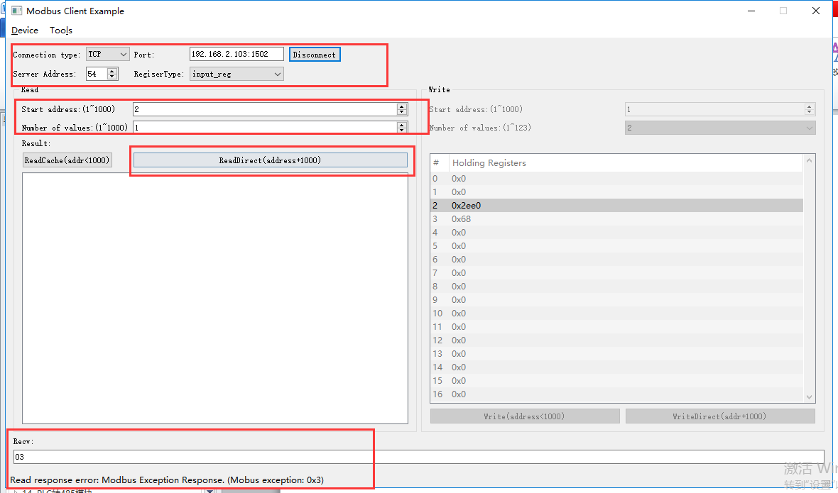

rcv from 192.168.2.113:63416:

[ 00 3a 00 00 00 06 36 04 03 ea 00 01 ]

snd to 192.168.2.113:63416:

[ 00 3a 00 00 00 03 36 84 03 ]

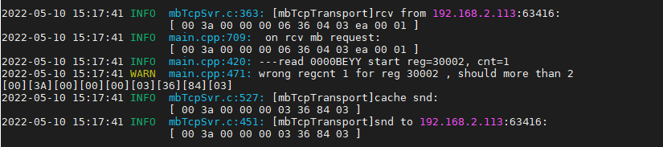

读错误地址3

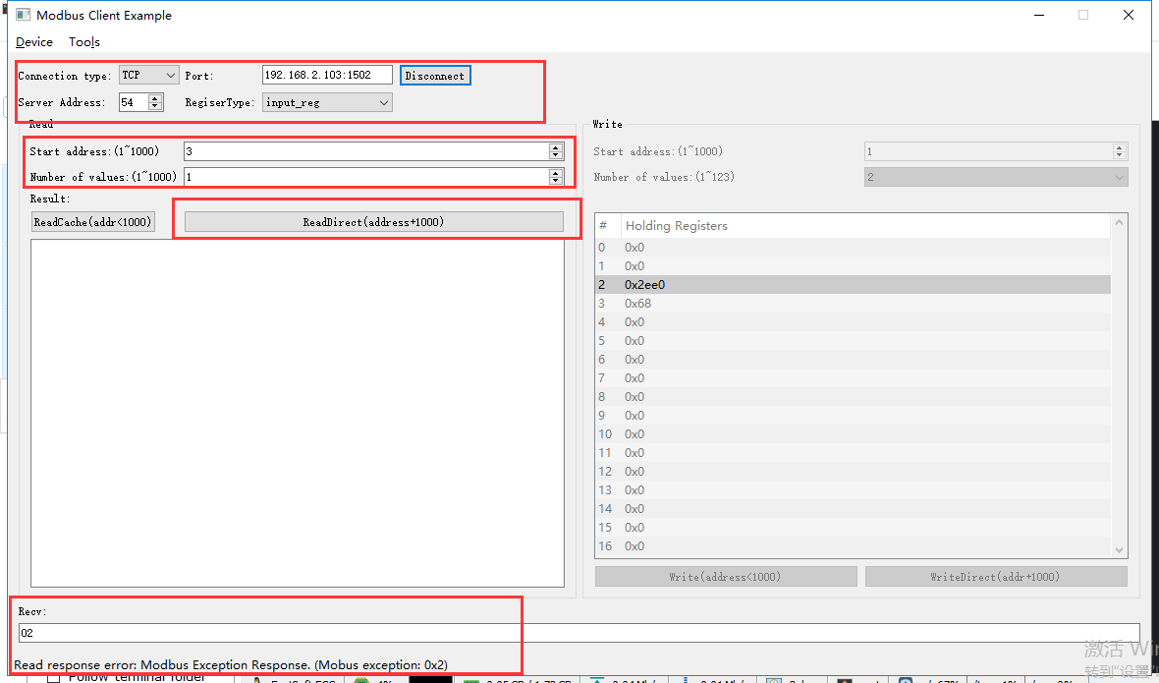

rcv from 192.168.2.113:63416:

[ 00 3b 00 00 00 06 36 04 03 eb 00 01 ]

snd to 192.168.2.113:63416:

[ 00 3b 00 00 00 03 36 84 02 ]

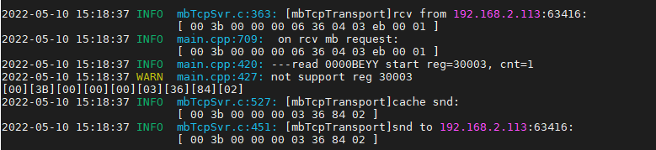

### 功率

直读

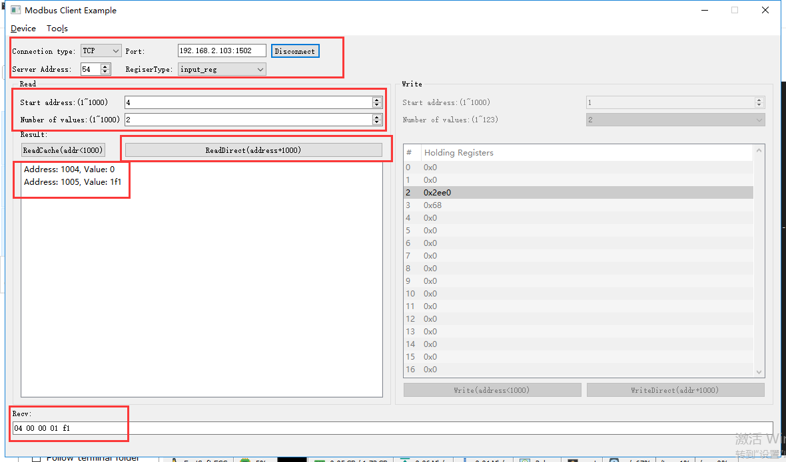

rcv from 192.168.2.113:63416:

[ 00 3c 00 00 00 06 36 04 03 ec 00 02 ]

snd to 192.168.2.113:63416:

[ 00 3c 00 00 00 07 36 04 04 00 00 01 f1 ]

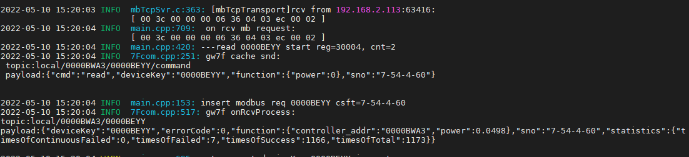

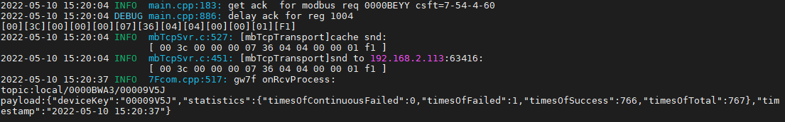

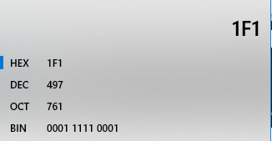

读缓存

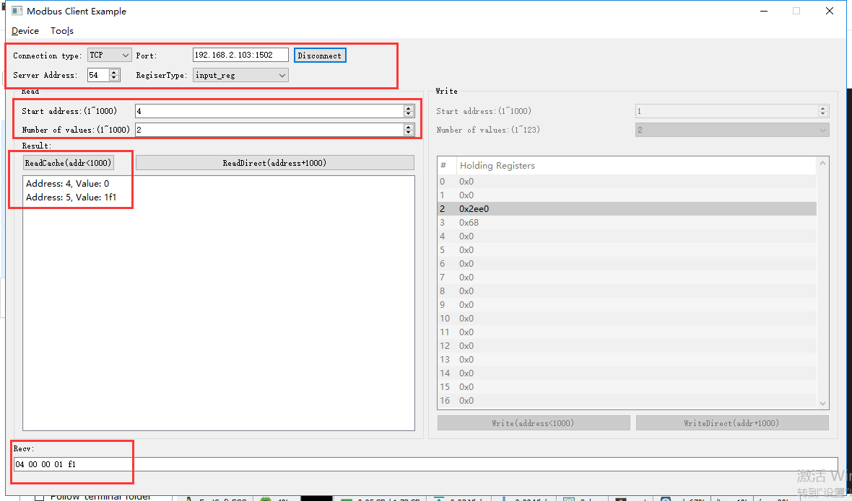

rcv from 192.168.2.113:63416:

[ 00 3d 00 00 00 06 36 04 00 04 00 02 ]

snd to 192.168.2.113:63416:

[ 00 3d 00 00 00 07 36 04 04 00 00 01 f1 ]

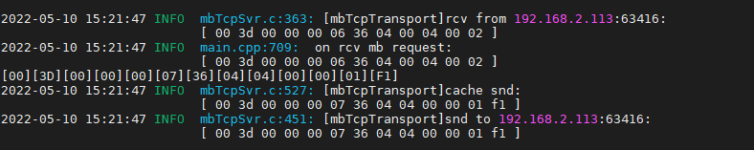

读错误地址4

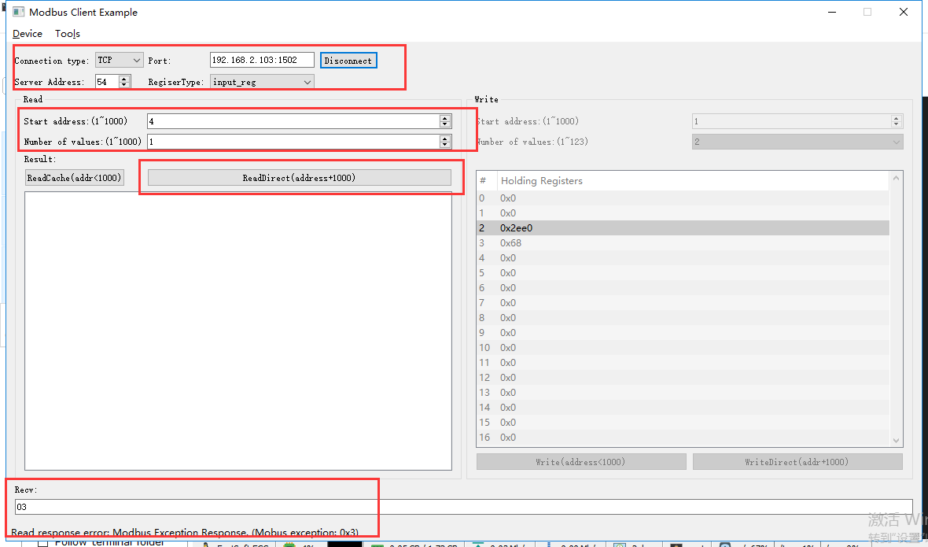

rcv from 192.168.2.113:63416:

[ 00 3e 00 00 00 06 36 04 03 ec 00 01 ]

snd to 192.168.2.113:63416:

[ 00 3e 00 00 00 03 36 84 03 ]

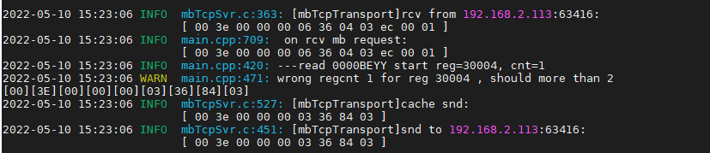

读错误地址5

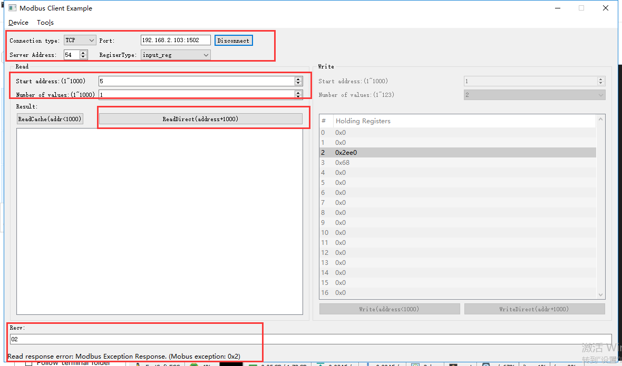

rcv from 192.168.2.113:63416:

[ 00 3f 00 00 00 06 36 04 03 ed 00 01 ]

snd to 192.168.2.113:63416:

[ 00 3f 00 00 00 03 36 84 02 ]

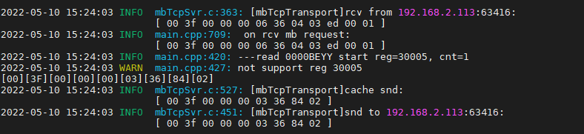

### 多变量读取

#### 直读地址1-5

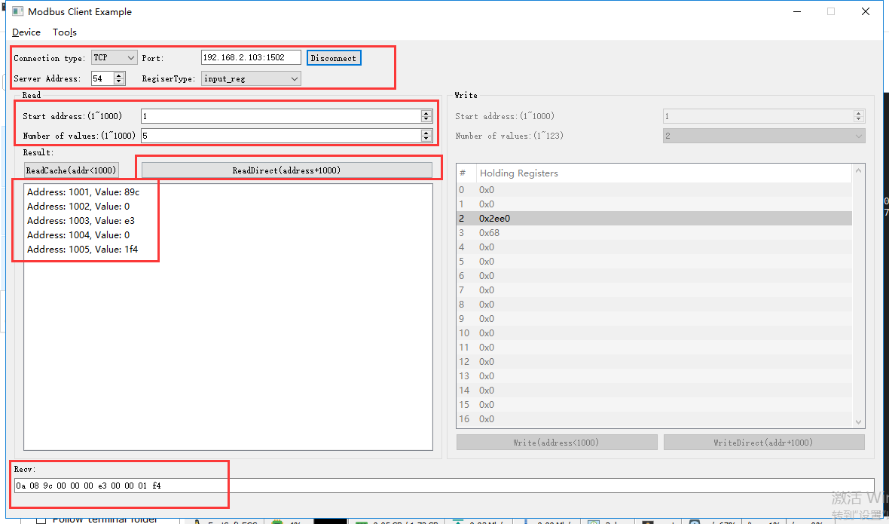

rcv from 192.168.2.113:63416:

[ 00 40 00 00 00 06 36 04 03 e9 00 05 ]

snd to 192.168.2.113:63416:

[ 00 40 00 00 00 0d 36 04 0a 08 9c 00 00 00 e3 00 00 01 f4 ]

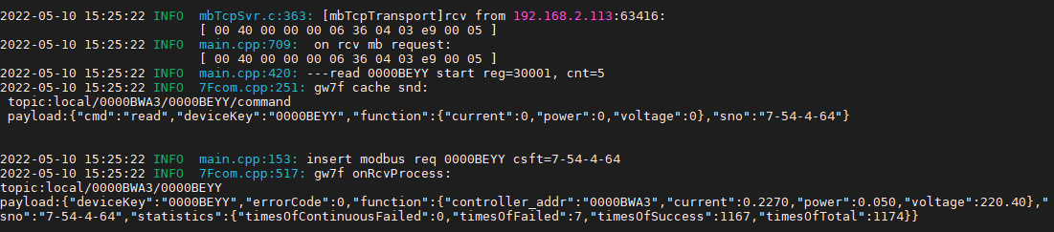

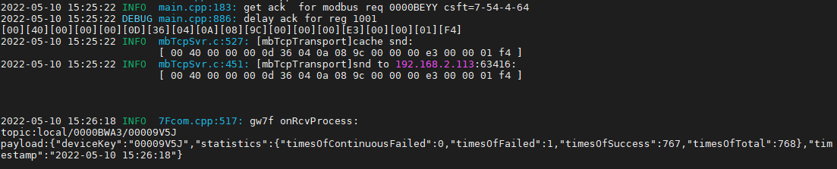

#### 读缓存地址1-5

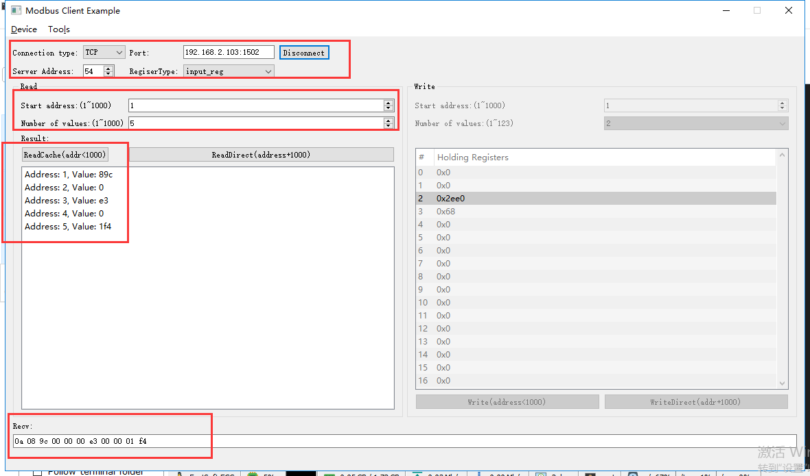

rcv from 192.168.2.113:63416:

[ 00 41 00 00 00 06 36 04 00 01 00 05 ]

snd to 192.168.2.113:63416:

[ 00 41 00 00 00 0d 36 04 0a 08 9c 00 00 00 e3 00 00 01 f4 ]

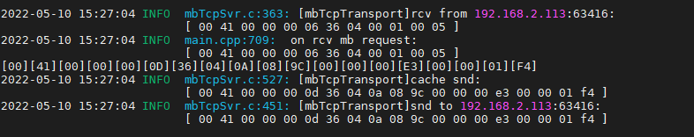

#### 直读1-3

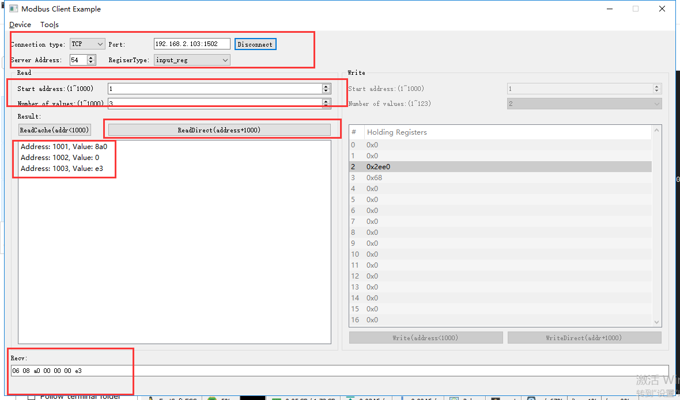

rcv from 192.168.2.113:63416:

[ 00 42 00 00 00 06 36 04 03 e9 00 03 ]

snd to 192.168.2.113:63416:

[ 00 42 00 00 00 09 36 04 06 08 a0 00 00 00 e3 ]

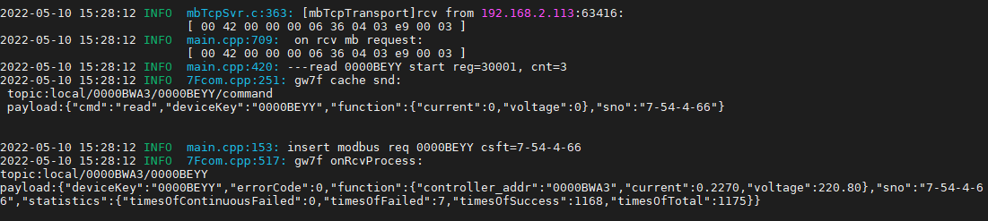

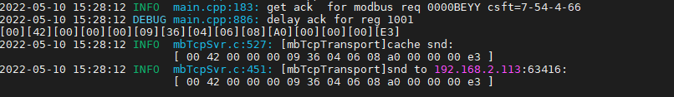

#### 直读2-5

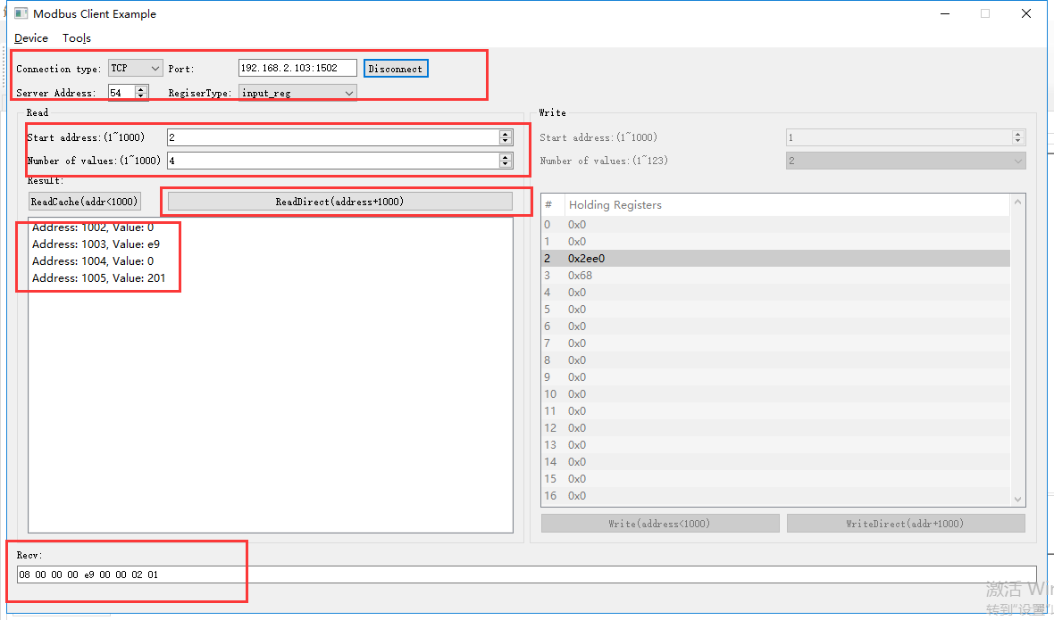

rcv from 192.168.2.113:63416:

[ 00 43 00 00 00 06 36 04 03 ea 00 04 ]

snd to 192.168.2.113:63416:

[ 00 43 00 00 00 0b 36 04 08 00 00 00 e9 00 00 02 01 ]

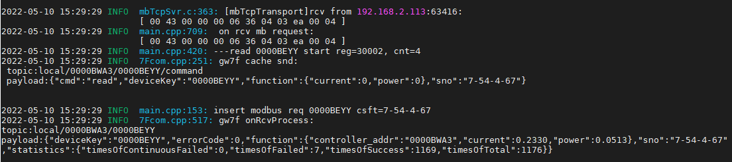

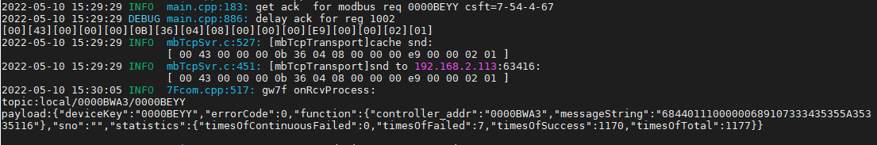

#### 读错误地址1-4

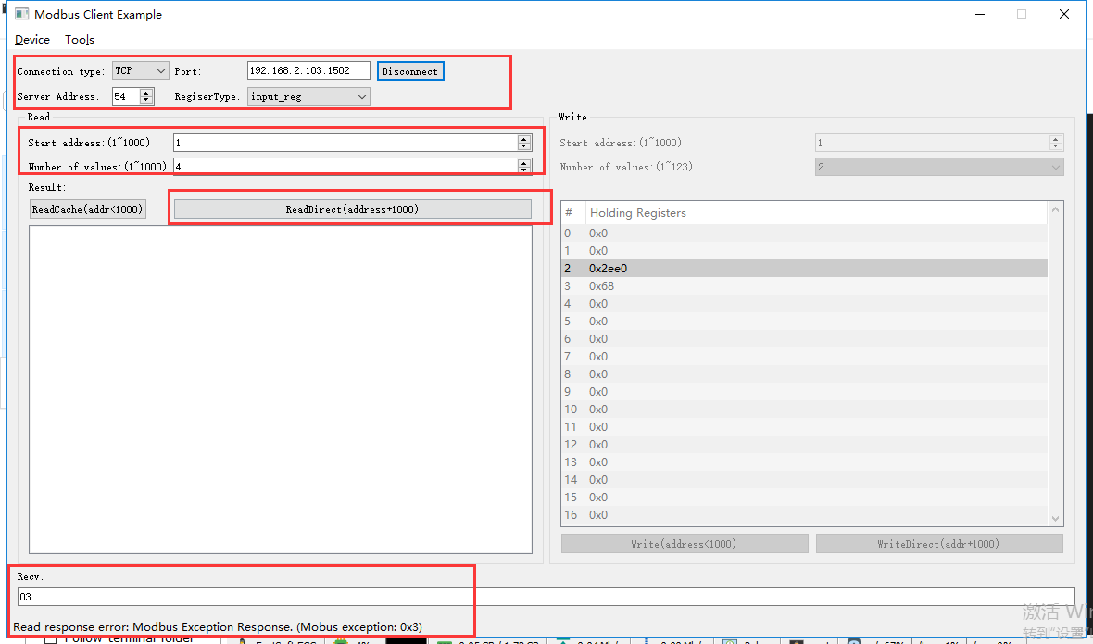

rcv from 192.168.2.113:63416:

[ 00 44 00 00 00 06 36 04 03 e9 00 04 ]

snd to 192.168.2.113:63416:

[ 00 44 00 00 00 03 36 84 03 ]

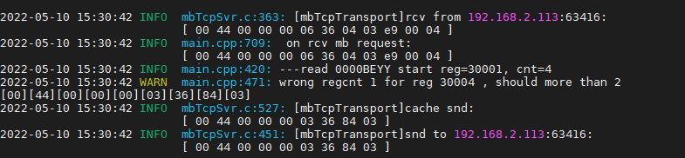

#### 读错误地址1-2

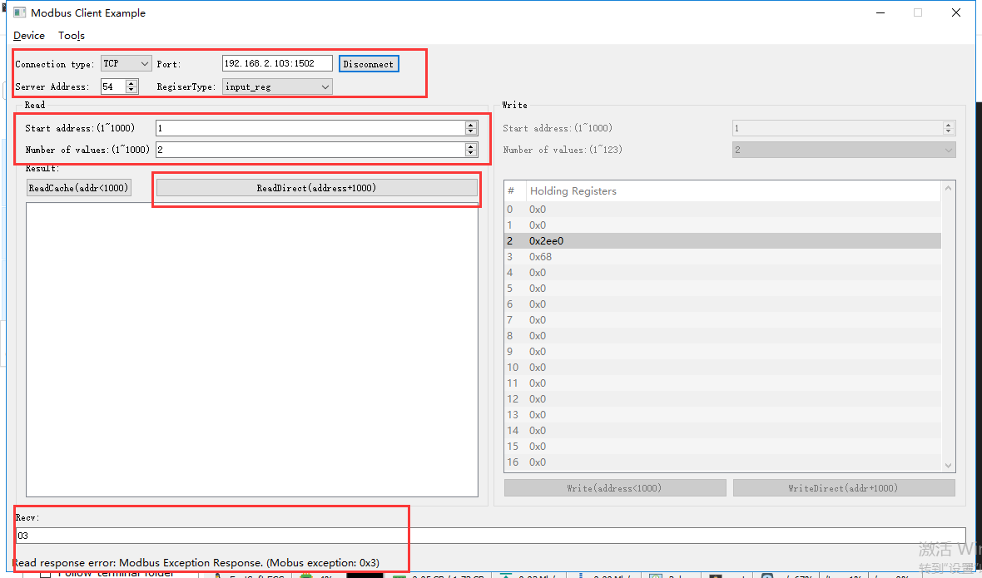

rcv from 192.168.2.113:63416:

[ 00 45 00 00 00 06 36 04 03 e9 00 02 ]

snd to 192.168.2.113:63416:

[ 00 45 00 00 00 03 36 84 03 ]

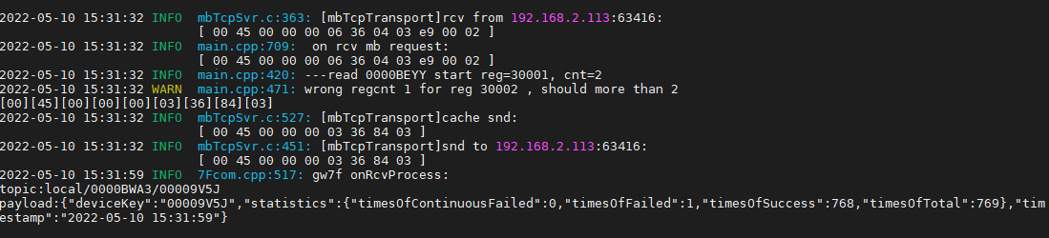

#### 读错误地址2-4

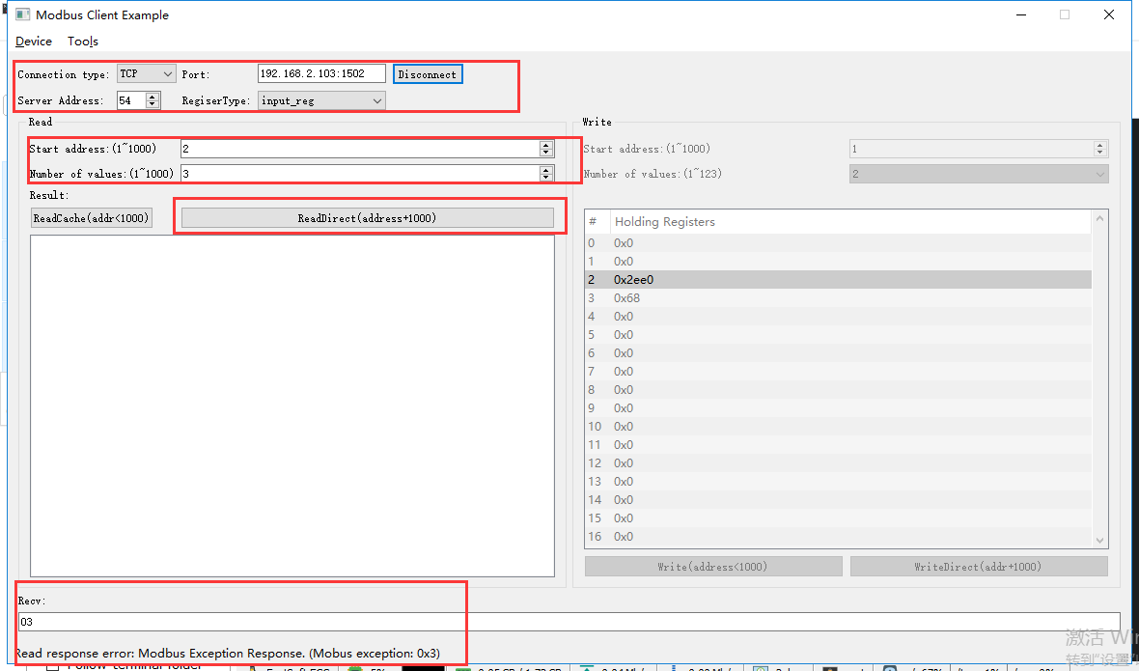

rcv from 192.168.2.113:63416:

[ 00 46 00 00 00 06 36 04 03 ea 00 03 ]

snd to 192.168.2.113:63416:

[ 00 46 00 00 00 03 36 84 03 ]

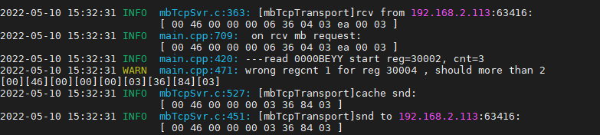

# 人体红外传感器ok

**说明：**根据转换程序所支持的设备，典型选取一种测试。

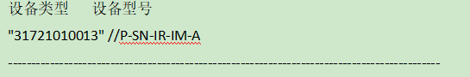

**寄存器定义：**



## 直读有无人

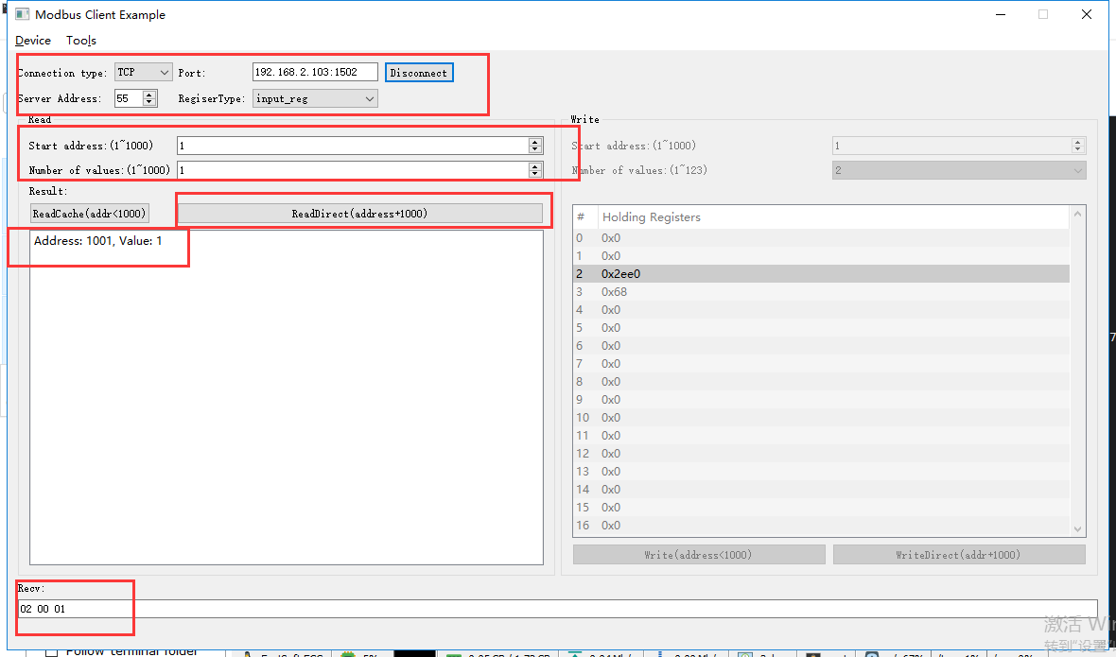

rcv from 192.168.2.113:64222:

[ 00 4d 00 00 00 06 37 04 03 e9 00 01 ]

snd to 192.168.2.113:64222:

[ 00 4d 00 00 00 05 37 04 02 00 01 ]

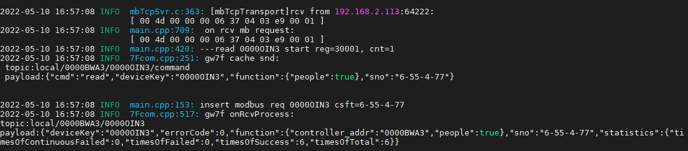

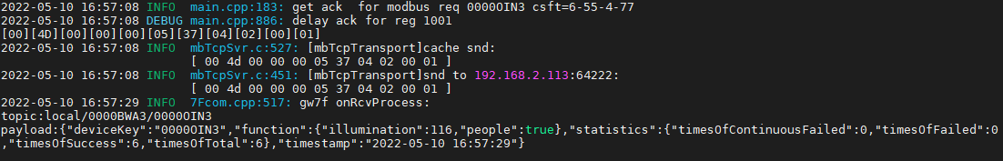

显示有人

等待至无人

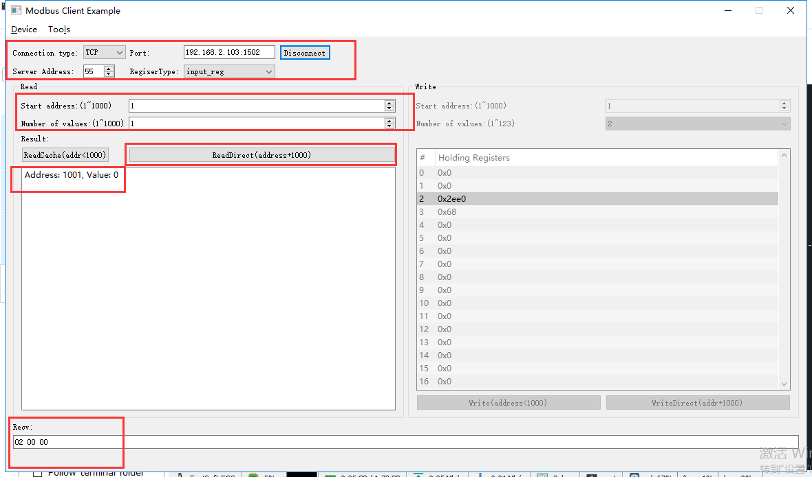

rcv from 192.168.2.113:64222:

[ 00 50 00 00 00 06 37 04 03 e9 00 01 ]

snd to 192.168.2.113:64222:

[ 00 50 00 00 00 05 37 04 02 00 00 ]

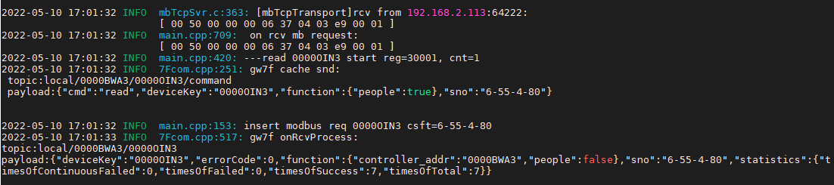

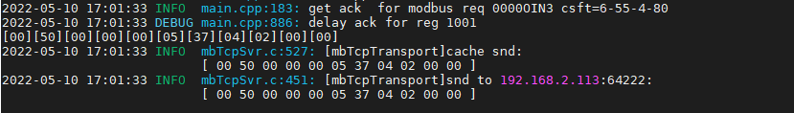

## 读取缓存有无人

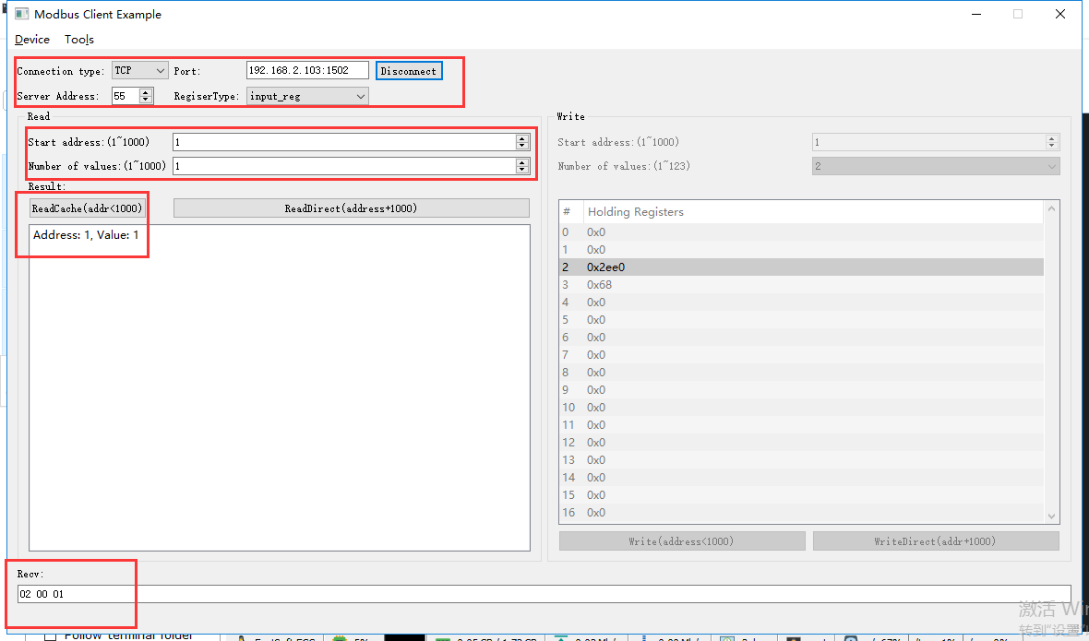

rcv from 192.168.2.113:64222:

[ 00 4f 00 00 00 06 37 04 00 01 00 01 ]

snd to 192.168.2.113:64222:

[ 00 4f 00 00 00 05 37 04 02 00 01 ]

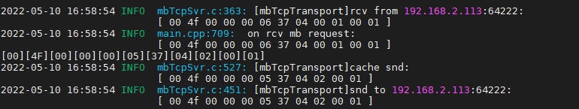

显示有人

等待至无人

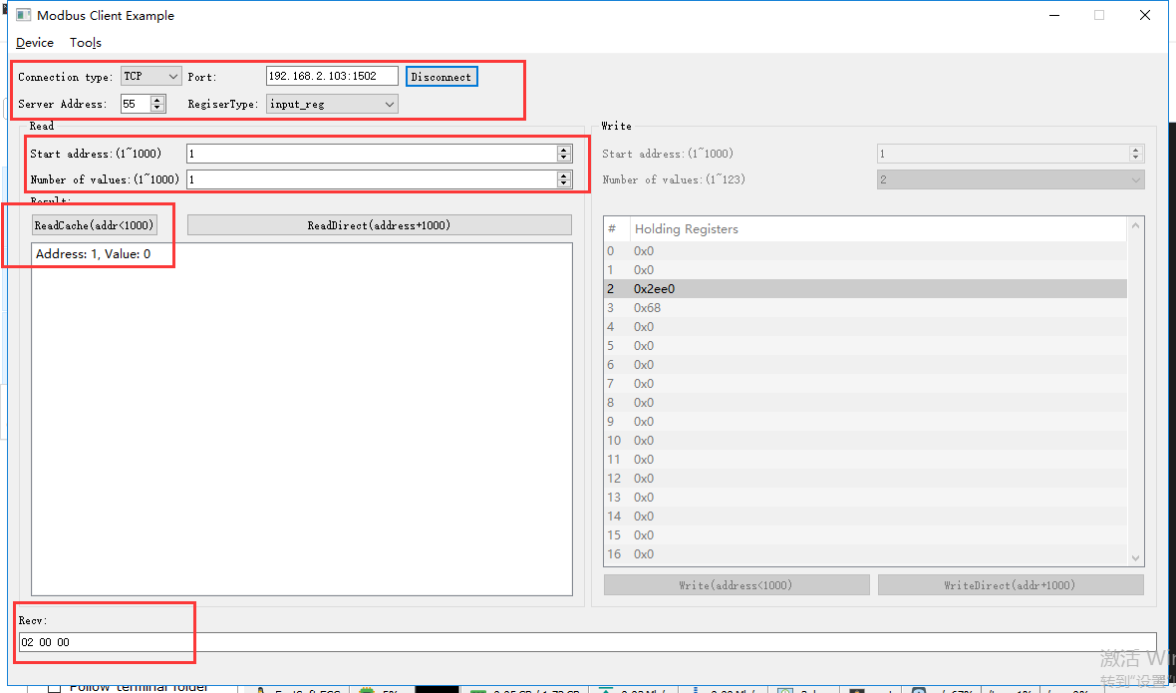

rcv from 192.168.2.113:64222:

[ 00 52 00 00 00 06 37 04 00 01 00 01 ]

snd to 192.168.2.113:64222:

[ 00 52 00 00 00 05 37 04 02 00 00 ]

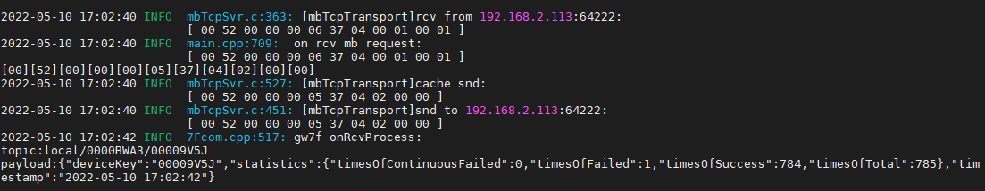

## 直读照度

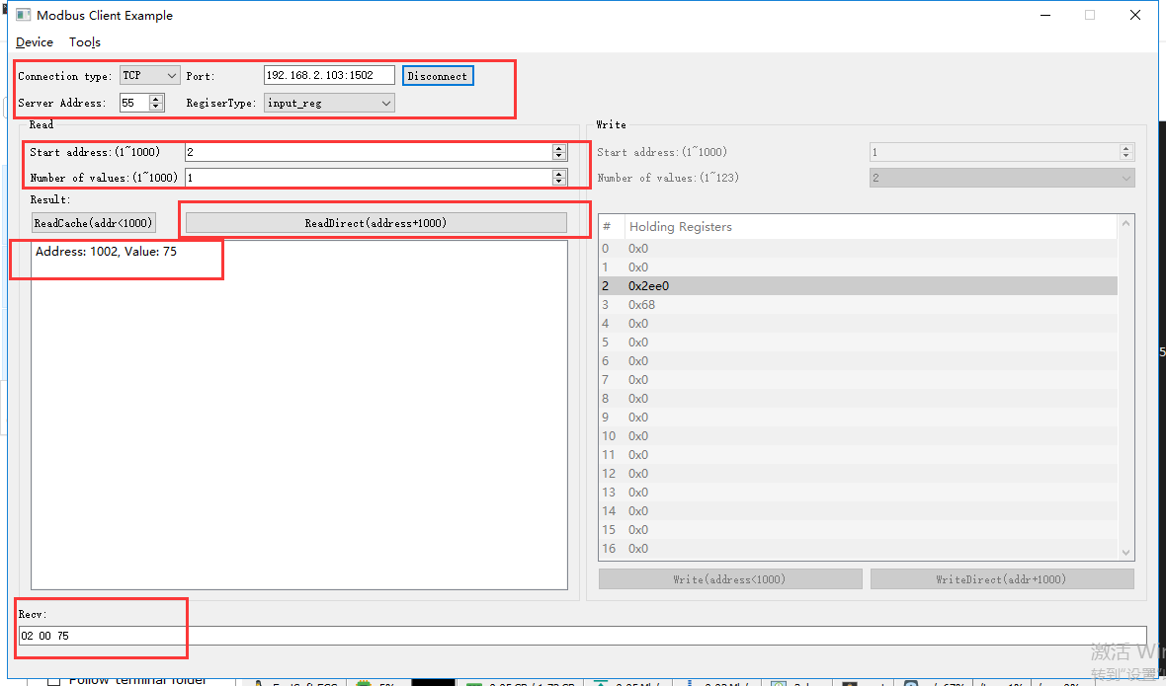

rcv from 192.168.2.113:64222:

[ 00 53 00 00 00 06 37 04 03 ea 00 01 ]

snd to 192.168.2.113:64222:

[ 00 53 00 00 00 05 37 04 02 00 75 ]

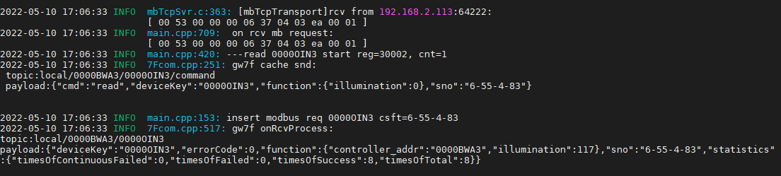

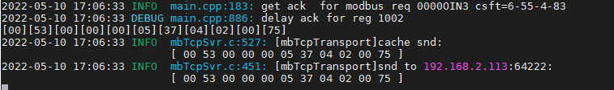

## 读取缓存照度

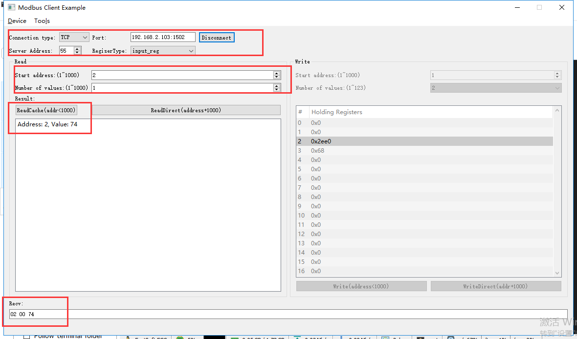

rcv from 192.168.2.113:64222:

[ 00 54 00 00 00 06 37 04 00 02 00 01 ]

snd to 192.168.2.113:64222:

[ 00 54 00 00 00 05 37 04 02 00 74 ]

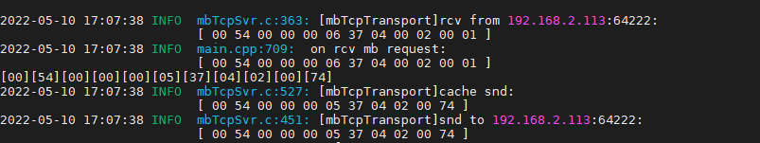

# 干接点开关ok

输入通道的配置类型有：

0x00：信号无效

0x01：机械开关（自锁类）

0x02：按键开关（自复位类）

0x03：常开类传感器

0x04：常闭类传感器

当输入信道配置成[传感器(常开/常闭)]或者[机械开关(自锁)]时候，有0、1两种状态，1表示传感器触发态或自锁开关闭合态，0表示传感器常态或者自锁开关断开态, 这时候channel_state应该是一种状态，外部读取不清零。

当输入信道配配置成[按键开关(自复位)]时，有1、2、3三种状态：1单击、2双击、3长按。这时候channel_state应该是一个信号，外部读取后清零。

## 2路干接点开关

设备类型识别码 设备型号

"31711010105",//P-ACT-2S1A-DCS 2路强电输出开关+4路输入+4路输出

"32011010105" //ESACT-2S1A-DCS 2路强电输出开关+4路输入+4路输出

寄存器地址 对应功能

coil:

1 第1路强电输出开关

2 第2路强电输出开关

input_reg:

1 DI1通道信号类型,0~4.

2 DI1状态,0~3,具体值范围根据通道信号类型确定。

3 DI2通道信号类型

4 DI2状态

5 DI3通道信号类型

6 DI3状态

7 DI4通道信号类型

8 DI4状态

9~16 预留

17 过温状态 0-可控硅未过热　1-可控硅过温

hold_reg:

1 面板锁定 0-面板锁定未开启，非0-面板锁定打开

**查询设备modbus地址--2**

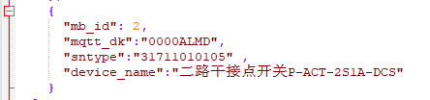

### 读取第一二通道开关状态

读开关缓存：

第一路开关状态：

发送：00 01 00 00 00 06 02 01 00 01 00 01

接收：00 01 00 00 00 04 02 01 01 00 //状态为关

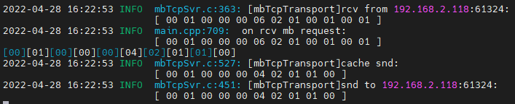

第二路开关状态：

发送：00 03 00 00 00 06 02 01 00 02 00 01

接收：00 03 00 00 00 04 02 01 01 00 //状态为关

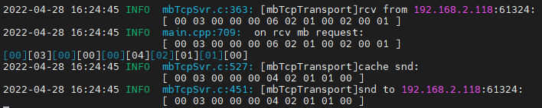

第一二路开关状态：

发送：00 05 00 00 00 06 02 01 00 01 00 02

接收：00 05 00 00 00 04 02 01 01 00 //状态均为关

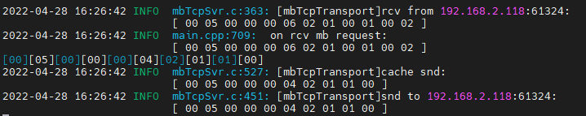

第三路开关状态：

发送：00 06 00 00 00 06 02 01 00 03 00 01

接收：00 06 00 00 00 03 02 81 02 //报错

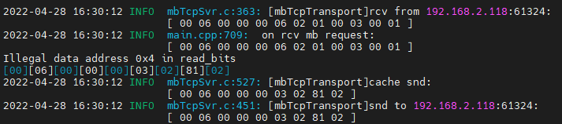

直读开关状态：

第一路开关状态：

发送：00 08 00 00 00 06 02 01 03 e9 00 01

接收：00 08 00 00 00 04 02 01 01 01 //状态为开

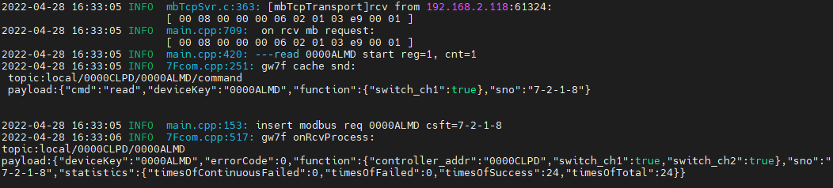

第二路开关状态：

发送：00 09 00 00 00 06 02 01 03 ea 00 01

接收：00 09 00 00 00 04 02 01 01 01 //状态为开

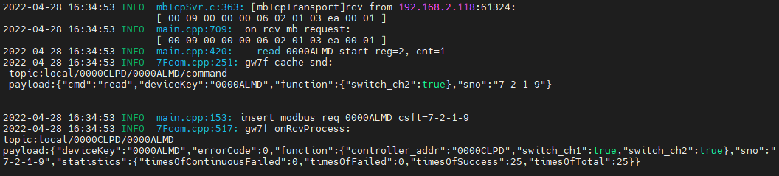

第一二路开关状态：

发送：00 0b 00 00 00 06 02 01 03 e9 00 02

接收：00 0b 00 00 00 04 02 01 01 03 //0011，一二路状态均为开，大端表示

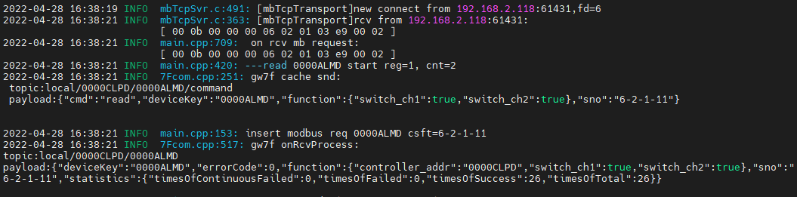

第三路开关状态：

发送：00 0a 00 00 00 06 02 01 03 eb 00 01

接收：00 0a 00 00 00 03 02 81 02 //报错

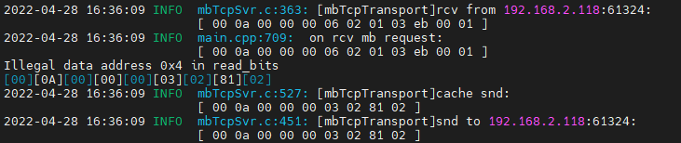

### 写入第一二通道开关状态

写入第一路通道开关：

发送：00 04 00 00 00 06 02 05 00 01 00 00

接收：00 04 00 00 00 06 02 05 00 01 00 00 //断开第一通道

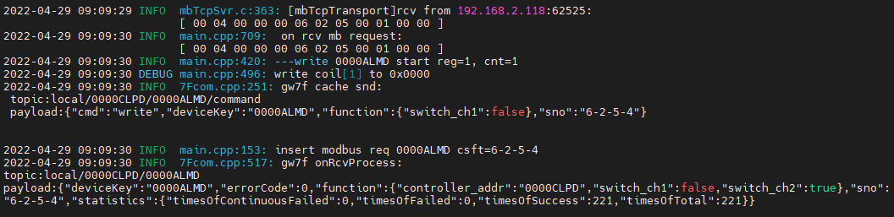

读取此时两路开关的状态：

发送：00 05 00 00 00 06 02 01 00 01 00 02

接收：00 05 00 00 00 04 02 01 01 02 //0010，开关，大端表示。

写入第二路通道开关：

发送：00 06 00 00 00 06 02 05 00 02 00 00

接收：00 06 00 00 00 06 02 05 00 02 00 00 //断开第二通道

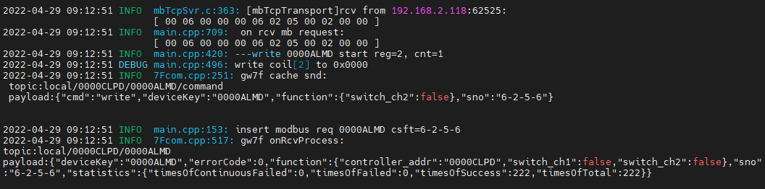

读取此时两路开关的状态：

发送：00 07 00 00 00 06 02 01 00 01 00 02

接收：00 07 00 00 00 04 02 01 01 00 //两路通道均断开

同时写入第一二路通道开关：

发送：00 08 00 00 00 08 02 0f 00 01 00 02 01 03 //两路通道均关闭

接收：00 08 00 00 00 06 02 0f 00 01 00 02

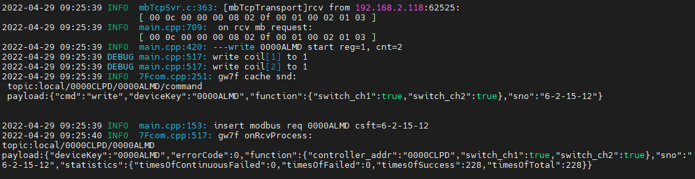

读此时两路通道状态：

发送：00 14 00 00 00 06 02 01 00 01 00 02

接收：00 14 00 00 00 04 02 01 01 03 //0011，开开，大端表示。

写入第三路通道开关：

发送：00 15 00 00 00 06 02 05 00 03 ff 00

接收：00 15 00 00 00 03 02 85 02 //报错

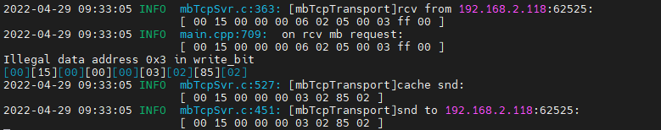

### 面板锁状态

读面板锁缓存状态：

发送：00 16 00 00 00 06 02 03 00 01 00 01

接收：00 16 00 00 00 05 02 03 02 00 00 //面板未锁定

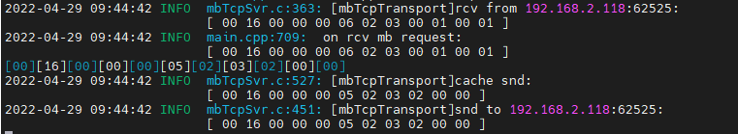

直读面板锁状态：

发送：00 17 00 00 00 06 02 03 03 e9 00 01

接收：00 17 00 00 00 05 02 03 02 00 00 //面板未锁定

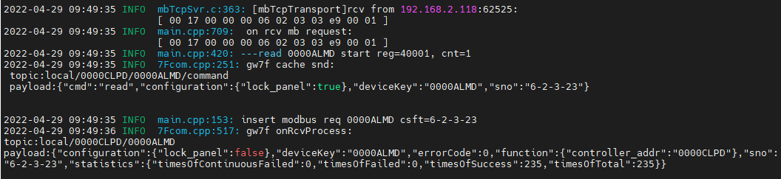

写入面板锁状态：

发送：00 18 00 00 00 06 02 06 00 01 00 01

接收：00 18 00 00 00 06 02 06 00 01 00 01 //面板锁定

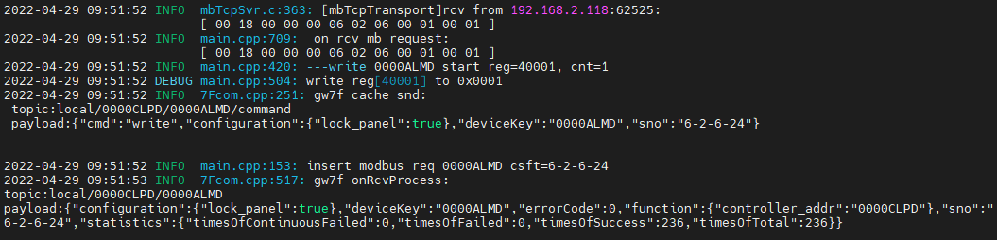

读取此时面板锁状态：

发送：00 19 00 00 00 06 02 03 03 e9 00 01

接收：00 19 00 00 00 05 02 03 02 00 01

此时，通过外接开关控制一二三路通道打开关闭，设备不响应。

当面板锁写入非0状态时：

发送：00 1d 00 00 00 06 02 06 00 01 00 02

接收：00 1d 00 00 00 06 02 06 00 01 00 02

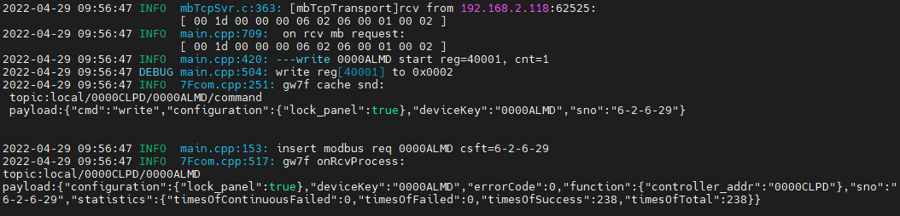

通过外接开关控制一二三路通道打开关闭，设备不响应。

### 读输入通道缓存

手机APP上分别配置通道一二三四为自锁开关，复位开关，常开传感器，常闭传感器（状态为上报）。

发送：00 34 00 00 00 06 02 04 00 01 00 08 //查询通道一~四状态

接收：00 34 00 00 00 13 02 04 10 00 01 00 00 00 02 00 01 00 03 00 00 00 04 00 01 通道四 通道一 通道二 通道三

再读一次，复位开关上的上报会被清除。

发送：00 35 00 00 00 06 02 04 00 01 00 08

接收：00 35 00 00 00 13 02 04 10 00 01 00 00 00 02 00 00 00 03 00 00 00 04 00 01 //通道2的状态被清除

更改4路通道不同的状态：

发送：00 36 00 00 00 06 02 04 00 01 00 08

接收：00 36 00 00 00 13 02 04 10 00 01 00 01 00 02 00 02 00 03 00 01 00 04 00 00

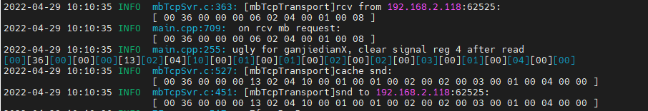

再读一次，复位开关上的上报会被清除。

发送：00 37 00 00 00 06 02 04 00 01 00 08

接收：00 37 00 00 00 13 02 04 10 00 01 00 01 00 02 00 00 00 03 00 01 00 04 00 01

分别修改一二三四通道为常闭传感器，常开传感器，复位开关，自锁开关（状态为上报）。

查询通道一~四状态：

发送：00 38 00 00 00 06 02 04 00 01 00 08

接收：00 38 00 00 00 13 02 04 10 00 04 00 01 00 03 00 00 00 02 00 01 00 01 00 00

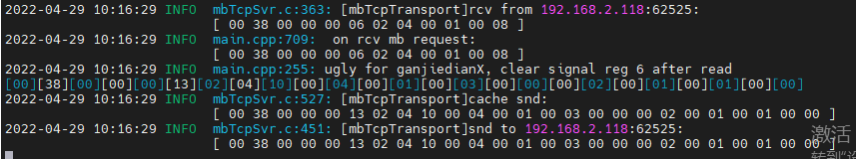

测试合格

### 过温状态

**寄存器定义：**

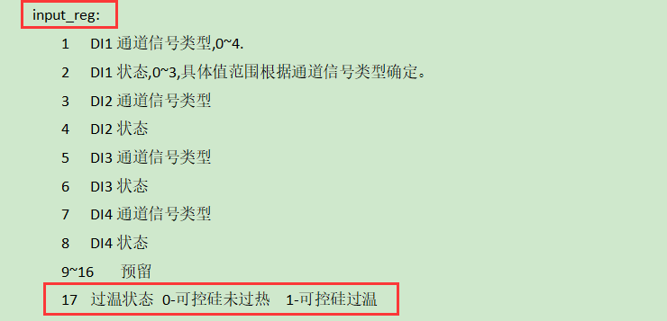

注：设备端仅上报，不可读

**测试方法：**在设备输出端接大负载，使温度上升，当温度达到90摄氏度时，干接点开关进行过温上报。此时进行读缓存（不支持直读）；关闭大功率设备使2路干接点降温，低温60度时告警解除，此时进行读缓存（不支持直读）。

抄控器读取温度--此时无告警



设备上报超温

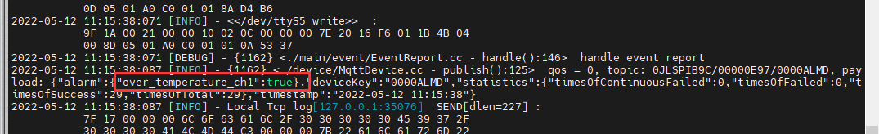

读取缓存

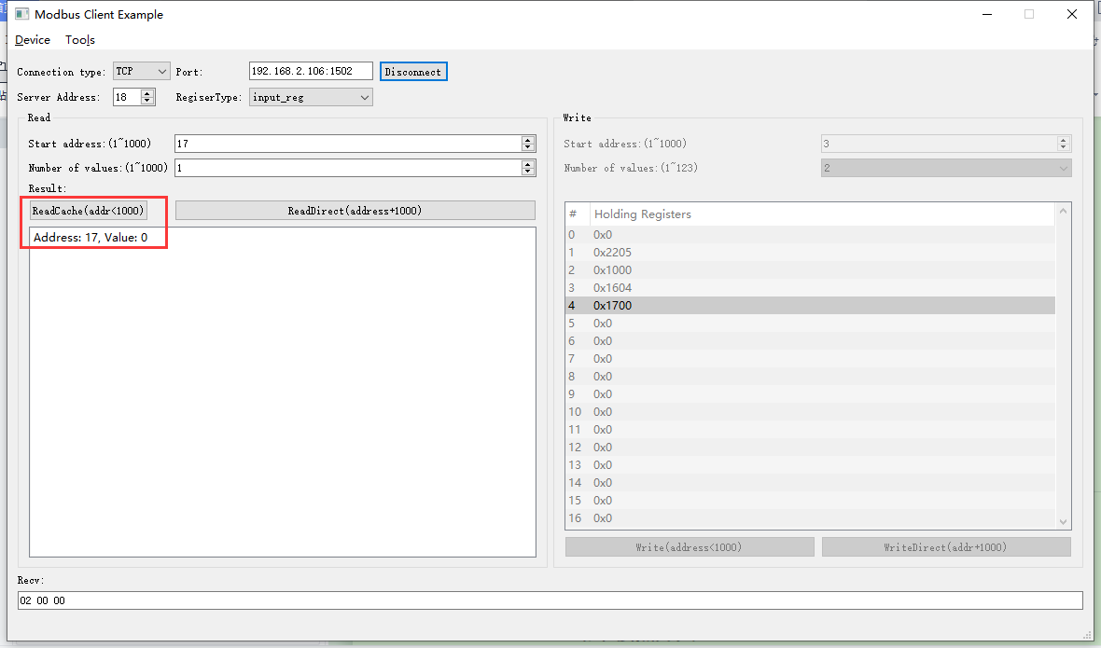

2022-05-12 11:18:26 INFO mbTcpSvr.c:363: [mbTcpTransport]rcv from 192.168.2.104:50299:

[ 00 7e 00 00 00 06 12 04 00 11 00 01 ]

2022-05-12 11:18:26 INFO main.cpp:709: on rcv mb request:

[ 00 7e 00 00 00 06 12 04 00 11 00 01 ]

[00][7E][00][00][00][05][12][04][02][00][00]

2022-05-12 11:18:26 INFO mbTcpSvr.c:527: [mbTcpTransport]cache snd:

[ 00 7e 00 00 00 05 12 04 02 00 00 ]

2022-05-12 11:18:26 INFO mbTcpSvr.c:451: [mbTcpTransport]snd to 192.168.2.104:50299:

[ 00 7e 00 00 00 05 12 04 02 00 00 ]

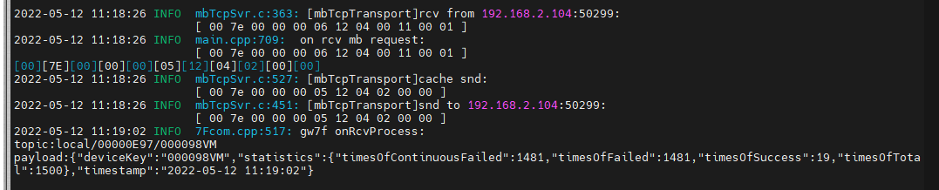

问题：2路干接点开关（过温状态测试）设备超温上报后，读取缓存状态与设备不一致；另外（设备问题）两路干接点开关在超温后虽然上报了关闭可控硅，但是实际上此路上依然有电压，可控硅过温后不可控。

## 3.1.2 **3路干接点开关**

当前支持的设备类型为：

"31711010106",//P-ACT-3S5A-DCS

"32011010108" //ESACT-3S5A-DCS

寄存器地址 对应功能为：

coil:

1 第1路强电输出开关

2 第2路强电输出开关

3 第3路强电输出开关

input_reg:

1 DI1通道信号类型,0~4

2 DI1状态,0~3,具体值范围根据通道信号类型确定。

3 DI2通道信号类型

4 DI2状态

5 DI3通道信号类型

6 DI3状态

7 DI4通道信号类型

8 DI4状态

hold_reg:

1. 面板锁定 0-面板锁定未开启，非0-面板锁定打开

**查询设备modbus地址--1**



### **3.1.2.1.读取第一二三通道开关状态**

读开关缓存;

第一路开关状态：

发送: 00 09 00 00 00 06 01 01 00 01 00 01

回复：00 09 00 00 00 04 01 01 01 00//状态为关

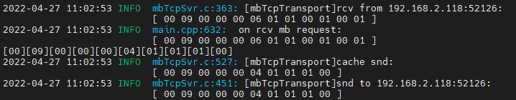

第二路开关状态：

发送：00 0b 00 00 00 06 01 01 00 02 00 01

回复：00 0b 00 00 00 04 01 01 01 00//状态为关

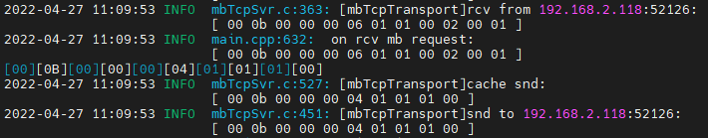

第三路开关状态：

发送：00 0c 00 00 00 06 01 01 00 03 00 01

接收：00 0c 00 00 00 04 01 01 01 00 //状态为关

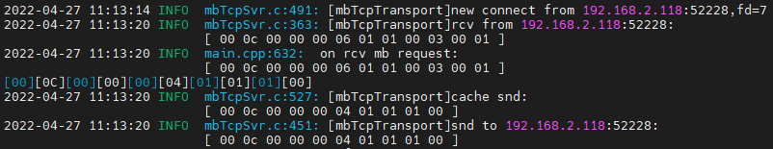

第一二三路开关状态：

发送：00 0d 00 00 00 06 01 01 00 01 00 03

接收：00 0d 00 00 00 04 01 01 01 00 //状态为关

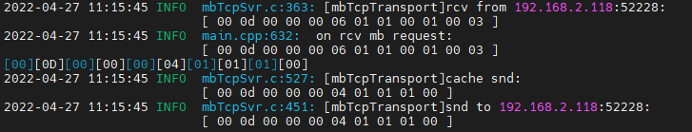

第四路开关状态：

发送：00 11 00 00 00 06 01 01 00 04 00 01

接收：00 11 00 00 00 03 01 81 02 //报错

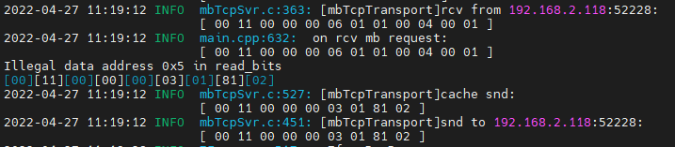

直读开关状态：

第一路开关状态：

发送：00 15 00 00 00 06 01 01 03 e9 00 01

接收：00 15 00 00 00 04 01 01 01 00 //状态为关

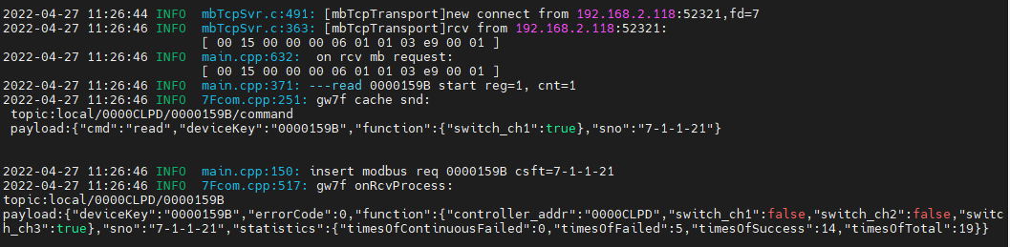

第二路开关状态：

发送：00 17 00 00 00 06 01 01 03 ea 00 01

接收：00 17 00 00 00 04 01 01 01 00 //状态为关

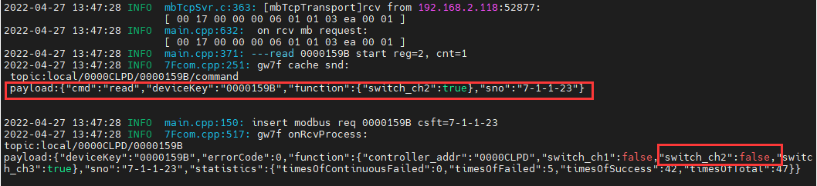

第三路开关状态：

发送：00 19 00 00 00 06 01 01 03 eb 00 01

接收：00 19 00 00 00 04 01 01 01 01 //状态为开

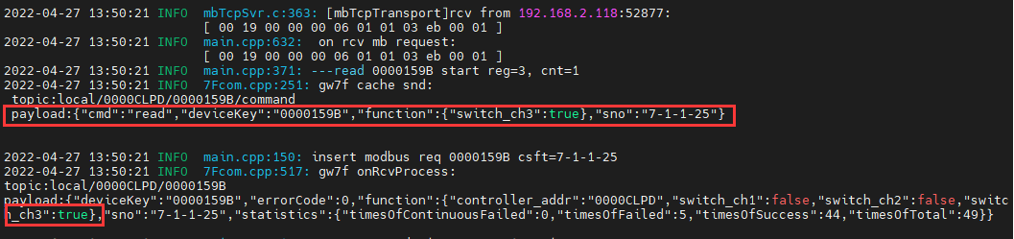

第一二三路开关状态：

发送：00 1b 00 00 00 06 01 01 03 e9 00 03

接收：00 1b 00 00 00 04 01 01 01 04 //状态为100（开，关，关）大端表示

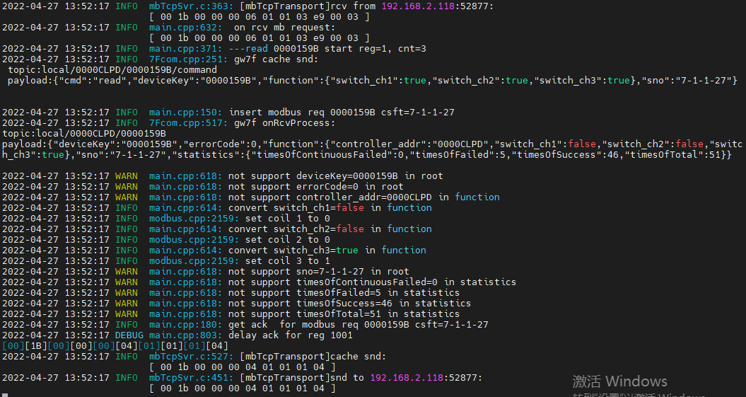

第四路开关状态：

发送：00 1d 00 00 00 06 01 01 03 ec 00 01

接送：00 1d 00 00 00 03 01 81 02 //报错

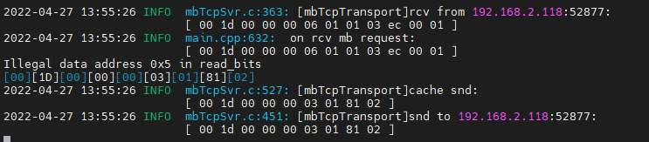

发送：00 1f 00 00 00 06 01 01 03 ea 00 03 //第二三四路开关状态

接收：00 1f 00 00 00 03 01 81 02 //报错

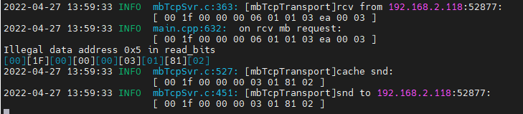

### 3.1.2.2.写入第一二三通道开关状态

写入第一路通道开关：

发送：00 62 00 00 00 06 01 05 00 01 ff 00 //打开第一路通道

接收：00 62 00 00 00 06 01 05 00 01 ff 00

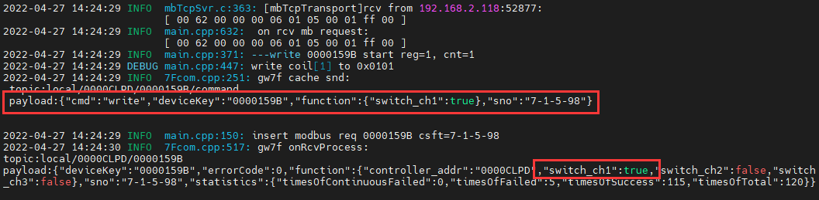

读取此时三路开关的状态：

发送：00 64 00 00 00 06 01 01 00 01 00 03

接收：00 64 00 00 00 04 01 01 01 01 //0001,关关开，大端表示。

写入第二路通道开关：

发送：00 7d 00 00 00 06 01 05 00 02 ff 00 //打开第二路通道

接收：00 7d 00 00 00 06 01 05 00 02 ff 00

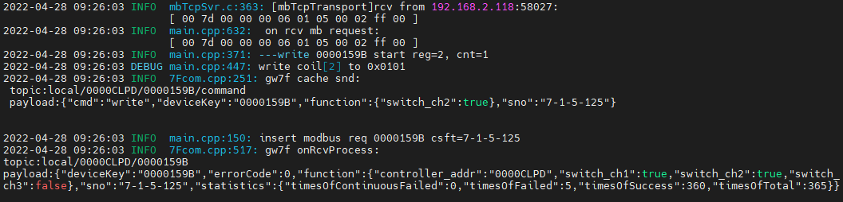

读取此时三路开关的状态：

发送：00 7e 00 00 00 06 01 01 00 01 00 03

接收：00 7e 00 00 00 04 01 01 01 03 //0011,关开开，大端表示。

写入第三路通道开关：

发送：00 7f 00 00 00 06 01 05 00 03 ff 00 //打开第三路通道

接收：00 7f 00 00 00 06 01 05 00 03 ff 00

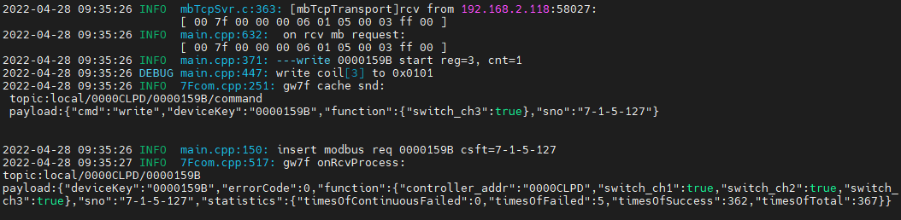

读取此时三路开关的状态：

发送：00 80 00 00 00 06 01 01 00 01 00 03

接收：00 80 00 00 00 04 01 01 01 07 //0111,开开开，大端表示。

同时写入通道一二三的状态：

发送：00 81 00 00 00 08 01 0f 00 01 00 03 01 00 //关闭三个通道

接收：00 81 00 00 00 06 01 0f 00 01 00 03

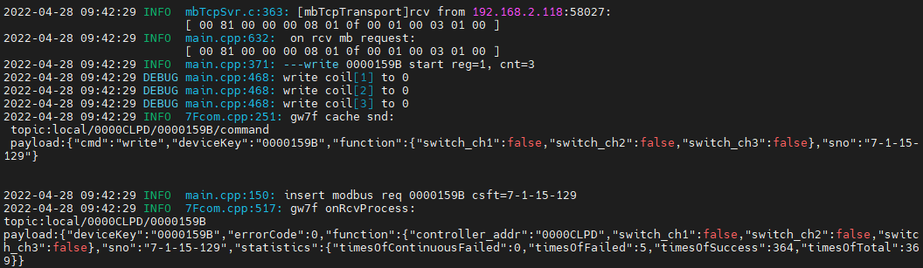

读此时一二三路通道状态：

发送：00 82 00 00 00 06 01 01 03 e9 00 03

接收：00 82 00 00 00 04 01 01 01 00 //此时三路通道都关闭

### 3.1.2.3.面板锁状态

读面板锁缓存状态：

发送：00 85 00 00 00 06 01 03 00 01 00 01

接收：00 85 00 00 00 05 01 03 02 00 00 // 面板未锁定

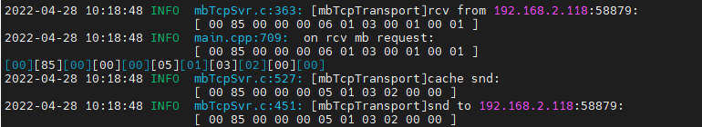

直读面板锁状态：

发送：00 89 00 00 00 06 01 03 03 e9 00 01

接收：00 89 00 00 00 05 01 03 02 00 00

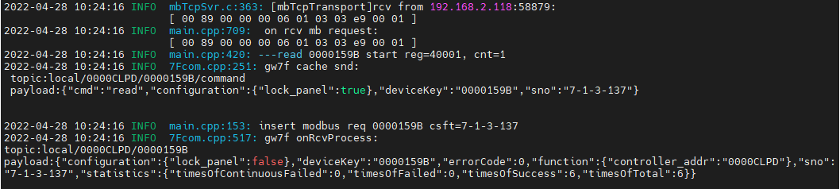

写入面板锁状态：

发送：00 8a 00 00 00 06 01 06 00 01 00 01

接收：00 8a 00 00 00 06 01 06 00 01 00 01 //锁定面板

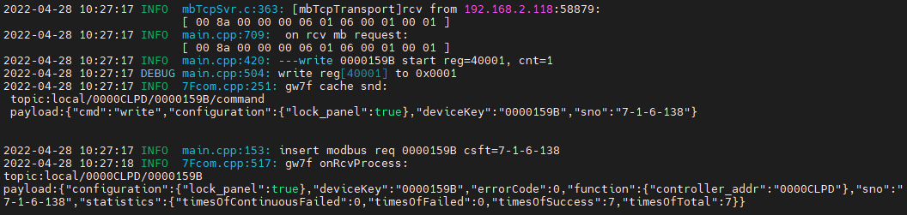

读取此时面板锁状态：

发送：00 8b 00 00 00 06 01 03 03 e9 00 01

接收：00 8b 00 00 00 05 01 03 02 00 01

此时，通过外接开关控制一二三路通道打开关闭，设备不响应。

当面板锁写入非0状态时：

发送：00 95 00 00 00 06 01 06 00 01 00 02

接收：00 95 00 00 00 06 01 06 00 01 00 02

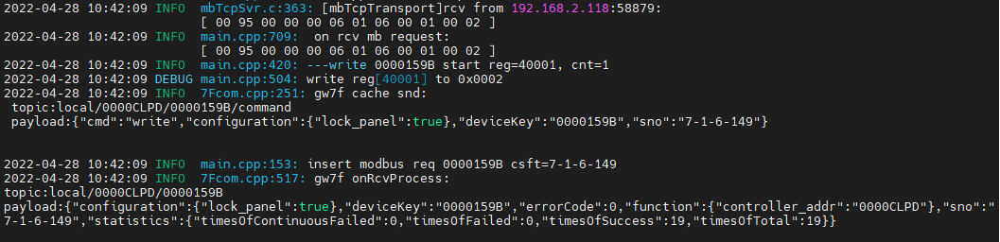

通过外接开关控制一二三路通道打开关闭，设备不响应。

### 3.1.2.4.读输入通道缓存

手机APP上分别配置通道一二三四为自锁开关，复位开关，常开传感器，常闭传感器（状态为上报）。

发送：00 8d 00 00 00 06 01 04 00 01 00 08 //查询通道一~四状态

接收：00 8d 00 00 00 13 01 04 10 00 01 00 00 00 02 00 03 00 03 00 00 00 04 00 01 通道四 通道一 通道二 通道三

再读一次，复位开关上的上报会被清除。

发送：00 8e 00 00 00 06 01 04 00 01 00 08

接收：00 8e 00 00 00 13 01 04 10 00 01 00 00 00 02 00 00 00 03 00 00 00 04 00 01 //通道2的状态被清除

分别修改一二三四通道为常闭传感器，常开传感器，复位开关，自锁开关（状态为上报）。

查询通道一~四状态：

发送：00 72 00 00 00 06 01 04 00 01 00 08

接收：00 72 00 00 00 13 01 04 10 00 04 00 01 00 03 00 01 00 02 00 03 00 01 00 00

测试合格。

# 睿智智能开关ok

## 三路开关

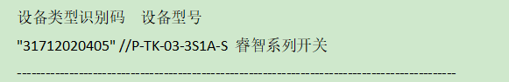

**寄存器定义：**

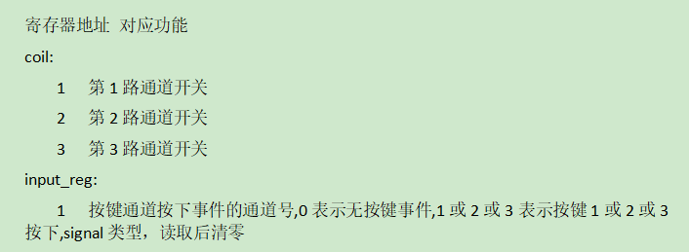

将设备添加到网关

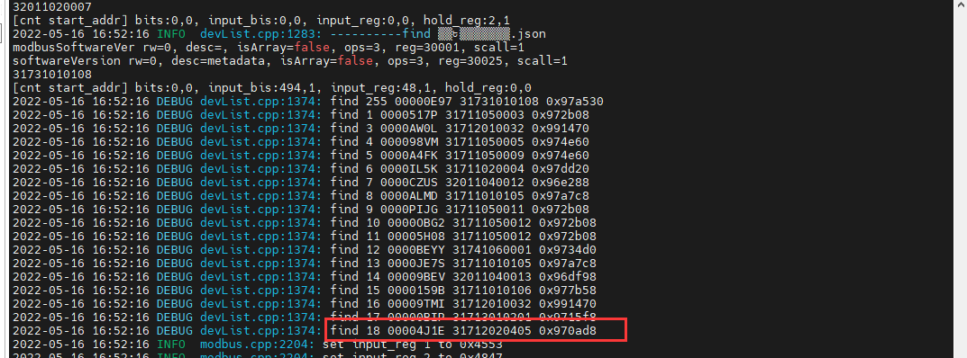

### 通道1

#### 闭合

1. 写闭合

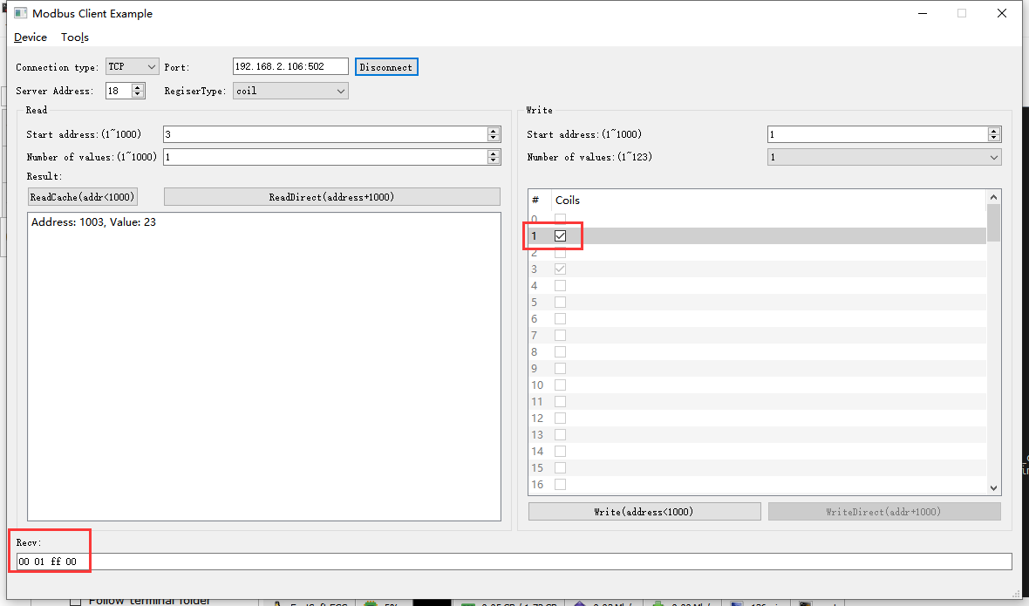2022-05-16 17:12:47 INFO mbTcpSvr.c:363: [mbTcpTransport]rcv from 192.168.2.104:58828:

[ 00 0a 00 00 00 06 12 05 00 01 ff 00 ]

2022-05-16 17:12:47 INFO main.cpp:709: on rcv mb request:

[ 00 0a 00 00 00 06 12 05 00 01 ff 00 ]

2022-05-16 17:12:47 INFO main.cpp:420: ---write 00004J1E start reg=1, cnt=1

2022-05-16 17:12:47 DEBUG main.cpp:496: write coil[1] to 0x0101

2022-05-16 17:12:48 INFO 7Fcom.cpp:517: gw7f onRcvProcess:

topic:local/00000E97/00004J1E

payload:{"cmd":"write","deviceKey":"00004J1E","errorCode":0,"function":{"controller_addr":"00000E97","switch_ch1":true,"switch_ch2":false,"switch_ch3":false},"sno":"6-18-5-10","statistics":{"timesOfContinuousFailed":0,"timesOfFailed":0,"timesOfSuccess":13,"timesOfTotal":13}}

2022-05-16 17:12:48 INFO mbTcpSvr.c:451: [mbTcpTransport]snd to 192.168.2.104:58828:

[ 00 0a 00 00 00 06 12 05 00 01 ff 00 ]

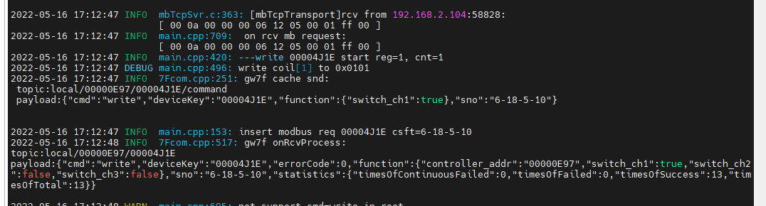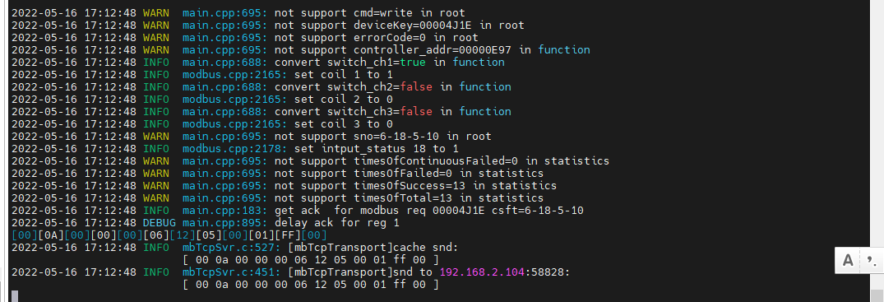

1. 直读

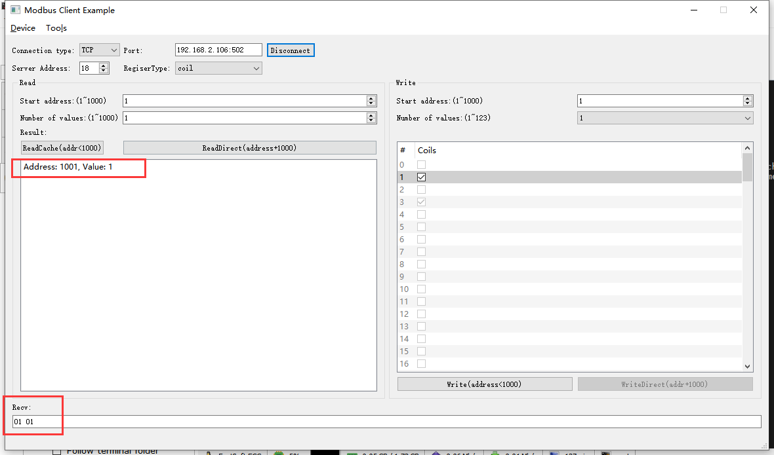2022-05-16 17:14:34 INFO mbTcpSvr.c:363: [mbTcpTransport]rcv from 192.168.2.104:58828:

[ 00 0b 00 00 00 06 12 01 03 e9 00 01 ]

2022-05-16 17:14:34 INFO main.cpp:709: on rcv mb request:

[ 00 0b 00 00 00 06 12 01 03 e9 00 01 ]

2022-05-16 17:14:34 INFO main.cpp:420: ---read 00004J1E start reg=1, cnt=1

2022-05-16 17:14:34 INFO 7Fcom.cpp:517: gw7f onRcvProcess:

topic:local/00000E97/00004J1E

payload:{"cmd":"read","deviceKey":"00004J1E","errorCode":0,"function":{"controller_addr":"00000E97","switch_ch1":true,"switch_ch2":false,"switch_ch3":false},"sno":"6-18-1-11","statistics":{"timesOfContinuousFailed":0,"timesOfFailed":0,"timesOfSuccess":14,"timesOfTotal":14}}

2022-05-16 17:14:34 INFO mbTcpSvr.c:451: [mbTcpTransport]snd to 192.168.2.104:58828:

[ 00 0b 00 00 00 04 12 01 01 01 ]

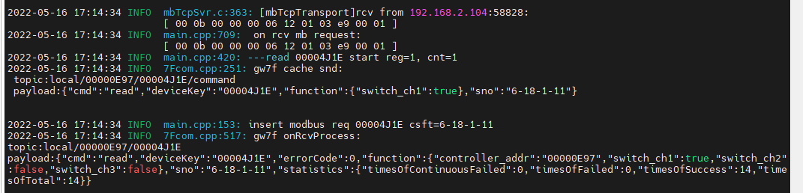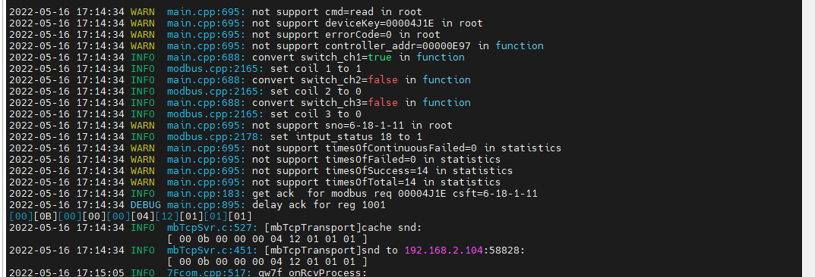

1. 读取缓存

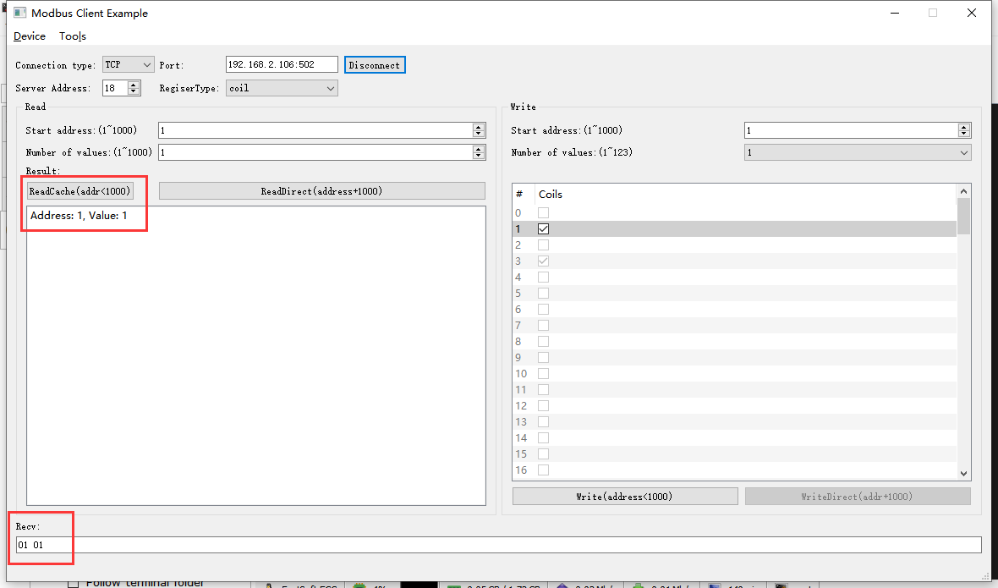2022-05-16 17:17:16 INFO mbTcpSvr.c:363: [mbTcpTransport]rcv from 192.168.2.104:58828:

[ 00 0c 00 00 00 06 12 01 00 01 00 01 ]

2022-05-16 17:17:16 INFO main.cpp:709: on rcv mb request:

[ 00 0c 00 00 00 06 12 01 00 01 00 01 ]

[00][0C][00][00][00][04][12][01][01][01]

2022-05-16 17:17:16 INFO mbTcpSvr.c:527: [mbTcpTransport]cache snd:

[ 00 0c 00 00 00 04 12 01 01 01 ]

2022-05-16 17:17:16 INFO mbTcpSvr.c:451: [mbTcpTransport]snd to 192.168.2.104:58828:

[ 00 0c 00 00 00 04 12 01 01 01 ]

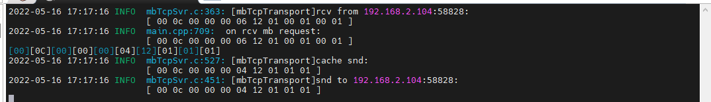

再次读取缓存-验证状态没有被清空

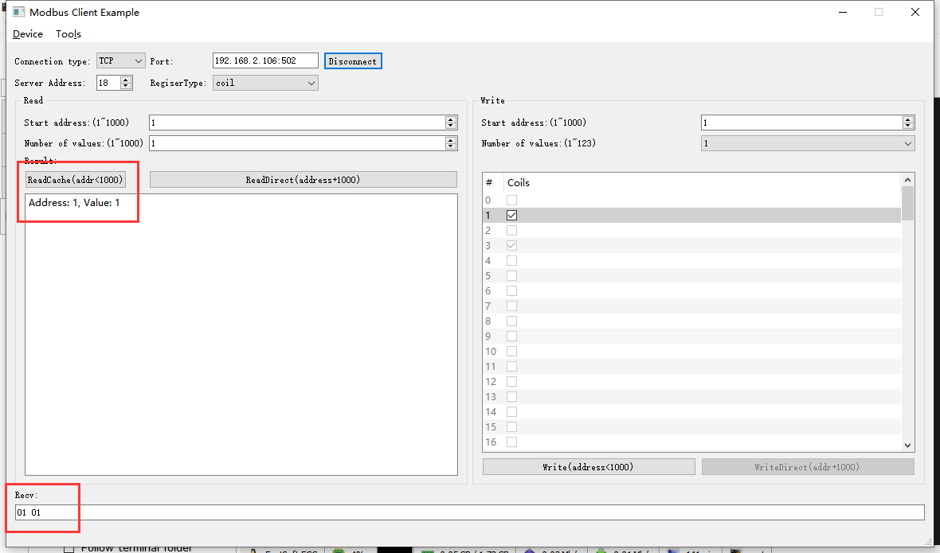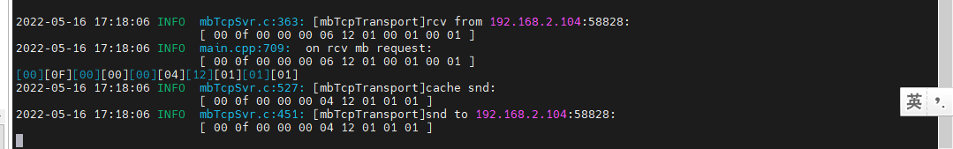

#### 断开

1. 写断开

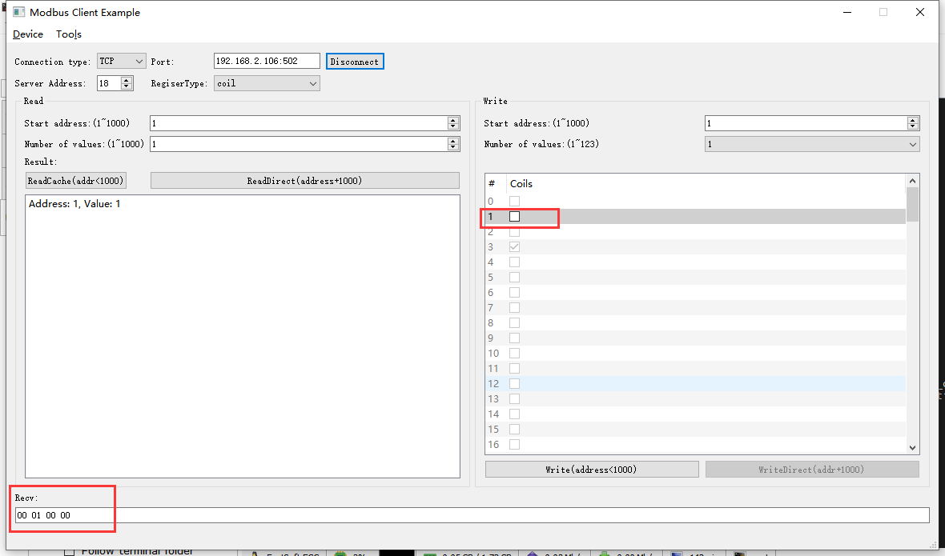2022-05-16 17:19:14 INFO mbTcpSvr.c:363: [mbTcpTransport]rcv from 192.168.2.104:58828:

[ 00 10 00 00 00 06 12 05 00 01 00 00 ]

2022-05-16 17:19:14 INFO main.cpp:709: on rcv mb request:

[ 00 10 00 00 00 06 12 05 00 01 00 00 ]

2022-05-16 17:19:14 INFO main.cpp:420: ---write 00004J1E start reg=1, cnt=1

2022-05-16 17:19:14 DEBUG main.cpp:496: write coil[1] to 0x0000

2022-05-16 17:19:14 INFO 7Fcom.cpp:517: gw7f onRcvProcess:

topic:local/00000E97/00004J1E

payload:{"cmd":"write","deviceKey":"00004J1E","errorCode":0,"function":{"controller_addr":"00000E97","switch_ch1":false,"switch_ch2":false,"switch_ch3":false},"sno":"6-18-5-16","statistics":{"timesOfContinuousFailed":0,"timesOfFailed":0,"timesOfSuccess":15,"timesOfTotal":15}}

2022-05-16 17:19:14 INFO mbTcpSvr.c:451: [mbTcpTransport]snd to 192.168.2.104:58828:

[ 00 10 00 00 00 06 12 05 00 01 00 00 ]

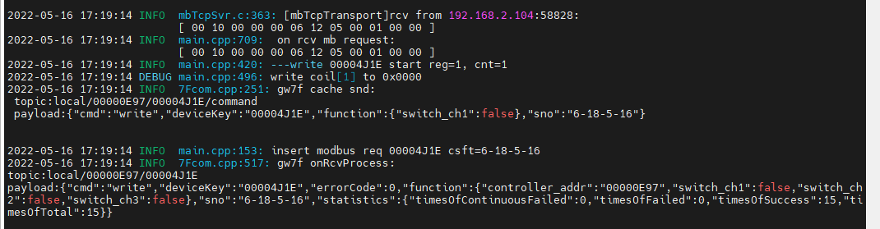

1. 直读

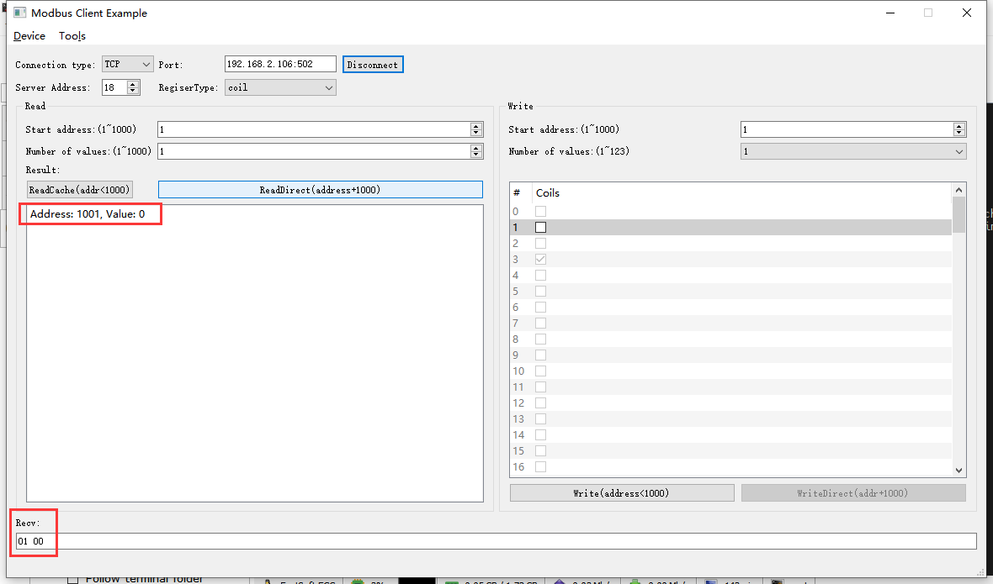2022-05-16 17:20:23 INFO mbTcpSvr.c:363: [mbTcpTransport]rcv from 192.168.2.104:58828:

[ 00 11 00 00 00 06 12 01 03 e9 00 01 ]

2022-05-16 17:20:23 INFO main.cpp:709: on rcv mb request:

[ 00 11 00 00 00 06 12 01 03 e9 00 01 ]

2022-05-16 17:20:23 INFO main.cpp:420: ---read 00004J1E start reg=1, cnt=1

2022-05-16 17:20:23 INFO 7Fcom.cpp:517: gw7f onRcvProcess:

topic:local/00000E97/00004J1E

payload:{"cmd":"read","deviceKey":"00004J1E","errorCode":0,"function":{"controller_addr":"00000E97","switch_ch1":false,"switch_ch2":false,"switch_ch3":false},"sno":"6-18-1-17","statistics":{"timesOfContinuousFailed":0,"timesOfFailed":0,"timesOfSuccess":16,"timesOfTotal":16}}

2022-05-16 17:20:23 INFO mbTcpSvr.c:451: [mbTcpTransport]snd to 192.168.2.104:58828:

[ 00 11 00 00 00 04 12 01 01 00 ]

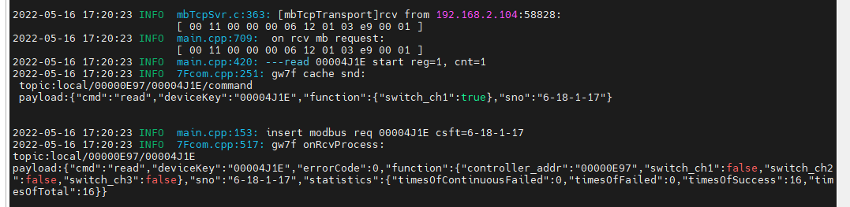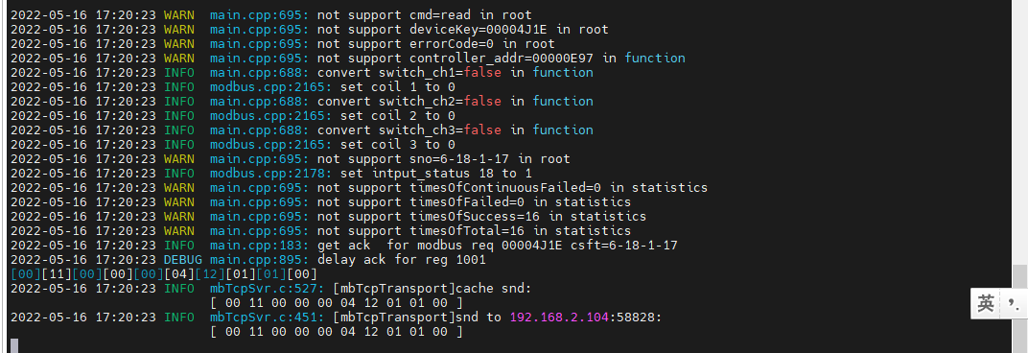

1. 读取缓存

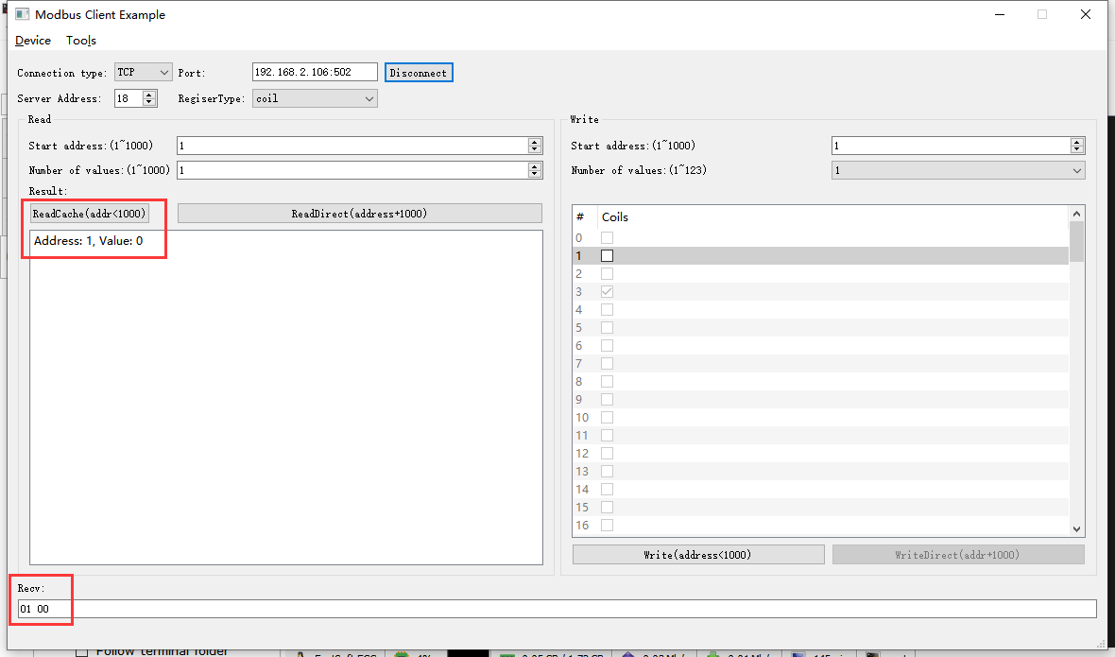2022-05-16 17:21:51 INFO mbTcpSvr.c:363: [mbTcpTransport]rcv from 192.168.2.104:58828:

[ 00 12 00 00 00 06 12 01 00 01 00 01 ]

2022-05-16 17:21:51 INFO main.cpp:709: on rcv mb request:

[ 00 12 00 00 00 06 12 01 00 01 00 01 ]

[00][12][00][00][00][04][12][01][01][00]

2022-05-16 17:21:51 INFO mbTcpSvr.c:527: [mbTcpTransport]cache snd:

[ 00 12 00 00 00 04 12 01 01 00 ]

2022-05-16 17:21:51 INFO mbTcpSvr.c:451: [mbTcpTransport]snd to 192.168.2.104:58828:

[ 00 12 00 00 00 04 12 01 01 00 ]

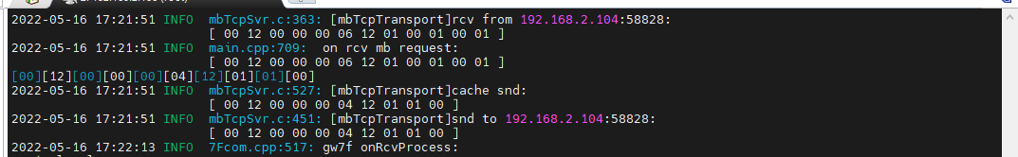

再次读取缓存-验证缓存有没有被清空

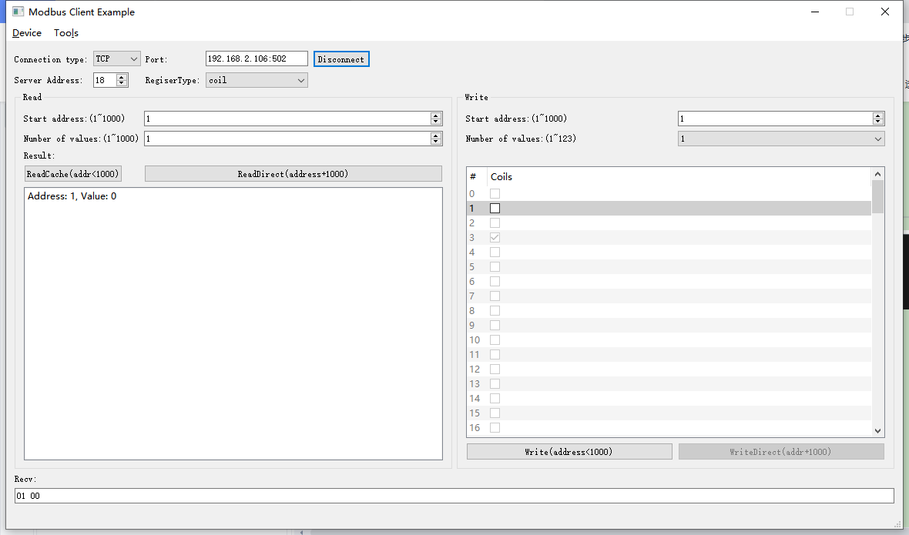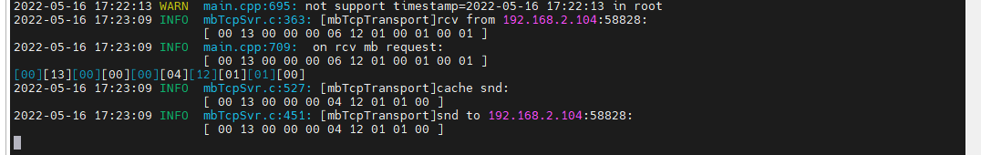

### 通道2

#### 闭合

1. 写入

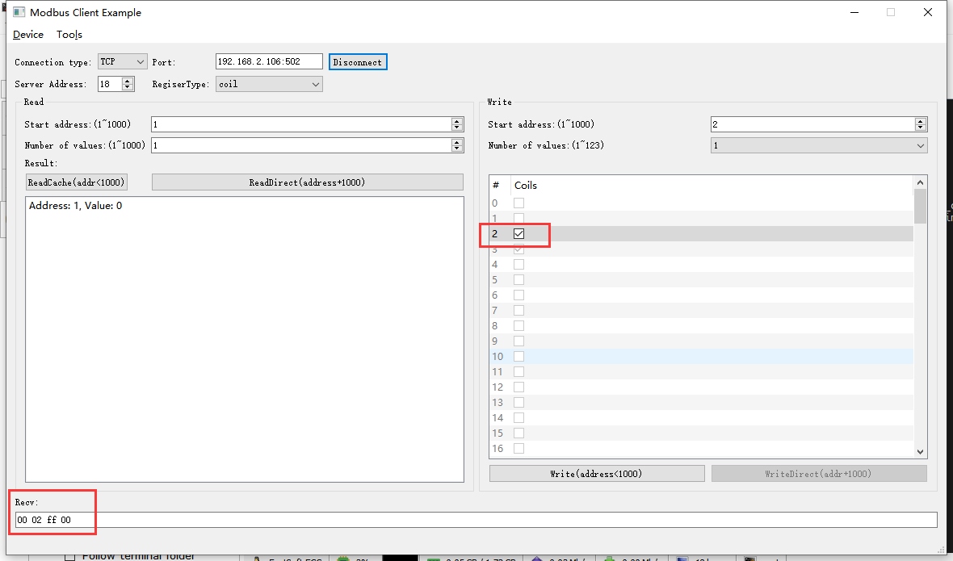2022-05-17 08:59:54 INFO mbTcpSvr.c:363: [mbTcpTransport]rcv from 192.168.2.104:62506:

[ 00 14 00 00 00 06 12 05 00 02 ff 00 ]

2022-05-17 08:59:54 INFO main.cpp:709: on rcv mb request:

[ 00 14 00 00 00 06 12 05 00 02 ff 00 ]

2022-05-17 08:59:54 INFO main.cpp:420: ---write 00004J1E start reg=2, cnt=1

2022-05-17 08:59:54 DEBUG main.cpp:496: write coil[2] to 0x0101

2022-05-17 08:59:54 INFO 7Fcom.cpp:517: gw7f onRcvProcess:

topic:local/00000E97/00004J1E

payload:{"cmd":"write","deviceKey":"00004J1E","errorCode":0,"function":{"controller_addr":"00000E97","switch_ch1":false,"switch_ch2":true,"switch_ch3":false},"sno":"6-18-5-20","statistics":{"timesOfContinuousFailed":0,"timesOfFailed":0,"timesOfSuccess":52,"timesOfTotal":52}}

2022-05-17 08:59:54 INFO mbTcpSvr.c:451: [mbTcpTransport]snd to 192.168.2.104:62506:

[ 00 14 00 00 00 06 12 05 00 02 ff 00 ]

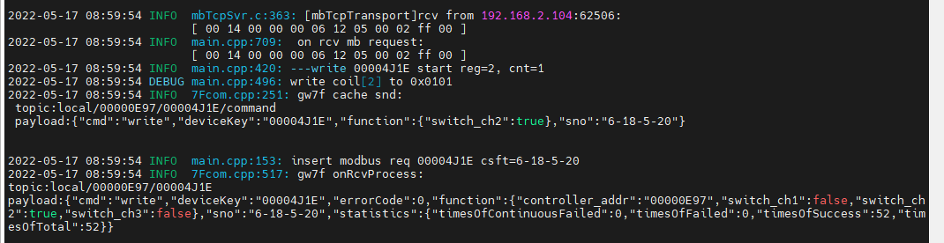

1. 直读

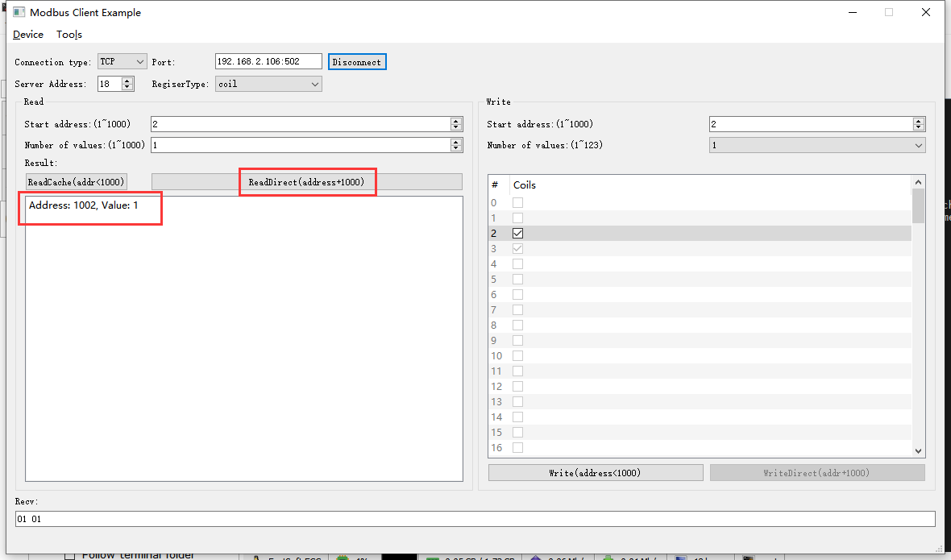2022-05-17 09:02:29 INFO mbTcpSvr.c:363: [mbTcpTransport]rcv from 192.168.2.104:62506:

[ 00 15 00 00 00 06 12 01 03 ea 00 01 ]

2022-05-17 09:02:29 INFO main.cpp:709: on rcv mb request:

[ 00 15 00 00 00 06 12 01 03 ea 00 01 ]

2022-05-17 09:02:29 INFO main.cpp:420: ---read 00004J1E start reg=2, cnt=1

2022-05-17 09:02:29 INFO 7Fcom.cpp:517: gw7f onRcvProcess:

topic:local/00000E97/00004J1E

payload:{"cmd":"read","deviceKey":"00004J1E","errorCode":0,"function":{"controller_addr":"00000E97","switch_ch1":false,"switch_ch2":true,"switch_ch3":false},"sno":"6-18-1-21","statistics":{"timesOfContinuousFailed":0,"timesOfFailed":0,"timesOfSuccess":53,"timesOfTotal":53}}

2022-05-17 09:02:29 INFO mbTcpSvr.c:451: [mbTcpTransport]snd to 192.168.2.104:62506:

[ 00 15 00 00 00 04 12 01 01 01 ]

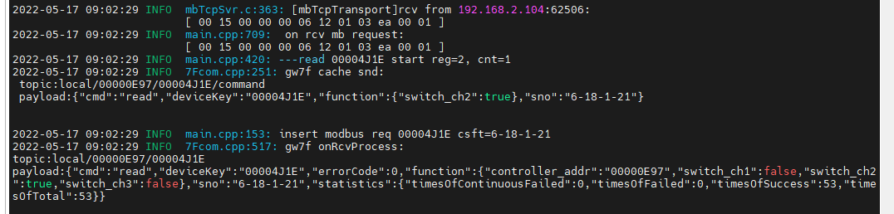

#### 断开

1. 写入

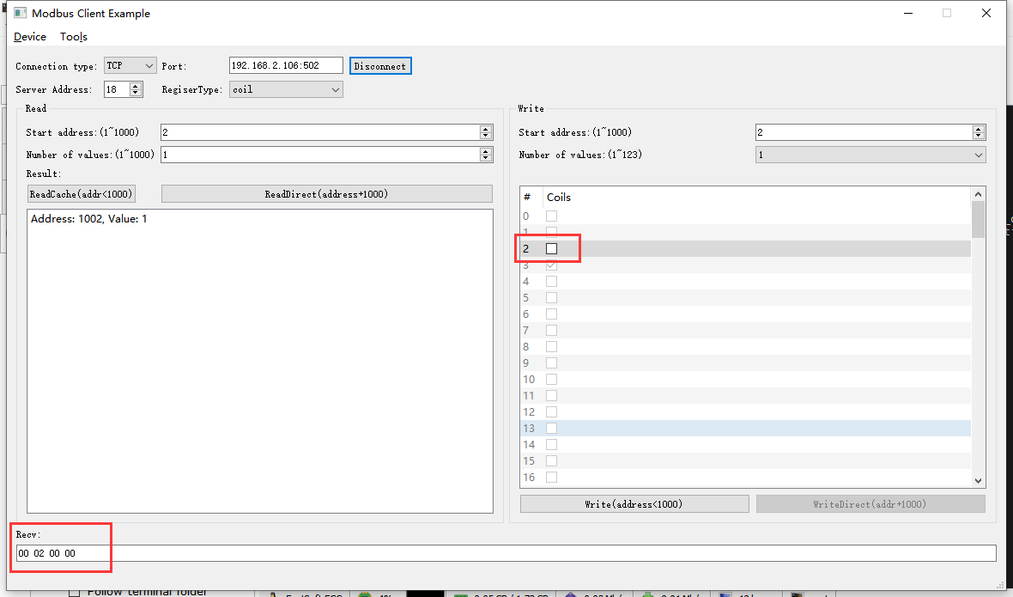2022-05-17 09:04:14 INFO mbTcpSvr.c:363: [mbTcpTransport]rcv from 192.168.2.104:62506:

[ 00 16 00 00 00 06 12 05 00 02 00 00 ]

2022-05-17 09:04:14 INFO main.cpp:709: on rcv mb request:

[ 00 16 00 00 00 06 12 05 00 02 00 00 ]

2022-05-17 09:04:14 INFO main.cpp:420: ---write 00004J1E start reg=2, cnt=1

2022-05-17 09:04:14 DEBUG main.cpp:496: write coil[2] to 0x0000

2022-05-17 09:04:14 INFO 7Fcom.cpp:517: gw7f onRcvProcess:

topic:local/00000E97/00004J1E

payload:{"cmd":"write","deviceKey":"00004J1E","errorCode":0,"function":{"controller_addr":"00000E97","switch_ch1":false,"switch_ch2":false,"switch_ch3":false},"sno":"6-18-5-22","statistics":{"timesOfContinuousFailed":0,"timesOfFailed":0,"timesOfSuccess":54,"timesOfTotal":54}}

2022-05-17 09:04:14 INFO mbTcpSvr.c:451: [mbTcpTransport]snd to 192.168.2.104:62506:

[ 00 16 00 00 00 06 12 05 00 02 00 00 ]

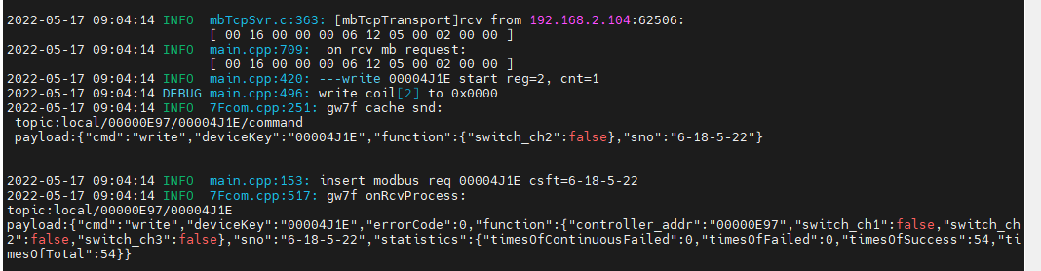

1. 直读

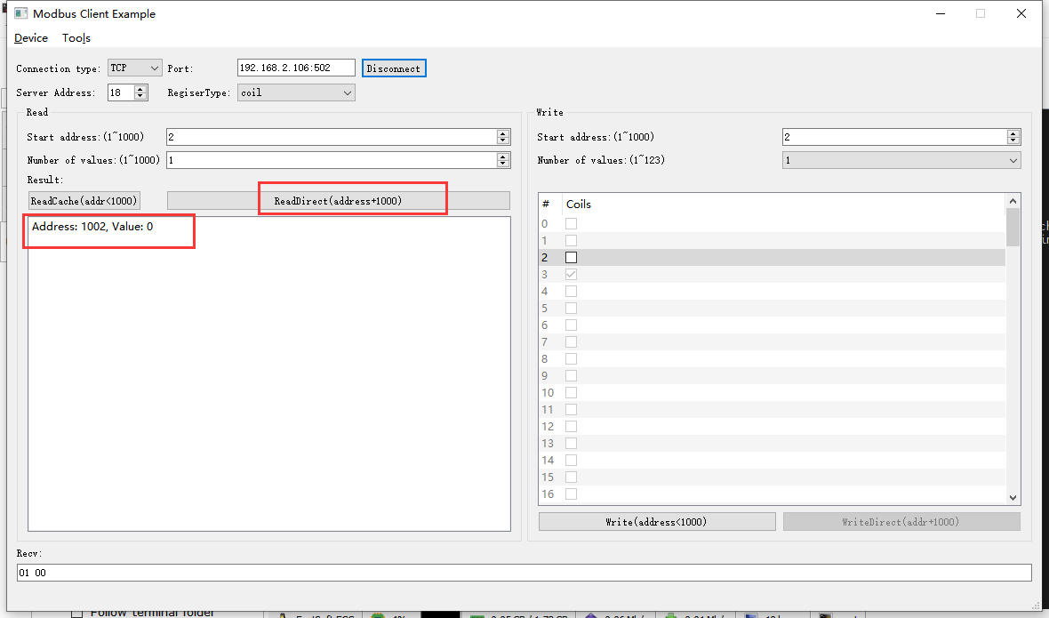2022-05-17 09:05:50 INFO mbTcpSvr.c:363: [mbTcpTransport]rcv from 192.168.2.104:62506:

[ 00 17 00 00 00 06 12 01 03 ea 00 01 ]

2022-05-17 09:05:50 INFO main.cpp:709: on rcv mb request:

[ 00 17 00 00 00 06 12 01 03 ea 00 01 ]

2022-05-17 09:05:50 INFO main.cpp:420: ---read 00004J1E start reg=2, cnt=1

2022-05-17 09:05:50 INFO 7Fcom.cpp:517: gw7f onRcvProcess:

topic:local/00000E97/00004J1E

payload:{"cmd":"read","deviceKey":"00004J1E","errorCode":0,"function":{"controller_addr":"00000E97","switch_ch1":false,"switch_ch2":false,"switch_ch3":false},"sno":"6-18-1-23","statistics":{"timesOfContinuousFailed":0,"timesOfFailed":0,"timesOfSuccess":55,"timesOfTotal":55}}

2022-05-17 09:05:50 INFO mbTcpSvr.c:451: [mbTcpTransport]snd to 192.168.2.104:62506:

[ 00 17 00 00 00 04 12 01 01 00 ]

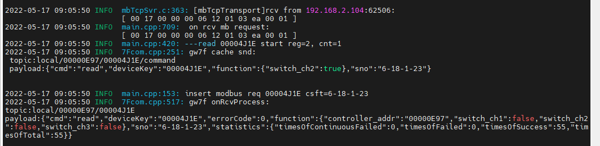

### 通道3

#### 闭合

1. 写入

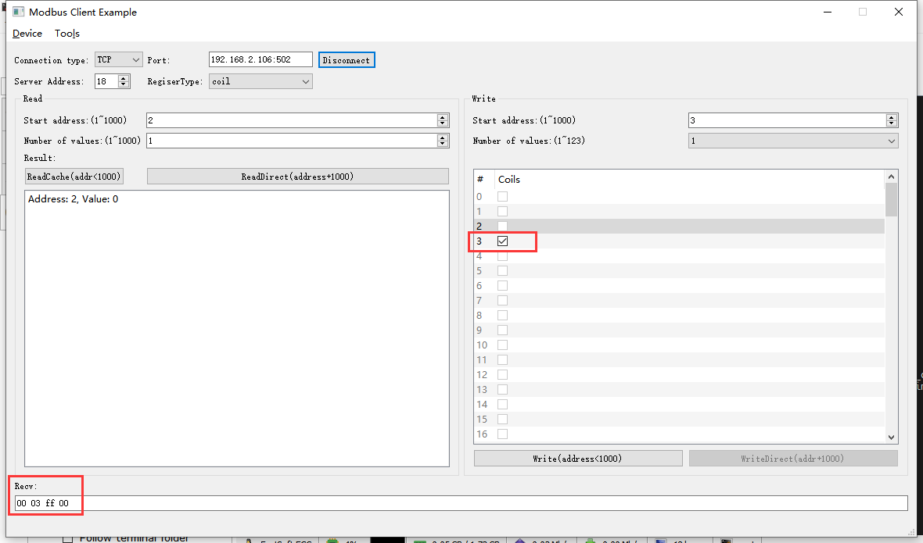2022-05-17 09:07:51 INFO mbTcpSvr.c:363: [mbTcpTransport]rcv from 192.168.2.104:62506:

[ 00 1a 00 00 00 06 12 05 00 03 ff 00 ]

2022-05-17 09:07:51 INFO main.cpp:709: on rcv mb request:

[ 00 1a 00 00 00 06 12 05 00 03 ff 00 ]

2022-05-17 09:07:51 INFO main.cpp:420: ---write 00004J1E start reg=3, cnt=1

2022-05-17 09:07:51 DEBUG main.cpp:496: write coil[3] to 0x0101

2022-05-17 09:07:51 INFO 7Fcom.cpp:517: gw7f onRcvProcess:

topic:local/00000E97/00004J1E

payload:{"cmd":"write","deviceKey":"00004J1E","errorCode":0,"function":{"controller_addr":"00000E97","switch_ch1":false,"switch_ch2":false,"switch_ch3":true},"sno":"6-18-5-26","statistics":{"timesOfContinuousFailed":0,"timesOfFailed":0,"timesOfSuccess":56,"timesOfTotal":56}}

2022-05-17 09:07:51 INFO mbTcpSvr.c:451: [mbTcpTransport]snd to 192.168.2.104:62506:

[ 00 1a 00 00 00 06 12 05 00 03 ff 00 ]

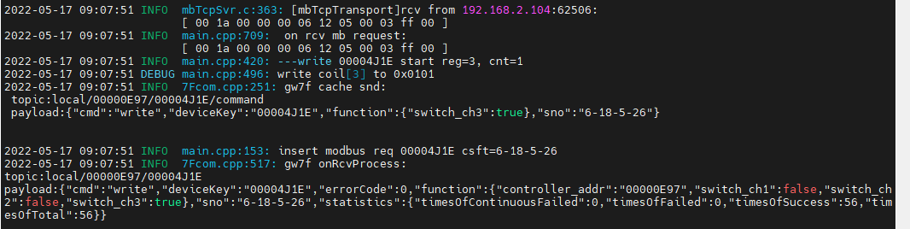

1. 直读

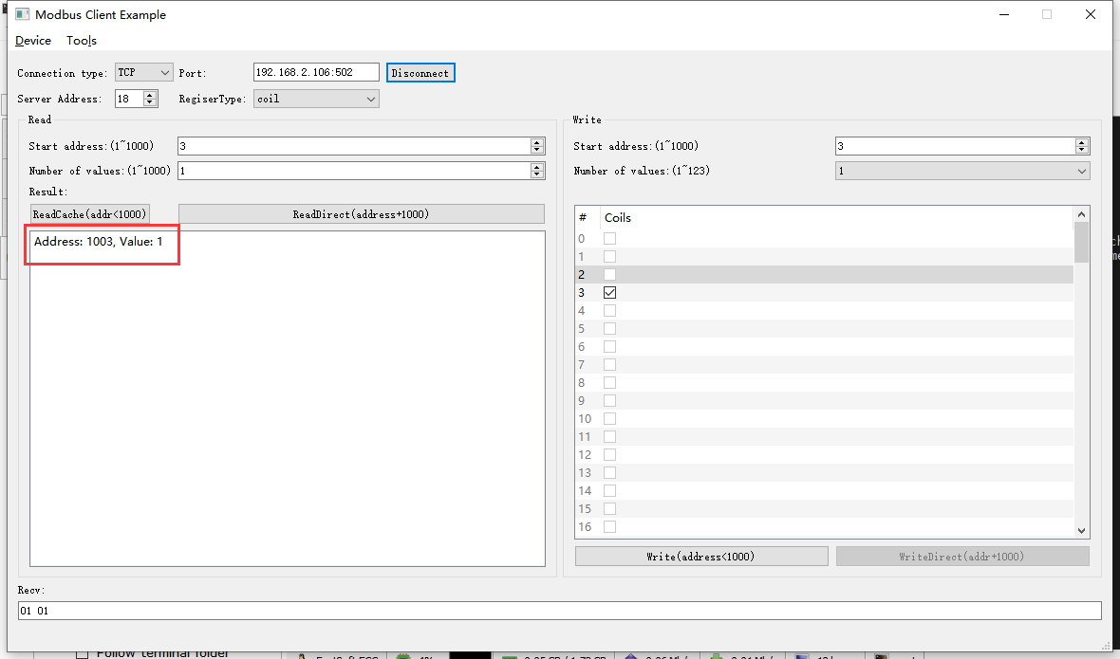2022-05-17 09:11:35 INFO mbTcpSvr.c:363: [mbTcpTransport]rcv from 192.168.2.104:62506:

[ 00 1b 00 00 00 06 12 01 03 eb 00 01 ]

2022-05-17 09:11:35 INFO main.cpp:709: on rcv mb request:

[ 00 1b 00 00 00 06 12 01 03 eb 00 01 ]

2022-05-17 09:11:35 INFO main.cpp:420: ---read 00004J1E start reg=3, cnt=1

2022-05-17 09:11:35 INFO 7Fcom.cpp:517: gw7f onRcvProcess:

topic:local/00000E97/00004J1E

payload:{"cmd":"read","deviceKey":"00004J1E","errorCode":0,"function":{"controller_addr":"00000E97","switch_ch1":false,"switch_ch2":false,"switch_ch3":true},"sno":"6-18-1-27","statistics":{"timesOfContinuousFailed":0,"timesOfFailed":0,"timesOfSuccess":57,"timesOfTotal":57}}

2022-05-17 09:11:35 INFO mbTcpSvr.c:451: [mbTcpTransport]snd to 192.168.2.104:62506:

[ 00 1b 00 00 00 04 12 01 01 01 ]

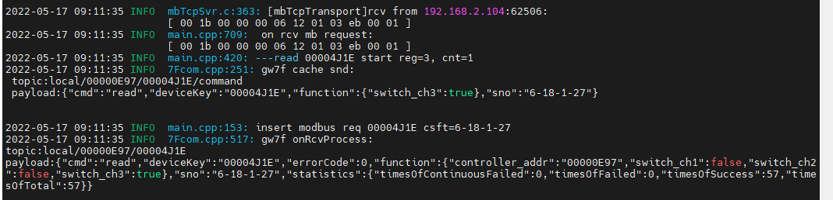

#### 断开

1. 写入

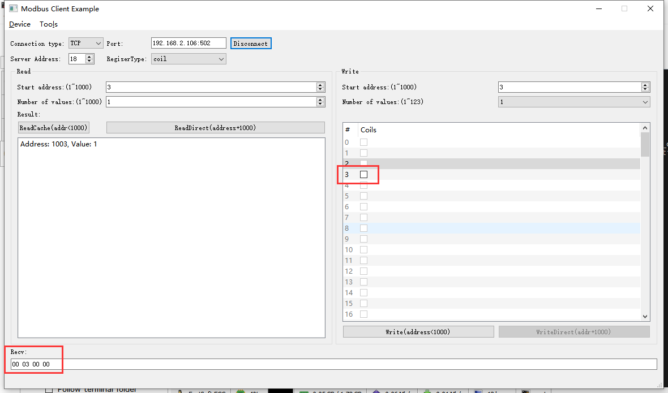2022-05-17 09:26:36 INFO mbTcpSvr.c:363: [mbTcpTransport]rcv from 192.168.2.104:62506:

[ 00 1c 00 00 00 06 12 05 00 03 00 00 ]

2022-05-17 09:26:36 INFO main.cpp:709: on rcv mb request:

[ 00 1c 00 00 00 06 12 05 00 03 00 00 ]

2022-05-17 09:26:36 INFO main.cpp:420: ---write 00004J1E start reg=3, cnt=1

2022-05-17 09:26:36 DEBUG main.cpp:496: write coil[3] to 0x0000

2022-05-17 09:26:36 INFO 7Fcom.cpp:517: gw7f onRcvProcess:

topic:local/00000E97/00004J1E

payload:{"cmd":"write","deviceKey":"00004J1E","errorCode":0,"function":{"controller_addr":"00000E97","switch_ch1":false,"switch_ch2":false,"switch_ch3":false},"sno":"6-18-5-28","statistics":{"timesOfContinuousFailed":0,"timesOfFailed":0,"timesOfSuccess":58,"timesOfTotal":58}}

2022-05-17 09:26:36 INFO mbTcpSvr.c:451: [mbTcpTransport]snd to 192.168.2.104:62506:

[ 00 1c 00 00 00 06 12 05 00 03 00 00 ]

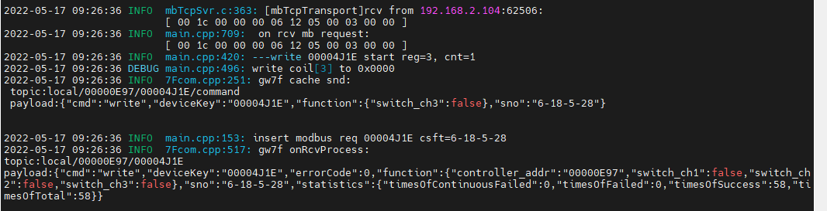

1. 直读

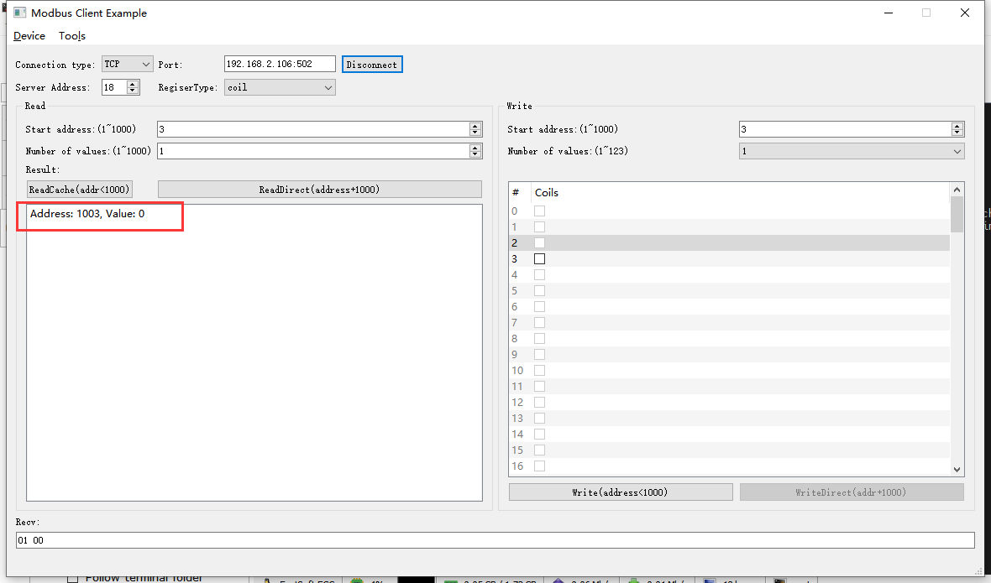2022-05-17 09:27:48 INFO mbTcpSvr.c:363: [mbTcpTransport]rcv from 192.168.2.104:62506:

[ 00 1d 00 00 00 06 12 01 03 eb 00 01 ]

2022-05-17 09:27:48 INFO main.cpp:709: on rcv mb request:

[ 00 1d 00 00 00 06 12 01 03 eb 00 01 ]

2022-05-17 09:27:48 INFO main.cpp:420: ---read 00004J1E start reg=3, cnt=1

2022-05-17 09:27:48 INFO 7Fcom.cpp:517: gw7f onRcvProcess:

topic:local/00000E97/00004J1E

payload:{"cmd":"read","deviceKey":"00004J1E","errorCode":0,"function":{"controller_addr":"00000E97","switch_ch1":false,"switch_ch2":false,"switch_ch3":false},"sno":"6-18-1-29","statistics":{"timesOfContinuousFailed":0,"timesOfFailed":0,"timesOfSuccess":59,"timesOfTotal":59}}

2022-05-17 09:27:48 INFO mbTcpSvr.c:451: [mbTcpTransport]snd to 192.168.2.104:62506:

[ 00 1d 00 00 00 04 12 01 01 00 ]

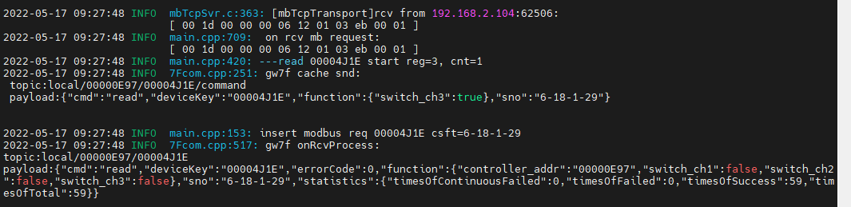

### 按下事件

**说明：**signal类型，读取后清零

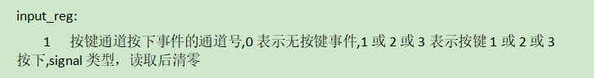

通过手机APP将设备的对应通道配置为上报平台

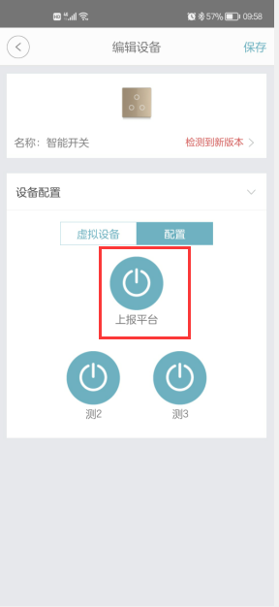

#### 通道1按下

1. 触发按键

手动触摸通道1 按键，网关程序、modbus程序收到上报。

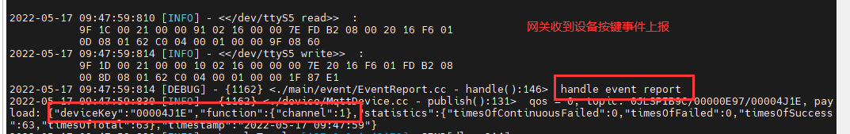

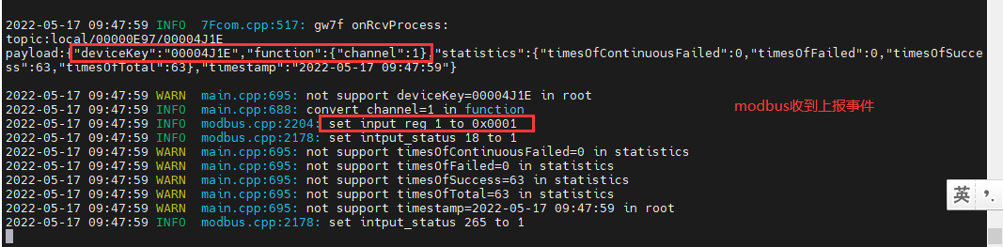

1. 读取缓存状态

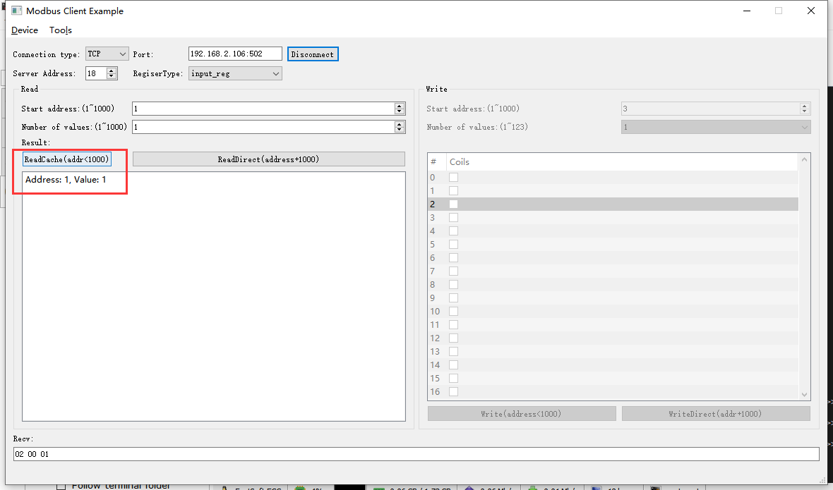2022-05-17 09:51:47 INFO mbTcpSvr.c:363: [mbTcpTransport]rcv from 192.168.2.104:62506:

[ 00 30 00 00 00 06 12 04 00 01 00 01 ]

2022-05-17 09:51:47 INFO main.cpp:709: on rcv mb request:

[ 00 30 00 00 00 06 12 04 00 01 00 01 ]

2022-05-17 09:51:47 INFO main.cpp:237: clear signal reg 1 after read

[00][30][00][00][00][05][12][04][02][00][01]

2022-05-17 09:51:47 INFO mbTcpSvr.c:527: [mbTcpTransport]cache snd:

[ 00 30 00 00 00 05 12 04 02 00 01 ]

2022-05-17 09:51:47 INFO mbTcpSvr.c:451: [mbTcpTransport]snd to 192.168.2.104:62506:

[ 00 30 00 00 00 05 12 04 02 00 01 ]

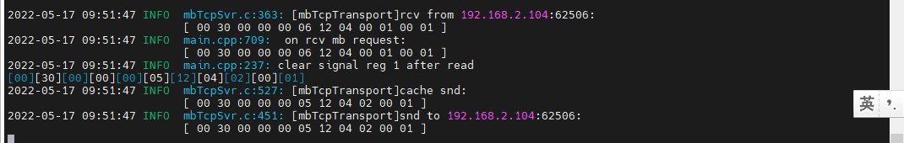

1. 再次读取缓存-清零

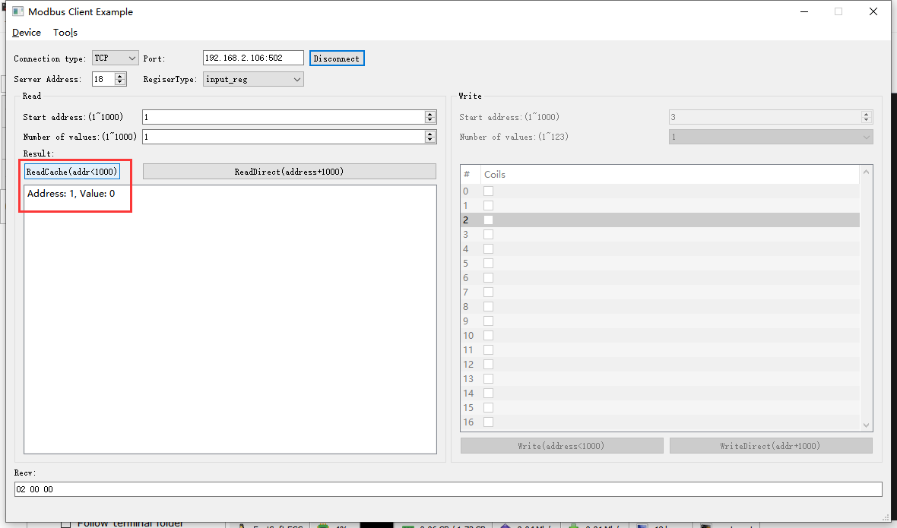2022-05-17 09:52:44 INFO mbTcpSvr.c:363: [mbTcpTransport]rcv from 192.168.2.104:62506:

[ 00 31 00 00 00 06 12 04 00 01 00 01 ]

2022-05-17 09:52:44 INFO main.cpp:709: on rcv mb request:

[ 00 31 00 00 00 06 12 04 00 01 00 01 ]

[00][31][00][00][00][05][12][04][02][00][00]

2022-05-17 09:52:44 INFO mbTcpSvr.c:527: [mbTcpTransport]cache snd:

[ 00 31 00 00 00 05 12 04 02 00 00 ]

2022-05-17 09:52:44 INFO mbTcpSvr.c:451: [mbTcpTransport]snd to 192.168.2.104:62506:

[ 00 31 00 00 00 05 12 04 02 00 00 ]

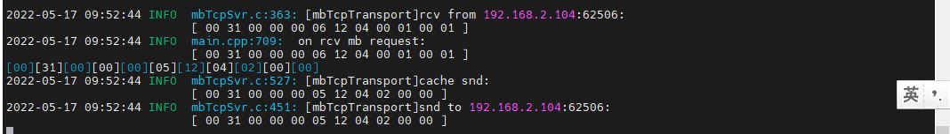

#### 通道2按下

1. 触发按键

手动触摸通道1 按键，网关程序、modbus程序收到上报。

网关日志

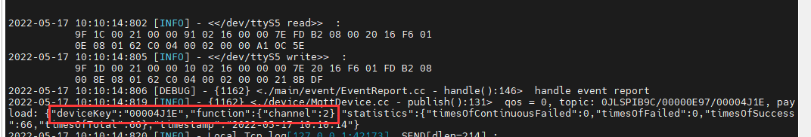

Modbus日志

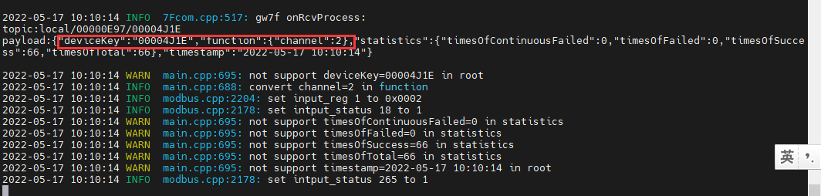

1. 读取缓存状态

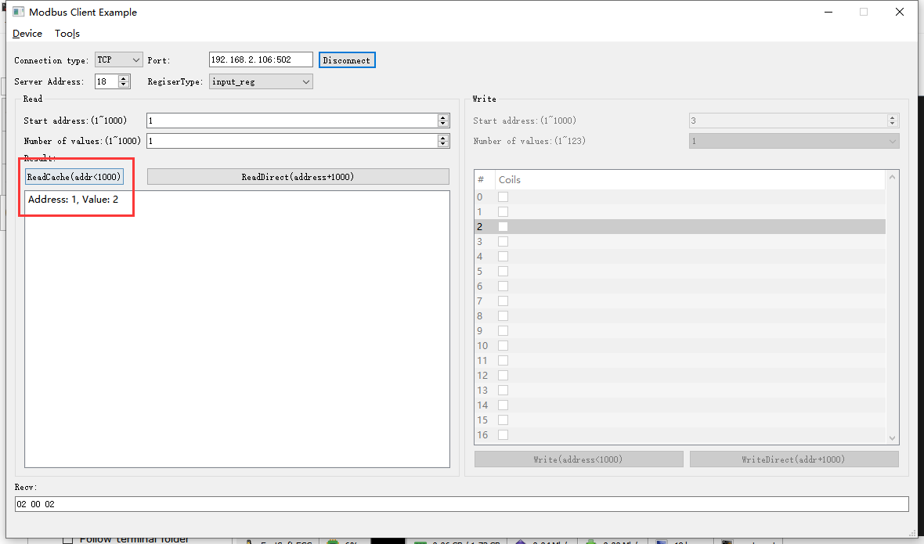2022-05-17 10:11:22 INFO mbTcpSvr.c:363: [mbTcpTransport]rcv from 192.168.2.104:62506:

[ 00 33 00 00 00 06 12 04 00 01 00 01 ]

2022-05-17 10:11:22 INFO main.cpp:709: on rcv mb request:

[ 00 33 00 00 00 06 12 04 00 01 00 01 ]

2022-05-17 10:11:22 INFO main.cpp:237: clear signal reg 1 after read

[00][33][00][00][00][05][12][04][02][00][02]

2022-05-17 10:11:22 INFO mbTcpSvr.c:527: [mbTcpTransport]cache snd:

[ 00 33 00 00 00 05 12 04 02 00 02 ]

2022-05-17 10:11:22 INFO mbTcpSvr.c:451: [mbTcpTransport]snd to 192.168.2.104:62506:

[ 00 33 00 00 00 05 12 04 02 00 02 ]

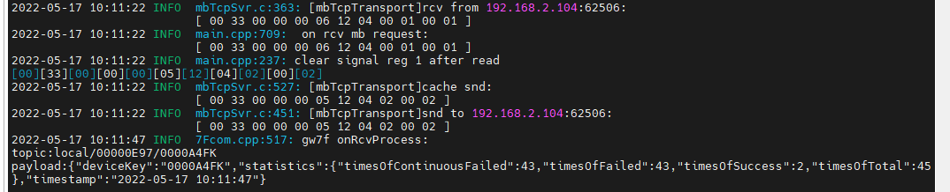

1. 再次读取缓存-清零

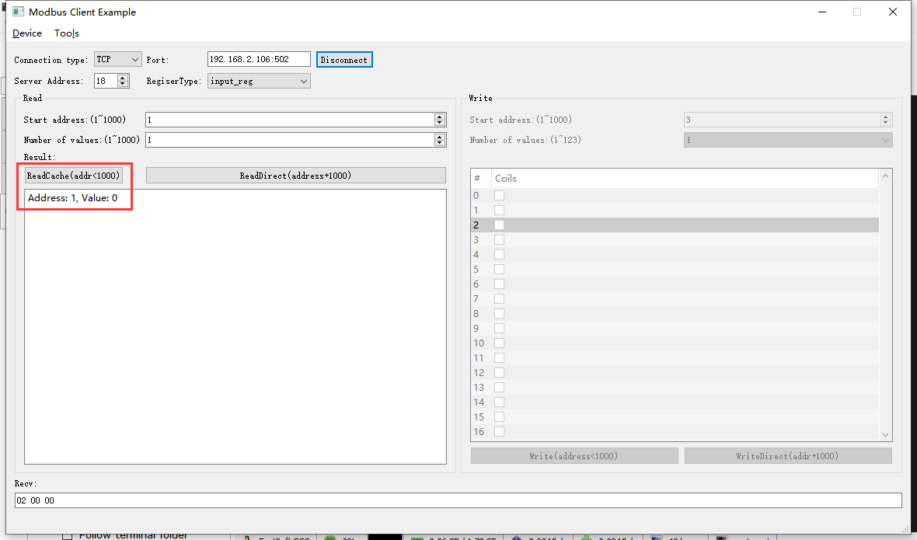2022-05-17 10:12:25 INFO mbTcpSvr.c:363: [mbTcpTransport]rcv from 192.168.2.104:62506:

[ 00 34 00 00 00 06 12 04 00 01 00 01 ]

2022-05-17 10:12:25 INFO main.cpp:709: on rcv mb request:

[ 00 34 00 00 00 06 12 04 00 01 00 01 ]

[00][34][00][00][00][05][12][04][02][00][00]

2022-05-17 10:12:25 INFO mbTcpSvr.c:527: [mbTcpTransport]cache snd:

[ 00 34 00 00 00 05 12 04 02 00 00 ]

2022-05-17 10:12:25 INFO mbTcpSvr.c:451: [mbTcpTransport]snd to 192.168.2.104:62506:

[ 00 34 00 00 00 05 12 04 02 00 00 ]

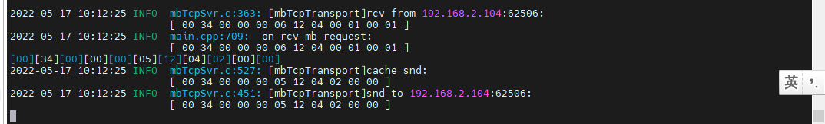

#### 通道3按下

1. 触发按键

手动触摸通道1 按键，网关程序、modbus程序收到上报。

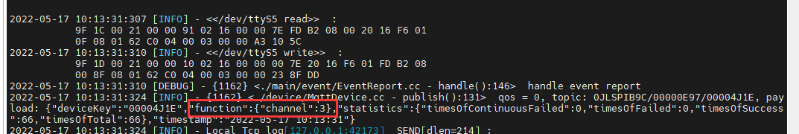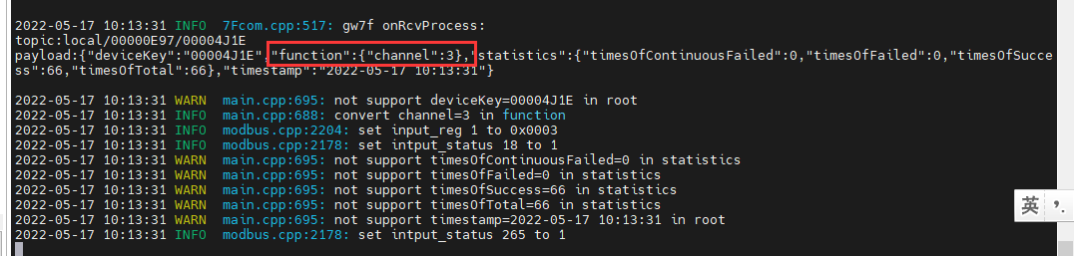

1. 读取缓存状态

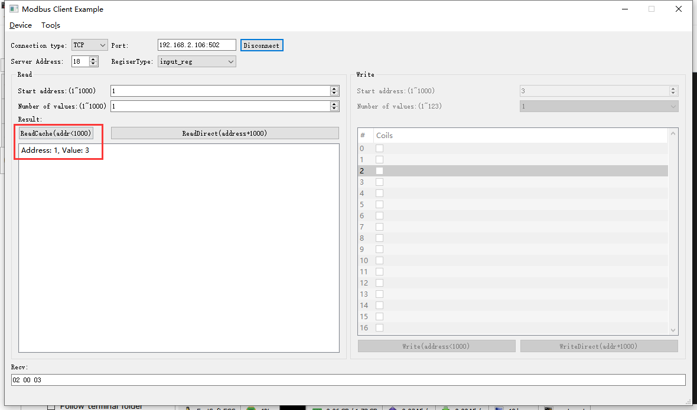2022-05-17 10:14:13 INFO mbTcpSvr.c:363: [mbTcpTransport]rcv from 192.168.2.104:62506:

[ 00 35 00 00 00 06 12 04 00 01 00 01 ]

2022-05-17 10:14:13 INFO main.cpp:709: on rcv mb request:

[ 00 35 00 00 00 06 12 04 00 01 00 01 ]

2022-05-17 10:14:13 INFO main.cpp:237: clear signal reg 1 after read

[00][35][00][00][00][05][12][04][02][00][03]

2022-05-17 10:14:13 INFO mbTcpSvr.c:527: [mbTcpTransport]cache snd:

[ 00 35 00 00 00 05 12 04 02 00 03 ]

2022-05-17 10:14:13 INFO mbTcpSvr.c:451: [mbTcpTransport]snd to 192.168.2.104:62506:

[ 00 35 00 00 00 05 12 04 02 00 03 ]

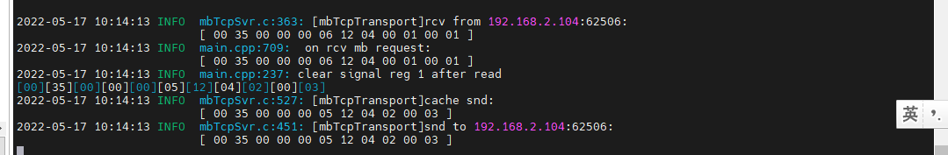

1. 再次读取缓存-清零

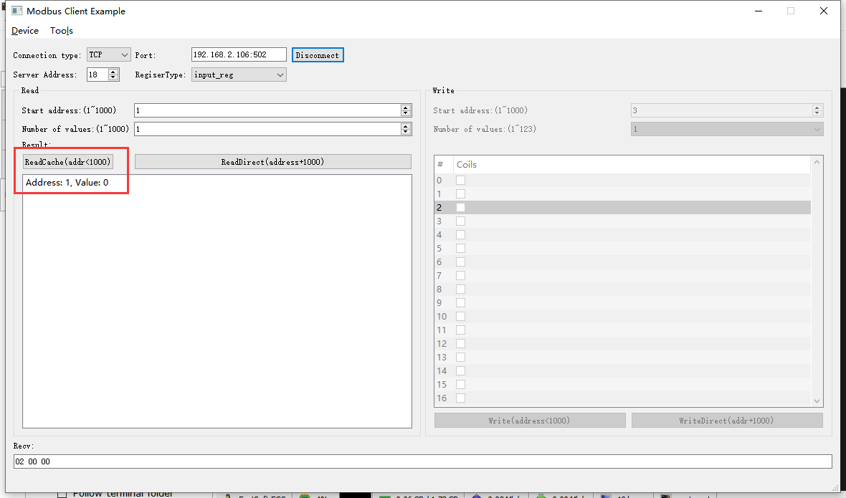2022-05-17 10:14:55 INFO mbTcpSvr.c:363: [mbTcpTransport]rcv from 192.168.2.104:62506:

[ 00 36 00 00 00 06 12 04 00 01 00 01 ]

2022-05-17 10:14:55 INFO main.cpp:709: on rcv mb request:

[ 00 36 00 00 00 06 12 04 00 01 00 01 ]

[00][36][00][00][00][05][12][04][02][00][00]

2022-05-17 10:14:55 INFO mbTcpSvr.c:527: [mbTcpTransport]cache snd:

[ 00 36 00 00 00 05 12 04 02 00 00 ]

2022-05-17 10:14:55 INFO mbTcpSvr.c:451: [mbTcpTransport]snd to 192.168.2.104:62506:

[ 00 36 00 00 00 05 12 04 02 00 00 ]

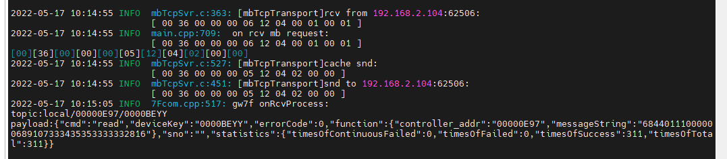

# 8路开关执行器ok

## 协议

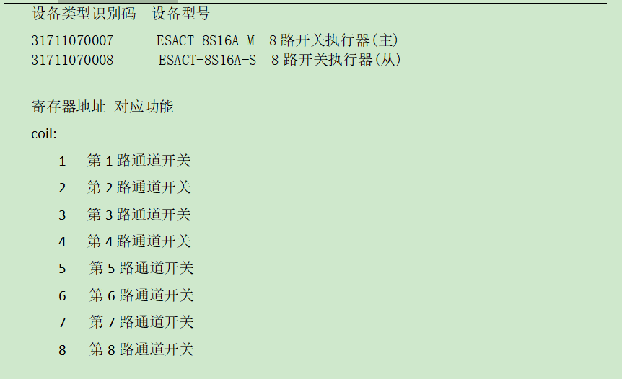

## 添加设备

在map.json中添加设备，同时添加到数据库中。

## 读写线圈

|  |  |  |  |
| --- | --- | --- | --- |
| 通道 | 写入 | 读取 | 写入非法制（bool） |
| 1 | √ | √ | √ |
| 2 | √ | √ | √ |
| 3 | √ | √ | √ |
| 4 | √ | √ | √ |
| 5 | √ | √ | √ |
| 6 | √ | √ | √ |
| 7 | √ | √ | √ |
| 8 | √ | √ | √ |
| 不存在的通道（11、9） | √ | √ | √ |
| 从机通道 | √ | √ | √ |

测试日志：



测试结果：

测试合格

# 2路色温控制器(0~10v)ok

问题：读取控制设备失败（报错：83 02），modbus地址映射错误。如下图所示



## 协议

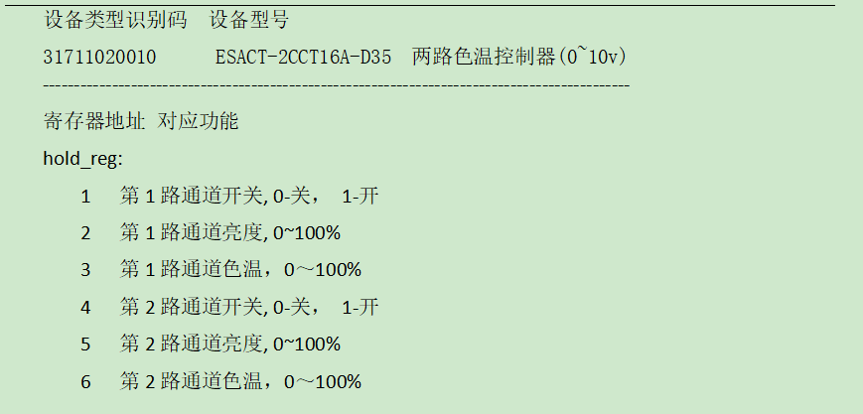

## 添加设备



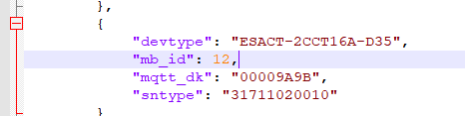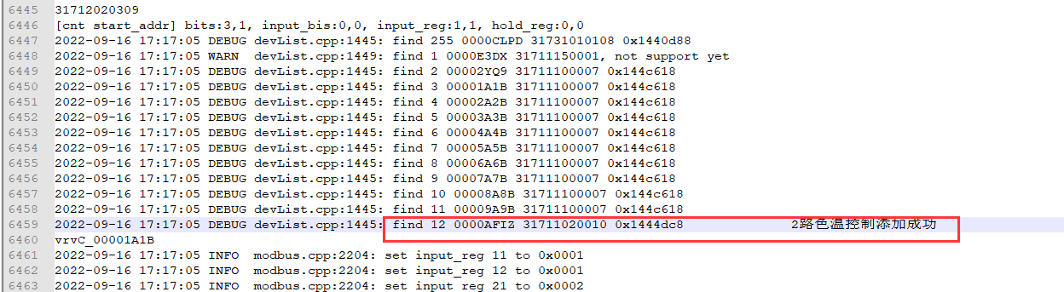

**结果:**添加成功

## 读取保持寄存器

|  |  |  |
| --- | --- | --- |
|  | 1通道 | 2通道 |
| 开关 | √ | √ |
| 亮度，0-100& | √ | √ |
| 色温，0～100% | √ | √ |
| 读取全部hold_reg：1-6 | √ | √ |
| 仅读取部分hold_reg | √ | √ |

## 写入保持寄存器

|  |  |  |
| --- | --- | --- |
|  | 1通道 | 2通道 |
| 开关（合法值0,1；非法值2,65535，-1） | √ | √ |
| 亮度，0-100&，非法值 | √ | √ |
| 色温，0～100%，非法值 | √ | √ |
| 写入全部hold_reg：1-6 | √ | √ |
| 写入取部分hold_reg | √ | √ |

**测试日志**



# 多联机空调控制器ok

## 协议

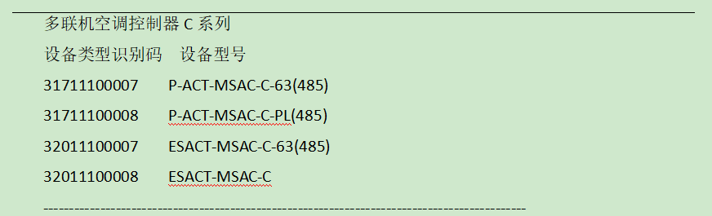

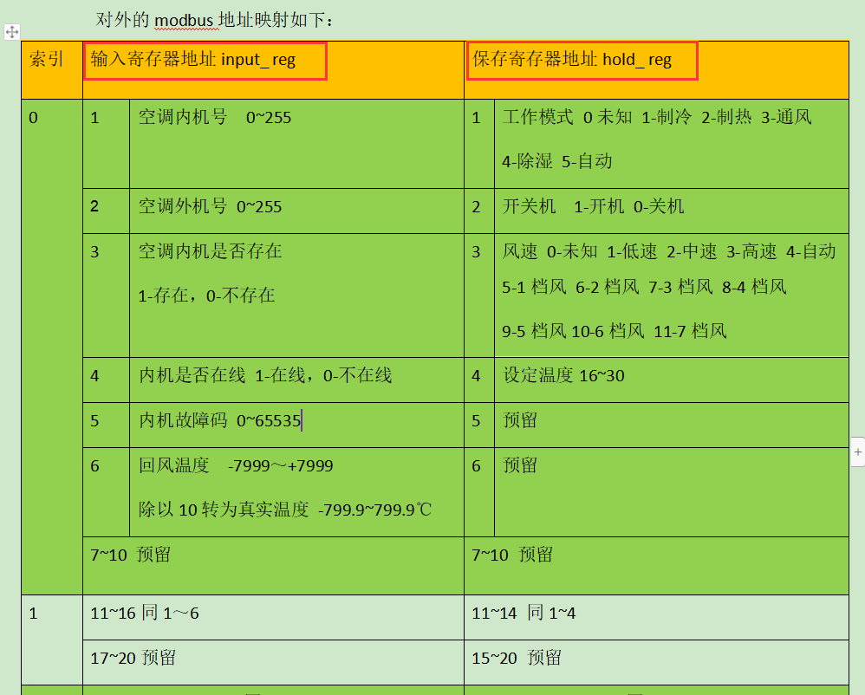

## 添加设备

添加设备到网关中（网关数据库+map.json）

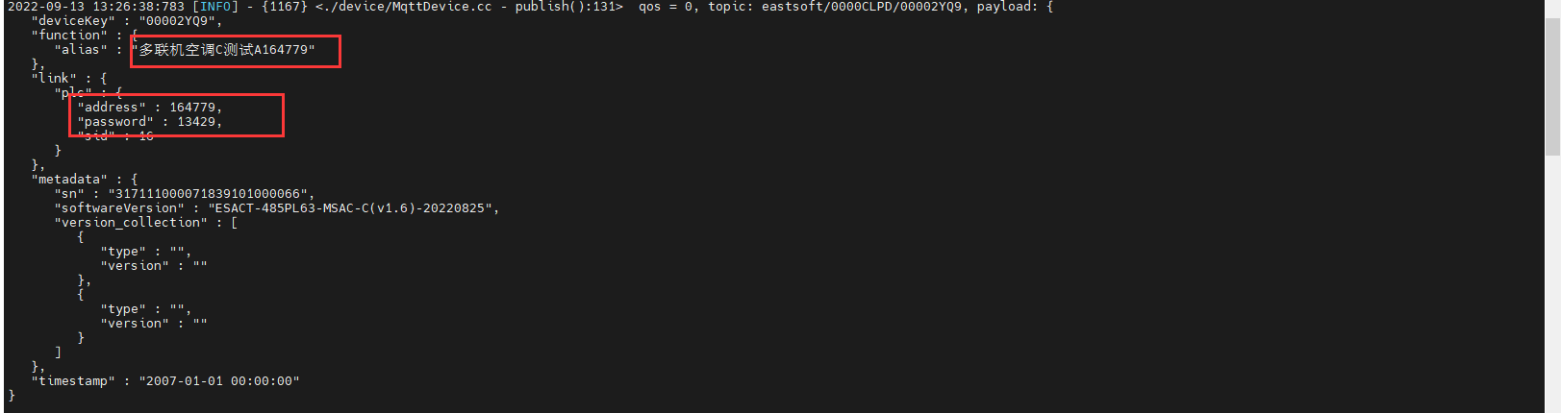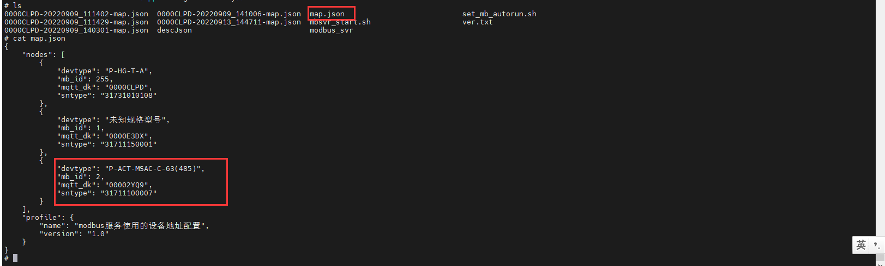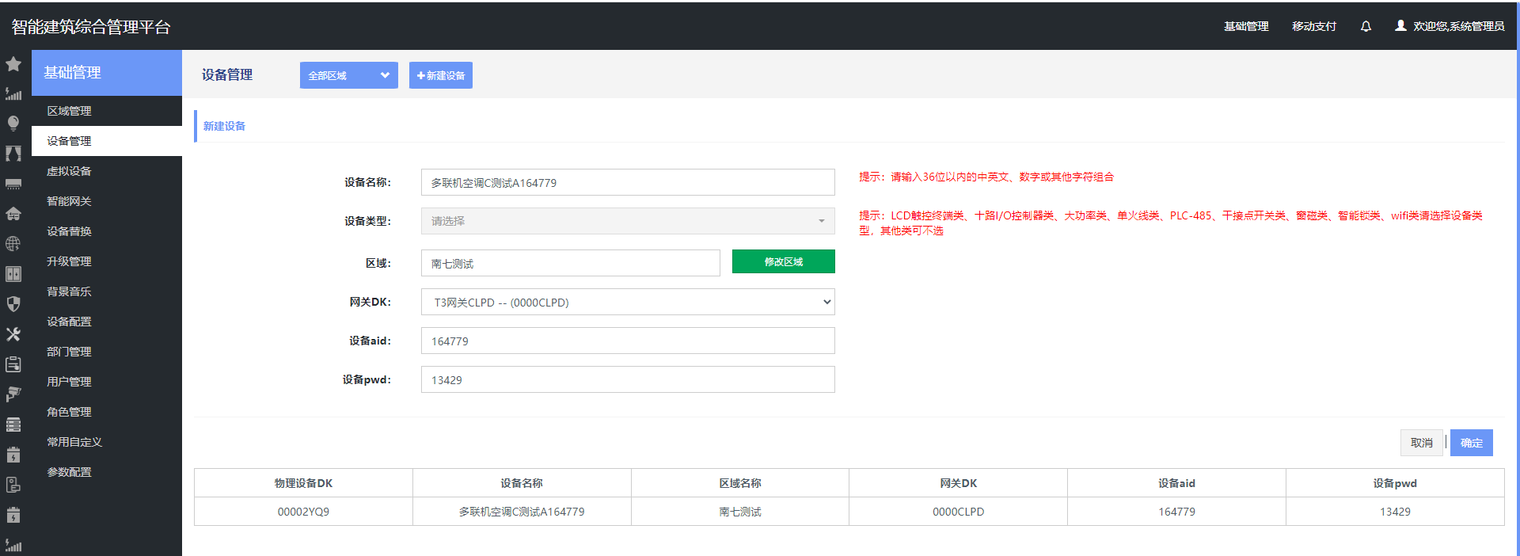

添加虚拟内机

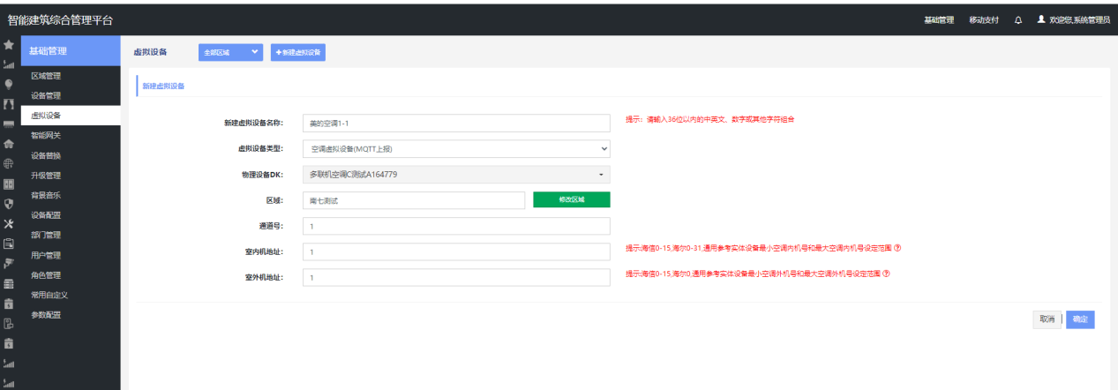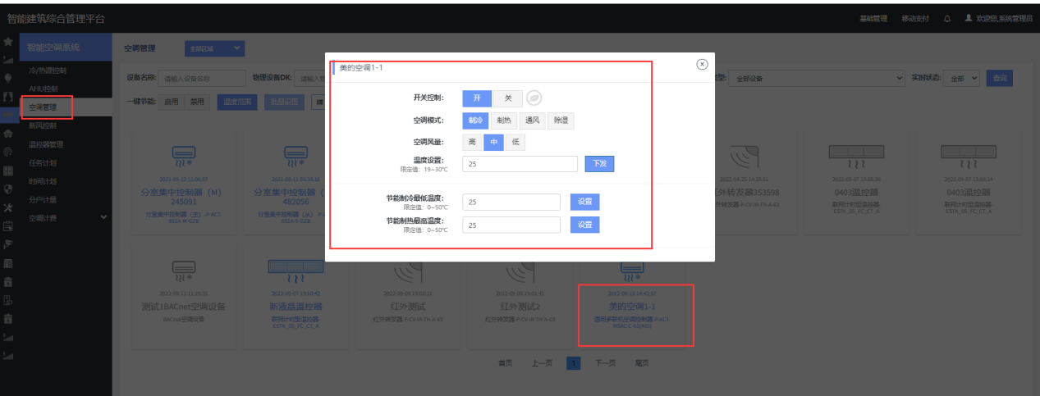

## Modbus读取

一次性读取所有寄存器-读取正常

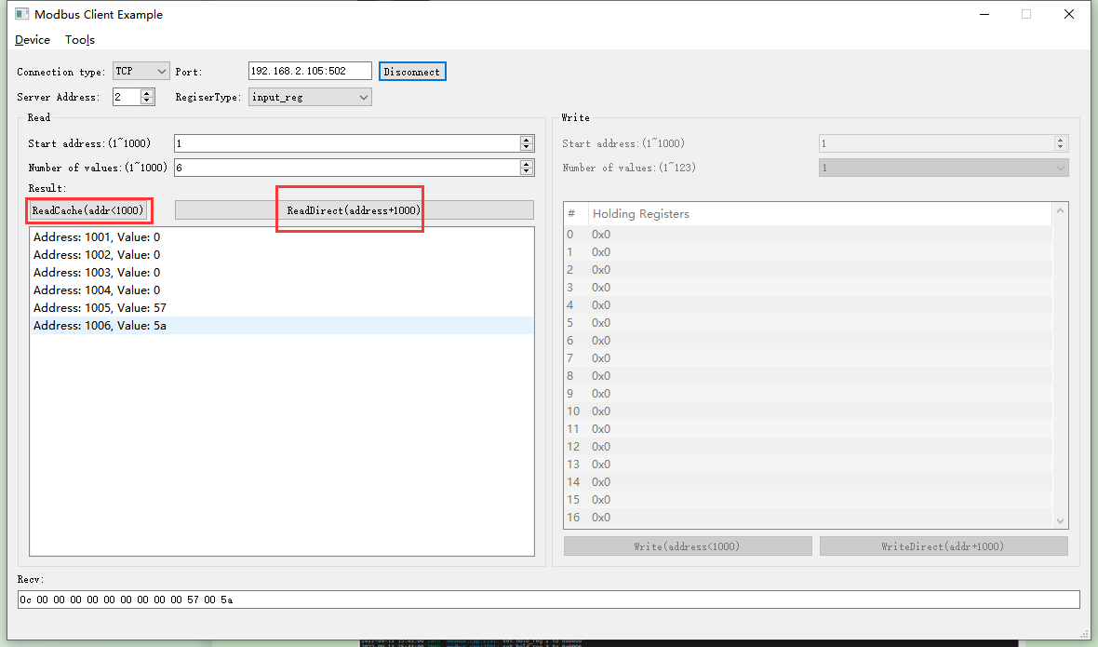

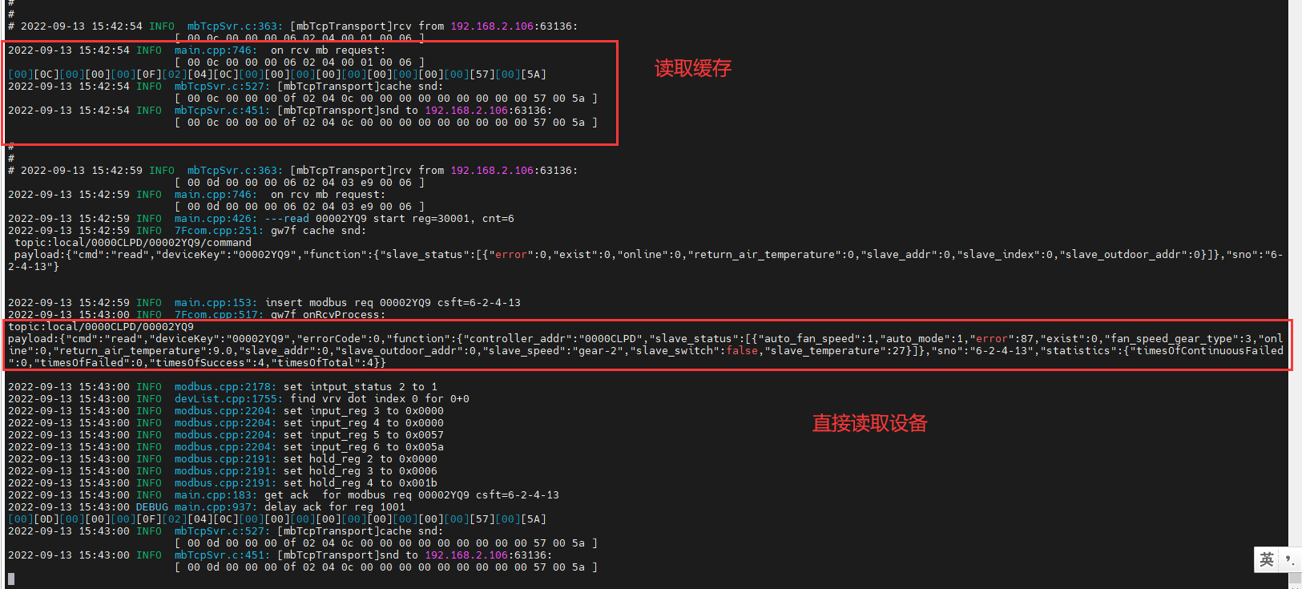

## 寄存器值写入测试

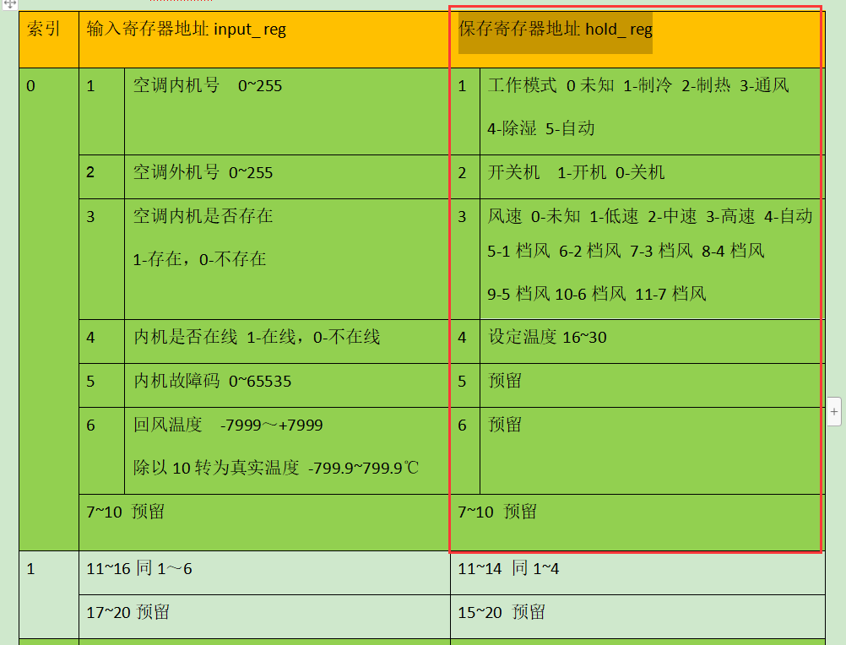

**测试内容：**

如上图的寄存器定义

1. 保存寄存器hold-reg，写入工作模式、开关机、风速、设定温度；写入范围内合法值，写入非法制。
2. Modbus服务程序（SVR）最多支持10只多联机空调控制器C，每只多联机C下最多支持128个内机点位，则共1280个点位，测试满载数据读写，测试相关配置文件最大情况下的读取和解析。

**测试方法：**

1. 使用如下图测试工具，通过TCP连接网关，并下发配置，读取设备状态。

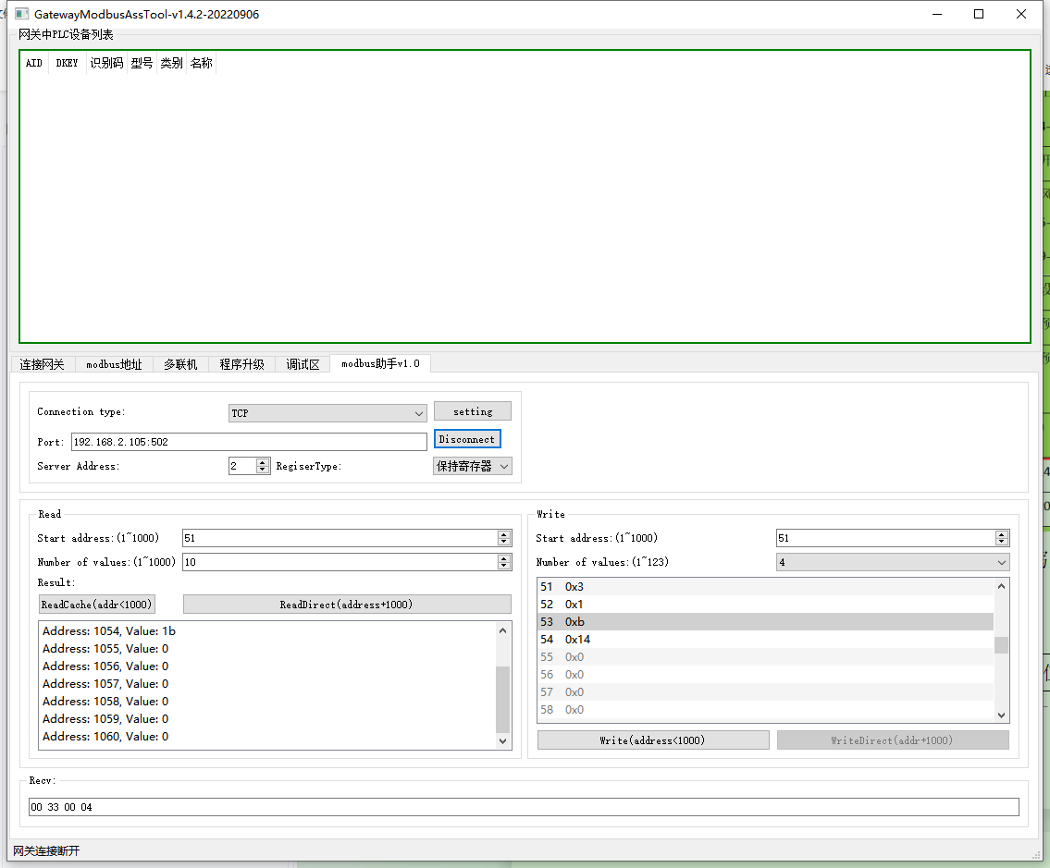

1. 添加10只多联机C，每只多联机C下中添加128个内机。或者制造文件vrvC.json（128个内机）和0000CLPD-map.json（10只多联机的DK）达到数量要求。

**注：**modbus服务程序在处理多联机空调时（如10个多联机，每个多联机中含有128个内机），每个多联机设备使用其DK（如vrvC_00001A1B）表征。

比如有一个空调室内机，它的地址为23,归属的空调室外机的地址为1,归属的多联机空调控制器modbus地址为1,那么modbus主站要先根据空调内外机地址来确定索引值N(0~127),然后再读modbus地址为1的[N*10+1~N*10+6输入寄存器]，或者读写modbus地址为1的[N*10+1~N*10+4保持寄存器].

**测试结果：**

|  |  |  |  |  |
| --- | --- | --- | --- | --- |
| 序号 | 项目 | 非法制（范围外） | 合法值（范围内） | 问题描述&现象记录 |
| 1 | 工作模式 | √ | √ |  |
| 2 | 开关机 | √ | √ | 现象：0是关机，其他值均认为开机 |
| 3 | 风速 | √ | √ | 注:十六进制值 |
| 4 | 设定温度 | √ | √ |  |
| 5 | 预留 | √ | √ |  |
| 6 | 同时写入多个寄存器 | √ | √ |  |
| 7 | 多个室内机控制 | √ | √ |  |
| 8 | 文件数据极限（最大内外机容量） | √ | √ |  |

**测试报文&日志**



**建议：**测试上位机的地址范围建议做最新适配。



# 4路调光控制器ok

## 协议

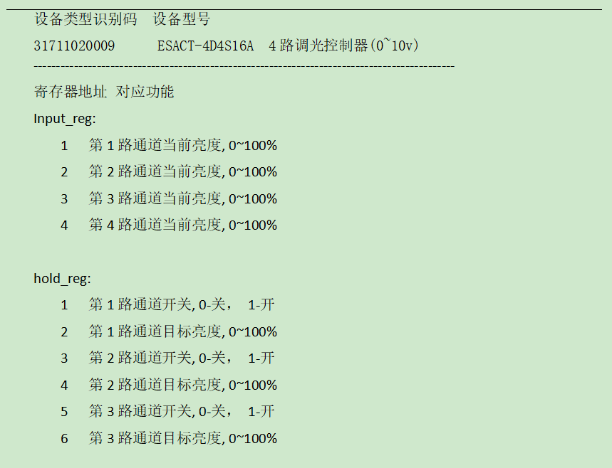

## 添加设备



结果：添加成功

## Modbus读取

|  |  |  |
| --- | --- | --- |
| √ | 读缓存-亮度，0-100& | 直读 |
| 1通道 | √ | √ |
| 2通道 | √ | √ |
| 3通道 | √ | √ |
| 4通道 | √ | √ |
| 仅读取部分Input_reg（含不存在通道6） | √ | √ |
| 读取全部Input_reg（含不存在通道10） | √ | √ |
| 读取不存在的通道5、6 | √ | √ |

测试方法



测试日志



结果：测试合格

## 寄存器值写入测试

|  |  |  |  |  |  |
| --- | --- | --- | --- | --- | --- |
| √ | 1通道 | 2通道 | 3通道 | 4通道 | 写入后读取（读缓存、直读） |
| 开关（合法值0,1；非法值2,7f，ff） | √ | √ | √ | √ | √ |
| 亮度，0-100&，非法值 | √ | √ | √ | √ | √ |
| 写入全部hold_reg：1-8 | √ | √ | √ | √ | √ |
| 写入取部分hold_reg（按通道写入、单独写入、随机写入） | √ | √ | √ | √ | √ |

测试日志：



测试结果：测试合格